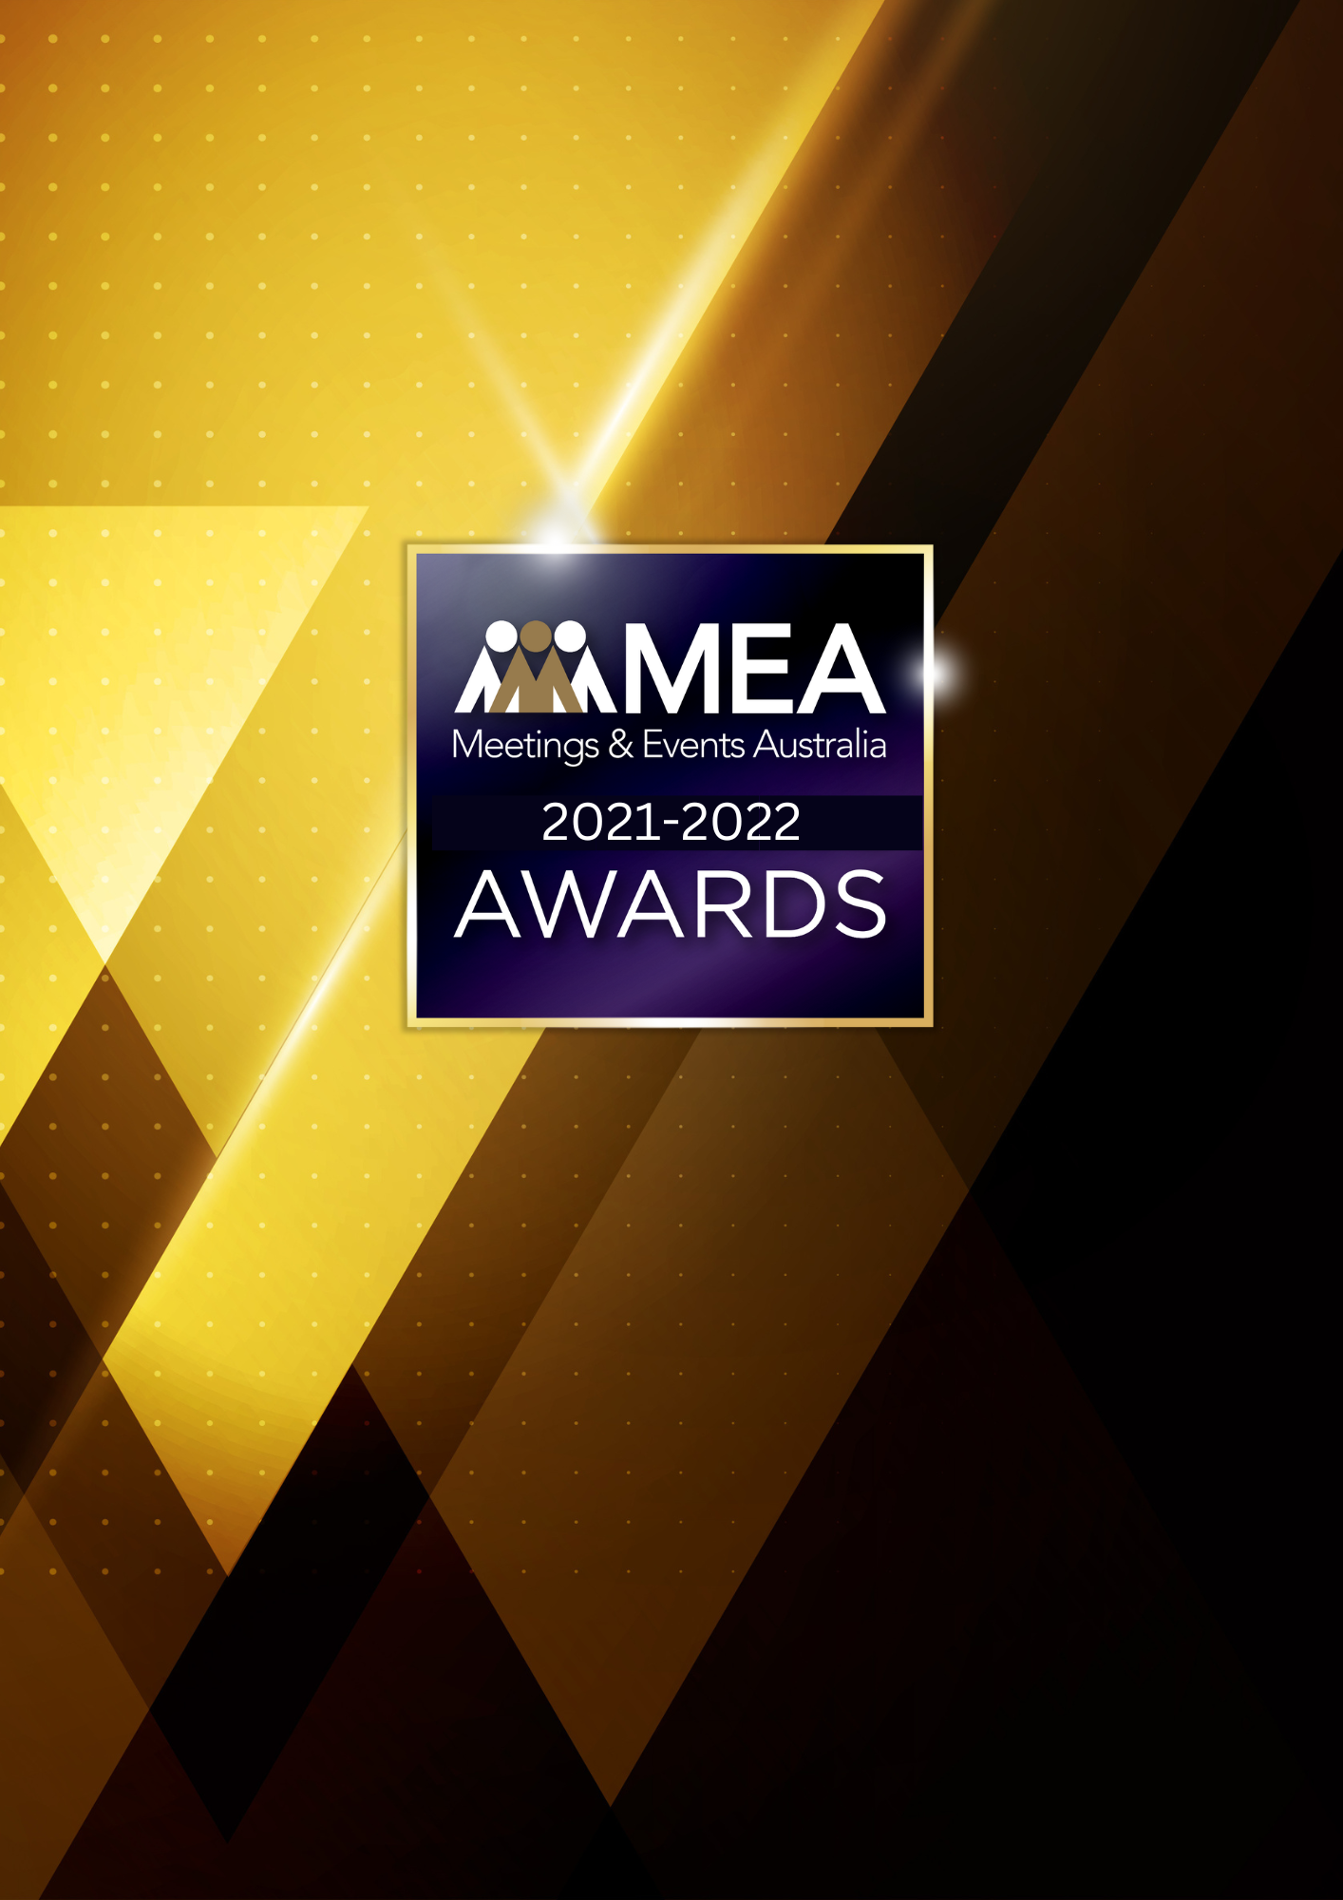

**OPERATIONS PERSON**

**OF THE YEAR AWARD**

SUBMISSION FORM

**2021-2022 MEA AWARDS  
OPERATIONS PERSON OF THE YEAR AWARD**

**AWARD DESCRIPTION**

The Operations Person of the Year Award recognises the hard work and efforts of personnel involved in any events industry-related organisation, such as venues, caterers, exhibition organisers/contractors, audio visual/staging and production, transport, or software/technology companies.

**ARE YOU ELIGIBLE TO APPLY?**

This Award is open to those whose role and daily responsibilities is in the operational delivery of events. The nominee must have demonstrated exceptional skills within the qualifying period, providing outstanding service to clients and value to their organisation. The nominee must be employed either full or part-time by the organisation.

Excludes: Sales, business development, marketing personnel, event managers of a PCO, event agency or an in-house event management team, production/event execution staff (stagehands, show callers or producers).

The National Winner of this Award will be eligible for the MEA Platinum Event Professional of the Year Award.

**GENERAL GUIDELINES**

Ensure that your submission is restricted to the qualifying period 1 January 2021 – 31 December 2022.

* Answer all the questions. There is a maximum word count for all answers that cannot be exceeded. After completing each question, indicate your word count.
* The examples provided are suggestions only that provide some guidance as to what the judges will be seeking. Do not simply answer each of these evidence types in order.
* If your evidence takes form in charts, video links or graphs, there is a separate area within the submission portal to add these. Videos must not be longer than 1-minute (60 seconds). Please indicate in your submission if you have included additional attachments outside of the form below.
* All applications must be made using the below submission form in either Microsoft Word or PDF format. No external or specialised branding may be used in lieu of this submission form.
* Judges’ feedback will be provided to applicants as soon as possible after the conclusion of the National Awards Ceremony.
* Judges will look for evidence that you are well organised, your business is well managed, how you have adapted during COVID-19 to future-proof your business, and that you have systems and procedures that are appropriate and well-maintained.
* Judges do not want details of your financial accounts, but rather are seeking to understand how your business has operated during the qualifying period.
* All applications must be submitted prior to **28 February 2023 at 11:59pm AEDT.**

**2021-2022 MEA AWARDS  
OPERATIONS PERSON OF THE YEAR AWARD**

**SCORING**

How your submission is weighted:

* How the Nominee Delivers Excellence – 20%
* Contribution to the Organisation – 30%
* Contribution to the Industry – 20%
* Sustainability – 15%
* Nominee’s Vision – 15%

**2021-2022 MEA AWARDS  
OPERATIONS PERSON OF THE YEAR AWARD**

|  |
| --- |
| **FULL NAME OF NOMINEE** |
| *Please note, this will be the name displayed on all relevant marketing and trophies, should your application be successful.* |
| **NAME OF ORGANISATION** |
|  |

1. **HOW THE NOMINEE DELIVERS EXCELLENCE**

**Maximum word count for this section: 900**

**Provide evidence demonstrating exceptional skills in the management of events (live, virtual or hybrid) resulting in outstanding services to clients and to their organisation.**

*Examples of evidence could include but are not restricted to:*

* *Company awards/recognition*
* *Client evaluations*
* *Education and experience*
* *In what ways the nominee delivers excellence*
* *Testimonials from suppliers or clients*

**2021-2022 MEA AWARDS  
OPERATIONS PERSON OF THE YEAR AWARD**

1. **CONTRIBUTION TO THE ORGANISATION**

**Maximum word count for this section: 1,200**

**Outline the results the nominee has achieved. Demonstrate how they have worked in the best interest of clients and the employing organisation.**

*Examples could include but are not restricted to:*

* *Challenges faced*
* *Contribution to the organisation’s strategic plan*
* *Financial results*
* *Industry partnerships*
* *Innovation/creativity*
* *KPIs achieved/exceeded*
* *Managing staff/teams*
* *New and creative ideas generated*
* *Objective achieved*
* *Organisational profile/leadership*
* *Problem solving*
* *Staff retention*
* *Streamlining and implementing policies and procedures*

**2021-2022 MEA AWARDS  
OPERATIONS PERSON OF THE YEAR AWARD**

1. **CONTRIBUTION TO THE INDUSTRY**

**Maximum word count for this section: 900**

**Describe how the nominee has contributed to the growth and professionalism of the events industry overall. Outline the benefits to the industry of their contribution.**

*Examples could include but are not restricted to:*

* *Involvement in industry panels or committees*
* *Membership of professional associations, accreditation or recognition programs*
* *Mentoring*
* *Participation at industry forums or focus groups*
* *Presentations at professional development workshops/seminars*
* *Published articles in trade/industry magazine/online forums*

**2021-2022 MEA AWARDS  
OPERATIONS PERSON OF THE YEAR AWARD**

1. **SUSTAINABILITY**

**Maximum word count for this section: 600**

**Outline the sustainability policy and processes that are implemented for your events (live, virtual or hybrid).**

**2021-2022 MEA AWARDS  
OPERATIONS PERSON OF THE YEAR AWARD**

1. **NOMINEE’S VISION**

**Maximum word count for this section: 600**

**What issues does the nominee foresee challenging the sustainability of the Australian events industry, and what is their vision to overcome this?**