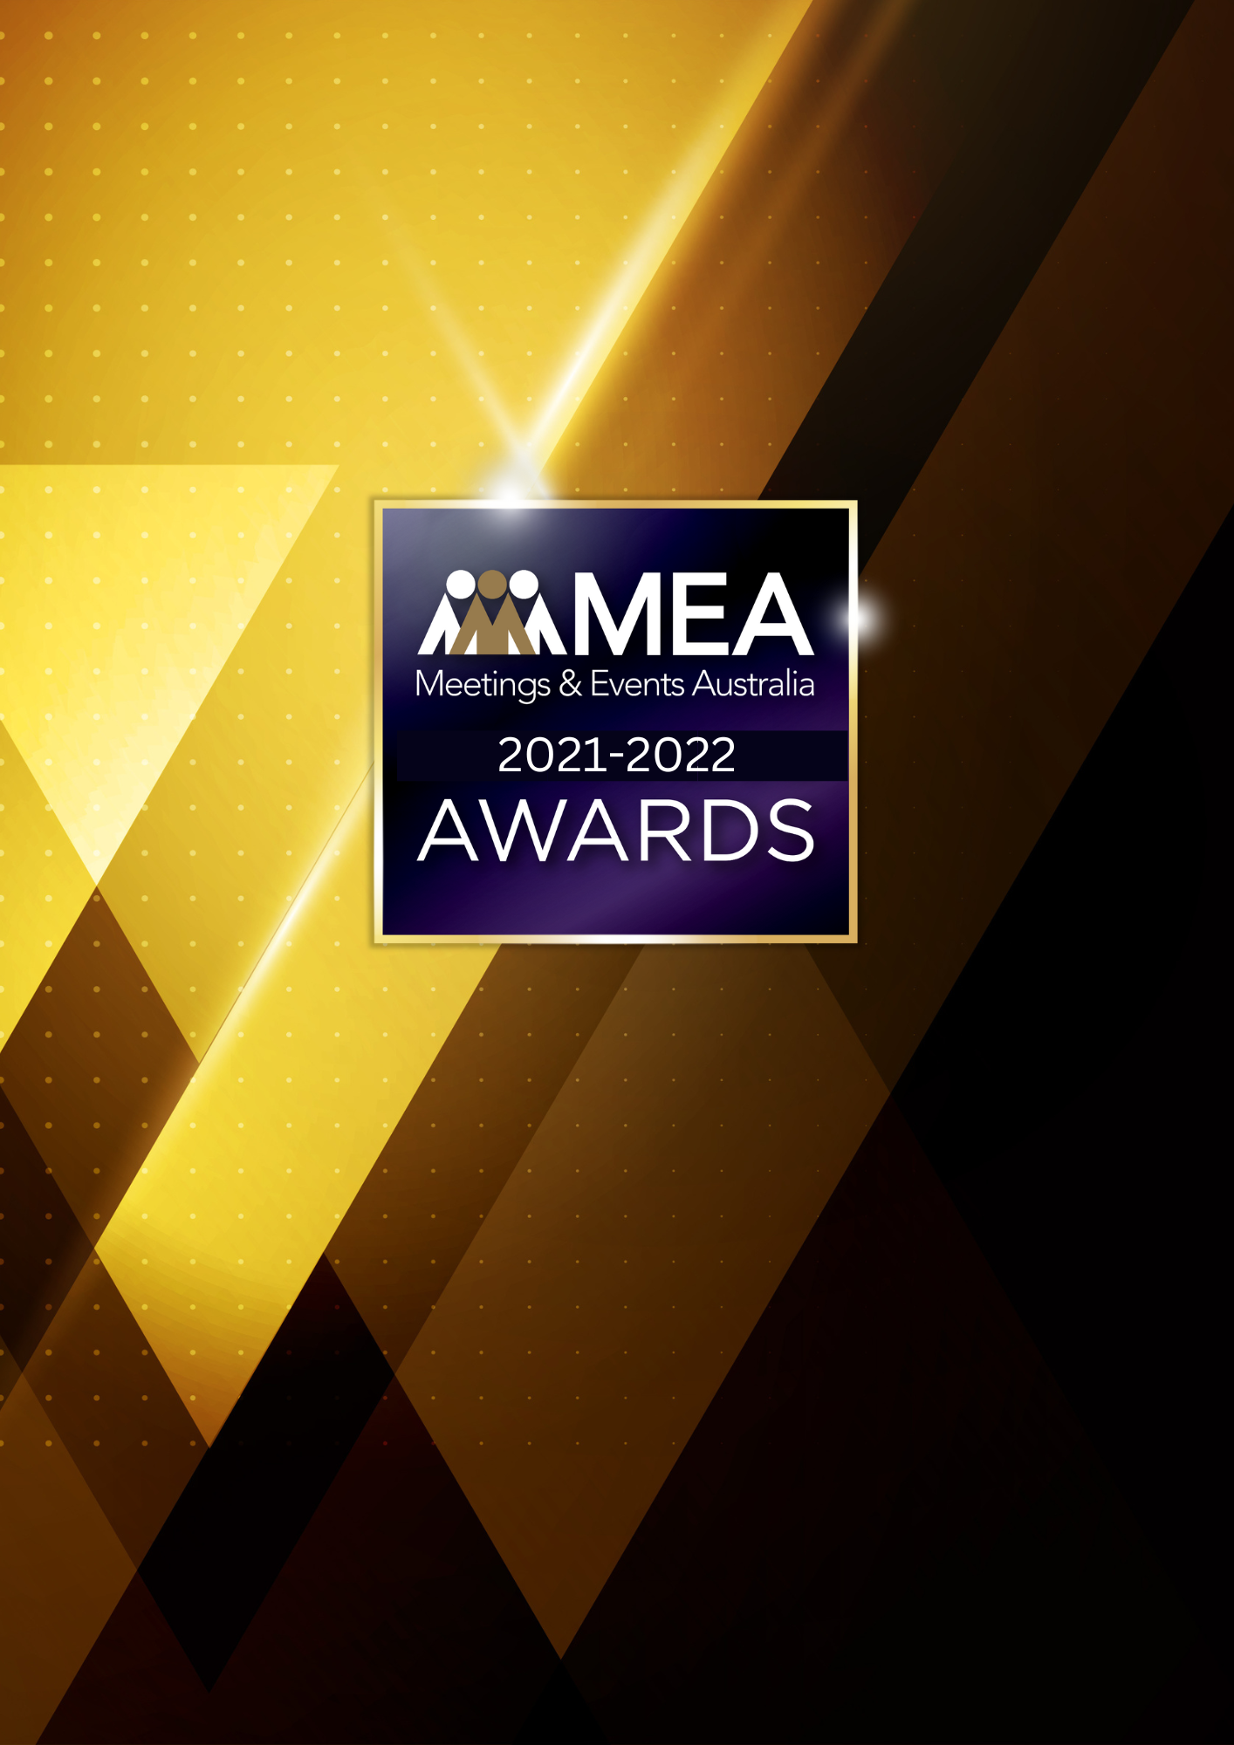

**DESTINATION MARKETING   
BUSINESS AWARD**

SUBMISSION FORM

**2021-2022 MEA AWARDS  
DESTINATION MARKETING BUSINESS AWARD**

**AWARD DESCRIPTION**

The Destination Marketing Business Award focuses on destination marketing services relating specifically to the events sector. It does not cover general tourism, hospitality, or destination activities in the case of tourist organisations.

This Award enables organisations to discuss and promote the quality of the services they provide, and the results obtained within the established parameters and objectives outlined in the below Submission Form.

**ELIGIBILITY**

The Destination Marketing Business Award is open to either regional or metropolitan convention bureau or tourist organisations working in or servicing the events sector.

The National Winner of the Award will be eligible for MEA’s 2021-2022 Company of the Year Platinum Award.

**GENERAL GUIDELINES**

Ensure that your submission is restricted to the qualifying period 1 January 2021 – 31 December 2022.

* Answer all the questions. There is a maximum word count for all answers that cannot be exceeded. After completing each question, indicate your word count.
* The examples provided are suggestions only that provide some guidance as to what the judges will be seeking. Do not simply answer each of these evidence types in order.
* If your evidence takes form in charts, video links or graphs, there is a separate area within the submission portal to add these. Videos must not be longer than 1-minute (60 seconds). Please indicate in your submission if you have included additional attachments outside of the form below.
* All applications must be made using the below submission form in either Microsoft Word or PDF format. No external or specialised branding may be used in lieu of this submission form.
* Judges’ feedback will be provided to applicants as soon as possible after the conclusion of the National Awards Ceremony.
* Judges will look for evidence that you are well organised, your business is well managed, how you have adapted during COVID-19 to future-proof your business, and that you have systems and procedures that are appropriate and well-maintained.
* Judges do not want details of your financial accounts, but rather are seeking to understand how your business has operated during the qualifying period.
* All applications must be submitted prior to **28 February 2023 at 11:59pm AEDT.**

**2021-2022 MEA AWARDS  
DESTINATION MARKETING BUSINESS AWARD**

**SCORING**

How your submission is weighted:

* Business Planning & Resource Management – 20%
* Sales & Marketing Activities – 30%
* Challenges & Responses – 20%
* Outcome & Evidence – 15%
* Contribution to the Industry – 5%
* Sustainability – 5%
* Final Statement – 5%

**2021-2022 MEA AWARDS  
DESTINATION MARKETING BUSINESS AWARD**

|  |
| --- |
| **NAME OF ORGANISATION** |
| *Insert organisation name here.*  *Please note, this will be the name displayed on all relevant marketing and trophies, should your application be successful.* |

**BUSINESS PROFILE**

This section is not scored during judging but acts as an overview to provide context of your submission in the judging process.

**Maximum word count for this section: 600**

1. **PROVIDE A GENERAL DESCRIPTION OF YOUR BUSINESS AS IT RELATES TO EVENTS:**

*Examples could include but are not restricted to:*

* *Destinations you market in/to*
* *Funding model – whether the Government contributes, and if so, to what extent*
* *Number of members/partners*
* *Target markets*
* *Types of products & services*

1. **WHAT IS YOUR ORGANISATION’S HISTORY OF INVOLVEMENT IN THE EVENTS INDUSTRY:**

*Examples could include but are not restricted to:*

* *Growth year on year*
* *Years of operation*

1. **WHAT IS YOUR ORGANISATIONAL STRUCTURE, AS IT RELATES TO EVENTS:**

*Examples could include but are not restricted to:*

* *Number of employees*
* *Organisational chart (please attach in submission portal as a PDF)*
* *The number and type of internal departments*

**2021-2022 MEA AWARDS  
DESTINATION MARKETING BUSINESS AWARD**

1. **BUSINESS PLANNING & RESOURCE MANAGEMENT**

**Maximum word count for this section: 900**

1. **Describe your business plan review process.**

*Examples could include but are not restricted to:*

* *How it is communicated to your team/organisation*
* *How often you review your business plan*
* *How you measure progress and performance*
* *How you structure the planning process (e.g. brainstorming workshops)*
* *Procedures created in response to COVID-19*
* *Timeline/schedule*
* *Tools used (e.g. SWOT analysis)*
* *Who is involved (e.g. staff and/or external consultants)*

1. **Describe the ways you manage resources and staff to achieve the most effective outcomes.**

*Examples could include but are not restricted to:*

* *Communication strategies*
* *Goal setting*
* *How staff are consulted and involved*
* *Other resources that could include technology, specialist equipment or contractors and consultants*
* *Staff appraisals*
* *Staff training*

**2021-2022 MEA AWARDS  
DESTINATION MARKETING BUSINESS AWARD**

1. **SALES & MARKETING ACTIVITIES**

**Maximum word count for this section: 1,200**

**What sort of marketing initiatives and/or bidding strategies has your organisation used to encourage meetings and events into your destination? Use up to 5 examples.**

*Examples could include but are not restricted to:*

* *Advocacy and ambassador programs*
* *Bid opportunities, research and development*
* *Engagement with stakeholders/members*
* *Engagement with Tourism Australia/Bid Fund*
* *Hosted buyer programs/familiarisations*
* *Media profiling*
* *Participation in trade shows*
* *Partnering with stakeholders*
* *Publicity materials*

**2021-2022 MEA AWARDS  
DESTINATION MARKETING BUSINESS AWARD**

1. **CHALLENGES & RESPONSES**

**Maximum word count for this section: 900**

**Demonstrate your use of creativity, originality and innovation in managing challenges. Use up to 5 examples.**

*Examples could include but are not restricted to:*

* *Budgetary/funding restraints*
* *Capital expenditure*
* *Competition/competitor activity*
* *Marketing and brand awareness*
* *Membership growth and retention*
* *Repositioning in response to COVID-19*
* *Retaining and attracting business*
* *Staff retention, career pathing/succession planning*

**2021-2022 MEA AWARDS  
DESTINATION MARKETING BUSINESS AWARD**

1. **OUTCOME & EVIDENCE**

**Maximum word count for this section: 600**

1. **Staff achievements in the qualifying period.**

*Examples could include but are not restricted to:*

* *Awards*
* *Graduating in education & training courses*
* *Improved management/staff relationships*
* *Staff initiatives*
* *Staff retention rates*
* *Successful staff initiatives*

1. **Provide evidence of your client/member/stakeholder satisfaction. In addition to this, please upload one client/member/stakeholder testimonial as a PDF to the submission portal.**

*Examples could include but are not restricted to:*

* *Bids presented and won*
* *Feedback from a specific bid*
* *Increase in delegate days*
* *Increased funding*
* *Increased media exposure and recognition*
* *Legacies from events*
* *Member retention rates*
* *New member growth*
* *Word-of-mouth referrals from satisfied clients.*

**2021-2022 MEA AWARDS  
DESTINATION MARKETING BUSINESS AWARD**

1. **CONTRIBUTION TO THE INDUSTRY**

**Maximum word count for this section: 300**

**Describe how your activities have contributed to the growth and professionalism of the events industry overall.**

*Examples could include but are not restricted to:*

* *Contributions to trade publications/online forums*
* *Cross-industry promotion through committee participation (BECA, AACB etc)*
* *Industry forums or focus groups*
* *Involvement on industry panels or committees*
* *Presentations at professional development workshops*

**2021-2022 MEA AWARDS  
DESTINATION MARKETING BUSINESS AWARD**

1. **SUSTAINABILITY**

**Maximum word count for this section: 300**

**Outline the sustainability policy that you implement within your organisation.**

**2021-2022 MEA AWARDS  
DESTINATION MARKETING BUSINESS AWARD**

1. **FINAL STATEMENT**

**Maximum word count for this section: 300**

**Summarise your submission and let us know why you should win the 2021-2022 Destination Marketing Business Award.**