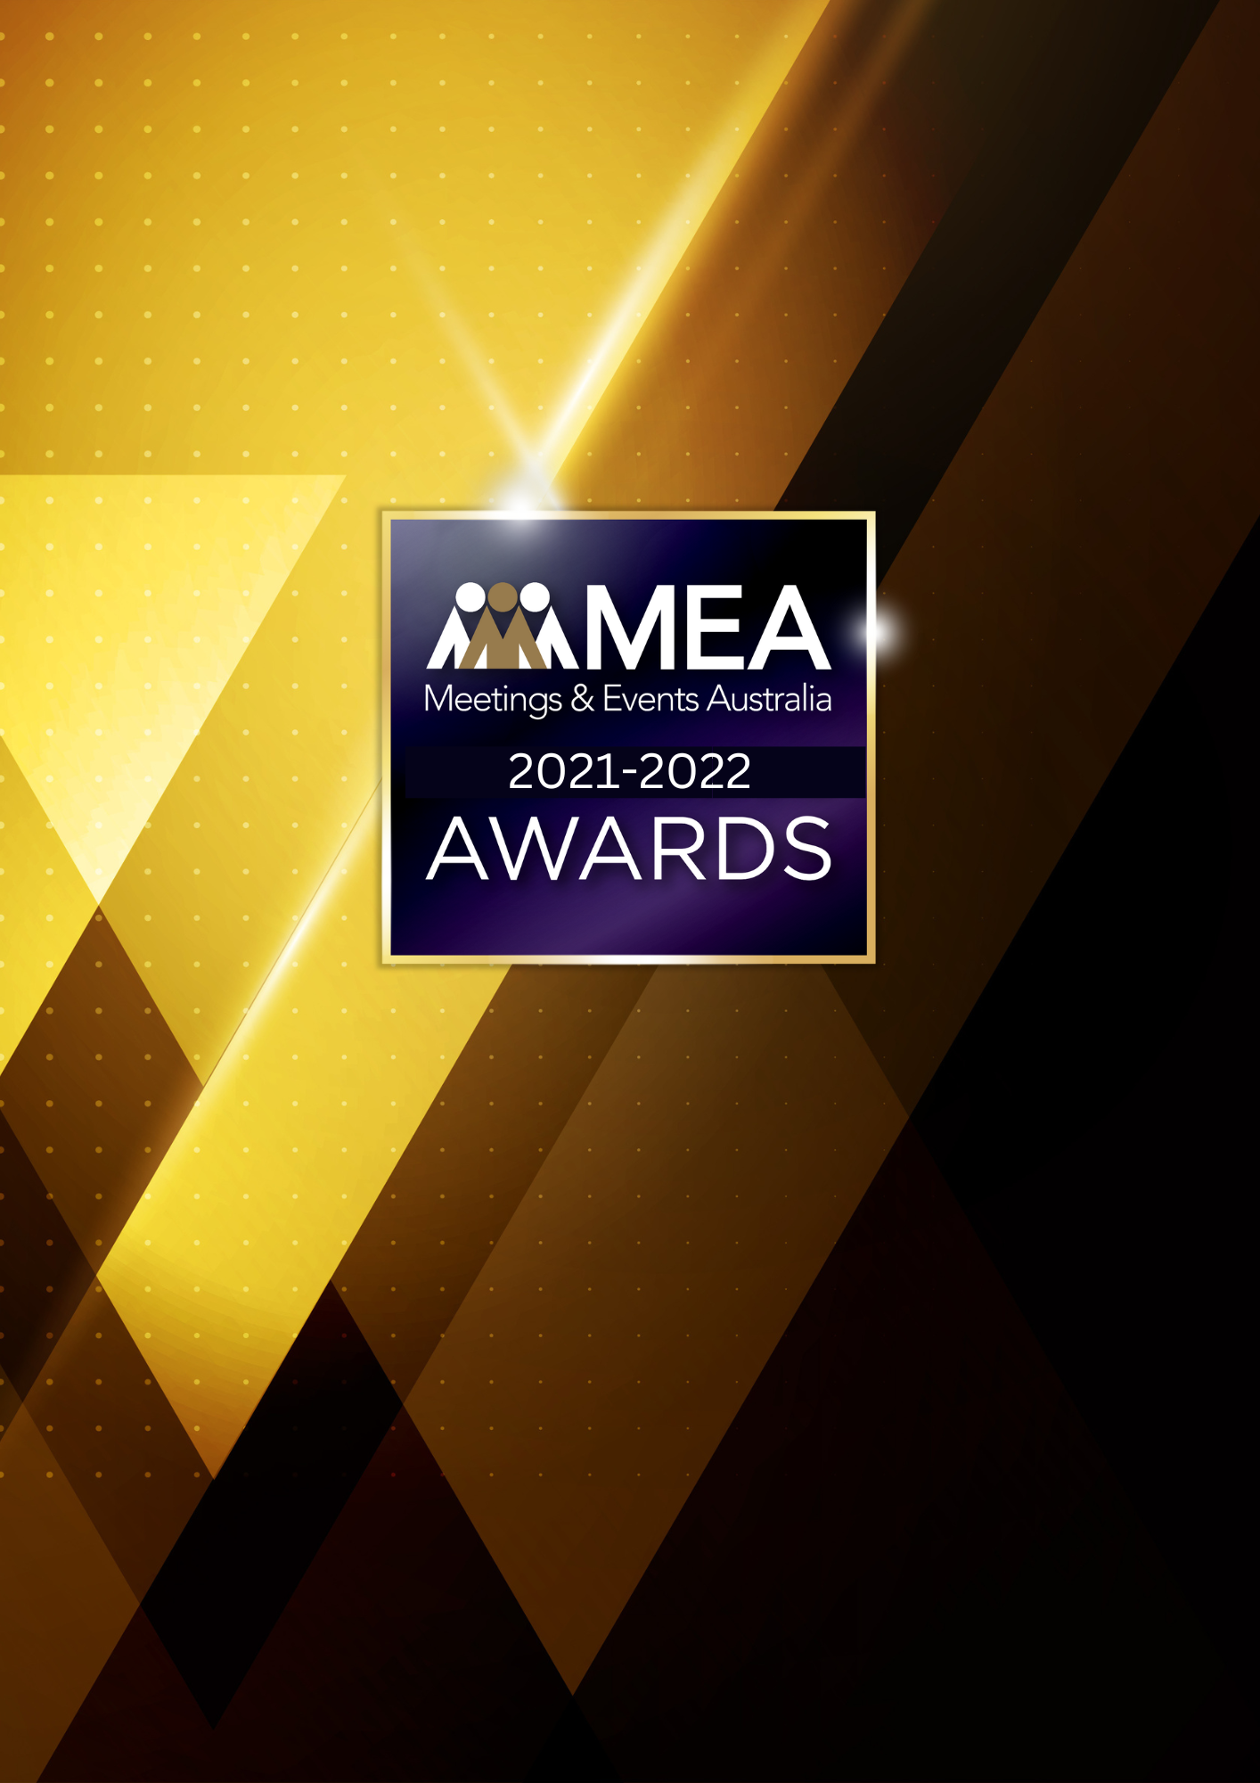

**OUTSTANDING CONTRIBUTION AWARD**

SUBMISSION FORM

**2021-2022 MEA AWARDS  
OUTSTANDING CONTRIBUTION AWARD**

**AWARD DESCRIPTION**

The Outstanding Contribution Award is the highest honour the MEA community bestows on an individual from within the Australian events industry. It is a recognition of the contribution made by the candidate and the influence they have within our industry.

This Award recognises major contributions across the industry on a national scale and MEA within the past five years. If no nominations are received, the MEA Board will nominate a person they believe deserves recognition for their contribution to the Association.

It is not necessary for this Award to be given out every year and the number of Awards within this category are not limited.

**FORM OF AWARD**

The recipient of this Award will receive a trophy and will be featured in MEA’s Celebration of Excellence booklet.

**CRITERIA**

In nominating an individual for the Outstanding Contribution Award, regard should be given to the nominee’s achievements over the past five years and ongoing contribution to the wider events industry.

The individual need not be a current member of Meetings & Events Australia (MEA), however, the nominator must be a member of MEA.

To nominate someone for this Award, you are required to provide the following details:

* A written statement of 500 words on why the nominee deserves this recognition. This would include, but not be limited to, the following:
  + Demonstrated leadership in the events industry in Australia
  + Demonstrated excellence in their field
  + Specific examples of industry achievements and in particular how the nominee has given back to the industry
  + Achievements as an individual or as part of a group or organisation
* 3-5 supporting letters from individuals and organisations who endorse the nomination. Names, addresses, phone numbers and email addresses of the supporting contacts must be included.

We encourage you to also include supporting documentation with your nomination. This can include references, biographies, newspaper, or industry publication articles. All documentation will be retained by MEA.

**2021-2022 MEA AWARDS  
OUTSTANDING CONTRIBUTION AWARD**

**ELIGIBILITY OF NOMINEE**

* This Award is not able to be given posthumously.
* Self-nominations will not be accepted
* Nominees must be at least 25 years of age
* Unsuccessful nominees may be re-nominated in subsequent years
* The nominee need not be a current member of MEA

**SELECTION COMMITTEE**

Each year, MEA appoints a committee of three individuals to review the submissions for the Award. Each member of this committee is appointed on the basis that they do not know or have worked with any of the candidates nominated for the Award. They may be a past recipient of this Award, or from outside the events industry. The MEA Board is required to endorse the selection committee.