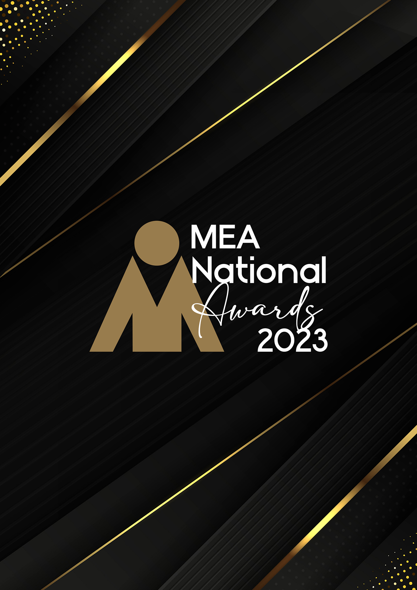

**SALES, MARKETING OR BUSINESS DEVELOPMENT PERSON OF THE YEAR AWARD**

Submission Form

**AWARD DESCRIPTION**

The Sales, Marketing or Business Development Person of the Year Award recognises the hard work and efforts of an individual person who has demonstrated outstanding sales, marketing or business development skills within the events industry. The Award highlights those who have been successful in achieving both positive results and a significant profile for their organisation.

**ARE YOU ELIGIBLE TO APPLY?**

This Award is open to persons who are full time or permanent part-time employed as business development executives or managers, marketing team members or managers, and proactive sales staff. The applicant’s core role must be to either proactively source and secure new business, manage repeat business, or support the sales effort with effective marketing programs.

The National Winner of this Award will be eligible for the MEA Platinum Individual of the Year Award.

**GENERAL GUIDELINES**

Ensure that your submission is restricted to the qualifying period 1 January 2023 – 31 December 2023.

* Answer all the questions. There is a maximum word count for all answers that cannot be exceeded. After completing each question, indicate your word count.
* The examples provided are suggestions only that provide some guidance as to what the judges will be seeking. Do not simply answer each of these evidence types in order.
* If your evidence takes form in charts, video links or graphs, there is a separate area within the submission portal to add these. Videos must not be longer than 1-minute (60 seconds). Please indicate in your submission if you have included additional attachments outside of the form below.
* All applications must be made using the below submission form in either Microsoft Word or PDF format. No external or specialised branding may be used in lieu of this submission form.
* Judges’ feedback will be provided to applicants as soon as possible after the conclusion of the National Awards Ceremony.
* Judges do not want details of your financial accounts, but rather are seeking to understand how your business has operated during the qualifying period.
* All applications must be submitted prior to **Monday 12 February 2024 at 11:59pm AEDT.**

**SCORING**

How your submission is weighted:

* How the Nominee Delivers Excellence – 20%
* Contribution to the Organisation – 30%
* Contribution to the Industry – 20%
* Sustainability – 15%
* Nominee’s Vision – 15%

|  |  |
| --- | --- |
| **FULL NAME OF NOMINEE** | |
| *Please insert the name of the nominee in the black space provided. Please note, this will be the name displayed on all relevant marketing and trophies, should your application be successful.* | Insert name here |
| **NAME OF ORGANISATION** | |
| *Please insert the name of the organisation in the black space provided. Please note, this will be the name displayed on all relevant marketing and trophies, should your application be successful.* | Insert name here |

1. **HOW THE NOMINEE DELIVERS EXCELLENCE**

Maximum word count for this section: 900

**Provide evidence demonstrating exceptional skills in the procurement of events (live, virtual or hybrid) that have resulted in outstanding services to clients and to their organisation.**

*Examples of evidence could include but are not restricted to:*

* *Company awards/recognition*
* *Client evaluations*
* *Education and experience*
* *In what ways the nominee delivers excellence*
* *Testimonials from suppliers or clients*

Type response here. Space will expand.

1. **CONTRIBUTION TO THE ORGANISATION**

Maximum word count for this section: 1,200

**Outline the results the nominee has achieved for their organisation. Within your answer, include evidence of the below:**

* **How the nominee has contributed to the organisation’s strategic plan.**
* **How the nominee’s achievements have enhanced and/or elevated the organisation through retaining business, securing new clients, or achieving above-average results from an advertising or marketing campaign.**

*Examples could include but are not restricted to:*

* *Achieving/exceeding targets and KPIs*
* *Campaign results*
* *Financial results*
* *Industry partnerships*
* *Measurement of success*
* *Occupancy or venue uses*
* *Organisational profile*

Type response here. Space will expand.

.

1. **CONTRIBUTION TO THE INDUSTRY**

Maximum word count for this section: 900

**Describe how the nominee has actively contributed to the growth and professionalism of the events industry within the qualifying period. Outline the benefits to the industry of their contribution.**

*Examples could include but are not restricted to:*

* *Contributing articles in /industry magazines/online forums*
* *Involvement in industry panels or committees*
* *Membership of professional associations, accreditation or recognition programs*
* *Mentoring*
* *Participation in industry forums or focus groups*
* *Presentations at professional development workshops/seminars*

Type response here. Space will expand.

1. **SUSTAINABILITY**

Maximum word count for this section: 600

**Outline the sustainability policy and processes that are implemented for your events (live, virtual or hybrid) and with your team.**

Type response here. Space will expand.

1. **NOMINEE’S VISION**

Maximum word count for this section: 600

**What issues does the nominee foresee challenging the sustainability of the Australian events industry, and what is their vision to overcome this?**

Type response here. Space will expand.