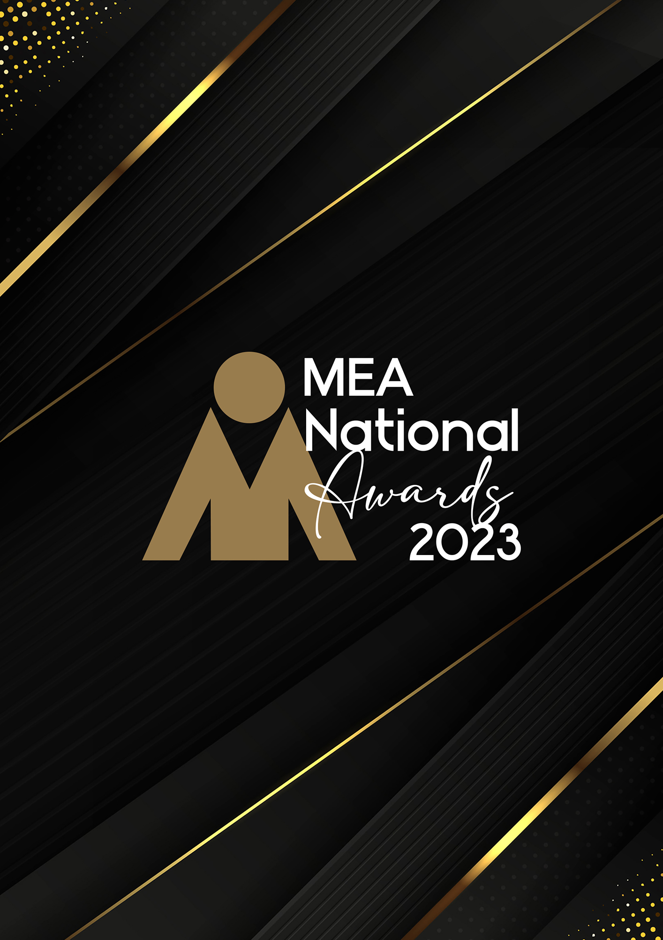

**SPECIALIST SERVICES &  
SUPPLIERS AWARD**

Submission Form

**AWARD DESCRIPTION**

The Specialist Services & Suppliers Award recognises the many and varied support services essential to the successful delivery of events. It focuses on the excellence in the delivery of specialist services that enhance, support or positively impact the planning, delivery, and experience of outcomes of a physical and/or virtual meeting or event.

**ELIGIBILITY**

This Award is open to organisations that support the conference, meetings, special events and exhibition industry through the delivery of products and services whether these be physical, hybrid or virtual.

This category is not intended for marketing or digital service providers, event managers or individuals or organisations offering technology services. These are covered in other award categories.

An example of services included in this Award is design, autocue, transport, security, airlines, coach and ground operators, interpreting services, photography, stylists and publishing.

This Award will recognise the company as the recipient of the Award.

The National Winner of the Award will be eligible for MEA’s 2023 Company of the Year Platinum Award.

**GENERAL GUIDELINES**

Ensure that your submission is restricted to the qualifying period 1 January 2023 – 31 December 2023.

* Answer all the questions. There is a maximum word count for all answers that cannot be exceeded. After completing each question, indicate your word count.
* The examples provided are suggestions only that provide some guidance as to what the judges will be seeking. Do not simply answer each of these evidence types in order.
* If your evidence takes form in charts, video links or graphs, there is a separate area within the submission portal to add these. Videos must not be longer than 1-minute (60 seconds). Please indicate in your submission if you have included additional attachments outside of the form below.
* All applications must be made using the below submission form in either Microsoft Word or PDF format. No external or specialised branding may be used in lieu of this submission form.
* Judges’ feedback will be provided to applicants as soon as possible after the conclusion of the National Awards Ceremony.
* Judges will look for evidence that you are well organised, your business is well managed, how you are future-proofing your business, and that you have systems and procedures that are appropriate and well-maintained.
* Judges do not want details of your financial accounts, but rather are seeking to understand how your business has operated during the qualifying period.
* All applications must be submitted prior to **Monday 12 February 2024 at 11:59pm AEDT.**

**SCORING**

How your submission is weighted:

* Business Planning & Resource Management – 30%
* Challenges & Responses – 40%
* Outcome & Evidence – 15%
* Contribution to the Industry – 5%
* Sustainability – 5%
* Final Statement – 5%

|  |  |
| --- | --- |
| **NAME OF COMPANY** | |
| *Insert the company’s name in the blank space provided. Please note, this will be the name displayed on all relevant marketing and trophies, should your application be successful.* | Insert name here |

**BUSINESS PROFILE**

This section is not scored during judging but acts as an overview to provide context of your submission in the judging process.

Maximum word count for this section: 600

1. **PROVIDE A GENERAL DESCRIPTION OF YOUR BUSINESS AS IT RELATES TO EVENTS:**

*Examples could include but are not restricted to:*

* *Diversity of clients*
* *Number, size, and range of events serviced*

Type response here. Space will expand.

1. **WHAT IS YOUR BUSINESS’S HISTORY OF INVOLVEMENT IN THE EVENTS INDUSTRY:**

*Example includes but is not restricted to:*

* *Years of operation*

Type response here. Space will expand.

1. **WHAT IS YOUR BUSINESS STRUCTURE, AS IT RELATES TO EVENTS:**

*Examples could include but are not restricted to:*

* *Number of employees*
* *Organisational chart (please attach in submission portal as a PDF)*
* *The number and type of internal departments*

Type response here. Space will expand.

1. **BUSINESS PLANNING & RESOURCE MANAGEMENT**

Maximum word count for this section: 1,200

1. **Describe your business planning process undertaken in the qualifying period.**

*Examples could include but are not restricted to:*

* *How often you review your business plan*
* *How it is communicated to your team/organisation*
* *How you measure progress and performance*
* *How you structure the planning process (e.g. brainstorming workshops)*
* *Timeline/schedule*
* *Tools used (e.g. SWOT analysis)*
* *Who is involved (e.g. staff and/or external consultants)*

Type response here. Space will expand.

1. **Describe the ways you manage resources and staff to achieve the most effective outcomes over the qualifying period.**

*Examples could include but are not restricted to:*

* *Career pathing/succession planning*
* *Communication strategies*
* *How staff are consulted and involved*
* *Other resources that could include technology, specialist equipment or contractors and consultants*
* *Reward schemes*
* *Staff appraisals*

Type response here. Space will expand.

1. **CHALLENGES & RESPONSES**

Maximum word count for this section: 1,200

**Demonstrate your use of creativity, originality and innovation in managing challenges. Use up to 5 examples.**

*Examples could include but are not restricted to:*

* *Budgetary restraints*
* *Competition/competitor activity*
* *Complying with industry work health and safety requirements*
* *Creating maintaining a culture of innovation in your organisation*
* *Maintaining industry best practice*
* *Maintaining/creating strategies to deliver exceptional experiences, products or programs for your clients.*
* *Managing risk*
* *Marketing and brand awareness*
* *Remaining abreast of industry, product, or service developments*
* *Retaining and attracting business*
* *Staff retention, career pathing/succession planning*

Type response here. Space will expand.

1. **OUTCOME & EVIDENCE**

Maximum word count for this section: 600

1. **Share some of your organisation’s achievements during the qualifying period.**

*Examples could include but are not restricted to:*

* *Awards (corporate, team or individual)*
* *Improved management/staff relationships*
* *Media recognition*
* *Referrals and repeat business*
* *Staff retention rates*
* *Successful outcomes delivered to clients*
* *Successful staff initiatives*
* *Winning new business*

Type response here. Space will expand.

1. **Provide evidence of your client/customer satisfaction. In addition to this, please upload one client/key supplier testimonial as a PDF to the submission portal.**

*Examples could include but are not restricted to:*

* *Client retention and referrals*
* *Feedback from a specific event/exhibition*
* *Repeat business*

Type response here. Space will expand.

1. **CONTRIBUTION TO THE INDUSTRY**

Maximum word count for this section: 300

**Describe how your activities have contributed to the growth and professionalism of the exhibitions, meetings, and events industry overall.**

*Provide evidence for contributions within MEA and other industry organisations during the qualifying period, such as:*

* *Contribution to trade magazines/online forums*
* *Global partnerships/memberships*
* *Involvement in industry panels or committees*
* *Involvement with your local destination marketing organisation*
* *Mentoring*
* *Participation in industry forums or focus groups*
* *Presentations at industry briefings, webinars, conferences (physical or virtual)*

Type response here. Space will expand.

.

1. **SUSTAINABILITY**

Maximum word count for this section: 300

**Outline the sustainability policy that you implement within your organisation.**

Type response here. Space will expand.

1. **FINAL STATEMENT**

Maximum word count for this section: 300

**Summarise your submission and let us know why you should win the 2023 Specialist Services & Suppliers Award.**

Type response here. Space will expand.