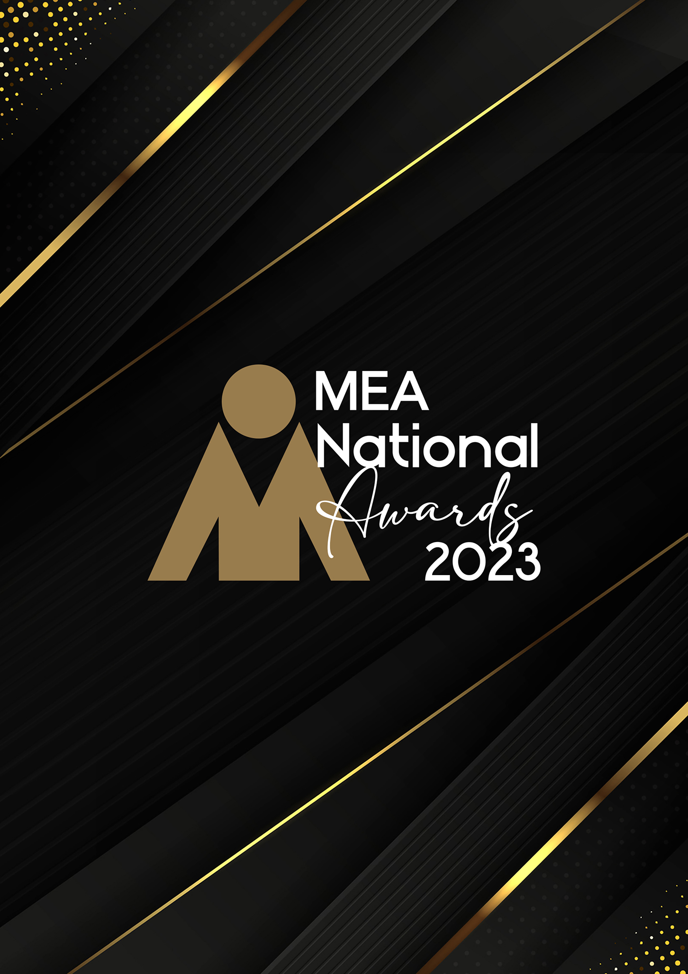

**EXHIBITION OF THE YEAR   
AWARD**Submission Form

**AWARD DESCRIPTION**

The Exhibition of the Year Award recognises the combined team effort that is required to successfully plan, organise and manage an exhibition (public or trade).

An exhibition for the purposes of this Award is defined as an event at which goods and services for a specific industry are exhibited. This could either be as a stand-alone event or as part of a business event. The minimum exhibition size for this submission is no less than 40 exhibitors.

The exhibition must be considered significant in achieving objectives through the challenges, complexities, and imaginative use of resources, innovation, creativity and overall management.

Projects must have been completed in the qualifying period to be judged for this Award. Joint entries from the event or exhibition organisers, venues, display companies, and other key suppliers are encouraged. A joint entry requires payment per submission as opposed to per contributing partner, and just 1 award is presented for the event irrespective of the number of named contributing partners.

If the exhibition being submitted for this Award has been managed on behalf of an external client or organisation, the event owner must be made aware that a submission is being made and support the nomination.

**ARE YOU ELIGIBLE TO APPLY?**

If you are an exhibition organiser, PCO, event management company, or in-house event team organising an exhibition with 40 or more exhibitors you are eligible to apply.

The National Winner of this Award will be eligible for the MEA Platinum Event of the Year Award.

**GENERAL GUIDELINES**

Ensure that your submission is restricted to the qualifying period 1 January 2023 – 31 December 2023.

* Answer all the questions. There is a maximum word count for all answers that cannot be exceeded. After completing each question, indicate your word count.
* The examples provided are suggestions only that provide some guidance as to what the judges will be seeking. Do not simply answer each of these evidence types in order.
* If your evidence takes form in charts, video links or graphs, there is a separate area within the submission portal to add these. Videos must not be longer than 1-minute (60 seconds). Please indicate in your submission if you have included additional attachments outside of the form below.
* All applications must be made using the below submission form in either Microsoft Word or PDF format. No external or specialised branding may be used in lieu of this submission form.
* Judges’ feedback will be provided to applicants as soon as possible after the conclusion of the National Awards Ceremony.
* Judges will look for evidence that you are well organised, your business is well managed, how you are future-proofing your business, and that you have systems and procedures that are appropriate and well-maintained.
* Judges do not want details of your financial accounts, but rather are seeking to understand how your business has operated during the qualifying period.

All applications must be submitted prior to **Monday 12 February 2024 at 11:59pm AEDT.**

**SCORING**

How your submission is weighted:

* Event Significance – 5%
* Financial Performance – 5%
* Sustainability – 5%
* Project Planning & Resource Management – 30%
* Challenges & Response – 30%
* Outcome & Evidence – 20%
* Final Statement – 5%

|  |  |
| --- | --- |
| **NAME OF THE EXHIBITION** | |
| *Insert the name of your exhibition in the blank space provided. Please note, this will be the name displayed on all relevant marketing and trophies, should your application be successful.* | Insert name here |
| **NAME OF ORGANISATION** | |
| *Insert the name of your organisation in the blank space provided. Please note, this will be the name displayed on all relevant marketing and trophies, should your application be successful.* | Insert name here |

**EVENT PROFILE**

This section is not scored during judging but acts as an overview to provide context of your submission in the judging process.

Maximum word count for this section: 600

1. **PROVIDE AN OVERVIEW OF THE EXHIBITION**

Type response here. Space will expand.

1. **OUTLINE THE OBJECTIVES AND PURPOSE OF THE EXHIBITION**

*Examples could include but are not restricted to:*

* *Educational, financial, social, awareness, diversity objectives, team building/reward*
* *Event history (if any)*
* *Expected outcomes*

Type response here. Space will expand.

1. **EVENT SIGNIFICANCE**

Maximum word count for this section: 300

**Detail the significance of the exhibition and its impact.**

*Examples could include but are not restricted to:*

* *Social impact*
* *Stakeholders (clients, delegates, exhibitors, host organisation, presenters, sponsors)*
* *Economic impact*
* *The venue, local and regional area*
* *The wider public*

Type response here. Space will expand.

1. **FINANCIAL PERFORMANCE**

Maximum word count for this section: 300

**How did the exhibition perform in a financial capacity?**

*Examples could include but are not restricted to:*

* *Budget forecast and actual results*
* *Profitability*
* *Increase in delegate attendance from previous event*
* *Increase in sponsorship/exhibition sales*

Type response here. Space will expand.

1. **SUSTAINABILITY**

Maximum word count for this section: 300

**Outline the sustainability policy and processes that you implement within your organisation.**

Type response here. Space will expand.

1. **PROJECT PLANNING & RESOURCE MANAGEMENT**

Maximum word count for this section: 1,200

**Provide insight into how you planned this project. Use examples.**

*Examples could include but are not restricted to:*

* *Engagement of contractors (if applicable)*
* *Identification of objectives*
* *Methods used in planning – both formal and informal*
* *Risk mitigation/crisis management*
* *The timeline, schedule, critical path or goal setting used*
* *Who was involved*

Type response here. Space will expand.

1. **CHALLENGES & RESPONSE**

Maximum word count for this section: 1,200

**Demonstrate your use of creativity, originality, and innovation in managing challenges. Use up to 5 examples.**

*Examples could include but are not restricted to:*

* *Accommodation*
* *Attendance building*
* *Branding*
* *Budgeting*
* *Business program*
* *Catering*
* *Client liaison*
* *Communications*
* *Exhibition*
* *Media management*
* *Off-site activities*
* *On-site activities*
* *Promotional activities*
* *Raising revenue*
* *Social functions*
* *Speaker liaison*
* *Speaker support media*
* *Sponsorship*
* *Staff management*
* *Team building*
* *Technology*
* *Travel*
* *Venue*
* *Visas*

Type response here. Space will expand.

1. **OUTCOME & EVIDENCE**

Maximum word count for this section: 900

1. **Was the exhibition successful? Provide your answer with measurable metrics.**

*Examples could include but are not restricted to:*

* + *Delegate numbers*
  + *Financials*
  + *Legacies created – refer to Event Legacy option on the last page of this form*
  + *Media coverage*
  + *Objectives met*
  + *Stakeholder satisfaction*

Type response here. Space will expand.

1. **Provide evidence of the host’s satisfaction. In addition to this, please upload one client/key supplier testimonial as a PDF to the submission portal.**

*Examples could include but are not restricted to:*

* + *Anecdotal feedback*
  + *Evidence of professional completion of all aspects of the project*
  + *Formal evaluation*
  + *Opportunities for repeat business*

Type response here. Space will expand.

1. **FINAL STATEMENT**

Maximum word count for this section: 300

**Summarise your submission and let us know why you should win the 2023 Exhibition of the Year Award.**

Type response here. Space will expand.

**OPTIONAL: EVENT LEGACY**

**MEA recognises the impact that events have on business, community, the local & Australian economy and on social outcomes.**

Each Award within the Event of the Year category includes an optional question on Event Legacy. There is no requirement to complete this question, as it does not add to your scoring for the Exhibition of the Year Award, and the legacy does not need to have occurred within the qualifying period. Event Legacy refers to an event that has a long-term positive impact on the host area, be this culturally, economically, or physically.

The below questions will be judged separately to go in the running for the specialised MEA Event Legacy Award. There is no additional fee associated with submitting an Award in this category if you have already submitted for an Event of the Year Award.

**QUESTIONS**

**Maximum word count for this section: 2,000**

1. What type of legacy did the event deliver?
2. Was the legacy planned from the outset, or did it arise by chance?
3. What was entailed in creating & delivering the legacy?
4. Did it meet ready approval by stakeholders, or were there challenges in getting them on board with the legacy objectives?
5. Were there any budgetary, time or personnel constraints?
6. Have any previous legacies been created?
7. What is the life expectancy of the legacy?
8. Did any difficulties arise in delivering the legacy and how were they overcome?
9. How was it measured?
10. What are the future outcomes from the legacy?

Type response here. Space will expand.