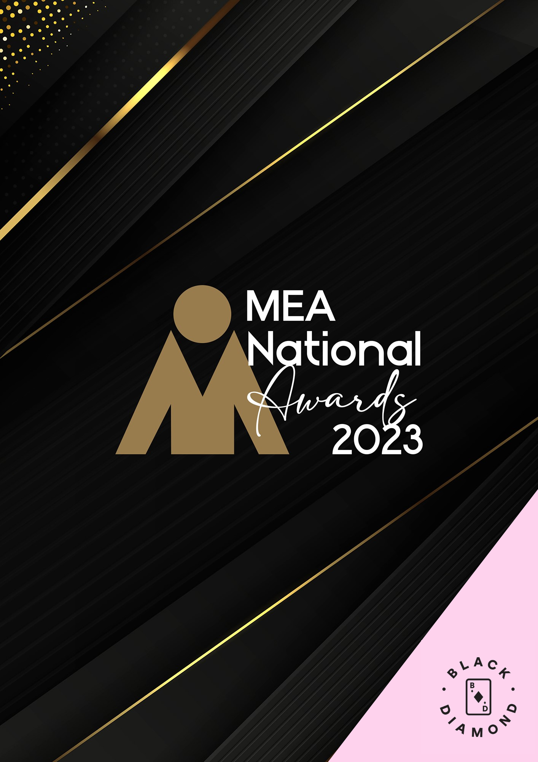

**IN-HOUSE EVENT MANAGEMENT TEAM (CORPORATE) AWARD**

Submission Form

**AWARD DESCRIPTION**

The In-House Event Management Team (Corporate) Award, sponsored by [**Black Diamond Agency**](https://blackdiamondagency.com/)**,** judges the business of running an ‘in-house’ event management team within an organisation that is neither a government entity nor an industry association, rather than the management of any one event.

**ELIGIBILITY**

This Award is open to those who are employed by their corporate organisation to manage in-house meetings, conferences, exhibitions or events.

Excludes: Professional conference organisers, event agencies, associations or government in-house teams that organise meetings, conferences, exhibitions, or events on behalf of external clients.

The National Winner of this Award will be eligible for MEA’s 2023 Company of the Year Platinum Award.

**GENERAL GUIDELINES**

Ensure that your submission is restricted to the qualifying period 1 January 2023 – 31 December 2023.

* Answer all the questions. There is a maximum word count for all answers that cannot be exceeded. After completing each question, indicate your word count. Judges will not read beyond the word count.
* The examples provided are suggestions only that provide some guidance as to what the judges will be seeking. Do not simply answer each of these evidence types in order.
* If your evidence takes form in charts, video links or graphs, there is a separate area within the submission portal to add these. Videos must not be longer than 1-minute (60 seconds). Please indicate in your submission if you have included additional attachments outside of the form below.
* All applications must be made using the below submission form in either Microsoft Word or PDF format. No external or specialised branding may be used in lieu of this submission form.
* Judges’ feedback will be provided to applicants as soon as possible after the conclusion of the National Awards Ceremony.
* Judges will look for evidence that you are well organised, your business is well managed, how you are future-proofing your business, and that you have systems and procedures that are appropriate and well-maintained.
* Judges do not want details of your financial accounts, but rather are seeking to understand how your business has operated during the qualifying period.
* All applications must be submitted prior to **Monday 12 February 2024 at 11:59 pm AEDT**.

**SCORING**

How your submission is weighted:

* Business Planning & Resource Management – 20%
* Project Planning & Client Management – 30%
* Challenges & Responses – 20%
* Outcome & Evidence – 15%
* Contribution to the Industry – 5%
* Sustainability – 5%
* Final Statement – 5%

|  |  |
| --- | --- |
| **NAME OF CORPORATE IN-HOUSE MANAGEMENT TEAM** | |
| *Insert your In-house team’s name in the blank space provided. Please note, this will be the name displayed on all relevant marketing and trophies, should your application be successful.* | Insert name here |

**BUSINESS PROFILE**

This section is not scored during judging but acts as an overview to provide context of your submission in the judging process.

*Maximum word count for this section: 600*

1. **PROVIDE A GENERAL DESCRIPTION OF YOUR BUSINESS AS IT RELATES TO EVENTS:**

*Examples could include but are not restricted to:*

* *Number, size and range of events, including those that were finalised as well as those in progress*
* *The range and diversity of event services and projects undertaken*
* *Diversity of client’s services*

Type response here. Space will expand.

1. **WHAT IS YOUR ORGANISATION’S HISTORY OF INVOLVEMENT IN THE EVENTS INDUSTRY:**

*Examples could include but are not restricted to:*

* *Growth year on year*
* *Years of operation*

Type response here. Space will expand.

1. **WHAT IS YOUR ORGANISATIONAL STRUCTURE, AS IT RELATES TO EVENTS:**

*Examples could include but are not restricted to:*

* *Number of employees*
* *Organisational chart (please attach in submission portal as a PDF)*
* *The number and type of internal departments*

Type response here. Space will expand.

1. **BUSINESS PLANNING & RESOURCE MANAGEMENT**

*Maximum word count for this section: 900*

1. **Describe your business planning process undertaken in the qualifying period.**

*Examples could include but are not restricted to:*

* *How it is communicated to your team/organisation*
* *How often you review your business plan*
* *How you measure progress and performance*
* *How you structure the planning process (e.g. brainstorming workshops)*
* *Timeline/schedule*
* *Tools used (e.g. SWOT analysis)*
* *Who is involved (e.g. staff and/or external consultants)*

Type response here. Space will expand.

1. **Describe the ways you manage resources and staff to achieve the most effective outcomes over the qualifying period.**

*Examples could include but are not restricted to:*

* *Communication strategies*
* *Career pathing/succession planning*
* *How staff are consulted and involved*
* *Other resources that could include technology, specialist equipment or contractors and consultants*
* *Reward schemes*
* *Staff training*

Type response here. Space will expand.

1. **PROJECT PLANNING & CLIENT MANAGEMENT**

*Maximum word count for this section: 1,200*

1. **Provide insight into how you plan your events. Use up to 5 examples.**

*Examples could include but are not restricted to:*

* *Budgeting and financial management*
* *Calling for papers, expressions of interest*
* *Consideration of alternative delivery formats (e.g. hybrid & virtual options)*
* *Methods used in planning, both formal and informal (e.g. brainstorming workshops)*
* *Program design*
* *Risk mitigation/crisis management*
* *Room scheduling, floor plan design*
* *The timeline/schedule/critical path/goal setting*
* *Understanding your client and their objectives*
* *Venue sourcing*

Type response here. Space will expand.

1. **Provide insight into how you plan your events. Use up to 5 examples.**

*Examples could include but are not restricted to:*

* *Design and delivery of business, scientific, social program*
* *Exhibition management*
* *Managing fatigue, risk and safety*
* *Managing registrations or ticketing*
* *Media liaison*
* *Resourcing and approach to roles & activities*
* *Security considerations*
* *Traffic and crowd control*
* *Venue liaison*

Type response here. Space will expand.

**3. CHALLENGES & RESPONSES**

*Maximum word count for this section: 900*

**Demonstrate your use of creativity, originality and innovation in managing challenges. Use up to 5 examples.**

*Examples could include but are not restricted to:*

* *Adverse weather conditions*
* *Budgetary/timing restraints*
* *Competition/competitor activity*
* *Diversification of your service/product offerings*
* *Heath issues*
* *Internal referrals*
* *Marketing and brand awareness*
* *Speaker no-shows*
* *Staff retention, career pathing/succession planning*
* *Travel delays*

Type response here. Space will expand.

**4. OUTCOME & EVIDENCE**

*Maximum word count for this section: 600*

1. **Provide some insight into your organisation’s achievements in the qualifying period.**

*Examples could include but are not restricted to:*

* *Awards (corporate, team or individual)*
* *Financial success*
* *Improved management/staff relationships*
* *Internal referrals*
* *Staff engagement and retention*
* *Number of events managed and any visible trends*

Type response here. Space will expand.

1. **Provide evidence of your client/customer’s satisfaction. In addition to this, please upload one client/key supplier testimonial as a PDF to the submission portal.**

*Examples could include but are not restricted to:*

* *How an event achieved your client’s objectives*
* *Increased number of client referrals*
* *Media exposure*
* *Stakeholder feedback from a specific event*

Type response here. Space will expand.

**5. CONTRIBUTION TO THE INDUSTRY**

*Maximum word count for this section: 300*

**Describe how your activities have contributed to the growth and professionalism of the events industry overall.**

*Examples could include but are not restricted to:*

* *Attendance at industry events*
* *Global partnerships/memberships*
* *Involvement in industry panels or committees*
* *Involvement with your local destination marketing organisation/tourism office*
* *Mentoring*
* *Presentations at professional development workshops, industry forums or focus groups*
* *Published articles/columns in industry publications*

Type response here. Space will expand.

**6. SUSTAINABILITY**

*Maximum word count for this section: 300*

**Outline the sustainability policy that you implement within your organisation.**

Type response here. Space will expand.

**7. FINAL STATEMENT**

*Maximum word count for this section: 300*

**Summarise your submission and let us know why you should win the 2023 In-House Event Management Team (Corporate) Award.**

Type response here. Space will expand.