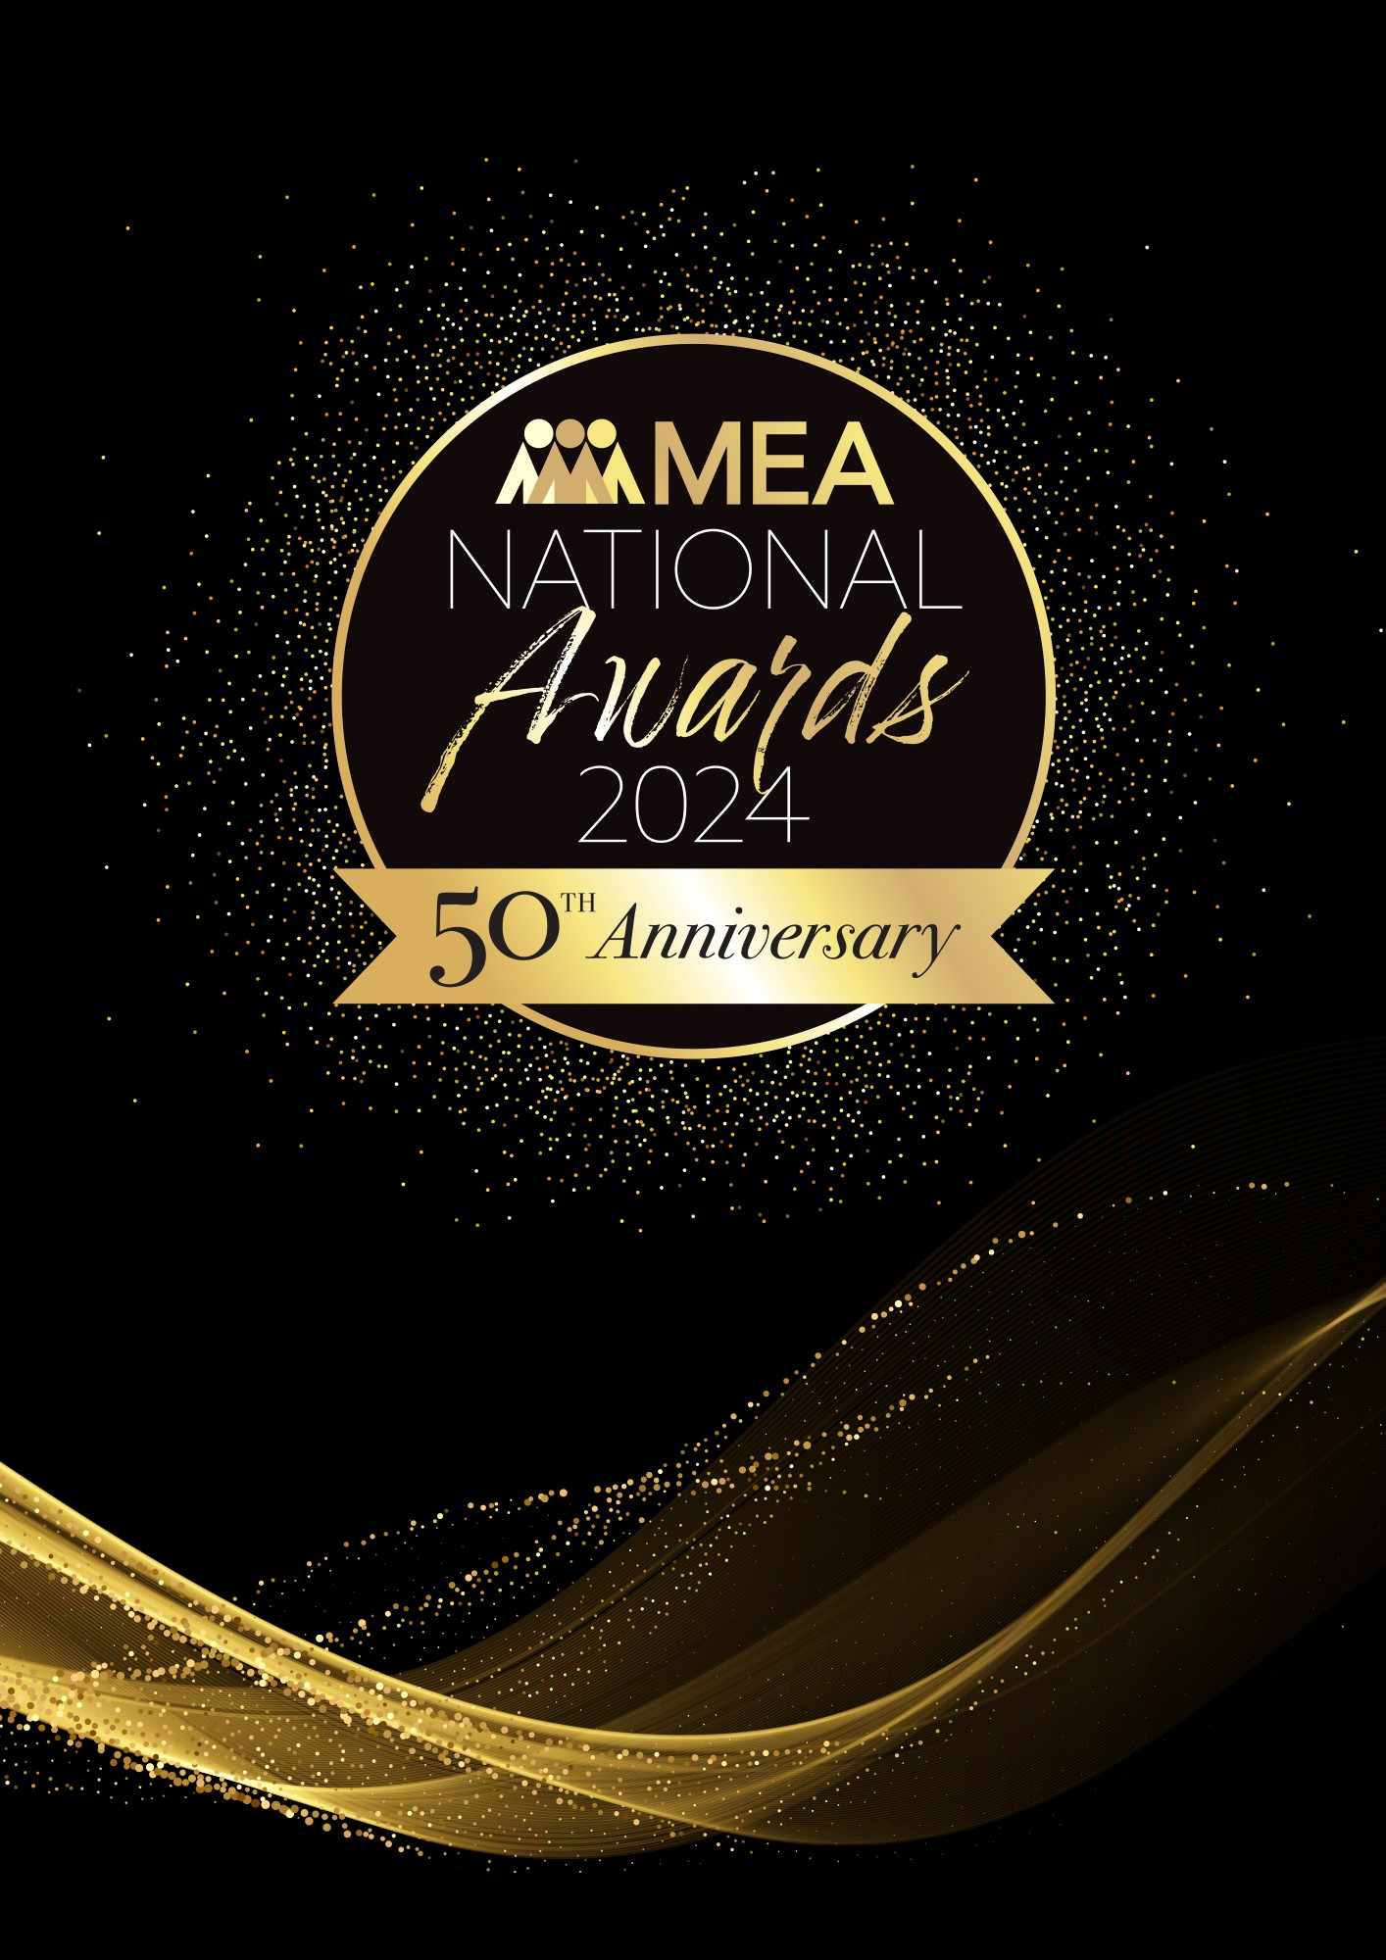

**EVENT MARKETING  
 AWARD**

Submission Form

**AWARD DESCRIPTION**

The Event Marketing Award focuses on recognising the creativity, innovation and success of marketing strategies and campaigns from any sector of the events industry.

It focuses specifically on the marketing strategies and creative campaigns that have built awareness, developed communities and audiences or achieved a specific return on investment for an exhibition, destination, brand, business, or public event (live or virtual).

**ELIGIBILITY**

This Award is open to individuals or companies who developed the marketing strategy and/or undertook publicity, digital, creative, engagement or a promotional campaign to promote an event.

The National Winner of the Award will be eligible for MEA’s 2024 Company of the Year Platinum Award.

**GENERAL GUIDELINES**

Ensure that your submission is restricted to the qualifying period 1 January 2024 – 31 December 2024.

* Answer all the questions. There is a maximum word count for all answers that cannot be exceeded. After completing each question, indicate your word count.
* The examples provided are suggestions only that provide some guidance as to what the judges will be seeking. Do not simply answer each of these evidence types in order.
* If your evidence takes form in charts, video links or graphs, there is a separate area within the submission portal to add these. Videos must not be longer than 1-minute (60 seconds). Please indicate in your submission if you have included additional attachments outside of the form below.
* All applications must be made using the below submission form in either Microsoft Word or PDF format. No external or specialised branding may be used in lieu of this submission form.
* Judges’ feedback will be provided to applicants as soon as possible after the conclusion of the National Awards Ceremony.
* Judges will look for evidence that you are well organised, your business is well managed, how you are future-proofing your business, and that you have systems and procedures that are appropriate and well-maintained.
* Judges do not want details of your financial accounts, but rather are seeking to understand how your business has operated during the qualifying period.
* All applications must be submitted prior to **Friday 14 February 2025 at 11:59pm AEDT.**

**SCORING**

How your submission is weighted:

* Marketing Strategy – 20%
* Approach – 30%
* Challenges & Responses – 20%
* Outcome & Evidence – 15%
* Contribution to the Industry – 5%
* Sustainability – 5%
* Final Statement – 5%

|  |  |
| --- | --- |
| **NAME OF COMPANY** | |
| *Insert the company name in the blank space provided. Please note, this will be the name displayed on all relevant marketing and trophies, should your application be successful.* | Insert name here |

**BUSINESS PROFILE**

This section is not scored during judging but acts as an overview to provide context of your submission in the judging process.

Maximum word count for this section: 600

1. **PROVIDE AN OVERVIEW OF THE EVENT OR CAMPAIGN, INCLUDING:**

*Examples could include but are not restricted to:*

* *Location of event/delivery platform (if applicable)*
* *Number of attendees/delegates*
* *Objectives of the event*
* *Ownership of the event*
* *Timeline/schedule/critical path/goal setting*
* *Type of event (public, trade, association, government or corporate event or exhibition)*
* *Who was involved*

Type response here. Space will expand.

1. **MARKETING STRATEGY**

*Maximum word count for this section: 900*

**Describe your campaign planning process.**

*Examples could include but are not restricted to:*

* *Market research undertaken, target markets, objectives, ROI/outcomes, how the marketing strategy addressed these examples*
* *Identification of objectives*
* *What measurement tools were implemented*

Type response here. Space will expand.

1. **APPROACH**

*Maximum word count for this section: 1,200*

1. **Provide an overview of the campaign, including use of platforms, channels, and the creative and engagement techniques used.**

Type response here. Space will expand.

1. **Provide an insight into speaker, delegate, sponsor or exhibitor engagement activities and processes.**

Type response here. Space will expand.

1. **Describe the creative or innovative ways in which technology or specific platforms were used to elevate the event/attract numbers/increase visitation/provide a ‘wow’ factor.**

Type response here. Space will expand.

1. **How was sustainable practice included in this campaign?**

Type response here. Space will expand.

1. **CHALLENGES & RESPONSES**

*Maximum word count for this section: 900*

**Demonstrate your use of creativity, originality and innovation in managing challenges. Use up to 5 examples.**

*Examples could include but are not restricted to:*

* *Achieving strategic outcomes*
* *Budget constraints*
* *Key internal and external marketing challenges*
* *Meeting client/stakeholder needs and wants*
* *Modifying the campaign in response to setbacks or unforeseen circumstances*

Type response here. Space will expand.

1. **OUTCOME & EVIDENCE**

*Maximum word count for this section: 600*

**Provide insight into the outcome of this campaign by answering the below questions:**

* *Describe any legacy outcomes resulting from the marketing campaign*
* *Describe how the campaign grew audiences, event awareness and/or membership*
* *Describe how the campaign performed against strategies, ROI, and budget*
* *How was the campaign’s success recognised? E.g. Media.*
* *Did the campaign provide increased profits and new business?*
* *How were industry stakeholders included in the process?*

*Include details of the effectiveness of the campaign compared to previous campaigns (year-on-year growth – if applicable)*

Type response here. Space will expand.

1. **CONTRIBUTION TO THE INDUSTRY**

*Maximum word count for this section: 300*

**Describe how your activities have contributed to the growth and professionalism of the events industry overall.**

*Provide evidence for contributions within MEA and other industry organisations during the qualifying period, such as:*

*o Contribution to trade magazines/online forums*

*o Involvement in industry panels or committees*

*o Involvement with your local destination marketing organisation*

*o Mentoring*

*o Participation in industry forums or focus groups*

*o Presentations at industry briefings, webinars, conferences (physical or virtual)*

Type response here. Space will expand.

1. **SUSTAINABILITY**

*Maximum word count for this section: 300*

**Outline the sustainability policy that you implement within your organisation.**

Type response here. Space will expand.

1. **FINAL STATEMENT**

*Maximum word count for this section: 300*

**Summarise your submission and let us know why you should win the 2024 Event Marketing Award.**

Type response here. Space will expand.