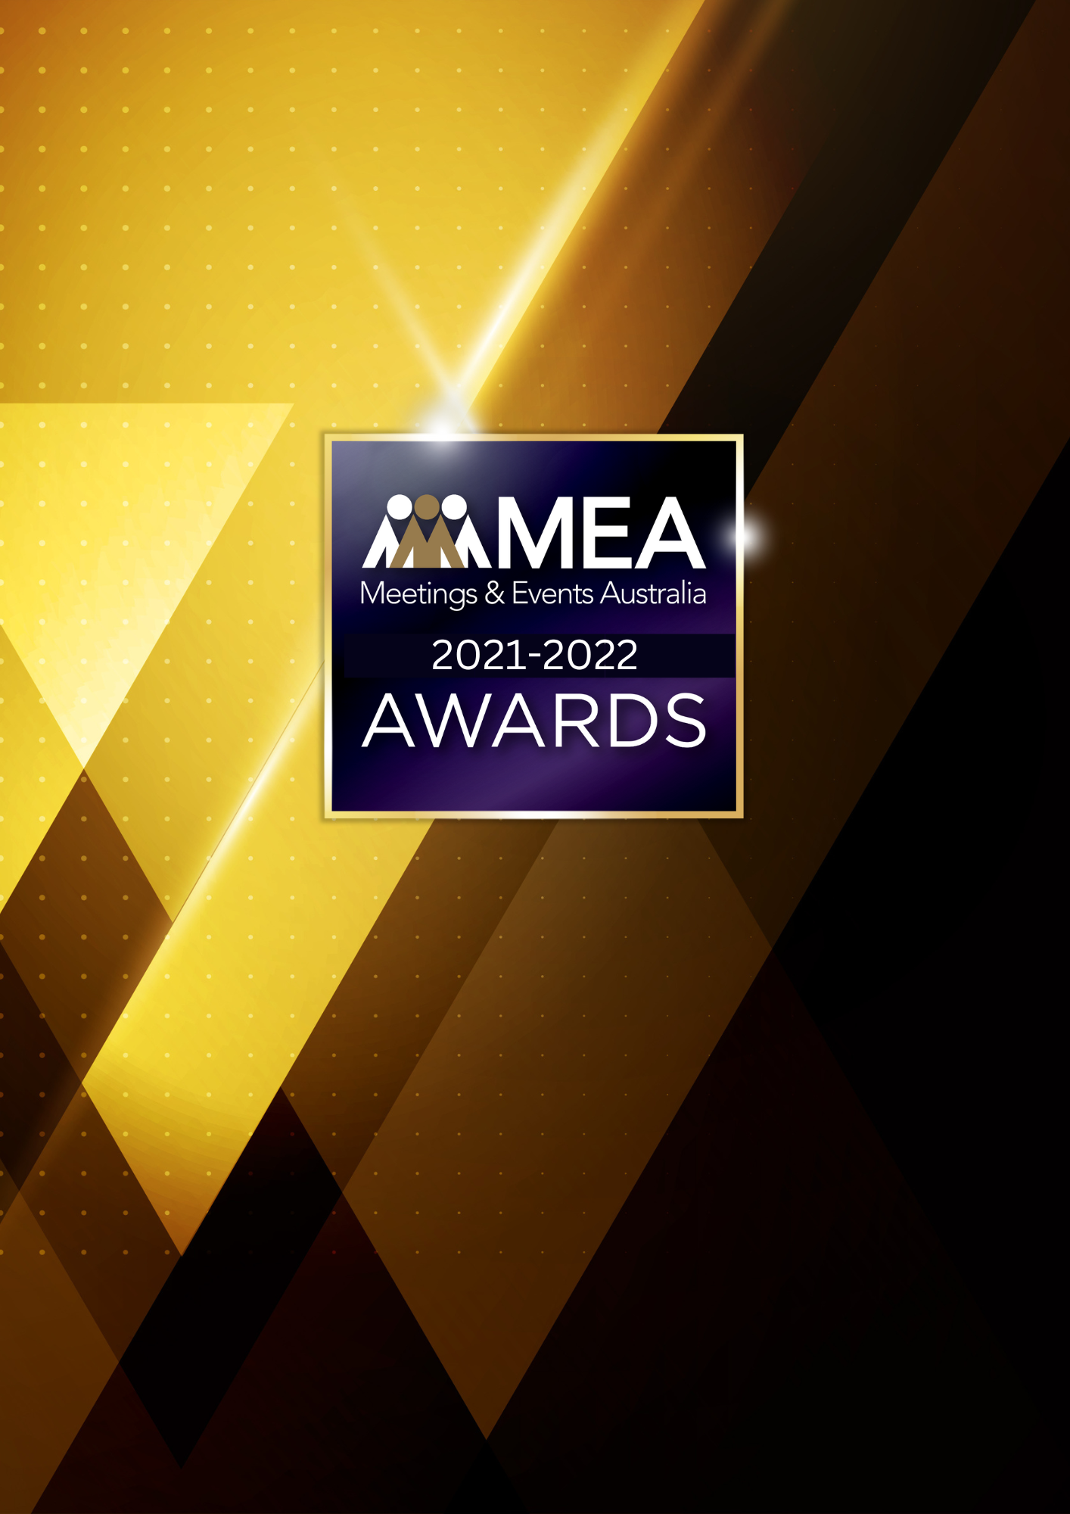

**SKILLING PROGRAM OF  
THE YEAR AWARD**

SUBMISSION FORM

**2021-2022 MEA AWARDS  
SKILLING PROGRAM OF THE YEAR AWARD**

**AWARD DESCRIPTION**

The Australian events industry was incurring a skills shortage even before the COVID-19 pandemic. The Skilling Program of the Year Award recognises an admirable skills development initiative by an Australian events industry employer as a means of mitigating the shortage and improving its attractiveness as an employer, and the greater industry as a viable career path.

The program may be one that is internally developed and executed, or be one where that is done in collaboration with another employer or/and an organisation delivering nationally recognised training.

**ARE YOU ELIGIBLE?**

This Award is open to organisations within the industry that manage, hold, or produce events, or are organisations that employ businesses to supply their teams with skills development initiatives. The program must be developed for the purpose of upskilling individuals whose primary role is to ensure the successful delivery of events.

The National Winner of the Award will be eligible for MEA’s 2021-2022 Company of the Year Platinum Award.

**GENERAL GUIDELINES**

Ensure that your submission is restricted to the qualifying period 1 January 2021 – 31 December 2022.

* Answer all the questions. There is a maximum word count for all answers that cannot be exceeded. After completing each question, indicate your word count.
* The examples provided are suggestions only that provide some guidance as to what the judges will be seeking. Do not simply answer each of these evidence types in order.
* If your evidence takes form in charts, video links or graphs, there is a separate area within the submission portal to add these. Videos must not be longer than 1-minute (60 seconds). Please indicate in your submission if you have included additional attachments outside of the form below.
* All applications must be made using the below submission form in either Microsoft Word or PDF format. No external or specialised branding may be used in lieu of this submission form.
* Judges’ feedback will be provided to applicants as soon as possible after the conclusion of the National Awards Ceremony.
* Judges will look for evidence that you are well organised, the program is well managed, and that you have systems and procedures that are appropriate and well-maintained.

**2021-2022 MEA AWARDS  
SKILLING PROGRAM OF THE YEAR AWARD**

* Judges do not want details of your financial accounts, but rather are seeking to understand how your business has operated during the qualifying period.
* All applications must be submitted prior to **28 February 2023 at 11:59pm AEDT**.

**SCORING**

How your submission is weighted:

* Overview of Skilling Program – 20%
* Outcomes & Evidence – 35%
* Challenges & Responses – 25%
* Contribution to the Industry – 15%
* Final Statement – 5%

**2021-2022 MEA AWARDS  
SKILLING PROGRAM OF THE YEAR AWARD**

|  |
| --- |
| **NAME OF ORGANISATION** |
| *Insert the organisation’s name/s in the blank space above. Please note, this will be the name/s displayed on all relevant marketing and trophies, should your application be successful.* |
| **NAME OF SKILLING PROGRAM** |
| *Insert the name of the skilling program in the blank space above. Please note, this will be the name/s displayed on all relevant marketing and trophies, should your application be successful.* |

**BUSINESS PROFILE**

This section is not scored during judging but acts as an overview to provide context of your submission in the judging process.

**Maximum word count for this section: 600**

1. **PROVIDE A GENERAL DESCRIPTION OF THE PARTIES INVOLVED IN THE PROGRAM:**

*Examples could include but are not restricted to:*

* *Names and natures of any additional organisations involved outside of your own*
* *Scope of services*
* *The range and diversity of projects undertaken*

1. **WHAT IS YOUR ORGANISATION’S HISTORY OF INVOLVEMENT IN THE EVENTS INDUSTRY:**

*Examples could include but are not restricted to:*

* *Growth year on year*
* *Years of operation*

1. **WHAT IS YOUR ORGANISATIONAL STRUCTURE, AS IT RELATES TO EVENTS:**

*Examples could include but are not restricted to:*

* *Number of employees*
* *Organisational chart (please attach in submission portal as a PDF)*
* *The number and type of internal departments*

**2021-2022 MEA AWARDS  
SKILLING PROGRAM OF THE YEAR AWARD**

1. **OVERVIEW OF SKILLING PROGRAM**

**Maximum word count for this section: 600**

**Provide a detailed overview of the program.**

*Examples could include but are not restricted to:*

* *Purpose of the program*
* *Size and scale of the program (number of staff undertaking the program)*
* *Who delivers the program?*
* *Where the program is delivered (e.g. online, classroom, on the job)*
* *Course details*
* *Curriculum summary/subject outlines*
* *Assessment methodology (if any)*
* *Origin of any collaboration*
* *Lines of communication for any collaboration*
* *How and why any partners were selected*

**2021-2022 MEA AWARDS  
SKILLING PROGRAM OF THE YEAR AWARD**

1. **OUTCOMES & EVIDENCE**

**Maximum word count for this section: 1,200**

**Demonstrate how the program delivered learning outcomes for staff/students and a return on investment for your organisation.** **Please upload one testimonial from a student/staff member or key supplier as a PDF.**

*Examples could include but are not restricted to:*

* *Are/were there plans in place for further skilling programs/partnerships?*
* *Course completion rates*
* *Contribution to the professional development of staff or students*
* *Graduate outcomes*
* *Graduate success stories*
* *How did the training program improve the results/culture of the organisation?*
* *Link to current unit of competency or other accredited education*
* *Staff retention levels*
* *Response rates to recruitment initiatives*
* *Subsequent internal promotion of staff*
* *Improved client satisfaction/repeat business bookings*
* *Impact the program has had on your organisation*
* *Impact the program has had on issues currently impacting your business/the sector*
* *What innovative aspects are a feature of the program?*

**2021-2022 MEA AWARDS  
SKILLING PROGRAM OF THE YEAR AWARD**

1. **CHALLENGES & RESPONSES**

**Maximum word count for this section: 900**

**Demonstrate your use of creativity, originality and innovation in managing challenges. Use up to 5 examples.**

*Examples could include but are not restricted to:*

* *Difficulty in preparing, delivering or assessing the program*
* *Budgetary restraints*
* *Staff turnover*
* *Maintenance of staff engagement*
* *Capacity to recruit*
* *Availability of/compatibility with suitable training partners*

**2021-2022 MEA AWARDS  
SKILLING PROGRAM OF THE YEAR AWARD**

1. **CONTRIBUTION TO THE INDUSTRY**

**Maximum word count for this section: 600**

**Describe how your program has contributed to the growth, professionalism and skill level of the greater Australian events industry.**

*Examples could include but are not restricted to:*

* *Increasing attraction of the industry as a viable career path*
* *How can the outcomes of the program be replicated, modelled, or transferred to other industry businesses? Have any efforts been made in this regard?*
* *New standards the program has identified to enhance the industry*
* *What improvements in process/procedure have been implemented to benefit the larger industry*

**2021-2022 MEA AWARDS  
SKILLING PROGRAM OF THE YEAR AWARD**

1. **FINAL STATEMENT**

**Maximum word count for this section: 300**

**Summarise your submission and let us know why you should win the 2021-2022 Skilling Program of the Year Award.**