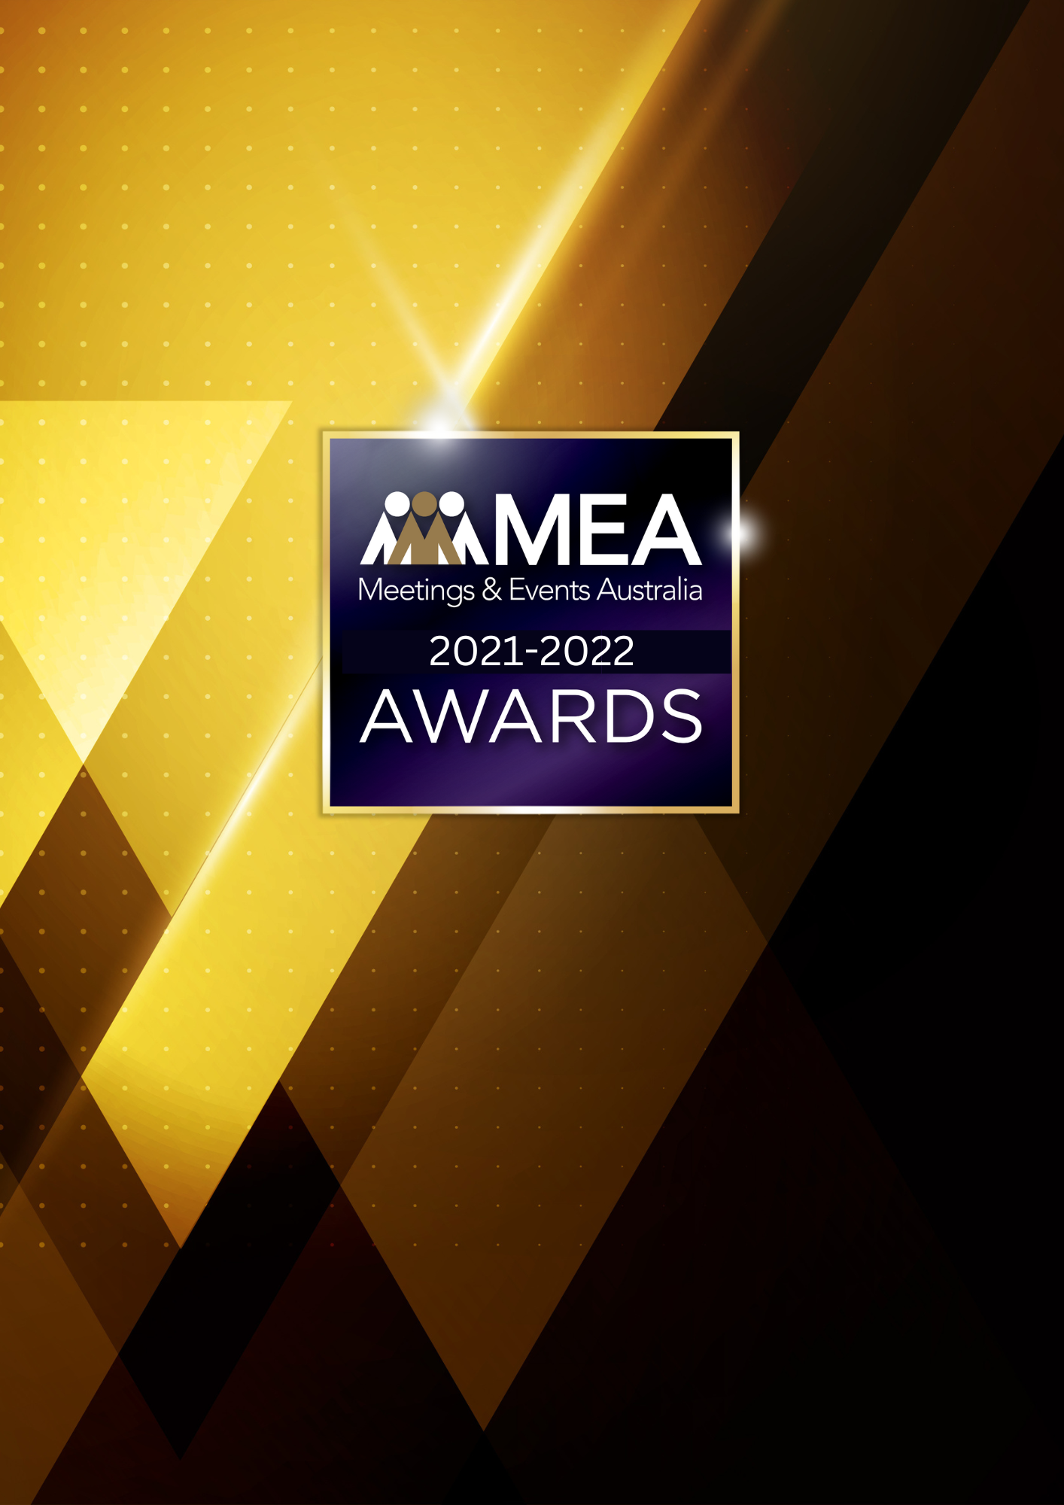

**EVENT MANAGER OF**

**THE YEAR – PCO**

**AWARD**

SUBMISSION FORM

**2021-2022 MEA AWARDS  
EVENT MANAGER OF THE YEAR – PCO AWARD**

**AWARD DESCRIPTION**

The Event Manager of the Year – PCO Award recognises the hard work and efforts of those who have demonstrated exceptional skills in conference and event management by providing outstanding service to their clients and contributing to their organisation’s well-being and success.

**ARE YOU ELIGIBLE TO APPLY?**

This Award is open to those who work for a PCO/conference management company either in a full-time or part-time capacity. The nominee’s main role must be the management and operations of meetings, exhibitions, and conferences for external clients.

Excludes: Special event company employees, agency event managers, or in-house event managers (association, government or corporate).

The National Winner of this Award will be eligible for the MEA Platinum Event Professional of the Year Award.

**GENERAL GUIDELINES**

Ensure that your submission is restricted to the qualifying period 1 January 2021 – 31 December 2022.

* Answer all the questions. There is a maximum word count for all answers that cannot be exceeded. After completing each question, indicate your word count.
* The examples provided are suggestions only that provide some guidance as to what the judges will be seeking. Do not simply answer each of these evidence types in order.
* If your evidence takes form in charts, video links or graphs, there is a separate area within the submission portal to add these. Videos must not be longer than 1-minute (60 seconds). Please indicate in your submission if you have included additional attachments outside of the form below.
* All applications must be made using the below submission form in either Microsoft Word or PDF format. No external or specialised branding may be used in lieu of this submission form.
* Judges’ feedback will be provided to applicants as soon as possible after the conclusion of the National Awards Ceremony.
* Judges will look for evidence that you are well organised, your business is well managed, how you have adapted during COVID-19 to future-proof your business, and that you have systems and procedures that are appropriate and well-maintained.
* Judges do not want details of your financial accounts, but rather are seeking to understand how your business has operated during the qualifying period.
* All applications must be submitted prior to **28 February 2023 at 11:59pm AEDT.**

**2021-2022 MEA AWARDS  
EVENT MANAGER OF THE YEAR – PCO AWARD**

**SCORING**

How your submission is weighted:

* How the Nominee Delivers Excellence – 20%
* Contribution to the Organisation – 30%
* Contribution to the Industry – 30%
* Sustainability – 15%
* Accreditation – 5%

**2021-2022 MEA AWARDS  
EVENT MANAGER OF THE YEAR – PCO AWARD**

|  |
| --- |
| **FULL NAME OF NOMINEE** |
| *Please note, this will be the name displayed on all relevant marketing and trophies, should your application be successful.* |
| **NAME OF ORGANISATION** |
|  |

1. **HOW THE NOMINEE DELIVERS EXCELLENCE**

**Maximum word count for this section: 900**

**Provide evidence demonstrating exceptional skills in the management of events (live, virtual or hybrid) resulting in outstanding services to clients and to their company.**

*Examples of evidence could include but are not restricted to:*

* *Company awards/recognition*
* *Client evaluations*
* *Education and experience*
* *In what ways the nominee delivers excellence*
* *Testimonials from suppliers or clients*

**2021-2022 MEA AWARDS  
EVENT MANAGER OF THE YEAR – PCO AWARD**

1. **CONTRIBUTION TO THE ORGANISATION**

**Maximum word count for this section: 1,200**

**Provide examples of the nominee’s achievements that produced outstanding results for their organisation. Include an outline of the results that were achieved for either the organisation or the client.**

*Examples could include but are not restricted to:*

* *Contribution to the organisation’s strategic plan*
* *Financial results*
* *Implementation of processes and procedures*
* *Industry partnerships*
* *Managing staff/teams*
* *Objectives achieved*
* *Organisational profile*
* *Problem solving/overcoming challenges*
* *Repeat business*
* *Targets met/exceeded*

**2021-2022 MEA AWARDS  
EVENT MANAGER OF THE YEAR – PCO AWARD**

1. **CONTRIBUTION TO THE INDUSTRY**

**Maximum word count for this section: 1,200**

**Describe how the nominee has contributed to the growth and professionalism of the events industry overall. Outline the benefits to the industry of their contribution.**

*Examples could include but are not restricted to:*

* *Contribution to online forums/trade publications*
* *Involvement in industry panels or committees*
* *Membership of professional associations*
* *Mentoring*
* *Participation at industry forums or focus groups*
* *Presentations at professional development workshops/seminars*

**2021-2022 MEA AWARDS  
EVENT MANAGER OF THE YEAR – PCO AWARD**

1. **SUSTAINABILITY**

**Maximum word count for this section: 600**

**Outline the sustainability policy and processes that are implemented for your events (live, virtual or hybrid) and team.**

**2021-2022 MEA AWARDS  
EVENT MANAGER OF THE YEAR – PCO AWARD**

1. **ACCREDITATION**
2. **Does the nominee hold MEA Accreditation or recognition?**

**AEP –** Accredited Event Professional

**AFMEA –** Accredited Fellow of MEA

1. **Does the nominee hold another Accreditation or Certification? If so, please indicate this below.**

*Examples could include but are not restricted to:*

* *Certified Event Manager*
* *Diploma*
* *First Degree*
* *Higher Degree*
* *St Johns Ambulance Certificate*