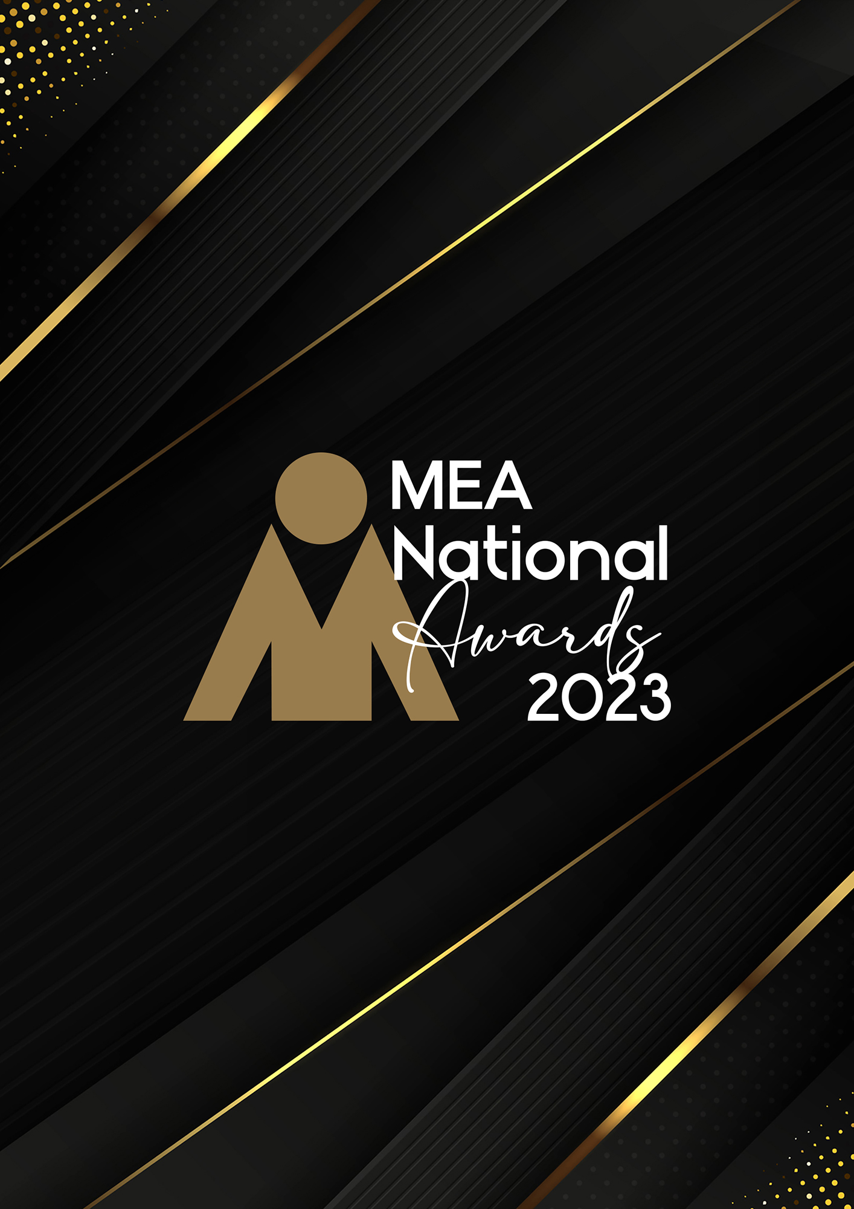

**INNOVATION AWARD**

Submission Form

**AWARD DESCRIPTION**

The Innovation Award is aimed at organisations that have demonstrated original problem-solving initiatives in response to the challenges they have faced and overcome within the qualifying period. Innovation is defined as the practical implementation of ideas that result in the introduction of new goods or services or improvement in offering goods or services. Innovation often takes place through the development of more effective products, processes, services, technologies, or business models. This Award is intended to celebrate innovative approaches to any aspect of the events industry that improves or enhances the delivery of events.

**ELIGIBILITY**

This Award is open to organisations from all segments of the events industry who can articulate innovation in the context of its definition in the preceding section as applicable to event management or delivery.

If the innovation relates to a significant development in virtual or hybrid event technology, it could additionally be submitted for the Event Technology Award as well as for the Innovation Award. Note that management of hybrid or virtual events should be incorporated within other MEA Awards categories (e.g. Event of the Year, Event Management, Products and Services, Venues).

This Award shall recognise the company as the recipient of the Award.

The National Winner of the Award will be eligible for MEA’s 2023 Company of the Year Platinum Award.

**GENERAL GUIDELINES**

Ensure that your submission is restricted to the qualifying period 1 January 2023 – 31 December 2023.

* Answer all the questions. There is a maximum word count for all answers that cannot be exceeded. After completing each question, indicate your word count.
* The examples provided are suggestions only that provide some guidance as to what the judges will be seeking. Do not simply answer each of these evidence types in order.
* If your evidence takes form in charts, video links or graphs, there is a separate area within the submission portal to add these. Videos must not be longer than 1-minute (60 seconds). Please indicate in your submission if you have included additional attachments outside of the form below.
* All applications must be made using the below submission form in either Microsoft Word or PDF format. No external or specialised branding may be used in lieu of this submission form.
* Judges’ feedback will be provided to applicants as soon as possible after the conclusion of the National Awards Ceremony.
* Judges do not want details of your financial accounts, but rather are seeking to understand how your business has operated during the qualifying period.
* All applications must be submitted prior to **Monday 12 February 2024 at 11:59pm AEDT.**

**SCORING**

How your submission is weighted:

* Background to Innovation – 15%
* Approach to Innovation – 30%
* Challenges & Responses – 20%
* The Impact of Your Innovation – 20%
* Contribution to the Industry – 5%
* Sustainability – 5%
* Final Statement – 5%

|  |  |
| --- | --- |
| **NAME OF ORGANISATION** | |
| *Insert the organisation’s name in the blank space provided. Please note, this will be the name displayed on all relevant marketing and trophies, should your application be successful.* | Insert name here |

**BUSINESS PROFILE**

This section is not scored during judging but acts as an overview to provide context of your submission in the judging process.

Maximum word count for this section: 600

1. **PROVIDE A GENERAL OVERVIEW OF YOUR ORGANISATION:**

*Examples could include but are not restricted to:*

* *Diversity of client services*
* *Number, size and range of meetings and events*
* *The range and diversity of projects undertaken*
* *Scope of services*

Type response here. Space will expand.

1. **BACKGROUND TO INNOVATION**

*Maximum word count for this section: 600*

**Describe the opportunity or gap in the market your organisation sought to fill.**

*Examples could include but are not restricted to:*

* *The options considered*
* *The problem solved*
* *Your solution*

Type response here. Space will expand.

1. **APPROACH TO INNOVATION**

*Maximum word count for this section: 1,200*

1. **Describe how the innovation was founded and scoped.**

*Examples could include but are not restricted to:*

* *Was it a ‘lightbulb’ moment or an innovation developed over a long period of time?*
* *Was it a collaborative effort or the work of an individual?*
* *What prompted the innovation? E.g. gap in the market, evolution of a product or service.*

Type response here. Space will expand.

1. **Describe the planning and development stages of this innovation.**

*Examples could include but are not restricted to:*

* *Did you have the help of an innovation committee?*
* *How was the budget developed and managed?*
* *Strategic thinking and planning that underpinned the new idea/innovation*
* *What resources were required?*

Type response here. Space will expand.

1. **How did you bring the innovation to market?**

Type response here. Space will expand.

1. **CHALLENGES & RESPONSES**

*Maximum word count for this section: 900*

**Demonstrate your use of originality and innovation in managing challenges. Use examples.**

*Examples could include but are not restricted to:*

* *Competitor activity*
* *Current culture of organisation*
* *Forecast market demand and acceptance*
* *Funding restraints, accurate budgeting, financial control*
* *Gaining market acceptance*
* *How the innovation was tested; internal or external*
* *Opportunity cost*
* *Risk aversion*

Type response here. Space will expand.

1. **THE IMPACT OF YOUR INNOVATION**

*Maximum word count for this section: 900*

**How has this changed the culture, processes and business prospects within your organisation or the broader events industry?**

*Examples could include but are not restricted to:*

* *Feedback from the market*
* *Has the innovation been copied by others?*
* *Has the innovation provided a springboard for the development of further initiatives?*
* *Media exposure*
* *What has been the market acceptance and impact of your innovation*

Type response here. Space will expand.

1. **CONTRIBUTION TO THE INDUSTRY**

*Maximum word count for this section: 300*

**Describe how your activities have contributed to the growth and professionalism of the events industry overall.**

*Provide evidence for contributions within MEA and other industry organisations during the qualifying period, such as:*

* *Contribution to trade magazines/online forums*
* *Involvement in industry panels or committees*
* *Mentoring*
* *Participation in industry forums or focus groups*
* *Presentations at industry briefings, webinars, conferences (physical or virtual)*
* *Presentation at professional development workshops*

Type response here. Space will expand.

1. **SUSTAINABILITY**

*Maximum word count for this section: 300*

**Outline the sustainability policy that you implement within your organisation.**

Type response here. Space will expand.

1. **FINAL STATEMENT**

*Maximum word count for this section: 300*

**Summarise your submission and let us know why you should win the 2023 Innovation Award.**

Type response here. Space will expand.