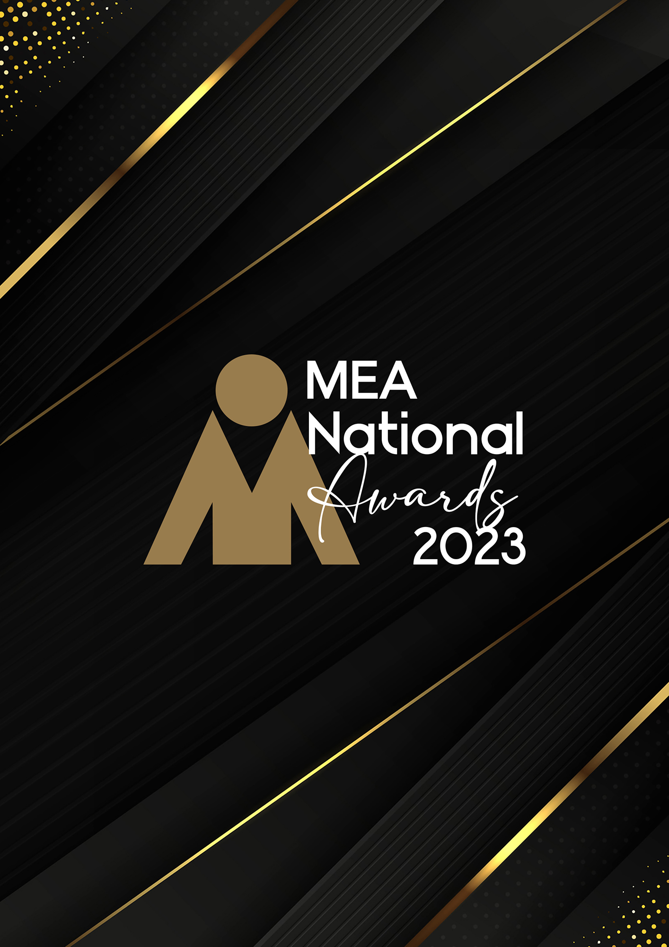

**VIRTUAL EVENT**

**OF THE YEAR AWARD**

Submission Form

**AWARD DESCRIPTION**

The Virtual Event of the Year Award recognises events that have been successfully planned, organised and delivered in a purely virtual format, with no physical face-to-face participation by delegates.

This event could have either been hosted within Australia or internationally by an Australian organisation. The event must be considered significant in achieving objectives through the challenges, complexities, and imaginative use of resources, innovation, creativity and overall management.

Projects must have been completed in the qualifying period to be judged for this Award. Joint entries from the event owner, event organiser, virtual platform and other virtual suppliers are encouraged. A joint entry requires payment per submission as opposed to per contributing partner, and just 1 award is presented for the event irrespective of the number of named contributing partners.

If the event being submitted for this Award has been managed on behalf of an external client or organisation, the event owner must be made aware that a submission is being made and support the nomination.

**ARE YOU ELIGIBLE TO APPLY?**

If you have organised a virtual event that has been hosted within Australia or internationally by an Australian organisation within the qualifying period, then you are eligible to apply. This Award is open to every sector of the events industry.

The National Winner of this Award will be eligible for the MEA Platinum Event of the Year Award.

**GENERAL GUIDELINES**

Ensure that your submission is restricted to the qualifying period 1 January 2023 – 31 December 2023.

* Answer all the questions. There is a maximum word count for all answers that cannot be exceeded. After completing each question, indicate your word count.
* The examples provided are suggestions only that provide some guidance as to what the judges will be seeking. Do not simply answer each of these evidence types in order.
* If your evidence takes form in charts, video links or graphs, there is a separate area within the submission portal to add these. Videos must not be longer than 1-minute (60 seconds). Please indicate in your submission if you have included additional attachments outside of the form below.
* All applications must be made using the below submission form in either Microsoft Word or PDF format. No external or specialised branding may be used in lieu of this submission form.
* Judges’ feedback will be provided to applicants as soon as possible after the conclusion of the National Awards Ceremony.
* Judges will look for evidence that you are well organised, your business is well managed, how you are future-proofing your business, and that you have systems and procedures that are appropriate and well-maintained.
* Judges do not want details of your financial accounts, but rather are seeking to understand how your business has operated during the qualifying period.

All applications must be submitted prior to **Monday 12 February 2024 at 11:59pm AEDT.**

**SCORING**

How your submission is weighted:

* Event Significance – 5%
* Financial Performance – 5%
* Sustainability – 5%
* Project Planning & Resource Management – 30%
* Challenges & Response – 30%
* Outcome & Evidence – 20%
* Final Statement – 5%

|  |  |
| --- | --- |
| **NAME OF THE EVENT** | |
| *Insert the name of your event in the blank space provided. Please note, this will be the name displayed on all relevant marketing and trophies, should your application be successful.* | Insert name here |
| **NAME OF ORGANISATION** | |
| *Insert the name of your organisation in the blank space provided. Please note, this will be the name displayed on all relevant marketing and trophies, should your application be successful.* | Insert name here |

**EVENT PROFILE**

This section is not scored during judging but acts as an overview to provide context of your submission in the judging process.

*Maximum word count for this section: 600*

1. **PROVIDE AN OVERVIEW OF THE EVENT**

Type response here. Space will expand.

1. **OUTLINE THE OBJECTIVES AND PURPOSE OF THE EVENT**

*Examples could include but are not restricted to:*

* *Educational, financial, social, awareness, diversity objectives, team building/reward*
* *Event history (if any)*
* *Expected outcomes*

Type response here. Space will expand.

1. **EVENT SIGNIFICANCE**

*Maximum word count for this section: 300*

**Detail the significance of the event and its impact.**

*Examples could include but are not restricted to:*

* *Social impact*
* *Stakeholders (clients, delegates, exhibitors, host association, presenters, sponsors)*
* *Economic impact*
* *Embracing of technology*

Type response here. Space will expand.

1. **FINANCIAL PERFORMANCE**

*Maximum word count for this section: 300*

**How did the event perform in a financial capacity?**

*Examples could include but are not restricted to:*

* *Budget forecast and actual results*
* *Profitability – relative to previous in-person event (if applicable)*
* *Delegate attendance relative to previous in-person event (if applicable)*
* *Sponsorship/exhibition sales relative to previous in-person event (if applicable)*

Type response here. Space will expand.

1. **SUSTAINABILITY**

*Maximum word count for this section: 300*

**Outline the sustainability policy and processes that you implement within your organisation.**

*Consider the 4 pillars of sustainability:*

* *Human*
* *Social*
* *Economic*
* *Environmental*

Type response here. Space will expand.

1. **PROJECT PLANNING & RESOURCE MANAGEMENT**

*Maximum word count for this section: 1,200*

**Provide insight into how you planned this project. Use examples.**

*Examples could include but are not restricted to:*

* *Engagement of contractors (if applicable)*
* *Identification of objectives*
* *Methods used in planning – both formal and informal*
* *Risk mitigation/crisis management – including use of technology*
* *The timeline, schedule, critical path or goal setting used*
* *Who was involved*

Type response here. Space will expand.

1. **CHALLENGES & RESPONSE**

Maximum word count for this section: 1,200

**Demonstrate your use of creativity, originality, and innovation in managing challenges. Use up to 5 examples.**

*Examples could include but are not restricted to:*

* *Attendance building*
* *Branding*
* *Budgeting*
* *Business program*
* *Client liaison*
* *Communications*
* *Media management*
* *Promotional activities*
* *Raising revenue*
* *Social interaction*
* *Speaker liaison*
* *Speaker support media*
* *Sponsorship – engagement and servicing*
* *Staff management*
* *Team building*
* *Technology*
* *Venue*
* *Virtual exhibition*

Type response here. Space will expand.

1. **OUTCOME & EVIDENCE**

*Maximum word count for this section: 900*

1. **Was the event successful? Provide your answer with measurable metrics.**

*Examples could include but are not restricted to:*

* + *Attendee numbers*
  + *Virtual delegate experience in comparison to in-person attendance (if applicable)*
  + *Financials*
  + *Objectives met*
  + *Stakeholder satisfaction*

Type response here. Space will expand.

1. **Provide evidence of client, delegate and sponsor satisfaction. In addition to this, please upload one client/key supplier testimonial as a PDF to the submission portal.**

*Examples could include but are not restricted to:*

* + *Anecdotal feedback*
  + *Formal evaluation*
  + *Evidence of professional completion of all aspects of the project*
  + *Opportunities for repeat business (if applicable)*

Type response here. Space will expand.

1. **FINAL STATEMENT**

*Maximum word count for this section: 300*

**Summarise your submission and let us know why you should win the 2023 Virtual Event of the Year Award.**

Type response here. Space will expand.