Waste 2027 Conference Abstract Submission
*** SELECT A MAXIMUM OF 4 TOPIC AREAS ONLY ***
☐ | Challenging waste streams (plastics, PFAS, solar panels, batteries, textiles, hazardous materials, asbestos, clinical & medical wastes) | ☐ | Litter & illegal dumping (prevention, surveillance, innovative approaches, smart systems, updates to reduction initiatives)
☐ | Circular economy (policy, strategy, industrial & local initiatives, right to repair, material traceability, climate change impacts, major projects) | ☐ | Local government issues (urban & metropolitan challenges, large-scale service delivery, policy alignment, community expectations)
☐ | Collection systems (innovations in kerbside & business collection, vehicles, shared systems, contract management, service design, AI and new applications) | ☐ | Organics (FOGO and food-only systems, implementation strategies, contamination management, processing challenges, new services, material acceptance procedures)
☐ | Container deposit schemes (scheme updates, successes, expansion to new materials, innovation in CDS operations) | ☐ | Policy & strategic planning (national, state & local waste strategies, long-term planning, stakeholder engagement)
☐ | Disaster waste management (planning & response for bushfires, floods, pandemics, other disaster events) | ☐ | Procurement, tenders & contracts (procurement approaches, tender processes, contract structures, service delivery challenges, contractor responses)
☐ | Economics, financing & case studies (business cases, cost estimates, financial impacts of waste strategies, reviews & analyses) | ☐ | Product stewardship & extended producer responsibility (policy & legislation updates, national schemes, local recovery programs, industry success stories)
☐ | Education & community engagement (design & delivery of education programs, behaviour change campaigns, FOGO education, community consultation, social media) | ☐ | Project delivery (planning, business cases, project management, grant delivery, overcoming barriers)
☐ | Energy from waste (facility updates, new projects, case studies, agreements, EfW capacity, integration with circular precincts) | ☐ | Regional issues (challenges unique to smaller and regional councils, distance & logistics, collaboration across councils, joint projects, indigenous waste management)
☐ | Infrastructure (material recovery & organics processing facilities, planning & approvals, environmental planning and approvals, new builds, upgrades) | ☐ | Regulation & compliance (legislation, regulations, levies, EPL management, monitoring, reporting obligations)
☐ | Innovation & technology (AI, smart systems, digital tools, new innovations, case studies, improvements to services) | ☐ | Resource recovery (recycling of C&I and C&D waste, organics, emerging markets, data, trends, performance reviews)
☐ | Investments, consolidations and private equity  (plans, processes and the changing waste management investment landscape) | ☐ | Social enterprise & community waste management  (case studies & projects led by social enterprises or community groups, outcomes & opportunities)
☐ | Landfill & facility management (operations, compliance, closure & capping, gas & leachate management, strategic planning) | ☐ | * Other / Panel Proposals / Workshop Ideas  Suggest a topic outside these categories, propose a panel discussion with nominated participants or a workshop concept

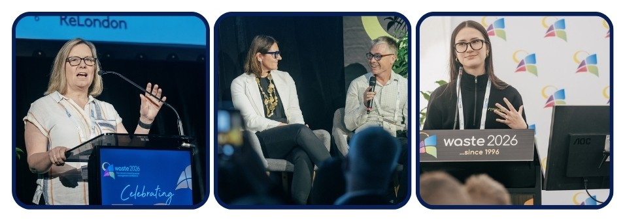

COMPLETE ALL INFORMATION BELOW
***INCOMPLETE SUBMISSIONS MAY NOT BE CONSIDERED***

Presenter details

Presenter name: Insert presenter name
Presenter position: Insert presenter title
Presenter organisation: Insert organisation name
Presenter email address: Insert presenter email address
Presenter phone number: Insert presenter landline
Presenter mobile number: insert presenter mobile number

Biography

Insert biography here (max 150 words)

Presentation Title

Insert presentation title here (max 10 words)

Abstract Summary

Insert abstract summary here (max 100 words)

Abstract

Insert abstract here (400-600 words)

