Factors Affecting Overall Online Course Performance Across Different Platforms

Le Thu Ha Tran

Table of Contents

1. Introduction 2

2. Business questions 2

3. Dataset description 3

4. Exploratory data analysis 4

4.1 Descriptive statistics of online course metrics 4

4.2 Distribution analysis of key course metrics 6

4.3 Cross-platform performance of online courses: Insights from ratings, completion, and pricing data 10

5. Diagnostic analysis 18

5.1 Correlation heatmap 18

5.2 Multiple regression 18

6. Business insights 19

6.1 Platform-level insights: Quality vs. Enrolment 19

6.2 Course duration: Engagement is not linear 20

6.3 Pricing: Perception of value over absolute cost 20

6.4 Course categories: Soft skills drive demand 20

6.5 Diagnostic analysis: Pricing and duration do not predict enrolment 20

7. Review and revise business questions 21

8. Conclusion 21

9. References 22

# Introduction

Online learning platforms have transformed education by providing flexible and scalable solutions. The global e-learning market, valued at USD 214.26 billion in 2021, is projected to grow at a compound annual rate of 20.5% from 2022 to 2030 (Polaris Market Research, 2022). This growth is driven by the increased adoption of e-learning software, demand for interactive environments (Deterding et al., 2011; EI Design, 2022), and a focus on human capital development (World Economic Forum, 2020). Additionally, advances in AI and machine learning enable personalised content, further enhancing e-learning (Polaris Market Research, 2022).

As of 2023, leading platforms like Coursera, Udemy, and LinkedIn Learning collectively serve over 223 million learners worldwide (Business of Apps, 2025). However, not all courses achieve the same levels of engagement, enrolment, or completion.

Understanding the factors that influence course success is essential for optimising design, pricing, and engagement strategies. This report will analyse how pricing, duration, and category impact online course success, providing actionable insights to improve learner outcomes. These findings will be vital for University X as it aims to optimise its online offerings and strengthen its competitive position.

# Business questions

University X is undertaking a strategic initiative to enhance the competitiveness of its online learning platform in response to evolving global market dynamics. This necessitates a comprehensive understanding of the global online education landscape, particularly insights from leading platforms like Coursera, Udemy and LinkedIn Learning. University X can use these insights to refine its course design, optimise pricing strategies, and integrate advanced technologies to enhance learner satisfaction and engagement. This strategic approach will position the university's online learning platform to effectively compete in the dynamic and rapidly evolving global online education market.

**Business questions**

1. Which platforms offer the highest-performing courses across key metrics (enrolment, ratings, and completion rates)?
2. How do course characteristics such as price, duration, category, and platform influence user satisfaction and enrolment across different platforms?

* How does pricing affect enrolments and ratings?
* Are shorter courses generally associated with higher completion rates?

1. Which skills are most in-demand across different platforms, and how do they perform in terms of ratings and enrolment?

# Dataset description

This dataset includes detailed information about 10,000 online courses, including attributes such as course ID, name, category, duration, enrolment, completion rate, platform, price, and rating. It provides an overview of various online courses across different platforms and categories.  
**Data source**

|  |  |  |  |  |  |  |
| --- | --- | --- | --- | --- | --- | --- |
| **Name of dataset** | **Number of columns** | **Number of courses** | **Source** | **Data type** | **Data size** | **Published** |
| Online courses usage and history | 9 | 10,000 | <https://www.kaggle.com/datasets/mitul1999/online-courses-usage-and-history-dataset> | CSV format | 781 KB | 2024 |

**Data variables**

| **Data variables** | **Types of variables** | | | |
| --- | --- | --- | --- | --- |
| **Categorical** | | **Numerical** | |
| Nominal | Ordinal | Interval | Ratio |
| Course ID (A unique identifier for each course) |  |  |  |  |
| Course Name (The name of the course) |  |  |  |  |
| Category (The category under which the course falls (e.g., Technology, Office Tools, AI, Business, Design, Data Science, and Programming). |  |  |  |  |
| Duration (The total duration of the course in hours) |  |  |  |  |
| Enrolled Students (The number of students enrolled in the course) |  |  |  |  |
| Completion Rate (The percentage of students who completed the course) |  |  |  |  |
| Platform (The platform offering the course (e.g., Coursera, edX, LinkedIn Learning, Udemy) |  |  |  |  |
| Price (The price of the course in dollars) |  |  |  |  |
| Rating (The rating of the course, out of a possible 5 stars) |  |  |  |  |

# Exploratory data analysis

A range of descriptive statistics and visualisations were employed to understand the central tendencies, variability, and patterns in the data. Key metrics (duration, enrolment, rating, price, and completion rate) were assessed using:

• Histograms for distributions

• Boxplots for outlier detection

• Pareto charts for price clusters

• Cross-tabulated platform/category performance

## 4.1 Descriptive statistics of online course metrics

**Table: Summary of descriptive statistics for online course dataset**

|  |  |  |  |  |  |  |
| --- | --- | --- | --- | --- | --- | --- |
| Variable | Mean | Median | Mode | Std. Dev. | Min | Max |
| Duration (hours) | 55.14 | 55.00 | 58 | 26.20 | 10.00 | 100.00 |
| Enrolled Students | 2,530.65 | 2,532.00 | 4,777 | 1,423.81 | 101 | 5,000 |
| Completion Rate (%) | 75.12 | 75.16 | 76.69 | 14.46 | 50.01 | 99.99 |
| Price ($) | 106.39 | 108.05 | 155.32 | 55.10 | 10.04 | 199.96 |
| Rating (out of 5) | 3.99 | 4.00 | 4.10 | 0.58 | 3.00 | 5.00 |

The table above summarises the key statistical measures for five core variables in the course dataset: **duration, enrolment, completion rate, price**, and **user rating**. These figures offer valuable insights into learner behaviour, content performance, and pricing effectiveness across platforms.

**Course duration**

The analysis of course duration reveals that the average course is approximately 55 hours long, with the median and mode also close to this figure, indicating a relatively balanced distribution. However, a standard deviation of over 26 hours highlights a wide variation in course lengths, ranging from as short as 10 hours to as long as 100 hours. This suggests a diverse course portfolio, but also raises a question of whether longer courses are affecting learner engagement or completion rates. It may be useful to explore how course duration correlates with performance metrics such as satisfaction and completion.

**Enrolled students**

Courses average 2,530 enrolled students, with enrolments ranging from 100 to 5,000. The large standard deviation (1,423) suggests a disparity in popularity, highlighting the need for further analysis by platform or subject area to inform content and marketing strategies.

**Completion rates**

Completion rates are generally strong, with a mean of 75.12% and minimal variation between the minimum (50%) and maximum (almost 100%). Most courses maintain high learner retention, indicating effective course delivery. However, further analysis by course category or duration could reveal factors influencing performance.

**Course price**

Course prices vary significantly, averaging $106.39, with a range from $10 to $200. The high standard deviation ($55.10) and skew towards higher prices suggest a broad pricing strategy, highlighting opportunities for tiered pricing, discount bundling, or pricing based on learner outcomes.

**User rating**

Courses have an average rating of 3.99/5, with low variation (0.58). Most learners rate courses positively, though there is room for improvement at the lower end. Comparing ratings with enrolment and price could reveal how perceived quality influences learner choices.

## 4.2 Distribution analysis of key course metrics

**Distribution of course duration**

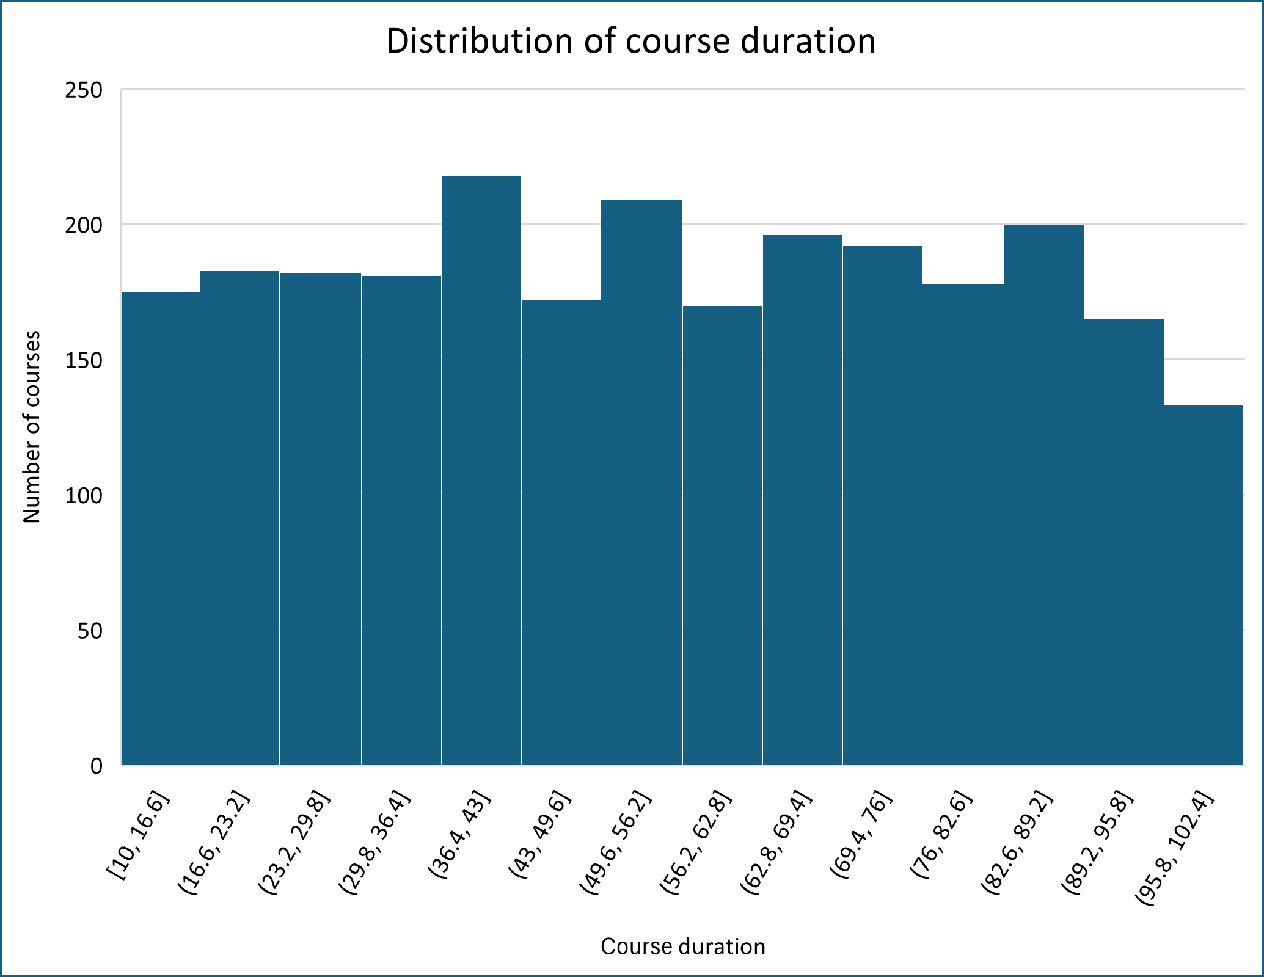

The histogram of course durations reveals that most online courses cluster between 36 and 56 hours, with these ranges showing the highest frequency. Overall, the distribution is relatively balanced, with a large proportion of courses falling between 30 and 80 hours. Very short (under 17 hours) and very long (over 95 hours) courses are less common, as indicated by the shorter bars at both ends. This pattern suggests that course designers tend to favour moderate durations, likely to maintain learner engagement while delivering sufficient content. The data reflects a preference for structured yet manageable learning experiences across platforms.

**Distribution of course enrolment**

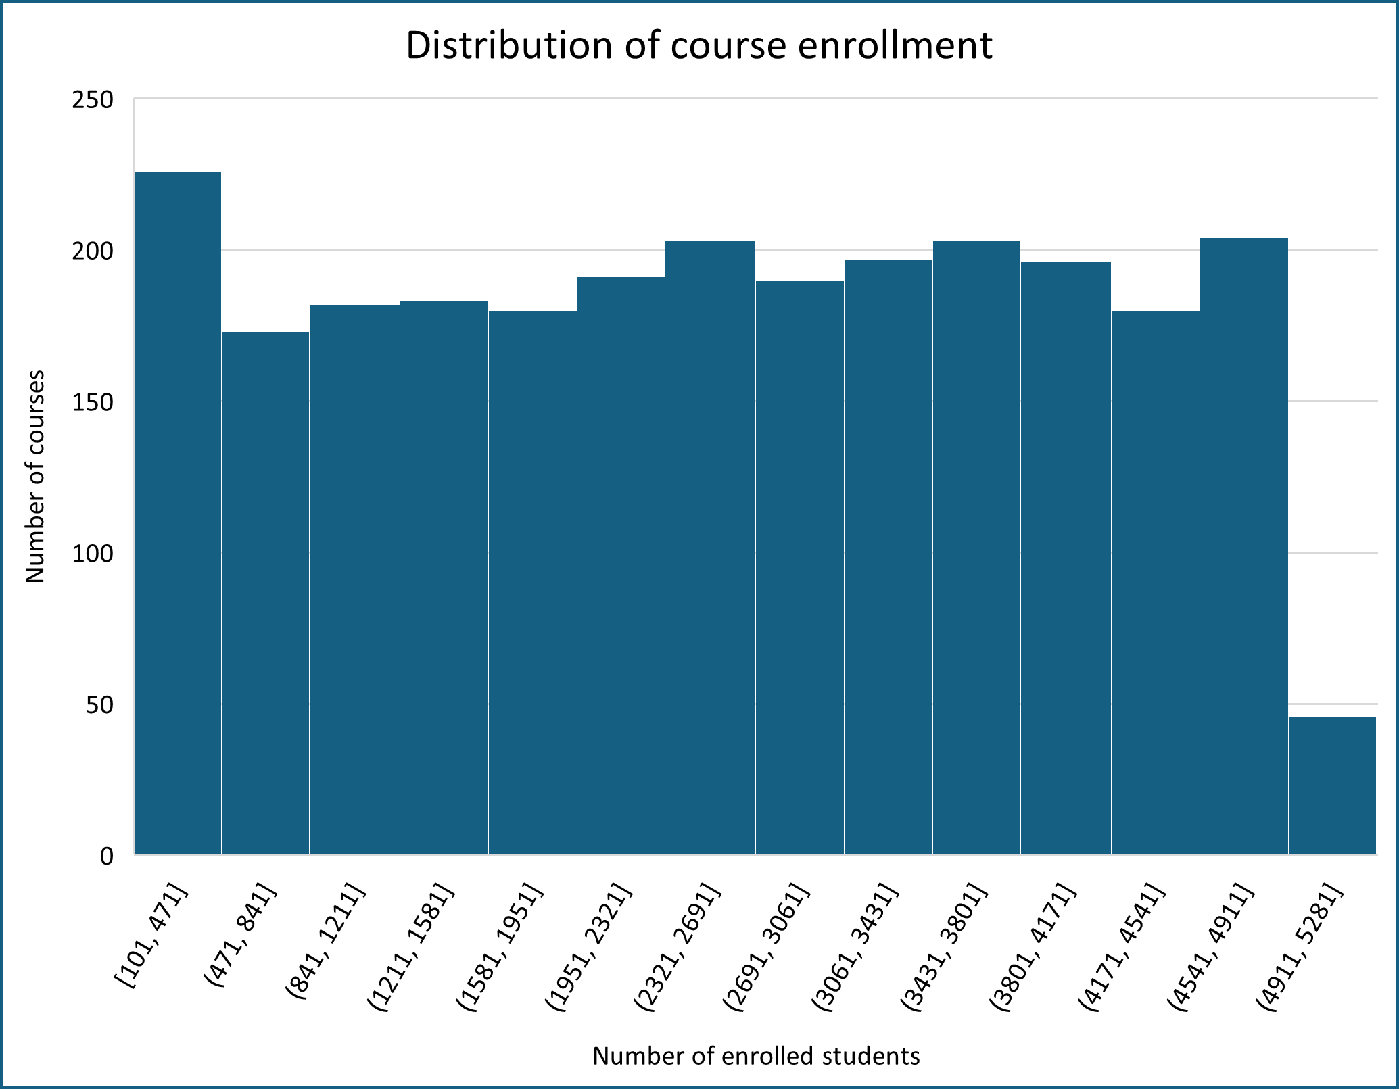

The histogram of course enrolment shows that the majority of courses have fewer than 500 students, with enrolment levels becoming more evenly spread in mid-tier ranges up to around 4,900. Only a small number of courses reach peak enrolment beyond 4,900, suggesting that while a few courses achieve viral reach, most maintain moderate to low engagement. This reflects a long-tail distribution typical of online learning platforms, where few courses dominate in reach while many attract smaller, niche audiences.

**Distribution of course completion rates**

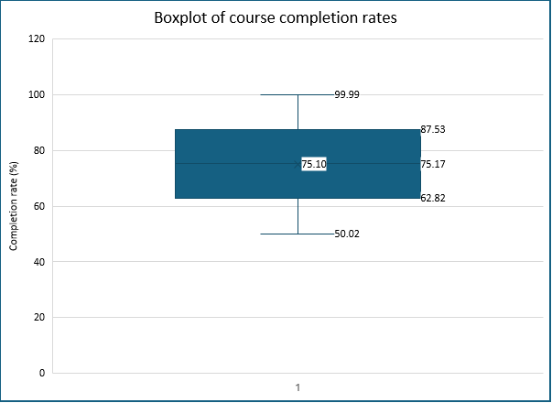

The boxplot shows that the majority of online courses have high completion rates, with the central 50% of courses falling between 62.82% and 87.53%. The median (75.17%) and mean (75.10%) are nearly identical, indicating a symmetric distribution with minimal skew. The minimum and maximum completion rates range from just over 50% to nearly 100%, suggesting that most courses achieve strong learner retention. This consistent trend highlights the effectiveness of online platforms in engaging students through to completion.

**Distribution of course prices**

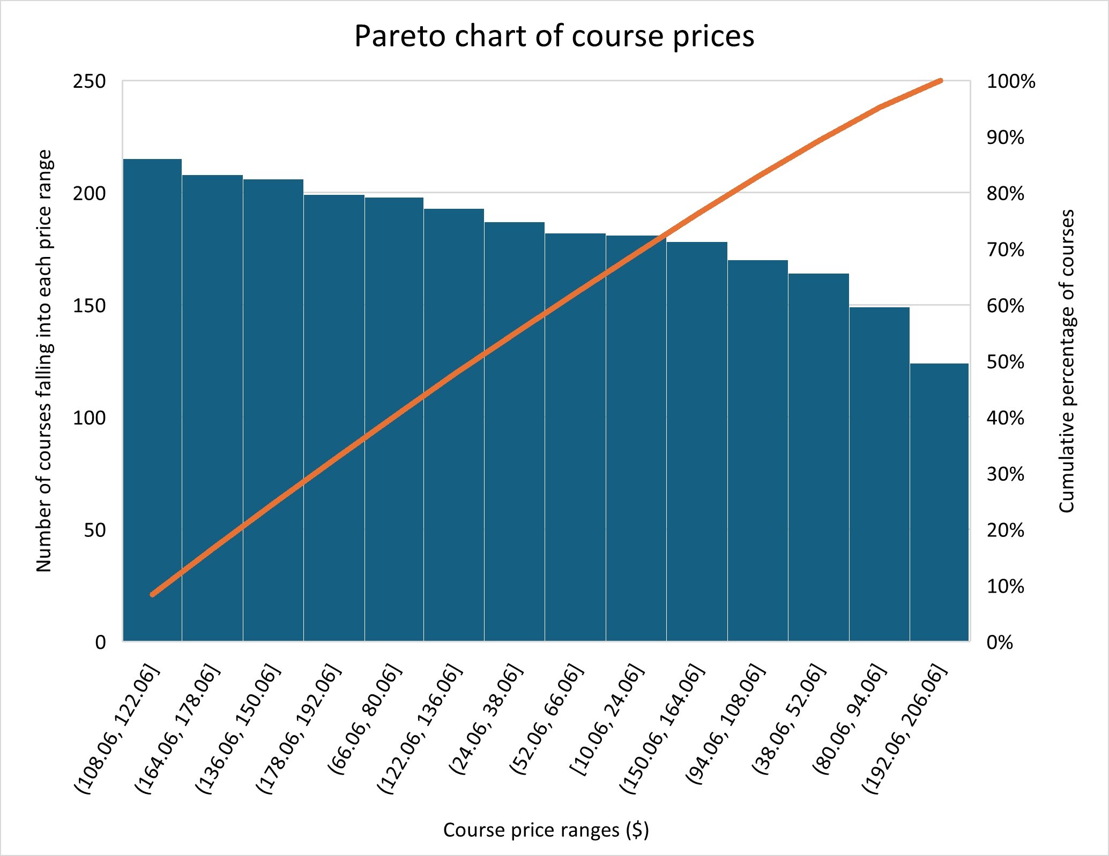

The Pareto chart of course prices shows that most online courses are concentrated in the mid-to-high price ranges, with the $108–122 range being the most common, hosting over 200 courses. Other price brackets, such as $136–150 and $164–178, also include a large number of courses, suggesting that course providers often choose these pricing tiers. In contrast, very low-priced courses (e.g., $10–24) and very high-priced ones ($192–206) are much less common.

The cumulative percentage line indicates that a small number of price ranges account for the majority of courses, following the Pareto principle. For instance, approximately 80% of all courses are priced within the first seven price ranges. This insight is valuable for course providers or marketers to focus on these dominant pricing tiers, as they represent the bulk of offerings in the market. Conversely, fewer courses fall into lower or extremely high price ranges, such as $10.06–24.06 or $192.06–206.06, suggesting limited demand or supply in these segments.

**Distribution of course ratings**

The histogram of course ratings reveal a clear pattern: the majority of online courses are rated between 4.0 and 4.8, with the highest concentration in the 4.05–4.2 range. This suggests that learners generally provide positive feedback, and platforms tend to maintain a high quality standard. Very few courses fall below a rating of 3.5, indicating that poorly rated courses are rare. The distribution is right-skewed, showing a strong tilt toward higher ratings. This reflects a competitive landscape where new or existing courses must maintain high quality and learner satisfaction to stand out. To remain competitive, course providers should target a minimum rating of 4.2 or above.

## 4.3 Cross-platform performance of online courses: Insights from ratings, completion, and pricing data

**Table: Average course rating by platform**

|  |  |
| --- | --- |
| Platform | Average Rating (out of 5) |
| Coursera | 4.0003 |
| edX | 4.0032 |
| LinkedIn Learning | 3.9726 |
| Udemy | 4.0006 |

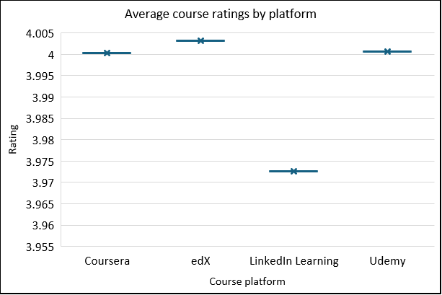

The chart illustrates the average user ratings across four online learning platforms: Coursera, edX, LinkedIn Learning, and Udemy, based on a 5-point scale. edX stands out with the highest average rating, slightly above 4.00. This suggests that learners perceive edX courses as being of very high quality and consistency. Udemy and Coursera follow closely, both averaging just above 4.00. Their nearly identical scores reflect a strong and stable level of learner satisfaction. LinkedIn Learning, while still rated positively, shows a slightly lower average of just under 3.98. Though this is a marginal difference, it may point to variability in course quality or differences in learner expectations.

**Impact of course duration on ratings and completion rates**

**Table: Average rating and completion rate by course duration**

|  |  |  |
| --- | --- | --- |
| Course Duration (hours) | Average Rating (out of 5) | Average Completion Rate (%) |
| 10–20 | 4.01 | 74.62% |
| 20–30 | 4.00 | 75.00% |
| 30–40 | 4.00 | 75.37% |
| 40–50 | 4.01 | 75.30% |
| 50–60 | 3.97 | 74.88% |
| 60–70 | 3.97 | 74.58% |
| 70–80 | 4.02 | 75.10% |
| 80–90 | 3.96 | 76.00% |
| 90+ | 4.00 | 75.22% |

The chart illustrates the average user ratings and completion rates across different course duration categories, providing insights into how course length may influence learner satisfaction and engagement. Based on a 5-point rating scale and completion percentage, the data is segmented into 10-hour duration intervals ranging from 10–20 hours to 90+ hours.

Courses within the 70–80 hour range stand out with the highest average rating of approximately 4.02, suggesting that learners in this duration group found the course quality particularly high. This is followed closely by the 10–20 hour and 40–50 hour groups, both with ratings just above 4.00, reflecting consistently strong learner satisfaction in these timeframes.

In contrast, courses in the 80–90 hour range exhibit the lowest average rating, at approximately 3.96, which may indicate diminishing perceived value or engagement in longer course formats. However, this same category shows the highest average completion rate of 76%, suggesting that although learners may rate the experience slightly lower, they are highly likely to finish these courses—possibly due to their structure, content depth, or learner commitment.

Across all duration bands, completion rates remain relatively stable, hovering between 74.5% and 76%, with shorter courses (20–40 hours) maintaining solid completion performance. The lowest completion rate is seen in the 60–70 hour range at 74.58%, indicating a possible engagement drop in mid-length courses.

Overall, the chart reveals that course length alone does not dramatically impact ratings or completion, but certain patterns emerge: very short and very long courses tend to drive higher completion, while learner satisfaction remains high across all durations with minor variability. These insights suggest that course design and learner motivation may play a more significant role than duration alone in determining course success.

**Table: Platform performance across key metrics**

|  |  |  |  |
| --- | --- | --- | --- |
| Platform | Total enrolled students | Average rating (out of 5) | Average completion rate (%) |
| edX | 6,232,148 | 4.0032 | 75.34% |
| Udemy | 6,538,277 | 4.0006 | 75.10% |
| Coursera | 6,212,505 | 4.0003 | 74.96% |
| LinkedIn Learning | 6,323,600 | 3.9726 | 75.08% |

The table compares four major online learning platforms—Coursera, edX, LinkedIn Learning, and Udemy—across three key metrics: average rating, total enrolment, and completion rate. A visual representation of this data is provided in the chart titled "Platform performance: Enrolment, Rating & Completion Rate" (see Figure below).

All platforms show high learner satisfaction, with average ratings clustered around 4.00. edX leads slightly at 4.0032, followed closely by Udemy and Coursera, while LinkedIn Learning trails slightly at 3.9726, yet still reflects positive user feedback.

Enrolment figures are strong across the board, each exceeding 6 million learners. Udemy ranks highest with over 6.5 million enrolments, followed by LinkedIn Learning and edX, while Coursera records a slightly lower but still substantial total.

In terms of completion, edX again leads with an average rate of 75.34%, with Udemy and LinkedIn Learning close behind. Coursera follows at 74.96%, with only a marginal difference.

Overall, edX shows the most balanced performance, combining strong ratings, high completion, and competitive reach. Udemy excels in scale, while Coursera maintains consistent satisfaction and engagement. LinkedIn Learning, despite lower ratings, remains a solid performer in enrolment and completion.

Based on the analysis, edX demonstrates the most balanced performance across all three key metrics. It has the highest average user rating of 4.0032, indicating strong learner satisfaction, and also leads in average completion rate at 75.34%, suggesting high learner engagement. Although its total enrolment is slightly lower than Udemy’s, it remains highly competitive at over 6.2 million students.

Udemy stands out with the highest total enrolment—over 6.5 million learners—reflecting its broad reach and popularity. It maintains a solid average rating of 4.0006 and a high completion rate of 75.10%, making it a strong performer overall.

Coursera offers consistent results across all metrics, with an average rating of 4.0003, enrolment above 6.2 million, and a completion rate of 74.96%.

LinkedIn Learning, while slightly lower in average rating (3.9726), achieves a completion rate of 75.08% and total enrolment exceeding 6.3 million, demonstrating solid performance despite minor differences in perceived quality.

In summary, edX is the top performer in terms of quality and engagement, while Udemy leads in reach. Coursera and LinkedIn Learning remain strong contenders with consistent, high-performing course offerings.

**Impact of course pricing on enrolment and ratings**

The chart shows that enrolment increases with course price, with the lowest price range ($0–50) attracting 5.2 million students and the highest ($151–200) reaching 6.9 million. This suggests higher-priced courses may be seen as more valuable, driving enrolment.

Learner satisfaction, measured by ratings, is highest in the $51–100 range (4.01/5). Ratings are slightly lower in the $0–50 and $101–150 ranges, though the variation is narrow across all price bands.

Overall, the $51–100 range offers the best balance of strong enrolment and high ratings, indicating that mid-priced courses may offer the optimal mix of affordability and quality.

**Table: Course category performance: Enrolment and average rating**

|  |  |  |
| --- | --- | --- |
| Course category | Sum of enrolled students | Average of rating (out of 5) |
| Marketing | 2949738 | 4.014 |
| Finance | 2892437 | 3.990 |
| Office Tools | 2882713 | 4.004 |
| Business | 2848578 | 3.994 |
| AI | 2809869 | 3.983 |
| Design | 2783497 | 3.999 |
| Data Science | 2734806 | 4.015 |
| Technology | 2728293 | 3.957 |
| Programming | 2676599 | 3.991 |

The table and chart show that Marketing leads with the highest enrolment at 2.95 million, followed by Finance and Office Tools with 2.89 million and 2.88 million students, respectively. Categories such as Business, AI, and Design also attract strong enrolments, while Data Science, Technology, and Programming have lower figures, ranging from 2.67 to 2.73 million. This suggests that learner demand is higher for soft skills and business-focused courses, with less emphasis on technical fields.

In terms of satisfaction, ratings are generally high, with Data Science and Marketing leading at 4.015 and 4.014, respectively. Technology has the lowest rating at 3.957, possibly reflecting issues with course quality or learner expectations

# Diagnostic analysis

## 5.1 Correlation heatmap

|  |  |  |  |  |  |
| --- | --- | --- | --- | --- | --- |
|  | *Duration (hours)* | *Enrolled students* | *Completion rate (%)* | *Price ($)* | *Rating (out of 5)* |
| Duration (hours) | 1 |  |  |  |  |
| Enrolled students | -0.015 | 1 |  |  |  |
| Completion rate (%) | 0.033 | -0.038 | 1 |  |  |
| Price ($) | 0.007 | 0.009 | -0.046 | 1 |  |
| Rating (out of 5) | -0.023 | -0.001 | 0.013 | 0.026 | 1 |

This heatmap displays the pairwise Pearson correlation coefficients between five key course metrics: Duration (hours), enrolled Students, completion rate (%), price ($), and rating (out of 5). Correlation values range from –1 (indicating a strong negative relationship) to +1 (a strong positive relationship). In this matrix, most values are close to zero, indicating that there is little to no linear relationship between these variables.

**Four key findings emerge:**

**Duration** has no strong correlation with enrolment, price, rating, or completion. Slight positive correlation with completion (+0.033) suggests longer courses may be completed slightly more often.

**Enrolment** is weakly negatively correlated with completion (–0.038), hinting that larger courses may face engagement challenges. No meaningful link with rating.

**Price** shows minimal influence on other metrics. Slight negative correlation with completion (–0.046) and a weak positive link to rating (+0.026).

**Rating** is slightly positively correlated with completion (+0.013), indicating that better-rated courses may see marginally higher completion rates.

## 5.2 Multiple regression

To further explore how course characteristics influence enrolment, a multiple regression model was run with course enrolment as the dependent variable, and course price and duration (in hours) as the independent variables. The model was not statistically significant (F(2, 2550) = 0.39, *p* = 0.68) and explained virtually none of the variance in enrolment (*R²* = 0.0003). Both predictors showed no meaningful effect on enrolment. The coefficient for price was –0.81 (p = 0.46), and for duration it was 0.24 (*p* = 0.63). These results suggest that price and duration do not significantly influence enrolment decisions, and other factors such as course topic, platform, or marketing may have a stronger impact.

|  |  |  |  |  |  |  |  |  |  |  |  |  |  |  |  |  |
| --- | --- | --- | --- | --- | --- | --- | --- | --- | --- | --- | --- | --- | --- | --- | --- | --- |
| SUMMARY OUTPUT | |  |  | |  | |  | |  | |  | |  | |  | |
|  | |  |  | |  | |  | |  | |  | |  | |  | |
| *Regression Statistics* |  | | |  | |  | |  | |  | |  | |  | |
| Multiple R | | 0.017394475 |  | |  | |  | |  | |  | |  | |  | |
| R Square | | 0.000302568 |  | |  | |  | |  | |  | |  | |  | |
| Adjusted R Square | | -0.000481509 |  | |  | |  | |  | |  | |  | |  | |
| Standard Error | | 1426.15887 |  | |  | |  | |  | |  | |  | |  | |
| Observations | | 2553 |  | |  | |  | |  | |  | |  | |  | |
|  | |  |  | |  | |  | |  | |  | |  | |  | |
| ANOVA | |  |  | |  | |  | |  | |  | |  | |  | |
|  | | *df* | *SS* | | *MS* | | *F* | | *Significance F* | |  | |  | |  | |
| Regression | | 2 | 1569748.47 | | 784874.2352 | | 0.385890652 | | 0.679884555 | |  | |  | |  | |
| Residual | | 2550 | 5186519263 | | 2033929.123 | |  | |  | |  | |  | |  | |
| Total | | 2552 | 5188089012 | |  | |  | |  | |  | |  | |  | |
|  | |  |  | |  | |  | |  | |  | |  | |  | |
|  | | *Coefficients* | *Standard Error* | | *t Stat* | | *P-value* | | *Lower 95%* | | *Upper 95%* | | *Lower 95.0%* | | *Upper 95.0%* | |
| Intercept | | 2577.716626 | 86.26462032 | | 29.88150434 | | 1.7808E-168 | | 2408.560788 | | 2746.872465 | | 2408.560788 | | 2746.872465 | |
| 43 | | -0.81011947 | 1.092963596 | | -0.74121359 | | 0.458632196 | | -2.95330602 | | 1.333067075 | | -2.953306015 | | 1.333067075 | |
| 96.25 | | 0.243215134 | 0.510143512 | | 0.476758261 | | 0.633575122 | | -0.75712259 | | 1.243552854 | | -0.757122587 | | 1.243552854 | |

# Business insights

The following insights were derived from a combination of descriptive and diagnostic analyses, offering actionable recommendations for University X as it seeks to strengthen its online course offerings in a competitive global market.

## 6.1 Platform-level insights: Quality vs. Enrolment

The platform comparison reveals that:

* edX demonstrates the strongest performance overall, leading in both learner satisfaction (average rating 4.0032) and completion rate (75.34%).
* Udemy attracts the highest total enrolment, with over 6.5 million learners, suggesting superior market penetration.
* Coursera and LinkedIn Learning maintain strong metrics, though LinkedIn trails slightly in satisfaction.

**Implication for university X:**  
Stakeholders responsible for platform partnerships or benchmarking (e.g., strategy leads, academic directors) should look to edX as a model for course quality and engagement. Meanwhile, Udemy’s marketing and outreach strategies offer inspiration for expanding reach. University X can position its platform by combining quality-driven design (like edX) with scalability initiatives.

## 6.2 Course duration: Engagement is not linear

From the EDA:

* Courses of 70–80 hours receive the highest satisfaction (avg. rating 4.02).
* Very short (10–20 hrs) and very long (80–90 hrs) courses show the highest completion rates, around 75–76%.
* Mid-length courses (50–70 hrs) underperform slightly in both metrics.

**Implication for University X:**  
This is critical for course designers and curriculum planners. Offering diverse durations—particularly short introductory and in-depth long-format courses—can increase both satisfaction and completion. Mid-length courses may require improved structure or pacing.

## 6.3 Pricing: Perception of value over absolute cost

The analysis of price bands shows:

* Higher enrolment is seen in higher-priced courses (up to $200), suggesting perceived value plays a role.
* The $51–100 range offers the best combination of strong enrolment and highest average ratings (4.0095).

**Implication for University X:**  
Product and pricing strategists should consider tiered pricing models with clear value communication. Courses in the $51–100 range can be positioned as premium, yet accessible, aligning with market trends and learner expectations. Excessively low pricing may undervalue the offering.

## 6.4 Course categories: Soft skills drive demand

* Marketing, Finance, and Office Tools are the top three in learner demand, based on total enrolment.
* Data Science and Marketing lead in learner satisfaction, both scoring above 4.01.
* Surprisingly, technical categories like Programming and Technology, while still strong, show slightly lower enrolment and ratings.

**Implication for University X:**  
The program development team should prioritize new offerings in Marketing and Data Science, aligning with both learner demand and satisfaction. For technical areas, quality refinement may be needed to improve perceived value. This informs content strategy and helps align University X’s offerings with labour market trends.

## 6.5 Diagnostic analysis: Pricing and duration do not predict enrolment

The correlation matrix and regression analysis show:

* Price and duration have negligible influence on enrolment.
* Course topic, platform, and potentially marketing factors are more likely to influence learner decisions.

**Implication for University X:**  
Marketing teams and product managers should focus less on adjusting price or course length as levers for enrolment. Instead, they should invest in content marketing, category targeting, and platform visibility to drive engagement. These findings can also be shared with finance and analytics units to inform future experimentation.

# Review and revise business questions

|  |  |  |
| --- | --- | --- |
| **Existing business question** | **Revised question** | **Justification (based on my data analysis)** |
| **1. Which platforms offer the highest-performing courses across key metrics (enrolment, ratings, and completion rates)?** | *No change needed* | My analysis of platform-level data (Table: enrolment, rating, and completion) fully supports this question. Strong analysis with clear comparative insights. |
| **2. How do course characteristics such as price, duration, category, and platform influence user satisfaction and enrolment across different platforms?** | How do course characteristics such as price, duration, and category influence user satisfaction and completion across platforms? | Minor refinement: The correlation matrix and regression models show minimal impact of price/duration on enrolment, but some influence on completion. “Satisfaction and completion” better reflect what my data can explain” |
| **2.1 How does pricing affect enrolments and ratings?** | What is the relationship between pricing and learner satisfaction? | My data analysis shows no significant correlation between price and enrolment), and only a weak relationship with rating. Therefore, this revised question narrows scope to reflect where patterns are slightly more visible. |
| **2.2 Are shorter courses generally associated with higher completion rates?** | *No change needed* | Supported by my duration band analysis, which clearly shows patterns in ratings and completion by course length. |
| **3. Which skills are most in-demand across different platforms, and how do they perform in terms of ratings and enrolment?** | Which course categories are most in-demand, and how do they perform in terms of enrolment and learner satisfaction? | Suggested for clarity: The dataset refers to "categories" (e.g., Marketing, Data Science), not specific skills. Rewording improves accuracy and matches my analysis (Table: category vs enrolment & ratings). |

# Conclusion

In conclusion, this analysis provides valuable insights into the factors influencing online course performance across different platforms. Key findings show that platform quality, course duration, pricing strategies, and category play significant roles in driving learner satisfaction and engagement. edX emerges as the top performer in terms of quality and engagement, while Udemy excels in enrolment numbers. Additionally, course pricing and duration exhibit minimal direct influence on enrolment, emphasising the importance of course content, platform, and marketing efforts. These insights will guide University X in refining its course offerings and positioning itself more effectively in the competitive online education market.

# References

Business of Apps. (2025, January 22). Online courses app revenue and usage statistics (2025). <https://www.businessofapps.com/data/online-courses-app-market/>

Deterding, S., Dixon, D., Khaled, R., & Nacke, L. (2011). From game design elements to gamefulness: Defining "gamification." Proceedings of the 15th International Academic MindTrek Conference, 9–15. <https://doi.org/10.1145/2181037.2181040>

EI Design. (2022, March 10). eLearning trends in 2022 – How to leverage them to design high-impact L&D programs for the hybrid workforce. Adobe eLearning. <https://elearning.adobe.com/2022/03/elearning-trends-in-2022-how-to-leverage-them-to-design-high-impact-ld-programs-for-the-hybrid-workforce/>

Polaris Market Research. (2022, February). E-learning market share, size, trends, industry analysis report, 2022–2030. Polaris Market Research. <https://www.polarismarketresearch.com/industry-analysis/e-learning-market>

World Economic Forum. (2020). The future of jobs report 2020. World Economic Forum. <https://www.weforum.org/reports/the-future-of-jobs-report-2020>