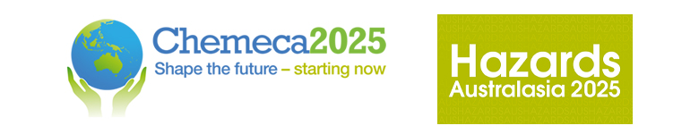

Chemeca 2025 and Hazards Australasia
28 – 30 September, Adelaide, South Australia

A gap to be filled in process safety for low carbon mineral processing.
Christopher Jansen
FIchemE
Christopher.jansen@worley.com

ABSTRACT
The oil and gas industry and the mining, minerals and metals industry have traditionally required unique skill sets in the fields of chemical engineering and process safety. It has been common for university graduates to select either the likes of BP/Shell or Rio/BHP and then become embedded the their corresponding sectors for the majority of their careers. The energy transition is causing the sectors to merge when it comes to process safety. Skills and processes must adjust accordingly.
Low-carbon iron making involves producing pig iron (a key feedstock to steel production) using hydrogen and/or natural gas as an input. Previously, the highest process safety risks in iron-making processes were associated with high temperature molten metal batch processes. However, the relatively benign coal as an input, is being replaced with the highly flammable hydrogen, as the reducing agent that converts iron oxide to metallic iron. The source of this hydrogen can come from green hydrogen or natural gas, both of which carry significant and different process safety risks, that a mining engineer may have never encountered before.
Chemical engineers who haven’t been involved in both sectors will have many questions. Is an oil and gas HAZOP the same as a mineral processing HAZAOP? Can I be the lead process engineer in a green iron HAZOP if I don’t know much about Longford?
This paper reviews the process safety considerations required for low carbon pig iron production. It uses a case study to illustrate the importance of taking learnings from both the oil and gas industry and the mining, minerals and metals industry to ensure adequate risk mitigation of this blended process. These learnings will be critical as pilot plants are scaled up and integrated into tradition steel making facilities.

KEY WORDS
Low-carbon steel, iron, hydrogen, natural gas

BIOGRAPHY
Chris Jansen is a senior associate in Worley’s Front End Energy team, where he manages complex and challenging projects. He has developed his design and project delivery expertise through work with Chevron, BP, Santos, and Shell, across upstream oil & gas, refining and hydrogen production. Chris recently completed his MBA capstone course where he developed a business case for Victoria University’s Green Steel technology. He aspires to take a leading role in sustainability transformations, by leveraging his experience in process technology, customer relationships and new business initiatives.

Conference Program

Please indicate which conference program your abstract relates to:

Hazards Australasia

Chemeca

