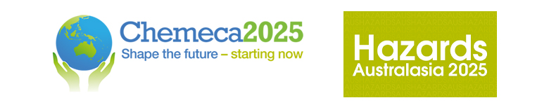

Chemeca 2025 and Hazards Australasia
28 – 30 September, Adelaide, South Australia

Selective Carbon Chain Growth to C₃₊ Chemicals: from Mechanistic Insights to Electrocatalytic Engineering
Ling Chen ¹, Damien Voiry,² Yan Jiao ¹
¹The University of Adelaide, Adelaide, SA 5005, Australia.
² Institut Européen des Membranes, IEM, UMR 5635, Université Montpellier, ENSCM, CNRS, Montpellier, France.
yan.jiao@adelaide.edu.eu

ABSTRACT
The electrocatalytic CO₂ reduction reaction (ECRR) toward high-value chemicals conversion is a promising pathway for transforming industrial production and promoting carbon cycle sustainability. However, its selective reduction to C₃₊ chemicals remains challenging due to two key limitations: low overall C3+ conversion rate and poor selectivity for specific C₃₊ products. To help the advance of this direction, we present a perspective on mechanistic insights to identify opportunities and approaches to overcome these challenges. In this perspective, we first summarize three primary mechanisms for ECRR-to-C₃₊ conversion: *CO-*CO-*CO coupling, *CO₂-*OCHCH₂ coupling (*CO₂ insertion), and *CO–*OCHCH₂ coupling (*CO insertion). Additionally, we propose thermodynamically feasible alternative pathways as competing mechanisms, offering a more comprehensive understanding of the process. Building upon these insights, we highlight a couple of new reaction environment engineering strategies to enhance ECRR-to-C₃₊ efficiency, which includes catalyst material engineering and electrolyte engineering. This integrated approach holds great promise for advancing sustainable and efficient production processes. Finally, major challenges and perspectives in this research area are proposed for future development and practical applications.

KEY WORDS
C₃₊, ECRR, Electrocatalytic engineering, Mechanism

BIOGRAPHY
My research centers on the computational design and discovery of efficient, low-cost catalysts for sustainable energy applications, using first-principles calculations and high-throughput screening techniques. I specialize in electrocatalysis, with complementary experience in photocatalysis, and focus on reactions central to the Water, Carbon, and Nitrogen cycles, including: Hydrogen Evolution (HER) and Hydrogen Oxidation (HOR), Oxygen Evolution (OER) and Oxygen Reduction (ORR), Carbon Dioxide Reduction (CO₂RR) and Nitrogen Reduction (NRR)

Conference Program

Please indicate which conference program your abstract relates to:

Chemeca

