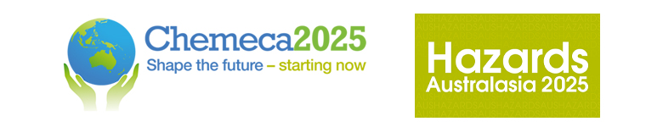

Chemeca 2025 and Hazards Australasia
28 – 30 September, Adelaide, South Australia
Engineering Carbon-Based Nanohybrids for Sustainable Water Purification
Associate Professor Xiaoguang Duan

School of Chemical Engineering, University of Adelaide, Adelaide, 5005 SA, Australia.

E-mail: xiaoguang.duan@adelaide.edu.au

ABSTRACT
The growing severity of environmental pollution necessitates advanced technologies for the effective removal of hazardous organic contaminants generated by human activities. Notably, during the COVID-19 pandemic, the excessive consumption and discharge of pharmaceuticals into water systems have posed significant and persistent threats to ecosystems. As a promising alternative to traditional transition and noble metal catalysts, carbon-based materials offer a sustainable and environmentally friendly solution for catalytic water treatment.
In this work, we utilize carbon-rich precursors—including nanodiamond, melamine, and metal-organic frameworks (MOFs)—to fabricate structurally and surface-engineered carbon composites. The encapsulated metallic counterparts facilitate electron transfer to the surrounding carbon shells due to their low work function, high conductivity, and multiple C/Metal-C bonds that promote electron tunneling. This hybrid structure effectively modulates the electron density of the outer carbon lattice, a key factor in activating peroxymonosulfate (PMS) to generate reactive sulfate radicals. These radicals exhibit strong oxidative potential, enabling the efficient degradation of organic contaminants and microplastics into harmless byproducts.
Furthermore, the carbon encapsulation effectively prevents metal leaching, while the metallic core enhances the carbocatalytic activity and redox capacity of the outer carbon shell. This interaction not only improves catalytic performance but also imparts exceptional long-term stability by protecting the carbon surface from oxidation. Through deliberate material design and theoretical computations, this study elucidates the structure–activity relationships governing enhanced carbocatalysis. Our findings provide a fundamental understanding of high-performance carbon nanohybrids, paving the way for sustainable and efficient environmental remediation technologies.

KEY WORDS

Green catalysis, water purification, pharmaceutical removal; catalytic mechanism, composite materials

BIOGRAPHY
Dr Xiaoguang Duan is an Associate Professor at the School of Chemical Engineering, The University of Adelaide. His research areas focus on catalytic engineering, functional materials, advanced water purification technologies. Dr Duan has published over 300 peer-reviewed research papers in Nature Water, Nature Communications, Chemical Review, Chemical Society Review, Advanced Materials, Angew Chem Int Ed, ACS Catalysis etc. His publications received >44,000 citations with h-index of 111. He was a highly cited researcher and received the ‘MIT Technology Review Innovator Under 35’, ACS ‘James J. Morgan’ Awards, and Young Tall Poppy Award.

Conference Program

Please indicate which conference program your abstract relates to:

Hazards Australasia

Chemeca

