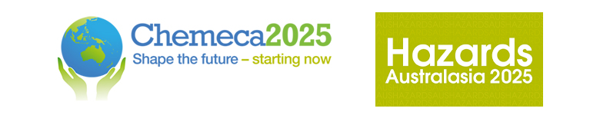

Chemeca 2025 and Hazards Australasia
28 – 30 September, Adelaide, South Australia
Advancing Rare Earth Elements (REE) Value Chain from Secondary Resources in India: CSIR-IMMT’s Strategic Initiatives
Kali Sanjay*, Abdul Rauf Sheik, Sujana M G and Ramanuj Narayan
CSIR-Institute of Minerals and Materials Technology, Bhubaneswar, India - 751013
ksanjay@immt.res.in

ABSTRACT
India’s growing focus on clean energy, electric mobility, and electronics technologies has significantly increased the strategic importance of Rare Earth Elements (REEs). Recognizing this, India has classified REEs as critical minerals. With increasing global demand and supply chain vulnerabilities, it has become imperative to identify sustainable alternatives beyond conventional primary ores. Secondary resources such as fly ash and bauxite residue have gained prominence due to their significant REE content, offering opportunities for waste valorization and circular economy integration.
The CSIR-Institute of Minerals and Materials Technology (CSIR-IMMT) is spearheading the development of innovative, eco-friendly processes for the holistic utilization of these secondary resources. A key breakthrough includes a patented process for bituminous fly ash that enables the recovery of high-purity alumina, calcium silicate, and quartz. This process concentrates REEs from ~400 ppm in the original material to ~7000 ppm in the iron hydroxide residue, significantly enhancing downstream recovery potential and overall resource efficiency. Further work is underway on lignitic fly ash, which naturally exhibits higher REE concentrations. Simultaneously, CSIR-IMMT is processing bauxite residue (red mud), an environmentally challenging industrial by-product, to recover REEs along with alumina, titania, and iron. Beyond industrial residues, CSIR-IMMT has developed recovery technologies for REE-bearing end-of-life products, including spent NdFeB magnets, Ni-MH batteries, and phosphor powders from lighting waste.
These processes are currently being scaled up to assess their techno-commercial viability. To enable a complete domestic REE value chain, CSIR-IMMT is also advancing downstream processing capabilities such as solvent extraction for REE separation and molten salt electrolysis for metal production.
This presentation outlines CSIR-IMMT’s integrated efforts to build a resilient and sustainable REE value chain from secondary resources in India, supporting priorities in resource mobilization and circular economy development.

KEY WORDS

Rare Earth Elements (REEs), Secondary Resources, Fly Ash and Bauxite Residue, Critical Minerals, ,Circular Economy

BIOGRAPHY

Dr. Kali Sanjay, Chief Scientist and Head of the Hydro, Bio & Electrometallurgy Department at CSIR-IMMT, Bhubaneswar, has over 30 years of experience in extractive metallurgy. He specializes in recovering critical and non-ferrous metals from low-grade ores, industrial wastes, and secondary resources. His notable work includes sustainable technologies for extracting valuable materials from red mud, fly ash, and spent catalysts. Dr. Sanjay has successfully commercialized nickel and cobalt recovery processes in India. He leads India’s deep-sea mineral metallurgy program and collaborates internationally, including CSIRO and the University of South Australia. He also teaches at AcSIR as a Professor.

Conference Program

Please indicate which conference program your abstract relates to:

Hazards Australasia

Chemeca

