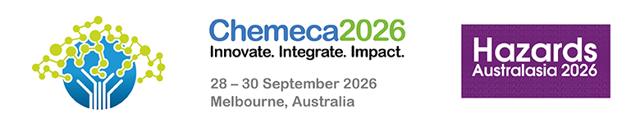

Chemeca 2026 and Hazards Australasia
28 – 30 September, Melbourne, Australia
Learning from the Florida Water Cyberattack and What Can Go Wrong
Author(s): Paresh Kerai
Affiliation(s):
E-mail: pkerai@exida.com

ABSTRACT

The 2021 Florida Water cyberattack exposed significant vulnerabilities in critical water treatment infrastructure. It highlighted how even small operational changes made by an attacker can pose serious risks to public health. In this incident, a threat actor gained remote access to a water treatment plant’s control system and attempted to alter chemical dosing levels. Although operators detected and reversed the change before it affected the water supply, the event demonstrated how quickly routine operations can be disrupted and how essential systems can be compromised.

This presentation explains the Florida Water incident, the weaknesses that enabled the intrusion, and the broader implications for water utilities of all sizes. It outlines how cyberattacks can lead to unsafe water quality, equipment damage, service interruptions, and loss of public trust. The session emphasises the importance of strong cybersecurity practices, access control, continuous monitoring, staff training, and incident‑response readiness to safeguard water treatment facilities from similar threats.

KEY WORDS
Cyberattack, safety instrument system, process and functional safety, risk management, cyber risk and consequences

BIOGRAPHY
Paresh is a strategic technology and Senior OT cybersecurity engineer who has worked with leading-edge cybersecurity and threat intelligence solutions for both Industrial Control Systems and Enterprise networks. With more than 15 years of experience, Mr Kerai continues to research emerging technologies being developed globally within the cybersecurity domain and actively attends and speaks at cybersecurity conferences. He has provided expert consultation to both the private and government sectors on various security standards, including IEC 62443, NIST CSF, SOCI Act, and AESCF.

Conference Program
Please indicate which conference program your abstract relates to:

Hazards Australasia
Chemeca

