DELIVER TO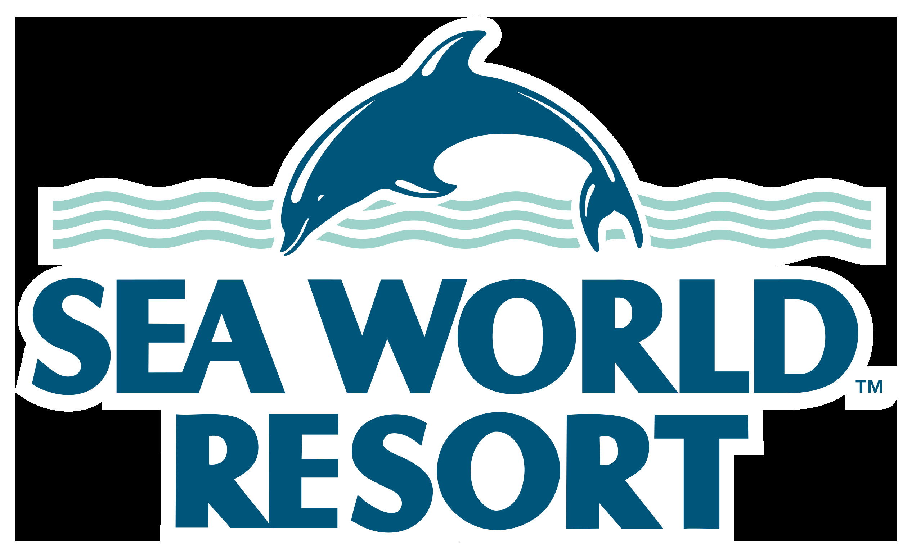 | Sea World Resort Loading Dock,  Sea World Drive,  MAIN BEACH, GOLD COAST, QLD 4217 |  | Loading dock  PH: 07 5591 0079
EVENT NAME
EVENT DATE
EXHIBITION BOOTH NAME  (if applicable) |  |  | BOOTH #
EXHIBITOR ON-SITE CONTACT |  |  | MOBILE #
PURPOSE OF PACKAGE  Please circle | SATCHEL PACKING | REGISTRATION | EXPO BOOTH
SPECIAL INSTRUCTIONS
ITEM _____ OF _____
CONFERENCE AND EVENTS CO-ORDINATOR: Dusica Cvetkovic 0420 991 730
PLEASE NOTE: Deliveries will only be received 3 business days prior to official event dates. Should goods arrive prior to this time they will be
turned away, please be aware deliveries can be received Monday to Friday 7am to 2pm.

