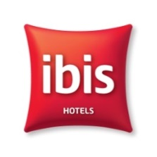
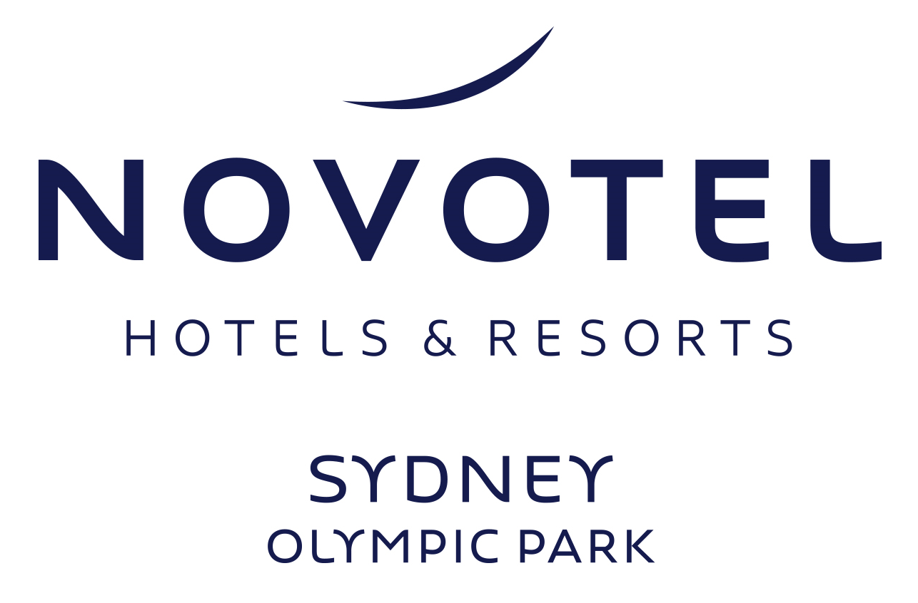
TO:
Attention: Jacinta Packer (+61 497 700 270)
Position: Conference & Events Cooridnator
Company: Novotel Hotel & Hotel Ibis
Address: Olympic Boulevard
SYDNEY OLYMPIC PARK
NSW 2127

FROM:
Sender: _____________________________
Company: ___________________________
Address: ____________________________
____________________________________
Function Date: _______________________
Function Name: _______________________
Function Room: _______________________
Box : _____________ of ________________

Special Instructions

Hotel must be notified of all deliveries in advance

Hours of the Loading Dock:
- Monday to Friday
- 0700am to 0300pm only

Entrance to the Loading Dock is via Showground Road, off Herb Elliott Avenue and Dawn Fraser Avenue.

Light equipment may be delivered 24 hours prior to your event to the hotel reception desk located off the main hotel entrance.

Large equipment may be delivered 24 hours prior to your event to the loading dock area off Showground Road and directly underneath the hotel complex.
** Roller doors of dock
Height - 3.20 m
** Double doors from dock to elevator:
Height 1.96m
Width 1.43m
** Elevator dimensions are as follows:
Height 2.10 m,
Width 1.37 m
Width between doors 1.1 m
Depth 1.90 m
Max weight: 1000kg

All delivieres to the loading dock are the responsibility of the sender to collect and take to the function room unless pre arranged with the hotel.

Please note: an unpacking fee of $150.00 applies per pallet sent to the hotel if sender does not unpack themselves

Parklands Room Door 2.4m x 1.8m

