Northern Pathway: AKORANGA TO CONSTELLATION DRIVE
Saeid Adli
Senior Transport Planner
NZ Transport Agency
Email: saeid.adli@nzta.govt.nz
Rhys Millier
Project Leader
WSP
Email: rhys.millier@wsp.com
Michael Jongeneel
Active Mode Specialist
Flow Transportation Specialists
Email: michael.jongeneel@flownz.com
Tobie Pretorius
Business Case Lead
Flow Transportation Specialists
Email: tobie.pretorius@flownz.com

Abstract
Waka Kotahi NZ Transport Agency is delivering transformational change in walking and cycling in Auckland, offering people active transport choices that are good for their health and the environment. We are working to create the Northern Pathway, a shared pathway across the Waitematā Harbour that will connect the suburbs of the North Shore with the growing walking and cycling network in the city. A business case for the section between Akoranga and Constellation Drive is being finalised to realise the full vision of the Northern Pathway and help unlock the region’s wider walking and cycling networks to serve the community now, and in generations to come.
Public engagement has been paramount to the successful delivery of the initial stages of the business case especially as the team has had to work through the recent unprecedented and uncertain times with the COVID-19 pandemic. The results of the project benefit analysis indicate encouraging potential modal shift and uptake of active modes.

Keywords: Business Case, Mode Shift, Engagement, North Shore, Auckland

Introduction
Auckland, New Zealand’s largest urban area, is home to about 1.6 million people and growing rapidly. The North Shore has seen significant spatial and population growth over recent decades and there is no sign that this will stop. The existing transport network is at or near capacity and more sustainable travel options will need to be promoted and supported going forward to manage the demand for growth.
Waka Kotahi NZ Transport Agency is delivering transformational change in walking and cycling in Auckland, offering people active transport choices that are good for their health and the environment.
Waka Kotahi is working to create the Northern Pathway (see Figure 1: The Northern Pathway project), a walking and cycling connection across the Waitematā Harbour that will connect the suburbs of the North Shore with the growing cycle network in the city. This is part of Auckland’s Better Travel Choice Mode Shift Plan which aims to provide better access and greater choice for residents to adopt new ways of moving around the city.
Once completed, the Northern Pathway will be part of the Regional Cycle Network linking several large residential and employment areas. There are currently no off-road cycle routes catering for north-south movements on the North Shore and limited on-road cycle routes. A quality off-road cycle route presents a great opportunity for improving the uptake of active modes on the North Shore.
The benefits/outcomes of the completed Northern Pathway are expected to be:
- Provides choice for people to travel between the city centre and North Shore using active modes of transport
- Travel using active modes such as on foot or by bike becomes a more appealing travel option, helping to get people out of their cars
- Reduces the number of short trips completed by private vehicle
- Provides people with a healthy, environmentally friendly way to commute to and from work and education, access services or connect with friends and family
- Supports future growth of the walking and cycling network on both sides of the harbour
- Increases access to transport hubs on the North Shore such as Akoranga, Constellation and Albany Bus Stations.
The first section of the Northern Pathway between Constellation Drive and Albany is already under construction as part of the Northern Corridor Improvements (NCI) Project. For the section of pathway between Westhaven and Akoranga, we are finishing the detailed design, seeking consents and approvals and plan to start construction next year. Our focus is on delivering the whole length of the Northern Pathway as soon as possible.
The authors are now developing a single stage business case (SSBC) for the section between Akoranga and Constellation Drive to realise the full vision of the Northern Pathway and help unlock the region’s wider walking and cycling networks to serve the community now, and generations to come. This paper assesses the impact the Northern Pathway may have on people taking up cycling and changing their current travel behaviours in North Shore, Auckland. To do so, the current travel behaviour of people is modelled based on 2013 census data.
The next section of this paper is a project summary followed by the method. The findings are then presented and discussed. The paper concludes with the overall impact of the project on the cycling network in Auckland.

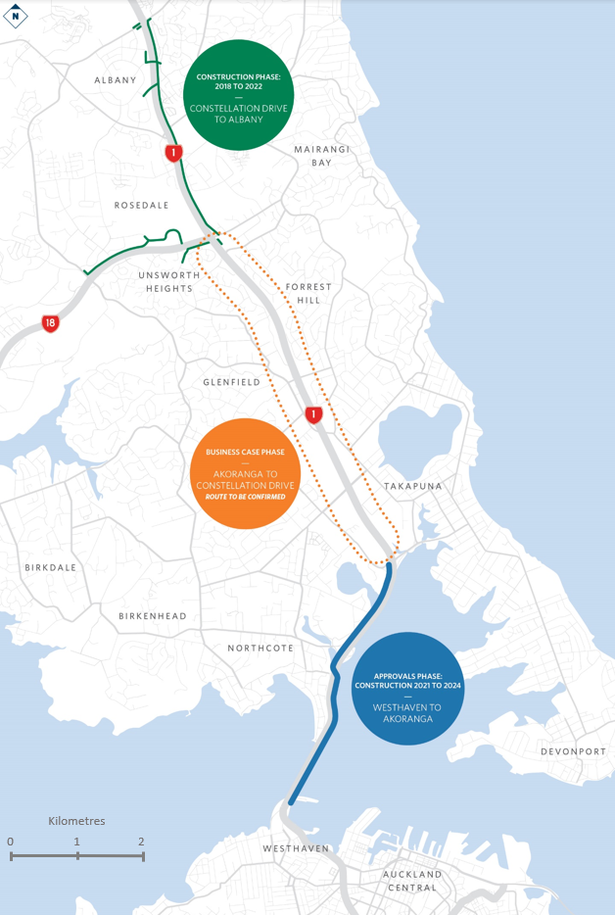
Figure 1: The Northern Pathway project

Project summary
Once completed, the Akoranga to Constellation Drive active mode infrastructure will connect the Westhaven to Akoranga section in the south and the Constellation to Albany section in the north and provide a seamless dedicated walking and cycling link between Auckland’s City Centre and Albany on the North Shore.

Outlining the need for investment in the Akoranga to Constellation Drive project
A facilitated Investment Logic Mapping (ILM) workshop was held on 10 March 2020 with attendance including technical stakeholders from Auckland Council, Auckland Transport and internal specialists from Waka Kotahi, to gain a better understanding of current problems and benefits of solving these problems.
The following problems were identified:
- Problem one: The uptake of active travel modes by mid-North Shore residents is being restricted by the perception of poor safety and lack of convenience. 40%
- Problem two: Barriers to accessing key destinations via active modes is limiting their uptake. 50%
- Problem three: A missing link in the active travel network is undermining the investment in this network elsewhere on the North Shore. 10%
The potential benefits of successfully investing to address these problems were identified as part of the same ILM workshop. The stakeholder panel identified and agreed on the following potential benefits for the proposal:
- Benefit one: Improved comfort and customer experience of active travel – 30%
- Benefit two: More inclusive access – 40%
- Benefit three: Improve active modes accessibility to key destinations – 30%

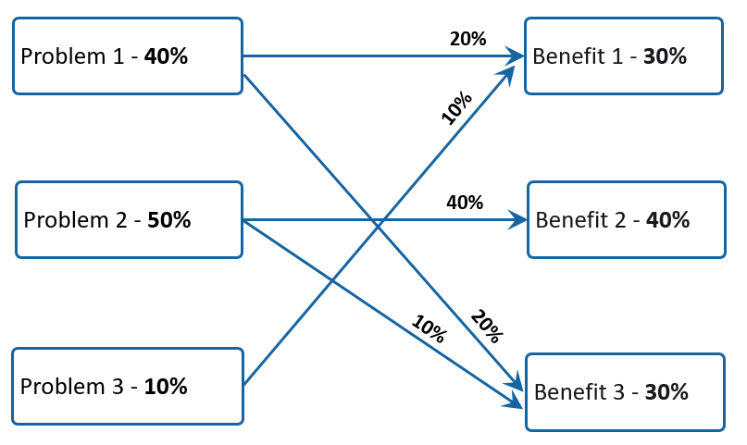
Figure 2: Investment Logic Mapping weighting ratios

STAKEHOLDER ENGAGEMENT

The project commenced in January 2020 and has progressed in unprecedented and uncertain times. The communications and engagement strategy emphasised early engagement with Mana Whenua as project partners, as well as strategic project partners represented by a broad cross section of Council, utility, and advocacy groups.
Through working in partnership with mana whenua, sites of cultural significance are recognised and incorporated into the design from the outset, strategic project partners can also ensure that local knowledge and insights are considered as part of the options development. This means that the short list of options will reflect community aspirations and will have eliminated unrealistic options in advance of wider public consultation.
An initial key stakeholder workshop was held on 4 March 2020 to gather local knowledge and insights into how this link in Auckland’s walking and cycling network can best meet the needs of the community. This involved representatives from Auckland Council, AUT, Bike Kaipātiki, Devonport Takapuna Local Board, Forest and Bird, Kaipātiki Local Board, Living Streets, Northern Corridor Improvements, Pest free Kaipātiki, Smales Farm, Upper Harbour Local Board, Walk Auckland, and Women in Urbanism.
When assessing the options, partners and key stakeholders asked the team to look beyond the pathway as simply a commuter route between Central Auckland and the North Shore and to think of it as a resource connecting the community to schools, public transport hubs, recreation centres, parks and town centres. They wanted the team to be mindful of the cultural, environmental, and geographical features in the area and the needs of families, students, the elderly, the mobility impaired and other users.
This feedback was included in the Investment Logic Mapping workshop on 10 March 2020 and Long List workshop on 19th March 2020.
The advantages of this engagement approach became evident in March with the level 4 lockdown conditions implemented by the government as part of the Covid-19 global pandemic response. Relationships had been established and the feedback analysed from various workshops has been instrumental in the options development. This has eased the transition to engaging solely in an online environment under Covid-19 restrictions.
The project team ran virtual workshops through April to present our option assessment approach and results. Given that virtual workshops were only starting to become the new norm, the team felt it was important to split the information transfer and feedback. Waka Kotahi ran the virtual workshops to inform stakeholders of progress and also sent the stakeholders an online questionnaire. Additional feedback sessions gave everyone the opportunity to take on board the information and provide feedback.
On May 25 consultation on the short list options commenced and ran for a three-week period. Due to the level of Covid-19 restrictions, only online feedback was possible.
Presented in the brochure (Waka Kotahi, 2020), were the initial findings of our technical investigations and the feedback received from partners and stakeholders. The purpose of the consultation was to capture the public feedback on the short-listed options on the western and eastern side of the motorway.
We were interested to know how the public wanted to use this section of the Northern Pathway, the destinations they want to reach and what would make the path attractive to use. We also asked for people to share their local knowledge and let us know if there is anything else we should be considering as we move forward towards a preferred option for this section.

Substantiating the ILM identified problems
The road network, in the context of the Project, consists of SH1, regional connectors, arterials, collectors and low volume local streets.
SH1 is a critical national transport link connecting Auckland, the North Shore and Northland. Between Akoranga and Constellation Drive. It is a six-lane motorway that carries around 120,000 vehicles per day. It faces significant congestion, particularly at peak times, which has grown substantially in recent years and is predicted to worsen with continued increases in population, housing and freight movements over the next 30 years.
The segregated Northern Busway runs alongside SH1, with key stations at Akoranga, Smales Farm, Sunnynook and Constellation. The Busway serves as the spine of a bus-based rapid transit system for the North Shore.
Cycle infrastructure within the study area is generally disconnected and sparse. There are existing shared use paths on Forest Hill Road, Shakespeare Road, Akoranga Drive, Esmonde Road and on sections of East Coast Road and Taharoto Road. The shared use paths are generally narrow, have many driveways along its length, and are obstructed by signs, poles and bus shelters. There are existing painted cycle lanes on sections of Glenfield Road and Taharoto Road, but these too are narrow, have regular driveways along its length, and provide less protection from general traffic. Other streets within the study area have no dedicated cycle infrastructure.
Throughout the project, we have used Auckland Transport’s cycle facility Quality of Service (QoS) procedures to identify any gaps in the existing cycle network, and to set targets for the project. The QoS evaluation process assigns scores of 1 to 4 to elements of cycle routes, with 1 representing all ages and abilities infrastructure, and 4 representing environments unsuitable for most users. The 8 key routes evaluated above all fall within the QoS 3 to 4 range, and other streets within the study area are expected to similarly fall within this range. Most people will not feel comfortable cycling on these routes.
Auckland has a growing network of QoS 1 to 2 cycle infrastructure. Within the North Shore, this includes the sections of Northern Pathway to the north and south, and the Northcote Safe Cycle Route. There will be a notable gap between Akoranga and Constellation Drive once the adjacent sections of Northern Pathway are completed. Central Auckland has better connected networks of QoS 1 to 2 infrastructure than the North Shore.
With the aim of linking Albany to the city centre and better connecting destinations within the North Shore, this project ties in with the following two planned walking and cycling connections as part of the Northern Pathway:
- Westhaven to Akoranga
The Westhaven to Akoranga section of Northern Pathway was formerly known as SkyPath and SeaPath. It will provide km of new walking and cycling facilities across the Auckland Harbour Bridge and on to Akoranga Drive on the North Shore
- Constellation Drive to Albany
The NCI project between Constellation Drive and Albany is widening SH1 as well as providing better links with the Upper Harbour Highway. This project will also deliver over 7kms of new shared use path as part of Northern Pathway between Albany and Constellation Drive and a wide range of local road and park connections.

Collective and personal risk
The uptake of active travel modes by mid-North Shore residents is being restricted by the perception of poor safety and the lack of convenience of active modes of travel. Part of this perception is that it is difficult, unpleasant, feels unsafe, and involves stopping and starting delays as people wait to cross difficult at-grade intersections/carriageways/motorways.
The project team assessed the study area for Collective and Personal. Collective risk is a measure of the fatal and serious crash density per kilometre of road over a section of road. A high collective risk indicates a high fatal and serious crash density. The collective risk map (Figure 2) indicates that many of the existing north-south routes available to pedestrians and cyclists, such as Taharoto Road and Wairau Road, have a medium-high collective risk.
The personal risk, like the collective risk, is also a measure of the fatal and serious crash density, however personal risk also accounts for traffic volumes. The personal risk is, therefore, a measure of the likelihood that an individual will be involved in a fatal or serious crash while travelling through the section.
A high personal risk denotes that a section has a high fatal and serious crash density relative to the number of vehicles that travel through the section. The personal risk map (Figure 3) indicates that a number of roads within the project area, including Northcote Road, Shakespeare Road, Sunnynook Road and the Tristram Avenue interchange have a high or medium-high personal risk.
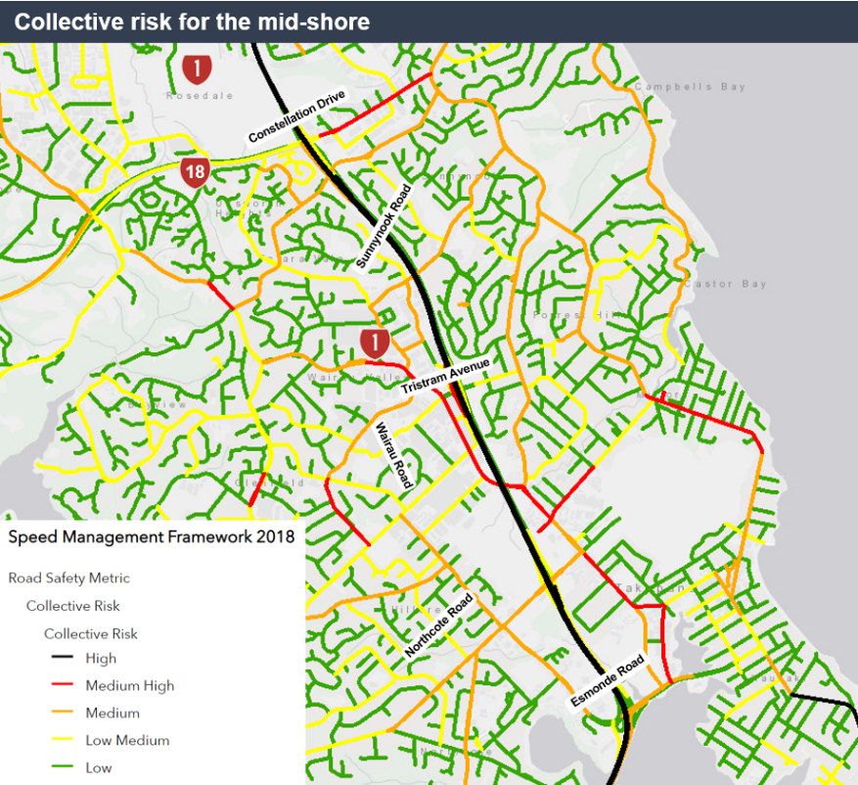
Figure 2 Collective risk for the mid-North Shore

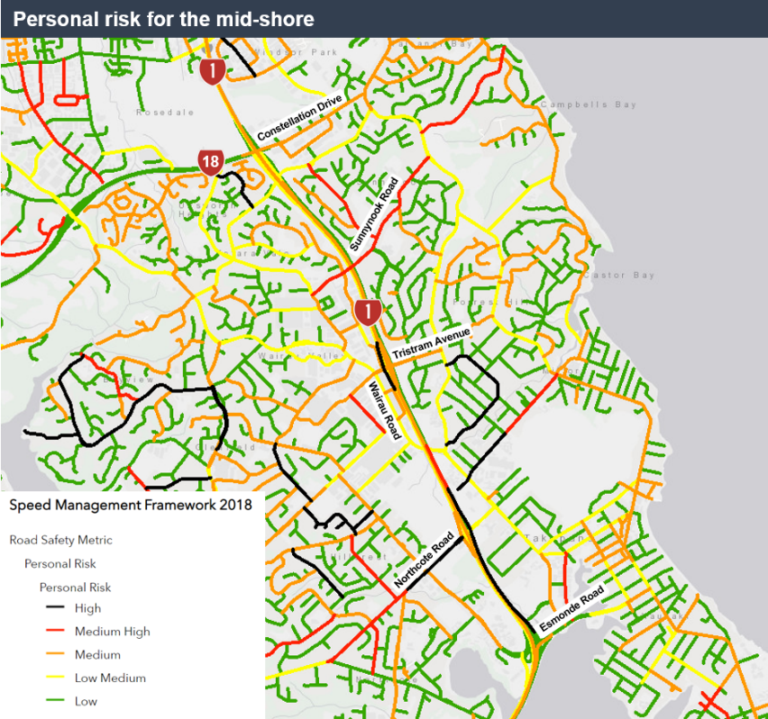
Figure 3 Personal risk ratings for the mid-North Shore
There are quite a few good examples of the physical and psychological barriers that keep people from choosing active modes as a good option for travel. The SH1 interchange with Tristram Avenue illustrates these barriers in the context of this project (see Figure 4 and 5).
The active mode facilities provided here are not suitable for most people’s abilities. It takes 5-10 minutes to cross through the interchange from west to east, only 300m. The main issues here are:
- Narrow footpaths (nominally 1-1.2m wide)
- No footpaths on the south side of the interchange
- Missing pedestrian crossing legs
- No off-street cycling facilities
- No on-street cycling facilities
- Poor pedestrian phasing at the signalised intersection
- Poor wayfinding
- An uncontrolled left turn lane from the southbound off ramp.

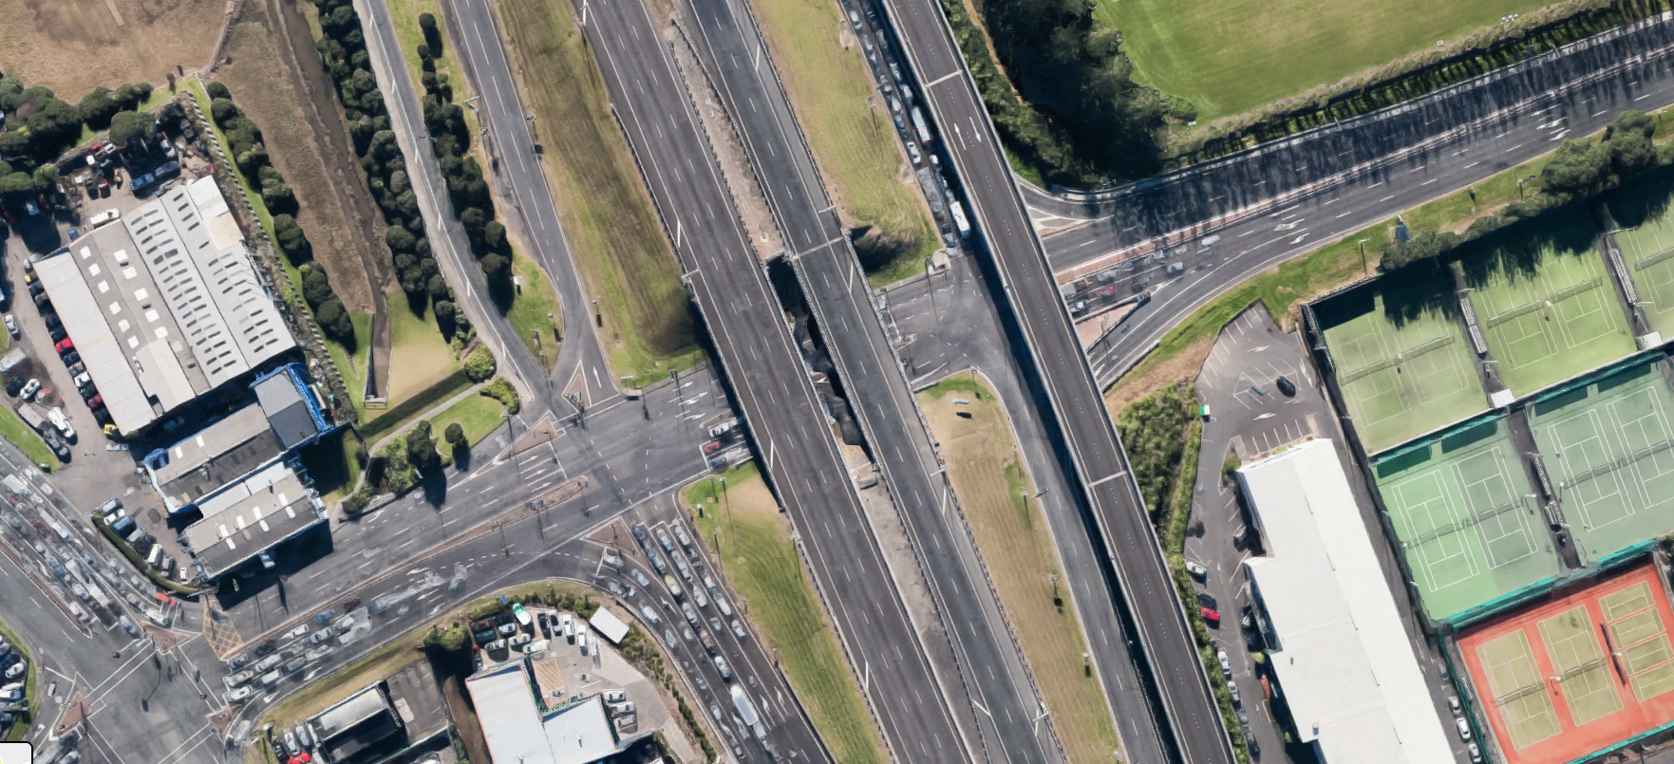
Figure 4 SH1/Tristram Avenue interchange
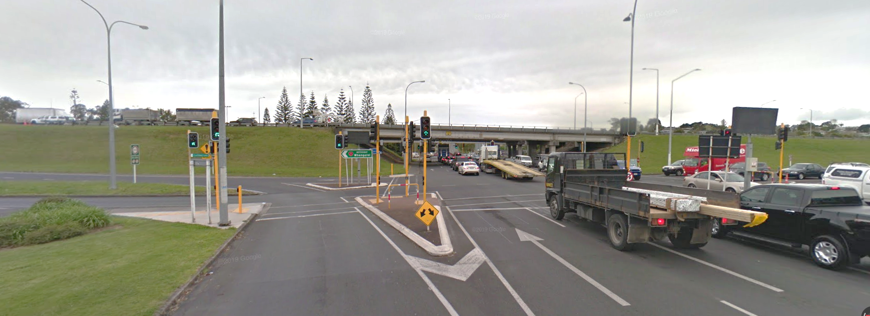
Figure 5 The view from Wairau Road towards the SH1/Tristram Avenue Interchange

Potential use of Northern Pathway
There are currently relatively few cycling trips on the existing north-south corridors within the area of the proposed Northern Pathway, with for example (Gravitas, 2015)
- 290 to 360 daily cyclists on Taharoto Road
- 120 to 220 on East Coast Road
- 50 to 110 on Glenfield Road.
Auckland’s existing Northwestern Cycleway presents itself as a ready comparison for the proposed Northern Pathway. Both facilities share a number of similarities, including:
- Comparable lengths, with the Northwestern Cycleway extending 19 km from the city centre, and the proposed Northern Pathway extending approximately 18 km
- Both crossing major bodies of water – the 2.5 km long SH16 causeway and the 1.3 km Auckland Harbour Bridge, respectively
- Both serving major Metropolitan Centres at their extremity – Westgate and Albany, respectively
- Both serving tertiary education facilities – Unitec Mt Albert and AUT Akoranga, respectively
- Both serving significant areas of employment – Lincoln Road and Rosebank Road in the case of the Northwestern Cycleway, and Rosedale Road, Wairau Road, Smales Farm, North Shore Hospital and Takapuna in the case of the proposed Northern Pathway.
The North Shore has better public transport services than Auckland’s northwest, but conversely a significant portion of the North-western Cycleway’s catchment is harbour and estuary, while the catchment of a future Akoranga to Constellation route would be entirely urban area. As a result, the comparison to the Northwestern Cycleway is valid at a high level only.
As a point of reference, the Northwestern Cycleway currently carries between 730 and 1,030 daily cyclists. In terms of cycle to work mode shares, the following were recorded for the North Shore’s Local Board areas:
- 0.6% for Hibiscus and Bays
- 0.7% for Kaipatiki
- 1.0% for Upper Harbour
- 2.1% for Devonport-Takapuna
- 1.0% for the North Shore on average.

These mode shares are relatively low when compared to central Auckland Local Boards, including 2.8% for Albert-Eden, 2.3% for Waitemata and 2.1% for Orakei. Higher mode shares were recorded at the smaller, Census Area Unit level, with 4% or more recorded in areas of Pt Chevalier, Grey Lynn, Mt Eden, Devonport and Takapuna.
The above mode shares are even lower when viewed against other New Zealand cities, such as Christchurch’s 6-7% and Nelson’s 9%. In research carried out for Auckland Transport (TRA, 2018), 59% of Aucklanders stated that they would be willing to cycle if conditions were improved. This suggests that higher mode shares than those recorded above are possible if suitable cycling infrastructure is provided.
In terms of the cycle to school mode shares, on average a 2% mode share was recorded across 20 local schools within the project area, with a high of 10% recorded in the case of Takapuna Normal Intermediate. While this is consistent with the Auckland regional average, it is low when compared to the potential at other Auckland schools, which range up to 30%.
To a large degree, these relatively low existing cycle volumes are the result of a lack of safe and attractive cycle infrastructure on these corridors and on connecting routes
Short trip origins and destinations
Figure 6 illustrates the predicted origins and destinations of short motorised trips, from the regional transport model. The major employment destinations such as Smales Farm, Takapuna, Wairau Valley and the North Harbour Business Area are prominent in this map, each being the focal point of large numbers of short trips. Major education centres such as AUT Akoranga, Westlake Girls/Boys High Schools, Takapuna Grammar and a cluster of schools within Northcote are also prominent. These concentrations of trip ends will tend to be destinations in the morning peak. The origins of these trips will tend to be the dispersed residential areas around them, shown in the map by the lighter blue circles.
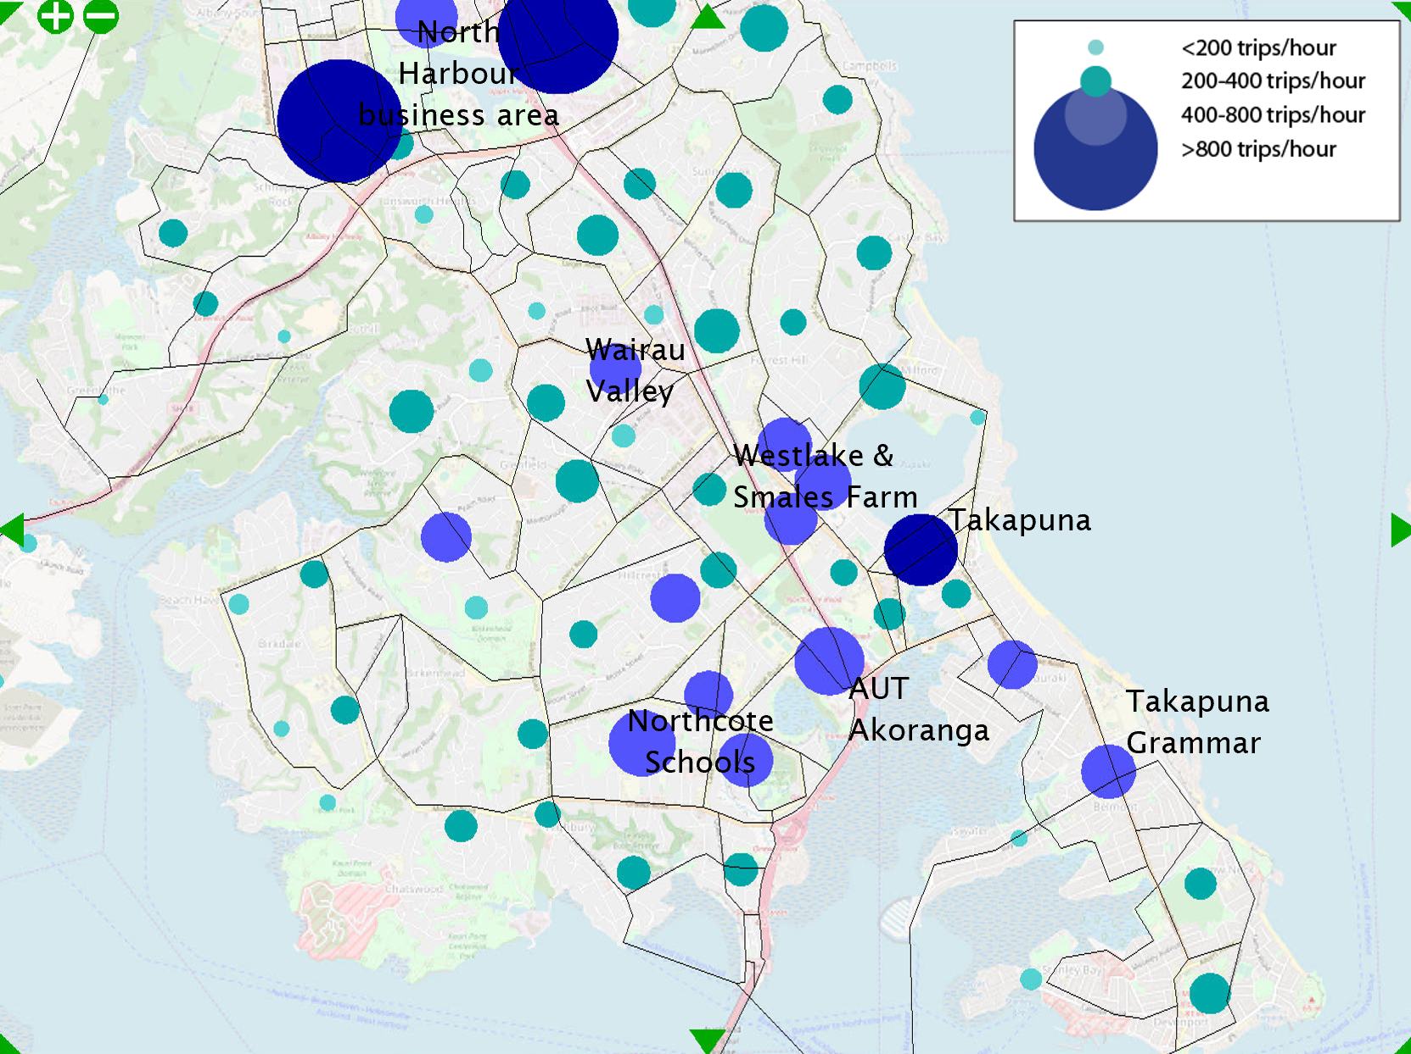
Figure 6 Origins and destinations of short car/PT trips to work/school, 2028 am
Routes used by short trips
Figure 7 illustrates the routes that the above short motorised trips are predicted to take, based on a simple arterial and collector road network. This map illustrates that a significant volume of these short trips would use arterial roads such as Taharoto Road, Northcote Road, Wairau Road and Glenfield Road. Some short trips would also use the Northern Motorway, as well as its interchanges at Constellation Drive, Tristram Avenue, Northcote Road and Esmonde Road. Each of these arterial roads operates with congested conditions during peak commuter periods.
Should safe and attractive cycle infrastructure be provided within the mid-North Shore, some of these short, motorised trips can be expected to change mode to cycling, reducing the traffic demands and congestion on those corridors. This map demonstrates the potential value in providing safe walking and cycling infrastructure that encourages car and public transport users to change mode.
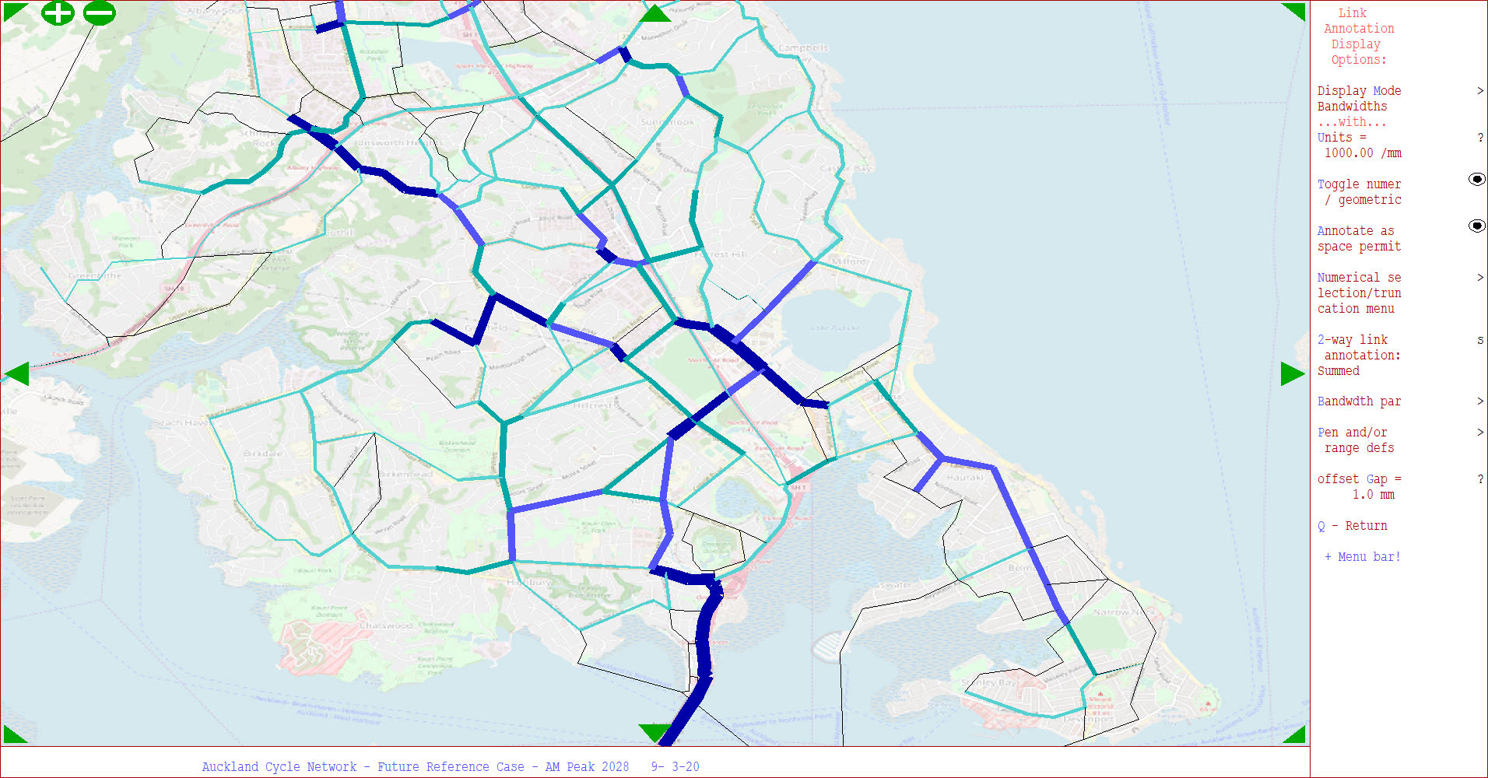
Figure 7 Short car/PT trips to work/school, 2028 Weekday Morning Peak
Longer trips to key activity centres
Beyond the immediate project area, Auckland’s city centre lies to the south across the Auckland Harbour Bridge. On completion of the Northern Pathway Westhaven to Akoranga, destinations within the city centre will be an approximately 7-9 km cycle from Akoranga Drive, and 13-15 km from Constellation Drive.
These distances are longer than the average existing Auckland cycle commute to work trip, which is approximately 6 km long. These distances are nonetheless cyclable for some users, and we note that:
- The distribution of existing cycle to work trips within Auckland has a very long “tail”, in that while the average trip is approximately 6 km, there are a significant number of relatively long trips. Approximately 20% of these trips are 9 km or longer, and approximately 10% are 12 km or longer.
- The existing Northwestern Cycleway extends 18-20 km from Westgate to destinations within the city centre. This facility is already used by a significant number of longer distance commuters, with 730 daily cyclists recorded at Te Atatu (11-13 km to destinations within the city centre) and 1,030 daily cyclists at Kingsland (1.5-3.5 km to destinations within the city centre). The Te Atatu count site, in particular, is a comparable distance to city centre destinations as Sunnynook Road, which hints at the potential for longer distance cycle commutes on the Northern Pathway.
- We further note that immediately east of Te Atatu, the Northwestern Cycleway crosses a causeway that ensures there are very few intermediate destinations accessed within the next 5 km toward the city centre. As a result, the majority of the 730 existing daily cyclists recorded at this location are expected to continue eastward more than 5 km to destinations within Auckland’s inner west and city centre.
- The existing average Auckland cycle to work trip length of 6 km is based on 2013 data, when few users owned e-bikes. The available international research on the effects of e-bikes on cycle commute trip lengths concludes that e-bikes allow people to travel 50-100% further than they would by traditional bikes (Cairns et al 2017). This suggests that the average Auckland e-bike commute to work trip may potentially be 9 to 12 km.
Each of the above suggests that while the Northern Pathway is expected to predominantly facilitate local trips within the North Shore, it is also expected to have a secondary role as a viable commuter route for trips to destinations within the city centre and inner west.
Ultimately, the number of cyclists on the Akoranga to Constellation section of Northern Pathway will depend on a number of factors, including:
- The standard of infrastructure on the facility, and the form of major road crossings
- The location of access points to the facility, and any future connecting cycle infrastructure
- The location along the route being considered, with generally fewer cyclists anticipated at the northern end, and more at the southern end and close to key destinations at Smales Farm
At the time of writing each of the above were yet to be fully resolved. However early modelling results suggest Akoranga to Constellation may be used by between 700 and 1,500 daily cyclists in 2028. This would make the northern end of the Northern Pathway comparable to western sections of the Northwestern Cycleway, but southern sections of the former somewhat busier than central sections of the latter.

Preferred Alignment
While both sides of the motorway provide clear community benefits, our preferred route follows the western side of the motorway from where it connects with the Westhaven to Akoranga section, crossing around Sunset Road, to connect with the Constellation Drive to Albany section.
We arrived at this decision through various technical workshops, presentations, evaluation and analysis of short list and long list options with mana whenua, project partners, key stakeholders as well as consideration of the public feedback discussed earlier in the paper.
Through this systematic and considered process, we found that the western segments will deliver a community resource that provides the following advantages for users:
- More direct with fewer road crossings
- Less potential impact on property and the environment
- Safer through avoiding potential conflict for space around the public transport hubs
- More cost effective to implement as there is more space which is not obstructed by dense residential and commercial areas.
At this stage, the project team has several areas to investigate before completing the business case, including:
- Refining the preferred option including investigating mitigation opportunities (such as boardwalks or elevated platforms) where the path will pass Smiths Bush
- East-west connections including integration with existing cycleways and pathways, and entry and exit points
- Street level connections at key intersections as well as grade separated (underpass or overpass) crossings
- Opportunities for urban design and places of interpretation.

Conclusions
- Auckland is growing rapidly with the North Shore specifically seeing significant spatial and population growth. The existing transport network is under pressure and more sustainable travel options need to be promoted and supported going forward to manage the demand for growth.
- Once the Akoranga to Constellation Drive project was identified for further development through the business case process, a clear communications and engagement process was followed to involve project partners, key stakeholders, and the public. This has not only made it a very collaborative process, but it has also made it possible to progress a very robust business case through the recent challenging COVID-19 restrictions.
- Potential for modal shift and active mode up take
  - The early project analysis indicates that the introduction of safe and attractive cycle infrastructure within the mid-North Shore could lead to some short, motorised vehicle trips switching mode to walking or cycling. This would lead to a reduction in the traffic demands and congestion in this area.
  - The Northern Pathway, once completed, will provide a seamless dedicated walking and cycling link between Auckland’s City Centre and Albany on the North Shore which would make it a viable commuter route for trips from the North Shore suburbs to destinations in the city centre and surrounds.

Acknowledgements
We would like to acknowledge our project partners and various key stakeholders who have been involved during the development of the business case.

References
Gravitas, 2015. 2015 Auckland Region Manual Cycle Monitor – North Shore Ward, Gravitas Research and Strategy Limited, Auckland.

Northern Pathway Akoranga to Constellation Drive: Have your say. May 2020. Waka Kotahi NZ Transport Agency, retrieved from <https://www.nzta.govt.nz/assets/projects/northern-pathway/docs/northern-pathway-akoranga-to-constellation-drive-engagement-brochure.pdf>

TRA, 2018. Measuring and growing active modes of transport in Auckland, Auckland Transport, Auckland

S. Cairns et al, 2017. Electrically-assisted bikes: Potential impacts on travel behaviour. Transportation Research Part A: Policy and Practice Volume 103.

Declaration of competing interests
The author(s) declare(s) no competing financial interests.

Auckland Transport automated cycle count data, Te Atatu and Kingsland count sites, 2019 calendar year
2013 Census data analysis
Auckland Transport 2017 Travelwise data
Pasadena and Belmont Intermediates
Short trips have been defined as commute to work trips 6 km or less, and school trips 3 km or less
The Macro Strategic Model, MSM
2013 Census data analysis

