TRANSPORTATION 2022 CONFERENCE

SHOULD APPLE DESIGN OUR STREETS FOR PEOPLE?

This paper has been peer reviewed

Gemma Dioni, BSc(Hons), MSc, MEngNZ – Presenter -
Senior Transportation Engineer, Christchurch City Council gemma.dioni@ccc.govt.nz

ABSTRACT
“Built-in features designed for you to make something wonderful”, Apple.

Tech giant Apple simply takes an existing concept (computers, phones, music players) and makes it user-friendly. Their accessibility design guidelines promote the belief that everyone should have a great user experience, and that;
“Accessibility is not just about making information available to users with disabilities — it’s about making information available to everyone, regardless of their capabilities or situation. Designing with accessibility in mind means prioritizing simplicity and perceivability and examining every design decision to ensure that it doesn’t exclude users who have different abilities or interact with their devices in different ways.”

If this formula, which has worked pretty well for Apple, was applied to our public spaces and in particular our streets, would they not be more successful for people regardless of their capabilities, and be available to the widest audience?

If everyone is so interested in the latest apple device, why are we as transport planners and designers not giving people a great user experience by promoting devices that are safe, obvious and step-free? When Abbey Road was released in 1969, the zebra crossing became a star feature in the most famous images in music history. If Apple can make an iPod to make it easy to listen to the Beatles, why not take a zebra and simply raise it to make it safer to cross the street?

If devices like raised priority crossings democratise our street space, help us to create walkable neighbourhoods, enable us to live locally, improve accessibility to opportunities, and allow people to engage in their communities for their social well-being, why are we not seeing more of them?

This think piece explores the potential of raised priority crossings from a point of user experience and the barriers to installing such devices in Aotearoa New Zealand.

INTRODUCTION
Empathy was the first of three key ideas in the original one page “Apple Marketing Philosophy” back in 1977, with the subtext of truly understanding and serving the customer unlike anyone else. Simplicity and accessibility were design focal points of Steve Jobs, “design isn’t just what it looks like and feels like — design is how it works.” This ensured that the product was intuitive enough for anyone to be able to use it, with a focus on simplicity, ease of use and consumer experience. Jobs also believed that good design was a key component of evolution, and was quoted saying, “I think that’s where we should focus more today; how does the design I work on today affect the bigger picture?” This marketing and design philosophy has made Apple market leaders for technology devices. Fans form queues on days leading up to product releases, sales have boomed even through the COVID-19 pandemic, and designs have fundamentally changed the way we listen to music, tell the time, or enable connection with others anytime and anywhere. This guiding philosophy of Apple has been highly successful.

Apple’s Accessibility Human Interface Guidelines state:
“Approximately one in seven people worldwide have a disability that affects the way they interact with the world and their devices. People can experience disabilities at any age, for any duration, and at varying levels of severity. Situational disabilities — such as a wrist injury from a fall or voice loss from overuse — can affect the way almost everyone interacts with their devices at various times.”
They recommend that for an application to be inclusive and accessible to everyone, the four main categories of disabilities (vision, hearing, physical and motor, and literacy and learning) need to be addressed, so the features that can make it individual are built in are for the customer to make something wonderful as per the Accessibility Guidelines (Figure 1)


Figure 1: Basic principle of Apple’s Accessibility Guidance (Apple, 2021)

But do we take the same approach as designers of streets? Do we empathise with our customers, and really take the time to understand them? If we were to take this approach of simplicity, accessibility, and inclusivity, would our streets be more successful for the customer that walks?

This however brings the question, who is our customer? Walking is a basic human activity, whether it forms an individual’s transport mode or is included as part of other trips using other modes. The new Pedestrian Network Guidance (2021) recognises that,
“walking is the glue that holds together the transport system, connecting all the different modes and places within it.”
Our customers, being humans, are diverse in both physical and mental states. This requires people planning and designing streets and spaces to understand that every human is unique and has different characteristics which can change over time or with situational disabilities.

This think piece will explore the potential of raised priority crossings as a device for our customers and the barriers to installing such devices in Aotearoa New Zealand. It is acknowledged early that there are limitations of the Apple metaphor, but it still supports points made through the paper.

PEDESTRIAN CROSSINGS
‘Safe, Obvious and Step-free’ choices was the design thinking of Burdett (2021) for creating inclusive environments with a human-centred approach for universal access. Outlined in the Pedestrian Network Guidance, but summarised in short, pedestrians should be safe from harm and feel safe and comfortable in an environment. Routes and wayfinding should be clear for all people, and step-free route choices should be available.

One device that is available to street designers to help create safer, step-free, and obvious streets is raised zebra crossings. A zebra crossing is a formal pedestrian crossing where people walking take priority over vehicles when crossing the road. A raised zebra crossing is usually at the same height as the kerb and therefore provides a step-free and level journey for people on foot or using an aid. This also helps to reduce the speed of vehicles making the crossing safer. An example is shown in Figure 2.

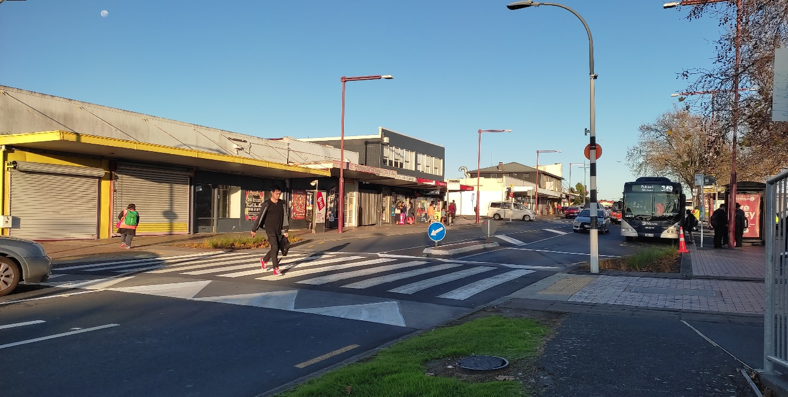
Figure 2: Raised zebra crossing outside Papatoetoe Station (Tāmaki Makaurau, Auckland).

This paper will refer to zebra crossings as white painted bars on a black surface as shown in Figure 3.

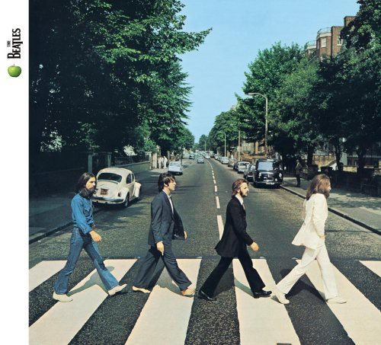
Figure 3: The most well-known traditional at-grade zebra crossing for rock star pedestrians (courtesy of Real Groovy).
While recent initiatives seek to use bright colours on the roadway as part of placemaking projects, these can be detrimental to the journeys by those with low vision or people who are neurodivergent or neurodegenerative. A recent letter to the Mayor of London (2021) from a coalition of charities stated that;

“The Asphalt Art Project demonstrates exactly what happens when meaningful engagement does not take place: it sadly results in schemes that are neither accessible nor inclusive.”

The impact of this is significant. Not only does it result in a pedestrian not crossing the street due to anxiety or hesitation but;

“given the safety and accessibility implications, many disabled people will avoid the crossings and so will be persuaded away from these spaces altogether. Avoiding public space can lead to individuals becoming cut off from their communities and facing even greater loneliness and isolation.”

On the other hand, the black and white lines of a road surface at a zebra crossing are familiar to the majority of people. Use of the application shown in Figure 4 gives consistency, and therefore clarity to a wide range of users.

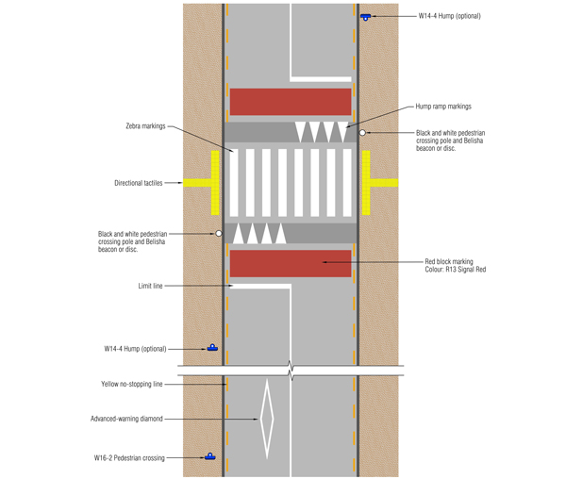
Figure 4: Standard raised zebra crossing design from the Pedestrian Network Guidance (PNG).

There are over 30 different features of an iPhone 13 specifically to make it more accessible to customers and respond to everyone’s needs. In May 2021, Apple announced that powerful software features designed for people with mobility, vision, hearing, and cognitive disabilities would be rolled out within months. This was to showcase Apple’s belief that accessibility is a human right and an integral part of design.

In September 2021, raised mid-block crossings were confirmed as a primary safe system intervention by Waka Kotahi New Zealand Transport Agency. This means that if the crossing meets the criteria set out in the Standard Safety Intervention Toolkit, it is eligible for funding though the streamlined investment pathway. The two main criteria for implementation are:
- Is there is a need for a priority pedestrian crossing?
- Is there evidence of pedestrian related crashes or near misses?

The PNG highlights the following potential negative implications of raised zebra crossings:
- High pedestrian flows can dominate and cause traffic delays.
- Can create discomfort for vehicle occupants travelling over platforms if not well designed (particularly bus passengers).
- May increase noise as vehicles brake, slow, pass over them, and then accelerate (particularly heavy vehicles).

A safe, obvious and step-free device is currently available and now endorsed by Waka Kotahi. This can attract funding and enable implementation, so what is stopping a street device designed for people including those with mobility, vision, hearing, and cognitive disabilities from being delivered at a larger scale?

Are these potential negative implications to vehicle traffic stated above, stopping designers from affording priority to people crossing the road? If, as Steve Jobs said, the designs we work on today affect the bigger picture, should these disadvantages or the lack of evidence for pedestrian related crashes even matter? The status quo requires a crash history to justify a road safety intervention, but we should consider a proactive safe system design approach if we want to achieve the shift in focus to inclusive, walkable, and liveable streets and cities.

As planners and designers, would we be more successful if we asked why more often? According to Sinek (2010), all great aspiring leaders and organisations in the world all think, act and communicate the same way. Why? How? What? Apple believes in thinking differently and challenging the status quo. If we don’t know why we do what we do, or are driven by a different purpose or belief, how do we enable innovation and acceptance of change in our transport system to provide better outcomes for our customers?

INDUSTRY SURVEY
An online survey was completed in November 2021 to understand current thinking about the implementation of raised zebra crossings by people who plan and design crossings in Aotearoa New Zealand. The survey was sent out through an e-mail to the Transportation Group members. There were 128 responses to the survey, comprising of planners and designers, decision makers and those who identify as both as shown in Figure 5.

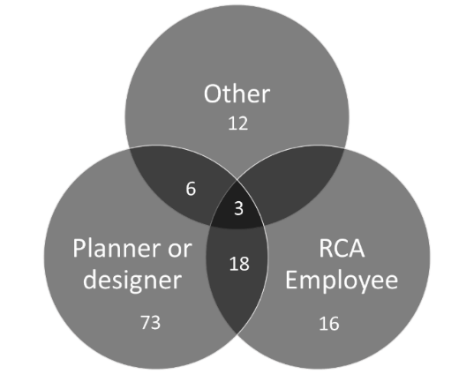
Figure 5: Background of survey respondents (number of respondents in circles).

The outcomes of survey questions are discussed below. It should be noted that in the responses there is reference to warrants for justification of crossing types such as signals and zebra crossings. These could originally be found in the Guide to Pedestrian Crossing Facilities (2001) document, which stated, in relation to zebra crossings:
“Many authorities in New Zealand make use of Austroads standard AS 1742.10, in which the following criteria should be met: Pedestrian flows > 60 per hour, vehicle flows > 600 per hour, and the product of the two > 90,000”.

This warrant became redundant in 2008 with the release of the Pedestrian Planning Design Guide. Current guidance is set out in the Pedestrian Network Guidance (2021).

There is also reference to the safety deficiencies of at-grade zebra crossings. As stated by Huard (2021) these deficiencies have been well researched, but also have conflicting outcomes:
“Herms (1972) and Elvik (2000) both concluded that zebra crossings may give pedestrians a “false sense of security” and reduce their vigilance, whereas Redmon (2003) found that pedestrians generally do not expect drivers to stop for them and so are more vigilant, and are therefore unlikely to assert their priority given the safety risks. The safety deficiencies of zebra crossings are also recognised in the New Zealand Pedestrian Planning and Design Guide (NZ Transport Agency, 2009 – table 6.4), which cites that zebra crossings with no additional physical aid (such as a kerb extension or refuge) have a -28% crash reduction benefit; that is, installing a zebra crossing on its own has been shown to increase the risk of a pedestrian crash.”

The research completed by Huard concluded that there are clearly affordable improvements that could be implemented and may provide safety benefits. Raising the crossing onto a table is an effective means of slowing vehicles to 30 km/h or less. Slow speeds are essential in contributing to pedestrian safety. The Standard Safety Intervention toolkit states that the assumed death and serious injury (DSi) reductions for midblock raised pedestrian crossings are:
  - 40% reduction in casualty crashes & 45% reduction in vehicle-pedestrian crashes: Austroad’s AP-T330-17 'Safe System infrastructure on mixed use arterials'.
  - 50% reduction in fatal and serious (interpolated based on reducing impact speed from 60km/h to 40km/h): Source: Jurewicz et al. (2016) based on Bahouth et al. (2014), Davis (2001).

Being able to cross the road/street is fundamental in creating walkable neighbourhoods and community centres for all. The first question in the survey sought to understand the types of crossings being installed on streets by people planning and designing infrastructure, which are summarised in Figure 6.

Figure 6: Previous crossing designs used.

It was promising to see that raised priority crossings are being selected for implementation and that flush priority zebra crossings were chosen the least. In hindsight, it would have been useful to have asked in which locality the respondents were planning or designing. This would have helped to understand if differences across New Zealand exist. From a safe system perspective, it would be great to see the number of raised signalised crossings increasing and replace flush signalised crossings as the preferred option for that crossing type. Other crossing types included dual crossings and school crossings.

Respondents then provided some insight as to why the raised zebra crossing option was chosen:
- Safest option for a pedestrian crossing to ensure low speeds.
- Because it was an urban environment where pedestrians are meant to be prioritised. Continuous- at-grade facilities for the pedestrians indicates priority to the pedestrians.
- Provided an additional level of safety including the benefit of reducing vehicle speeds on busy road.
- It was associated with a Danish style roundabout which was being installed to slow traffic and improve a poor crash record.
- Raised format keeps the paint above the water. - far more visible.
- It was the appropriate safe and efficient facility for all modes within the public road reserve.
- Part of the client’s objective was to improve accessibility for local residents and visitors across a relatively busy road.
- Seemed the safest option - as cars have to stop and by being raised it slows cars. It was the most preferred by the disability community in Hamilton.

There was a general theme throughout the responses of prioritising people, improving accessibility and safety as key decisions by the planners and designers. The following are insights from people who chose other options for the crossings (excluding raised signal crossings):
- Greater intervention was not needed.
- Financial constraints/limited budget/budget availability.
- With busy roads, a priority crossing is pretty much the same as no crossing. It excludes all but the most athletic of pedestrians.
- It was appropriate for the situation and doesn't give people a false sense of security
- Client driven/determined by RCA.
- Was a heavy vehicle route.
- Raised option not being appropriate due to the strategic nature of the corridor in terms of traffic volumes and mix of heavy vehicles.
- Multiple lanes to cross. Considering it was an arterial with a bus lane, I sadly did not feel a raised signalised crossing would have been accepted by authorities.
- Most appropriate form of crossing in that particular situation, which was on a local but fairly busy road with a moderately high pedestrian demand.
- Expected future usage will not be high enough to meet existing warrant for controlled crossing. I recognise North American minimum pedestrian crossing volumes to warrant controlled crossings are far lower than in NZ so if you were to put some credentialed research into lower thresholds, it would be helpful!
- Appropriate to the level of activity and the need to manage stormwater flow paths.

It was positive to see that respondents have been recommending raised zebra crossing in designs as shown in Figure 7. The most prominent locations for recommendation were identified as central city locations, neighbourhood shopping areas, mixed use areas, close to schools, side road entry and left turn slip lanes. Those that indicated they had not been recommending raised zebra crossings, provided the following justification:
- Inconvenience for motorists.
- Usually, a raised courtesy crossing is sufficient. It inherently has both parties active / involved in considering safety. A courtesy crossing is also more flexible.
- Zebra crossing high perceived safety but low actual safety benefits.
- Zebras can be less safe as peds think they are safer when they are not.
- Generally, our crossings do not have the volumes - ped and/or vehicles to warrant a pedestrian crossing using the Waka Kotahi guidance.

As previously stated, warrants for crossings have not existed in New Zealand for over 12 years.

Figure 7: Respondents have been recommending raised zebra crossings.

Figure 8 identifies the reasons why respondents would not recommend a raised zebra crossing for a mid-block crossing location.

Figure 8: Response to why raised zebra crossings were not being recommended.

Whilst stormwater was only mentioned twice specifically in Question 4, in Question 5 (Do you have any other insights/thoughts on delivering raised zebra crossings on our streets?) it was raised a further nine times.

Other concerns or issues raised when asked for further insights/thoughts included:
- Reiterating - zebras not safer - are you trying to fix a zebra safety issue by putting it on a Raised Safety Platform?
- The ramp grades and thickness of the raised platform need to be carefully monitored otherwise you end up with ramps that are too steep or too shallow.
- The concerns about vibration and noise are well covered from international research, and unless there are high volumes of unladen trucks they are unlikely to result in any measurable change to residents.
- Waka Kotahi's draft P40 Noise Mitigation Specification is recommending that vertical deflection devices should not be used within 200m of residential properties. That may change as a result of consultation, but noise remains an issue.
- Raised zebra crossings on arterial roads can cause disruption to traffic. On arterial roads due to high volumes of traffic, could contribute to emissions due to braking and accelerating.
- Evidence of noise and vibration created by the table, how bad it is? Any affecting on climate change?
- For each speed table on an arterial road potentially thousands of drivers must slow down and then speed up which uses more fuel and creates additional carbon emissions.
- Funding, or lack thereof, remains a key challenge.

In summary, most of the concerns around the use of raised zebra crossings include noise and vibration, drainage and stormwater mitigation, disruption to traffic, or traffic stopping and starting, creating additional carbon emissions and funding availability to build the raised platform.

Other suggestions identified by respondents when asked for further insights/thoughts include:
- Great accessibility for all users, especially people in wheelchairs or mobility impaired.
- Could be more semantically helpful to frame these as 'continuous footpath crossings'.
- It is great to have another tool in the toolbox which is becoming increasingly more accepted.
- They should be used instead of the current trend of courtesy crossings.
- These types of installations are vital to create walkable urban places.
- A raised zebra crossing would be a good solution as it clearly defines the priority.
- These should be standard across all legs of all non-signalised intersections.
- Can they be installed more efficiently, (level platform that fits across standard K&C profile) to avoid the need to dig up the existing K&C to provide a seamless and accessible crossing?
- Make them mandatory. Given their impact on stormwater flow paths, any maintenance work that impacts the stormwater network should look for opportunity to install a platform at the same time.
- Some projects now as-of-right include raised tables at side streets, but these are often confused for raised zebra crossings, so we can confuse drivers/motorists by having similar treatments for both crossings and non-crossings. Clearer guidance on how to best design each would help.
- As well as providing a safer environment for crossing users they can be part of a wider slower streets programme, eg to control speed through a CBD.
- NZ needs published research or standards recommending lower minimum crossing volumes so that we (RCAs) can implement them. North American commonplace standards now require minimum of 20 +/- per hour with vulnerable users counting for more.

The responses that are more positive or include suggestions regarding increased ease of implementation are focussed on providing for the user and enabling more of these crossing types to be introduced. It is fair to point out that a signalised crossing (raised or not) may likely be a more appropriate solution for a site than a raised zebra.

DISCUSSION
There appears to be two schools of thoughts on the implementation of raised zebra crossings. Those that are in support of this device associate this crossing type with accessibility, people priority, placemaking and safe systems.

On the other hand, those that they may not support the device as much, identify issues unrelated to the walking customer, but rather focused on the negative effects on vehicles and driver delay, perceived impact on emissions, and the perceived and actual safety benefits. It is acknowledged that some of the survey responses reflect some valid practical issues in making raised crossings work in some locations (such as drainage), but they are generally not insurmountable.

Noise and vibration should not be easily overlooked due to stress and anxiety they can cause, particular if a resident close by is sensitive to heightened sound. This can be a complex issue to resolve but it does requires further testing of the device and the environments in which they are promoted. If housing is provided on local streets, the scenario of heavy trucks using this street should be tested and could potentially be remedied with heavy vehicle restrictions (essential and emergency services excluded). Housing on busier roads and the roads themselves (given the levels and mix of traffic they intend to carry) should be constructed to mitigate noise and vibrations. Thus, the potential for these impacts should already be minimised, and the anxiety around this could be further addressed through further understanding of ground conditions, improved standards of road construction, and to home building practices.

It would be interesting to understand how much product testing occurs between engineers who are responsible for designs and the construction industry who implement the designs. Is there more testing required before designs go to market? Getting the design right is important, but installing a quality produce that matches the design is just as important. Do the design and construction industries work as seamlessly as Apple? Acting in the best interests of the product, delivering it to the market in the right way and at the right cost?

If noise and vibration concerns could be designed and constructed out of the implementation of raised platforms, could the same be achieved with drainage and stormwater? People crossing the road should not be getting wet feet, or having to detour to other crossing locations due to ponding of water at the crossing. When weighing up the costs and benefits of a raised zebra crossing (safe system solution to reduce death or serious injury) does the extra costs of piping and drainage pits really cost that much? The Ministry of Transport (2020) states, “to ensure we target our road safety resources most effectively, the cost of any safety interventions should be evaluated against the resulting benefit expressed in terms of social cost.” The average social cost per fatality is $4,464,500, $839,000 per reported serious injury and $79,000 per reported minor injury. Using current rates, four double sumps and two lots of 20 metres of piping is still likely to be under $50,000. The greater costs appear to be managing overland flow paths. As a system, would changes to our building codes and better management of the overall stormwater system facilitate better outcomes for our streets in terms of safety?

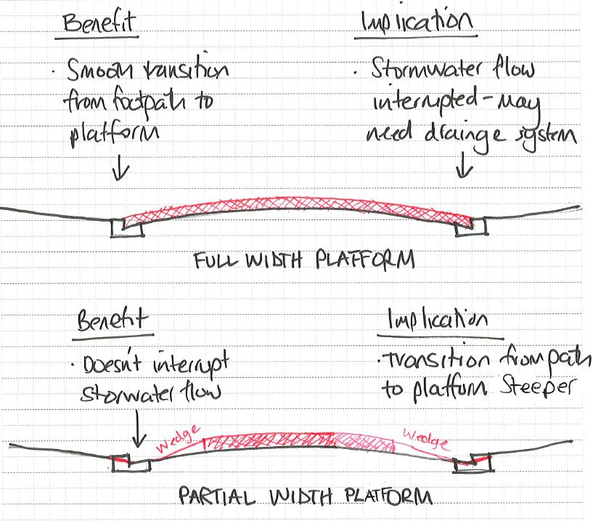
Figure 9: Balancing the movement of people crossing and stormwater (courtesy of Jeanette Ward).

Understanding the emissions argument is still something to be grappled with. Speed calming devices are effective measures to regulate speed and improve safety. This theory has been widely tested, yet there appears to be less investigation into the higher number of acceleration or deceleration events and the impact on emissions. TRL (2001) suggest that emissions for a traffic calmed road employing speed humps were shown to be 2-3 times as high as a non-calmed road negotiated smoothly. This was supported by more recent work by Pérez-Sansalvador etal (2020) where the team identified a strong to middle influence of speed humps on the generation of CO2, NOx and PM emissions. The finding of their study concluding that for roads with a low number of vehicles, speed humps “highly increase CO2, NOx and PM emissions. The outputs however are also variable to a large number of external factors that may introduce variations on measurements such as driver’s behaviour, number of monitored vehicles, variability on vehicles types, weather conditions and road conditions”. It was also concluded, that when there is a high density of vehicles, the impact of speed humps on average velocity and traffic flow may be ignored because most of the vehicles are not moving due to congestion.

Yet, system wide, there is latent demand for travel by active modes to consider. More people would walk or cycle if the street environment were more suitable. Litman (1999), suggests that residents in neighbourhoods with suitable street environments tend to walk and bicycle more, ride transit more, and drive less than comparable households in other areas. By providing more walkable mixed-use neighbourhoods and using devices that prioritise people walking and crossing the road, more people may choose to walk and spend time in their community. This would by extension reduce the overall vehicle kilometres travelled, and coupled with changes in the vehicle fleet to more electric based vehicles, how long will the emissions argument continue to be as valid?

A common feature of Apple devices is consistency across their range. As raised by Transport for All (2021) in their letter to the Mayor of London, for blind and visually impaired people, consistency and predictability is fundamental to being able to navigate safely and independently. This shows the need for consistency in our streets. Reducing the variance in raised zebra crossing designs for our customers is just one aspect of this larger consistency effort.
To recommend application of a big picture philosophy like Apple’s, promoting inclusive, accessible and consistent design to encourage walking, a focus on addressing the above challenges is paramount. Understanding that our designs today affect the bigger picture and could enable change, could the challenges identified by respondents be minimised to enable more people to walk more often? The potential to approach street design like product or industrial design to achieve better outcomes should be considered. There are two product design processes that could be useful to the discussion.

Design thinking (Figure 10) is a human-centred approach to innovation that draws from the designer’s toolkit integrating the needs of people, possibilities of technology, and requirements for business success.
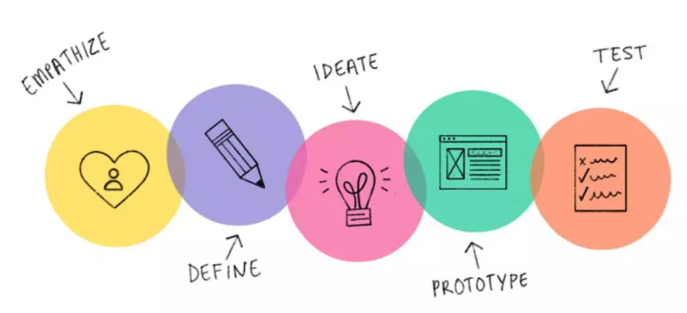
Figure 10: Design thinking approach to product design.

The Double Diamond Design Process (Figure 11), from the Design Council, captures the commonalities of creative processes across disciplines and divides it into four distinct phases: Discover, Define, Develop, Deliver. The two diamonds represent the process of exploring an issue more widely and deeply (divergent thinking), then taking focused action (convergent thinking).

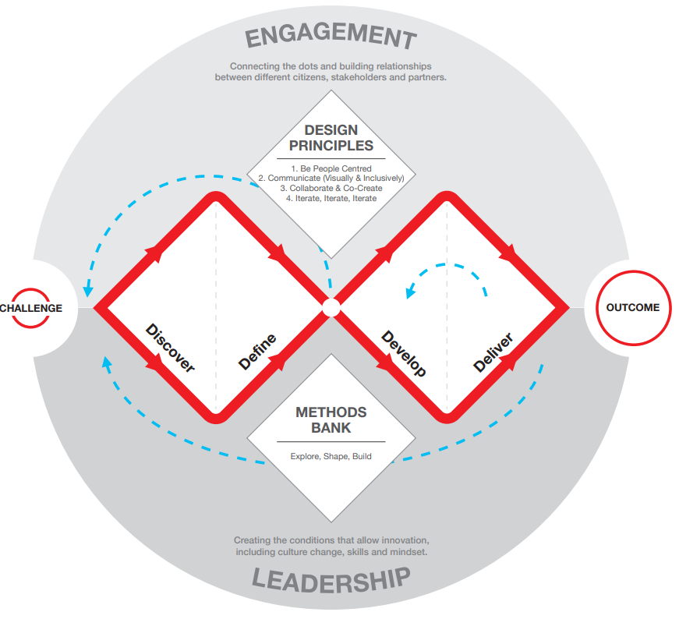
Figure 11: Double diamond approach to product design.

Both processes start with helping people understand, rather than assume, what the problem is and developing a deep understanding of people they are designing for. Only then can the users’ needs be thoroughly defined. In the transport design space, this part of the process is often missing. As designers we have a set of standards to adhere too, but sometimes there is a lack of observation at sites, a tendency to count vehicles not people, and more importantly not seeking out or discovering the people who are not visible to understand why they are not taking the trip. Only by bringing diversity to the table can we really understand the needs and wants of stakeholder communities.

A WAY FORWARD
When we understand the context of the site, and the ideal solution fits, the process continues through a standard design and build process. However, when we encounter issues that make it more difficult to implement, do we challenge ideas or identify innovative solutions?

Are we encumbered by fixed standards enforced by our pattern of thinking (repetitive or commonly accessed knowledge) or are we failing to continually develop our profession and capability in the sector? Are there more ways that we can prototype and test using research laboratories with our diverse customers? Can this aid in developing creative solutions that work for people?

“One of the things I’ve always found is that you’ve got to start with the customer experience and work backwards to the technology,” (Jobs, 1997). In his speech to Apple’s Worldwide Developer Conference, Jobs told the audience that you start with a simple question about the customer: “’What incredible benefits can we give to the customer? Where can we take the customer?’ Not starting with ‘let’s sit down with the engineers and figure out what awesome technology we have and then how are we going to market that?’“

Extensive market research and focus groups are heavily used in developing or launching new products and devices. Apple relies on customer knowledge and insight for continuous improvement. On purchasing a device from an Apple Store, customers will receive a request for feedback to rate their satisfaction level and the likelihood of using that service again. But how often do we ask the walking customer, which usually forms part of any trip, about their satisfaction of using a space or a device, particularly just after the transaction or use of a device is made?

Jobs stated that “It's really hard to design products by focus groups. A lot of times, people don’t know what they want until you show it to them.” Katie Dill, during her time as Lyft’s Vice President of Design, recommends that observing how people use products, rather than asking directly can help identify people’s reactions, “There are so many people that use our product that I can’t and should not assume what they want. We need to learn. We need to understand what life is like in the community to understand what they want, or what they’re gonna want in the future.”

Each street and user is unlikely to ever be the same. Jacobs (1992) likened streets to an “intricate ballet in which the individual dancers and ensembles all have distinctive parts which miraculously reinforce each other and compose an orderly whole. The ballet of the good city sidewalk never repeats itself from place to place, and in any once place is always replete with new improvisations.”
How often as planners and engineers do we take the time to sit and watch the ‘ballet’ or just simply how people use our products?

CONCLUSIONS & RECOMMENDATIONS
The above leads me to believe that if we approached street design using a product design approach, users could enjoy higher quality travel through devices that are more inclusive and accessible, such as the experience that Apple gives to their customers.

Whilst the analogy and use of a big technology brand like Apple may oversimplify street design approaches, Apple puts customers at the heart of their brand and generates devices that are inclusive and can be used by the widest audience. This has been achieved through simple, intuitive, consistent and user-friendly design.

It is recommended that as planners and designers we continue to question the why, dig deeper to understand our customers by asking and watching, and continue to build understanding in human-centred design. These efforts could be a game changer in the ongoing effort to improve our access and the enjoyment of neighbourhoods and communities.

REFERENCES
Allen, Frederik E, (2011). The Three Principles That Always Drove Apple viewed 6 November 2021, https://www.forbes.com/sites/frederickallen/2011/11/07/the-three-principles-that-always-drove-apple/?sh=3baae65714a3
Apple, (nd). Accessibility Human Interface Guidelines viewed 6 November 2021, https://www.apple.com/nz/accessibility/
Apple, (2021). Press Release - Apple previews powerful software updates designed for people with disabilities viewed on 6 November 2021, https://www.apple.com/nz/newsroom/2021/05/apple-previews-powerful-software-updates-designed-for-people-with-disabilities/
Burdett, B, (2021). Safe, Obvious, Step-free: principles for inclusive places, 2Walk&Cycle Conference, Ōtepoti, 18 March 2021
Design Council, (nd). What is the framework for innovation? Design Council's evolved Double Diamond viewed on 13 November 2021 https://www.designcouncil.org.uk/news-opinion/what-framework-innovation-design-councils-evolved-double-diamond
DevTeam.Space, (nd). How to Use the Design Thinking Process to Develop a Product viewed 13 November 2021 https://www.devteam.space/blog/how-to-use-the-design-thinking-process-to-develop-a-product/
Gadd, M.L, (2001). Guide to Pedestrian Crossing Facilities, Trafinz
Huard, K, (2021). Zebra crossings: A threatened species in New Zealand? 2Walk&Cycle Conf, 18 March 2021
Ideo, (nd). Design Thinking Resources viewed 14 November 2021 https://designthinking.ideo.com/resources
Jobs, S (1997, Apple’s Worldwide Developer Conference, viewed 27 January 2022, https://www.youtube.com/watch?v=yQ16_YxLbB8
Isaacson, W, (2012). How Steve Jobs’ Love of Simplicity Fuelled A Design Revolution viewed on 6 November 2021, https://www.smithsonianmag.com/arts-culture/how-steve-jobs-love-of-simplicity-fueled-a-design-revolution-23868877/
Jacobs, J (1992) The Death and Life of Great American Cities
Litman, T (1999). Traffic Calming Benefits, Costs and Equity Impacts viewed 8 January 2022, https://www.vtpi.org/calming.pdf
Ministry of Transport (2020) Social cost of road crashes and injuries 2020 update viewed 8 January, https://www.transport.govt.nz/assets/Uploads/Social-Cost-of-Road-Crashes-and-Injuries-2020_final.pdf
Pérez-Sansalvador, J.C.; Lakouari, N.; Garcia-Diaz, J.; Hernández, S.E.P. (2020) The Effect of Speed Humps on Instantaneous Traffic Emissions. Appl. Sci. 2020, 10, 1592
Smith, D (2019) What everyone gets wrong about this famous Steve Jobs quote, according to Lyft’s design boss viewed 20 January 2021 https://www.businessinsider.com.au/steve-jobs-quote-misunderstood-katie-dill-2019-4
Transport for All, (2021). Open letter to the Mayor of London, Safety and accessibility of the Asphalt Art Project viewed on 14 November 2021, https://www.transportforall.org.uk/campaign/colourful-crossings/
Transport Research Laboratory (2001), The Impact of Traffic Calming measures on vehicle exhaust emissions, TRL report 482, 2001
Waka Kotahi (2021). Pedestrian Network Guidance viewed 14 November 2021 https://www.nzta.govt.nz/walking-cycling-and-public-transport/walking/walking-standards-and-guidelines/pedestrian-network-guidance/planning/pedestrian-planning-principles/
Waka Kotahi (2021). Standard safety intervention toolkit Streamlined investment pathway viewed on 14 November 2021 https://www.nzta.govt.nz/assets/resources/standard-safety-intervention-toolkit/standard-safety-intervention-toolkit.pdf
Walker, R, (2003). The Guts of a New Machine viewed on 6 November 2021, https://www.nytimes.com/2003/11/30/magazine/the-guts-of-a-new-machine.html

