TE ARA MUA – FUTURE STREETS PRELIMINARY OUTCOMES

(This paper has been peer reviewed)

Hamish Mackie (PhD, MPhEd, CNZHFE), Director Mackie Research, hamish@mackieresearch.co.nz (Presenter)

Alex MacMillan (MB ChB MPH(Hons) PhD FNZCPHM), Senior Lecturer Department of Preventive and Social Medicine, University of Otago, alex.macmillan@otago.ac.nz.

Karen Witten (PhD, MSc), Professor Shore & Whariki Research Centre, Massey University, K.Witten@massey.ac.nz.

Adrian Field (MA(hons), PhD), Director Dovetail Consulting Ltd, adrian@dovetailnz.com

Melody Smith (PhD), Associate Professor School of Nursing, The University of Auckland, melody.smith@auckland.ac.nz

Jamie Hosking, (MBChB MPH(Hons), FNZCPHM) Senior Lecturer School of Population Health, Faculty of Medical and Health Sciences, University of Auckland, jamie.hosking@auckland.ac.nz.

Alistair Woodward (MB BS, MMedSci, PhD, FNZCPHM), Professor, School of Population Health, Faculty of Medical and Health Sciences, University of Auckland, a.woodward@auckland.ac.nz.

Bert van der Werf, Senior Research Fellow, School of Population Health, Faculty of Medical and Health Sciences, University of Auckland. bert.vanderwerf@auckland.ac.nz.

Lily Hirsch (PhD, BSocSci), Researcher, Mackie Research, lily@mackieresearch.co.nz.

ABSTRACT

Te Ara Mua - Future Streets is a controlled before-after study of neighbourhood infrastructure changes that aims to make walking and cycling safer and easier as well as reflect cultural identity in Māngere, Auckland. The aim of this paper is to synthesise the first round of preliminary outcome measures from Future Streets, including road user behaviour, crash data and community perceptions. Following a researcher, stakeholder, and community co-design process, changes to streets were completed in 2016 despite a range of planning and delivery difficulties. The street changes included improved crossings, separated cycle lanes, wider footpaths, better access to the town centre, a recreational loop, traffic calming and mana whenua design elements. Preliminary outcomes include slower and less traffic on local streets, evidence of more user-friendly road environments particularly for pedestrians and those using wheelchairs and prams, fewer high severity crashes with large crash reductions on streets that were treated, and a generally positive view of the changes by residents. However, the cycle lanes have attracted some negative attention, particularly for those who do not cycle, and there are continuing concerns about personal safety. Overall, the project has achieved its aim of making walking and cycling safer and easier. A range of further actions including street improvements across a wider area, more locally driven activation, and addressing safety problems from other people and dogs are needed to yield longer-term benefits. Further research will be carried out over coming years to provide greater depth and certainty to these findings, to assess the impacts on active mode uptake, and to model the wider costs and benefits of this approach for New Zealand. In parallel, a conversation is needed to agree on the distribution and focus of transport funding in order to optimise overall societal benefit.

INTRODUCTION

The design of streets in cities and towns affects liveability and has implications for injury, health and wellbeing, the environment, and the desirability of neighbourhoods (Frank and Kavage 2009, Giles-Corti, Vernez-Moudon et al. 2016). Accordingly, there is increasing focus on how streets can be designed so that they are more user-friendly for a wider range of road users (Hamilton-Baillie 2008, Gehl 2013), and policy and practices are increasingly reflecting this (MOT 2019). However, in New Zealand in particular there is relatively more focus on retrofitting city centres to be more liveable than there is on suburban neighbourhoods. This is understandable given the density of settlement which may amplify impacts of street changes in busier areas. However, suburban streets are much more numerous and overall carry more traffic than their urban counterparts.

There is therefore a need to consider how suburban neighbourhood streets should function to meet people’s transport needs, and contribute to solutions for road safety, public health, climate change, and community opportunity. There are potentially multiple benefits from focussing more deliberately on walking, cycling, and public transport (Maizlish et al. 2017), while reducing private car travel. However, while the evidence suggests potentially effective directions for investment that would increase public and active transport, it is not clear how to achieve the necessary shift in policies, processes and ways of working that maintain business as usual. Niche projects (Geels 2004) or smaller scale demonstration projects of potential approaches are important so that engagement, design and delivery approaches can be tested and outcomes measured. In this way, the risk associated with very different policy directions can be significantly mitigated. Previous niche projects have demonstrated how road safety outcomes might be achieved across a neighbourhood setting taking a Self-Explaining Roads approach (Charlton et al. 2010). More effort is needed to investigate and understand street changes that will promote community well-being more broadly, particularly in lower socio-economic communities where transport disadvantage is greatest.

Te Ara Mua - Future Streets is a controlled before-after study of neighbourhood infrastructure changes that aims to make walking and cycling safer and easier as well as reflect cultural identity in Māngere, Auckland. It utilises the Self Explaining Roads (Theeuwes and Godthelp 1995, Charlton et al, 2010) concept by making the desired functions of neighbourhood streets very clear through their design, with active travel deliberately prioritised on residential streets. Its purpose is to act as a niche or demonstration project so that lessons can be used for future transport planning and delivery, particularly in lower socio-economic suburban communities. The process of development and implementation has already been reported (Mackie et al. 2018), and the street modifications were completed in 2016. The aim of this paper is to synthesise the first round of preliminary outcome measures from Future Streets, from the various strands of research in this large-scale research programme. Specifically, this paper focusses on road user behaviour, crash data, and early community perceptions in the period soon after road changes were completed. Although sufficient information about the methods and findings are presented for the reader to understand the overall current findings, more detailed methods and findings from each strand of the research are, and will be, presented in other papers.

METHODS

Future Streets intervention

A researcher, stakeholder, community co-design approach was adopted for the development and delivery of Future Streets. Key stakeholders involved in the development process included the Māngere Otahuhu Local Board, Auckland Transport and NZ Transport Agency. An engagement process bought together mana whenua (local Māori, indigenous New Zealanders who have authority over their locality), community, and professional knowledge to arrive at design principles (Mackie et al. 2018) which were used as a basis for the intervention designs (Table 1). Examples of the street changes are shown below in Figure 1.

Design objectives | Design response
- Street/route hierarchy giving greater priority to pedestrians and cyclists | Intensive infrastructure on collector/arterial routes using raised table zebra crossings, wider footpaths with improved lighting and protected cycle lanes.
2. People feel safe on routes | As above, and new, wider pathways and lighting in parks that were intimidating.
3. Reduce traffic speed and make it more consistent | Speed calming including raised pedestrian tables, narrower vehicle carriageway (via protected cycle lanes), coloured and tactile intersection treatments and planted islands on lower category streets.
- Improve people’s ability to cross the road safely | Raised table zebra crossings on collector roads and new crossings on arterial road where desired crossing behaviour was indicated.
- Schools and the mall are priority destinations for the walking and cycling network | Schools served by better crossings and traffic calming. More attractive and usable pathways to the town centre, including better lighting.
- An arterial separated bike network is important | Protected cycleways on collector roads and plans for protected cycleways on arterial road (arterial cycleways will be constructed at a later date).
- Improvements reflect the identity of Māngere people | Coloured pathway (Kōkowhai – yellow) reference to shark oil traditionally used by Māori (shown in Insert in Figure 5), Traditional Pou (carved poles), endemic plant species, wayfinding to culturally relevant landmarks, and improving the linkages from the marae to other destinations such as the town centre.

Table 1. Design responses to design objectives.

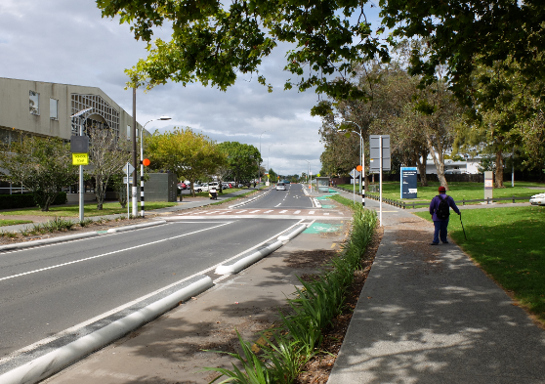
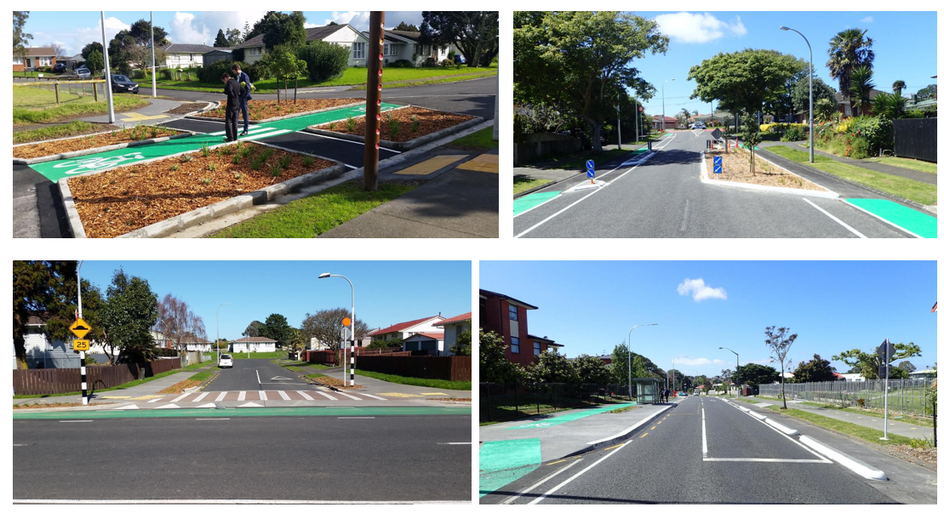
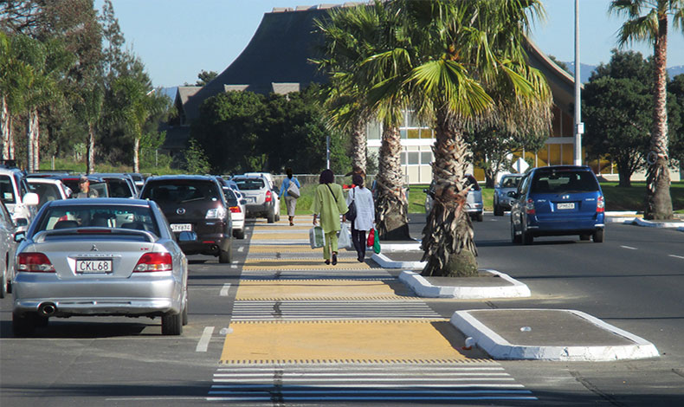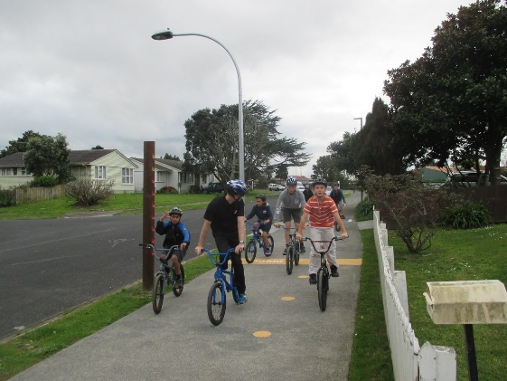

Figure 1. Examples of Future Streets changes.

Study design and methods

The full description of the study methods used for Future Streets is described elsewhere (Macmillan, et al. 2018). The overall study design was a mixed-methods, controlled before-after intervention study to assess the effect of retrofitting street changes at the suburb scale on multiple health, social and environmental outcomes, with Māngere Central as the intervention area and Māngere East as the control area (Figure 2). Selection criteria included the presence of local trip generators, higher than average traffic injuries, higher social deprivation, treatment and control areas of similar road layouts, no significant severance within each area (e.g. river or motorway), and alignment with Auckland Transport’s future cycle network. Baseline data were collected in 2014 and follow up measurements have been carried out in 2017 and 2018.

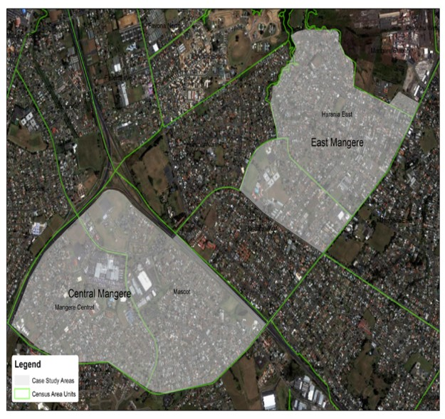
Figure 2. Intervention and control areas for Future Streets.

A key component of the study design is a timeline for the outcome measures where we expect to see change resulting from the future streets intervention. It is important to understand the realistic sequence and timing of this likely change, to ensure that realistic evaluation of project outcomes can be achieved. The outcomes pathway for the project is shown below in Figure 3. This pathway of expected change is important, because transport projects are often overly optimistic about the timeframe over which changes is expected.

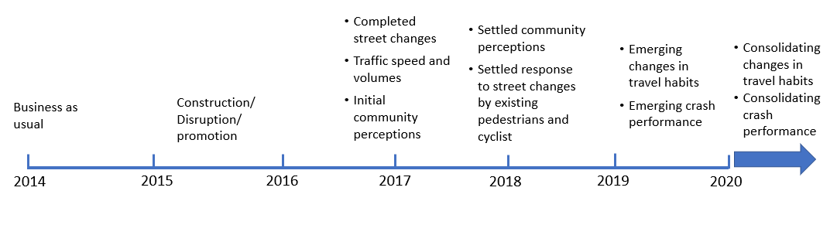
Figure 3. Expected outcomes pathway for Future Streets.

This paper focusses on what we expect to be the earliest changes following the roll-out of Future Streets. The methods for these aspects of the research are shown below (Table 2). Changes in walking and cycling numbers are also being investigated but are currently being analysed and not available here.

Measure | Method
Completed street changes | Description of the changes, the extent to which they influence the overall study area, and the difficulty of implementing the changes
Traffic speed and volume | Tube counters placed at eight locations in free-flow locations around the intervention area and eight locations around the control area 7-days of volume and speed data collected with raw data analysed.
Behavioural responses to street changes by pedestrians and cyclists | Video cameras located at three locations to understand how pedestrians and cyclists are interacting with the new infrastructure and other road users. Coding framework developed to describe pedestrian and cyclist movements and their interactions of varying severity with other road users (Hirsch et al. 2019). Data for this paper is presented from the busiest location only – Mascot Ave adjacent to the town centre.
Emerging crash performance | Crash Analysis System (CAS) analysis for intervention and control areas – fatal, serious, minor, and non-injury crashes - for five years before intervention (2011-2015), and two years following the intervention (mid 2017-mid 2019). Crashes were also mapped to understand more detail about how crash patterns are emerging in relation to the specific street changes.
Community perceptions | Household interviews with 1,900 residents across intervention and control areas, ‘go-along’ interviews and school focus groups. The current results report on neighbourhood safety and social cohesion for the survey and interviews, but full household interview results are still being analysed.

Table 2. Summary of methods for road user behaviour measures.

RESULTS

Completed street changes
The changes to the streets are described above and previously (Mackie et al. 2018), and also shown below in Figure 4. Approximately NZ$10m was spent on planning, designing, and implementing the changes. Projects that were deemed to fulfil the project objectives were chosen for implementation with less high-ranking projects not surviving the initial funded package. At a later date, some additional projects were funded through unspent Auckland Transport funds in the 2016 financial year. However, even with this additional funding, untreated aspects of the intervention area remained. Some local streets that were targeted for traffic calming, a key pathway through a reserve, and a range of low-cost temporary initiatives to calm traffic in the town centre were not implemented. On balance however, the changes across the intervention area did substantially modify the area to an extent that it was likely to have a tangible impact on road user behaviour, as shown in Figure 4.

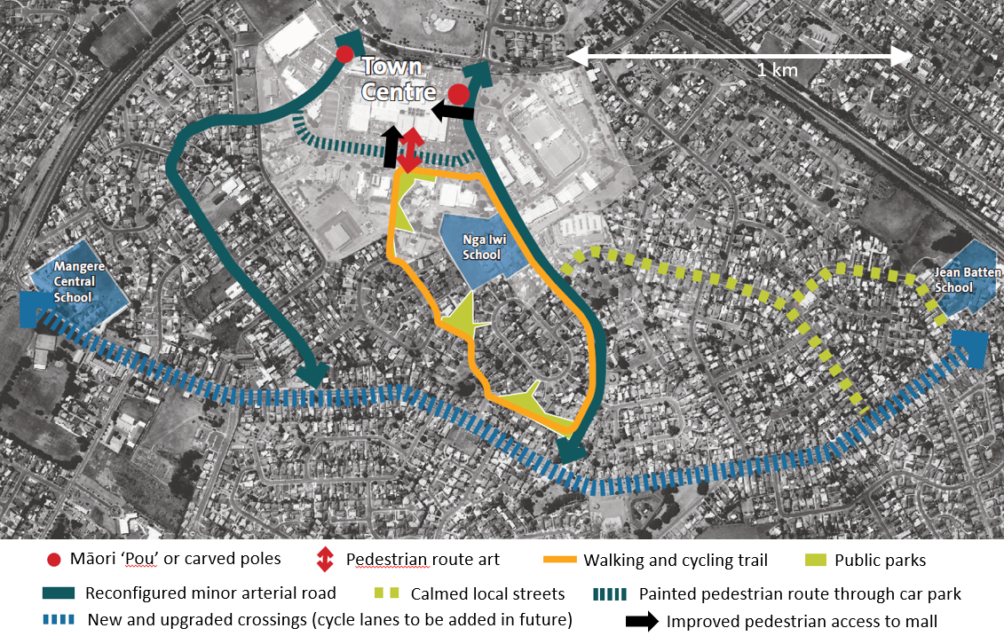

Figure 4. Extent of scope of works for Future Streets.

Although there were innovative aspects of how the project was delivered, there were a range of difficulties in delivering the project related to unclear governance, design processes, timing, funding, engagement, and lack of innovation culture surrounding the project. These aspects are explained more thoroughly elsewhere (Mackie et al 2018, Opit and Witten 2018, Witten et al 2018).

Traffic speed and volume
A summary of speed data is presented in Table 3. A key finding was there was negligible change in speed on all road types in the control area, but changes were seen in the treatment areas on collector and local roads. In the intervention area, average speeds on treated local streets fell to 35 and 28 km/h from 49 and 39 km/h respectively (speed profiles for all local streets shown in Figure 5 below). One local street had high speed at baseline as it was used as short-cut by traffic, and hence was operating more like a collector road, which explains the relatively high speed for local streets in the intervention area. Note there was very little change in speeds on nearby local streets where no treatments were applied. On the treated collector road where speed was measured at three locations, speed reductions were much greater nearer the town centre where there was a much higher density of intervention such as raised platform crossings. There was a negligible speed reduction on arterial roads in the intervention area where speed reduction was not the goal of arterial road treatments, and these were not treated as part of the scheme, apart from the addition of the odd pedestrian crossing.

 |  |  | 85% Speed (km/h)
Study area | Road Type | # data collection locations | 2014 | 2018* | Change
Control | Arterial | 1 | 48 | 49 | 1
Control | Collector | 1 | 53 | 55 | 2
Control | Local | 6 | 50 | 49 | -1
Intervention | Arterial | 3 | 56 | 54 | -2
Intervention | Collector | 3 | 48 | 39 | -9
Intervention | Local | 3 | 53 | 41 | -12

Table 3. 85% speed summaries for all intervention and control area streets

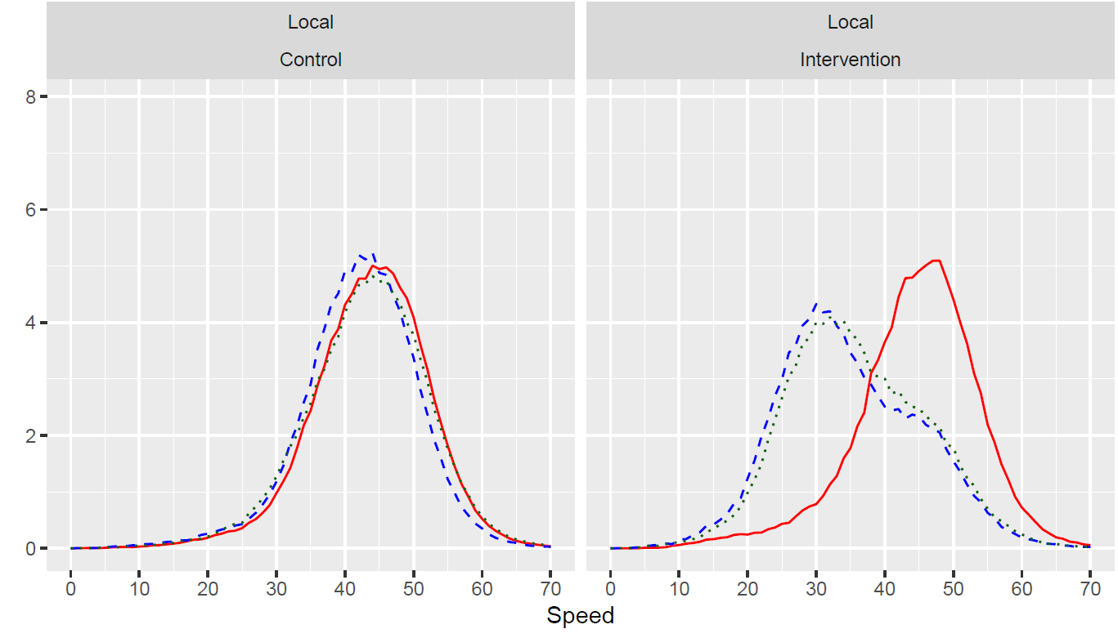
(Km/h)
2018
2017
2014

Figure 5. Example of speed reductions in local streets resulting from street changes.

Traffic volume for all control area streets increased between 2014 and 2018 (Figure 6), reflecting the overall growth of traffic in Auckland. In the intervention area, traffic also increased on arterial and collector roads but decreased on local streets. Key to this was a local street in the study area that had been acting as a ‘rat-run’ (Fresian Drive). This street was treated, and traffic volume fell here by 26% between 2014 and 2018.

Figure 6. Traffic volume changes across all street types in intervention and control areas.

Behavioural responses to street changes by pedestrians and cyclists

Video data were gathered at four sites for two weekdays and two weekend days (12 hours per day) before and after the street changes (Hirsch et al. 2019), to understand the effects of the treatments on road users’ behaviour. Data presented here mostly focuses on the busiest location where video data were collected. Figure 6 shows Mascot Ave, a collector road adjacent to the Māngere town centre. At this location a single pedestrian refuge was upgraded with a raised intersection, having zebra crossings across two legs of the intersection. A raised table zebra crossing was also added across a sideroad accessing the town centre. Cycle lanes and widened footpaths were also included.

Figure 7 shows how the patterns of interactions between pedestrians and vehicles has changed following the street changes, with higher concentrations of interactions shown by the pink, and then purple colours. A number of high-risk interactions in the middle of the road where traffic was originally free flowing have been removed and displaced/reduced to lower speed locations (where traffic speed is now lower).

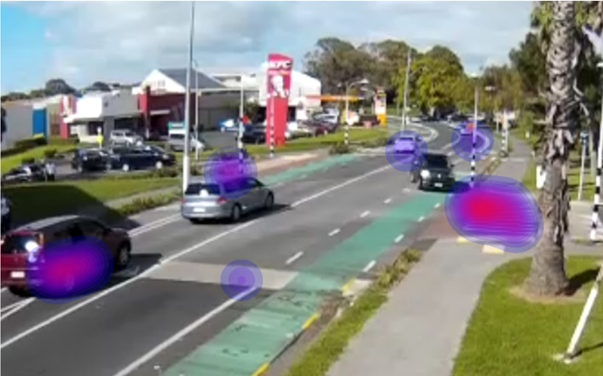
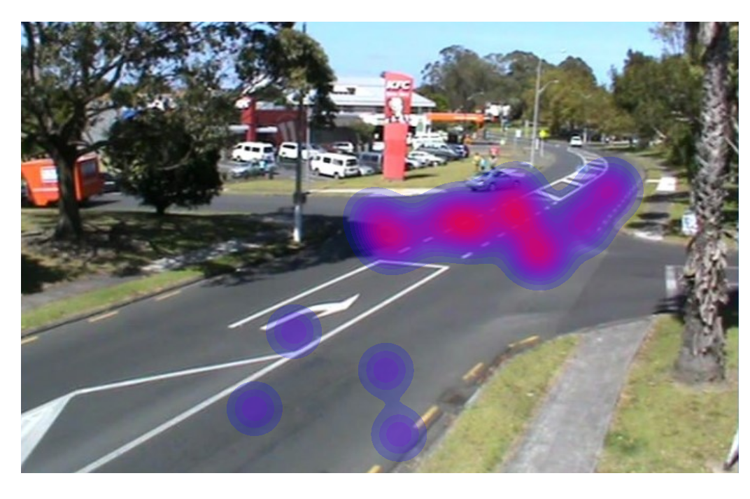
Figure 7. Changes in road user interactions before (left) and after (right) the street changes.

Other key findings from the video analysis revealed the following results:
- Delays faced by pedestrians crossing the road at all locations, not only at the new zebra crossings, have reduced (13% increase in those waiting less than 3 seconds).
- Pedestrians no longer have to wait in the middle of the road to cross (3% compared with 51% before the street changes).
- Fewer examples of people running to cross the road follow the street changes.
- 3.4% of pedestrians crossing the road following street changes used wheeled devices (e.g. wheelchairs, prams, shopping trolleys), compared with 1.2% at baseline.
- At this stage there are still relatively low levels of cycling in Mangere, and on the basis of what we know about interventions elsewhere, it is expected that it will take longer for a culture of cycling to emerge. Hence there are relatively low numbers of cyclists from which to draw behavioural conclusions. However, early indications are that there are clear examples of local cycling and there are a range of behaviours, with some using the cycle lanes, and others continuing to use the widened footpaths. Further initiatives to discourage vehicles parking in cycle lanes may be needed.

Emerging crash performance
Using the Crash Analysis System (CAS), the emerging crash performance of the Future Streets intervention and control areas were analysed by comparing two years of crash data following the completion of the street changes with five years prior to the street changes. Crashes were converted to crashes/month so that a comparison between these different time periods could be made.

Figure 8 shows that Death and Serious Injury (DSIs) crashes have reduced by 23% in the intervention area while DSIs have increased by 59% over the same period in the control area. Taking a more detailed view of the crash data the following findings are also noteworthy:
- Within the treated streets in the intervention area there have been no deaths or serious injuries since the Future Streets changes were made.
- There were 30 crashes on the busiest treated streets (Thomas/Orly, Mascot, Fresian) in the two years before the street changes and 15 in the two years following
- All serious injury crashes in the study area post-intervention have occurred on streets where changes were not made.

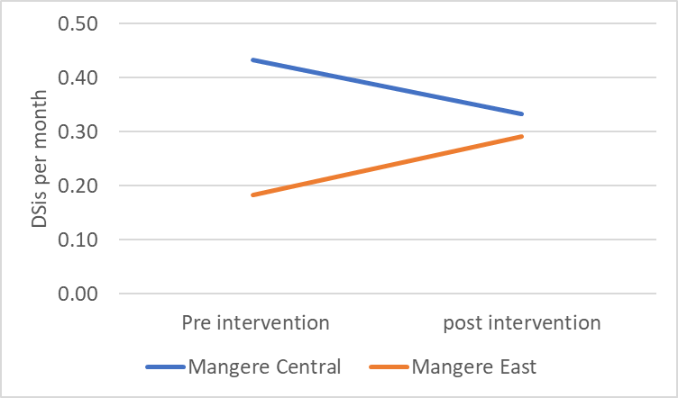

Figure 8. Change in deaths and serious injuries following future Streets intervention

Other related preliminary findings
A range of other preliminary findings (which will be published in more detail later) help support this early understanding of how road users are experiencing the infrastructure changes. In particular, qualitative interviews and the household survey contribute to this understanding:
- There are mixed perceptions of the infrastructure changes depending on one’s point of view. People who commonly walk in the area report support for the changes and believe crossing is now much safer, particularly for those accessing the mall and local schools. However, some drivers feel that the changes have led to their movement being somewhat restricted and made more difficult, particularly when negotiating concrete cycle lane separators.
- While most aspects of the street changes have been viewed positively, support for the separated cycle lanes has been mixed. In the absence of a strong cycling culture, some people see them as relatively under-utilised. On the other hand, there are local groups working to develop cycling, and people who affiliate with cycling, tend to view the cycle lanes more positively. Generally, people see the benefits of the cycling infrastructure will accrue to the next generation who grow up as children experiencing cycling as a normal transport choice.
- Residents with mobility impairments have shared positive responses to the new infrastructure, with comments ranging from support for the smoothness of the new paths, to more transformational effects such as no longer needing a support person to help them negotiate the streets.
- The residents’ survey also showed improvements in social cohesion and safety perceptions compared with the control area.
- There are continuing concerns about safety, but they are now less about traffic and more about remaining issues such as free roaming dogs and intimidating people, suggesting that more needs to be done in a range of areas to unlock the full potential of the investment.
Although there have been some reports of driver annoyance in response to certain aspects of the designs, there has been little evidence of difficulty or reduced safety with some of the more innovative aspects of the designs such as a partial street closure, informal give-way road narrowing to calm traffic, or the side road pedestrian priority crossings. On the other hand, there are clear areas where the designs could be improved to enhance performance or understanding including extra crossing locations where people are informally crossing, cleaning of cycle-lanes, and implementing treatments that were not initially included in the scheme, but where remaining safety hazards or usability issues remain (such as innovative zebra crossing safety enhancements).

DISCUSSION

Overall, the preliminary outcomes from the Te Ara Mua - Future Streets changes suggest that from a road user-behaviour and safety perspective, the scheme is performing well. Speed and traffic patterns have been modified to suit pedestrian and cyclist priority and amenity where appropriate, and accordingly there is evidence that pedestrians, and in particular those using mobility aids, find using the modified streets much easier than before. The emerging safety performance is also positive with fewer and less severe crashes happening on the treated streets compared with untreated streets. Overall, evidence collected to date suggests that the project has achieved its aim of making walking and cycling safer and easier.

A key component of behaviour change on Māngere central streets is the re-distribution of traffic away from local streets as part of a strategy to make lower-order streets more inviting for walking and cycling. This was achieved and a vehicular ‘rat-run’ through a key local street is now much less attractive to non-residential traffic. This has helped to create more positive perceptions of the environment for walking and cycling, but it has also annoyed some motorists. Nevertheless, it is a useful example of being more deliberate about matching street design with intended road use. This will become increasingly important as road hierarchy frameworks such as the One Network Road Classification system - a framework for classifying the type and function of all roads, become more operationalised in urban settings. New Zealand currently has a somewhat fluid road hierarchy, which has meant that many local streets have suffered from increasing traffic, reduced actual and perceptions of safety, and reduced propensity to walk or cycle. Further work is needed to explore how more deliberate and organised road use can be designed and delivered.

However, there are limits to the completeness of the Future Streets modifications. Some streets were left unmodified due to project constraints and there is some evidence that where streets have not been improved, safety issues remain. Furthermore, the street changes have a finite boundary. Outside the project area untreated streets remain hostile to walking and cycling, and there are enduring injury risks. This is particularly the case for busy arterial roads that surround the intervention area. This suggests that the Future Streets changes have been a catalyst for change with some tangible local positive outcomes, but does not extend to suburb-wide transformational safety, or walking and cycling amenity. Comparing Future Streets with an earlier related Self-Explaining Roads demonstration project in Point England, Auckland (Charlton et al, 2010), Future Streets achieved much more walking and cycling focussed infrastructure, particularly on collector roads, but didn’t achieve the completeness that was achieved for Pt England.

This raises an important point about the benefits of projects relating to their completeness. The more comprehensive a project is in addressing all aspects of a neighbourhood’s transport related problems, the more likely the project is to have transformational benefits. This means that network-wide change systematically addressing all streets within an area – particularly those where risks are evidenced, but also addressing other non-infrastructural problems identified such as dogs and personal safety fears should be prioritised.

Te Ara Mua - Future Streets represented a relatively substantial investment compared with most suburban road safety or walking and cycling improvement projects. Yet, as mentioned, there were still aspects of the scheme that were not addressed. A more complete approach to treating neighbourhood streets, building on Te Ara Mua - Future Streets concepts, might further develop two key areas:
- A better understanding of the combined safety, health, access, environmental and social equity benefits to determine the appropriate investment for these kinds of projects. This may indicate that enhanced funding for suburban safety, walking, and cycling projects is warranted depending on the combined benefits.
- In further developing solutions for intervention, lower cost and high benefit interventions could be further tested. These might include an expanded arrangement of partial street closures where vehicles but not pedestrians and cyclists are restricted, and cheaper tactical changes that may offer more value for money, allow new concepts to be tested, and potentially be implemented more quickly.

However, these perspectives suggest a substantial departure from business as usual transport planning and delivery, and the experience of Future Streets suggests that structural changes to how transport is planned, funded, and delivered may be needed if optimised suburban streets are to eventuate.

Related to the conference theme – equity in transportation, Future Streets has explored various types of equity. Firstly, there is equity in transport investment across communities. Māngere is a lower socio-economic South Auckland neighbourhood, and it has been anecdotally mentioned through the project, and reported earlier, that South Auckland suburbs do not enjoy the same levels of transport investment as more affluent areas of the city (Hopgood et al 2013, Collins and Kearns 2005), and certainly residents who were interviewed often viewed the project positively simply because some investment was being made in their community.

Access equity for the most vulnerable road users is a positive outcome from Future Streets, with young, old, and those with disabilities reporting the changes being favourable for their mobility. Geographical equity is another concept that Future Streets has raised questions about. Particularly for walking and cycling infrastructure, city centres have been a strategic priority for programmes such as the Urban Cycleways Programme. However, there are vast tracts of suburban streets, where most people live, that are relatively unusable for cycling and often walking. This reinforces the point that a planning, funding, and design model is needed to make suburban streets safer and more user-friendly for walking and cycling. Lastly, funding equity needs to be considered. To some, the $10m spent on Future Streets was seen as expensive, and yet a nearby expressway intersection grade separation cost $160m. It seems a fundamental discussion about the proportion of the overall transport budget that should be targeted to various social outcomes is needed to inform future planning and investment decisions.

Finally, Future Streets is a longitudinal project and these preliminary outcomes provide an overview of how the street changes are performing thus far. Further research will be carried out over coming years to provide greater depth and certainty to these findings, along with lessons for a broader range of outcomes.

Conclusion
The preliminary findings synthesised from a range of data suggest that overall Te Ara Mua – Future Streets has achieved its aim of making walking and cycling safer and easier in Māngere. Further actions including street improvements across a wider area, more locally driven activation, and addressing safety problems from other people and dogs are needed to yield longer-term benefits. Continuing research will determine household perceptions across the area, mode shift, and longer-term safety benefits.

AUTHOR CONTRIBUTION STATEMENT

The authors who have contributed to this paper are acknowledged. More specifically the following contributions were made by each author:

Hamish Mackie – Overall project leader, main author, presenter

Alex MacMillan – Research lead

Karen Witten – co-researcher, paper peer review

Adrian Field - co-researcher, paper peer review

Melody Smith - co-researcher, paper peer review

Jamie Hosking – analysis lead

Alistair Woodward - co-researcher, paper peer review

Bert van der Werf – Biostatistician

Lily Hirsch – road user behaviour lead.

REFERENCES

CHARLTON, S. G., MACKIE, H.W., BAAS, P.H., HAY, K., MENEZES, M. and DIXON, C. (2010). Using endemic road features to create self-explaining roads and reduce vehicle speeds, Accident Analysis & Prevention 42(6): 1989-1998.
COLLINS, D. and KEARNS, R. (2005). Geographies of inequality: Child pedestrian injury and walking school buses in Auckland, New Zealand, Social Science and Medicine 60(1), 61-69.
FRANK, L. and KAVAGE, S. (2009). A national plan for physical activity: The enabling role of the built environment, Journal of Physical Activity and Health 6(Suppl 2): S186-195.
GEELS, F.W. 2004. From sectoral systems of innovation to socio-technical systems: Insights about dynamics and change from sociology and institutional theory. Research Policy, 33(6-7): 897-920. doi.org/10.1016/j.respol.2004.01.015
GEHL, J. (2013). Cities for people. Washington, Island Press
GILES-CORTI, B., VERNEZ-MOUDON, A., REIS, R., TURRELL, G., DANNENBERG, A.L. BADLAND, H., FOSTER, S., LOWE, M., SALLIS, J.F., STEVENSON, M. and OWEN, M. (2016). City planning and population health: a global challenge, The Lancet 388(10062): 2912-2924.
HAMILTON-BAILLIE, B. (2008). Towards shared space, Urban Design International 13(2): 130-138.
HIRSCH, L., MACKIE, H., CROMBIE, C., BOLTON, L., WILSON, N., CORNILE, Z. and HAWLEY, G. Understanding Road User Behaviour Change in Te Ara Mua – Future Streets. Paper presented at the Australasian Road Safety Conference, Adelaide, 25-27 September, 2019.
HOPGOOD, T., PERCIVAL, T., STEWART, J. and AMERATUNGA, S. (2013). A tale of two cities: paradoxical intensity of traffic calming around Auckland schools, New Zealand Medical Journal,126(1374).
MACKIE, H., MACMILLAN, A., WITTEN, K., BAAS, P., FIELD, A. et al, (2018). Te Ara Mua-Future Streets suburban street retrofit: A researcher-community-government co-design process and intervention outcomes, Journal of Transport & Health 11: 209-20. doi.org/10.1016/j.jth.2018.08.014

MACMILLAN, A., MACKIE, H., HOSKING, J., WITTEN, K, SMITH, M., FIELD, A. WOODWARD, A. HOSKINS, R. STEWART, J., VAN DER WERF, B and BAAS, P. (2018). Controlled before-after intervention study of suburb-wide street changes to increase walking and cycling: Te Ara Mua-Future Streets study design, BMC Public Health 18(1): 850.
MAIZLISH, N., LINESCH, N. and WOODCOCK, J. (2017). Health and greenhouse gas mitigation benefits of ambitious expansion of cycling, walking, and transit in California, Journal of Transport and Health, 6, pp. 490-500.
MINISTRY OF TRANSPORT. Road to Zero. Consulatation on the 2020-2030 Road Safety Strategy, 2019.
OPIT, S. and WITTEN, K. (2018). Unlocking transport innovation: A sociotechnical perspective of the logics of transport planning decision-making within the trial of a new type of pedestrian crossing. Building Better Homes Towns and Cities SRA - The Architecture of Decision-making. Auckland, New Zealand, Shore Whariki, Massey University.
THEEUWES, J. and GODTHELP, H. (1995). Self-explaining roads, Safety science 19(2): 217-225.
WITTEN, K., CARROL, P., CALDER-DAWE, O., SMITH, M., FIELD, A. and HOSKING, J. (2018). Te Ara Mua-Future Streets: Knowledge exchange and the highs and lows of researcher-practitioner collaboration to design active travel infrastructure, Journal of Transport & Health 9: 34-44.

