MAKING RAISED INTERSECTIONs WORK FOR WALKING
Author:
Jeanette Ward,
Technical Director, Abley Ltd
MET BE (Civil) NZCE CMEngNZ CPEng
jeanette.ward@abley.com
Co-author:
Gerry Dance,
Team Leader Multi Modal, NZTA
gerry.dance@nzta.govt.nz

Co-author:
Rahul Kumar
Transportation Engineer, Abley Ltd
BE(Hons) MEngNZ
rahul.kumar@abley.com

Abstract
A raised platform can be used within an entire intersection. This helps to reduce speed making the intersection safer – assuming the platform ramp gradients are effective. The platforms are usually paved so they also contribute to overall attractiveness of the streetscape. The raised intersection concept can apply at uncontrolled, priority controlled, signalised or roundabout configurations. There may also be a design intent that drivers will yield to pedestrians waiting to cross the road (known as courtesy crossing).

There is limited design guidance in New Zealand on how and where to apply raised platforms within intersections. International guidance exists but the key aspect of when it is not appropriate to use only a raised intersection at non-signalised intersections, because they may have an adverse impact on pedestrian level of service, is not clearly articulated. This is particularly important given the range of pedestrians, including visually and mobility impaired, elderly and children, and the potential perceptions of crossing these types of intersections. A raised intersection could also feature refuge islands and/or kerb extensions to improve pedestrian outcomes but there is no guidance on the contexts where this may be appropriate.

This paper explores the existing guidance and reviews a range of existing raised priority intersections in New Zealand and Australia. Recommendations on how to balance the needs of users, and what design guidance could apply, are made.

INTRODUCTION
This paper was motivated by an increased use of raised platforms at cross and T-intersections and concern that the available guidance does not clearly articulate how pedestrians should be catered for. All intersection designs need to consider pedestrians, but the authors are concerned that raised intersections are being seen as a ‘silver bullet’ as they can reduce the speed of drivers. Is full consideration being given to the wide range of pedestrians, including visually and mobility impaired, elderly and children, and the issues they may experience issues crossing these types of intersections if traffic volumes are high? Guidance exists with the Pedestrian Planning and Design Guide (NZTA, 2007) for how to cater for pedestrians crossing the road but this guidance is not always referenced or embedded in the intersection design guidance.

The ‘raised intersection’ concept can apply at uncontrolled, priority controlled, signalised or roundabout configurations. This paper focuses on priority controlled cross and T-intersections with both fully raised intersections or raised side road intersections, and how guidance can better consider pedestrians. How effective raised intersections are at speed reduction is not assessed.

Traditional cross and T-intersections in New Zealand generally involve wide streets within 20.1m wide road reserves. The street with priority is called the ‘major road’ and the side streets are called the ‘minor road’. The corner radii are generally large and this can mean driver negotiation speeds are high. These intersections can be difficult for pedestrians to cross. Figure 1 shows the traditional layout and the types of interventions that have been used for some years to improve the pedestrian level of service. The interventions include pedestrian refuge islands to facilitate a two-stage crossing, kerb extensions to reduce the crossing width, or a combination of the two. Raised side road treatments have also been used for a number of years.

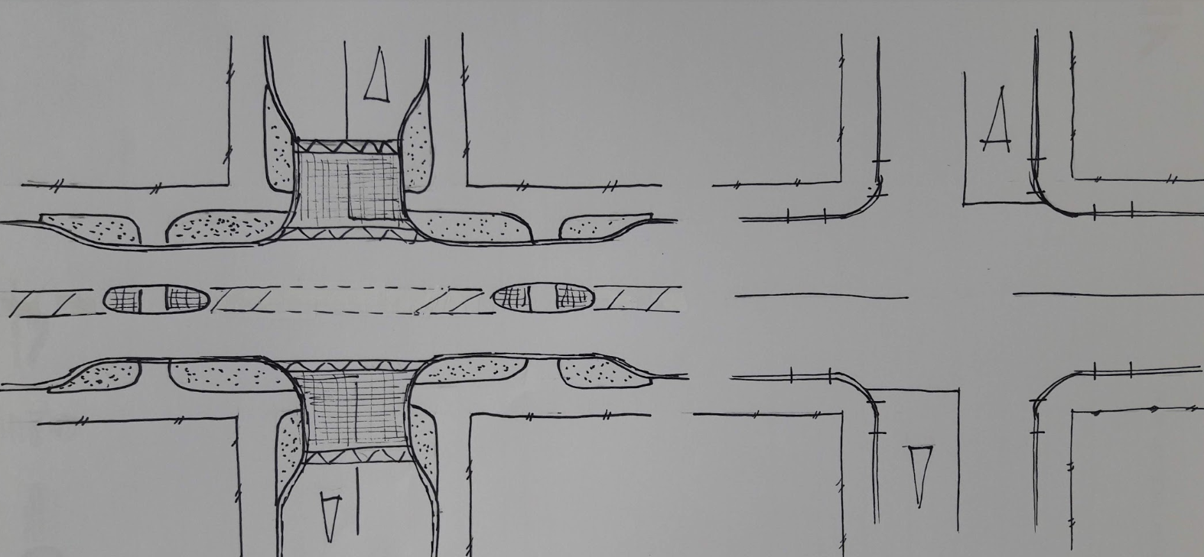

Figure 1 – Traditional intersection layout and methods to improve pedestrian crossing
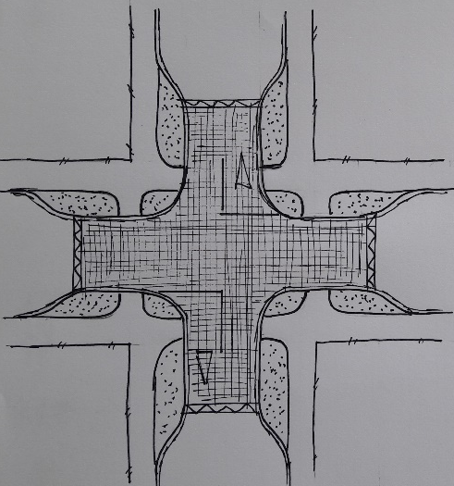
A raised platform can be used within an entire intersection and generally used in conjunction with kerb extensions as shown in Figure 2. They help to reduce vehicle speed making the intersection safer – assuming the platform ramp gradients are effective. The design intent is that drivers will yield to pedestrians waiting to cross the road (known as courtesy crossing). The platforms are usually paved so they also contribute to overall attractiveness of the streetscape. The platforms are either entirely raised so that they are flush with the top of kerb or raised at the centreline but tapered to the kerb fender for drainage reasons.
Raised platforms and intersections are part of the NZTA Standard Safety Interventions Toolkit (NZTA, 2019) and are considered ‘low cost, low risk roading improvement projects’.
Figure 2 – Typical raised intersection

EXISTING GUIDANCE
There appears to be limited design guidance in New Zealand on how and where to apply raised platforms within intersections. Table 1 outlines the guidance that exists in Christchurch and Auckland and also within the NZTA Standard Safety Interventions Toolkit (NZTA, 2019). The Toolkit states that the crossing locations within the raised intersection are expected to operate as courtesy crossings (“encourage motorists to yield to pedestrians at the crosswalk”). There is no guidance on the scale of motorised traffic on the intersecting roads, or speed when that may not be appropriate for pedestrians. The NZTA (2019) guidance implies that raised intersections can be used at minor intersections but what ‘minor’ means is not defined. The NZ Manual of Traffic Signs and Markings (MOTSAM) uses the terms low, medium and high traffic volumes to differentiate between intersection layouts, albeit with no volume values provided to define low, medium or high.
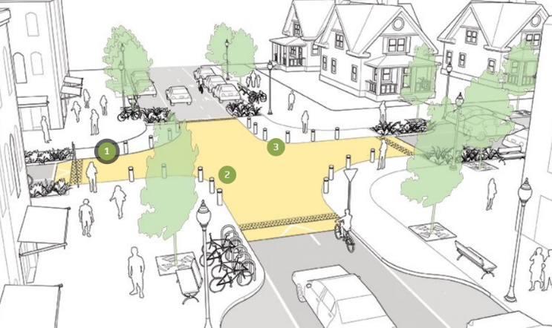
A scan of international guidance from Austroads, Vic Roads (given their guidance was referenced by NZTA) and also NACTO (National Association of City Transportation Officials) showed a similar finding (see Table 2). The focus of guidance relates to conspicuity between road space and pedestrian space, particularly when the platforms are flush with adjacent land. Guidance is provided on additional delineation such as contrasting coloured pavement marking and line marking. NACTO suggests bollards are used for delineation as shown in Figure 3.
Figure 3 – NACTO raised intersection

Guidance within the NZTA Pedestrian Planning and Design Guide (PPDG) (NZTA, 2007) outlines how the level of service for crossing pedestrians can be achieved by using physical aids. These reduce the crossing distance and the amount of traffic the pedestrian has to negotiate at each stage. The crossing distance can be reduced through kerb extensions, medians and pedestrian islands. The amount of traffic the pedestrian has to negotiate at each stage can be halved by separating the crossing into two separate crossing manoeuvres (medians and pedestrian islands). Figure 4 shows how the various aids and combination of aids impact the mean delay to pedestrians as the peak hourly traffic volume increases.
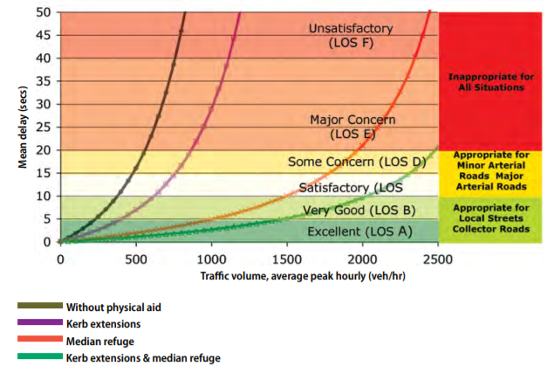
This guidance is relevant to priority controlled intersections, be it raised or flush. Figure 4 illustrates that above approximately 750 vehicles per hour (vph), even with kerb extensions, the delay for pedestrians is no longer satisfactory. A median refuge and a refuge with kerb extensions used with greater than 750 vph reduces the crossing delay and brings level of service back to at least ‘satisfactory’ until the hourly volume exceeds 1750 vph.

Figure 4 – Mean delay for various facilities on a two-lane, two-way urban road (uninterrupted flow) (NZTA, 2007)

Table 1- New Zealand guidance – priority and uncontrolled cross and t-intersections
Description of raised intersection | Appropriate location guidance | Design guidance for catering for pedestrians

NZTA – Standard Safety Intervention Toolkit (2019)
Section 4.10  Raised safety platforms create a safe, slow-speed crossing and public space at minor intersections. They can be described as either an approach platform located on the approach to an intersection or a raised intersection by raising the entire intersection so that motorists ascend on the approach to, and descend on the departure from, the intersection. Similar to speed humps and other vertical speed control elements, they reinforce slow speeds and encourage motorists to yield to pedestrians at the crosswalk. | - …at minor intersections (minor is not defined)  - To assist designers/project managers with the selection of suitable sites for raised intersection platforms, the following guidelines have been developed:  - Does the intersection have risk rating of medium or higher?  - Is the posted speed limit or measured mean speed 60km/h or less on the corridor?  - Is there evidence of turning/crossing type reported crash types and/or crashes involving vulnerable road users? | - Raised intersections are to be flush with the adjacent footpath to ensure that drivers traverse the crossing slowly.  - Refers to:  - https://www.vicroads.vic.gov.au/-/media/files/technical-documents-new/road-designnotes/road-design-note-0307-raised-safety-platforms-rsp-oct-2018.ashx  - https://www.nzta.govt.nz/resources/traffic-notes/traffic-notes/

Auckland Transport – Urban Street and Road Design Guide (2019)
Chapter 6 – Intersections  A raised table or raised crossing extends the footpath across the intersections and creates a ramp to slow down crossing vehicles. This design solution makes it easier for pedestrians to cross and slows vehicle movements.  Unsignalised intersections – For compact intersections and mini-roundabouts, the whole intersection can be raised, provided vehicles cannot gain too much speed once they have entered the intersection before reaching a cycleway crossing their exit lane.  Chapter 6 - Local to local intersections  Consider adding traffic calming elements that provide vertical deflection, in order to effectively slow traffic. These could be either raised tables that span the intersection, or individual speed bumps on each of the approaches to the intersection. | - Side road intersections – Raised tables are appropriate in town centre contexts with high pedestrian volumes and at local or collector street intersections. | - No specifics

Auckland Transport – Code of Practice (2013)
Section 8.5.2.2 – Raised tables are devices which are predominately used at intersections or crossing locations, and allow a level surface for both larger vehicles to negotiate and for pedestrians to cross at. The devices generally have a flat surface and are designed to sit flush with the kerbs. At intersections, raised tables are generally the same size as the intersection but extend a little beyond the intersection to allow the ramps to be positioned away from the crossing points. | - Raised tables are not generally preferred by bus operators. Consultation with AT’s relevant operational units must be undertaken if the proposed location is on a bus route.  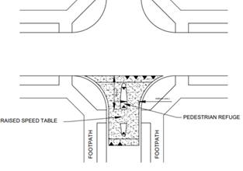 | - Raised tables that are constructed for use as uncontrolled crossing points are often interpreted by pedestrians as formal pedestrian crossings. This can lead to unsafe use of the crossing point by pedestrians as they assume they have right of way. To avoid this situation it is recommended that raised tables used as uncontrolled crossing points are constructed from a material of similar appearance and colour to the surrounding road surface and that they are clearly distinguishable from the footpath  - Note - Entry threshold detail (side road intersections) includes pedestrian refuge island as shown in TC011 opposite.

Christchurch City Council -Infrastructure Design Standard (2016)
Raised intersections are included as a “traffic device measure” in section 8.14  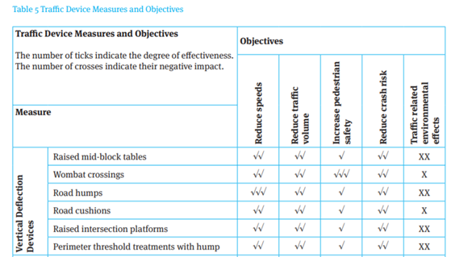 | The installation of traffic management devices (TMD) is most appropriate to local residential streets where:  - the posted speed limit < 85th percentile operating speed < posted speed limit + 20km/hr;  - peak hour traffic volumes exceed 60 vehicles (equivalent to approximately 600 vehicles/day);  - the length of the road segment under consideration > 250m;  - the road has a documented crash history of the type that could be corrected by the devices considered for implementation;  - there are significant pedestrian safety issues | - No specifics

Table 2- International guidance
Description of raised intersection | Appropriate location guidance | Design guidance

Austroads Guides to Safety, Design and Traffic Management
Austroads guidance exists for raised side road intersections – known as continuous footpath treatments. However, this is based on different legal framework to NZ whereby pedestrians have a right of way over the side road turning traffic.  Fully raised intersections are referred to as ‘raised pavements located at intersections’ in Guide to Traffic Management Part 8: Local Area Traffic Management.  A raised pavement is a raised section of roadway approximately 90 to 100 mm high ramped up from the normal level of the street with a platform extending over more than a standard car length (at least 6 m but typically more). It can be located either mid-block or cover the entire intersection. | Application of raised pavements: It is appropriate to use raised pavements on streets:  - where there is a need to reduce vehicle speeds  - where there is adequate street lighting to maximise visibility  - on streets with a low speed environment (less than 60 km/h).  It is inappropriate to use raised pavements:  - …on bends or crests or other locations where sight distance is insufficient  - on undivided streets wider than two lanes  - where there are high volumes of pedestrians (i.e. a thoroughfare) and priority is unclear. | - None for fully raised intersections

Austroads research - Achieving Safe System Speeds on Urban Arterial Roads: Compendium of Good Practice
Raised intersections (also known as platform intersections, raised junctions or plateaus) are a speed management device, typically with the aim of reducing the speed of vehicles to 50 km/h or less. The entire intersection can be raised, with the pavement surface sometimes flush with the adjoining footpath. Alternatively, raised sections can be placed in advance of the intersection (sometimes referred to as raised stop bars) in order to achieve a similar effect. Raised intersections can be painted or paved in a manner such that they serve to further increase driver awareness of the intersection. | This research includes raised intersections however it appears to be focused on signalised intersections. | - Confusion of priorities may occur, therefore proper pedestrian crossings should be designed with raised intersections.

VicRoads – Road Design Note – Raised Safety Platforms (RSPs) (2018)
At intersections:  - placing platforms on the approach to an intersection (often referred to as ‘Approach Platforms’ or ‘raised stop bars’)  - raising the entire intersection so that motorists ascend on the approach to, and descend on the departure from, the intersection (often referred to as a ‘Raised Intersection’) | - Raised Intersections are most appropriate for undivided carriageways, sites with small footprints, where high pedestrian movements are expected or pedestrians have increased priority.  - A major advantage of raised Intersections is they are well suited for a large portion of existing metropolitan sites (i.e. those with undivided carriageways), and have the potential to create a more pedestrian friendly area with crossing paths raised closer to connecting footpaths. | - The introduction of RSPs may lessen the conspicuity between road space and pedestrian space, particularly when proposed platforms are flush with adjacent land. Therefore, additional delineation such as contrasting coloured pavement marking and/or white kerbside linemarking may be considered to improve the conspicuity of the RSP.  - To further emphasise the separation between road space and pedestrian space, the following treatments should be considered to deter motorists from tracking in this area:  - Edge-linemarking (including tactile linemarking)  - Coloured pavement treatment within pedestrian space  - Energy absorbing bollards and/or street furniture at the roads edge

NACTO – Urban Street Design Guide (2018)
Raised intersections are flush with the sidewalk and ensure that drivers traverse the crossing slowly.  Similar to speed humps and other vertical speed control elements, they reinforce slow speeds and encourage motorists to yield to pedestrians at the crosswalk. | - Raised intersections create a safe, slow-speed crossing and public space at minor intersections. | - Bollards along corners keep motorists from crossing into the pedestrian space. Bollards protect pedestrians from errant vehicles.  - Crosswalks do not need to be marked unless they are not at grade with the sidewalk. ADA-compliant ramps and detector strips are always required.

NEW ZEALAND CASE STUDIES

A selection of brief case studies are provided below to provide some context for how guidance for pedestrian considerations might evolve for raised intersections. These studies describe the intersection and outline the observations made. The sites are:
- Mackenzie Ave, Christchurch – Cross roads intersection on a low volume residential street
- Wakefield Ave, Christchurch – T-intersection on a medium volume mixed use street
- Walters Road, Auckland – T-intersection on a low volume street adjacent to a stadium
- Hawford Road, Christchurch - T-intersection on a low volume residential street

Case study 1 - Mackenzie Ave, Christchurch

Project description

Mackenzie Ave is classified as a local road with approximately 1,000 vehicles per day. It is part of the Heathcote Expressway cycleway. It is not a bus route. The speed limit is 30km/hour. The intersection with Hopkins Street was upgraded in 2006 and included kerb extensions to reduce crossing distances. In 2018 the intersection was further upgraded with a raised intersection platform as part of the cycleway project to support the lower speed limit of 30km/hour. The street is designed as a ‘’neighbourhood greenway’’. This intersection platform is raised at the centreline and tapered to the kerb fender.

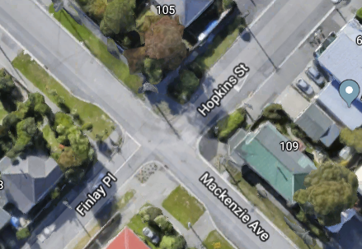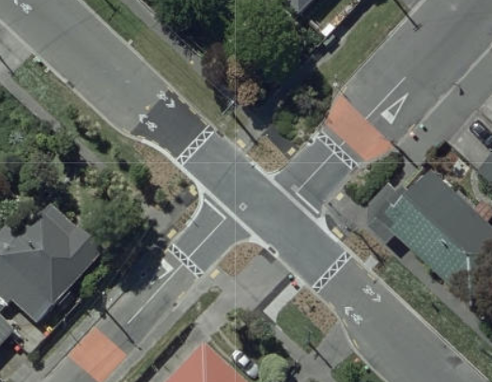
After
Before

Observations

The pedestrian peak on this street is at the start and end of the school day as there are schools nearby. Observations of how people were using the space were made at the school morning peak. Children are confident crossing the roads at this intersection as the traffic volumes are low at this time and generally are parent drivers that are watching out for children. The children found sufficient gaps to cross and the raised platform generally does not function as courtesy crossings.

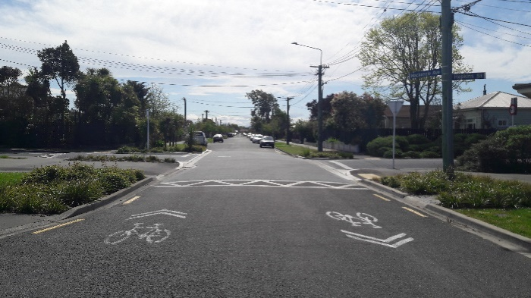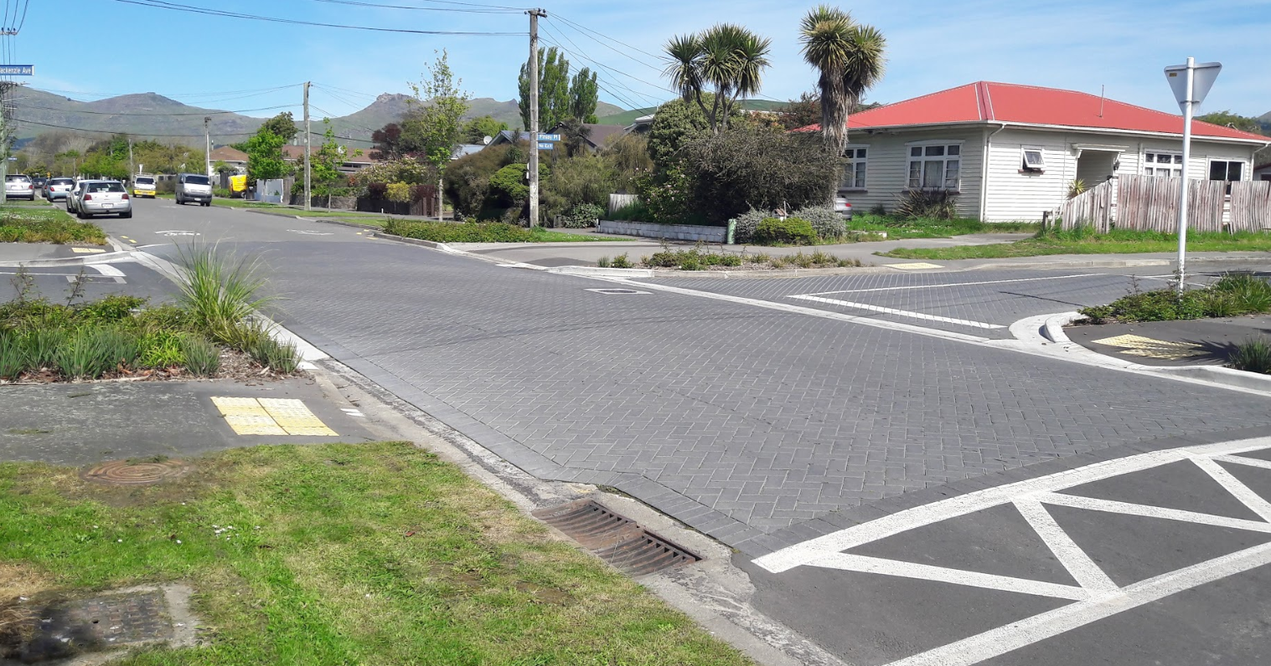

Case Study 2 - Sumner Village Centre, Christchurch

Project description

Marriner Street west/Wakefield Ave through Sumner Village is classified as a minor arterial route in the Christchurch District Plan with approximately 10,000 vehicles per day. The intersection of this route with Burgess Street and Marriner Street east occurs on the bend where Marriner Street west becomes Wakefield Ave. It is also a bus route, an over-dimension route and a dangerous goods route over Evans Pass to the Port of Lyttelton. The route is also part of a popular road cycling route. The speed limit through the village is 30km/hour. The street also provides one of the key public spaces within the Village Centre, and is the primary retail street. The quality and amenity of the street environment was relatively low prior to the redevelopment of the streetscape as part of the Sumner Village Centre Master Plan to support “a charming and relaxed beachside village”. The Master Plan was prepared in response to the damage caused to the centre in the 2010 and 2011 earthquakes. The streetscape project included the installation of a raised intersection on the bend as shown below, this creates a flush surface across the entire space. The road surface pavers are a similar colour to the footpath pavers, almost giving the impression of a shared space. The intersection is intended to operate as a courtesy crossing with tactile pavers right on the bend.

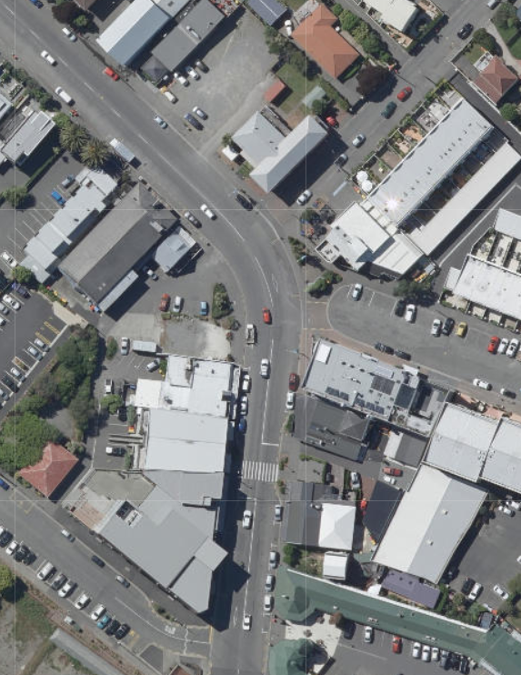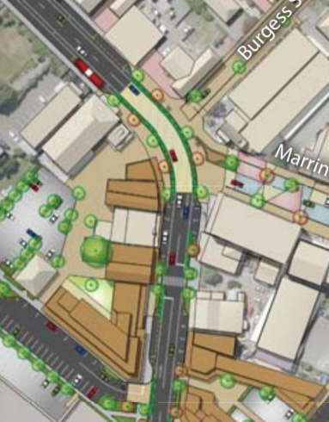
Design
Before
Raised intersection

Observations

Observations of how people were using the space were made on a sunny Sunday afternoon. The traffic flow was reasonably continuous, and most drivers were travelling faster than 30km/hour. People crossed the road in a range of locations, usually when the way was clear. Only a few people walked out requiring the drivers to slow and yield as per the intent of a courtesy crossing. Some people tried to cross right on the bend where the tactile pavers are located but gave up and moved away from this location to cross. Several older pedestrians gave up trying to cross, no disabled users were observed crossing or attempting to cross the road. The drivers turning right out of Marriner Street east were often taking small gaps and entering the main flow at speed, this added to the complexity for the people crossing the road. Overall drivers did not seem to reduce their speed and anticipate pedestrians crossing within the space.

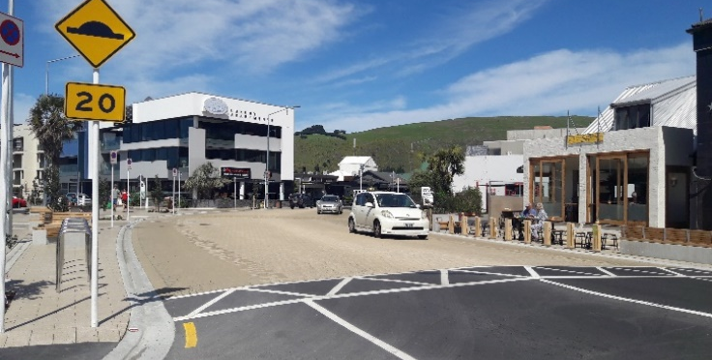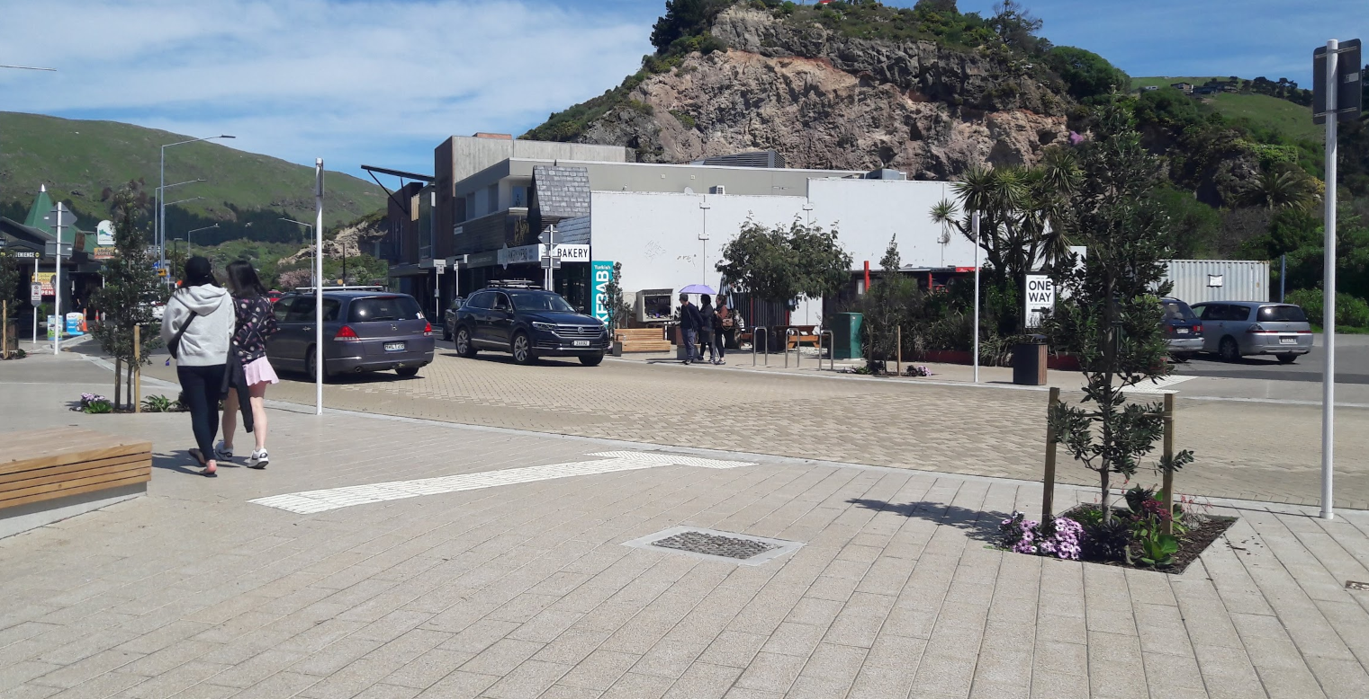

Case Study 3 – Walters Road, Auckland

Project Description

Walters Road is classified as an arterial road in the Auckland Unitary Plan with approximately 5,000 vehicles per day. It is also a bus route and 2% of the daily traffic is made up of heavy commercial vehicles. Walters Road is not identified as a cycling route on Auckland Transport’s cycling maps. The speed limit on Walters Road is 50km/hour. Walters Road borders the north side of Eden Park and is closed to general traffic when Eden Parking is holding events. Parking is also heavily restricted during these times. Thousands of people use Walters Road to access Eden Park. The intersection of Walters Road and Cricket Avenue is raised for a length of 75m on Walters Road and does not extend into Cricket Avenue. The ramp on each approach is about 1m long and the intersection is raised by about 75mm. The raised section of the intersection is on the same level as the surrounding footpath but there are no formal footpath connections on the raised intersection except at one location which is the black and white chequered pedestrian walkway, linking Sandringham Road to Walters Road. The surface of the intersection is formed in concrete but looks similar in colour to the existing asphaltic surface on the rest of Walters Road. When Eden Park is not holding any events, parking is permitted along the entire length of the raised area. The raised intersection is formed on a section of Walters Road which has a downwards grade in the eastern direction and there is a vertical crest on the intersection.

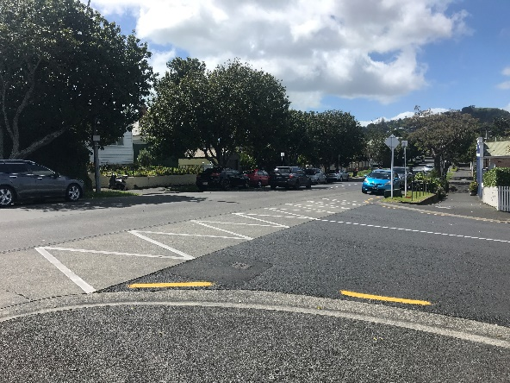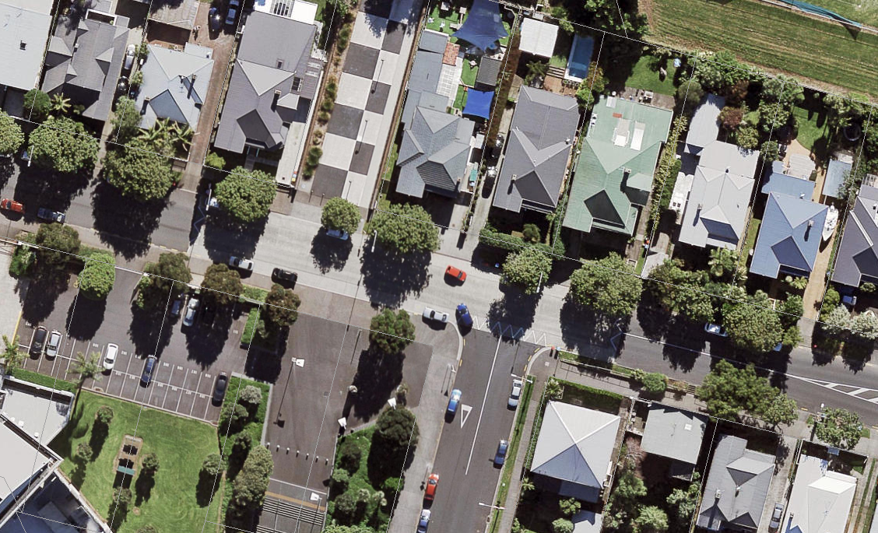
Raised

Observations

Observations of how people were using the space were made midday on a Tuesday. The traffic flow was continuous with frequent busses and trucks also travelling through the intersection. Most vehicles were estimated to be travelling at between 40-50km/hour. The presence of the raised intersection did not seem to slow down vehicles which is likely due to the long length of the raised intersection and the fact that vehicles had to accelerate to climb the crest on Walters Road. When there were no vehicles, pedestrians crossed at various locations, many diagonally. When there were vehicles, and there was a pedestrian waiting to cross, the vehicles did not yield to the pedestrians. When crossing, pedestrians had to pay attention and wait for a gap in traffic. No elderly or disabled users were observed crossing or attempting to cross the road. There were parked vehicles on either side of Walters Road along the length of the raised section. This blocked inter-visibility between vehicles and pedestrians which lead to drivers not being able to see pedestrians until they were on the road, next to the live lanes. Drivers not being able to see pedestrians also meant that they could not be courteous and giving way to pedestrians. Due to the length of the raised intersection, when pedestrians were crossing in the middle, they were not able to tell that they are about to walk on to a raised intersection as from a pedestrian’s perspective, the intersection did not look raised. Overall, the raised intersection did not appear to improve the safety of pedestrians to cross as from the observations pedestrians were behaving as they would on any other, non-raised road.

Case study 4 – Hawford Road/Beckford Road, Christchurch

Project description

Hawford Road and Beckford Road are both classified as local roads with approximately 2,000 vehicles per day. The intersection is not part of a bus route however coaches use the intersection to access Hansen Park to the south on Hawford Road for sports events. There are also schools to the south and north of the intersection. The speed limit is 50km/hour. The raised intersection was installed as part of a street renewal project in the early 1990’s. A pedestrian refuge island was included on the Beckford Road leg due to the high pedestrian flow along Hawford Road due the schools and sports park, and also the overall link in the walking network. This intersection platform is raised at the centreline and tapered to the kerb fender.

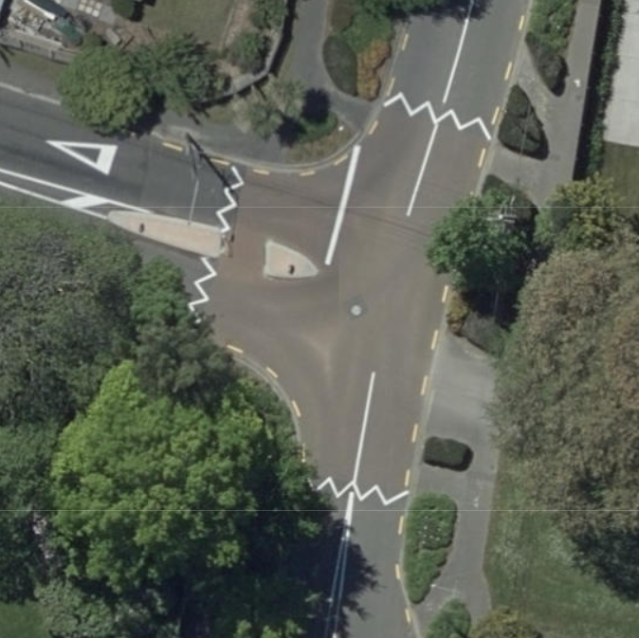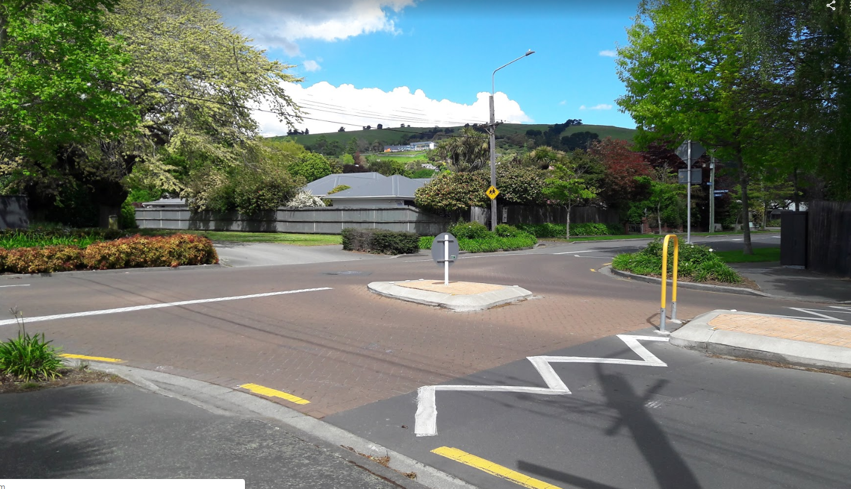
Hawford Road
Beckford Road

Observations

The pedestrian peak on this street is at the start and end of the school day, and also Saturday mornings for sports events. Observations of how people were using the space were made at the school morning peak. Most people cross on the Beckford Road leg and use the refuge to stage their crossing due to the turning movements at the intersection. People appear comfortable crossing the Hawford Road legs of this intersection as the traffic volumes are low and therefore sufficient gaps are available to cross and the raised platforms generally do not function as courtesy crossings.

CONCLUSIONS

The following conclusions are made from the review of guidance and the case studies
- Some guidance exists but the key aspect of when it is not appropriate to use only a raised intersection, because they may have an adverse impact on pedestrian level of service, is not clearly articulated. For example, a raised intersection could also feature refuge islands and/or kerb extensions to improve pedestrian outcomes but there is no direct guidance on the contexts where this may be appropriate. It relies on designers being aware of the impact on the level of service for pedestrians as outlined in the PPDG. The PPDG is not explicitly referenced in the current NZ guidance for raised intersections. It is noted that this level of service aspect is also not explicit in general intersection design guidance.
- The case studies, albeit limited in number, showed that in low traffic volume environments raised intersections work well for pedestrians and the arrangement does not rely on the crossings being ‘courtesy crossings’. It is noted that the definitions of ‘low’, ‘medium’ and ‘high’ environments in NZ guidance does not have numerical bands.
- In higher volume environments such as the Sumner Village case study, where peak hour traffic volumes are around 1000 vehicles per hour, pedestrians, particularly less able people, can struggle to find gaps and drivers are not expecting to yield to pedestrians, particularly on a bend or when turning out of a side road. The lack of compliance with the 30km/hour speed limit also contributes to a lack of gaps.
- Pedestrian refuge islands on the minor road, even with low traffic volumes, are a useful provision when the route is on the desire line for walking as intersection turning movements can create complexity for pedestrians crossing. The AT COP encourages this design.

RECOMMENDATIONS

It is recommended that the following be included in the NZ design guidance for raised intersections to improve the outcomes for walking (noting that this should also apply to priority controlled intersections without raised platforms):
- If the speed limit is greater than 60km/hour then pedestrian refuge islands must be provided on the major road of the raised intersection.
- If the traffic volumes on the major road exceed 750 vehicles per hour (as discussed earlier) in the peak hour (medium to high traffic volume) then kerb extensions and a pedestrian refuge (either on one or both sides of the intersection), should be included to ensure that pedestrians are able to the cross the road in two stages. Low traffic volume environments (less than 750 vehicles per hour in the peak hour should have kerb extensions but do not need the pedestrian refuge island. The two scenarios are shown in Figure 5.

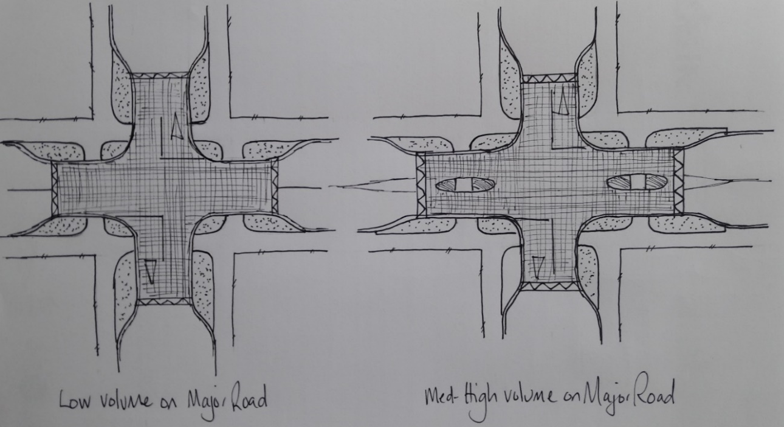

Figure 5 – Traffic volume scenarios and associated pedestrian provision on the major road

- If the crossing of the minor road is on a key desire line for walking, regardless of traffic volumes, then kerb extensions and a pedestrian refuge island are recommended as shown in Figure 6, and effectively applied in Case Study 4.

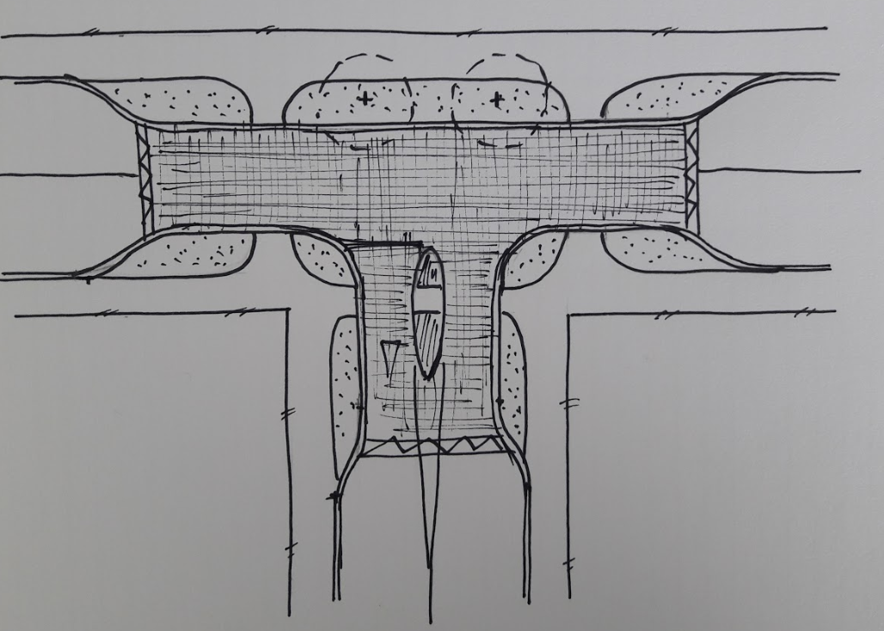

Figure 6 – Pedestrian provision on the minor road to cater for high pedestrian demand

REFERENCES
Austroads, Guides to Traffic Management and Road Design – various
Austroads, Achieving Safe System Speeds on Urban Arterial Roads: Compendium of Good Practice, https://austroads.com.au/publications/road-safety/ap-r514-16
Auckland Transport (2013), Code of Practice, https://at.govt.nz/about-us/auckland-transport-code-of-practice/
Auckland Transport (2019), Urban Streets and Roads Design Guide, https://at.govt.nz/media/1980686/urban-street-and-road-design-guide.pdf
Christchurch City Council (2016), Infrastructure Design Standard, https://ccc.govt.nz/assets/Documents/Consents-and-Licences/construction-requirements/IDS/IDS-Part-08-Roading-V3-September-2016.PDF
NACTO (2018), Urban Street Design Guide, https://nacto.org/publication/urban-street-design-guide/
NZTA (2019), Standard Safety Interventions Toolkit, https://nzta.govt.nz/resources/standard-safety-intervention-toolkit/
NZTA (2007), Pedestrian Planning and Design Guide, https://www.nzta.govt.nz/resources/pedestrian-planning-guide/
Vic Roads (2018), Road Design Note 03/07: Raised Safety Platforms (RSPs), https://www.vicroads.vic.gov.au/business-and-industry/technical-publications/road-design

