Zebra crossings: A threatened species in New Zealand?
Kylie Huard
B Sc. (Environmental Biology)
Senior Transportation Planner, Stantec
kylie.huard@stantec.com

Abstract
Over the past fifty years, there has been ongoing debate about the safety and benefits of zebra crossings. An influential study by Herms in 1972 concluded that painted crosswalks had a higher crash rate than unpainted crosswalks. Following the publication of Herms’ study, many cities and towns removed crossings or refrained from installing new ones. Herms’ study has influenced traffic guidelines and manuals and continues to be referenced by engineers as justification for not installing new crossings.
The New Zealand Pedestrian Planning and Design Guide states that standalone zebra crossings have been shown to increase the risk of a pedestrian crash, aligning with Herms’ findings. In New Zealand, engineers either apply warrant criteria or use the Pedestrian Selection Tool to justify new crossings or determine appropriate pedestrian facilities for the relevant site. While engineers may be hesitant about installing new zebra crossings, communities often demand new or upgraded zebra crossings to resolve local road safety issues.
Despite their safety concerns, zebra crossings are one of the few treatments available that give pedestrians priority when crossing the road, and they continue to be widely used across New Zealand. In an effort to improve the pedestrian environment and enhance accessibility, engineers and urban designers are installing creative and bespoke pedestrian treatments such as courtesy crossings and “crosswalk” art. However instead of tinkering with new and untested solutions, should we seek to address the key problem? Ultimately, engineers and planners are aiming to provide safe and appropriate crossing places for pedestrians that achieve an appropriate and desirable level of service for pedestrians and motorists. Is there an opportunity to focus on identifying ways to improve safety at zebra crossings, a universally recognised pedestrian treatment and one that gives pedestrians right of way, rather than inconsistent and bespoke treatments that create uncertainty and ambiguity?
This paper seeks to understand the deficiencies of zebra crossings in New Zealand by comparing the regulation and design of zebra crossings between New Zealand with Australia and the United Kingdom. It also explores road user attitudes and understanding of various types of pedestrian treatments, with a focus on zebra and courtesy crossings, as well as comparing the visibility of zebra crossings across the three countries.

Introduction
Over the past fifty years, there has been ongoing debate about the safety and benefits of zebra crossings. An influential study by Herms in 1972 concluded that painted crosswalks in the United States had a higher crash rate than unpainted crosswalks. Following the publication of Herms’ study, many city traffic departments removed crossings or refrained from installing new ones (McGrane, 2013; Mitman et al., 2008). Herms’ study has influenced traffic guidelines and manuals and continues to be referenced by engineers as justification for not installing new crossings (Zegeer et al., 2005).
However, pedestrians are legitimate road users and provision of facilities to enable them to safely and conveniently cross the road is required. Zegeer (2005) argues the point and states that “pedestrians have a right to cross roads safely, and planners and engineers have a professional responsibility to plan, design and install safe and convenient crossing facilities”.
The New Zealand Pedestrian Planning and Design Guide (NZ Transport Agency, 2009) references that standalone zebra crossings have been shown to increase the risk of a pedestrian crash, aligning with Herms’ findings. In New Zealand, engineers either apply warrant criteria or use the Pedestrian Selection Tool¹ to justify new crossings or determine appropriate pedestrian facilities for the relevant site. Both methods use inputs such as traffic and pedestrian volumes, road geometry, speed data, crash history data and road user delay. While engineers may be hesitant about installing new zebra crossings, communities often demand new or upgraded zebra crossings to resolve local road safety issues (NZ Transport Agency, n.d.).
Despite their safety concerns, zebra crossings are one of the few treatments available that give pedestrians priority when crossing the road, and they continue to be widely used across New Zealand. In an effort to improve the pedestrian environment and enhance access, engineers and urban designers are installing creative and bespoke pedestrian treatments. Newer types of facilities such as courtesy crossings and “crosswalk” art are increasingly being trialled across the network. However instead of tinkering with new and untested solutions, should we be seeking to address the key problem? Ultimately, engineers and planners are seeking solutions to provide safe and affordable crossing places for pedestrians that achieve an appropriate and desirable level of service for pedestrians and motorists. Is there an opportunity to focus on identifying ways to improve safety at zebra crossings, a universally recognised pedestrian treatment and one that gives pedestrians right of way, rather than inconsistent and bespoke treatments that create uncertainty and ambiguity?
This paper seeks to understand the deficiencies of zebra crossings in New Zealand by comparing the regulation and design of zebra crossings between New Zealand with Australia and the United Kindgom. It also explores road user attitudes and understanding of various types of pedestrian treatments, with a focus on zebra and courtesy crossings, as well as comparing the visibility of zebra crossings across the three countries.

Background
In New Zealand, there are just three locations where pedestrians have priority when crossing the road: zebra crossings, traffic signals and patrolled school crossings. While these treatments enhance access for pedestrians, concerns of the safety deficiencies of zebra crossing are well researched. Herms (1972) and Elvik (2000) both concluded that zebra crossings may give pedestrians a “false sense of security” and reduce their vigilance, whereas Redmon (2003) found that pedestrians generally do not expect drivers to stop for them and so are more vigilant, and are therefore unlikely to assert their priority given the safety risks. The safety deficiencies of zebra crossings are also recognised in the New Zealand Pedestrian Planning and Design Guide (NZ Transport Agency, 2009 – table 6.4), which cites that zebra crossings with no additional physical aid (such as a kerb extension or refuge) have a -28% crash reduction benefit; that is, installing a zebra crossing on its own has been shown to increase the risk of a pedestrian crash.
A review of NZ Transport Agency’s Crash Analysis System (CAS) data for the past 10 years found that there were 166 crashes at zebra crossings in New Zealand resulting in a pedestrian death or serious injury (DSI), and a further 597 resulting in minor injury. Pedestrian DSI crashes account for 13.0% of all DSI crashes, with 5.7% of all pedestrian DSI crashes occurring at zebra crossings.
Despite their risks, zebra crossings continue to be widely used across New Zealand and are perceived positively by many local communities (Birkenhead Residents Association, 2018; Leighton, 2019; Gisborne Herald, 2018). In an effort to improve their safety, some engineers have modified the layout of zebra crossings. While the design and layout of zebra crossings is specified in the Pedestrian Planning and Design Guide (NZ Transport Agency, 2009), the Manual of Traffic Signs and Markings (NZ Transport Agency, 2009) and the Traffic Control Devices Manual (NZ Transport Agency, 2008), Road Controlling Authorities (RCA) have some flexibility in using some core elements, including the choice of using a belisha beacon or an orange disc and whether to include the painted diamond as an advance warning to motorists. However, poor compliance to design requirements has prompted Waka Kotahi and predecessors to publish a number of technical notes over the last few decades:
- In 1989, Dunn (1989) published a paper providing the background and rationale for a new technical recommendation (TR11). TR11 was introduced by the Land Transport Safety Authority to establish standards for pedestrian crossings in New Zealand as local authorities were experimenting with altering the layout or adding different devices. The paper suggests that New Zealand “traffic engineers were becoming increasingly concerned over the conventional zebra crossing’s poor safety record”, resulting in some engineers trialling alternative layouts with the aim of improving safety. Most of this experimentation was not permitted by traffic regulations at the time nor met minimum requirements.
- In 2006, Land Transport NZ published a Traffic Note 1 (LTNZ, 2006) to highlight the correct layout for pedestrian crossings, as well as relevant road user rules as they were becoming increasingly concerned about poor and incorrect installations of pedestrian crossings.
- In 2011, Traffic Note 1 (Rev 3) was updated and reissued again (NZ Transport Agency, 2011) to highlight the requirements and correct installation of pedestrian crossings to RCAs.

Given the negative crash reduction benefit of zebra crossings, engineers have few options left in their ‘toolbox’ to enhance pedestrian access. Mid-block traffic signals and grade-separated crossings are expensive, and kerb extensions and refuges do not give priority to pedestrians, providing them with a lower level of service. There is currently no other available treatment that provides a safe, convenient, accessible and affordable crossing for pedestrians. This problem has led to some local government authorities to be more creative, with many trialling alternative types of pedestrian facilities and treatments. Some local Councils have developed modified zebra crossings, including red crossings (extensively used in Napier and Rotorua), as well as creative zebra crossing elements such as three-dimensional designs and complementary artwork (refer to Figure 2-1).
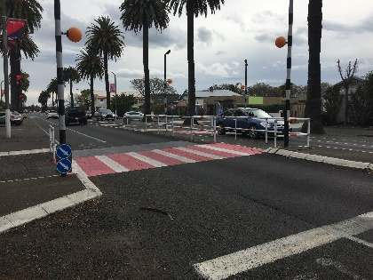 | 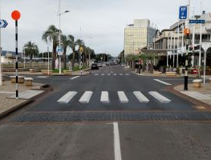 | 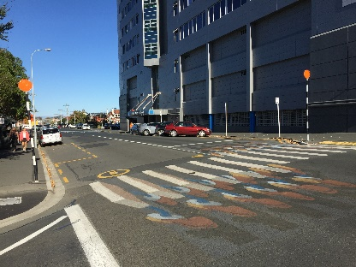
Figure 2-1: Modified zebra crossings in Napier, Tauranga and Dunedin respectively
In other locations, bespoke pedestrian facilities have been installed with the aim of improving pedestrian access and safety, while ‘crosswalk art’ is increasingly being used by urban designers to enhance amenity and public realm. The aim of this approach is to engage with motorists to slow down and encourage them to take more care when driving through an area with high pedestrian activity. Examples of alternative types of treatments and crossings that have been implemented In New Zealand recently are shown in Figure 2-2 below.
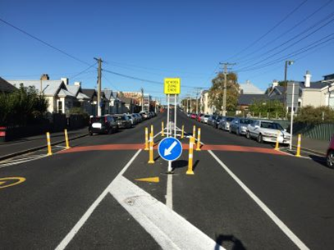 | 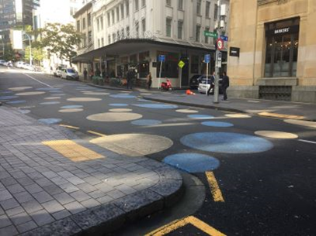 | 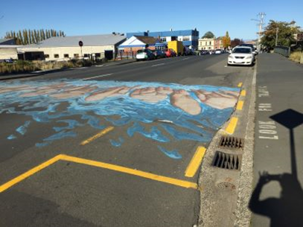
Figure 2-2: Examples of bespoke pedestrian facilities
Platforms are increasingly being used at key pedestrian desire lines. Some of these treatments feature tactiles and hold rails, while the image shown on the right in Figure 2-3 is used as a patrolled school crossing (kea crossing). These facilities guide pedestrians to use the facility, however these are not the same as courtesy crossings, and nor do they give pedestrians priority.
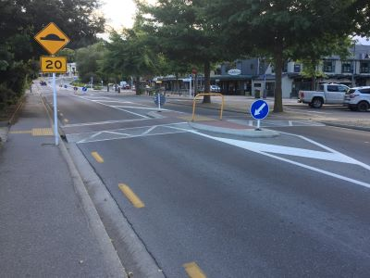 | 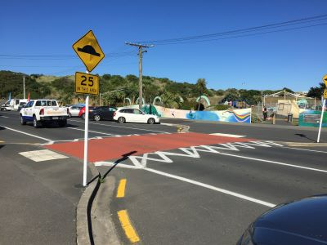 | 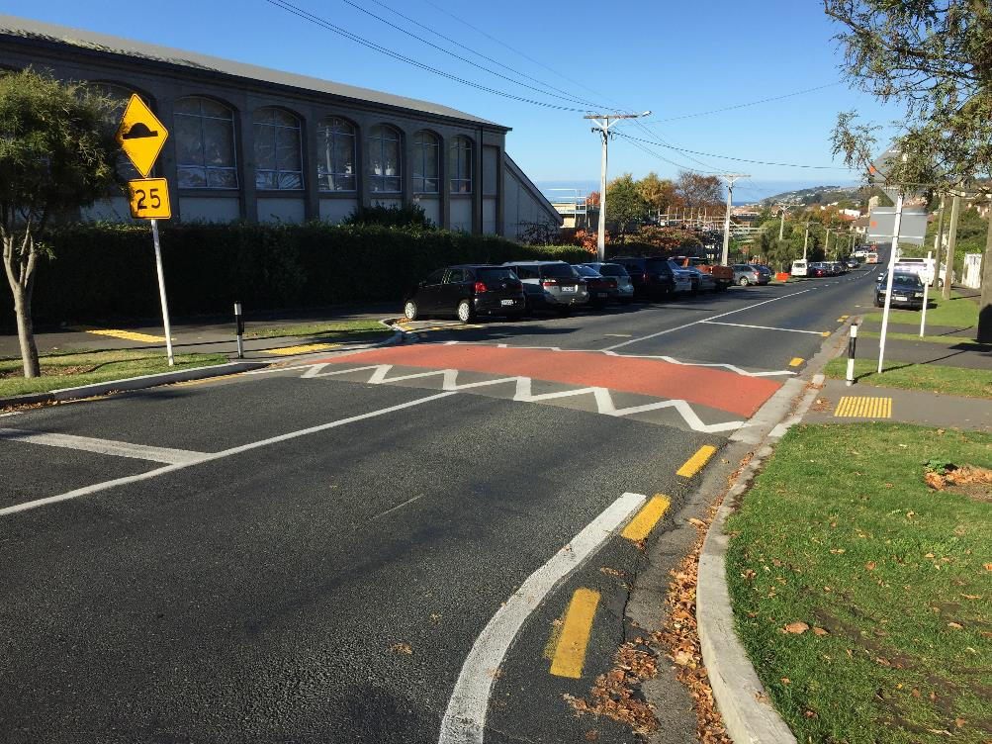
Figure 2-3: Examples of various platform treatments
In areas of high pedestrian activity, pedestrian treatments on platforms are commonly referred to as ‘courtesy crossings”. Courtesy crossings provide a place for pedestrians to cross, and while drivers are not required to stop, it is recommended that drivers are courteous to pedestrians using or waiting to use a courtesy crossing (NZ Transport Agency, 2015). The Pedestrian Planning and Design Guide supports the use of platform crossings, however the design and installation of these is not prescriptive.
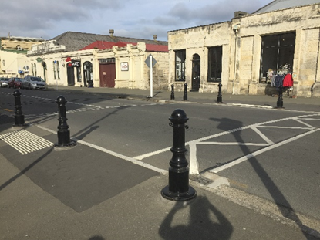 | 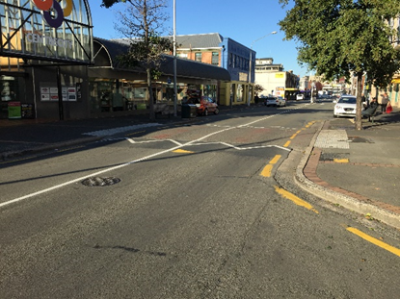 | 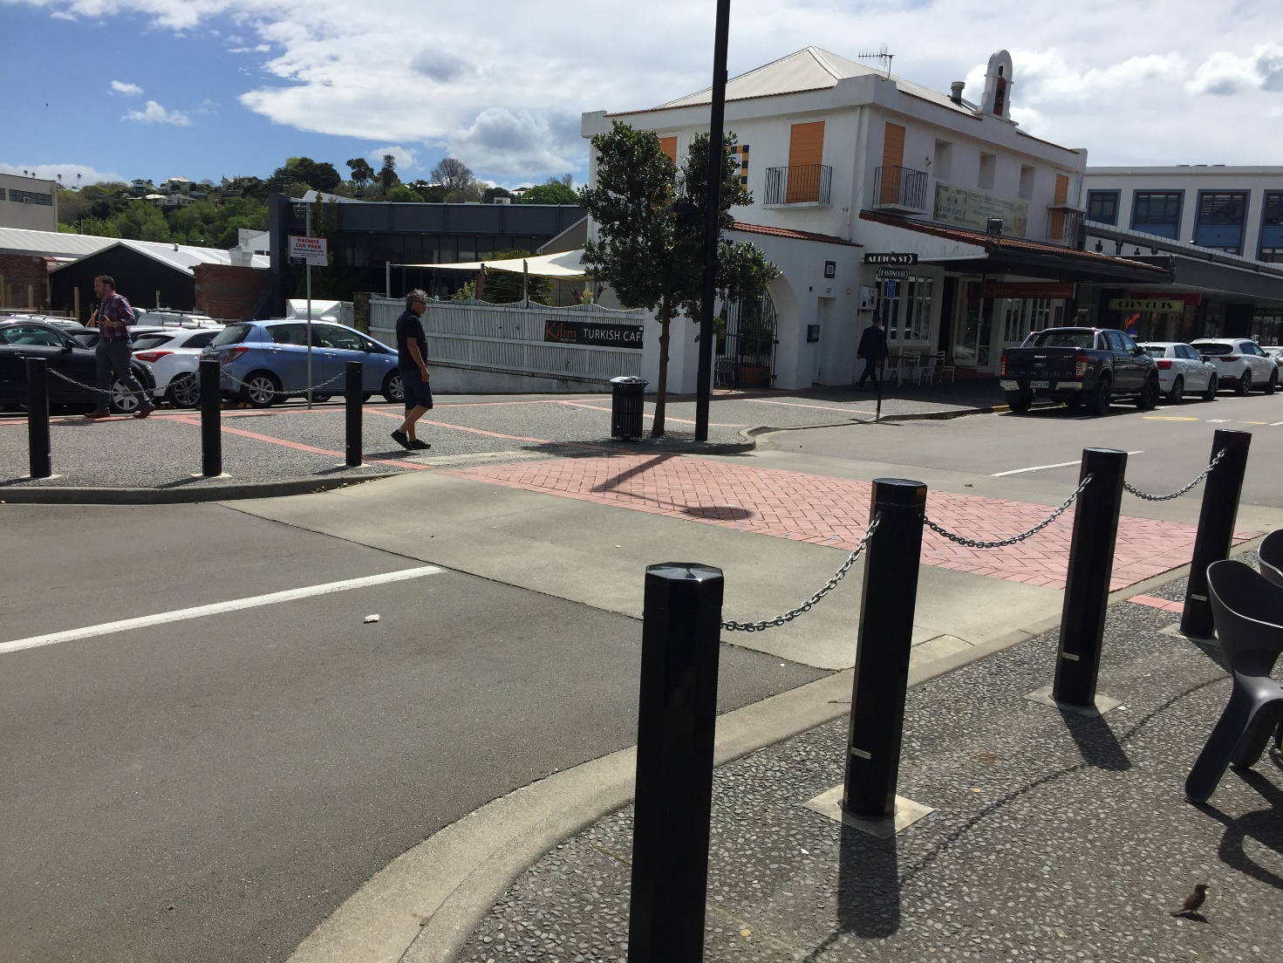
Figure 2-4: Examples of courtesy crossings
Inconsistent application of these various crossings is creating confusion for pedestrians and motorists alike. Recent media coverage (Edens, 2017; Dine, 2018; Kilmister, 2018) has highlighted the confusion around courtesy crossings, prompting local authorities such as Nelson City (2019) and Hamilton City (n.d.) as well as the Automobile Association (2019) to post information on their websites on how to use them. While proponents of courtesy crossings aim to create ambiguity so road users can negotiate priority, the inconsistent use and application of courtesy crossings means they are not intuitive to use.
Rather than considering new pedestrian treatments and variations of existing facilities, this paper seeks to determine whether improvements or changes to zebra crossings in New Zealand could be made to improve their visibility, and ultimately their safety. This paper compares the road rules governing the regulation of road user behavior at zebra crossings in New Zealand, Australia and the United Kingdom, as well as a comparison of the differences between the design, layout and core elements of zebra crossings across the three countries. Road user behavior and understanding of priority at different types of pedestrian crossings is tested via a survey of New Zealand Automobile Association (AA) members.
The AA survey also explores whether New Zealand motorists understand the meaning of the diamond linemarking on approach to the crossing. Anecdotal evidence suggests that some motorists use the diamond as an indicator to determine road user priority. That is, if a motorist arrives at the diamond before a pedestrian reaches the crossing, then a motorist does not have to yield to the pedestrian, which is not legally correct. Varhelyi (1998) reviewed drivers’ speed behaviour at zebra crossings and found that some drivers ‘compete’ for priority, knowing that pedestrians are unlikely to force priority due to the risks involved. This hypothesis is tested in the AA road user survey, which includes a question to determine whether drivers understand the purpose of the diamond.

Methodology
To determine road user attitudes and understanding of different types of pedestrian treatments, as well as any potential deficiencies of zebra crossings in New Zealand, a number of research methods and approaches were adopted including:
- A comparison of the regulation of zebra crossings in New Zealand with those in Australia and United Kingdom to understand key differences and determine whether this may influence road user behavior.
- A comparison of the core elements and layout of zebra crossings in New Zealand, Australia and United Kingdom to understand whether these may influence visibility or compliance.
- A survey distributed to 20,000 randomly selected Automobile Association members to explore participants’ understanding of:
  - road user priority;
  - knowledge of specific road rules relating to zebra crossings;
  - awareness of core elements of zebra crossings; and
  - awareness and understanding of courtesy crossings.
Further details of each aspect of this research is provided as follows.

Results and Discussion

Zebra crossing regulation
A comparison of road rules relating to zebra crossings was undertaken for three countries (New Zealand, Australia and the United Kingdom). The review initially included the United States, however the laws vary between US states, and pedestrian priority is substantially different compared to the other three countries. In many US states, any extension of a footpath beyond the kerb is considered a ‘crosswalk’, where drivers must give priority to pedestrians regardless of whether the crossing is marked. Given this difference, the literature review focused on just the three test countries.

New Zealand
In New Zealand, there are provisions in the Land Transport (Road User) Rule (10.1) 2004 for pedestrian priority at pedestrian (zebra) crossings as follows:
10.1 (1) A driver approaching a pedestrian crossing must:
(a) give way to pedestrians, and to riders of wheeled recreational devices or mobility devices:
(i) on the pedestrian crossing; or
(ii) obviously waiting to cross it; and
(b) if necessary, slow down and stop the driver’s vehicle for that purpose.
Note that the Land Transport (Road User) Rule is regularly updated. Prior to 2009 this Road User Rule did not include Part (1)(a)(ii), that is the reference to “obviously waiting to cross it”. This means that 10 years ago, drivers were only required to give way to pedestrians while on the crossing, but not for anyone obviously waiting to cross.
A road user rule (11.5) also applies for pedestrians at zebra crossings to ensure they provide sufficient warning for a motorist to yield prior to entering a pedestrian crossing. The rule states that a pedestrian must:
“not suddenly enter a pedestrian crossing when an approaching vehicle is so close to the pedestrian crossing that the driver of the vehicle is unable to give way to the pedestrian.”

Australia
The Australian Road Rules (ARR) have some subtle differences in their give way rule at pedestrian crossings, emphasising that a driver must be prepared to stop on approach to a pedestrian crossing:
“ARR 81: Giving way at a pedestrian crossing
- A driver approaching a pedestrian crossing must drive at a speed at which the driver can, if necessary, stop safely before the crossing.
- A driver must give way to any pedestrian or bicycle rider on or entering a pedestrian crossing”
Unlike New Zealand, there is no equivalent rule for pedestrians when entering a pedestrian crossing in Australia, however ARR 236 provides an overarching general rule, where “A pedestrian must not cause a traffic hazard by moving into the path of a driver”.

UK
In the United Kingdom, motorists are not obliged to give priority to a pedestrian waiting to cross a pedestrian crossing. However, drivers are encouraged to look out for pedestrians and be ready to slow down. Unlike Australia and New Zealand, pedestrians have priority only once they have stepped out onto the road. Rule 195 of the UK Highway Code states:
“As you approach a zebra crossing:
- look out for pedestrians waiting to cross and be ready to slow down or stop to let them cross
- you MUST give way when a pedestrian has moved onto a crossing”

Summary
The road rules from New Zealand and the United Kingdom share similar language and intent, however the Australian rule has a key subtle difference, stating that motorists must to be prepared to stop on approach to a zebra crossing. The Australian rule puts the onus on the driver, advising motorists to be proactive and reduce their speed when approaching a zebra crossing. For New Zealand drivers, the requirement to give way to a pedestrian obviously waiting to cross is a relatively new addition to the road rules. It is likely that some drivers in the community are not aware of these changes and may not give priority to pedestrians waiting to cross at zebra crossings.
The inclusion of a specific road rule in New Zealand that governs pedestrian behaviour at zebra crossings in New Zealand is intended to reduce crash risk, however it also introduces ambiguity about road user priority. The additional road rule for pedestrians reduces a drivers’ responsibility to yield to pedestrians. The power ratio between road users (Sucha et al., 2017) is heavily skewed towards the motorist as they have the power to kill or injure, while a pedestrian is unlikely to assert their priority due to the threat of injury.

Design and layout of zebra crossings
A review of the design and layout of zebra crossings in New Zealand, Australia and the UK was undertaken to understand the key differences in the core elements of zebra crossings that may impact on visibility or compliance. Images of typical zebra crossings in the three countries are shown in Figure 4-1 below.
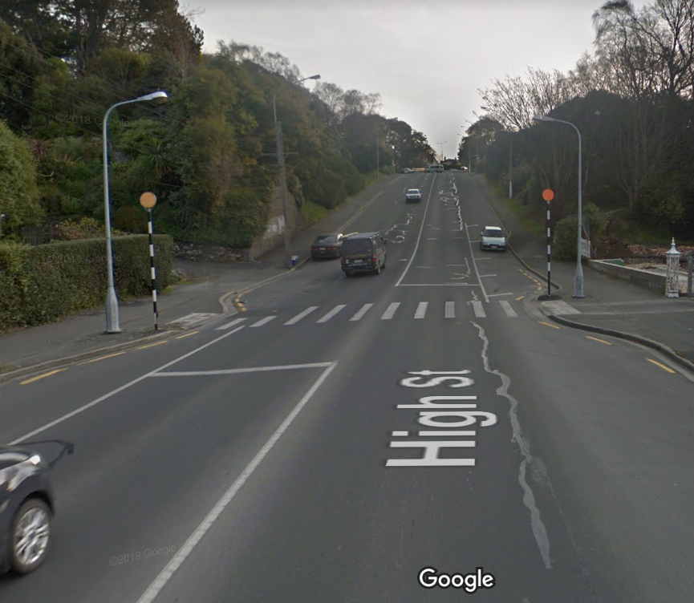 | 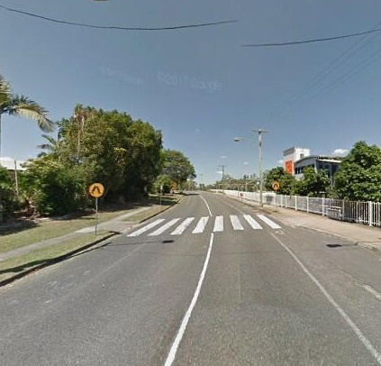 | 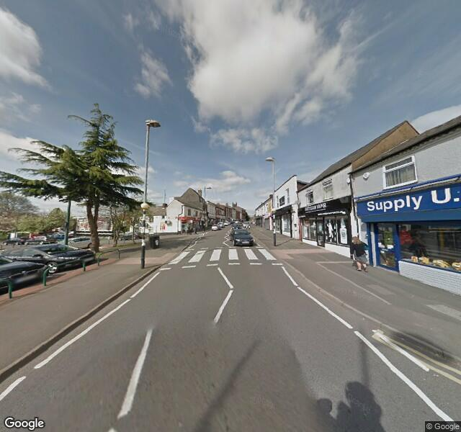
Figure 4-1: Images of zebra crossings in New Zealand, Australia and UK respectively
A summary of the key differences between the design elements that make up zebra crossings in the three countries in Table 4-1 below. Additional detail, and a discussion of these differences is provided below.

Table 4-1: Summary of zebra crossing design elements in New Zealand, Australia and the United Kingdom
 | New Zealand (MOTSAM, 2010) | Australia (MUTCD, 2009) | United Kingdom (DoT, 1995)
Bar markings (length) | ≥ 2 metres long | 3 - 6 metres long | 2.4 – 10 metres long
Bar markings (width) | 300mm white stipe with 600mm gap  300  600 | 600mm white stipe with 600mm gap  600  600 | Similar to Australia. Each stripe of equal thickness:  500- 715mm wide
Advance warning | White painted diamond (now optional) | Two zig zag lines on either side of the lane (designates no parking) | A single zig zag line in the middle of the lane
Beacon | Flashing belisha beacon or orange disc | n/a | Flashing belisha beacon
Parking restrictions | > 6m (8-15m preferred) of no stopping lines on upstream approach. | Minimum of 20m on the approach and 10 m on the departure side (for crossings without kerb protrusions) | 15m - 35m on both sides of the crossing

Bar Markings
The white bar markings are the most universal element of zebra crossings, as well as being one of the most visible. The width of the white bar markings is likely to influence the visibility of the crossing. Table 4-1 above, and the images in Figure 4-1 reveal that the bar markings in New Zealand are half the width of those in Australia and the UK, but each marking is painted the same width apart (~600mm). This is likely to influence the contrast and visibility of the crossing.

Advance Warning
New Zealand is one of a few countries to use a painted diamond symbol as an advance warning linemarking of a zebra crossing. In the US and Canada, the diamond symbol is often used to depict a High Occupancy Transit Lane (HOT) or a bicycle lane. Australia and the UK both use zig zag line marking at zebra crossings, although their meaning is different. In Australia, the zig zag linemarking is used as an advance warning of a zebra crossing ahead, as per the diamond in New Zealand. In the UK, zig zag linemarking is used on both sides of the road and either side of the crossing to denote areas of no parking.
In 2004, a trial of pedestrian zig zag linemarking was approved in Auckland in 2004 as Land Transport NZ was concerned that motorists did not clearly understand the purpose of the diamond symbol used. There were no conclusive safety benefits at the trialled locations, and the option was subsequently not approved for use in New Zealand.

Beacons
Flashing Belisha beacons were a standard feature of all zebra crossings in New Zealand up until the 1990s, before the orange disc was introduced as an alternative. There are no firm rules about which option to choose, although the draft Traffic Control Devices Manual Part 5 (NZ Transport Agency, 2018) provides some guidance, recommending “it is better to use belisha beacons where there are a lot of urban signs and light clutter”.
The orange disc was considered more conspicuous than a non-illuminated beacon, however a survey completed by 31 RCAs on the issue (NZ Transport Agency, 1999) found concerns with the impact of orange discs at night and their continued visual impact once weathering had taken place. Results from the survey also ascertained that flashing belisha beacons were a maintenance problem, with at least one Belisha beacon not operating at 16% of pedestrian crossings that featured the beacons.

Parking
Of the three countries, New Zealand is substantially more permissive in allowing parking close to a zebra crossing, with a minimum requirement of just six metres of no stopping lines on the upstream approach (although 8 to 15 metres is preferred). However, the proximity of parked vehicles impacts on the drivers’ sightlines, making it difficult to see pedestrians waiting to cross. MUTCD (2009) states that the primary way to achieve adequate sight distance between approaching vehicles and pedestrians is “by means of parking restrictions near the crossing”. While multiple variables including the width of the road, operational speeds, the provision of kerb extensions and the height of adjacent parked vehicles influence the ability of a motorist to see a pedestrian and stop in time, Dunn (1989) highlights that the most significant safety problem at pedestrian crossings is vehicles parking too close to crossings and restricting visibility.

AA Member Survey
A survey was sent out to 20,000 Automobile Association members in September 2019, with 1179 members completing the survey (5.9% a response rate). Surveying members from the Automobile Association was considered appropriate to understand road user attitudes and understanding of priority at crossings, as nearly all members drive (99.1% of respondents stated that they had a driver licence).
The aim of the survey was to explore participants’ understanding of:
- road user priority at common and bespoke pedestrian crossing facilities;
- knowledge of specific road rules relating to zebra crossings;
- familiarity of core elements of zebra crossings and understanding of the diamond linemarking; and
- priority at courtesy crossings, and experience using these crossings.
The survey questions were designed primarily to understand whether participants understood road user priority at different types of pedestrian crossing facilities, as well as self-reported behaviour at zebra and courtesy crossings. Two questions were also included to test the hypotheses that some motorists use the advance warning diamond symbol to ‘compete’ for priority at zebra crossings. Anecdotal evidence suggests that some road users believe that the symbol serves as a guide for whether a motorist needs to give way to a pedestrian, where if a motorist passes the diamond before a pedestrian arrives at the crossing, then the pedestrian must yield to the motorist.

Road user priority
Survey participants were shown 10 photographs of various types of pedestrian treatments and were asked whether the pedestrian or motorist was meant to give way. Participants could also select a ‘not sure’ response. Table 4-2 shows the percentage of respondents who selected the wrong answer or were ‘not sure’ which road user had to give way.
Table 4-2: Road user priority survey results
Pedestrian Treatment | Incorrect answer | Not sure | Total
Zebra crossing | 2.1% | 0.1% | 2.2%
3D Zebra Crossing | 2.0% | 0.2% | 2.2%
Refuge island | 3.7% | 0.8% | 4.6%
Shared zone | 55.0% | 11.4% | 66.4%
Courtesy crossing 1 | 21.6% | 3.9% | 25.5%
Courtesy crossing 2 | 25.8% | 6.1% | 31.9%
Cross walk art 1 | 18.5% | 18.0% | 36.5%
Cross walk art 2 | 11.1% | 16.5% | 27.6%
Bespoke school zone | 39.4% | 8.7% | 48.1%
Threshold treatment | 24.5% | 3.9% | 28.4%
The data highlights that most people understand road user priority at traditional pedestrian treatments such as zebra crossings and refuge islands. However, the results confirm that many of the participants did not understand road user priority at many of the less common or bespoke treatments. The types of facilities that were considered the most ambiguous were the shared zone and the school zone (refer to Figure 4-2).
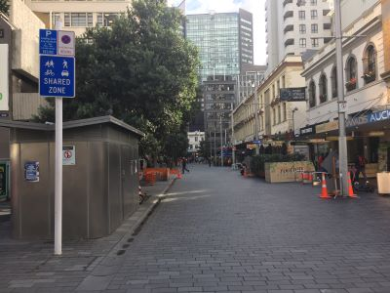 | 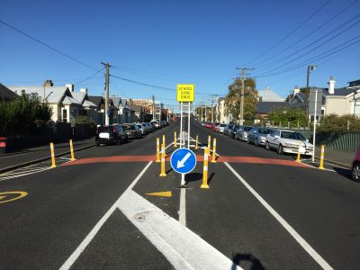
Figure 4-2: Images of the shared zone (L) and school zone (R) used in the AA member survey
Shared zones are a relatively new and uncommon treatment in New Zealand, however generally the urban design of these zones promotes a low speed environment by removing separation and regulation. The concept of creating confusion and ambiguity was championed by Hans Mondermann who trialled removing signs and traffic controls (known as naked streets) and found that drivers became uncertain and therefore more alert and accommodating (Johnson, 2017).
The school zone treatment is one of several bespoke treatments that form a gateway cordon around a cluster of five schools in central Dunedin, with the aim of reducing vehicle speeds and improving pedestrian safety (DCC, 2019). The gateway cordons were temporary treatments that are now being fitted with permanent kerb protrusions and refuge islands.
Survey participants were asked which types of path users, including those using mobility and wheeled recreational devices (such as scooters, skateboards and e-scooters) had priority at zebra crossings. The results were as follows:
- Pedestrians 99.6%
- Person riding a bicycle 65.9%
- Person riding on a kick scooter 75.1%
- Person riding on an e-scooter (e.g. Lime scooter) 68.7%
- Skateboarders 74.4%
- Person riding on a mobility scooter 93.2%
Overwhelmingly, most respondents were aware that pedestrians, and to a lesser extent a person using a mobility scooter had priority at zebra crossings. However, between 25 to 30% of respondents were unaware that a person on a scooter, e-scooter or skateboard also has priority. A person riding a bike does not have priority at a zebra crossing, however nearly two-thirds of respondents considered that drivers had to give way to a cyclist riding across the crossing.
At a zebra crossing with a raised median refuge in the middle, motorists are only required to give way to a pedestrian on the same half of the crossing as the motorist. Nearly 60% of survey respondents were familiar with this rule. While 37.1% of responses thought that the pedestrian had to finish crossing the road, driving courteously in the vicinity of zebra crossings results in a safer and less hostile environment.

Elements of zebra crossings
Several questions were included in the AA member survey to gauge the understanding, visibility and preferences of core elements of zebra crossings. Images of the advance warning signs used in four countries were shown to participants, who were asked to determine which sign they thought best depicted a zebra crossing (refer to Figure 4-3). Nearly 95% of respondents selected the New Zealand sign (second from left in Figure 4-3). This is not surprising, given that the respondents largely live in New Zealand and this is the sign people are most exposed to and familiar with. Of interest is that the New Zealand sign depicts the infrastructure, that is the crossing itself, whereas the signs from the other three countries portrays the user.
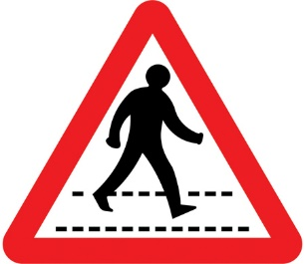 | 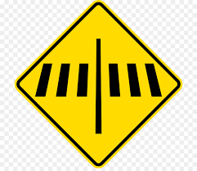 |  | 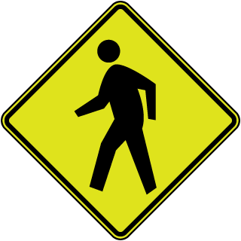
Figure 4-3: Zebra crossing signs from UK, New Zealand, Australia and the US
Survey participants were shown images of the core elements of zebra crossings and asked how often they noticed each, on a scale of 0 (never) to 5 (always). By calculating the number of responses at each point of the scale, it is possible to determine the relative ‘noticeability’ ranking of each element.

- Painted stripes Most noticeable
- Zebra sign
- Belisha beacon
- Orange disc
- Painted diamond
- Black and white striped pole Least noticeabile
It is not surprising that the painted stripes are the most visible element of a zebra crossing as they are located in the drivers’ line of sight. The yellow warning sign as well as the orange beacon or disc are also relatively noticeable as they are bright and intentionally contrasting to enhance visibility of the crossing. The painted diamond is an optional treatment and not used at all crossings, while the black and white striped pole is located on the kerb in the drivers’ peripheral vision.
Survey participants were specifically asked about the purpose of the diamond linemarking on approach to a zebra crossing. Responses were as follows:
- To provide a guide for who should give way i.e. if a motorist passes the diamond before a pedestrian gets to the crossing, then the pedestrian should give way  - To provide a guide for motorists to ensure they are driving in the middle of their lane  - To alert drivers that there is a zebra crossing ahead  - I don't know | 18.4%  0.3%  73.7%  7.7%
While most participants understood that the purpose of the diamond was to alert drivers of a zebra crossing ahead, 216 participants believed that the purpose of the diamond was to provide a guide to determine road user priority. A one-tailed t-test was used to determine whether there was a significant difference between the number of responses received for the correct answer (answer 3) and the answer relating to drivers competing for priority at zebra crossings (answer 1). The t-statistic was statistically significant (p<0.0001), determining that the number of participants providing answer 1 was statistically significant.
This supports the theory that some drivers do use the diamond as an indicator of priority, which may influence their behaviour when driving towards a zebra crossing. This aligns with the study by Varhelyi (1998) who concluded that some drivers compete for priority at zebra crossings. Slowing down to give way to pedestrians punishes the driver with loss of time as well as inconvenience, while accelerating rewards the driver with priority. Drivers expect the pedestrian to stop, as pedestrians are unlikely to compete due to the personal risks involved. In his research, Varhelyi found that three quarters of drivers maintain the same speed or accelerate on the approach to zebra crossings, signalling that they do not intend to give way to pedestrians.
Further analysis of these results using a chi-square test found there was no statistical difference between responses from males and females (p=0.086), however there was a statistically significant difference in responses received from those under 55 years compared to those over 55 years (p=0.034). Just over 20% of under 55 year olds assumed the purpose of the diamond was to determine road user priority, compared to 16.7% of over 55 year olds.
Note that the comparison of people aged above and below 55 was used throughout the analysis of results as it was the median age of survey respondents. While this is substantially higher than the median age of the New Zealand population (37 years), those aged under 16 are not legally allowed to drive, and therefore are unlikely to have participated in the survey. Removing this subset of the population means that the median age of the driving population is likely to be close to 55 years.

Courtesy Crossings
Three questions about courtesy crossings were included in the survey. The first question related to driver behaviour at courtesy crossings where participants were asked, “When driving, do you give way to pedestrians at courtesy crossings?”. Responses were as follows:
- Yes 33.7%
- No 9.8%
- Sometimes 36.4%
- Only if the pedestrian has already started crossing 20.1%
Respondents were subsequently asked which road user has to give way at a courtesy crossing. Responses were as follows:
- Person using the crossing 63.3%
- Driver or rider using the road 15.4%
- They have to work it out between them 15.3%
- I don’t know 6.0%
The variation in responses to both questions demonstrates that priority at these crossings is unclear. However, the ambiguity is intentional, with the NZ Road Code (the official user-friendly guide to New Zealand’s traffic law and safe driving practices) stating that while courtesy crossings are “not official pedestrian crossings, they do provide a place for pedestrians to cross. Drivers should be courteous to pedestrians using a courtesy crossing” (NZ Transport Agency, 2015). The intention at these sites is that road users ‘negotiate’ priority, for example by using eye contact and body language. This is based on the ‘naked street’ concept championed by Mondermann (Speck, 2018) that is widely used in the Netherlands and other parts of Europe. However, woonerfs work because the car is considered a guest in the environment, with traffic speeds reduced to near walking speed. The principles of naked streets are applied consistently and are well recognised across the Netherlands; the onus of legal liability is also heavily weighted against the motorist in crashes with vulnerable road users (Slimmen and Van Boom, 2017).
By contrast, courtesy crossings in New Zealand are often installed as a standalone feature located in a busy urban environment on a pedestrian desire line, rather than forming part of a wider traffic calming scheme. Courtesy crossings don’t emphasise the car as a guest in the environment, as vehicle priority along the remainder of the corridor is clearly demarcated using standard markings, kerbs and traffic control devices. Courtesy crossings are sometimes used in 50km/h zones and the New Zealand Road code does not stipulate that they have to be installed on raised platforms. Higher speed environments make it difficult for road users to establish eye contact and negotiate priority. Yet the safety benefits of platform crossings are estimated to provide a potential crash reduction of 80% (NZ Transport Agency, n.d.).
In 2006, Quimby and Castle undertook a review of ‘simplified streetscape schemes’ which use ambiguity as a traffic management scheme. Their findings were that results varied between schemes, and there was no single successful model that could be replicated. In some locations, drivers gave priority, while others required pedestrians to ‘force control’. While the review found that road users can safely interact in less regulated spaced, there were frequent observations of confused priority, where road users were not aware of who had priority.
Courtesy crossings are not specifically defined (nor referenced) in the current Pedestrian Planning and Design Guide, although guidance for the layout and siting of pedestrian platforms is included. However, the New Zealand Road Code states “Courtesy crossings are usually made of bricks or paving and are often raised above the level of the road” (NZ Transport Agency, 2015), suggesting that they don’t have to be installed on raised platforms. Three examples of pedestrian crossings in central Dunedin are shown in Figure 4-4 below. These crossings are located within 300 metres of each other and highlight the different and inconsistent treatments used within a single city. The photo on the left depicts a ‘conventional’ courtesy crossing, which is located on a strong desire line with high pedestrian flows and features a brick paved area positioned on a raised platform.
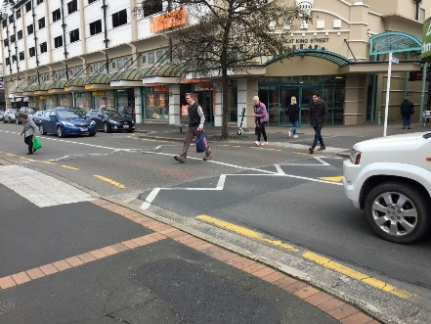  1 | 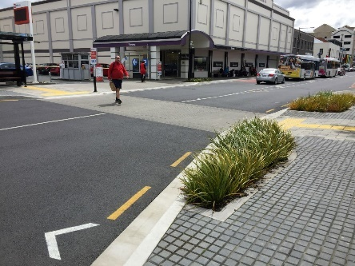  2 | 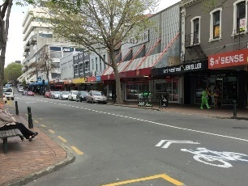  3
Figure 4-4: Courtesy crossings at Great King Street (1) Bus Hub (2) George Street (3)
Discussions with the local authority traffic engineer (H. Poulson, pers.com., 2019) confirmed that this crossing provides a good level of service for pedestrians, with many drivers demonstrating courteous behaviour towards pedestrians. However, the other two crossing points shown in Figure 4-4 are at-grade, yet both feature kerb protrusions and drop kerbs, communicating to pedestrians to cross at these locations. The crossing at the Dunedin bus hub (image 2) even includes tactile pavers, directing people with visual impairments to cross here. The crossing on George Street (image 3), Dunedin’s main shopping street, has a poor level of service, lacks visibility and contrast with the surrounding environment, and does not send any cues to the motorist to slow down. Pedestrian movements are dispersed across George Street meaning that desire lines are not strong nor well defined.
As the second and third images in Figure 4-4 are at-grade, it is unclear what they are and what their purpose is. They could be considered courtesy crossings as the New Zealand Road Code suggests that courtesy crossings do not have to be raised, however they do not encourage slower speeds and motorists are unlikely to be ‘courteous’ to pedestrians. The variation in the types of treatments used makes it difficult for road users to understand how to interact with these treatments. If the community is having to be educated about how to use courtesy crossings, adding crossings with similar features but a different purpose will add confusion and heighten the pedestrian crash risk.
In addition, the road rules in New Zealand specify that one road user does actually have priority over the other, giving the motorist a choice as to whether to give way to a pedestrian at a courtesy crossing. This choice is validated by the mixed responses given by participants when asked whether they give way to pedestrians at courtesy crossings when driving. This is reinforced in the subsequent question, where nearly two thirds of survey participants correctly answered that the pedestrian has to give way to a motorist at a courtesy crossing. However, the Road Code states that drivers should be courteous to pedestrians at courtesy crossings. Yet only 15% of participants responded that road users need to “work it out between them”, or negotiate priority, which, while not the technically correct answer, is the desired intent of courtesy crossings.
Analysis of the results from both questions was performed using a chi-square test and found that there was no statistical difference between responses from males and females (p=0.73 and p=0.347 respectively), however there were statistically significant differences between those under and over 55 for both questions (p=0.0001 and p=0.039 respectively).
The third question related to courtesy crossings sought to understand whether road users felt safe using courtesy crossings. Just over 40% of respondents stated that they did not feel safe. Analysis of age and gender differences found 45.1% of females stated that did not feel safe at courtesy crossings, compared to 39.7% of men, while 57.5% of respondents under 55 considered them unsafe compared to 45.2% of over 55 year olds.
A chi-square test was performed to test whether the difference in responses between age and gender were statistically significant; for gender, p=0.032, and for age (under and over 55), p=0.0001 highlighting that differences between responses based on age and gender were statistically significant. This aligns with research that women are generally more risk averse than men (Borghans et al., 2009), however surprisingly the survey results revealed that more people under 55 considered them unsafe compared to over 55 year olds, who are more risk averse than younger people (Grubb et al., 2016).

Conclusion
This research paper explores whether there may be opportunities to improve zebra crossings in New Zealand by undertaking a comparison of the design and regulation of zebra crossings in New Zealand, Australia and the UK. The paper also examines understanding of road user priority at various types of pedestrian treatments.
The review of road user rules in the three test countries found subtle differences between road rules relating to zebra crossings that are likely to influence driver behaviour. In Australia, motorists must be prepared to stop on approaching zebra crossings, encouraging motorists to proactively reduce their speed. Changes to the road rules in New Zealand 10 years ago may mean that some drivers may be unaware that they must give priority to pedestrians waiting to cross at zebra crossings. New Zealand is also the only country of the three test countries that also included a rule governing pedestrian behaviour at zebra crossings.
The key findings from the comparison of design elements was that the white bar markings of zebra crossings in New Zealand are half the width of those in the UK and Australia. Similarly, parking provision in the vicinity of zebra crossings is the most permissive in New Zealand. The proximity of parked vehicles to zebra crossings is a key factor in restricting the visibility of pedestrians waiting to cross.
The deficiencies of zebra crossings are well researched, however there are clearly affordable improvements that could be implemented that may provide safety benefits. It is recommended that a linemarking trial using the Australian zebra crossing layout is implemented to monitor safety improvements. A review of the road rules relating to pedestrian and driver behaviour could also be considered.
Analysis of AA member survey results confirm that there is a poor understanding of road user priority at some of the less traditional pedestrian treatments. Priority at shared zones was poorly understood, as was the bespoke school zone treatment and at sites that used cross walk art. Responses relating to driver behaviour and understanding of priority at courtesy crossings were variable, highlighting that these crossings are ambiguous. Over 40% of respondents also stated that they felt unsafe using courtesy crossings. Road user understanding of the diamond symbol was also explored. While most respondents provided the correct answer, nearly 20% of participants stated that its purpose was to provide a guide for priority. The response was statistically significant and supports the theory that some drivers use the diamond to compete for priority.
Traditional traffic engineering principles of ‘segregate and regulate’ are being challenged with new design philosophies that aim to create ambiguity. This research demonstrates that road users are unclear about how to interact with these facilities. While creating uncertainty may be the point of these treatments, some users are feeling unsafe using them. It is recommended that some design guidance for courtesy crossings is developed to provide engineers, planners and urban designers with some parameters around their design, use and implementation.

References
Australian Standards (2009). Manual of Uniform Traffic Control Devices (MUTCD). Part 10: Pedestrian Control and Protection. AS 1742.10—2009
Austroads (2019). Australasian Pedestrian Crossing Facility Selection Tool [V2.1.4]. Retrieved from http://austpedtool.com/index.html
Automobile Association (2019). Road rules - using pedestrian crossings safely. Retrieved from https://www.aa.co.nz/membership/aa-directions/driver/road-rules-using-pedestrain-crossings-safely/
Birkenhead Residents Association (2018, February 9). Community ‘delighted’ with crossing win after two-year argument with AT. Retrieved from https://www.bra.org.nz/community-delighted-crossing-win-two-year-argument/
Borghans, L., Golsteyn, B. H. H., Heckman, J. J. and Meijers, H. (1995). Gender Differences in Risk Aversion and Ambiguity Aversion. Journal of the European Economic Association, MIT Press, vol. 7(2-3), pages 649-658, 04-05. Retrieved from https://www.nber.org/papers/w14713
Department of Transport (1995). The design of pedestrian crossings: Local Transport Note 2/95. Retrieved from https://assets.publishing.service.gov.uk/government/uploads/system/uploads/attachment_data/file/330214/ltn-2-95_pedestrian-crossings.pdf
Dine, J. (2018, July 26). What’s the deal with … Speed bumps or pedestrian crossings? Nelson Weekly. Retrieved from http://nelsonweekly.co.nz/2018/07/whats-the-deal-with-speed-bumps-or-pedestrian-crossings/
Dunedin City Council (2019). Dunedin Central City Schools Cluster. Retrieved from https://www.dunedin.govt.nz/services/roads-and-footpaths/projects/dunedin-central-city-schools-cluster
Dunn, R. (1989). Unsignalised Pedestrian Crossings: New Zealand’s Technical recommendation. ITE Journal September 1989 pp 19-32
Eden, J. (2017, March 16). Courtesy crossing confusion? Here's a handy guide for pedestrians and drivers. Stuff Limited. Retrieved from https://www.stuff.co.nz/motoring/news/90496754/courtesy-crossing-confusion-heres-a-handy-guide-for-pedestrians-and-drivers
Elvik, R. (2000). Which are the relevant costs and benefits of road safety measures designed for pedestrians and cyclists? Accident Analysis and Prevention 32 (2000) 37-45.
Gisborne Herald (2018, September 18). Call for zebra crossings. Retrieved from http://gisborneherald.co.nz/localnews/3634706-135/call-for-zebra-crossings
Grubb, M. A., Tymula, A., Gilaie-Dotan, S., Glimcher, P. W. and Levy, I. (2016). Neuroanatomy accounts for age-related changes in risk preferences. Nature Communications vol 7(13822). Retrieved from https://www.nature.com/articles/ncomms13822
Hamilton City Council (n.d.). Pedestrian FAQs: Who has right of way at a raised courtesy crossing? Retrieved from https://www.hamilton.govt.nz/our-services/transport/movingaround/Pages/Walking.aspx
Herms, B. (1972). Pedestrian Crosswalk Study: Accidents in Painted and Unpainted Crosswalks. Highway Research Board, Issue 406 pp 1-13
Humphries, M. (2019, May 22). It’s no illusion: the crosswalk art you see here might save your life. Nation Swell. Retrieved from http://nationswell.com/3d-crosswalks-save-lives/
Johnson, S. (2017, August 31). Want Less Car Accidents? Remove Traffic Signals and Road Signs. Big Think. Retrieved from https://bigthink.com/want-less-car-accidents-get-rid-of-traffic-signals-road-signs
Kilmister, S. (2018, December 28). Woman’s warning after car hits her on crossing. Manawatu Standard. Retrieved from https://www.pressreader.com/new-zealand/manawatu-standard/20181228/281487867467993
Land Transport NZ (2006). Traffic Note 1 – Revision 2: Pedestrian Crossings – Requirements. Retrieved from https://www.nzta.govt.nz/assets/resources/traffic-notes/docs/traffic-note-01-rev2.pdf
Leighton, K. (2019, August 28). Urenui residents frustrated by Government agency's lack of action over safe pedestrian crossing. Stuff Limited. Retrieved from https://www.stuff.co.nz/taranaki-daily-news/news/115190249/urenui-residents-frustrated-by-government-agencys-lack-of-action-over-safe-pedestrian-crossing
Martin, A. (2006). Factors influencing pedestrian safety: a literature review. Published Project Report PPR241, Transport for London. Retrieved from https://trl.co.uk/reports/PPR241
McGrane, A. (2013). An Overview and Recommendations of High-Visibility Crosswalk Marking Styles. Pedestrian and Bicycle Information Centre. Retrieved from http://www.pedbikeinfo.org/cms/downloads/PBIC_WhitePaper_Crosswalks.pdf
Mitman, M.F., Ragland, D.R. and Zegeer, C.V. (2008). Marked Crosswalk Dilemma. Transportation Research Record Journal of the Transportation Research Board 2073:86-93
Nelson City Council (2019). How to use our courtesy crossings. Retrieved from https://our.nelson.govt.nz/stories/how-to-use-our-courtesy-crossings/
NZ Transport Agency (n.d.). Guidelines for the selection of Pedestrian Facilities. Retrieved from https://www.nzta.govt.nz/assets/resources/pedestrian-planning-guide/docs/guidelines-selection-of-pedestrian-facilities.pdf
NZ Transport Agency (1999). Floodlighting pedestrian crossings.Retrieved from https://www.nzta.govt.nz/resources/road-safety-survey/rss12/index.html
NZ Transport Agency (2009). Pedestrian Planning and Design Guide. NZ Transport Agency, Wellington. Retrieved from https://www.nzta.govt.nz/assets/resources/pedestrian-planning-guide/docs/pedestrian-planning-guide.pdf
NZ Transport Agency (2010). Manual of traffic signs and markings (MOTSAM): Part 2, Section 4: Miscellaneous Pavement Markings. Retrieved from
https://www.nzta.govt.nz/assets/resources/motsam/part-2/docs/motsam-2-section-4.pdf
NZ Transport Agency (2008). Traffic Control Devices Manual. Retrieved from https://www.nzta.govt.nz/resources/traffic-control-devices-manual/
NZ Transport Agency (2011). Traffic Note 1 – Revision 3: Pedestrian Crossings – Requirements. Retrieved from https://www.nzta.govt.nz/assets/resources/traffic-notes/docs/traffic-note-01-rev3.pdf
NZ Transport Agency (2015). The official New Zealand Road Code: Sharing the road with pedestrians. Retrieved from https://www.nzta.govt.nz/resources/roadcode/about-other-road-users/sharing-road-with-pedestrians/
NZ Transport Agency (2018). Traffic control devices manual part 5 – Draft for consultation. Retrieved from https://www.nzta.govt.nz/about-us/consultations/traffic-control-devices-manual-part-5/
Poulson, H. (2019, October 10). Personal communication/ site visit.
Quimby, A. and Castle, J. (2006). A review of simplified streetscape schemes. Published project report PPR292. Transport for London. Retrieved from http://content.tfl.gov.uk/review-of-simplified-streetscape-schemes.pdf
Redmon, T. (2003). Assessing the attitudes and behaviours of pedestrian and drivers in traffic situations. Institute of Transportation Engineers Journal (April 2003), pp26-30. Retrieved from https://pdfs.semanticscholar.org/5183/15a8d0a0bc82aa33f5895af2da3e705bcac4.pdf
Slimmen, M. and Van Boom, W.H. (2017). Road Traffic Liability in the Netherlands. Retrieved from http://dx.doi.org/10.2139/ssrn.2975796
Speck J. (2018) Build Naked Streets and Shared Spaces.. Island Press, Washington, DC. https://doi.org/10.5822/978-1-61091-899-2_77
Youth for Road Safety (2012, March 15). The Dutch 'Woonerf' - an example of safe road spaces. Youth for Road Safety (YOURS). Retrieved from http://www.youthforroadsafety.org/news-blog/news-blog-item/t/the_dutch_woonerf_an_example_of_safe_road_spaces.
Zegeer, C.V., Stewart, J.R., Huang, H.H., Lagerwey, P.A, Feaganes, J. and Campbell, B.J. (2005). Safety Effects of Marked Versus Unmarked Crosswalks at Uncontrolled Locations: Final Report and Recommended Guidelines. Federal Highway Administration. Retrieved from https://www.fhwa.dot.gov/publications/research/safety/04100/04100.pdf

Declaration of competing interests
The author declares no competing financial interests

https://www.abley.com/case-studies/pedestrian-crossing-facility-selection-tool/
While zebra crossings are technically referred as pedestrian crossings in New Zealand, for clarity, the word zebra crossing has been used throughout this paper.
In the many states in the United States, pedestrians have priority across all legs of an intersection, regardless of whether there is a marked crossing or not.

