***Towards the Electrification of Road Infrastructure***

**(This paper has been peer reviewed)**

Parichehr Dogani Aghcheghloo, PhD Candidate, The University of Auckland, pdog287@aucklanduni.ac.nz

Douglas Wilson, Senior Lecturer, The University of Auckland, [dj.wilson@auckland.ac.nz](mailto:dj.wilson@auckland.ac.nz)

Tam Larkin, Senior Lecturer, The University of Auckland, [t.larkin@auckland.ac.nz](mailto:t.larkin@auckland.ac.nz)

As the demand for mobility and access via transport systems continues to grow around the world, alongside an imperative to reduce environmental impacts, there is consequently a strong desire and need to provide better sustainable transportation outcomes. An alternative that will promote greater sustainability in transportation systems, is to replace internal combustion engines (ICE) vehicles with Electric Vehicles (EVs). Replacing ICE vehicles that burn fossil fuels with EVs is a good strategy to move towards sustainability; since, this will result in less greenhouse emissions and consequently lower air pollution during the passage of a vehicle.

Currently, the use of EVs is suppressed by public perception of several limitations, including limited battery capacity that results in “range anxiety” (the fear of running out of power). A potential solution to overcome/reduce these shortcomings is to develop a wireless charging system, known as Inductive Power Transfer (IPT) for EVs. This will encourage an increased uptake of EVs by society and remove/lower user range anxiety. IPT charging pads may be embedded in roadway infrastructure and EVs can wirelessly receive charge while stationary or in motion. This lowers the need and reliance on plug in charge systems creating greater confidence by users.

In this study, a brief overview of the implementation of IPT pads is presented. This novel technology brings with it a need to develop numerical and physical models to examine the interaction of IPT pads and pavement materials from vehicle wheel loads that may bring about the failure of the pad and/or the pavement materials. The opportunities, challenges and recommendations for further research about the use of EVs and implantation of IPT pads are also discussed in this paper. It is concluded that the development of EVs can be a cost-effective and sustainable strategy for road transportation in New Zealand.

Key words: Electric Vehicles, Electrification of roads, Inductive Power Transfer

**INTRODUCTION**

Growth in population, the internet, and the world economy, produces an increased demand for transportation of goods and mobility of people to access economic, social and recreational opportunities. Sustainable transportation systems are needed, some would say desperately, to counter the effects of increasing greenhouse gases (Cordoba 2015). Among all human activity, the quest for increased mobility, including by the use of motor vehicles, causes the most detrimental gasses, such as CO2 emissions (Yang et al. 1997). It is highly necessary that mobility, which is one of our needs, be clean, safe, reliable and cheap (Mori and Hirose 2009). Nowadays, the main source of energy for vehicles is from the burning of fossil fuels. The use of fossil fuels in road transportation has harmful effects that result in climate change, global warming, and greenhouse emissions leading to adverse effects on the environment, and consequently human health. In addition, fossil fuel resources are limited, so there is a need to move towards alternative vehicular fuels that provides improved sustainable transportation outcomes. Also, by using alternative and renewable fuels, air pollution problems will be decreased (Poulton 1994).

Considering the disadvantages of fossil fuels, various alternative fuels have been introduced as a replacement, such as Compressed Natural Gas (CNG), propane, bio-diesel, and hydrogen fuel cells. Among these available alternate fuels, CNG is naturally clean burning; so, it is helping to meet the needs of countries worldwide who want to switch over to alternative fuel sources. CNG is made by compressing natural gas (mainly CH4) to less than 1% of the volume of it at standard atmospheric pressure. This fuel was originally used in vehicles in 1930 in Italy as a result of the increase in oil costs. Now, it has become one of the most important sources of energy (Khan et al. 2015). Whilst the use of CNG will reduce greenhouse emissions, the magnitude of the reduction is not significant (Huo et al. 2013). CNG will produce approximately one quarter to one third less CO2 than other fossil fuels, (Yang et al. 1997). Thus, we should not look towards CNG as a silver bullet for the solution to global warming.

EVs have a potentially significant contribution towards making the world’s energy needs more sustainable especially when that energy is generated from renewable resources (Chen et al. 2015; Cordoba 2015). In general, EVs are vehicles which use stored electric charge to move, and they were initially available by the end of the 19th century (Larminie and Lowry 2012). EVs have greater benefits than CNG vehicles in reducing greenhouse gas emissions (Huo et al. 2013). A transition to EVs will be especially beneficial for New Zealand, since it will significantly reduce total greenhouse emissions compared with regular ICE vehicles as New Zealand’s power sources are already generated largely from renewable resources (>80%). This is an important issue, because New Zealand’s per capita greenhouse gas emissions are about three times the world average. Greenhouse gas emissions cause global warming which has a detrimental effect on human’s health (Foley et al. 2010). Also, EVs will cause less dependency on fossil fuel, which due to limited known availability makes EVs an attractive alternative for many countries (Foley et al. 2010).

However, currently there are issues with EVs which restricts their use and the speed at which they replace ICE vehicles. As a result, despite the advantages of using EVs, they have not yet gained overall acceptance or significant market penetration (Covic et al. 2010). Since early EVs were slower and more expensive than ICE vehicles, the use of EVs decreased in the early 20th century to nearly zero (Chan and Chau 1993). Other shortcomings with EV technologies are their limited range, high initial cost, lengthy charge time, and small battery capacity (Covic et al. 2010; Chen et al. 2015; Cordoba 2015). Although the battery technology has improved, there are still some challenges such as high cost of batteries, and time-consuming charging (Andwari et al. 2017). In addition, a new network of charging stations is required, and currently the vehicles must be stationary whilst charging (Cordoba 2015).

These problems can be solved by a smart road solution called electrified road or eRoad infrastructure. A smart road is defined as a road that contains various technologies that have been incorporated to enhance efficient mobility and generate an interactive system between users, vehicles, infrastructure, and the environment (Cordoba 2015). It is important to develop a transportation network that will charge EVs while they are in motion. This concept, a Dynamic Electric Road System (DERS), is quite different from and superior to static methods (Cordoba 2015). By this technology, vehicles can pick up charge from the road while moving, stopping at traffic signals, slowly moving along a taxi rank or parked (Chen et al. 2015). This would increase the overall acceptance or significant market penetration of EVs. The objective of this paper is to investigate the background to EVs, electrification of roads and IPT systems, and how they may be developed. Future challenges for the implementation of IPT systems in road infrastructure are discussed, to inform and guide future research about EVs and the electrification of road infrastructure.

**TYPES OF ELECTRIFIED ROADS**

In general, there are two methods to provide electrical energy to a stationary or moving EV: conductive and induction (contactless) methods. Fig. 1 shows conductive and inductive charging methods for EVs. Overhead electric lines e.g. trolleybuses, and the electric railroad are two examples for conductive charging methods. As shown in Fig. 1 in conductive methods, EVs can be charged by power transmission from above, the side, or under the EVs. Recently, new methods are being introduced to charge heavy vehicles from conductors; overhead or on the road surface.

Induction or contactless methods have advantages over the older technologies using conduction. In contactless methods, i.e. a system where there is no direct physical contact between the source and receiver, the EVs are charged by Wireless Power Transmission (WPT) which is a method that has characteristics of being noiseless and cost efficient. Wireless charging makes the charging process easy and safe which would improve the attractiveness of EVs (Das et al. 2018). There is no need to use a cable to charge a vehicle in inductive or contactless method which would have a positive impact on the environment (Santini et al. 2016). In this method, vehicle charging can be done in different places. This multiple charging of the battery at different places causes the battery to operate more efficiently and its life will be extended (Boys and Covic 2015). In this method, the capacity of EV batteries could be decreased to 20% or more compared to EVs with conductive charging methods (li and Mi 2014). In Inductive methods, the charging efficiency is mostly lower than the conductive technologies and it is related to the distance between the emitter and the battery and the position of the vehicle (Andwari et al. 2017). There are currently five methods to transfer power wirelessly (Musavi et al. 2012; Cordoba 2015):

* Inductive Power Transfer (IPT)
* Capacitive Power Transfer (CPT)
* Permanent Magnet Coupling Transfer (PMPT)
* On-line Inductive Power Transfer (OLPT)
* Resonant Antennae Power Transfer (RAPT)

The CPT Method uses high frequency alternating electric fields to transfer power energy without direct electric connection (Lu et al. 2015). Due to the CPT’s small system volume, it has limited power transfer with very short air gap distances between 10-4 and 10-3 and can be used only for small scale applications such as mobile devices (Kline et al. 2011; Theodoridis 2012). The advantage of CPT is that the system is small and inexpensive (Musavi et al. 2012; Cordoba 2015). The IPT system uses a magnetic field to transfer power (Lu et al. 2015), thus the system is sensitive to nearby metal objects (Graham et al. 2011). An IPT device produces higher power transfer than a CPT device, and can be used for larger air gap distances (around several meters) which makes it more attractive in high power systems (Theodoridis 2012). Fig. 2 compares the transfer power and air gap distance for CPT and IPT systems. PMPT system is composed of different elements including magnetic gears and permanent magnet electric machines (Musavi et al. 2012; Cordoba 2015; Das et al. 2018). A transmitter and a receiver are the two main components of a PMPT system, which are shown in Fig. 3. This method is reported to have problems such as its noise, vibration, product life, high cost, and large size (Musavi and Eberle 2014; Cordoba 2015).

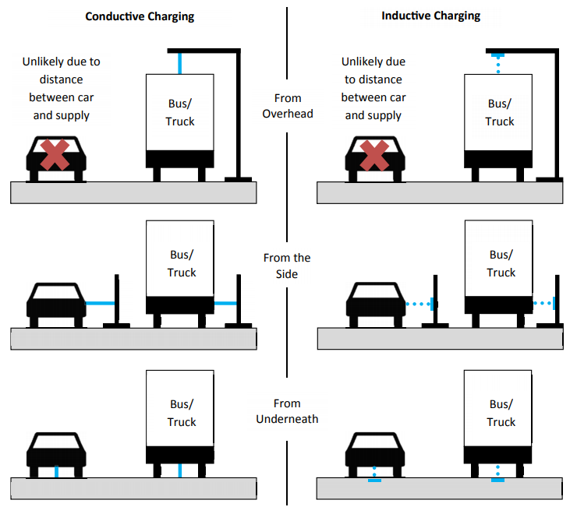

Fig. 1. Two methods for electrification of roads (Connolly 2017).

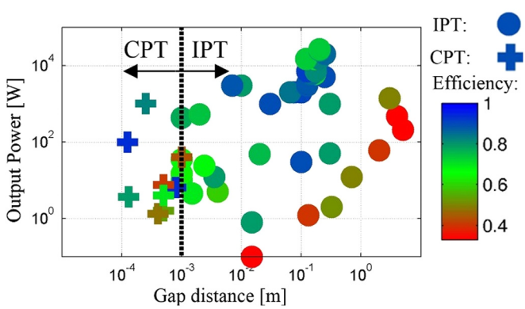

Fig. 2. The transfer power and air gap distance for CPT and IPT systems (Machura and Li 2019).

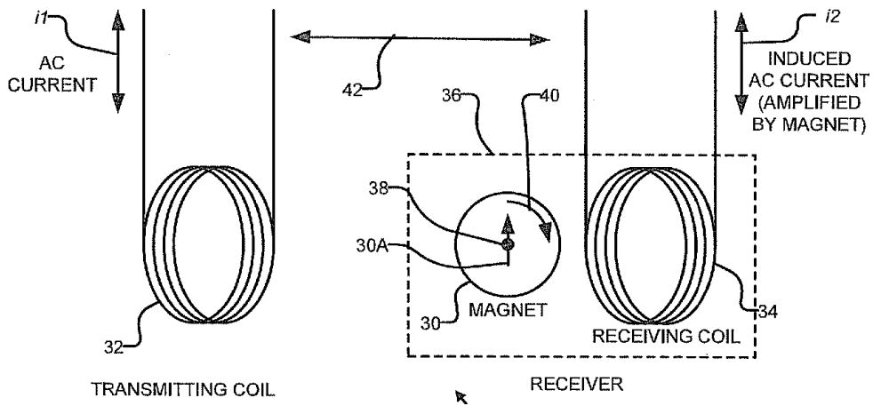

Fig. 3. Promoting inductive power transfer between two coils by a rotating magnet (Musavi and Eberle 2014).

An OLPT system which is almost the same as IPT, utilises charging facilities that are placed in the pavement, and a coil is placed on the under-side of the EV to pick up charge while moving (Santini et al. 2016). This method of charging is demonstrated in Fig. 4. The RAPT method which is initially promoted by Nikola Tesla, is also the same as IPT. In this method, two or more resonant antennae tuned to the same frequency are used (Musavi et al. 2012). A brief comparison between these types of wireless charging systems is shown in Table 1.

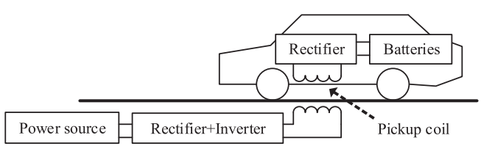

Fig. 4. A schematic of an OLPT system (Santini et al. 2016).

|  |  |  |  |  |
| --- | --- | --- | --- | --- |
| **Method** | **Efficiency** | **Frequency** | **Cost** | **Size** |
| IPT | medium | 10-20000 kHz | Medium | Medium |
| CPT | Low | 100-500 kHz | Low | Low |
| PMPT | Low | 100-500 Hz | High | High |
| OLPT | medium | 10-50 kHz | High | High |
| RAPT | medium | 100-500 kHz | Medium | Medium |

Table 1. A brief comparison between different WPT methods (Mousavi et al. 2012).

**IPT SYSTEMS**

IPT systems have been used since 1995 (Covic and Boys 2013), and currently they are widely used in many different applications such as portable electronic devices (Lu et al. 2015), biomedical devices (Covic and Boys 2013; Lu et al. 2015), lighting (Lu et al. 2015), clean factories (Lu et al. 2015) and electric vehicle charging (Covic and Boys 2013; Lu et al. 2015). Adoption of an IPT system can change many manufacturing processes. IPT systems are more powerful, tolerant to misalignment, reliable and more efficient than other methods of charging (Covic and Boys 2013). This charging system has an acceptable performance, and the power transfer is clean (Chen et al. 2015).

As research has exposed the advantages of an IPT system, the technology has become increasingly attractive to automobile manufacturers. In the case of applying for EVs, all systems are resonant. The implementation of IPT technology for EV charging can be considered in 3 main domains:

* Static or stationary (e.g. parking locations)
* Semi/quasi dynamic (e.g. traffic lights, bus stops)
* Dynamic (e.g. major highways)

Both static (stationary vehicle) and dynamic (moving vehicle) charging is now technically advanced, having been developed over the last few decades (Covic and Boys 2013). According to Chen et al. (2015) a typical stationary IPT system includes two technologies: “off board or primary pad” which is placed into the body of the pavement infrastructure, and the “on board or secondary pad” which is fixed to the under-side of the EV. These two technologies (primary and secondary pads) are shown in Fig. 5. In the fully dynamic application of this method, IPT pads are placed at intervals along the carriage way so that EVs can be charged while moving along the road, even at the speeds associated with freeways (Chen et al. 2015). Fig. 6 Shows IPT dynamic charging of EVs. As shown in Fig. 6 (a), the IPT primary pads (black pads) are embedded into the pavement infrastructure along the direction of EV travel and the secondary pad (blue pad) is fixed to the underside of the EV. The primary pads are energized and became red when the EV is directly above one primary pad (Fig. 6 (b)) or the EV is above 2 primary pads (Fig. 6 (c)).

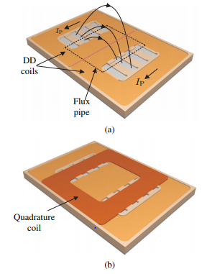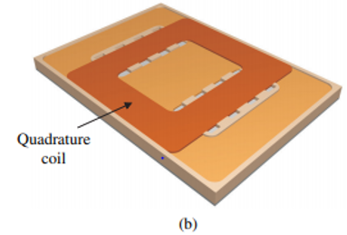

Fig. 5. Energized primary pad (a), and secondary pad (b) (Nagendra et al. 2017).

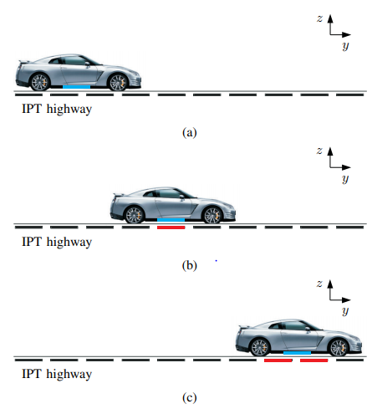

Fig. 6. The IPT primary pads (black pads) are embedded into the pavement infrastructure and the secondary pad (blue pad) is fixed to the underside of the EV (a), the primary pads are energized and became red when the EV is directly above one primary pad (b), and the primary pads are energized and became red when the EV is above 2 primary pads (c) (Nagendra et al. 2017).

In general, IPT systems transfer charge wirelessly between a stationary pad in the road infrastructure and a pickup device under the vehicle. As shown in the Fig.7, the devices embedded in the road infrastructure have three main parts (Chen 2016):

* AC source and a rectifier to produce an appropriate DC output voltage,
* Converter to provide high output frequencies, with compensation, and
* Transmitter that consists of coils, ferrite cores and a backing plate.

As mentioned before, the IPT system uses a magnetic field to transfer power and charge EVs (Lu et al. 2015), for which the mechanism is based on the Ampere and Faraday laws (Chen 2016). According to Ampere’s law, electric current will produce a magnetic field, while Faraday’s law states that a voltage would be induced in a coil by the changes in the magnetic field, and this will generate a magnetic flux. When the spacing of the source and receiver is satisfactory, the pickup coil will receive this magnetic flux and convert it into a current that will be used to charge the battery in the vehicle (Gardner 2017).

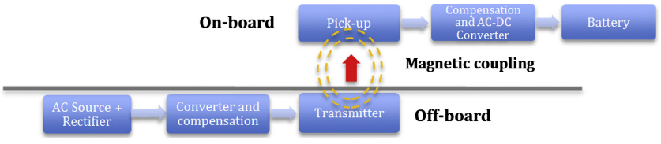

Fig. 7. A stationary IPT system to charge EVs (Chen 2016).

**LITERATURE REVIEW**

The first EV powered by a non-rechargeable battery was built by Thomas Davenport in 1834. Also, the first known non-rechargeable battery powered electric locomotive was built by Robert Davidson in 1837. After the invention of the lead acid battery, a rechargeable battery powered EV was built by David Salomons in 1874 (Chan and Chau 2001). The electrification of road infrastructure started in 1882 when Dr. Ernst Werner von Siemens invented the public transportation vehicles (trolley buses) powered by electric in Berlin. Although this technology was a great achievement for that time, some challenges such as high cost of the energy and overhead lines restricted their use. The Siemens E-Highway System and Volvo’s Slide-in Electric Road System are two recent examples of charging EVs with conductive methods either overhead or on the road surface (Chen et al. 2015).

In the late 19th century, Nicola Tesla introduced the idea of wireless power transfer (WPT) by designing the first wireless device, a wireless lightning bulb (Machura and Li 2019). In 1990, a suitable IPT system was developed for materials handling and other applications at the University of Auckland (Covic and Boys 2013). This invention was a start to charge vehicles wirelessly. In the 1990s, IPT system was used for stationary charging of EVs which its use was restricted. Kurs et al. (2007) used strongly coupled coils to improve WPT technology; enable wireless charging over distances longer than 2m which was an advance in this technology. Most of the research in this domain, focuses on stationary charging systems for EVs. For example, in 2007, a stationary IPT system was used to charge EV with an efficiency of 95% and an air gap distance of 20 cm (Villa et al. 2007). Another study was conducted in 2012 and they could increase the air gap distance to 265mm while the transfer efficiency was 90% (Wu et al. 2012). The researchers at the University of Auckland have designed a 766mm × 578mm pad for charging EVs stationary. They could transfer 5kw power for about 200mm air gap distance with an efficiency more than 90% (Li and Mi 2014).

Nevertheless, there are some recent pilot projects concerning dynamic charging of EVs by induction charging technologies (Connolly 2017). For example, California Partners for Advanced Transit and Highways (PATH) investigated a dynamic IPT system in the 1980s and 1990s at the UC Berkeley. In this project they developed a roadway IPT charging system with an air gap distance of 7.6 cm, for which the IPT system’s efficiency was 60%. Also, in this project they used a 35-passenger bus to travel along a 213 m long track with two powered sections (PATH 1994). In 2009, the Online Electric Vehicle (OLEV) concept was introduced by the Korean Advanced Institute of Science and Technology (KAIST). This project was based on an IPT system and its efficiency was 71% (Lee et al. 2010; Suh et al. 2011; KAIST OLEV 2015).

Other examples for dynamic charging of EVs are the “Slide-in Electric Road System” project which has been conducted in Sweden (Viktoria 2013), and the Flanders’ DRIVE project in Belgium (Beeldensa et al. 2016). Also, the FABRIC project was conducted in the European Union for the development of electrification of roads (FABRIC-project 2015). Currently, researchers at the University of Auckland are working on a project to develop a roadway charging system for EVs. This research is based on near field resonant IPT systems. Motivation for this project is to improve IPT system, extend travel distance, and thereby overcome barriers to EV take up. This would increase the social acceptance of EVs. Using these vehicles would be an opportunity for New Zealand to use clean and renewable energy; and reduce greenhouse gas emission, air pollution, and dependence on imported fuels. Dynamic charging of EVs is still in its early stages and more research needs to be done in this domain which the challenges and future work for this is discussed in the next section.

**CHALLENGES AND FUTURE WORK**

One alternative to encourage an increased uptake of EVs by society and remove/lower user range anxiety is implementation of IPT pads into a roadway which would allow vehicles to be charged while parked, stopped or even moving. Embedment of IPT pads into the road infrastructure will have effects and consequences. Some main challenges for implementation of IPT charging system are its high cost, the limited energy transfer distance (air gap between the source and receiver) and associated efficiency (Chen et al. 2015).

It is important to design and construct a pavement structure that has appropriate performance during its lifetime. One reason for this is the high cost of the design, construction and maintenance of a pavement. Moreover, road infrastructure has effects on the environment with associated safety issues. The performance of the pavement and the IPT pads should not be affected by the stresses caused by traffic loading and weather conditions. There are some requirements to consider in order to construct an electrified road successfully (Cordoba 2015):

* The electrical performance of the IPT system should not be negatively affected, and likewise
* The performance of the pavement should not be negatively affected.

To move towards improved sustainability in road transportation requires a shift to more EVs with less emissions; however, the designed and implemented road infrastructure that includes IPT pads must have appropriate long-term engineering life cycle performance. Moreover, the whole system must have positive environmental, social and economic outcomes. One challenge from this technology is how to achieve the structural and operational performance requirements in conjunction with the sustainability of the road infrastructure (Cordoba 2015). There is a need to analyse the mechanical properties of composite pavement structures containing IPT pads. In this regard, numerical and physical models may be developed to examine the interaction of IPT pads and pavement materials from vehicle wheel loads and weather/water effect in the pavement that may bring about the failure of the pad and/or the pavement materials.

Another challenge associated with this technology is the pavement design. It is important to use innovative materials in the design of a pavement with IPT pads to develop satisfactory performance of both the pad and the road. Moreover, an efficient method of putting the IPT pads into the road infrastructure and then maintaining both the pads and the surrounding pavement is required. The pavement and the IPT pad do not act independently. If the pavement undergoes fatigue distress in its lifetime, the IPT system will lose vertical and lateral support, possibly leading to structural failure of the pad, and failure to function properly. Electrified roads can be considered as composite pavements, so fatigue cracking, reflective cracking, and rutting/permanent deformation can become the main distress characteristics seen. The increase in energy transfer distance (air gap between the source and receiver), will cause the energy transfer efficiency to decrease. Based on a study by Ceravolo (2017), for WPT to function well, the pavement material between the top of the pad and the road surface must be constrained, and this distance is recommended to be 40-50 mm (Victoria 2013).

Using an IPT charging system currently requires the use of a ferrite component. This is an important part of the IPT system since it is instrumental in producing the electromagnetic field (Gardner 2017). The ferrite component is relatively fragile and susceptible to damage due to unfavourable traffic loading and environmental conditions, bringing associated negative consequences for electrified roads (Chen et al. 2015). In the IPT system, in addition to ferrite cores, there are other components, such as the coils and the sensors that may be affected by embedment in what is a structural system designed to limit deformations over the working life of the facility. Fragile components require careful design and placing in the road in a manner that enhances the probability that as a system both the road and the pad will successfully see out the design life with limited deformations caused by traffic loads and the environment.

Another challenge for successful implementation of IPT systems is the effect of heat generated by the primary power system, placed within the upper asphalt layer. The performance of asphalt mixes is temperature dependent as it is a visco-elastic material. In New Zealand existing pavement temperatures commonly range from -15 degrees Celsius to 65 degrees Celsius. Any additional heat generation from IPT pads in extreme climatic conditions will potentially extend the temperature beyond the normal performance range of standard bituminous materials. It is important to study the thermal effect of IPT systems on the performance of the pavement.

Studies regarding this topic are limited, and many of them are concerned with the development of EVs, promoting the performance of batteries and the power transmission of the vehicles. There are many challenges and gaps in knowledge regarding the embedment of IPT systems into the road infrastructure. Future work will be focused on the infrastructure, i.e. the mechanical stability (including fatigue), the thermal characteristics, the durability of the IPT system and the sustainability and economics of electrified roads.

**CONCLUSION**

Many countries are interested in developing more sustainable road transportation systems. This is because increasing greenhouse emissions and air pollution have serious detrimental effects on human and environmental health. One effective method of decreasing the greenhouse gas emissions is utilizing a greater proportion of EVs that replace ICE vehicles. Moreover, EVs can reduce the dependence on limited oil resources (Yilmaz 2012). Unfortunately, to date the use of EVs has been limited due to issues such as small battery capacity and in turn small travel range. One alternative to overcome these problems is dynamic charging of EVs. This would cause overall acceptance or significant market penetration for EVs. Despite the importance of this technology, currently there is a paucity of research activity concerning dynamic charging of EVs. Most of the studies in this domain concern the development of EVs, and static charging of them. If the pavement fails in its lifetime, the IPT system will fail to function properly. So, there is a need to study the consequences and effects of implementing IPT technology on the performance of the pavement and the IPT system in the long term. The future work for this technology can be improving the IPT system, battery technology and pavement performance, offering an effective method for IPT embedment into the pavement, and making the whole system (pavement with IPT pads) more cost effective.

**Acknowledgements**

The authors would like to express their gratitude to the Ministry of Business, Innovation and Employment (MBIE) for supporting the research, including student PhD scholarships. Thanks are also extended to the wider group associated with the work who have whole-heartedly faced the holistic aspects of the endeavours.

**REFERENCES**

Andwari, A. M., Pesiridis, A., Rajoo, S., Martinez-Botas, R., and Esfahanian, V. (2017). A review of Battery Electric Vehicle technology and readiness levels. *Renewable and Sustainable Energy Reviews*, *78*, 414-430.

Beeldensa, A., Hauspiec, P., and Perikd, H. (2016). Inductive charging through concrete roads: a belgian case study and application, *1st European Road Infrastructure Congress at Leeds*.

Boys, J. T., and Covic, G. A. (2015). The inductive power transfer story at the University of Auckland. *IEEE circuits and systems magazine*, *15*(2), 6-27.

California Partners for Advanced Transit and Highways (PATH), (1994). *Roadway powered electric vehicle project track construction and testing program phase*.

Ceravolo, R., Miraglia, G., and Surace, C. (2017). Fatigue damage assessment of electric roads based on probabilistic load models. *In Journal of Physics: Conference Series* (Vol. 842, No. 1, p. 012037). IOP Publishing.

Chan, C. C., and Chau, K. T. (1993). Power electronics challenges in electric vehicles. In *Proceedings of IECON'93-19th Annual Conference of IEEE Industrial Electronics* (pp. 701-706). IEEE.

Chan, C. C., and Chau, K. T. (2001). Modern electric vehicle technology (No. 47). *Oxford University Press on Demand.*

Chen, F., Taylor, N., and Kringos, N. (2015). Electrification of roads: Opportunities and challenges*. Applied Energy*, 150, 109-119.

Chen, F. (2016). Sustainable Implementation of Electrified Roads: Structural and Material Analyses, *Doctoral dissertation, KTH Royal Institute of Technology*.

Connolly, D. (2017). Economic viability of electric roads compared to oil and batteries for all forms of road transport. *Energy strategy reviews*, 18, 235-249.

Cordoba Ledesma, E. (2015). Analysis of effects and consequences of constructing Inductive Power Transfer Systems in road infrastructure: A case study for the Stockholm region (Sweden), *Master of Science dissertation, KTH Royal Institute of Technology*.

Covic, G. A., Boys, J. T., Budhia, M., and Huang, C. Y. (2010). Electric Vehicles–Personal transportation for the future. *World Electric Vehicle Journal*, *4*(4), 693-704.

Covic, G. A., and Boys, J. T. (2013). Inductive Power Transfer. *Proceedings of the IEEE*, 101(6), 1276-1289.

Covic, G. A., and Boys, J. T. (2013). Modern trends in inductive power transfer for transportation applications. *IEEE Journal of Emerging and Selected topics in power electronics*, *1*(1), 28-41.

Das, S., Pal, K., Goswami, P., and Kerawalla, M. A. K. (2018). Wireless Power Transfer in Electric Vehicles. *International Journal of Applied Environmental Sciences*, 13(7), 643-659.

FABRIC- project. (2015). Feasibility analysis and development of on-road charging solutions for future electric vehicles, viewed 15 October 2019. <http://www.fabric- project.eu>.

Foley, A. M., Winning, I. J., and Gallachóir, B. Ó. (2010). State-of-the-art in electric vehicle charging infrastructure. *In 2010 IEEE Vehicle Power and Propulsion Conference* (pp. 1-6). IEEE.

Gardner, T. (2017). Wireless Power Transfer Roadway Integration, *Master of Science dissertation, Utah State University*.

González-Santini, N. S., Zeng, H., Yu, Y., and Peng, F. Z. (2016). Z-source resonant converter with power factor correction for wireless power transfer applications. *IEEE Transactions on Power Electronics*, 31(11), 7691-7700.

Graham, D. J., Neasham, J. A., and Sharif, B. S. (2011). Investigation of methods for data communication and power delivery through metals. *IEEE Transactions on industrial electronics*, 58(10), 4972-4980.

Huo, H., Zhang, Q., Liu, F., and He, K. (2013). Climate and environmental effects of electric vehicles versus compressed natural gas vehicles in China: A life-cycle analysis at provincial level. *Environmental science & technology*, 47(3), 1711-1718.

KAIST OLEV. (2015). Online Electric Vehicle.Korean Advanced Institute of Science and Technology. viewed 15 October 2019. <<http://olev.kaist.ac.kr/en/about/1.php>>.

Khan, M. I., Yasmin, T., and Shakoor, A. (2015). Technical overview of compressed natural gas (CNG) as a transportation fuel. *Renewable and Sustainable Energy Reviews*, 51, 785-797.

Kline, M., Izyumin, I., Boser, B., and Sanders, S. (2011). Capacitive power transfer for contactless charging. *In 2011 Twenty-Sixth Annual IEEE Applied Power Electronics Conference and Exposition (APEC)* (pp. 1398-1404). IEEE.

Kurs, A., Karalis, A., Moffatt, R., Joannopoulos, J. D., Fisher, P., and Soljačić, M. (2007). Wireless power transfer via strongly coupled magnetic resonances. *science*, *317*(5834), 83-86.

Larminie, J., and Lowry, J. (2012). Electric vehicle technology explained. *John Wiley & Sons*.

Lee, S., Huh, J., Park, C., Choi, N. S., Cho, G. H., and Rim, C. T. (2010). On-line electric vehicle using inductive power transfer system. *In 2010 IEEE Energy Conversion Congress and Exposition* (pp. 1598-1601). IEEE.

Li, S., and Mi, C. C. (2014). Wireless power transfer for electric vehicle applications. *IEEE journal of emerging and selected topics in power electronics*, *3*(1), 4-17.

Lu, F., Zhang, H., Hofmann, H., and Mi, C. (2015). A Double-SidedLCLC-Compensated Capacitive Power Transfer System for Electric Vehicle Charging. *IEEE Transactions on Power Electronics*, 30(11), 6011-6014.

Machura, P., and Li, Q. (2019). A critical review on wireless cha2019rging for electric vehicles. *Renewable and Sustainable Energy Reviews*, *104*, 209-234.

Mori, D., and Hirose, K. (2009). Recent challenges of hydrogen storage technologies for fuel cell vehicles. *International journal of hydrogen energy*, 34(10), 4569-4574.

Musavi, F., Edington, M., and Eberle, W. (2012). Wireless power transfer: A survey of EV battery charging technologies. *In 2012 IEEE Energy Conversion Congress and Exposition (ECCE)* (pp. 1804-1810). IEEE.

Musavi, F., and Eberle, W. (2014). Overview of wireless power transfer technologies for electric vehicle battery charging. *IET Power Electronics*, 7(1), 60-66.

Nagendra, G. R., Covic, G. A., & Boys, J. T. (2017). Sizing of inductive power pads for dynamic charging of EVs on IPT highways. *IEEE transactions on transportation electrification*, *3*(2), 405-417.

Poulton, M. L. (1994). Alternative fuels for road vehicles. *Transport Research Laboratory, Crowthorne, UK*.

Suh, N. P., Cho, D. H., & Rim, C. T. (2011). Design of on-line electric vehicle (OLEV). *In Global product development* (pp. 3-8). Springer, Berlin, Heidelberg.

Theodoridis, M. P. (2012). Effective capacitive power transfer. *IEEE Transactions on Power Electronics*, 27(12), 4906-4913.

Viktoria Swedish, I. C. T. (2013). Slide-in Electric Road System*. Gothenburg, Sweden*.

Villa, J. L., Llombart, A., Sanz, J. F., and Sallan, J. (2007). Practical development of a 5 kW ICPT system SS compensated with a large air gap. In *2007 IEEE International Symposium on Industrial Electronics* (pp. 1219-1223). IEEE.

Wu, H. H., Gilchrist, A., Sealy, K. D., and Bronson, D. (2012). A high efficiency 5 kW inductive charger for EVs using dual side control. *IEEE Transactions on Industrial Informatics*, *8*(3), 585-595.

Yang, M., Kraft-Oliver, T., Yan, G. X., and Min, W. T. (1997). Compressed natural gas vehicles: motoring towards a cleaner Beijing. *Applied Energy*, 56(3-4), 395-405.

Yilmaz, M., and Krein, P. T. (2012). Review of battery charger topologies, charging power levels, and infrastructure for plug-in electric and hybrid vehicles. *IEEE transactions on Power Electronics*, 28(5), 2151-2169.