NZ Cycle Network Proximity Analysis

After years of investment and planning, towns and cities across New Zealand are starting to reap the benefits of their established cycle networks. Cycling infrastructure in the form of shared paths, cycle lanes, and cycleways is more connected than ever, and ridership continues to rise. We’re now at a point where we can begin to evaluate the impact of these networks. It is important to understand who is benefitting most from the existing network and also who has the greatest need for additional investment in the form of network expansion. A cycle network proximity analysis will identify which areas are furthest from the nearest facility. This can identify 'cycling deserts' which could help to inform decisions regarding future network investment, ultimately leading to a more equitable network.
This poster will highlight proximity analysis as a way to evaluate the coverage of both the existing and proposed cycling networks. Because this type of analysis is visual in nature, it can be presented to key decision makers as well as the public in a quick and easy to understand manner. Proximity analysis also provides the backbone for further research into the population and demographics of existing 'cycling deserts'. An example of this analysis was prepared for Auckland and is provided below. This poster will aim to promote a discussion around how to better understand the performance of our existing cycling networks as well as how to highlight the opportunity to enhance the prioritisation of future network investment.

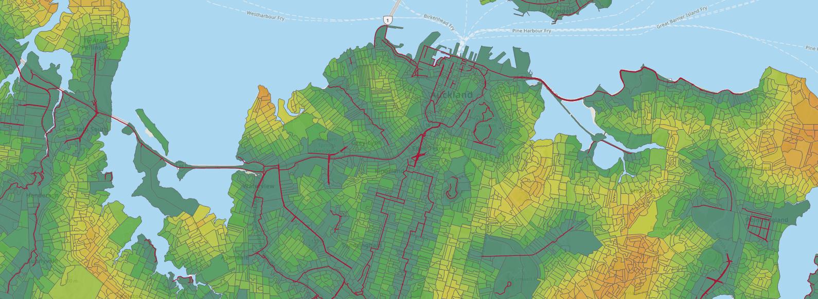
Proximity
Cycle Facilities
Auckland Cycle Network Proximity Analysis
N

