The Future of Auckland’s City Centre – the importance of Travel Demand Management

Lucy Millier

BSc Geography, MSc Transport Planning and Sustainable Development

Principal Transport Planner, Mott MacDonald

lucy.millier@mottmac.com

Daniel Newcombe

BPlan, MEngSt

Manager Strategic Projects: Central Access, Auckland Transport

daniel.newcombe@at.govt.nz

# Abstract

Auckland’s recently refreshed City Centre Masterplan (CCMP) sets the strategic direction for the city centre over the next 20 years with a vision to ensure the heart of the city remains ‘a vibrant, bountiful place for everyone’.  The CCMP includes the innovative ‘Access for Everyone’ concept, designed to enable the vision by transforming the city centre into a number of low-traffic neighbourhoods, creating more places for people and opening up space for people walking, cycling and using public transport.

Achievement of this vision is dependent on multiple factors, including a change in people’s travel behaviour towards more walking, cycling, and use of public and other shared transport modes.

Travel Demand Management (TDM) is a proven technique for managing demand on the transport network and delivering more sustainable patterns of travel behaviour. TDM has an excellent track record in Auckland, and is a tool used by cities across the world. The opportunity now, is to position TDM principles centre stage into all planning decisions for the city centre, from consenting to implementation and beyond, to help support and enable the Access for Everyone concept. A City Centre TDM Plan has been developed, outlining the range of innovative measures necessary to support mode shift and achieve the CCMP outcomes.

The recent unprecedented restrictions placed on the movement of Aucklanders as a result of COVID-19, and in particular the requirements for physical distancing, enabled some of the CCMP to be realised through reallocating traffic lanes to footway space on Queen Street and removing parking for cycle lanes along the waterfront.  This demonstrated the need for organisations to be agile in adapting to new opportunities and the importance of close working relationships with the community and local businesses and the valuable insight they bring.

Daniel Newcombe from Auckland Transport and Lucy Millier from Mott MacDonald will present on a coordinated City Centre TDM Plan aimed at achieving behaviour change and enabling the CCMP outcomes to be realised.  They will discuss how opportunities created by these emergency measures can be built upon and how this can help shape emerging travel patterns as part of people’s return to a ‘new normal’.

# INTRODUCTIOn

On 5 March 2020, Auckland Council’s Planning Committee agreed to adopt Auckland’s refreshed City Centre Master Plan (CCMP), the visionary plan to guide the city centre’s development for the next 20 years. It sets out the strategic direction for the city centre “…*to ensure the heart of our city remains a vibrant, bountiful place for everyone*”.A key part of the CCMP is Access for Everyone (A4E), a concept that redefines the use of street space in the city centre to provide a friendlier pedestrian environment and prioritises space-efficient modes of transport whilst enabling deliveries and access for emergency services.

The key concepts of A4E are:

1. Organising the city centre into low-traffic neighbourhoods including a pedestrian priority zone centred around Queen Street (illustrated in Figure 1);
2. Most trips will be required to exit the city centre from the same neighbourhood which they entered, hence reducing the number of intra-city trips made by private vehicle;
3. Diverting trips, not going to a destination in the city centre, to the motorway (State Highway) network;
4. Increasing priority for public transport through reallocation of space to bus priority measures as a result of reduced traffic volumes;
5. Active travel modes prioritised across the city centre neighbourhoods.

Figure 1: Access for Everyone Concept (aucklandccmp.co.nz)

# The implications of A4e for auckland’s travel patterns are significant

Since March 2018, more people have travelled to the city centre in the morning peak (7-9am) by public transport than by private vehicle[1] and there has been a slow decline in the number of private vehicles entering the city centre. In March 2019, private vehicle mode share into the city centre in the morning peak was 43%, compared to 48% for public transport and 9% for active travel modes[2]. This data is pre COVID-19 and the impacts of COVID-19 on mode share are being closely monitored.

Auckland Transport (AT) has undertaken initial modelling on the A4E concept, assuming implementation by 2028. This indicates that in order to prevent ‘grid-lock’ conditions on the network during the peak periods, the following changes will be required:

* Capacity improvements to accommodate an additional 11,000 additional public transport and active mode trips per 2-hour peak period. This is on top of the projected additional 30,000 trips due to population increase;
* New on-/off-ramps for the State Highway network to reduce congestion on routes into the city centre from the eastern part of the region; and
* Increased capacity of the State Highway network between the motorway and Tamaki Drive, as an important connection for the eastern part of the region and for freight.

This initial modelling indicates that the additional public transport trips would result in a 75% public transport mode share, which is an increase on the pre-COVID-19 public transport mode share of 48% (March 2019[3]). This is an ambitious mode target and 10% above what current projects are anticipated to cater for. Increases in infrastructure for active modes and increased uptake of this may relieve the pressure on public transport, however, there will need to be more investment to support this. This investment is currently under increasing pressure due to the negative impact of the COVID-19 pandemic on AT’s funding.

# travel demand management is a proven technique which can help support more sustainable travel patterns

Travel Demand Management (TDM) is the application of a focused, data-led strategy to change demand on transport networks by redistributing journeys to other modes, times, routes or taking the demand off the network altogether. This is known as the “Four R’s” – remode, reroute, retime and reduce. This could be an important enabler in delivering Auckland’s vision and supporting an increase in trips by public transport and active modes.

TDM also consists of three main components, which are supported by the four R’s (as shown in Figure 2). These are:

**Behaviour change:** empowering people to make informed choices about how and when they travel, the route they take and the number of trips they make.

**Network Management:** managing existing networks and infrastructure to maximise their efficiency.

**Capacity Creation:** ensuring there is capacity within the network to accommodate a particular mode of travel, for a particular route or time.

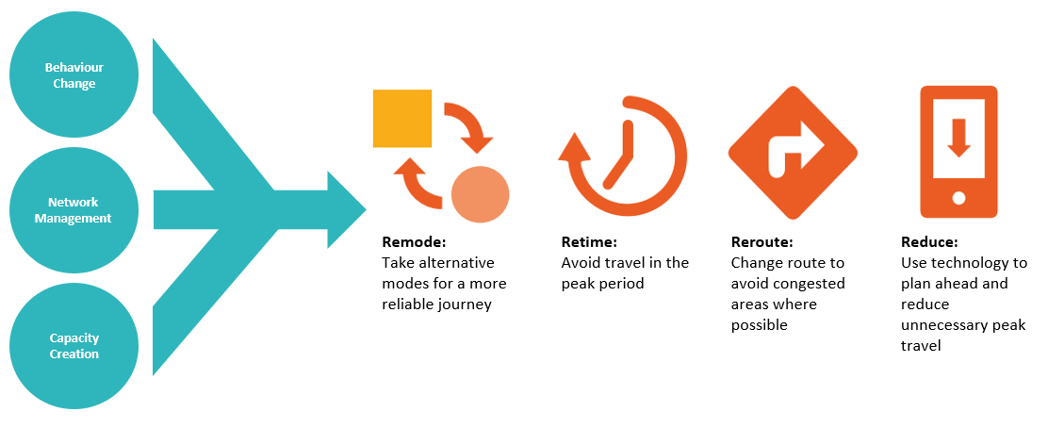

Figure 2: Concepts of Travel Demand Management (Mott MacDonald)

TDM has been used extensively in other cities to manage the impacts of construction, major events (such as sporting events and conferences) and unplanned events such as natural disasters. Best practice suggests that all communications and messages should be data led, there should be a single source of truth so customers know where to go for relevant, up to date information and all workstreams should be coordinated and aligned to the key messages.

AT is already undertaking several TDM initiatives focusing on increasing sustainable travel. These include providing travel planning support to businesses, campaigns focused on retiming journeys out of the peak period such as ‘Spread the Jam’ and optimising signals to prioritise public transport movements. However, these initiatives are not always coordinated across AT, sometimes resulting in confusing messages for customers.

# covid-19 physical distancing requirements presented an opportunity to trial aspects of A4E, supported by tdm approaches

As well as adopting the CCMP, Auckland Council’s Planning Committee also requested the commencement of a Queen Street pilot by March 2021 to coincide with the closure of the Victoria Street and Albert Street intersection for City Rail Link construction.

The environment created by COVID-19 enabled initial changes in line with this pilot to happen sooner than anticipated as AT were urgently required to install emergency measures along Queen Street in May 2020 to create additional space for pedestrians to support physical distancing (see Figure 3).

Figure 3: Additional space provided for pedestrians in Queen Street (Auckland Transport)

Measures included creating widened footways by removing a lane of general traffic in both directions. Loading spaces were retained as these are critical for local Queen Street businesses (these become available for general parking at certain times of the day). Other traffic restrictions were attempted but the urgent implementation did not leave the opportunity for necessary consultation to make these legally enforceable, so motorists tended to ignore the signage intended to deter through traffic.

The initial road cone layout was quickly replaced with plastic ‘hit posts’ in order to make the delineation of the new space look less like a construction zone, which was considered to deter users (see Figure 4). The bus stops had asphalt ‘boarders’ added so that a kerb was able to be maintained at the bus stops and disabled access between the bus and platform could be maintained. The new pedestrian space had minimal additional treatment other than some pavement stencils showing physical distancing symbols.

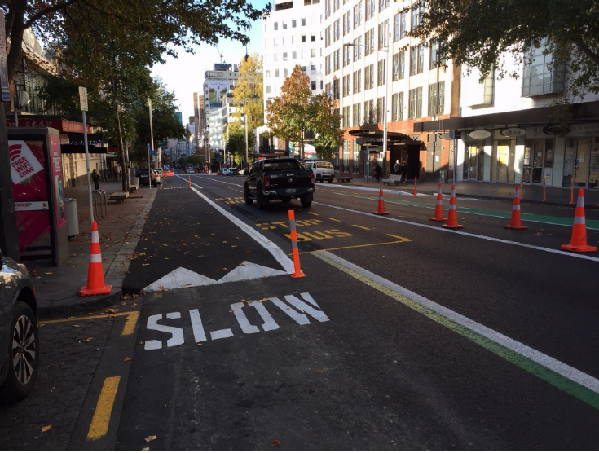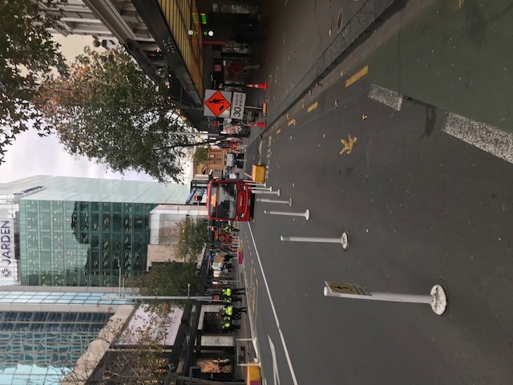

Figure 4: Moveable orange cones were replaced with white posts which were fixed to the ground (Auckland Transport)

Temporary changes were also put in place along other walking and cycling routes in Auckland, such as along Ponsonby Road and Tamaki Drive. However, these did not have active projects ready to take them over once physical distancing was no longer required. Treatments were therefore removed once New Zealand’s lockdown restrictions eased. This was despite online surveys taken at the time showing that the general public supported the principle of creating additional space for walking and cycling5.

With these measures still in place along Queen Street, AT can now study them to determine the extent to which they are making Queen Street more attractive and easier to use, thus bringing elements of the Queen Street pilot forward by several months.

A4E represents a longstanding desire to improve Queen Street and provide more and better-quality space for shoppers, residents, visitors and workers. It is also a system for coordinating construction access.

Whilst COVID-19 remains a potential threat, there is a need to maintain our ability to react quickly if physical distancing may once again be required.

Further changes to Queen Street will need to be made in order to prioritise bus movements through Auckland’s city centre during CRL construction in 2021-22. By bringing work on the Queen Street pilot forward, different systems for prioritising public transport and pedestrians can be tested and optimised. Auckland Council is currently facing severe budgetary pressures and it will reflect better on the council’s efficiencies if the recently installed Queen Street changes are developed, tested and adapted, as opposed to removed and potentially reinstalled later.

Such measures are popular with the public with respondents overwhelmingly supporting the principles of a pedestrian priority Queen Street, with 82 per cent supporting the A4E concept during the City Centre Masterplan consultation[4]. In May 2020, research into Aucklanders’ attitudes to pilot programmes found that 73 per cent support this type of initiative and more than half of people surveyed believe that these initiatives were more relevant since the pandemic began[5].

Co-design has successfully been used in High Street, quickly delivering improvements to the street, improving conditions for shoppers, businesses and residents. This process and changes have been well-received; in June 2020, the High Street co-design won a 2020 WSP Golden Foot Award from Living Streets Aotearoa. A similar approach is proposed for the Queen Street pilot.

# the new layout along queen street has recieved innovating streets FOR PEOPLE funding

Funding for the Queen Street pilot was received from Waka Kotahi’s Innovating Streets contestable fund. This fund was established in September 2019 to support trials of temporary treatments to improve street environments and provide more space for people. Funding is also being provided by the Auckland City Centre Advisory Board’s targeted rate.

A co-design process will adapt the existing Queen Street emergency measures, reflecting user needs and feedback. Being a pilot, it will continue to use temporary materials. It will also test a range of activities to help people better use the space. The co-design process has begun and is being led by Auckland Council with support from AT and Waka Kotahi. It is being shaped by a reference group of key partners who represent the Queen Street community. Engagement is taking place with individual businesses, residents and street users. It is important to note that no consultation took place for the implementation of the COVID-19 temporary works, so there is a need to engage thoroughly on this next phase.

Surveys will be undertaken throughout the duration of the pilot, to gauge people’s perceptions and attitudes towards the improvements. By focussing on people’s perceptions of Queen Street, the pilot will work to find the best layout and promote Queen Street as being ‘open for business’.

Objectives of the pilot are to:

* Support ongoing business activities by improving access for servicing and freight and facilitating customer access to Queen St;
* Prioritise and support public transport and active transport modes;
* Reduce non-essential private vehicle access to facilitate public transport, emergency services, construction, micro-mobility and active mode use of the street;
* Maintain or improve disabled mobility access.

Key metrics will be assessed, including changes in footfall and use of the space by pedestrians, the maintenance of reliable bus access, safe operation of remaining vehicles, ongoing access for servicing/loading/emergency vehicles, and sentiment of users.

Communication is key for successful pilot projects, with clear definition of intent and purpose; people need to understand why changes are being made. Auckland Council and AT will work in partnership across the pilot programme team to deliver the strategic and project communications. They will be jointly accountable for delivery of communications.

Although the co-design process will determine the areas of focus and the types of design that will be pursued, some initial lessons have already been identified. These include:

* The ‘construction zone’ aesthetic of initial treatments was an issue for many stakeholders (users and businesses alike) so a quick transition to more permanent treatments is required;
* The lack of enforceable traffic and parking restrictions meant that the full benefits of the new layout were not initially realised. A similar level of traffic tried to fit within a reduced space, and this generated negative feedback from a multitude of users;
* The lack of wider TDM messaging or wayfinding in the immediate area meant that the initial physical layout was not well supported by interventions that discouraged or prevented traffic from continuing to travel into the Queen Street valley;
* The initial lack of consultation with affected businesses (due to the emergency situation) meant some stakeholders were unaware of, or unhappy with, the temporary treatments and requested them to be removed once physical distancing was no longer required.

# City Centre TDM plan

AT recognises the importance of TDM in supporting Auckland’s vision and with Mott MacDonald has developed a TDM plan for the city centre.

AT’s TDM Plan recognises the impact that the COVID-19 pandemic has had on travel patterns and identifies actions to complement the TDM work already being undertaken by AT and identifies further interventions which can be undertaken to maximise the benefits that TDM can deliver.

The actions that have been recommended are based on extensive research of international best practice and understanding of what AT is already doing. These factors support AT in becoming a world leader in TDM. Proposed actions have been prioritised according to what can be most easily delivered with existing resources and can be easily adapted to respond to emerging travel patterns throughout COVID-19 and beyond.

# next steps

After an unexpected start, the Queen Street pilot represents a unique opportunity to trial and test various treatments to help guide Auckland’s city centre towards a new future as described in the CCMP.

The pilot will over time test physical layouts and treatments but will also test TDM messaging and supporting measures to ensure that mode share and travel patterns are adjusted to support the CCMP vision for Queen Street.

The results of the pilot will be known in mid-2021 but initial lessons have already been learnt showing the importance of accompanying any physical measures with coordinated TDM efforts.

# Declaration of competing interests

The author(s) declare(s) no competing financial interests.

# References

Auckland Council (2020), *City Centre Masterplan*, Auckland

[*https://www.aucklandccmp.co.nz/outcomes/outcome-2-connected-city-centre/vision-for-connected-city-centre/*](https://www.aucklandccmp.co.nz/outcomes/outcome-2-connected-city-centre/vision-for-connected-city-centre/)

Auckland Transport (2020)*, City Centre TDM Plan,* Auckland

1. *https://www.aucklandccmp.co.nz/outcomes/outcome-2-connected-city-centre/vision-for-connected-city-centre/*
2. *https://www.nzherald.co.nz/transport/news/article.cfm?c_id=97&objectid=12224871*
3. Auckland Transport City Centre network monitoring data, March 2019
4. https://www.aucklandcouncil.govt.nz/have-your-say/topics-you-can-have-your-say-on/city-centre-masterplan-refresh/Documents/city-centre-masterplan-consultation-summary.pdf
5. Innovating Streets Public Sentiment Survey, Auckland Transport, 2020