**PEDESTRIAN ROUTE CHOICE at ROAD CROSSINGS**

**This paper has been peer reviewed**

Ajjima Soathong*

Transportation Research Centre

Department of Civil and Environmental Engineering

University of Auckland, New Zealand, 1010

Email: asoa236@aucklanduni.ac.nz

Douglas Wilson

Transportation Research Centre

Department of Civil and Environmental Engineering

University of Auckland, New Zealand, 1010

Email: dj.wilson@auckland.ac.nz

Prakash Ranjitkar

Transportation Research Centre

Department of Civil and Environmental Engineering

University of Auckland, New Zealand, 1010

Email: p.ranjitkar@auckland.ac.nz

Subeh Chowdhury

Transportation Research Centre

Department of Civil and Environmental Engineering

University of Auckland, New Zealand, 1010

Email: s.chowdhury@auckland.ac.nz

*corresponding author

**ABSTRACT**

Walking is a cost-effective, healthy, and environmentally friendly mode of transport. The large majority of transport journeys have walking as a key component from origin to destination, but it is often less prioritized or planned in the vehicular-dominant urban road system. An increased exposure of pedestrian crash risk also occurs at road crossings. Globally, pedestrians account for 22% of all road deaths (WHO, 2015). In New Zealand, this group makes up for 8% of all road fatality crashes, and 89% of these crashes occur at mid-block sections (NZ Crash Analysis System (CAS), 2012-2016). New Zealand policies have emphasized the protection of pedestrians as the most vulnerable road users through the Safe System Approach. However, an effort to improve pedestrian safety is hampered by a lack of understanding on a broad range of factors, including pedestrian behaviour.

This paper aims to increase knowledge about pedestrian safety issues. The specific objectives are to examine NZ road safety policies in line with pedestrian crashes and pedestrians’ perceptions towards mid-block road crossing. The result shows that road safety policies have contributed to creating a safer transport system, although the annual road fatalities have begun increasing recently. Pedestrian safety has particularly not achieved as much gain as other road users over the same periods. Crashes are complex events with multi-factors involved but crossing at mid-block urban roads is one of the most common factors associated with crashes. With regards to pedestrians’ perception, they are self-motivated but still influenced by others. Pedestrians are aware of road rules but keep doing because jaywalking is perceived as an acceptable action by society. The finding is expected to provide transport authorities with increased understanding to enable more effective and safe pedestrian facilities and countermeasures to improve the safety of all road users.

**Keywords**: Pedestrian, Road safety policy, Vulnerable road user, Active modes, Crossing, Jaywalking

**PEDESTRIAN ROUTE CHOICE at ROAD CROSSINGS**

**1. INTRODUCTION**

Promoting safe walking is one of international road safety targets, that is integrated into most countries sustainable transport development plans. Improved quality of pedestrian infrastructure facilities is provided to enhance user mobility and safety, but concern exists as pedestrian crash exposures increases, primarily in urbanized areas. Based on the New Zealand Crash Analysis System (CAS, 2012-2016), 89% of pedestrian-related crashes occur at mid-block sections of a road in an urban environment. The severity of such collisions is more life-threatening to pedestrians as vulnerable road users rather than vehicle occupants because of the inherent protection of a vehicle chassis around vehicle occupants.

Road safety efforts globally have improved safe driving behaviours to improve pedestrian safety, and the benefits are evident (The Swedish Transport Administration, 2015; NZTA, 2018b). However, one of the critical factors that contribute to crashes and their severity of injury is pedestrian user behaviour, particularly intentional violations. In New Zealand, ‘pedestrian running and crossing heedless of traffic’ remain the most common factor for over half of the total urban pedestrian crashes (CAS, 2016-2019). To achieve greater success in the future, the behaviour of pedestrians needs to be better recognized and understood in the road traffic system.

Intuitively, individuals may choose to cross outside pedestrian crossing if there are available gaps in the traffic stream, regardless of the provision of crossing facilities nearby. However, there are multiple factors involved, such as distance to the destination, the condition of the environment, and motivation. This can also be affected by urban planning, policy, and design. Previous studies have indicated that psychological factors play an important role in pedestrians’ decision-making (Evan and Norman, 1998; 2003; Holland et al., 2009; Diaz, 2002). Our previous research (In press) has revealed that pedestrians are self-determined, which means that the motivation to cross the road at mid-block is based on their own choices. They are likely to trade off the risk and the benefit from quick progress, including saving time or reducing walking distance.

This paper is a part of ongoing research that aims to increase an understanding about pedestrian safety through different approaches, including examining road safety policy, crashes report and pedestrian’s perception. The main question we aim to answer is, “What can be done to improve pedestrian safety?”. The paper consists of two parts. The first part examines the New Zealand road safety policies from the pedestrian’s viewpoint and to analyse crash history data in identifying factors contributing to pedestrian crashes. The second part is to investigate the pedestrian perception and motivation toward crossing at mid-block sections (also known as jaywalking).

**2. LITERATURE REVIEW**

**2.1 Pedestrian road safety policy**

Many countries are experiencing a growing public concern regarding the ‘unacceptability’ of road deaths alongside increasing demands on transport infrastructure. As a response, many countries have adopted or are planning to implement a Vision Zero strategy to road fatalities (OECD, 2008; CCMTA, 2016; Vision Zero Network, 2017). This strategy aims to reduce the number of road fatalities and serious injury from transportation infrastructure with the premise of any death as a consequence of using transport infrastructure is unacceptable. Vision Zero was first introduced by the Swedish government under the concept that “no one should be killed or seriously injured within the transport system.” In the past, when crashes occurred, often the road users were blamed for making ‘errors of judgement’. However, in Vision Zero, we accept that humans make mistakes. So, the severity of the crash is minimised or addressed through the design of a more forgiving transport system. The responsibilities are also shared between system designers and road users. The system designer has the ultimate responsibility for transport design and operation, whereas the road user needs to follow traffic laws and rules. If the road user fails to obey these rules, the system designer is required to take a further step to design and improve infrastructure to reduce the severity of traffic injury and the probability of fatality.

In New Zealand, the Safe System Approach “Safer Journey” was first introduced as a national road safety strategy in 2010 with its vision for “A safe road system increasingly free of death and serious injury” (NZ MOT, 2018). The Safe System principles focus on creating a safe transport system for road users to reduce the consequences of crashes by recognising human fallibility and vulnerability. The policy was established by focussing efforts on four safe system pillars, including roads and roadsides, speeds, vehicles, and road users.

Table 1 summarises the immediate targets that were developed in the New Zealand Safer Journeys during the 2011-2020 period and a draft of road safety strategies being introduced in the Draft 2020-2030 strategy document (NZTA, 2019). The first pillar, Safe Roads and Roadsides, focuses on improving high crash risk location, particularly on high-risk rural roads and high-risk urban intersections. Funding is spent through various projects such as the Safety Boost Program along regional State highways. The second pillar, Safe Road Use, targets road user behaviour, especially young drivers, impaired drivers, and motorcyclists through enforcement and education campaigns. The third pillar, Safe Speed, aims to minimize the impact of vehicle speed as a causal factor to make a crash survivable. The last pillar, Safe Vehicle, seeks to improve the NZ vehicle fleet to meet international standards. Overall, it implies that NZ Safer Journeys does not include pedestrian safety or behaviour as a high concern, and little have targeted this group.

Table 1. Immediate targets in New Zealand Safer Journeys

|  |  |  |  |  |
| --- | --- | --- | --- | --- |
| **2011-2012** | **2013-2015** | | **2016-2020** | **2020-2030 (Draft)** |
| **Safe Roads and Roadsides** | | | | |
| * High-risk rural roads, high-risk urban intersections | | | | * Infrastructure improvements |
| * Improving road design standard (KiwiRAP) | | | | * Enhance safety and accessibility of footpaths, bike lanes and cycleways |
|  | * High-risk motorcycling routes | | | * Review infrastructure standards and guidelines |
| * Mixed used arterial for active modes | | |  |
| **Safe Road Use** | | | | |
| * Education, awareness | * Education, awareness | * Impaired driving/riding | | * Encourage safer choices and safer driving behaviour |
| * Motorcyclists | * Enforcement measures | * Enforcement | | * Enforcement (road policing) |
| * Young drivers and riders | * Drug and alcohol use in Drivers | * Motorcyclists | | * Motorcyclists |
| * Alcohol/ drug-impaired driving |  | * Young drivers and riders | | * Alcohol/ drug-impaired driving |
|  |  | * Cycling and pedestrian safety (medium concern) | | * Work-related road safety |
| **Safe Speed** | | | | |
| * Continuing to improve safe speed through a speed management program | | | | * Enforcing safe speed limit |
| * Roll-out of the safety camera program | | | |  |
| **Safe Vehicle** | | | | |
| * Continuing to improve the safety of the New Zealand vehicle fleet | | | | * Raising safety standards for vehicles |
|  |  | |  | * Promoting the availability of vehicle safety information |
|  |  | |  | * ABS for motorcycles |

**2.2 Pedestrian crossing behaviour**

The amount of jaywalking at road crossings has emerged as a viable predictor of safety concerns and pedestrian crash related conflicts. Such behaviours often occur randomly and unexpectedly. The collisions from road rule violation at mid-block locations, particularly aggravate the situation in comparison with other collision types because it is often involved with high operating-speed vehicles. Várhelyi (1998) pointed out that only one in four drivers would lower their speeds or brake when pedestrians were crossing at the midblock, and most of them did not prepare to reduce speed for unexpected situations. Besides, vehicles approaching uncontrolled crossing sites are not normally regulated by the traffic signals but rather the right of way. Consequently, drivers may not always yield to pedestrians, whereas pedestrians’ reactions can, on the other hand, be bold and high-risk forcing their ‘right of way’ at a crossing whether they should have right of way or not (Hamed, 2001). Pedestrian crossing behaviour may differ by the surroundings, including land use environment, road infrastructure, and traffic characteristics. They can be affected by the location where they are in the street elements. Himanen and Kulmala, 1988 suggested that pedestrians who are at the curb are less likely to take a risk crossing the road compared to those who have already walked onto the pavement from the curb. Pedestrians are commonly aware of the risk of being hit by cars. They look for acceptable gaps in traffic streams. However, when the waiting time increases, user patience seems to decrease. The longer they need to wait, the higher the proportion of users attempt crossings with high risk (Hamed, 2001).

Pedestrians who decide to violate the traffic rules are also significantly influenced by their characteristics, preferences, and other road users. Pedestrians who have experienced crashes previously seem to reject higher risk compared to those who have had no experience of crash involvement (Hamed, 2001). The local and regular pedestrians were more likely to accept a higher risk than non-regular commuters. Sisiopiku & Akin (2003) studied pedestrian perception at road crossing and revealed that nearly half of pedestrians crossed at any convenient locations. The distance of the crosswalk to the destinations is an important factor in deciding where to cross the roads. The study suggested that properly designed and placed pedestrian facilities complementing land use can improve the rate of pedestrians’ compliance as it better aligns with pedestrian desire crossing lines. Other studies emphasise that the presence of others crossing encourages individuals to follow the group. Zhou et al. (2009) revealed that pedestrians were more likely to follow others to illegally cross at the red phase rather than waiting for the green time at signalized crossings. Likewise, those who have tendency towards social norms tend to behave in a way that is acceptable for the majority (Soathong et al., 2020). Prior literature examines the relationship between demographic characteristics and pedestrian behaviour. A range of issues has been documented. Keall (1995) found that the elderly pedestrian may find it challenging to take an appropriate movement at the road crossing, and this may result in a higher risk of collisions. Sun et al. (2002) indicated that pedestrians’ age and gender were among the most critical factors contributing to pedestrians’ decisions. Young men were reported to behave more dangerously compared to other groups (Dıaz, 2002). However, with increasing age, women tended to make more unsafe crossing decisions (Holland and Hill, 2010).

**3. METHODOLOGY**

Part one of this study attempted to link together NZ pedestrian crash incidence and the implementation of national road safety policies. New Zealand Crash Analysis System (CAS) from 1990 to 2016 was used in assessing how close New Zealand is to achieving targets from a Safe System approach in terms of pedestrian safety. Part two of the study used an on-street questionnaire survey to identify pedestrians’ motivation to cross the road at mid-block sections. The target group was pedestrians who live in New Zealand for more than three years for all ages except the under 16s due to a consent issue. In total, 400 respondents were collected. The questionnaire was designed to take around 5-10 minutes. Respondents were randomly approached and screened by asking how long they live in New Zealand to exclude tourists before continuing. The first part of the survey collected socio-economic information, whereas 15 subsequent questions as shown in Table 2, focused on attitudes towards road crossings. Respondents were asked to rate from strongly agree to strongly disagree using a five-point Likert scale. The study was conducted at four mid-block urban road sections, including Symonds street, Park road, Broadway street, and Grafton road.

Table 2. questions regarding pedestrians’ perception towards jaywalking

|  |  |
| --- | --- |
|  | **Statements** |
| 1 | I typically cross the road instinctively when I see a gap in traffic. |
| 2 | I typically cross the road without thinking to my destination (bus stop / shop / building / parking). |
| 3 | I commonly cross the road in a traffic gap ONLY when I’m in a rush. |
| 4 | I commonly cross the road in a traffic gap because I want to save time. |
| 5 | I commonly cross the road in a traffic gap because it is less distance. |
| 6 | I do not think that it is wrong to cross the road without any pedestrian facilities. (e.g. zebra crossing or pedestrian crossing) |
| 7 | If there is a police car around, I do not cross the road even when there is a gap in the traffic. |
| 8 | I am not worried about using my mobile phone when crossing the road |
| 9 | I feel confident that I can cross the road without any issue. |
| 10 | I check several times while I am crossing the road in a traffic gap. |
| 11 | I always stay safe by crossing the road only when there is enough gap in the traffic. |
| 12 | I am familiar with traffic rule regarding pedestrian crossing |
| 13 | Most people cross the road without using pedestrian crossing facilities. |
| 14 | People who are important to me commonly cross the road without any pedestrian crossings. |
| 15 | My friends do not think that it is wrong to cross the road when there is a gap in the traffic. |

**4. RESULTS**

**4.1 Part 1: New Zealand road safety policies and pedestrian crashes analysis**

# Figure 1 shows New Zealand policies related to pedestrians in line with pedestrian fatalities per million population compared to other crash types (areas of high concern in action plans). The result indicated that New Zealand has made significant progress since 1990 in reducing fatal road crashes, particularly crashes related to driver’ behaviours (although, more recently, this has again been increasing). However, these policies did not achieve significant reductions in the number and severity of vulnerable road users, including pedestrians and motorcyclists. The evidence showed that the Road safety to 2010 and the Getting there-on foot, by bicycle were among NZ policies that possibly have had a positive impact on pedestrian safety. The number of pedestrian deaths had a significant drop after the policies were introduced. However, the pedestrian fatality trend has shown fluctuation for this period (For more detail, see Ajjima et al., 2019). Macbeth, Boulter, and Ryan (2005) suggested that many plans are poor quality or non-existent, although the local and regional strategy is recommended being on the ground and in the community. The lack of action plans and monitoring programmes focusing on pedestrians in the Safe System Approach may also result in a reasonably constant number of pedestrian deaths that has remained, unfortunately, stable since 2009 with little risk rate improvement.

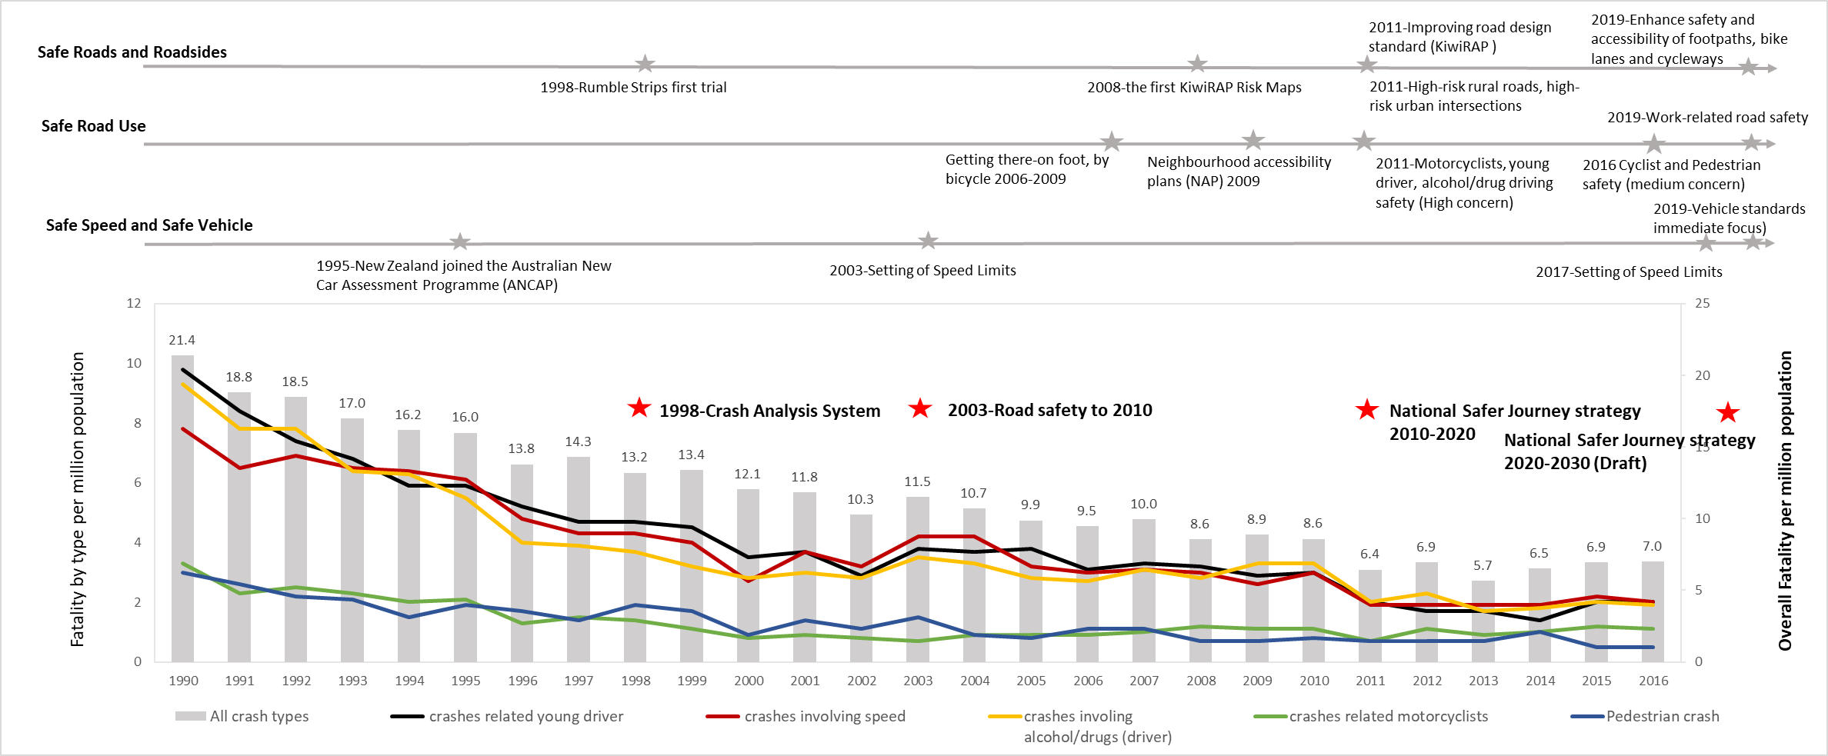

# Figure 1 Road safety policies related to pedestrian safety in New Zealand and fatality rate by crash types

# 4.1.1 Trend and Locations of Pedestrian Crashes in New Zealand

Figure 2 shows a trend of pedestrian fatalities and serious injuries (FSi) per million km walking from 2005 to 2015. The result has shown a gradual increase in the FSi rate since 2011 with a small fluctuation during this period, despite a slight drop in walking by an average annual rate of about 1%. However, this data must be interpreted with caution for the year of 2015 because the million km walking year result for 2015 was a preliminary result and had not been finalized. Overall, however, it can be concluded that pedestrian safety has not significantly improved. Figure 3 shows the location where crashes occur. It is evident that the majority of crashes occur when pedestrians cross at prohibited places without marking at center lines accounting for 56%. When filtering data to the crashes that particularly occurred at a pedestrian crossing, about 89% occurred at the uncontrolled crossing sites. The results are in line with the fact that crossing at the mid-block urban sections needs special attention.

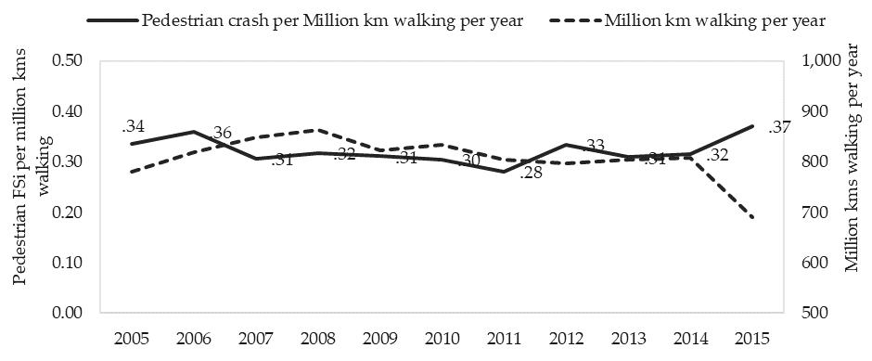

**Figure 2** Pedestrian fatality and serious injury (FSI) per million km walking



**Figure 3** Pedestrian crash locations

*Note: Uncontrolled crossings are facilities where provisions are made for cyclists and/or pedestrians to cross the road and priority is not given through the use of signals (NZTA, 2018c).*

## 4.1.2 Contributing Factors: Road Users’ Behaviour

# The encountering between pedestrians and vehicles is more frequent at road crossings and this consequently creates a higher risk of crash involvement, especially in urban areas. Pedestrian crash reports show that ‘crossing the road’ was the leading factor in pedestrian fatality and serious injury accounting for 28% of all pedestrian crashes. Crossing at mid-block accounted for about 70% of these crashes. In addition, more than half of crashes at mid-block sections occured in prohibited places without marking at centre line. Drivers ‘did not see or look for another party’ comprised of 12%, whilst ‘alcohol or drugs’ from both pedestrians and drivers accounted for a further 6%. In rural areas, pedestrians wearing dark clothes and alcohol-impaired non-drivers were the leading causes of pedestrian fatality and serious injury (CAS, 2012-2016). Poor visibility and higher operating speeds on rural roads may reduce drivers’ ability to see, perceive, or react appropriately. Therefore, impact speeds, and consequently, injury severity is expectedly higher in rural areas even though quantities are lower.

# Looking closely at road user behavior, a number of pedestrian crashes have involved people making unsafe choices such as the drivers’ decisions to go/not to go or pedestrians decided when and where to cross the road. The evidence showed that 89% of all factors related to road user behaviours and these were likely to be around pedestrian behaviours (CAS, 2012-2016). However, given that crashes are multi-factored, the majority of crashes are reported as having some human-related factors.

# Figure 4 displays that crossing road and running and crossing heedless of the traffic were the most common reasons accounted for over a half at both intersection and mid-block sections. Stepping out from behind a parked vehicle was another key issue that made up to 15.4% at the intersections and 9.4% at mid-block crossings. This figure may explain that hurry and impatience naturally influence pedestrians’ choices. In addition, not complying with traffic signals comprised 8.5% of factors at intersections and only 0.6% at mid-block sections (CAS, 2012-2016). A small proportion of non-compliance behaviour, however, should not be inferred that this is not a key issue. The evidence could be partly because the priority of traffic movement at the mid-block locations is not always given by the signals. Furthermore, pedestrian movements can be complicated compared to the vehicular traffic that is restricted to the road-rule and lane discipline. Pedestrians are required to use a pedestrian crossing if they are within 20 metres of pedestrian crossing and to not suddenly enter the pedestrian crossing when the driver approaches so close or unable to give way to pedestrian (NZTA, 2017).

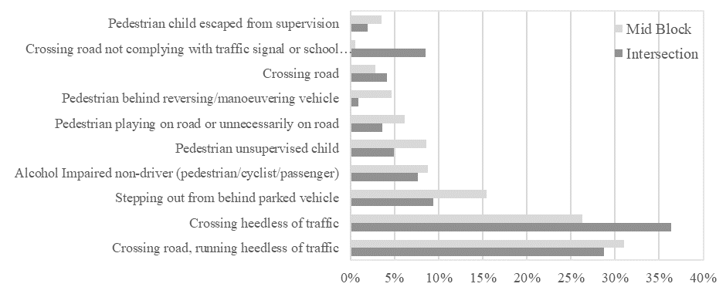

**Figure 4** Pedestrian factors

**4.2 Part 2: Pedestrians’ perception and motivation**

In total, 400 respondents were useable, which consisted of 188 males and 212 females. Most of them were under the age of 34. Over three-quarters (78.5%) have lived in New Zealand for more than five years. The key finding shows that pedestrians decide to cross at mid-block sections can be driven by psychological factors, including the belief of controllability or self-efficacy over the behaviour, attitudes towards road crossings, and whether the behaviour is acceptable within society. Figure 5 shows that 92% of respondents strongly agree/agree that they check several times while crossing and always stay safe by crossing the road only when the gap in traffic is sufficient.

**Figure 5** The belief that people have control over illegal crossing

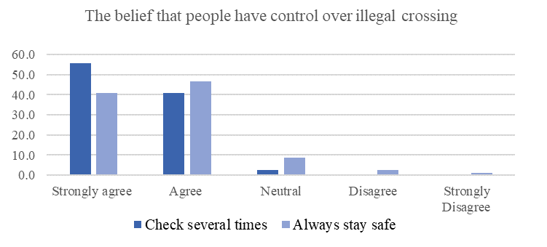

When respondents were asked about attitude and motivation towards the illegal crossing, 65% strongly agreed/agreed that they cross mid-block sections because they want to save time or reduce the walking distance (Figure 6). As for the questions, “I do not think that it is wrong to cross the road without any pedestrian facilities. (e.g., zebra crossing or pedestrian crossing)” and “I feel confident that I can cross the road without any issue.” The majority of people stated that they are confident and see nothing wrong with this act (Figure 7). However, around 40% reported that they would not cross outside pedestrian crossing facilities if there were police cars around. This indicated that people are aware that crossing outside pedestrian facilities violates traffic rules. In addition, most people said their friends and people who are important to them do not think that it is wrong to do so (Figure 8). With this belief in mind, the opinions of friends and family could influence the intention of respondents to cross at mid-block sections.

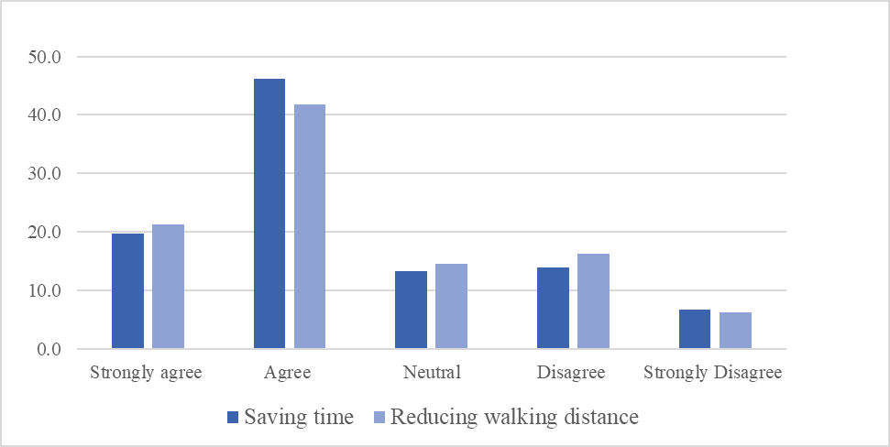

**Figure 6** Attitude towards jaywalking

**Figure 7** The belief that people have in their ability to cross the road at mid-block (jaywalking)

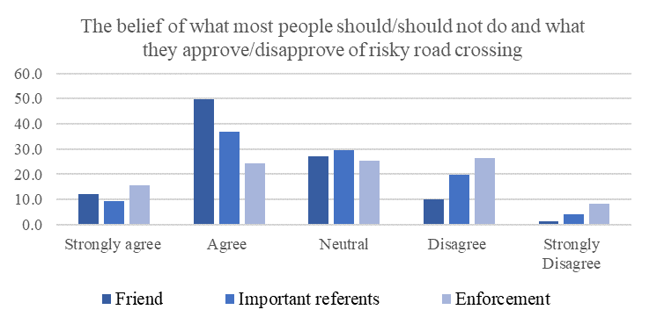

**Figure 8** The belief of what most people should/should not do and what they approve/disapprove of jaywalking

*Note: Important referents refer to the person whose respondents believe that they are important to them such as family members.*

**5. DISCUSSION AND CONCLUSIONS**

Walking is a common form of transport in many urban settings and it is increasingly being encouraged for health and environmental benefits. Throughout the world, however, pedestrians are faced with an increased risk of death and disability from road crashes whilst walking. The analysis of pedestrian crashes shows that there are multi-factors involved. In New Zealand, multiple road user behaviour causality factors from both drivers and pedestrians account for the occurrence of pedestrian crashes. Crossing the road in urban areas with high exposure creates the highest risk, particularly at uncontrolled crossing sites.

In recent decades, New Zealand has implemented a Safe System Approach trying to reduce the road toll. The strategy has been targeting driving behaviour to improve road safety as it is generally recognised that road crashes are highly associated with driver negligence, inattention, fatigue, and speeding behaviour. It also focuses on high crash risk locations to enhance the safety of overall road users. The reduction of overall crashes is evidence that global road safety policies focusing on drivers was successful for almost two decades in reducing crashes related to driver user behaviour. However, a reduction of pedestrian related crashes is less noticeable. The results point to the fact that its focus on road safety policy may have rarely been on equity or a fair deal for pedestrians. There is also little effort to research pedestrian behaviour analytically in line with strategic plans (Ministry of Transport [MOT], 2004; NZTA, 2018a). Overall, there is a poor and tenuous correlation between recent New Zealand road safety policy and pedestrian safety outcomes. It is suggested that a radical shift in pedestrian strategy should be introduced to complement current practices that specifically target pedestrian crashes, pedestrian behaviour and pedestrian infrastructure taking a Safe System Assessment approach to target improvements for vulnerable road users.

For further understanding of pedestrian behaviour, the second part of this study investigated pedestrian perception and motivation towards road crossings. The results reveal that pedestrians commonly perceive illegal crossing as an acceptable act in society, but they are aware of traffic regulations and follow the traffic rules if necessary. They also realise that there may be consequences of the risk of road crossing, but they believe that they are in control over such behaviour. In addition, the motivation to violate the traffic rules is related to convenience gain, including saving time and reducing walking distance. This may result in perceived ‘benefits’ that outweigh the potential ‘costs’ of a possible crash or an enforcement fine.

In many big cities, multimodal transport is expected to grow towards public transport and active modes that include walking in its function. Pedestrian safety can be improved if road user behaviours and perceptions are not abstracted from the engineering practices but grounded in it. Practically, areas with high walking activity and crash risk should be carefully re-evaluated to create a safe space and optimize pedestrians’ desire-lines. As mentioned, New Zealand road rules require pedestrians to use crossings if they are within 20 meters (NZTA, 2017). With this moderate restriction and the absence of any targeted enforcement, pedestrians may perceive crossing at mid-block as being a necessary risk worth taking (benefits outweigh any disbenefits). Prioritised research also needs to determine the risk profile of different types of transport and what factors contribute to this risk (Soathong et al., 2020). Future research should extend towards the role of enforcement and education. The results of the combined study will help provide further insight into pedestrian user behaviour at mid-block crossings, safety outcomes and evidence for improved policy and outcomes.

**6. AUTHOR CONTRIBUTION STATEMENT**

All authors were part of the conceptual idea. A.S. conceived and designed the analysis. All authors reviewed the results and approved the final version of the manuscript.

**7. REFERENCES**

1. CCMTA. Canada’s Road Safety Strategy 2025: Towards Zero: The Safest Roads in the World. Canadian Council of Motor Transportation Administrators. 2016. Available online: <http://roadsafetystrategy.ca/en/> (accessed on 9 May 2018).
2. Crash Analysis System (CAS). 2012-2016, Accessed Feb 6, 2018.
3. Dıaz, E. M. Theory of planned behavior and pedestrians' intentions to violate traffic regulations. *Transportation Research Part F: Traffic Psychology and Behaviour*, Vol. 5, No. 3, 2002, pp. 169-175.
4. Evans, D., and Norman, P. Understanding pedestrians' road crossing decisions: An application of the theory of planned behaviour. *Health Education Research*, Vol. 13, No. 4, 1998, pp. 481-489.
5. Evans, D., and Norman, P. Predicting adolescent pedestrians’ road-crossing intentions: An application and extension of the theory of planned behaviour. *Health Education Research*, Vol. 18, No.3, 2003, pp. 267-277.
6. Hamed, M.M. Analysis of pedestrians’ behavior at pedestrian crossings. *Safety Science*, Vol. 38, No.1, 2001, pp. 63–82.
7. Himanen, V., & Kulmala, R. An application of logit models in analysing the behaviour of pedestrians and car drivers on pedestrian crossings. *Accident Analysis & Prevention,* Vol. 20, No. 3, 1988, pp. 187-197.
8. Holland, C. A., Hill, R., and Cooke, R. Understanding the role of self-identity in habitual risky behaviours: Pedestrian road-crossing decisions across the lifespan. *Health Education Research*, Vol. 24, No. 4, 2009, pp. 674-685.
9. Holland, C. A., and Hill, R. Gender differences in factors predicting unsafe crossing decisions in adult pedestrians across the lifespan: A simulation study. *Accident Analysis & Prevention*, Vol. 42, No. 4, 2010, pp. 1097-1106.
10. Keall, M.D. Pedestrian exposure to risk of road accident in New Zealand. Accident Analysis & Prevention, Vol.27, No. 5, 1995, pp.729-740.
11. Macbeth, A.G., Boulter, R., & Ryan, P.S. New Zealand walking and cycling strategies: best practice. No. 275, 2015.
12. NZ MOT. Review of the Road Safety to 2010 Strategy New Zealand Government; (Land Transport New Zealand). Ministry of Transport. Final report Contract No. 170/04 2004 with Breen J Consulting. 2004.
13. NZ MOT. New Zealand’s Road Safety Strategy 2010–2020. NZ Ministry of Transport. Available online: [http://www.saferjourneys.govt.nz/. 2018](http://www.saferjourneys.govt.nz/.2018). (accessed on 15 July 2018).
14. NZTA. *Land transport (road user) rule 2004.* Wellington, New Zealand, October 2017.
15. NZTA. Road safety: Some key milestones in New Zealand’s road safety history. 2018a. Retrieved from https://nzta.govt.nz/roads-and-rail/research-and-data/fascinating-facts/road-safety/ (accessed on 9 May 2018).
16. NZTA. Young driver crashes. 2018b. Available online: <https://www.transport.govt.nz/mot-resources/new-road-safety-resources/young-drivers/> (accessed on 9 May 2018).
17. NZTA. Uncontrolled Crossings. 2018c. Available online: https://www.nzta.govt.nz/walking-cycling-and-public-transport/cycling/cycling-network-guidance/designing-a-cycle-facility/crossings/uncontrolled-crossings/(accessed on 9 June 2018).
18. NZTA. Road to Zero: A New Road Safety Strategy for NZ Consultation on the 2020-2030 Road Safety Strategy. Available online: <https://www.transport.govt.nz/multi-modal/keystrategiesandplans/road-safety-strategy/>(accessed on 9 October 2019).
19. OECD. *Towards Zero: Ambitious Road Safety Targets and the Safe System Approach;* Transport Research Centre, OECD/ITF: Paris, France, 2008.
20. Sisiopiku, V. P., and Akin, D. Pedestrian behaviors at and perceptions towards various pedestrian facilities: An examination based on observation and survey data. *Transportation Research Part F: Traffic Psychology and Behaviour*, Vol. 6, No. 4, 2003, pp. 249-274.
21. Soathong A, Wilson D, Ranjitkar P, Chowdhury S. A Critical Review of Policies on Pedestrian Safety and a Case Study of New Zealand. *Sustainability.* 2019; 11(19):5274.
22. Soathong A, Chowdhury S, Wilson D, and Ranjitkar P. To Jay-walk or Not to Jay-walk: Pedestrians’ decision to cross at mid-block sections of urban road, paper presented at the at TRB annual meeting, Washington DC, 12-16 January, 2020.
23. Sun, D., Ukkusuri, S., Benekohal, R. F., & Waller, S. T. Modelling of motorist-pedestrian interaction at uncontrolled mid-block crosswalks. *Urbana*, 2002, 51, 61801.
24. The Swedish Transport Administration. Statistic for Road Traffic Injuries 2015. Available online: https://www.trafa.se/en/tags/report/ (accessed on 9 May 2018).
25. Várhelyi, A. Drivers’ speed behaviour at a zebra crossing: A case study. *Accid. Anal. Prev.* 1998, 30, 731–743.
26. Vision Zero Network. Moving from Vision to Action: Fundamental Principles, Policies, Practices to Advance Vision Zero in the U.S. 2017. Available online: <http://www.visionzeronetwork.org> (accessed on 9 May 2018).
27. WHO. Global status report on road safety 2015. http:// www.who.int. Accessed May 9, 2019.
28. Zhou, R., Horrey, W. J., & Yu, R. The effect of conformity tendency on pedestrians’ road-crossing intentions in China: An application of the theory of planned behaviour. *Accident Analysis and Prevention,* Vol. 41, No. 3, 2009, pp. 491-497.