Zero emission fleet transition: How to create a business case
Many governments have developed targets for a zero-emission corporate fleet. Transport is the fastest-growing source of emissions and many governments have already committed to purchase 100% of their electricity from renewable sources. This has resulted in transport being the major contributor to emissions for many government agencies and corporate fleets.
Electric vehicle availability and capability have improved significantly in the last three years. In this presentation, a Zero Emission Fleet Transition Business Case will be presented. A step by step process will be described and includes:
- Understanding the importance of selecting ‘like for like’ vehicles
- Common challenges experienced by corporate fleet managers
- Utes – and what’s available now and in the future
- Salary sacrificed vehicles and where best to charge them
- Charging infrastructure development to support the electrified fleet
- Cost benefit analysis for transitioning a fleet to electric.
A framework is presented (see below) to help guide agencies in their fleet transition decisions.
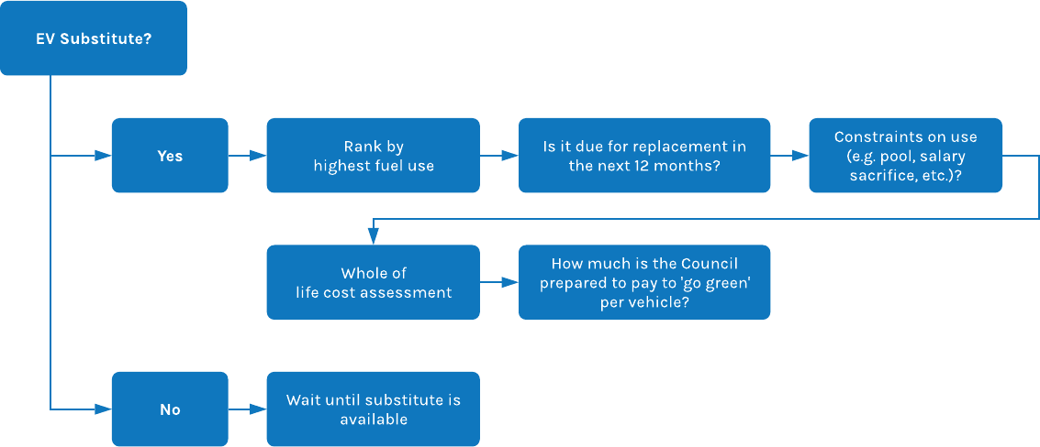
The presentation will provide attendees with the confidence of how to start their zero emission transition, the costs and the benefits, as well as how to avoid common areas of failure.

