Increasing active transport in NZ – what’s most effective?
For over 20 years, governments in New Zealand and Australia have had the policy objective of increasing walking and cycling mode share. A review of the data shows that levels of active transport have remained stagnant, and in some cases, have actually decreased. This presentation uses data prepared as part of an Austroads project that examines the effectiveness of interventions to boost active transport mode share.
A prioritisation framework is offered, allowing government to select the interventions that are most impactful in boosting active transport mode share. The findings of this study show that ambitious initiatives are required in order to boost levels of walking and cycling. Two decades of policy support for increasing active transport mode share may have stopped or slowed falls in walking and cycling levels but has not yet succeeded in achieving widespread and large increases. This presentation also highlights how in addition to impact, an intervention’s cost, and complexity is also necessary to make informed decisions.
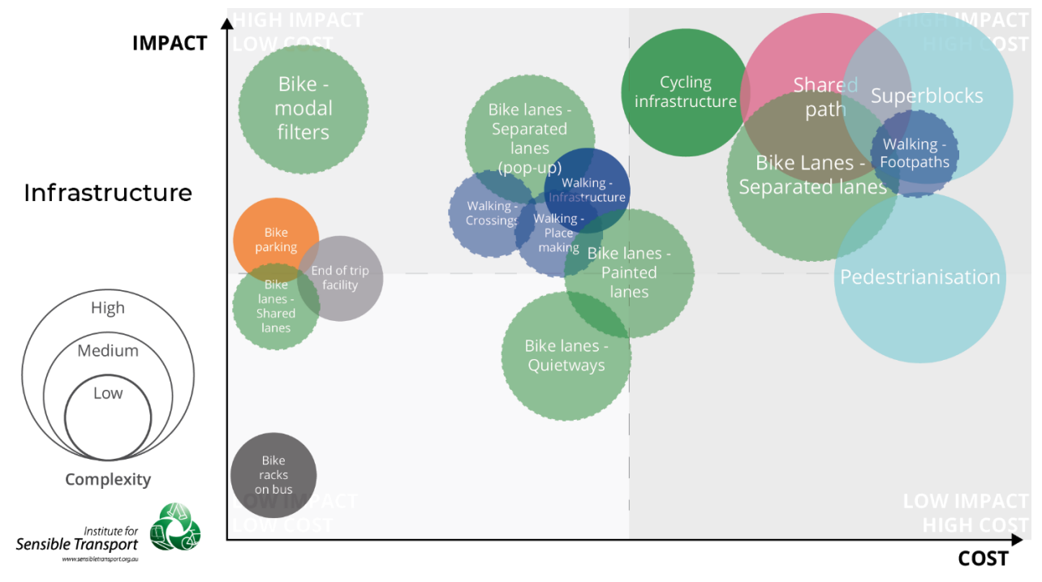
The presentation concludes with the insight that in order to grow active transport mode share, a mix of interventions will be required, including those that reduce or remove current incentives that encourage car use alongside interventions designed to encourage walking and cycling.

