Equity in Engagement: A Case Study of the Brougham-Moorhouse Area of Christchurch

This paper has been peer reviewed

Authors

Bryce Carter
Post Graduate Diploma in Management, University of Waikato (2012)
Bachelor of Engineering (Hons) (Civil), Canterbury University (1991)
Chartered Member of Engineering NZ
Member Construction Law Society
Principal - Transportation
Bryce.Carter@beca.com

Natalie Dixon
Bachelor of Media Arts – Communications
Diploma of Journalism
Certificate of Social Services
Certificate in International Association of Public Participation (IAP2)
Senior Stakeholder & Communications Advisor
Natalie.Dixon@beca.com

Martin Peat
ME (Hons) Operations Research
BE (Hons) Engineering Science
Associate Director - Transportation
Martin.Peat@beca.com

Greg Edwards
MSc Climate Science & Policy
BA Philosophy & Sociology
Transport Planner
Greg.Edwards@beca.com

Salina Li
MSc Transportation
MEng Civil Engineering with Construction Management
Member of Engineering NZ
Senior Engineer - Transportation
Salina.Li@beca.com

Presenters
Bryce Carter, Beca
Greg Edwards, Beca

Abstract
As Christchurch grows, communities form, and new technology creates more change, there is an exciting and challenging opportunity to shape the communities in which we live, work and play for now and for the next 30 years to come.
Currently a major route for freight movements in the region, we are working to make the Brougham Street and Moorhouse Avenue (Brougham-Moorhouse) area a safer and more attractive place, while maintaining movements through the area. It is a complex area and the solution is not as simple as building our way out of congestion with new infrastructure. A more balanced approach is needed to promote liveability in one of Christchurch’s busiest areas while considering the environment and our heritage, alongside key industries and the prosperity of local economy.
This paper is structured to discuss the challenges in balancing the competing demands in a changing strategic environment. We then look at the communication and engagement process used to obtain a more balanced public view from the Brougham-Moorhouse communities.

Introduction
The Brougham-Moorhouse area is situated adjacent to the Central City to the south, shown in Figure 1. The area is bound by two main arterial roads (Brougham Street and Moorhouse Avenue) travelling east-west, with multiple main north-south streets and other local streets. It serves as a place for people to live, shop, and work with a mixture of residential, commercial, and industrial land uses.
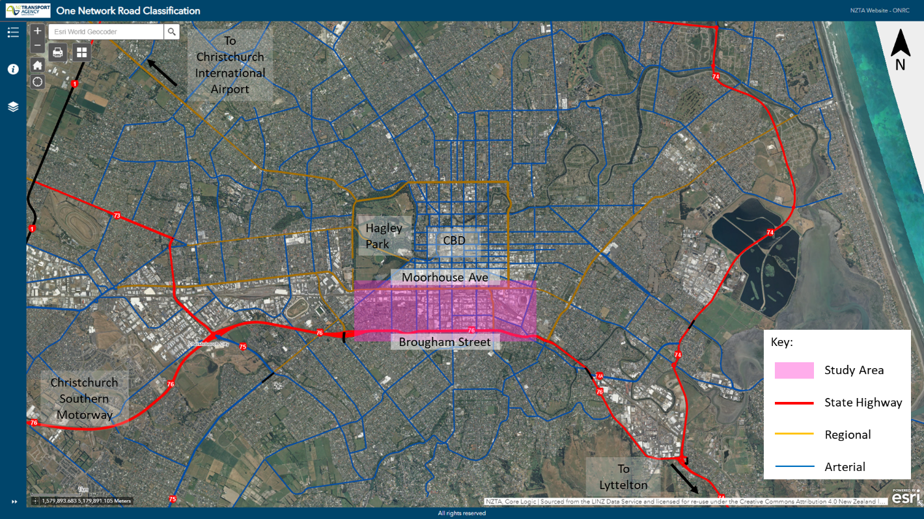
Figure 1: Location of the Brougham-Moorhouse Area
The two arterial roads provide largely for cross city journeys, as well as commuting to the City using shorter local trips. The main north south roads give access for the southern Christchurch suburbs to the city centre, as well as for traffic from the south west growth areas via Brougham Street. Brougham Street is State Highway 76 and is highly utilised by heavy freight vehicles travelling to and from the ports of Lyttelton.
The area serves as a transport corridor for communities to the south, southwest and east of the city both in the east west direction predominately along Moorhouse and Brougham Streets and a number of north south corridors accessing the city centre along with destinations to the north.
The local community includes residential, commercial and industrial uses.

Describe the problem
The transport system in the Brougham-Moorhouse area is struggling to satisfy all the conflicting needs of the communities that live, work, and travel through area as well as the businesses that operate there. Whilst existing access and passing trade provide economic benefits for communities living and working in the area, noise, pollution, congestion, and increased exposure to road safety hazards are leading to negative impacts. Figure 2, Figure 4 and Figure 2 illustrates some common problems with regards to safety, efficiency and access & amenity for this area that is experienced by the current users.
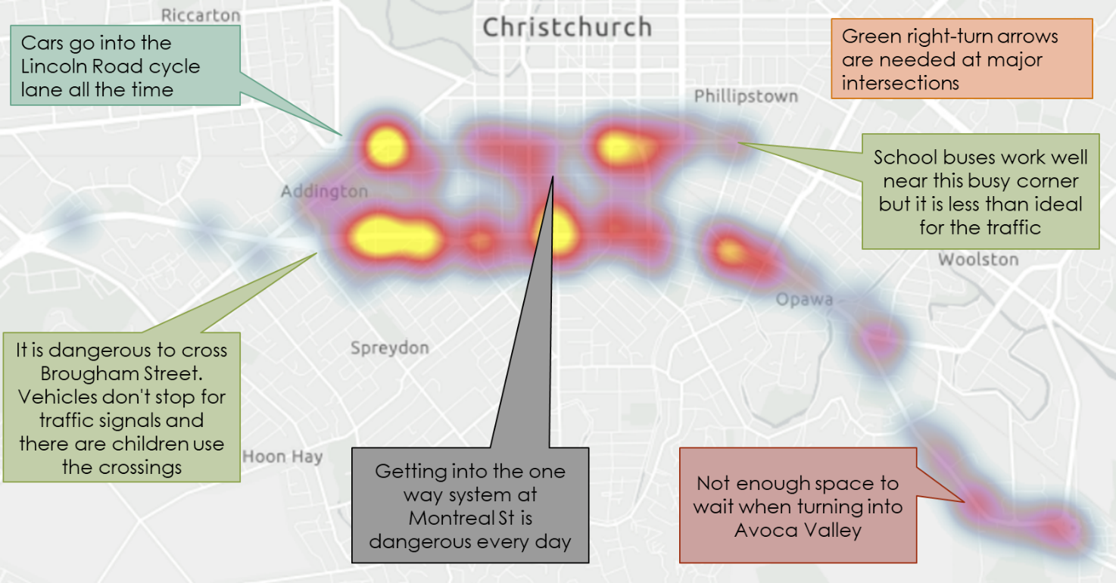
Figure 2 Common Problems with Safety
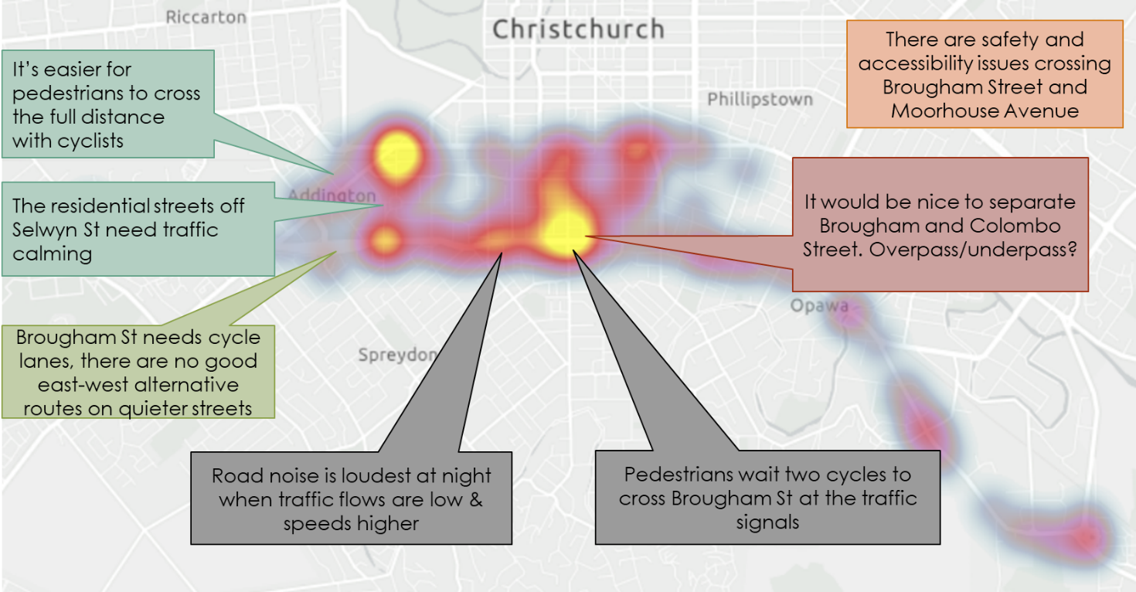
Figure 3 Common Problems with Efficiency

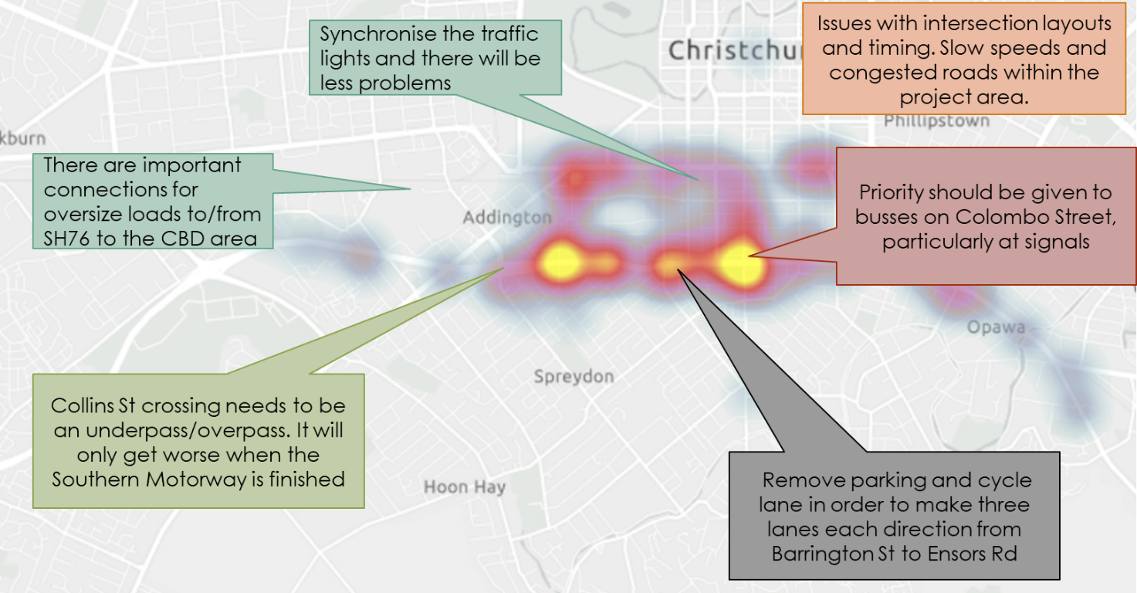
Figure 4 Common Problems with Access and Amenity
Conflicts between vehicles travelling east and west across the city and traffic travelling north and south from the central city to the south and south west cause disbenefits for both the economy and for residents of adjacent communities with reduced travel time reliability when travelling through the area. In terms of the economy (freight and business) and residents from adjacent communities travelling through the area there are also conflicts with between east west and north south traffic.
Regeneration of the city centre remains a key element of the Christchurch rebuild and is in part dependent on access through the study area. Similarly, the port and industrial areas to the east and south west of the city and the wider Canterbury region are dependent on transporting goods through the area.
Road space within the Christchurch transport corridors is dominated by private motor vehicles which is the predominant mode of transport in the city as a result of historic priorities and investment. The reliance on private vehicles is reflected in the Household Travel Survey with a reported 83% of trips to a workplace made via car/van. Data on vehicle occupancy indicates up to 85% of all vehicles are single occupancy.
Internationally, Christchurch sits amongst the cities with the highest percentage of private vehicle trips with a high proportion of single occupancy vehicles. This has been reinforced by development post Christchurch earthquakes with the slow construction of inner city residential developments. A transfer of residential population from the east (red zone) to more distant suburbs to the north, south and south west, low density car dependent residential developments outside the city limits, significant investment in motorway corridors and a preponderance of inner city parking are some of the influence factors.
Although this is somewhat offset by the current investment in cycleways, with two Major Cycle Routes constructed and completed within the study area, and the rise of micro-mobility. These modes generally impact mode choice on shorter journeys. The trend of increasing population in the suburbs of Christchurch means more longer distance journeys that is the primary contributing factor to the increase dependencies of single occupancy vehicles (SOV).
While the current congestion level is not detrimental to the prosperity of this area, Christchurch City Council Network Management Plan (NMP) models indicated that significant traffic congestion is likely to occur over the next 15 to 20 years with no change in travel behaviour. The weekday congestion on Brougham Street and Moorhouse Avenue alone for east-west movements is estimated to cost $29 million per year in 2018. This increase in congestion will exacerbate the negative impacts on the economy (freight and business), the local community within the area, and other communities whose residents depends on the local road network to function and live their daily lives.

What are the challenges
The challenges faced in the Brougham-Moorhouse area are systematic of the city’s challenges that continued population growth and the current reliance on the private vehicle to travel. If no intervention is proposed, the freedom and independence associated with the way the people of Christchurch travel around will be threatened. A mode shift towards more walking, cycling, and public transport trips is required.
The dominant challenge for the study area is catering for the needs of the local community, for people who travel through the area, and the businesses and their customers (including regional freight, the port and the city centre). At times their needs align but often their needs are in conflict.
When we look at other sites around the world, we know that building new roads alone will not address congestion issue and will result in worse community outcomes. However, we also need to be mindful of the negative impacts on the economy and regeneration of the central city when deciding what kind of investment decisions to make.
Disruptions to the distribution of housing and businesses caused by the 2010 and 2011 earthquakes, combined with damage to roads and infrastructure, have led to altered travel patterns and traffic volumes impacting the study area.
Underlying all these challenges is the need to design a transport system that can respond to known and potential stresses to society, economy, and the natural environment. Building infrastructure that is resilient and flexible enough to adapt to future pressures created by climate change is essential.
Equally, technology advances in alarming rate globally, the economy and the future labour market are under unprecedented threat and opportunities. The challenge is how to plan for the inevitable while maintaining an open mind to adapt and embrace changes in the future.

Our response to these challenges
Safe and efficient transport system plays a key role in facilitating growth and urban development. With the struggles Christchurch has been facing to regenerate since the earthquakes, it is positive to see a growth trend in population and economy. The challenges are stepping stones for Christchurch to grow and be even more resilient.
For the Brougham-Moorhouse area, this means ensuring that the transport system supports wider land use aspirations such as increased residential development density as well as supporting a transition from historical industrial land uses to more mixed-use. The impact of having a more compact urban form, with communities living closer to where they work, will contribute to an uptake in public transport, and reduced trip distances will make walking and cycling more attractive.
With the area supporting a wide range of business and industrial activity as well as being a key access corridor to the central city, it will be important to ensure that freight can be moved efficiently. Opportunities therefore exist to prioritise freight on certain corridors and to separate it from the congestion caused by general traffic. This will ensure the future commercial success of the study area and city as a whole.
The future success of this area and the city as a whole, relies on reducing dependency on private vehicles to satisfy all travel requirements. It is time to provide alternative transport options that are accessible and attractive to use. This means improving the street environment to make walking and cycling the most attractive option for shorter journeys that begin and travel through the project area. Similarly, it also means providing increased and better public transport services and dedicated infrastructure to make it the most attractive option for people travelling from further afield.
Reducing the number of vehicle trips will also improve community’s health, by reducing inactivity and improving air quality. It will contribute to an improved local environment and revitalisation of streets, making them nicer and more pleasant places to be.
Despite investment in active travel, there are still too many cyclists and pedestrians involved in road crashes. These factors contribute to the discouragement of these modes. There were 150 deaths and serious injuries within the area in the last 10 years. The relative exposure to road risk is reflected in the relatively high-risk profile of intersections, with ten in the area in the top 5% highest risk intersections nationally. By promoting active, efficient, and sustainable travel choices and invest in suitable infrastructure that supports these modes, the streets will be safer for everyone.

Why is it important to do it now?
The challenges with the proposed transformation of the Brougham-Moorhouse area are not unique, in fact, are shared in all large cities in New Zealand, such as Auckland, Wellington, and internationally, such as London and Sydney.
There is a cost in not acting in a timely matter. By not adapting to the demands in time, there is a financial cost that increase exponentially as congestion spread and journey time reliability reduces. There is also a social cost of which people are fed up with the negative environment traffic congestions brings and move their home and their businesses away from Christchurch.
An opportunity exists to enable a better functioning and more pleasant public realm. At a time when businesses activity is still sensitive post-quake, reducing the dominance of the car, reducing traffic noise and pollution, and improving access via alternative modes will help rejuvenate our streets and make them more people-friendly.
Making streets work for people and not just vehicles will attract shoppers and businesses but will also free up road space for the essential freight and commercial activities that maintain prosperity of the city, provide opportunities for jobs and ensure the economic success of the city.

Community Engagement
The communities/users are extremely varied - from cyclists and pedestrians, parents walking their kids to school to social housing clients, age care communities to commuters, people with disabilities, public transport users, bus companies, KiwiRail, businesses, the inland and Lyttelton Port and freight.
Some are travelling through or around the area, some are living in the area, some using it for businesses.
Striking the right balance with our solutions is not easy and gathering a representative range of comments from all users is yet another level of challenge. Early engagement with a wide range of people was key to overcome this challenge, so that everyone is aware of what the problems was defined as, to enable solutions to be developed through a collaborative approach.
A four-step method that involves taking stakeholders and the community on a step by step journey alongside the Project Partners is being adopted. The goal is to support the partners to achieve strong community support and ownership of the project following the completion of this study.

The benefit of this process is to gain a good understanding of community and stakeholders’ wants and needs. This process encourages the team to take time and examine how best to address the problems with the Project Partners (NZTA and Christchurch City Council) to make holistic and collaborative decisions.

Stakeholders
Relevant stakeholders to the project were identified by Beca, the Transport Agency and Council and were directly emailed details about the project, were invited to the workshops held and asked for feedback. Approximately 1,000 stakeholders were identified, and this list continues to grow as the project progresses.
The group of stakeholders consist of a wide range of background, including school principals, social housing groups, heavy haulage and freight organisations, and walking and cycling groups. This was undertaken to provide a broad range of inputs from stakeholders in order to provide an unbiased perspective on the area. It is important to the client and the project team that the proposed solutions are being understood and being supported.

Our Engagement Journey
The first phase of engagement sought to introduce the project and gain community and stakeholder insights. A variety of proven engagement and communication tools were used such as workshops, community open days and door-knocking, media release, radio and print advertising and e-newsletters. It was further advertised on the Transport Agency and Council website.

Newsletters
The printed newsletter provided explanation of the project and was distributed to all relevant organisations such as Council, libraries, Ara Institute of Canterbury, social housing, schools and to freight companies. Around 150 copies were also given to Council and the Transport Agency to distribute. Postal delivery of flyers with feedback forms were placed in mailboxes or given to businesses in the wider area. In total, 11,000 copies of the newsletter and 4,000 flyers with feedback form were distributed.
Efforts were made to ensure the design of this printed newsletter would connect with the widest range of audience. The language used was pure and simple, supported by relevant images. Prints in larger fonts or alternative languages, in audial form or in braille, were made available. These were advertised via Christchurch City Council’s website and through community centres and libraries.
PDF copies were also being uploaded onto the project page and emailed to the stakeholders.
Although large volume of printed material is not preferred, there was positive feedback from people who had received a copy and provided those who do not have the internet access an effective way to access the information.

Internal Newsletters
Information about the project, including a digital version of the newsletter, was sent to Transport Agency, Council and Beca staff before the project launch.
Addington School also featured details about the project and the consultation process in their school newsletter. These were quick and easy to produce, and the client took charge of sharing them internally. They worked well to keep all staff updated and helped engagement with more people as staff shared information with their own contacts.

Open days
The community open days took the form of five pop-up events held at different times and at various locations around Christchurch in early December 2018. There were three public events at the Colombo, the Christchurch Bus Interchange and at the Hagley Park South. There were two targeted events held at the Nazareth House Retirement Village and Addington School. The team spoke to approximately 600 people throughout the five events.
Each location was chosen to generate feedback from certain groups. For example, public transport users commuting home from Central City were being engaged at the Bus Interchange. Cyclists, pedestrians and taxi drivers were engaged at Hagley Park South. A mix of people who live, work or do business within the project area were engaged at The Colombo.
Depending on the type of audience targeted, the format of these open days would vary. For example, the event at Nazareth House took the form of a question and answers and we gathered information and thoughts through discussions.
The Colombo Mall and Hagley Park were considered the best public pop-up sessions as the team could have detailed conversations with more people. Although there were a lot of people at the Bus Interchange, the majority were in a rush to get home and were not prepared to stop.
Both Nazareth House and Addington School were good locations with receptive audiences who were keen to be involved in the project and going forward we will look to do more of these.
The open days provided an opportunity to be seen whilst exploiting the opportunities provided by face-to-face engagement to build relationships.

Newspaper and Radio Advertising
Newspaper and radio advertising were used to engage with a wider audience around Christchurch and Canterbury with the focus to direct people to the website or to attend open days.
A quarter-page print advert was placed in the Christchurch Star to introduce the project and how and where people could give feedback. A number of people attending the pop-up events said they had seen the advert.
A radio advertisement was played on radio stations ‘The Breeze’, ‘Magic’, ‘Radio Live’, ‘The Rock’ and ‘The Sound’ over 11 slots. These advertisements changed according to the day they were played. There was great feedback from the client who said staff had heard the advert and our contacts at The Blind Foundation also commented on this.

Door-to-door Visits
Door-to-door visits were undertaken at local businesses and organisations within the project area to capture their thoughts.

Media Release
A media release was sent to reporters by the Transport Agency media manager on November 26, 2018. Media releases are a good way to tell people about what you are doing and reach a wide audience, create excitement and build client reputation.
The release was picked up by media organisation ‘Stuff’ who wrote an online article. The following day there was a large article, covering pages two and three in the Christchurch Press.
The Star Newspaper and Newstalk ZB also ran pieces on the project and consultation process. All media coverage was positive, and the client was happy with the response.

Social Media
Social Media was used to advertise the project, consultation process and where to give feedback. A Facebook post highlighting the media release went live on the Transport Agency’s South Island page in late November 2018 taking people to the project page.
Facebook posts advertising the pop-up events and other ways to give feedback went live a week before, and on the day of the events. Posts pointing people to Social Pinpoint were boosted and geofenced in the local area every week until the first round of engagement finished in January 2019. These posts were shared by the council’s social media channels and by local community organisations, local schools and spread across to other groups organically. The webpage received 1657 page visits; 191 people made comments on Social Pinpoint while another 1400 people shared their thoughts on these ideas.
Social media was a good tool to use to get public sentiment, flush out any issues and get information to people who may not read the newspaper or attend open days. During the next round of engagement, it is planned to share some mode shift ideas and create more conversation around behaviour change on social media channels.
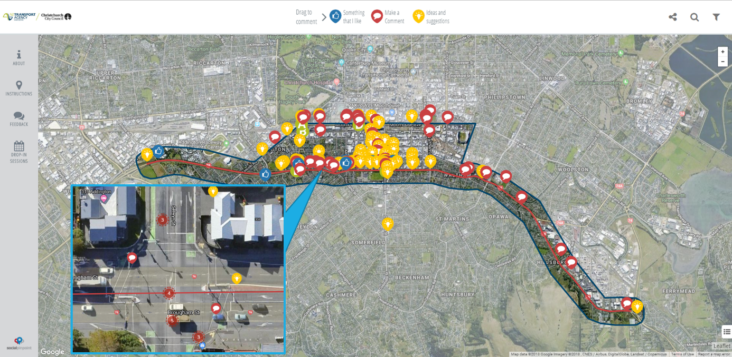

Website
The website was hosted by the Transport Agency and followed their traditional format. It was a good place to keep all the relevant information and connect people to Social Pinpoint. The webpage received 1,657 visits during the first phase of engagement. Many of the clicks came through social media posts.

Social Pinpoint
Social Pinpoint provides an interactive mapping platform that lets the community show the exact location with regards to their feedback, ideas and concerns. The Transport Agency is using it for projects across New Zealand. It is easy to use, interesting and the reports are useful.
Social Pinpoint helps the team to reach the silent majority who may not go to open days or bother filling out surveys. It is easy to use and can be shared. Project staff can also fill it out on behalf of people who called. For the first phase of engagement, 191 people made comments or shared ideas on Social Pinpoint while another 1,400 people shared their thoughts on those comments or ideas.

The Outcome
The engagement process involved talking to people about how they use the Brougham Street and Moorhouse Avenue and its surrounding area, asked about what it was like for them to get around, what works and what does not work, also asked if they had any ideas to improve things.
The feedback indicated that the Brougham Street/Moorhouse Avenue area is complex. It is used by a wide variety of people living, working and travelling through the area. Each person interacts with the area differently and movements include children and their parents walking or driving to school; people cycling to work; freight deliveries to the Port; locals crossing the road to get to a shop or business.
There were common themes that covered much of the project area. Many people said that it can be difficult to get around, with cars, freight, buses, pedestrians and cyclists all competing to travel through the same busy area. It is congested at peak times and people noted the high number of crashes and near-misses, especially at intersections.
While analysing the feedback, three main themes emerged: Safety, Congestion and Efficiency, and Access & Amenity.
The comments were split relatively evenly across the three main themes with a small amount of ‘other’ comments which did not fall within the main themes. This even split demonstrates that there is no one overriding issue. Instead, there are many competing demands which result in a comparatively even spread across the themes.
The engagement process illustrated how technology has broadened the way messages are being received. The ability to adapt is important to enable the whole spectrum of users are being informed and that messages from the whole community is being heard.
The process highlighted there being great value in using this approach to community engagement, which could be adopted for future projects or similar work. The benefits and opportunities it provided included:
- Enabling a large proportion of the community to be contacted and to hear their views;
- Facilitating a customer-centric or user perspective on the issues and challenges;
- Enabling more younger people to be involved in the consultation process than may be typically inclined to engage.

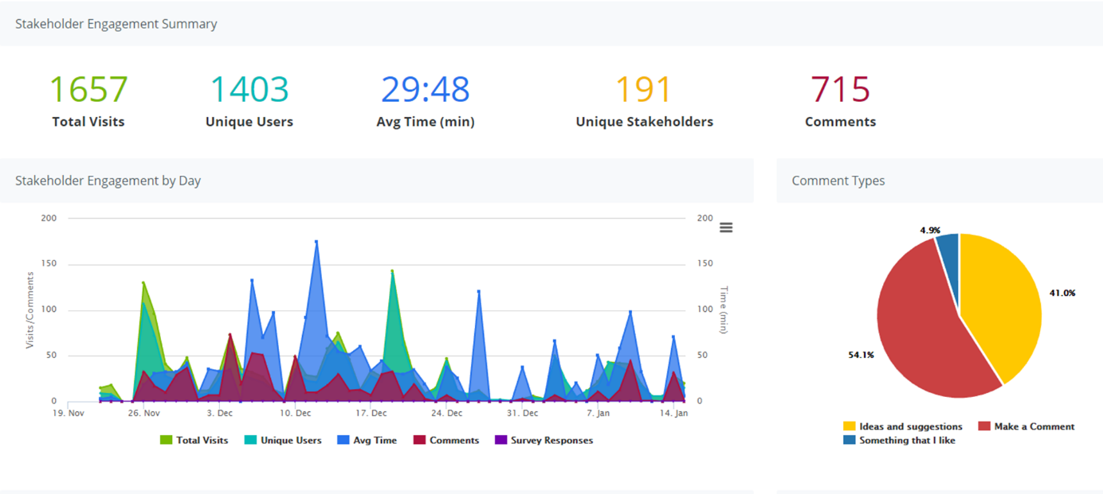

MOT Household Travel Survey 2012-2014 data.
Transport Agency commissioned surveys carried out by Abley Transportation.
Sourced from CAS 204-2018.

