Ian McKinnon Drive Cycleway

the importance of continuity and standards
Ken Lee-Jones
BSc. Civil Engineering, M.ENG Transportation
Director and Principal Consultant
KENLJ CONSULTING
+64 212459770
Ken.Lee-Jones@kenlj.com

Abstract
For many years a relatively short (one kilometre) technically challenging section of shared path/cycleway linking Upper Queen Street and the North Western Shared Path along Ian McKinnon Drive has been considered to have suppressed demand for the usage of the North Western Shared path and adjacent shared paths and cycleways. The Ian McKinnon Drive Cycleway project was developed and constructed in 2018 to provide a more direct, continuous and improved link to address this issue. The project in Auckland is a relatively short combination of cycleway and shared path (approx. 600m cycleway and 200m shared path for a total distance of approx. 800m). It provides a much-improved link between the North Western Shared path and the adjacent network of the Grafton Gully, Te Ara I Whiti - Lightpath and Nelson Street Cycleway. This has encouraged many new users to the route which includes interested but concerned cyclists as well as vulnerable cyclists to use this section of the cycle network.

The project has eliminated the need for people to climb a steep narrow shared path and cross two busy arterial roads. These improvements to the continuity and standard of the link have enabled more people, who would have previously avoided the route, to confidently use the route. Within weeks of the link being opened, usage of the route had increased and within four months the use of the adjacent connected network has increase from 26 to 56%. This increase includes weekend recreational riders. This sort of infrastructure is vital if we want to deliver mode shift and achieve our Vision Zero targets. The cycleway was an initiative supported by Auckland Council, Auckland Transport, Waka Kotahi NZ Transport Agency and the Waitemata and Albert-Eden Local Boards.

This paper focuses on the importance of route continuity and importance of high-quality design and appropriate standards. It presents data to demonstrate how effectively it has increased usage of the surrounding connected network. During construction there were additional design changes that resulted in improvements.

This is an excellent example of vision and co-operation between many organisations and community groups that has had a favourable outcome.

1. Introduction
Ian McKinnon Drive is at the confluence of four cycle routes: the North Western Cycleway, the Dominion Road Cycle Lanes, Grafton Gully Cycleway and the Nelson Street Cycleway (including the Te Ara I Whiti – Light path. The North Western, Grafton Gully and Light Path are all shared path routes accessible to pedestrians and cyclists (Figure 1).

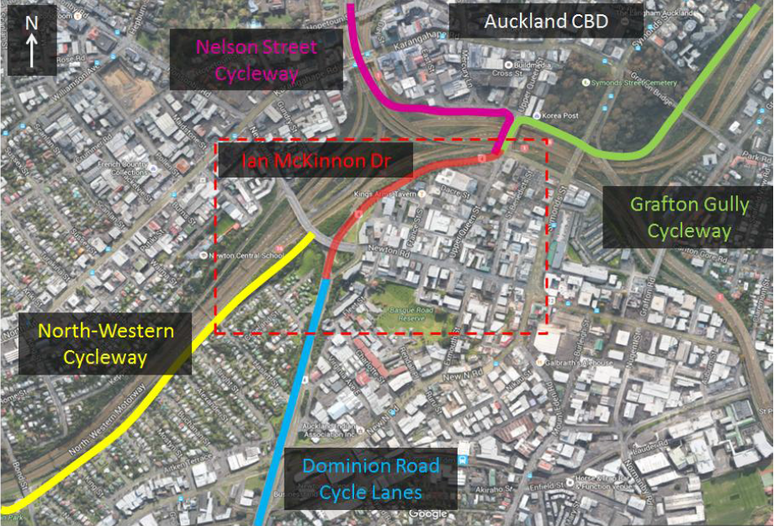
Figure 1: The confluence of routes at Ian McKinnon Drive (extract Jacobs SAR-2016)

The Northwestern shared path is one of the first shared paths in Auckland which encouraged pedestrian and cyclists to share a space mostly separated from traffic.

It was developed along the southern edge of the Northwestern Motorway and its primary purpose is to provide a safer, improved route for cycling and walking that forms a high-quality shared path connection between the central city and the western suburbs of Auckland. It is one of Auckland’s busiest routes, with a length of approximately 16km.
It had one relatively short section of about one km which is the last kilometer before Queen Street that was particularly challenging for cyclists and was suspected of suppressing cycling demand.

The proposal to improve this section of the route provided the mandate for the Ian McKinnon Drive Cycleway project whose primary objective was to:

“Deliver a low cost link between the North-western and the Grafton Gully cycleways that provides a
faster and safer route for existing cyclists while encouraging more people on bikes”

2.

BACKGROUND
There was a cycleway/shared path that was built to complement and link the North Western Shared Path to Upper Queen Street and the
route shown in the dashed line in Figure 2 below which also shows the extent of works of the “Ian McKinnon Drive Cycleway” project.
The challenging section on the North Western Shared Path requires city bound cyclists to share a steep (10%) 80m long ramp which is also narrow (2.0m) to climb to Newton Road, People on bikes then make some tight turns and cross over two busy four-lane roads depending on route choice.
Crossings
Newton Rd
Steep 10% grade section of 80m
Figure 2: The early (pre 2018) Ian McKinnon Cycleway (Extract Jacobs SAR 2016)

A preliminary design was done by GHD which identified the opportunity to use part of the “Suffolk Reserve” and a section of the motorway maintenance access to pass under Newton Road and to use one lane of Ian McKinnon Drive to create a two-way cycle path connecting to the cycle network at Upper Queen Street.

Key to this initiative was to improve the route continuity and provide a consistent and improved standard.

The project objectives were to:
- Create a more continuous route.
- Remove substandard sections from the route
- Increase safety and perceived safety along the route
The outcomes that were sought were:
- To reduce travel times
- Increase ridership on the North Western Shared path
- Contributed significantly to the improved usage of the adjacent Auckland Cycling Network

A lot of information about the project can be found on Auckland Transport’s website https://at.govt.nz/projects-roadworks/ian-mckinnon-drive-cycleway/. This includes the: overview and further details about the project, the expected benefits, the expected and actual timelines of the project and the results of public consultation.

An initial proposal for the project is shown in the dashed line in Figure 2.

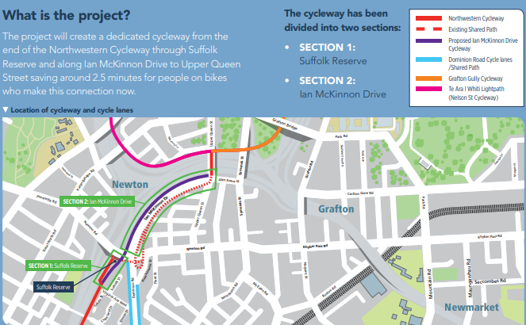
Figure 3: The Ian McKinnon Drive Cycleway Project
(extract Auckland Transport consultation)

The early proposal was developed through the Final Scheme Assessment Report (Jacobs 2017) and proceeded to detail design.

Construction of the project started in February 2018 and the project was opened on 30 November 2018

3.

Methodology
To determine whether the project has been effective it has been reviewed to determine:
- what has changed to improve route continuity,
- what standards were applied and incorporated into the project
- whether the changes have increased the usage of the route and adjacent connected network,
- what other factors contributed to the project’s success?

4. Findings
4.1 Route continuity

A preferred route selection identified the opportunity to use part of the “Suffolk Reserve” and utilize a section of the motorway maintenance access to pass under Newton Road and to use one lane of Ian McKinnon Drive to create a two-way cycle path connecting to the cycle network at Upper Queen Street. This route is shown in Figure 4.
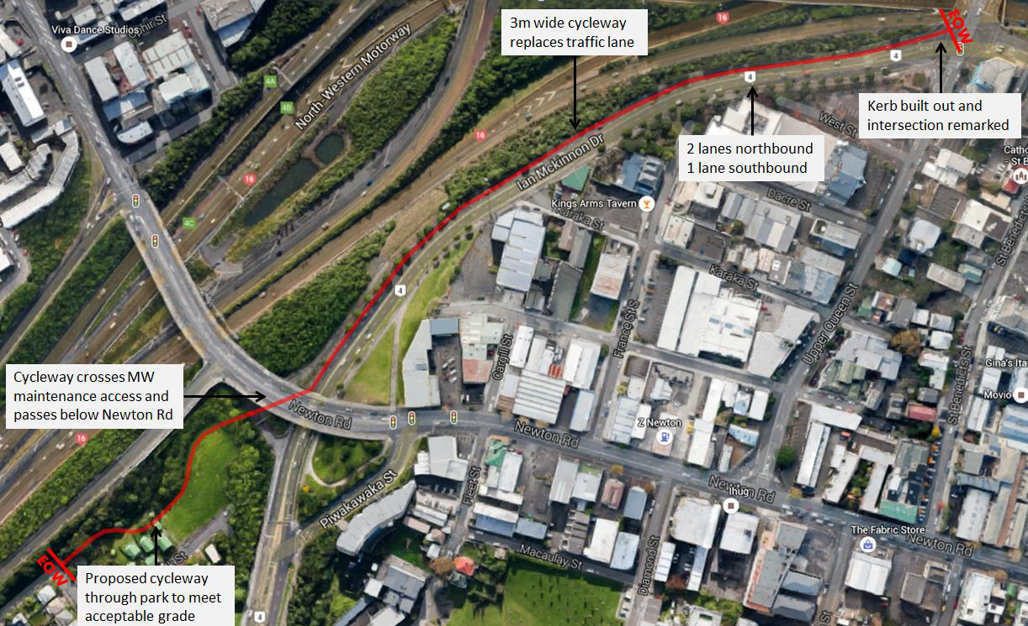
Figure 4: The feasibility proposal for McKinnon Cycleway (Extract Jacobs SAR 2017)

In terms of route continuity the route eliminates the steep section up to Newton Road, eliminates the crossing of Newton Road and also the need to cross Ian McKinnon Drive at Upper Queen Street.
Traffic modelling demonstrated that it would be feasible to reduce the traffic lanes on Upper Ian McKinnon Drive from two southbound to one lane southbound. After an initial settling period of about three months, which included the quieter December and January period followed by a busy February period, the usage of the intersection has shown an acceptable Level of Service as predicted.

Some comparison of the route as planned and as constructed are shown in the following photographs. These show that the planned more direct route has been achieved.

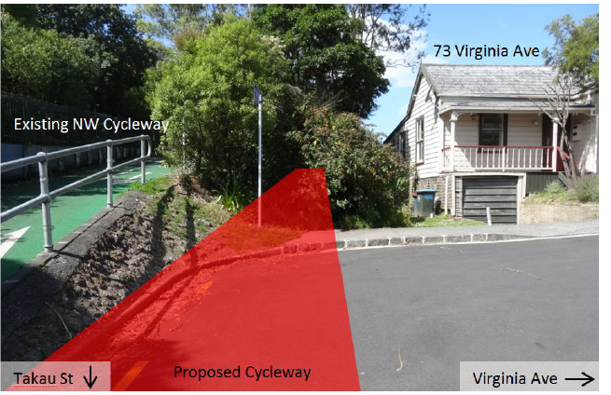

Photo 1 Western end.
Route as envisaged to eliminate steep rise and improve continuity of route through a more v
isually direct and flatter route

. 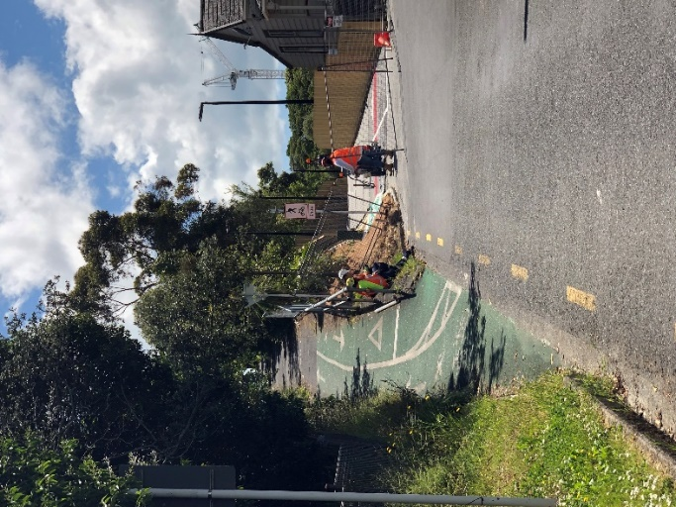
Photo 2 as built prior to opening

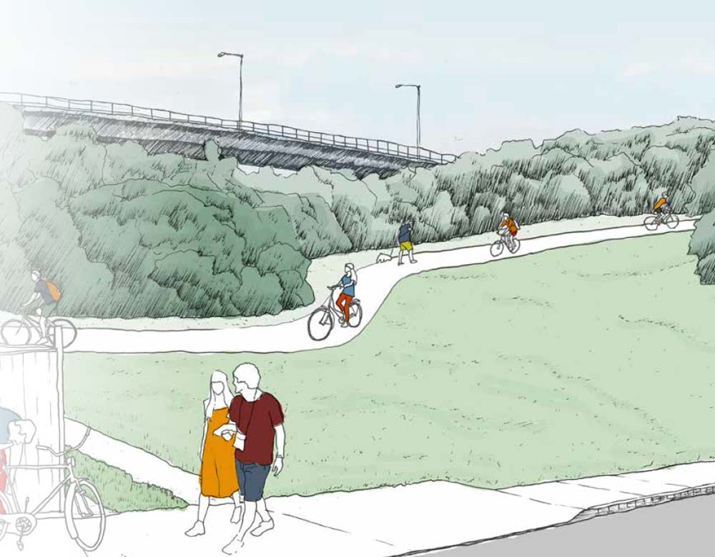
Photo 3 Route as envisaged through Suffolk Reserve
(Jacobs 2016)
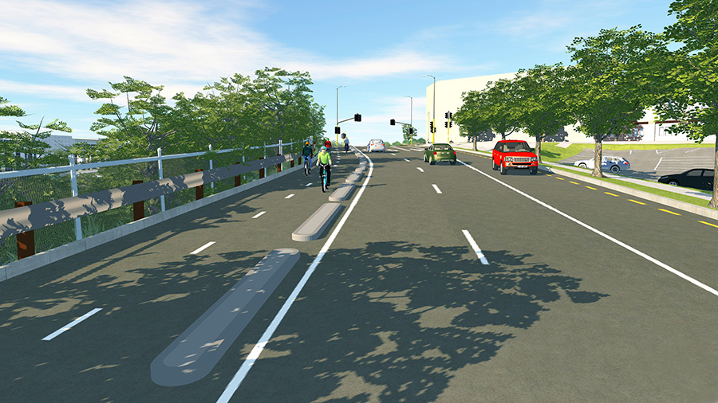
Photo 5 Section as envisaged up Ian McKinnon Drive (Jacobs 2016)

There was a lot of discussion about removing the old cycling markings on the route up to Newton Road (see Photo 2). It was decided to retain these as this is an established route and provides access to people who use Newton Road to progress their journey to that part of the city.
To help with continuity, way finding signage has been added to the route which is consistent with the route finding from the Start of Nelson street Wynyard Quarter through to the western end of the North Western shared path/ These signs are located at key decision points on the cycle network and are intended to be read by people either moving slowly or stationary who are not familiar with the network.

The signage indicates the distance to either connecting routes or destinations.

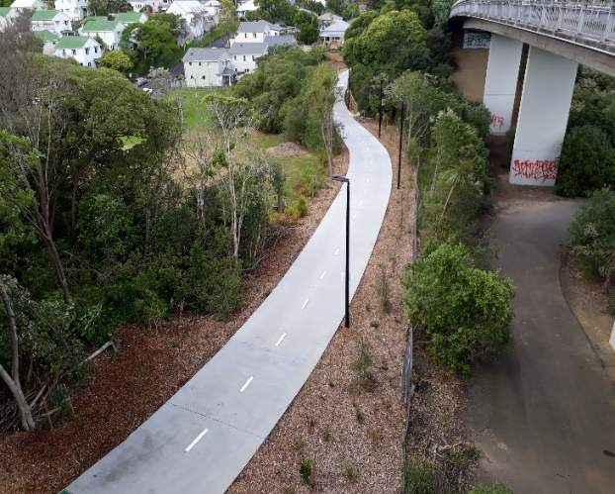 Photo 4 Route as built Suffolk Reserve (Nov 2018)

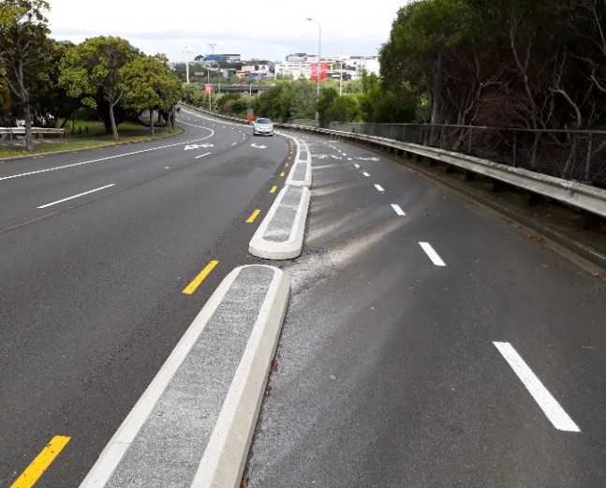
Photo 6 looking down Ian McKinnon Drive
(as built Nov 2018)

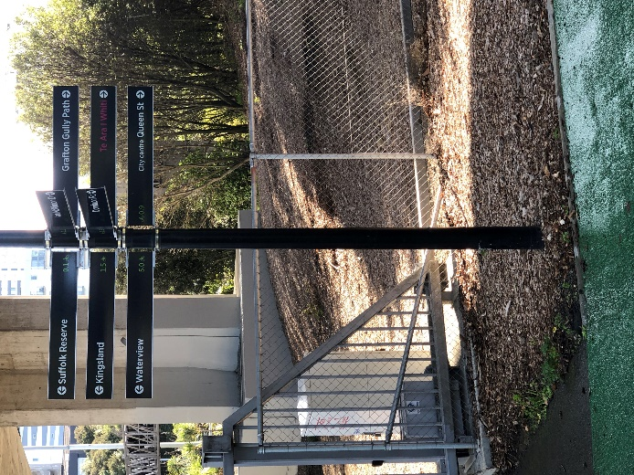
Photo 7 way finding signage under Newton Road

4.2 Design Standards
At the start of planning the current accepted design width for a two-way cycle path was 3m with a minimum of 2.5m. One of the concerns raised in the public participation was that this was too narrow for such a busy route and for the proposed section on Ian McKinnon Drive which has a gradient of up to 8%. Cyclists can travel quickly in a downward direction and the recommendation was that this section should be increased to a width of 4m. The main reason for this was to allow flexibility for cyclists of different ability to pass safely, especially when mixing high speed commuter cyclists with vulnerable and/or inexperienced cyclists. This speed differential dilemma has been exacerbated with the advent of E-Bikes. It is really important on a commuter route to have space for a faster E-bike to pass a slower uphill rider and avoid conflict with a fast downhill rider or at least have room to slow down and still have reasonable room to pass safely.
The design standard of 4m was chosen for the whole of the new project with an exemption for a width of 3.7m over the 350m section of Upper Ian McKinnon Drive. Here the road reserve width available and cost considerations dictated that the project team retain the original kerb line on Ian McKinnon Drive whilst incorporating safe dimensions for lane widths and all road users
A key feature that was considered was the existing shared path on the southern side (labeled ‘footpath’ at the right side of Figure 5). It was decided to retain this as it does form part of the connections to the city via Newton Road. It is also a slower shared environment for pedestrians.

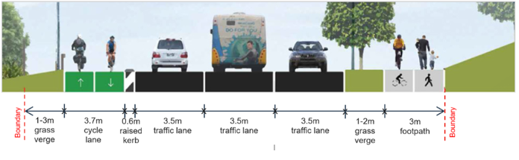
Figure 5: Design widths achieved (extract Auckland Transport 2017)
This project was one of many that provided information for appropriate design standards for cycleways adopted by AT in its engineering-design code for cycling infrastructure.
https://at.govt.nz/media/1982222/engineering-design-code-cycling-infrastructure_compressed.pdf

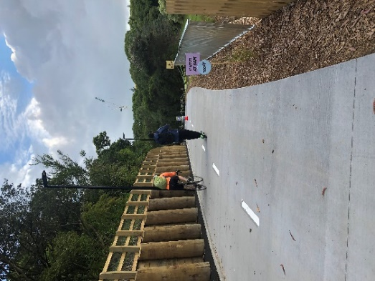

Photo 8 Design standard on shared path section 4m width

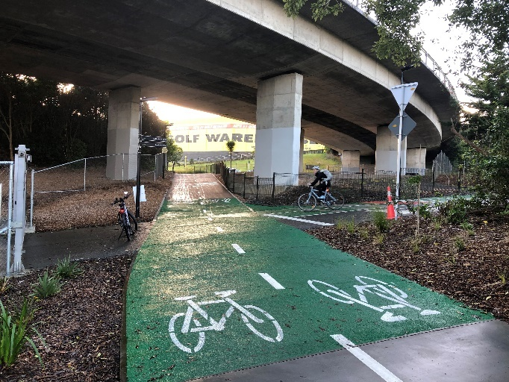
Photo 9 Transition point from Shared path to Cyclepath under Newton Road Bridge

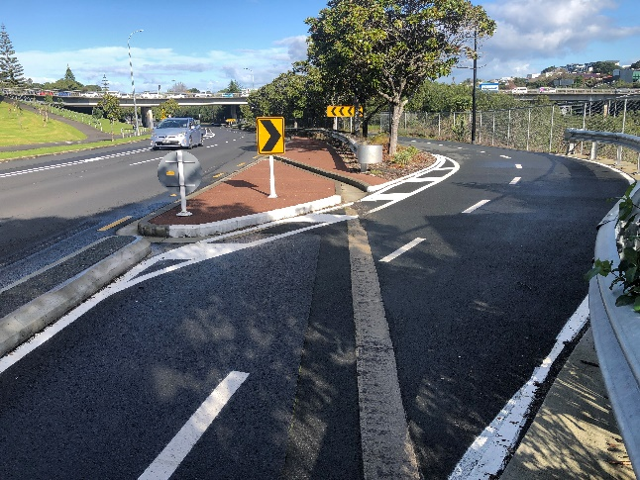
Photo 10 Transition from cyclepath on Upper Ian McKinnon Drive to cyclepath on maintenance access road.

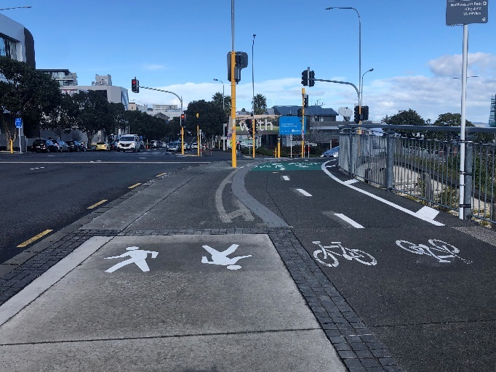
Photo 11 Transition at Upper Queen Street Bridge

Some further design standards that were applied through construction which contributed to positive project outcomes were:
- Drainage – there was an opportunity to simplify the design and by changing some levels the project was able to utilize the existing drainage on Ian McKinnon Drive more efficiently and this resulted in some savings to construction time and cost.
- Corner splays – as the project approached completion some practical tests highlighted the difficulty of negotiating a right angle turn just under the Newton Road Bridge. This turn had been deliberately designed to slow cyclists, but a small addition of a corner splay enables cyclists to negotiate the corner better at slow speeds.(Photo 9).
- Low maintenance interface for retaining wall – there is a large (1-4m) high retaining wall separating the pathway from the motorway on the northern side just west of Suffolk Reserve. An additional kerb had been installed to guide cyclist away from the large diameter poles (risk of catching handlebars on the poles) and the space between the poles and kerbing was filled in with structural asphalt to create a low maintenance area as it was too small for effective planting.(Photo 8).
- Design and construction interface with Waka Kotahi (NZTA) and the AMA on any design and construction on the Upper Queen Street bridge over the SH1 and SH16. One of the challenges was to install two pedestrian signal poles on the bridge structure itself. A methodology was approved which included using ground penetrating radar to locate the steel reinforcing so that drilling dowel holes for bolts would not compromise the bridge integrity.
- Electronic warning signage – the link to the steep section up to Newton Road was retained for network connectivity and there was a safety concern with cyclist conflict with cyclists using both paths merging to go westbound. An electronic sensor detects cyclists on the steeper section and alerts cyclists on the lower cycle path of their approach by way of flashing lights.
- Signage & Wayfinding – Signage and way finding was incorporated on the route to provide a seamless connection to the rest of the northwestern and central city cycle networks.

4.3 Increase in usage

The project path opened on Friday 30th November 2018. To provide evidence of how effective the project has been, data from four of AT’s automatic counting stations: Grafton Gully (GG Nelson Street Lightpath (LP), Nelson Street (NS), and North Western Shared Path in Kingsland (NW) have been sourced and compared.

The data analysis compares average weekday counts (Mon to Friday inclusive) and average weekend counts (Suturday and Sunday) over a continuous period of four weeks. The counts and data has been extracted for March 2018, November 2019 and March 2019. The comparison between March 2018 and November 2018 shows similar numbers. Comparison with counts for March 2019 shows substantial growth that may be attributed to the project being open and attracting additional cyclists. The author is a cycle commuter and recreational cyclist who used this route during this period on most weekdays and also on the weekend. What has been noticeable is the increase in E-bike ridership, families out on the weekend, occasional freight bikes and an overall large uptake in cyclists using the new link.

Figure 6 Comparison of average two-way cycle counts (Mon to Friday)

Figure 7 Comparison of average two-way cycle counts (Sat and Sunday)

The growth between March 2018 and March 2019 is:
 | Counting stations | Week  Mon-to Fri | Weekend  Sat and Sun
GG | Grafton Gully | 26% | 10%
LP | Lightpath | 42% | 52%
NS | Nelson Street | 56% | 9%
NW | North Western (Kingsland) | 31% | 8%

Table 1; Growth at data collecting stations

4.4 Good communications and responsiveness throughout the project life cycle
Communications included internal workshops and presentations to NZTA, Auckland Council and the local Council Boards to develop the design.

An extensive public consultation occurred in 2016 and then regular updates on the project including maintaining and updating the public facing website. During the finalization of the design and through the construction regular meetings were held with affected parties to hear their concerns and work through mitigations.

The full public consultation feedback and decisions report can be viewed here:
https://at.govt.nz/media/1972233/ian-mckinnon-drive-consultation-report.pdf

During the detail design and public consultation phase the following comments were addressed:
- that a wider path would be an improvement, - increased from three to four metre width,
- that there was an opportunity to further separate the key cycle/pedestrian movements at the intersection of Ian McKinnon Drive and Upper Queen – the initial design had the cyclists on the kerb side of Queen Street which created two conflicts between cyclists and pedestrians. The design decision was to move the cyclists to the western side of the bridge for direct continuity with Ian McKinnon Drive and the facility leading to the Light path - Photo 11.
- that there was an opportunity to incorporate a more direct crossing between Grafton Road and the nelson street Light Path at Canada Street at the southern end of the intersection of Canada Street and Upper Queen Street – project team worked with minor safety team, AT network operations, and Auckland Motorway Alliance (AMA) to enable this. The construction of this element was delivered through the Ian McKinnon Project and timed for simultaneous completion.
- Potential privacy concerns with residents adjacent to the “Suffolk Reserve” – responded to with landscaping, graphic visualization and a privacy fence.

5. DISCUSSION

The project has achieved its mandate through delivering:

- Route continuity
  - The steep section up to Newton Road has been eliminated as the primary route
  - The width, horizontal and vertical alignment of the project meets best practice standard and provides all users with good visibility of the route.
  - The route has eliminated the tight corners particularly around the section on Newton Road which required a reasonable level of competency on a bicycle to manage.
  - The crossings of Newton Road and Ian McKinnon Drive at Queen Street have been removed from the mainstream cycle demand.
  - The route is lit with pedestrian and cyclist friendly LED lighting so that is there is good lighting on the route 24/7
  - Signage has been added to the route to indicate key directions including distance to key destinations
  - The more direct route provides an average time savings of two and a half minutes per cycle trip.
- Standards
  - The route provides a wide path of 3.7 to 4.0m width which is consistent with other new sections of the North Western Cycleway eg link between St Lukes Road and Carrington Road and the improved section between Carrington Road and Royal Road.
  - the riding surface is suitable smooth for cyclists and this is achieved through a combination of concrete and asphalt surfacing
  - High quality lighting and cycle friendly drainage is achieved throughout the route
  - The quality of the route and finish achieved will contribute to lower future maintenance costs.
  - At the end of the defects liability period of 12 months there was minimal work required and it is now 20 months since the project has been opened and the quality of the route today is a tribute to the workmanship of the construction project team of Traffic Systems Limited (TSL).
  - A high degree of landscaping using natural fauna has been achieved with over eighty new trees planted
  - The cycleway has achieved a high level of Crime Protection through Environmental design (CPTED) with good visibility throughout the route
- Encouraging more people on bikes
  - The increase in ridership over comparable periods has shown an immediate rise that within four months the use of the route had increased by 26-56%.
  - The ridership has increase both on weekdays but also on weekends
  - Observations of the usage of the route has shown that there are families using the route, particularly on weekends, more people on E-bikes. occasional freight bikes and usage from various other modes of transportation such as electric scooters, electric skateboards and even gyrobikes.
  - The section past “Suffolk Reserve is used by pedestrians including people pushing prams and dog walkers.
- Other contributors to the project success
  - Good communication between the project team particularly through detail design and construction (see Table 1 Appendices)
  - Having a proactive response to project challenges through design and construction. Working through issues raised to identify solutions that could add value cost effectively. Some of these challenges and their responses are noted in Table 2 of the Appendices.

The total cost of the project was $3,2m. this was a relatively low cost as no additional property was acquired, no elaborate bridge structures or drainage structures were required. The original benefit (2017) was estimated at $5.9m and was based on a 8% growth rate years 1-10 and this has been well exceeded by the actual growth of 26 to 56% experienced in the first four months.

The project is a success and has encouraged additional cyclists and pedestrians to use the route and surrounding cycle network. The standards that have been achieved have also facilitated the interaction and safe movement between existing users and the new modes of E-bikes and E-scooters.
The project achieved its objectives of:
- Getting more trips by cyclists
- Increasing safety and perceived safety along the route
- Contributed significantly to the connected Auckland Cycling Network
- Showed that innovative solutions that re-purpose under-utilised infrastructure can be achieved:
  - Better mode share and usage of existing carriageway of Upper Ian McKinnon Drive,
  - Better usage of unused motorway reserve.

6. Conclusions
For new cycling and shared paths to be successful they need to have good route continuity, clear links to the surrounding roads and cycling paths, and meet the required standard for pedestrian and cycle facilities.
The standard of the route needs to be consistent and users need to have good visibility and adequate time to make decisions and not feel constrained or uncomfortable using the facilities.
A constraint in the form of a steep section, a narrow section or a technically challenging section can have a large impact on suppressing demand.
Route signage that provides clear directions with distances to other routes and focal points creates a better connected network.

During the design and construction process there needs to be a dynamic project environment where people listen to others and see challenges as opportunities to get a better product. It is a team effort.

It is important to have good data both before and after the construction of any facility to be able to demonstrate its effectiveness.

This sort of infrastructure is vital if we want to deliver mode shift and achieve our Vision Zero targets.

Acknowledgements
The project was made possible by a wide group of organisations and people, I would like to acknowledge the following:
Clients: - Auckland City Council, Auckland Transport
Network partners: Waka Kotahi (NZTA at the time), AMA
Designer: Jacobs
- Andrew Lawson, Sam Corbett, Tony Fu, Wenyu Ouyang
Contractors: Traffic Systems Ltd (TSL)
- Alister Brownlie, Ben Baxter and Neil Payne
Auckland Council Local Boards
Waitemata, Albert Eden
AT Project team
- Sponsors Tarun Ahuja (planning)/ Ken lee-Jones (Paper author and design/construction manager)
- Investigation and design - Sophia Wang/Zoe Douglas-Jones/Ina Stenzel
- Planner & Property - Patrick Buckley and Jeremy Pellow
- Internal review - Adam Beattie, Paul Buckle
- Construction supervision - Suppiah Maheswaran

References
Auckland Transport 2017, Ian McKinnon Drive - Business Case for Design, 2 February 2017.

Auckland Transport 2017, Ian McKinnon Cycleway Business case for Construction, 30 November 2017.
Auckland Transport, Projects and Roadworks/Ian McKinnon Drive cycleway/ https://at.govt.nz/projects-roadworks/ian-mckinnon-drive-cycleway/

Auckland Transport, Ian McKinnon Drive, Public consultation feedback and decisions report, 20 December 2016/
https://at.govt.nz/media/1972233/ian-mckinnon-drive-consultation-report.pdf

Auckland Transport, Manuals & guidelines, Roads and Streets Framework and the Transport Design Manual, Engineering Design, Engineering Design Code – Cycling Infrastructure/
https://at.govt.nz/media/1982222/engineering-design-code-cycling-infrastructure_compressed.pdf

Jacobs 2016, Ian McKinnon Drive Cycleway, Project Feasibility Report, Auckland, 31 March 2016.

Jacobs 2017, Ian McKinnon Drive Cycleway, Scheme Assessment Report, 22 December 2017.

Declaration of competing interests
The author declares no competing financial interests.

Appendices
Table 1: Communication and public consultation
Communicate with | How often | Type of information
AT Senior management | Monthly | Monthly reporting highlighting progress, risks and issues
Community Local Board | 6 monthly or when a major event/change or milestone is reached | Progress update  Decisions required  Support requested  Good news and bad  No surprises  Early communications
Public consultation | Initial 2016  Milestone related | 6000 brochures  298 submissions  72% support  Public information letters
Construction phase | Daily | Regular contact with affected parties to advise of work and construction related activities
Post construction | Daily | Addressing any queries or concerns from public
Good communication assisted the project to run smoothly with good communication and information flow.

Table 2: Design and construction - Challenges and responses
Challenge | What happened | How this was resolved
Corner of Upper Queen Street and Ian McKinnon Drive | Concern about pedestrian and cyclist conflict | Minimised by redesign to keep major cyclist movement from Upper Queen to Ian McKinnon Drive on Western and northern edge thereby eliminating pedestrian conflict
Getting good design and construction fit | Actively reviewing the design through construction | This was managed through a proactive approach between the contractors and the designers facilitated by the AT project team
Changing the width | Change from 3m to 3.7-4m width | The benefits of doing this have been shown to be effective particularly when cyclists are passing slower cyclists going uphill in the face descending cyclists.

Challenge | What happened? | How this was resolved
Starting construction before design was complete | The changes to the Upper Queen and Ian McKinnon Drive intersection had not been fully designed due to changes to in response to feedback. | A risk assessment showed that the design changes did not materially affect the quantities or programme, so a decision was made to proceed in parallel.
Ground conditions | Scoria fill encountered disrupting pile excavation | Larger pile drill rig used but still challenged to get the required depth, so design amended to allow for larger poles, greater stiffness and less depth required.
Tree removal | A large tree was removed by a sub-contractor when clearing the site –that was not part of the original design or consent. | Council advised – worked through mitigations – additional new trees were planted - turned into an opportunity to improve the design with a more consistent standard.
Tree overhang complications | The lane usage on the southern side was re-purposed as an all-purpose traffic lane which included double decker buses. The tree overhang would have prevented this. Overlooked in design as focussed predominantly on northern side | Council advised, arborist assessment and project team were able to trim back within AT’s generic tree maintenance consent.
Adding design elements to the design | There was an opportunity to bring in a minor safety improvement into the scope of the construction to strengthen links to adjacent network. | The complexity of installing additional signal poles on a bridge structure had to be worked through.
Underground services on SE corner of Upper Queen Street and Alex Evans Street (Ian McKinnon Drive) | A small service relocation was required to enable sufficient space to accommodate all traffic movements and the new cycle facilities safely at the intersection with Ian McKinnon Drive. This became a complex and potentially excessively costly due to an important junction pit being affected. | This area has a relatively low pedestrian demand and a redesign solution was developed that addressed all movements that needed to be accommodated while retaining the junction pit in its current location
People using the path when not quite complete | Cyclists started moving the fences and using the path prior to it being officially opened. | Managed through a combination of stronger fences to protect working areas and some flexibility around ensuring that if usage occurred prior to opening it would be safe.

