Pavement Recycling:

Climate Resilience and Carbon Footprint Reduction

(This paper has not been peer reviewed)

Authors:

Nick Schilov, BSc(Tech), BEngTech, CPEng, CMEngNZ

Technical Manager – New Zealand – Hiway

nick@hiways.co.nz

027 706 8019

Presenter

Allen Browne, BE, MEngSt, CPEng, FEngNZ, MIEAust, IntPE, RPEQ

General Manager – Technical and Innovation – Hiway

allen@hiways.co.nz

Introduction

Current pavement design methodology focusses on ensuring adequate cover to subgrade to protect the underlying soils (i.e. subgrade) to prevent permanent subgrade deformation – resulting in rutting. However, pavements in New Zealand tend to exhibit failure modes that are a consequence of poor moisture resilience in the aggregate before they fail due to lack of structural integrity (i.e. lack of cover to subgrade / design life is exceeded).

New Zealand pavements are typically constructed with unbound granular, moisture sensitive aggregates that are typically protected with a thin (2-4mm thick) layer of bitumen with chip embedded into it. The primary purposes of the surfacing are to protect the underlying aggregate from moisture ingress and provide texture for skid resistance. Chipseal may provide limited waterproofing in more heavily trafficked, higher speed environments – particularly where geometrics are marginal (see NZTA Research Report 390). In these scenarios, the action of repeated loading of tyres can force water through the thin bituminous surfacing layer. With moisture increase in the upper “basecourse” layer of the pavement with poor shear performance of the upper pavement with rut and pothole development, particularly in wheel paths as shown below in Figure 1.

Renewal and rehabilitation of New Zealand pavements have traditionally been undertaken using aggregate replacement, granular overlay, insitu cement recycling or a combination of treatments. These treatments are relied upon by asset owners but demand the use of finite quarry resources, promoting significant truck movements and where used, reliance on carbon intensive binders (e.g. cement).

Alternative rehabilitation / renewal treatments can be considered reducing moisture sensitivity of unbound granular pavement materials, whilst making use of New Zealand’s largest linear quarry resource, the existing pavement, with the added benefit of reducing carbon emissions.

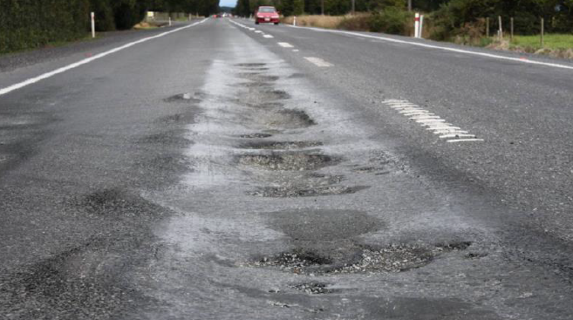
Figure 1: Unbound Granular Pavement Rutting and Potholes

Pavement Design and Materials

A typical unbound granular pavement is designed to have a thickness of aggregate sufficient to protect the underlying soils (subgrade) from deforming under loading of heavy vehicles. Austroads Figure 8.4 (shown below in Figure 2) is the basis for determining the required pavement thickness using the other two input parameters, subgrade strength and design traffic loading (Design Equivalent Standard Axles – DESA).

The Austroads design methodology does not consider the variability in the performance of different aggregates used to construct pavements but provides guidance on the minimum cover to subgrade. Granular materials properties used for construction of pavements are outlined in various engineering specifications. For granular pavements, the specifications are NZTA M/4 and NZTA B/2. The “M” series specifications provide minimum material properties that must be achieved to have a conforming granular material. Note the M/4 specification is for basecourse and there is no current NZTA specification for subbase – although there are some Local Authority and Consultant derived subbase specifications. The “B” series specifications relate to pavement construction and in particular detail the compaction levels to be achieved.

Engineers have relied upon bituminous surfacing to prevent moisture from entering pavement structures from above and ensuring suitable drainage to be constructed and functional to reduce the risk of moisture entering the pavement. Drainage is critical in ongoing performance of a pavements as it allows water to find its way out of the pavement and facilitate drainage. Current laboratory materials testing typically considers the material performance in a dry or moist condition and relies upon drainage design to achieve this.

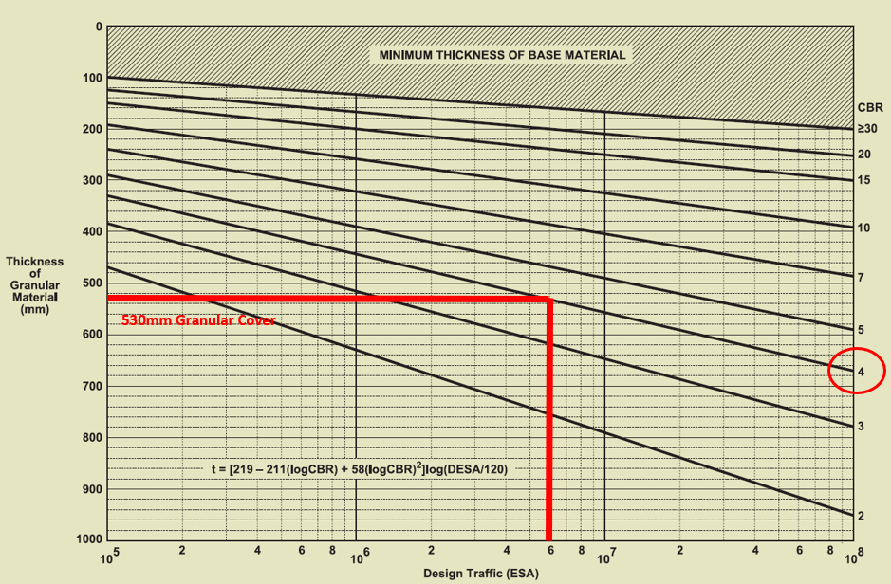
Figure 2: Austroads Figure 8.4

The moisture sensitivity of aggregates can be assessed using soaked undrained Repeated Load Triaxial (RLT) testing which infers rut potential of the material when wet. The RLT test specification used in New Zealand is NZTA T/15. At the time of writing this paper there are no requirements to perform soaked undrained RLT testing in current specifications. Note though that the current NZ Pavement Design Guide requires a drained / dry RLT test for Level 3 roads. To allow a full assessment of material performance RLT testing using unsoaked dry testing is recommended. The RLT test dynamically loads aggregate and measures the permanent strain over a given number of load cycles at 6 different load stages / stress conditions.

When assessing a pavement design the ideal outcome is to have a material that is able to resist repeated loading cycles and report a low permanent strain. A good quality material will have a low permanent strain over the six test stages (Figure 3 blue line) whereas a poor quality material will have a high permanent strain (Figure 3 red line).

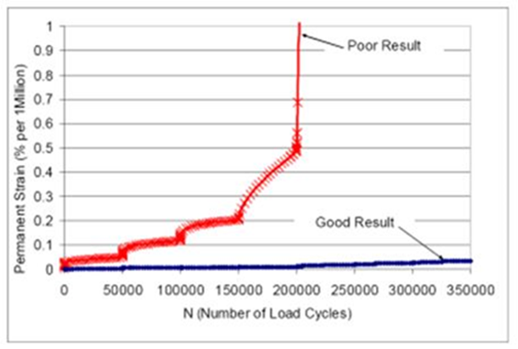
Figure 3: Example of RLT Test Results

All unbound materials tested using the RLT report a. high permanent strain (failure when measured against a specified allowable limit) when tested in a soaked / undrained condition. The reliance on a bituminous surfacing to prevent the ingress of moisture into the pavement is considered to be a high-risk strategy for reducing the risk of rutting of granular pavements when drainage is neglected (which may happen due to budgetary constraints). Treatments that offer protection to the pavement structure from failure, early in its life or reduce ongoing maintenance throughout its life must be a priority for network asset managers.

Stabilisation of granular materials has proven to be an effective treatment to improve the moisture resilience of granular materials, in particular basecourse as rut resistance is increased significantly by mitigating plasticity of fines. This is shown in Figure 4 with laboratory assessment. The resistance to rutting varies depending on the stabilisation treatment selected and this can affect the pavement performance when measured against rut development insitu with post-construction monitoring.

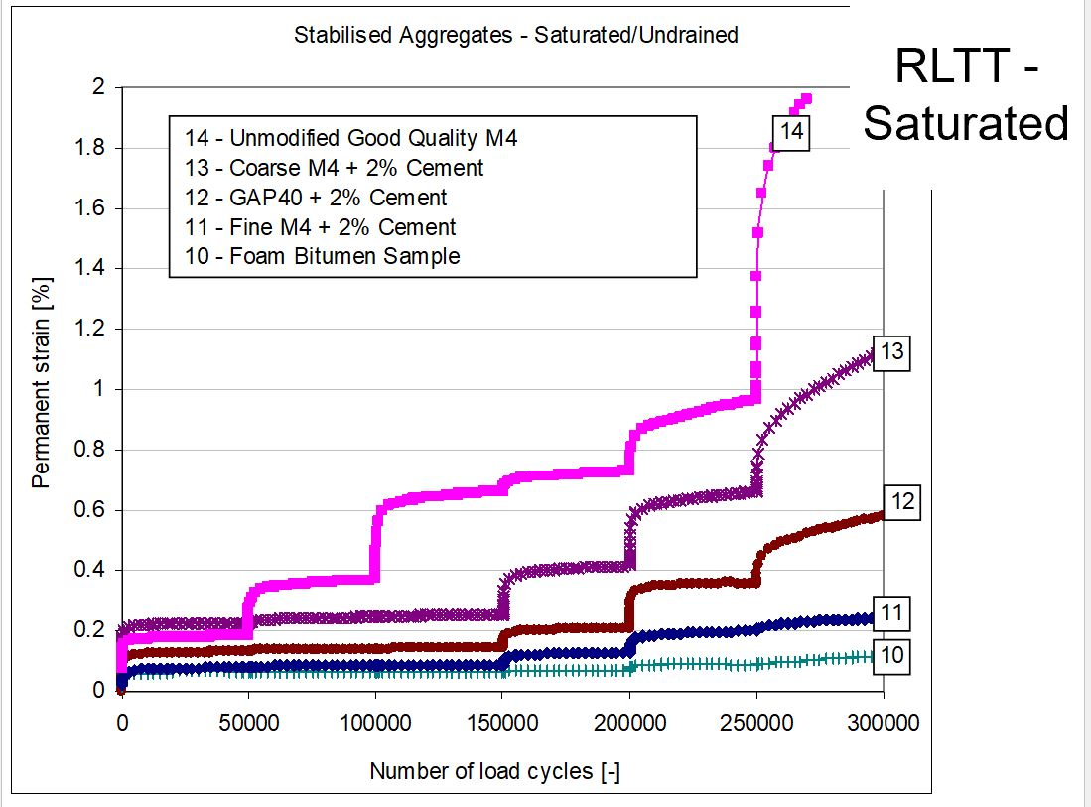
Figure 4: Saturated / Soaked RLT Testing of Stabilised Granular Material.

Pavement Renewal and Rehabilitation Treatments

Traditional pavement renewal and rehabilitation treatments can be, granular overlay (where not level constrained); granular replacement (where constrained by kerb and channel or road furniture), or insitu recycling. As discussed above, it is difficult to prevent the ingress of moisture in the upper pavement layers by relying on chipseal (or even thin asphalt) surfacing in the absence of drainage improvements – particularly in pavement rehabilitations – and with New Zealand having moisture sensitive aggregates, that tend to rut and/or shear leading to failure of the pavement structure through potholing requiring extensive patching, which in turn increases the maintenance requirement and cost. Once rutting begins, the pavement deterioration can proceed rapidly with moisture unable to drain freely from the pavement and in extreme cases remained captured on the pavement surface – see Figure 5. As free water is captured in the wheel paths, the action of rubber tyres “pumps” the water through the thin bituminous surface, chipseal or asphalt, promoting accelerate rutting of the pavement.

Unfortunately, it is also common for drainage improvements to be disregarded or provide inadequate egress when undertaking pavement rehabilitation. Some examples of drainage requirements are basic clearing of swales or installation of subsoil drainage at the base of cut batter slopes above the road.

Insitu recycling provides a number of benefits over traditional unbound granular treatments. These include:
- Correcting mechanical deficiencies (PSD and/or plasticity).
- Increase shear resistance of granular material.
- Increase the modulus or bearing capacity of a material.
- Improve resilience by reducing the permeability and/or moisture sensitivity.
- Reuse and recycle existing materials, reducing the amount of disposed material and thus reducing demand on finite virgin aggregates. Double life = half materials.
- Provide cost-effective pavement configurations.
- Accelerate construction programme when compared to dig out and replace methods.
- Sustainability - reduce carbon footprint.

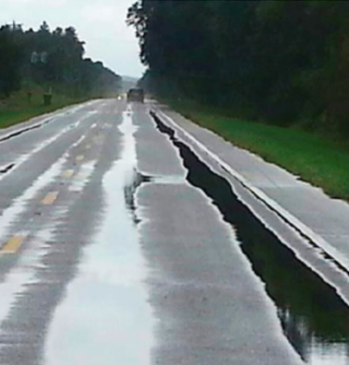

Figure 5: Granular Pavement with Water Ponding in Ruts

Moisture Resilient Renewal and Rehabilitation Treatments

The challenge for New Zealand asset managers and engineers is how to ensure moisture sensitive materials continue to perform when exposed to moisture, install drainage systems that require low maintenance intervals, and implementing testing protocols that consider undrained / soaked material state. New Zealand should look past its borders and investigate what other pavement managers are successfully implementing with regards to resilient pavements (e.g. Queensland TMR); and undertake assessment of whole of life performance with more rigor – factoring in the increasing cost of reactive maintenance and impact of climate change.

When considering the inferred traffic loadings that can be accommodated – based on RLT testing and validated by CAPTIF, substantial improvements over an unmodified material can be seen with addition of cement and / or bitumen. Figure 6 shows examples of the improvement in ability to accommodate traffic for several treatments.

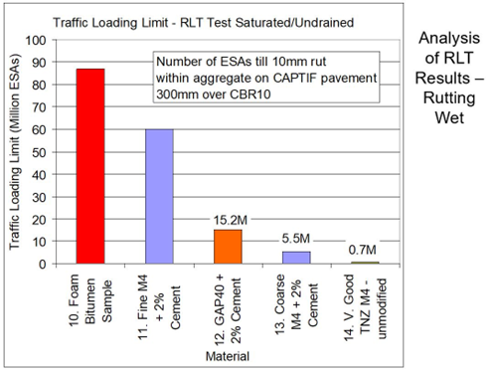

Figure 6: Traffic Loading Limits Based on Soaked / Undrained RLT Testing (Credit: Dr Greg Arnold)

When assessing design options or undertaking optioneering for pavement renewals – particularly on heavily trafficked roads – it is critical to design a treatment that does not require high levels of maintenance throughout the remaining pavement life. Engineers have access to a wide range of binders and additives that can be added to granular materials to improve the engineering properties, with foamed bitumen continually being proven as the best performing treatment, offering moisture and shear resistance, with the ability to treat old tired granular materials, for improved pavement performance.

Overseas Experience

When considering treatments and assessing what other countries are doing, we see that the results of laboratory testing are borne out in the real world. Queensland’s Department of Transport and Main Road (TMR) has invested heavily in Research and Development towards building more resilient pavements. TMR continue to confirm that well-constructed foamed bitumen pavements are more resilient to flooding events and have continued to perform when inundated, even after multiple weather events. The traditional unbound granular pavements with thin bituminous surfacing have suffered catastrophic damage, where the pavement is no longer trafficable and requires full reinstatement.

Transport & Main Roads Chief Engineer Julie Mitchell says these are just the latest encouraging examples of foamed bitumen’s resilience. “We are already using this technology widely in coastal regions of Queensland and seeing excellent results”. “By using foamed bitumen, the department is not only saving on the cost of construction, but also on the cost of maintaining & rehabilitating roads after natural disasters like Debbie.”

Tropical Cyclone Debbie in 2017 tested infrastructure - Caroline Evans, Chair of Climate Change & Road Network Resilience Committee for the World Road Association (PIARC). "When the waters receded the FBS pavements were still intact, so they didn't need to be fully rehabilitated afterwards.“.

Foamed Bitumen treatment through stabilisation (for new pavements) has also been applied to other roads as part of Queensland's move to make its roads more flood-resistant and this is proving more cost-effective than traditional deep lift asphalt. Queensland faces considerable challenges as it has the longest state-controlled road network of any Australian state or territory with over 33,300km of roads. So far it has built 1,000km of foamed bitumen road and is "continuing to develop foamed bitumen techniques", according to its transport department. BBC Feb 2022.

With the strong benefits of insitu recycling, other industries are now implementing the reuse of insitu materials with binders, and it is not limited to road construction and maintenance. Some examples of these other industries are:
- Solar Farms
- Wind Farms
- Railway Networks
- Ports
- Airports
- Mines
- Hardstands
- Heavily Traffic Roads
- Local Roads – Sealed
- Unsealed Roads

Carbon Emissions Assessment

Carbon emissions reduction is a key focus for businesses across all industries. This is no different for customers here in New Zealand, whether that is NZTA / Waka Kotahi, Local Authority or other industries as noted above. As an industry our drivers tend to be equally, price, time, quality and safety. Historical the primary focus of recycling pavement materials was to reduce the demand on limited resources, but recently there has been a considerable shift in thinking, where recycling offers environmental benefits, which include, but are not limited to emission reduction.

Currently there are a number of carbon emissions calculators being developed, but they are limited in their ability to assess carbon reduction through insitu recycling. They tend to be “high level” and did not include stabilisation or recycling options. NZTA / Waka Kotahi has LCAP and PEET sustainability assessment tools, but these were not specific enough in terms of assessing recycling, productivity gains and transport reductions on a site-by-site basis – although these tools are in constant development. There was no bespoke carbon calculator for the recycling / stabilisation industry. Hiway engaged WSP to develop a carbon calculator specific to our operations and this was critically reviewed by Aurecon.

To target emissions reduction, it was important to understand what could be influenced. It is possible to reduce a business’s own Scope 1 & 2 emissions and also their Customers’ Scope 3.

NZTA / Waka Kotahi presented Figure 7 at the Delivering Sustainability and Climate Reporting Conference held in February 2023 to outline what is considered to be Scope 3 emissions. Of note, they differentiated specifically between Construction and Operation and Maintenance. This showed an understanding that a well-built asset with lower maintenance throughout its life may be a better emissions proposition than an asset requiring ongoing maintenance.

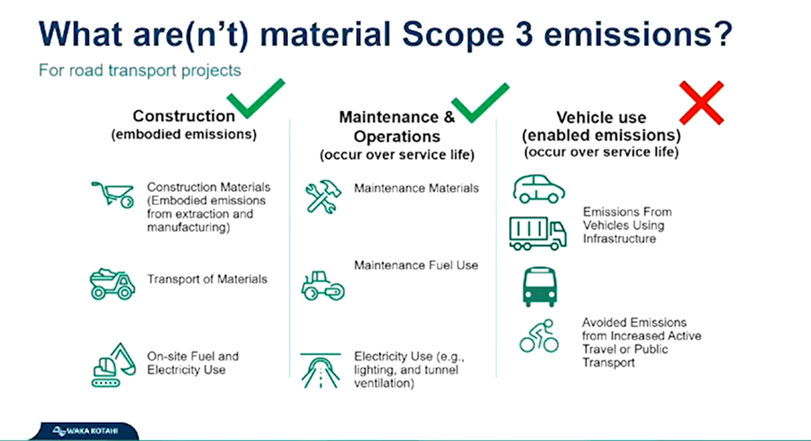

Figure 7: NZTA / Waka Kotahi Scope 3 Emissions Statement

Assessment of several select pavement treatment options was undertaken using the bespoke carbon emissions calculator. The treatment options are considered to meet relevant pavement design protocols and are shown in Figure 8 below.

Figure 8: Pavement Treatment Options Assessed

Using recognised emissions factors for the various material, transport, construction and maintenance phases of the pavement treatment an emission profile was built for each option. Maintenance was aligned with the NZTA Economic Evaluation Manual and had a 40-year life with maintenance and resurfacing at typical intervals for each treatment type.

The carbon emissions calculation outputs are shown in Figure 9 below and show that insitu recycling has significantly lower whole of life cost than traditional basecourse replacement treatment with foamed bitumen recycling having the lowest emissions of all treatment options.

Figure 9: Emissions Calculated for Pavement Options – Compared to Baseline of Basecourse Replacement

When assessing the four contributing areas of emissions, materials, transport, construction and maintenance it was determined that insitu recycling makes large savings in transport (as there is no removal to waste or import of aggregate), construction (as insitu recycling is faster) and maintenance (as insitu recycling – particularly foamed bitumen – is more resilient than a traditional treatment).

The target area for further emissions reduction is in the materials. Cement and lime production emit large amounts of CO₂ and it is critical to work with suppliers to reduce this over time. This may come with alternative fuel to fire the kiln or alternative additives to reduce the tonnage of cement / lime used.

We believe that this journey to lower carbon emission pavement treatments is a critical part of having a truly sustainable transportation industry.

CONCLUSION

When considering construction of long-term dependable pavements with lower whole of life emissions it is critical to consider the likely maintenance requirements for a given treatment and assess the carbon footprint of future resurfacing programs and resilience to moisture – leading to a lower maintenance cost, both in dollars and emissions.

The use of insitu pavement recycling, particularly with foamed bitumen has been demonstrated in the laboratory and in practice to provide a moisture resilient basecourse which performs better than traditional granular treatments. The insitu treatment is typically faster to construct, uses less finite aggregate resource and has a lower carbon footprint – particularly when considering whole of life.

AUTHOR CONTRIBUTION STATEMENT

Nick Schilov

Author of the paper

Data collection (co-with Allen Browne)

Data analysis (co-with Allen Browne)

Carbon emission calculations

Allen Browne

Reviewer of the paper

Data collection (co-with Nick Schilov)

Data analysis (co-with Nick Schilov)

