Planning The SH6 Corridor in Queenstown

Authors

Tony Sizemore tony.sizemore@nzta.govt.nz
New Zealand Certificate of Engineering (civil)
Transport Planning Manager
New Zealand Transport Agency

Chris Morahan chris.morahan@opus.co.nz
B.E.(Hons)(civil), MEngNZ
Transportation Engineer
WSP/ Opus

Reece Gibson reece.gibson@opus.co.nz
B.E.(Hons)(civil), MEngNZ
Associate
WSP/ Opus

Matthew Gatenby matthew.gatenby@opus.co.nz
M.Eng.(Hons)(civil), MCIHT
Principal Transportation Engineer
WSP/ Opus

Abstract

Queenstown is one of the fastest growing areas in the country. A rapidly growing residential population combined with a flourishing tourism industry is creating unprecedented demand for travel, and the transport system is coming under increasing pressure.

Significant topographic constraints together with intensified land use development form bottlenecks throughout the network. It has become obvious that removing all of these bottlenecks would be impractical and extremely expensive. It is also becoming increasingly obvious that adding more road capacity in the unconstrained parts of the network, whilst providing some local benefits, would largely just push traffic towards the bottlenecks quicker, and wouldn't provide the comprehensive system-wide solutions that Queenstown needs.

To improve mobility in Queenstown a step change in transport is required. Better provision for a greater variety of travel modes that are more spatially efficient are already being implemented. A new bus network has been developed with rationalised routes and lower fares together with fairer parking pricing, bus priority measures are being built, cycle tracks improved and a mobility as a service (MaaS) app introduced. The short-term plan includes bus lanes, bus priority at signals, new bus hubs and better provision for pedestrians and cyclists. In the medium to longer-term, the potential travel modes broaden to ferries, gondolas, congestion pricing, comprehensive and fully integrated MaaS, and autonomous shuttles.

This paper questions and discusses how we should plan our urban state highway corridors in the face of such significant changes taking place throughout the surrounding transportation network. It describes investigations conducted as part of the ongoing preparation of a detailed business case for improvements to the State Highway 6 Corridor through Frankton.

Introduction

This paper describes investigations conducted as part of the ongoing preparation of a detailed business case for improvements to the State Highway 6 Corridor through Frankton.

This project covers the State Highway 6 corridor through Frankton from Grant Road to the Kawarau Falls bridge, as shown in Figure 1.

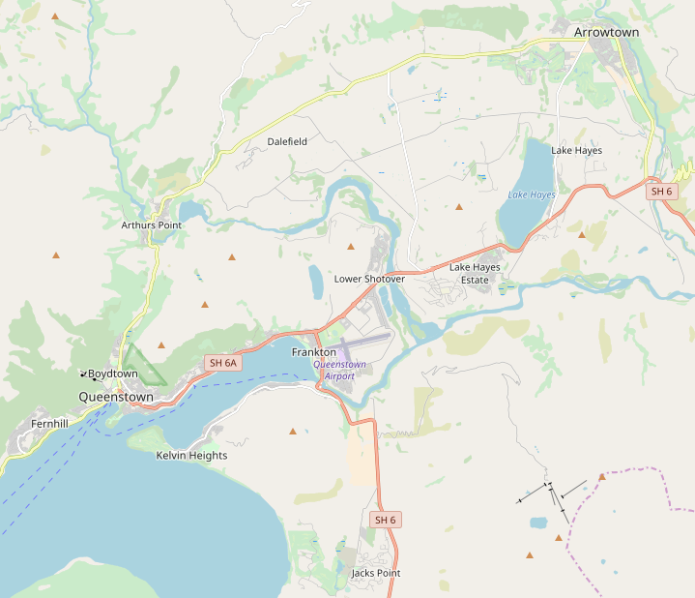
Project Location
N
Figure 1: Location of Project

The State Highway 6 corridor through Frankton is experiencing rapidly growing traffic volumes, with associated worsening congestion and travel time reliability. In the past, when a congestion hotspot has appeared in the Queenstown road network, it has been addressed through localised addition of capacity – intersection upgrades or road widening. This approach is fairly typical for smaller regional centres in New Zealand. For context, Queenstown has a permanent population of 19,000 (Census 2013), similar to Ashburton, Oamaru, Blenheim, Feilding, Levin and Taupo.

This project was initially perceived as a localised road widening project, aimed at relieving a congestion hotspot at a severe bottleneck. The project was framed this way in the media, with articles calling it a “four-laning project” and “traffic improvements”.

However, as the business case process progressed, it became more and more obvious that Queenstown is not a typical smaller regional centre. It has extreme topography which makes space more constrained than many towns, and it has volatile travel demands caused by extreme visitor numbers. The town’s permanent population of 19,000 is boosted by around 66,000 visitors at peak times (NZTA, 2017).This results in travel patterns that are significantly different in summer and winter, morning and evening, festival weekends and regular weekends, and even fine days and cloudy days (if it means the ski-fields close). Until recently, the largely mono-modal road network has coped with these travel demands. However, rapid growth in Queenstown over the last 5 years has meant that it has now reached a tipping point, where the road network is becoming increasingly congested, and the best solution to congestion hotspots is no longer as straightforward as simply adding more local road capacity.

Problems With The Transport System

The previously completed Queenstown Integrated Transport Programme Business Case (NZTA et al, 2017) defined two problem statements. A facilitated workshop was held in July 2017 with key stakeholders to confirm that these problem statements were also relevant and applicable to this SH6 project.

Stakeholders identified and agreed these problems as:
- The significant growth in visitors, residents and vehicles, leads to increasing trip unreliability and worsening customer experience across the network.
- Car dominance and associated congestion is affecting the liveability and attractiveness of the area.

Problem Statement 1: The significant growth in visitors, residents and vehicles, leads to increasing trip unreliability and worsening customer experience across the network.

The Frankton Flats area is undergoing considerable urban transformation in response to population growth in the Queenstown area. It has grown from a small semi-rural residential settlement on the outskirts of Queenstown in the 1990s, to a bustling gateway to Queenstown, including the region’s primary shopping centre, two schools (with a third school, Wakatipu High School, currently under construction), New Zealand’s fourth busiest international airport and more intensely developed residential areas. The 2.3km length of state highway fulfils a local access role to these rapidly developing land uses.

It also fulfils a regionally strategic role servicing the wider Queenstown Lakes District. Statistics New Zealand publish population projections for each area of New Zealand. The projected population of the Queenstown Lakes District is shown in Figure 2, together with the national population for comparison.

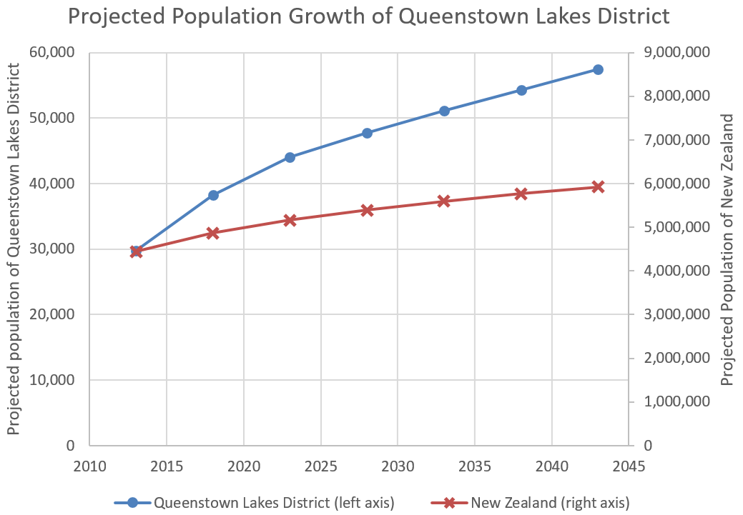
Figure 2: Historic and predicted population growth in Frankton (Statistics NZ, https://www.stats.govt.nz/ information-releases/area-unit-population-projections-2013base2043-update-nz-stat-tables-fifth-instalment, viewed 11 December 2017)

This shows that the rapid growth seen in recent years in the Queenstown Lakes District is predicted to continue in future. With limited undeveloped land in and around the Queenstown CBD, much of this growth is planned to occur in Frankton and further out. Development of the Frankton Flats has already begun accelerating, with several shopping/commercial centres recently completed, large hotels and a conference centre under construction, and a new high school opened in February 2018. Large residential developments have already been completed to the northeast and southeast of Frankton, with significantly more housing planned in these areas in future. Approximate locations of these developments in relation to the project are shown in Figure 3.

Proposed/ under construction residential developments
New secondary school, hotels, conference centre
Proposed residential/ commercial/ retail developments
Project Location
Figure 3: Approximate locations of developments in and around Frankton
Visitor numbers have grown rapidly in recent years, and are predicted to continue to do so. The Queenstown Airport Corporation predicts a significant growth in demand for airport passengers, as shown in Figure 4, taken from their recently released masterplan.

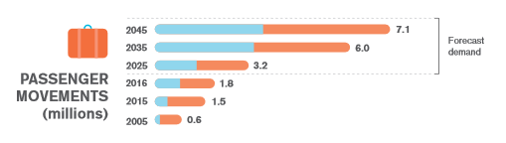
Estimated Maximum Capacity of Airport – 5.1 million
Figure 4: Historic and predicted passenger movements through Queenstown Airport (QAC, 2017)
High growth rates in Frankton and the wider Queenstown area are reflected in high growth in traffic volumes. Traffic volumes recorded on SH6 just east of the intersection with SH6A are shown in Figure 5.

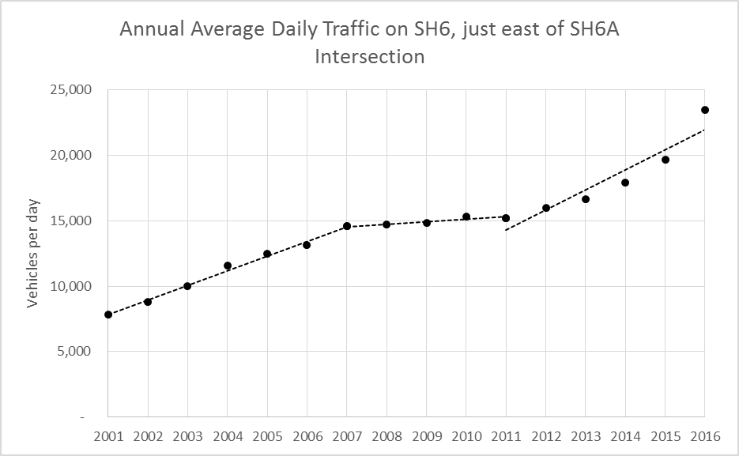
11% growth p.a.
14% growth p.a.
Figure 5: Traffic volumes on SH6, just east of SH6A (NZTA count site data, http://nzta.govt.nz/resources/state-highway-traffic-volumes/, viewed 11 December 2017)
In contrast to this picture of high growth in population and development, and subsequently high growth in demand for transport, until recently there has been relatively little investment in transport in and around Frankton.

In 2007, the Wakatipu Transport Strategy proposed a well-integrated transport system with an enhanced public transport system. However, the Strategy has only been partially implemented with the consequence that desired outcomes (including higher public transport mode share on Frankton Road) have not eventuated. There has also been a reluctance to aggressively pursue travel behaviour change while the current system has been perceived as ‘coping’ with demand.

Problem Statement 2: Car dominance and associated congestion is affecting the liveability and attractiveness of the area.

The SH6 corridor through Frankton is designed primarily for private motor vehicles. Some sections of SH6 do not provide any footpaths, and other sections provide a footpath on one side only. None of the corridor has cycle lanes, although some off road cycle paths exist in the surrounding area. Until very recently (November 2017), there was no bus priority, despite Kawarau Road being the busiest bus route in Queenstown with 4 bus routes converging on the Frankton bus hub located here.

The 2013 census recorded how people travelled to work. This is shown in Figure 6 for residents of Frankton Flats, Queenstown Lakes District, and New Zealand.

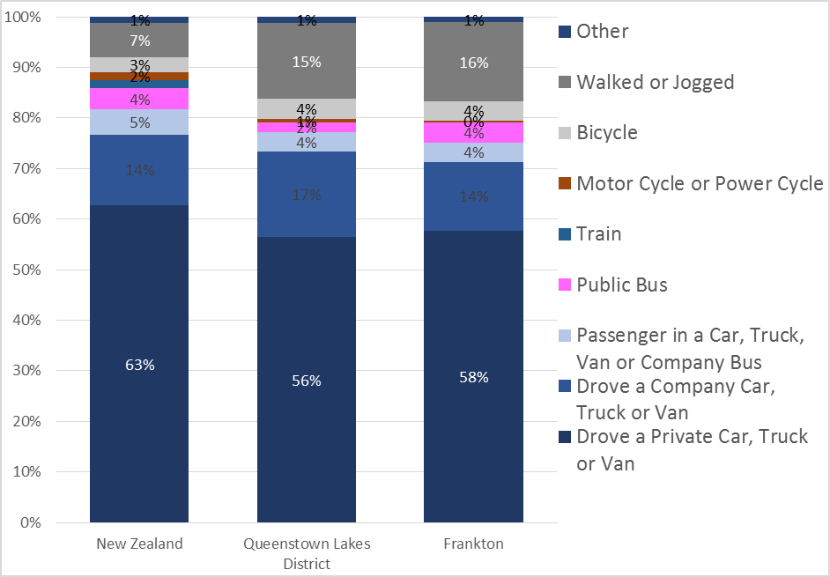
Figure 6: Modal share of travel to work (Census 2013)
The census data shows the majority of people in Frankton (and the wider Queenstown-Lakes District) drive cars, trucks or vans to work. Frankton (and the wider Queenstown-Lakes District)
have higher rates of walking and cycling than the national average. Queenstown-Lakes District has lower than average public transport use, although Frankton is similar to the national average.

Transport CONTEXT

There was a perception from some areas of the public that the SH6 corridor through Frankton was a traffic bottleneck and the answer was simple: build more road capacity. This is the approach that has previously been taken when localised congestion has started forming at a single point in the network, and to some extent it has satisfactorily resolved the traffic bottlenecks. This approach is fairly typical in smaller regional centres of similar size to Queenstown (population of around 19,000).

However, a wider view of the transport context that the project fits within immediately raises questions as to whether this approach will work in the SH6 corridor.

Although the project itself is located on flat land, the surrounding topography is extreme, with steep hills to the north, lake to the west, and rivers to the south and east. This has resulted in several key constraints surrounding this project. There are currently only 3 roads in/out of Frankton; the Kawarau Falls Bridge, the Shotover River Bridge, and SH6A Frankton Road. Two of these are bridges over relatively large rivers. SH6A is a two-way two-lane road located between the lake on one side and steep hills on the other, with development on both sides for most of its length.

A new road connecting Frankton and Queenstown via the north side of Queenstown Hill has been investigated in the past. This route presents extreme technical challenges due to traversing several active slips, and current investigations suggest this will make it prohibitively expensive.

These all work to limit the amount of traffic that can enter and exit the Frankton Flats. The constraints are shown in the map below.

Queenstown Hill
Existing alternative road into Queenstown
Two-way Two-lane Shotover Bridge
Previously investigated alternative road
Two-way two-lane SH6A
Two-way two-lane Kawarau Falls Bridge
Project Location
N
Figure 7: Constraints around Frankton
These roads and bridges all represent constraints to how much traffic can flow in and out of Frankton. Two of them are operating at capacity at peak times; SH6A into Queenstown, and the Shotover Bridge. Constructing more road capacity has been investigated previously at most of these constraints, and found to be difficult and extremely expensive. The Queenstown Integrated Transport Programme Business Case recommends a programme which does not include any significant increase in traffic capacity through any of these constraints.

The Queenstown town centre has also reached saturation level, where it cannot accommodate more vehicles without fundamental changes to parking and circulation.

The project is located at a critical point for the recently introduced bus network. The network is shown in Figure 8:

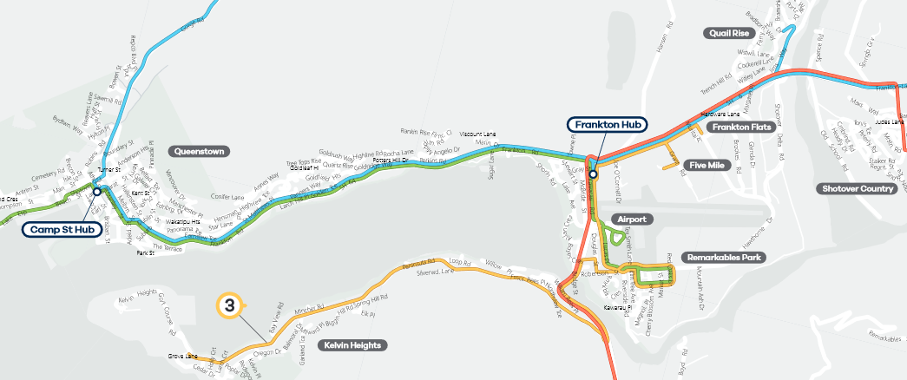
Project Extent
Figure 8: Queenstown bus network (https://orc.govt.nz/media/3973/queenstown-bus-timetable-leaflet.pdf, viewed 11/12/2017)
This shows that the 4 new bus lines all converge at the Frankton Hub, located just south of the SH6/SH6A intersection. The project is therefore of critical importance to the efficient functioning of the bus network.

In a similar fashion, several cycling routes converge at or near the project location. Cyclists travelling between Queenstown and Frankton, Kelvin Heights, Quail Rise, residential developments further south, large residential developments east of the Shotover River, and the popular tourist cycle trails to the east, all travel through the project extent. Also cyclists accessing local Frankton land uses such as the three schools, the airport, hospital, retail and employment centres will use the SH6 corridor. There is currently high-quality provision for cyclists in places, but the network is not continuous and has many gaps. This is shown in the map below.

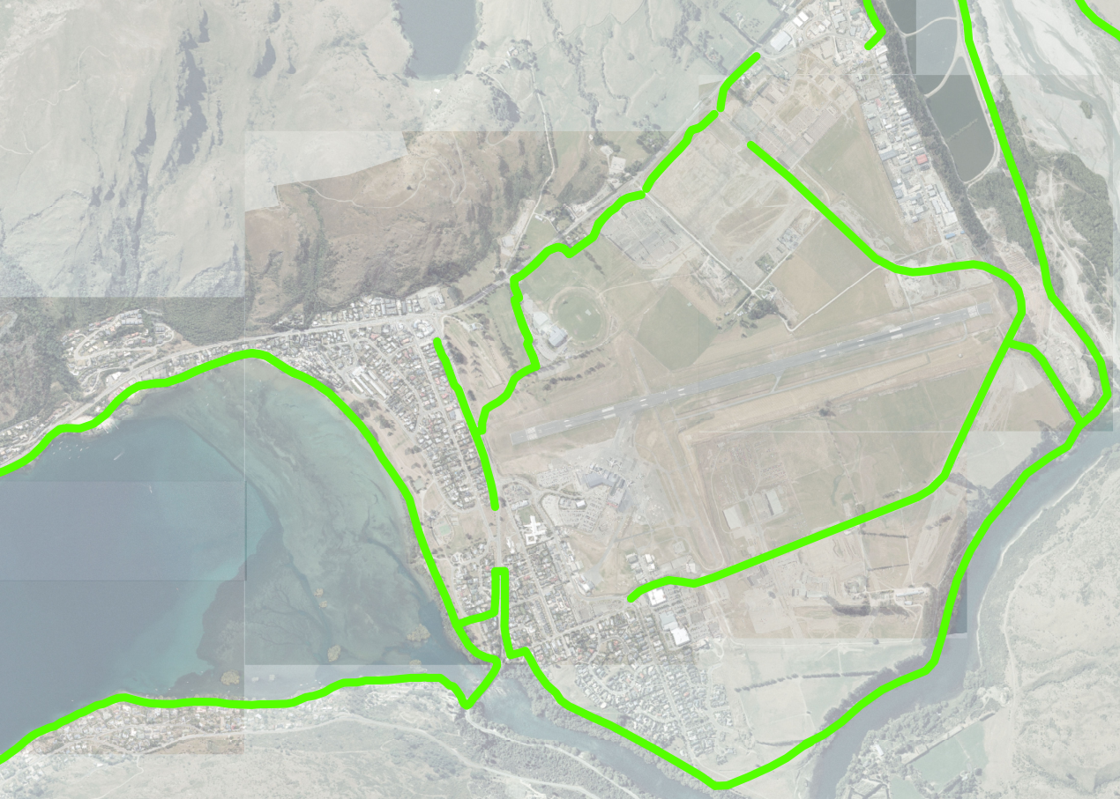
Project Extent
Legend
Existing cycle routes
Diagrammatic cycle desire lines

Figure 9: High quality off-road cycle routes in Frankton
The SH6 corridor through Frankton is therefore a critical part of the network for public transport, cycling and general traffic.

Wider Transport SYSTEM CHANGES

The SH6 corridor is not an isolated bottleneck like previous instances of congestion occurring in Queenstown. It is part of a region-wide road network which is reaching its capacity at multiple locations simultaneously. It is increasingly being recognised that continuing with a largely mono-modal approach will require wholesale capacity upgrades throughout the road network, which would be extremely expensive and impractical.

Work is being done to address this, with several projects already being completed. Some are aimed at adding traffic capacity through key bottlenecks, others are aimed at giving people options to travel using other modes:
- Two intersections in the CBD have been converted from roundabouts to traffic signal control, largely to facilitate high numbers of crossing pedestrians;
- An additional signalised pedestrian crossing has been constructed across SH6 in Frankton, accommodating a short bus lane with bus priority at the signals;
- An additional traffic lane has been constructed at the roundabout at the intersection of SH6/SH6A;
- A new two-lane bridge has been constructed across the Kawarau River, to replace the signalised one-lane bridge;
- A new road (Hawthorne Drive) has been constructed around the north side of the airport to link the two sides of Frankton;
- There has been significant investment in cycle trails throughout the Wakatipu Basin;
- A new approach to parking charges in the CBD has been adopted, with prices increasing significantly; and
- A bus-based public transport service has been introduced in November 2017, to replace a commercial (non-subsidised) service. This has resulted in a significant reduction in fares (for example travelling from Queenstown to the airport has reduced from $10 to $2 per trip). Initial result show that these changes have resulted in an approximate doubling of bus patronage, from 41,000 trips in December 2016 to 85,000 trips in December 2017.

The Queenstown Integrated Transport Programme Business Case (QITPBC) has recently been completed. This proposes a modally balanced approach, with an initial focus on improving public transport and active modes. Future projects proposed are shown in Figure 10.

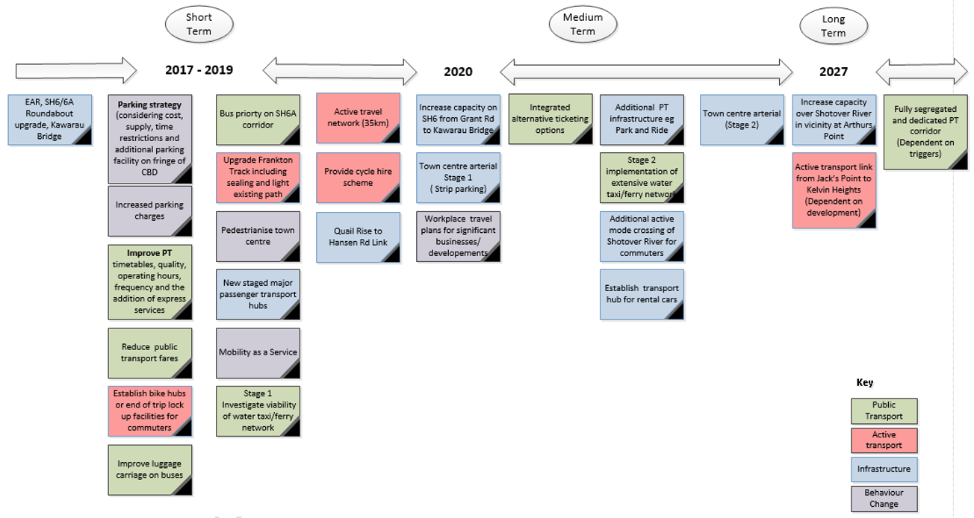
Figure 10: Projects proposed in Queenstown Integrated Transport Programme Business Case (NZTA, 2017)

This shows a variety of projects addressing different parts of the transport system. Of importance to this project is the fact that there are no planned upgrades to the three roads in and out of Frankton: SH6A (except for the addition of bus priority), the Shotover River Bridge and the Kawarau Falls Bridge. Instead, the expected increase in demand for travel in and through Frankton will be provided for through significantly improved public transport (buses initially, then ferry services, then a “fully segregated and dedicated PT corridor”), as well as investment in the walking and cycling networks.

Solutions

In light of the problems, the project context, and the transformation taking place throughout the wider Wakatipu transport system, the objectives for the solution have been determined by key stakeholders, as described below:

 | CRITERIA | WEIGHTING
Objectives | Increased throughput by mode:  a. Public Transport  b. Walking and cycling  c. Traffic | 50%  20%  15%  15%
Objectives | Increased integration and connectivity of modes | 30%
Objectives | Improved ease of access to key destinations | 20%
Objectives | a. Improved access to Queenstown Events Centre | 13%
Objectives | b. Improved access to Airport and Remarkables Park | 7%
Figure 11: Agreed project objectives

No preferred solution has yet been recommended. A long-list of options was initially formulated, which was then refined to a short-list through a multi-criteria analysis workshop with key stakeholders.

There was agreement among stakeholders that the solution for SH6 should only add traffic capacity in line with what can currently access Frankton through the three existing roads (two of these are already operating at their capacity and are unlikely to be upgraded in the foreseeable future). This means that most of the additional travel demand that is expected in future needs to be provided for through public transport and active travel. Traffic congestion in Queenstown is now unavoidable, and the focus for this SH6 upgrade should be on ensuring people can still travel by other modes safely and efficiently alongside this congestion. This means providing high-quality off road cycle and pedestrian infrastructure with safe and fast crossings of the highway, and providing bus lanes, bus signal priority and/or bus bypasses around congestion. It also means providing something that is flexible to connect into the future “fully segregated and dedicated PT corridor” from the Queenstown CBD to Frankton, whichever form this may take.

This change in attitude from traffic congestion being avoidable if we just fix up our bottlenecks, to traffic congestion now being an unavoidable reality of living in Queenstown, is a significant one for the public to accept. There are few other towns of similar size to Queenstown which are going through changes like this.

The key stakeholders for this project understand the need for change, because they have been heavily involved in the business case process. An online survey was made available to gauge the general public’s views. This showed very high dependence on private vehicles for transport currently, but also high support for improving alternative travel modes. For example, 60% of respondents said that they would use the bus more following the new bus service rollout (the survey was conducted prior to the new bus service beginning). Initial increases in patronage using the new bus service seem to be validating this attitude amongst the general public.

Another thing that needs to be recognised is that this SH6 project will be one of the earlier infrastructure projects implemented. As such, the solution implemented here will impact on what approach is taken in other projects in the surrounding network, so it has wider network importance.

All short-listed options include high-quality cycle infrastructure taking into account the wide variety of cyclists and cycle trip purposes in this area. These are largely aimed at filling in the gaps in the existing network, as well as allowing people to cross SH6 more easily. All options also include bus lanes and bus priority.

The differences in the short-list options for the SH6 corridor are largely focussed on the treatment at the intersection of SH6 with SH6A. Three intersection options being investigated are:
- 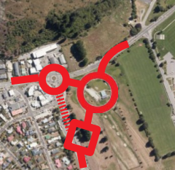Signalised roundabout shifted to the southeast;

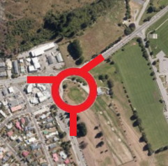
- Signalised roundabout in same location; and

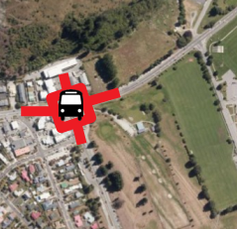
- Traffic signals (with bus bypass).

All options include a bus bypass to the southwest, linking with the bus hub just south of the existing intersection. A key difference between the options is the amount of land required for each. The land to the south east of the intersection is owned by the Crown, and is currently used for a Council operated golf course.

The signalised roundabout shifted to the southeast would result in the best transport outcomes for all modes, but would also require a significant amount of land which would likely lead to the closure or relocation of the golf course. Shifting the roundabout to the southeast enables the different travel modes to be separated out, with an expanded bus hub operating with a bus bypass to the west of SH6. Underpasses or signalised crossings would be provided at the roundabout for pedestrians and cyclists. Signalised intersections with bus priority would also be provided at the bus hub access to enable buses to enter and exit efficiently. Access to local land uses clustered around the existing intersection is also separated from the junction of the two highways.

The traffic signals would take up the least amount of land, but would also lead to poorer transport outcomes. This is broadly due to the fact that cyclists, pedestrians, long-range traffic and local access traffic are all being routed through the same intersection, within a very constrained footprint. Buses would be routed around a bypass, although this bypass would also be more constrained than the other two options.

The signalised roundabout in the same location represents a compromise between the two other options, with transport outcomes broadly in between the other two options, and land impacts in between the other two options.

Conclusions

Queenstown transport is going through a fundamental change from a primarily mono-modal system (private vehicle) to a multi-modal system. In light of this, planning of its urban highway corridors needs to do more than just react to congestion hotspots with the addition of more road capacity. It needs to be comprehensively integrated with wider transport systems, and take into account planned changes to other parts of the network, as well as acknowledge constraints where changes are unlikely to be possible. It needs to recognise that the infrastructure we provide should not just respond to travel behaviour, but will shape it, by enabling or hindering safe and efficient movement by various modes and dictating what can subsequently be provided throughout the surrounding transport network.

The SH6 corridor is a critical part of the Wakatipu transport network. It is the spine of the road network in a rapidly developing area, with more people accessing more intensive local activities, by foot, bus, bicycle and car. It is the junction of two State Highways fulfilling an important strategic role for inter-regional travel. It is the primary route in and out of Queenstown. It is the critical element of the new public transport system, with all four bus routes converging at the Frankton bus hub on SH6. It is a key connection for cyclists travelling to and from Queenstown. Being such a critical element for all modes, the implemented solution in the SH6 corridor will put down a marker for the design philosophy for the district’s entire transport system.

The three shortlisted options all aim to provide some increase in traffic capacity to ensure the SH6 corridor is no longer a local bottleneck. However, this will not be nearly enough to cope with future travel demands, and will still experience congestion due to the surrounding downstream constraints. The priority in all three options has therefore been to ensure alternative, higher-capacity modes can operate efficiently irrespective of traffic congestion. They achieve this to varying degrees based on how much land it is deemed worthwhile to devote to the transport network.

Whichever of these options is eventually chosen, it will be much more than merely a “four-laning” project as was initially assumed by the public. Queenstown is not a typical smaller regional centre; it has unique travel patterns and it has unique topography. It has reached a tipping point where it can no longer continue following the largely mono-modal approach that it has taken up till now. It has already begun taking some small steps towards a multi-modal system – the new bus service rolled out in November 2017 was a significant one. This SH6 project will another significant one that will set the tone for the rest of Queenstown’s urban highways.

References

I have referenced the following documents in this paper.

        - New Zealand Transport Agency, Queenstown Lakes District Council, Otago Regional Council, 2017, Queenstown Integrated Transport Programme Business Case, Queenstown, New Zealand
        - Transit New Zealand, Queenstown Lakes District Council and Otago Regional Council, 2007, Wakatipu Transportation Strategy, Queenstown, New Zealand.
        - Queenstown Airport Corporation, 2017, Masterplan Options, Queenstown, New Zealand

