Auckland’s revised approach to Place & Movement

The purpose of this paper is to update the industry on the review of Auckland Transport’s Roads and Streets Framework (RASF), discuss the changes made, and take a look at some initial outputs and case studies.
The RASF is a strategically aligned way to establish the role of a transport corridor. It is a planning tool and an application of strategy which takes a holistic and contextual view of roads and streets and the role they play alongside land use by considering their relative ‘Place’ and ‘Movement’ functions and significance.
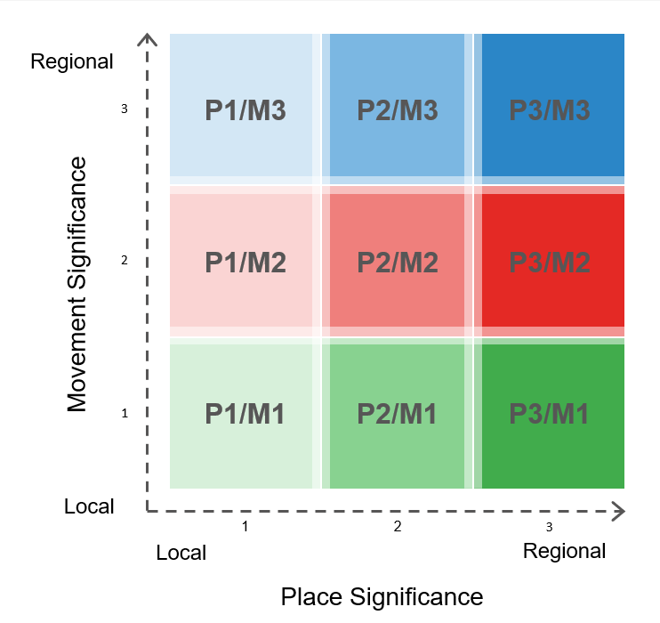
The RASF needed to evolve. Over the past year Auckland Transport, along with Auckland Council’s Design Office, has been reviewing the original 2017 Roads and Streets Framework. The review has been focussed on ensuring the RASF is fit for purpose, aligned to strategy, more user friendly and is simplified to ensure consistent results. Better alignment was also needed with the new Transport Design Manual. Overall, the review sought to allow Auckland Transport to better plan and manage our roads and streets and reflect the full range of modes, activities and functions that occur on them.
Now completed, the RASF is ready to shine. Auckland Transport and partners at Auckland Council are currently piloting the RASF as part of a regionwide assessment of the Auckland transport network, with the intention of every road and street in the region being assessed. This has included using the RASF on a variety of urgent projects and business cases, including Connected Communities and Airport to Botany projects.
Why this matters for the transport community? The revised RASF focuses the framework on what is important to the strategic functioning of Auckland from a ‘Place’ and ‘Movement’ function. It will provide project teams with better guidance to support project development, help deliver better outcomes for projects, and support integrated transport planning.

