TRANSPORTATION CONFERENCE 2026

Auckland Cycle Separator Condition Study Findings

(This paper has been peer reviewed)

Mitra Prasad, BSc, MEngSt (Transportation) (Hons) – Presenter

Technical Lead Active Modes Integration – Auckland Transport

mitra.prasad@at.govt.nz

Brian Yip, BE, MEngSt (Transportation) (Hons) – Presenter

Principal Transportation Engineer – Eliga

brian.yip@eliga.co.nz

Abstract

Given increasing budget pressures, Auckland Transport is increasingly using low cost, quick build infrastructure to expand the cycling and micromobility networks.

Where projects aim to provide separated cycling facilities between existing kerb lines, cycle lane separators are commonly used to provide a delineation between general traffic lanes and cycle paths. There have been varying types of separators used across the Auckland Region, including concrete, rubber and wood. A study was undertaken to look at all existing routes and collect condition rating data to help determine where separators were faring well and where vehicle manoeuvring is causing damage, reducing the life span of the infrastructure.

The study involved rating the condition of each separator along 26 different routes, along with collecting data about the speed environment, vehicle classification of pass-by traffic, lighting and other contextual data. The position of the separators was also noted such as whether the separator was next to an intersection, vehicle crossing, car parking, bus stops or was on a bend.

The analysis of the data collected gives insights into what aspects project designs need to take into account, to ensure the best outcomes are achieved when installing separators and ensuring the intended life of the infrastructure is reached. The lessons gleaned from the data also help designers reduce the incidence of vehicles hitting separators. This presentation is to share the findings of the Separator Condition Study to assist designers and Road Controlling Authorities in improving design outcomes when using cycle lane separators.

Introduction

Many transport authorities around the world recognise the benefits of increasing the modal share of active modes. Geller’s work in the early 2000’s (Geller, 2006) outlining the “Four Types of Cyclists” has focused transport authorities’ attention on appealing to the large group of people who are potentially interested in cycling but are concerned about their personal safety. One of the main concerns of less confident cyclists is fear of mixing with motor vehicles (NZTA 2023). Alleviating this concern is one of the key aspects of cycling infrastructure design, in order to attract more ridership.

In Auckland, the cycleway network has been slowing expanding, where some 700km of facilities are now in place across the network (includes all, physically separated, painted lanes, formalised quiet streets and shared paths). There is a focus on ensuring infrastructure is delivered in a cost-effective way, meaning a greater use of physical separators on the carriageway, to prevent motor vehicles from entering cycle lanes / paths and to help address concerns of less confident riders. Using physical separators allows for cycle infrastructure to be delivered efficiently, minimising civil works (shifting kerb lines, laying concrete paths, stormwater infrastructure, retaining etc) and disruption during construction.
There are now over 26 cycling corridors in Auckland that use cycle separators for part or all of the route. This provides an opportunity to investigate how the assets have been faring in different road environments to elicit information about where they are well suited and where further thinking on utilisation or design is needed.

Auckland Transport commissioned Eliga to conduct a condition survey of 26 routes that had incorporated separators as part of the design. At the time these 26 routes encompassed almost all the separators used to delineate cycle lanes on the Auckland road network.

Survey Methodology

Desktop Study
A desktop study was undertaken for each route noting the traffic characteristics, which includes:
- Speed limit
- Road hierarchy
- Traffic volumes
- Vehicle type distribution or classification
- Bus route / school bus route
- Over-dimension / overweight / HPMV / freight route
- Road lighting information (P or V category lighting)
As-built or construction drawings were obtained for all the routes for audit. Each auditor was briefed on the predefined condition rating tables for each material to ensure consistency with the audit.

Site Audit
Condition surveys were undertaken between March and July 2024 by a team of auditors during the daytime. Visual inspection of individual separators, flexi posts and bridge marker posts were undertaken, with a score according to the predefined condition rating as described in the condition matrix (see Table 1 below). The auditors also included notes on the separators with characteristics that may not be described in the condition rating metrics, or issues worth highlighting. The location of the separators (such as being immediately adjacent to driveways, bus stops, parking and intersections) were also noted. Photos were taken for documentation.

In addition to the scoring of the separators, the following information was also obtained on site:
- Full cross section of the road including widths of traffic lanes, cycle lanes, buffer width (between face of separator and the edge line)
- Width and length of the separator
- Spacing between separators
- General site observations (i.e. adjacent to a construction site, heavy turn movements)

Limitations and Constraints
It is difficult during a survey to accurately determine whether a separator may have been repaired or replaced. Therefore, the survey can only rate on the existing condition without knowledge of the repair history. All separators are assumed to be bolted on unless visibly indicated otherwise, with the exception of separators on Quay Street (separator IDs 1-7, west of Commerce Street), which are confirmed to be stuck on the road surface. If separators are missing on-site but are indicated on the design plan, and there are no signs of previous installation, they were marked as N/A rather than given a rating of 5.

Condition Ratings
The condition survey uses a 5-point scale to assess asset conditions, with 1 indicating excellent condition and 5 indicating the poorest condition. A rating of 4 suggests that maintenance is needed soon, while a rating of 5 indicates that immediate maintenance is required. Due to the difference in material and purpose of rubber separators and rubber speed humps compared to concrete separators, separate rating matrices is determined. The following (Table 1) are some of the examples of the condition for concrete separators (condition rating guides were also conceived for rubber separators, flexiposts, bridge marker posts and wooden separators).

Condition | Description | Example
1 | Recently installed OR almost new. No damage or tyre marks | 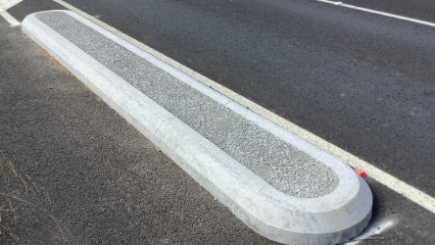
2 | Minor wear/ tear (paint chips, faded paint)  Either minor tyre marks OR minor chipping (from weathering) | 
3 | Typical weathering.  Tyre marks AND minor chipping from mounting.  Moderate damage likely to be sustained by single hit/mounting from vehicle. | 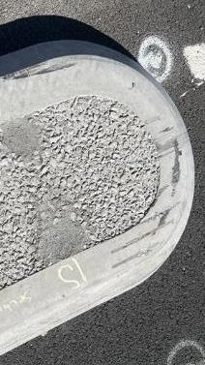
4 | Cracked, smashed, scratches Chipped corner but intact and functional.  Multiple tyre marks and chipping, moderate damage likely to be sustained by multiple hits/mounting from vehicles. | 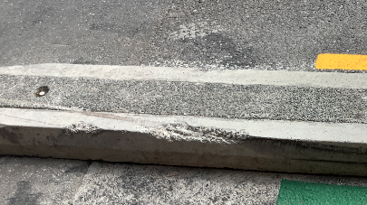
5 | Separator is missing, dislodged or seriously damaged | 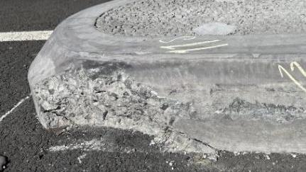

Table 1: Condition rating for concrete separators

Data Analysis

Overview
A total of 3080 separator units were surveyed. A breakdown summary of the asset composition and damage rating are as below:

Figure 1: Composition of Separators

Shown above in Figure 1, amongst the separator assets (not including signs, posts and humps), concrete separators make up 67% of all the surveyed separators, while rubber and wooden separators are 26% and 7% respectively.

An investigation of all assets revealed that certain site characteristics, such as recent installations or locations intended for short-term use, exhibit different usage patterns that significantly impact overall statistics and potentially skew the data's reliability. Furthermore, the limited sample size on wooden separators may compromise the accuracy of the analysis and findings. Therefore, these data were considered as outliers and excluded from the trend analysis. The reasoning and analysis of these outliers are outlined below.

Rubber Separators
Out of the total survey assets, 696 rubber separators were assessed, representing 26% of the total. These separators are primarily from four sites, and the graph below (Figure 2) illustrates that Upper Harbour Drive contributes to 70% of the total rubber separators.

Figure 2: Composition of the 696 rubber separators

The high composition from Upper Harbour Drive heavily influences the overall damage rating of rubber separators as a whole, which is shown in Figure 3 below:
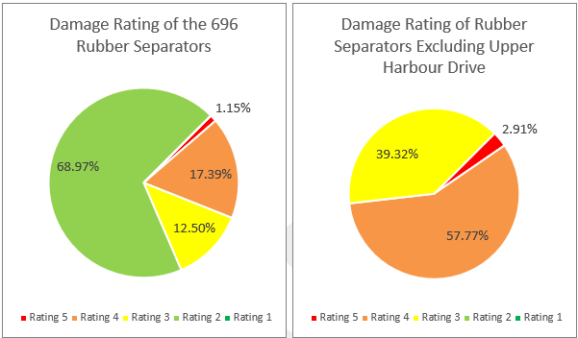

Figure 3: Comparison of damage rating with and without Upper Harbour Drive

The majority of rubber separators are rated 2 due to the separators on Upper Harbour Drive being recently installed in 2023 and therefore showing minimal damage. East Street was constructed in 2021 and was intended for short term use with an anticipated design life of 2 years due to construction of the City Rail Link station nearby. In addition, the high proportion of the separators rated 4 or worse are likely attributed to frequent site access by construction vehicles. The wear and tear is atypical and not representative of normal usage conditions and skews the analysis. Meanwhile, the expected design life for St Lukes Road and Sandringham Road is uncertain; both were installed seven years ago in 2017. Note that sample size from Sandringham Road only constitutes 1% (8 separators) of the entire asset class. This makes St Lukes Road the only route with rubber separators that lacks an extraordinary cause for outliers The age of the rubber separators of these four sites are on two ends of the spectrum (very old and new); therefore, it is noted that the outcome of the study may not be representative of the performance of rubber separators over time.

Wooden Separators
Orpheus Drive was the only site with wooden separators, with 181 wooden separators, contributing to 7% of all surveyed assets. The road characteristics of Orpheus Drive are different from the other sites, as the AADT is less than 1000 vpd in a low-speed environment with a series of speed humps at regular intervals. It is also a straight road with no significant corners. The separators were installed in 2016, making the asset 8 years old. The primary damage appears to be from weathering rather than traffic induced. As shown in Figure 4, around 74% of the wooden separators were rated 3 or worse, which is reflective of the age. The small sample size of wooden separators from a single route may not produce a representative overview
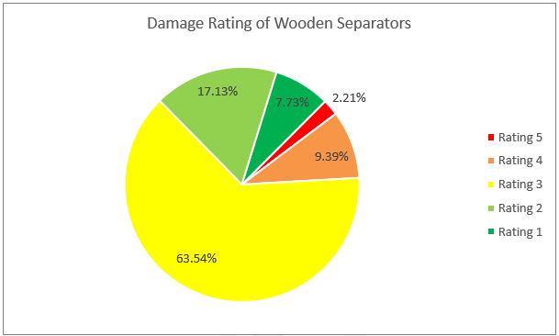

Figure 4: Damage rating of Wooden Separators

Concrete Separators
Concrete separators make up the bulk of the separators used in Auckland. The overall damage rating for concrete separators is shown below in Figure 5:

Figure 5: Overall damage rating for concrete separators

Given they have been used in a wide range of road environments, concrete separators offer the best potential to compare the impacts of differentiators in their design, or the road environment they are situated in. The following sections focus on the key factors that impact the separator conditions and some resultant design considerations. It should be noted that separators adjacent to parking are separated from the wider analysis. This is because, as expected, the observed trends found that damage caused by vehicles manoeuvring into parallel parking spaces tends to be of low impact, typically resulting in tyre marks rather than significant structural damage. Additionally, the presence of parked vehicles reduces the ability for vehicles to strike the separators at speed.

Relative Position of Concrete Separators
This section explores the correlation between position of the concrete separator and the effects on separator conditions. Below is an explanation of the terminology used in the section for clarity:

- End Separator (bus stop / driveway / intersection) – the separator located on the approach side of the bus stop / driveway / intersection in the direction of travel
- Starting Separator (bus stop) – The separator located on the departure side of a bus stop / driveway / intersection in the direction of travel
- Single Separator – a single separator between two driveways
- Starting separator (Start of site) – the first separator at the start of a cycle lane or site in the direction of travel that is located within a midblock section.
- End Separator (End of site) – the final separator in a cycle lane or site in the direction of travel
- Middle Separator – a separator positioned between two other separators at either end
- Single Separator (other) – separator that is positioned adjacent to pedestrian crossings, cycle by-pass or special features

Note that the sample size may be insufficient to fully support the identified trends. For example, there are only 6 instances of starting separators at bus stops. This limited sample size may impact the reliability of the trends observed. More data may be required to enhance the robustness of the findings. However, the following distribution on separator conditions (Figure 6) can be drawn from the data available.

Figure 6: Total percentage of damage rating with 4 and above at various locations ranked from highest to lowest

Start of site separators that occur midblock (i.e. not at an intersection) recorded the most damage ratings 4 or worse of all the positions (36.8%), followed by end separator at bus stops at 28.6%. Starting separators at intersection, single separators at driveway and end of site separators have similar results (21.8%, 20.5% and 19.0% respectively). Meanwhile, end separator at driveways has the lowest proportion of damaged with rating 4 or worse (5.2%). Generally, separators located near areas with turning movements exhibit higher damage compared to those located parallel to traffic.

Design considerations:
- Focus on reinforcing the start and end separators. Consider these to be keyed into the carriageway rather than bolted on.
- Emphasise the first separator as much as possible using signage, flexiposts, advanced edge lines or other markings.
- Set back the placement of separators at bus stops and driveways
- Improve the visibility of the first separator of a site with additional reflective markers either in the middle and/or the terminating end of the concrete unit to allow for redundancy.
- Improve the resilience of flexible signposts such as countersinking construction joints of the sign pole foundation into the concrete separator units, to avoid the flexible foundation to be sheared off easily when trafficked upon.
- Consider taper road marking or lengthen the taper prior to the first separator at the beginning of the site to guide drivers on the lane narrowing.
- Placing separators very close to intersections with the intent to reduce turning speed may not effectively deter drivers from navigating the area, as suggested by the damage observed on the starting separators at intersections.

Horizontal Alignment of Concrete Separators
A relationship was observed between the horizontal alignment of separators and the damage rating as shown in Figure 7

Figure 7: Damage rating distribution for horizontal alignment

Separators located on the inside bend (left turn corner) demonstrates the highest proportion of separators rated 4 or worse at 15.9%, while separators on the outside bend (right turn corner) have the least bad proportion of ratings 4 or worse at 7.4%. This can be attributed to vehicles that are turning left are turning towards the separators, which could bring them closer to the separators. This tighter turning radius increases the likelihood of encroaching on the separator area on the left, leading to higher rates of impact.

Design considerations:
- When road width is constrained, consider providing more buffer space on left turn corners on the traffic lane side, rather than distributing it equally on both sides.
- Consider using separators of a suitable width on the left-hand corners that provides more durability, while avoiding narrower options where possible.
- Consider additional warning features such as red RRPMs placed at shorter spacing along the edge line to guide drivers and reduce the tendency to cut corners too closely.

Functional Lane Width
This section explores the correlation between the lane widths adjacent to the separators and the separator conditions. Note that separators adjacent to parking spaces or buffers that taper with parking spaces are not included in this assessment. The data has been grouped to show the overall proportion of damage with various lane widths including the buffer space. This is effectively the functional lane width usable for vehicles.

Figure 8: Distribution of lane widths and damage rating

The highest proportion of damage rated 4 or worse is found in lanes with widths ranging from 3 m to 3.5 m (11.5%), while the least damage appears to be in lanes less than 3 m wide (7.7% rating 4 or worse). However, Mahuhu Lane is the only site in this study with lanes under 3 m wide and is situated in a low speed, low traffic environment. While the lowest percentage of rating 4 or worse is observed at Mahuhu Lane, the greatest percentage of rating 3 (69.2%) is also observed. The separators rated 3 at this location (most common rating) generally exhibit only tyre marks rather than significant damage. This indicates that in low-speed low volume conditions, concrete separators in narrower traffic lanes can still be appropriate, provided the environmental factors align with these conditions.

Design Considerations:
- In areas with constrained road widths, concrete separators can still be appropriate if the road environment maintains low speeds and low traffic volumes and should not be disregarded.

Buffer Widths
This following section explores the correlation between the buffer width adjacent to the separators and the separator conditions, excluding any separators with adjacent parking (Figure 9). It is noted that buffer width of more than 1m typically represents where the flush marking tapers from the parking lane.
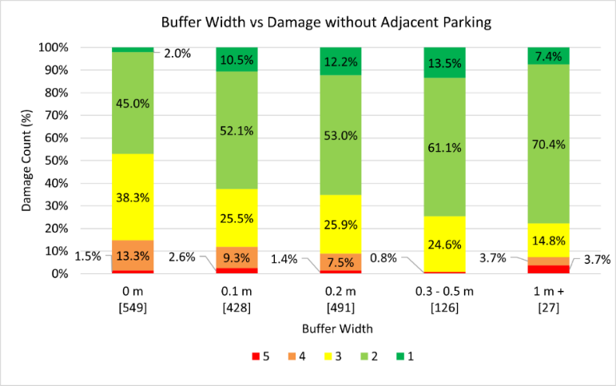

Figure 9: Buffer Width vs Damage Rating

Except for a 1m+ buffer width, the trends are within expectations of damage decreasing with increasing buffer width, with only 0.8% critical damage observed with 0.3 m to 0.5 m buffer width.
For buffer widths over 1m, the seemingly high total critical damage is 7.4% is only contributed by 2 separators due to the small sample size. The separators are both located at the Brigham Creek Road site and likely caused by the single lane diverging into a left turning and through lane at the signalised intersection.

Heavy Commercial Vehicles
Anecdotal evidence suggests that separators where significant damage has occurred are often caused by turning vehicles. From the data, it can be seen that there is a relationship between the percentage of heavy vehicles and damage to separators (Figure 10).
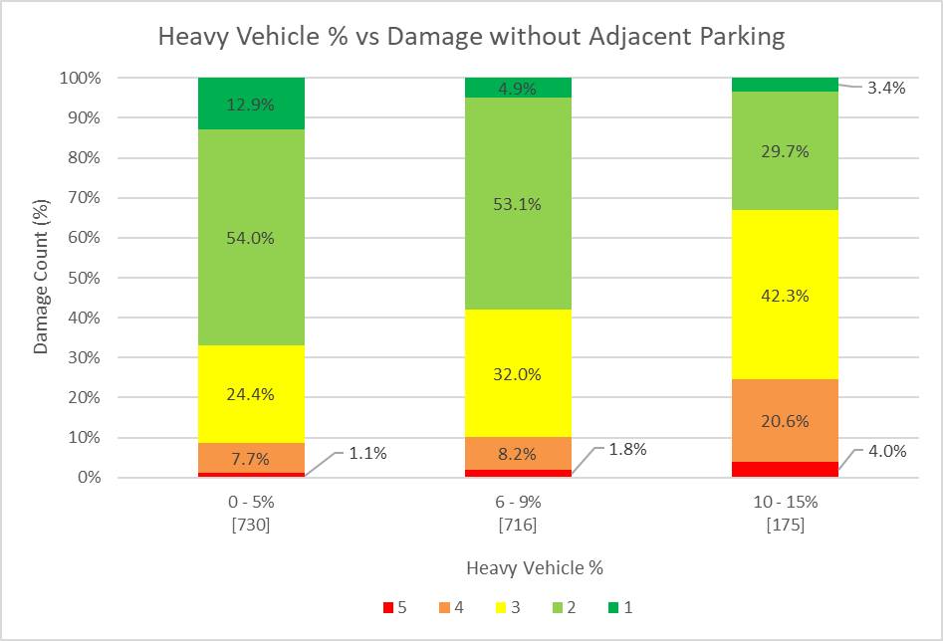

Figure 10: Heavy Commercial Vehicle (HCV) Percentage vs Damage Rating

There is an increasing trend of increased damage observed as the proportion of heavy vehicles travelling along the route increases. Heavy vehicles are more likely to damage a separator when run into, even at slow speeds, due to the weight and loading putting increased pressure on the concrete.

Design considerations:
- When proposing concrete separators on routes with high volumes of heavy vehicles, designers should be aware that separators will be prone to damage. Mitigation could include increased buffer widths or additional structural reinforcement within the separator construction.

Average Daily Traffic
This section explores the relationship between ADT and damage to concrete separators.

Figure 11: Average Daily Traffic (ADT) vs Damage Rating

From Figure 11, there appears to be a weak general trend of percentage of critical damage (rating 4 or worse) increasing as vehicle volumes increase. However, the data appears to plateau after 10,000 vpd, with little disparity in damage ratings for ADT between 10,000 and 25,000 vpd. This general trend was also observed when comparing road hierarchy to condition rating.

Posted Speed Limit
A less clear relationship between posted speed limit and damage was seen (Figure 12).
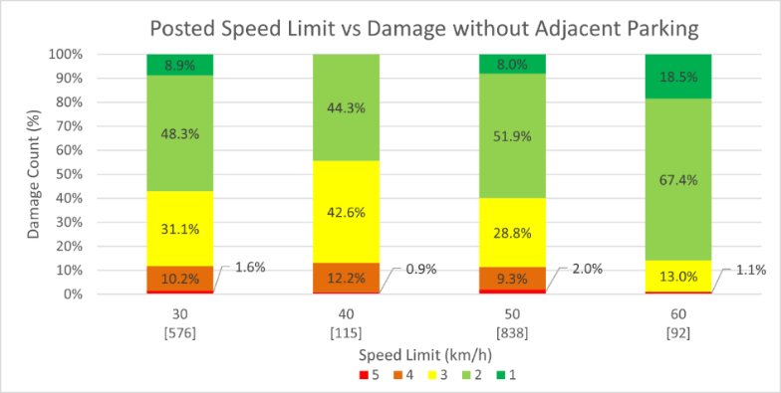

Figure 12: Posted Speed Limit vs Damage

Unintuitively this data is inconclusive, as no clear trend between damage and speed limits is observed. Further analysis indicates that separators within the 60 km/h speed limit category were present at only one site (Noel Burnside Road). It is understood that Noel Burnside Road is an outlier site with other unique site characteristics aside from having a posted speed limit of 60 km/h. The typical buffer width between edge of separator and edgeline is 0.5 m and the typical adjacent lane width is 3.5 metres. Furthermore, the site has limited vehicle access, as well as a relatively flat topography and relatively straight horizontal alignment. The combination of these characteristics are likely to attribute to the better performance of Noel Burnside Road separators, despite having the highest posted speed limit.

The speed limits shown in Figure 12 represent speeds following the 2020 Phase One Safe Speed Changes. It should be noted that, following the study, some speed limits have reversed to higher speed limits under Land Transport Rule: Setting of Speed Liimit 2024.

It also should be noted that concrete separators placed on Upper Harbour Drive in 2022 (initally under a 70km/h speed limit) experienced a lot of damage to the separators following vehicle collisions, particularly with the front end of the separators. However, prior to this study, the separators on Upper Harbour Drive had been completely swapped for rubber separators.

Installation Year
This section explores the relationship between the year the separators were installed and damage to concrete separators (Figure 13).

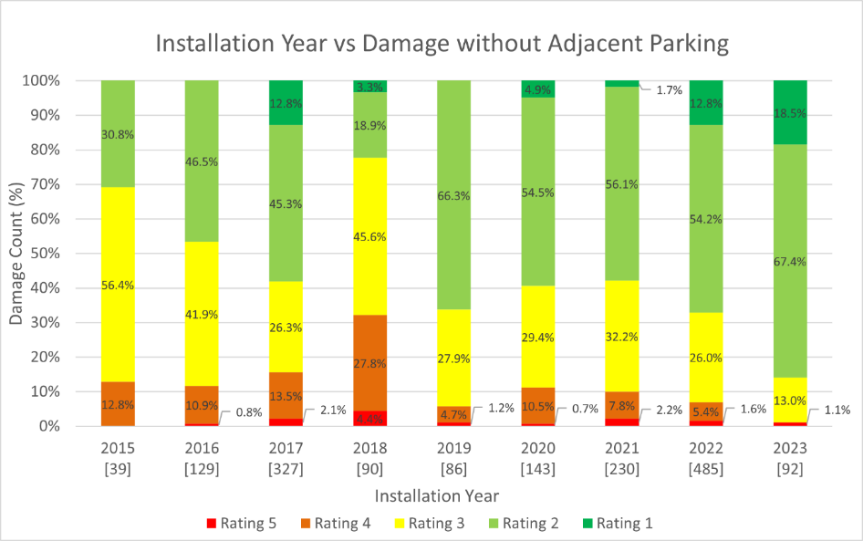

Figure 13: Installation year vs damage rating

It was expected that older separators would show more damage, but the trend is inconclusive with little or no relationship between damage and the year of installation. Given that the majority of separators were rated good or better, it may be indicating that the concrete separators are largely meeting their expected 10+year design life and that other factors are more determinative on whether separators were damaged.

Conclusions
Based on the data collected from the condition survey, the following trends can be identified, along with relevant design considerations:
- Concrete separators with widths of 0.5m and 0.7m exhibit the lowest proportion of high damage ratings, indicating greater durability and resistance to damage, with 0.5m being preferable for its similar durability and more efficient space use. For constrained spaces, 0.3m separators are recommended, as they offer comparable durability to 0.4m separators.
- Concrete separators near turning movements and alignment changes experience more damage than those positioned parallel to traffic. This includes separators at the start of a site and end separators at bus stops. As such, consider enhancing the visibility of the first separator with additional reflective markers and improve the resilience of flexible signposts to avoid the foundation being sheared off upon impact. Including taper road marking and increasing taper length prior to the starting separators can provide guidance and advance warning on the changes to alignment. The position of the separators at bus stops and driveways may require further set back to avoid being damaged.
- Concrete separators located along a left turn corner exhibit more damage than the ones on a straight section and a right turn corner. As such, consider allocating more buffer space on the traffic lane side, rather than distributing it equally on both sides of the separator. Also, consider using separators of a suitable width that provides more durability. Additionally, consider placing red RRPMs at shorter intervals for improved visibility.
- Concrete separators located in low-speed low-volume environments exhibit more wear and tear damage like tyre marks rather than significant damage like deteriorations. In areas with constrained road widths, concrete separators can still be appropriate if the road environment maintains low speeds and low traffic volumes and should not be disregarded.
- Parking adjacent to concrete separators may increase general wear and tear. However, it does not appear to elevate the risk of critical damage or reduce their functionality.

References
GELLER, R. (2006). "Four Types of Cyclists", Portland Bureau of Transportation, Portland, OR (further updated in 2009). https://www.portland.gov/transportation/walking-biking-transit-safety/bicycle-counts#toc-four-types-of-transportation-cyclists

NZ TRANSPORT AGENCY WAKA KOTAHI (2023). Understanding Attitudes and Perceptions of Cycling and Walking 2023. https://nzta.govt.nz/resources/walking-cycling-and-micromobility-monitor

