OPTIMAL CHARGING LOCATIONS FOR ELECTRIC VEHICLES

(This paper has been peer reviewed)

Cong Quoc Tran, Presenter
Main Author
PhD Student
Department of Civil and Natural Resources Engineering, University of Canterbury, Christchurch
Email: cong.tran@pg.canterbury.ac.nz

Dr. Dong Ngoduy, Associate Professor in Transport Engineering
Main Supervisor
PhD
Department of Civil and Natural Resources Engineering, University of Canterbury, Christchurch
Email: dong.ngoduy@canterbury.ac.nz

Dr. Mehdi Keyvan-Ekbatani, Lecturer in Transport Engineering
Co-supervisor
PhD
Department of Civil and Natural Resources Engineering, University of Canterbury, Christchurch
Email: mehdi.ekbatani@canterbury.ac.nz

ABSTRACT

On-road vehicles are known as a major contributor to energy crisis and environmental issues. Due to the efficient energy consumption and zero tailpipe emission, Electric Vehicles (EVs) has emerged as an effective solution to ease the petroleum dependence and reduce air pollution. However, the mass adoption of EVs is still low because of its limited driving range, long charging time and users’ range anxiety. Besides recent advances in battery and charging technology, sufficient charging infrastructures are critical to drive EVs’ uptake in this early stage. Recently, many studies focus on solving charging location problems to maximize the captured flows of EVs or minimize the infrastructures’ investments. Nevertheless, the increasing number of EVs’ in traffic networks poses another challenge by changing the traffic routing pattern and sometimes leading to even more congestion due to EVs’ charging nature. Therefore, it is imperative to establish charging infrastructures in the manner that not only satisfies the charging demand but also minimizes both travel time and the charging infrastructures’ installation cost. With these concerns, this paper attempts to address the problem of identifying simultaneously the optimal location and number of charging stations in the network considering the multiple recharging and route choice behaviours of travellers. The problem is formulated as a bi-level optimization programme in which upper level aims to minimize the system cost while lower level captures re-routing behaviour of travellers. We further utilized the cross-entropy method embedded Frank-Wolfe algorithm to solve the model with different levels of EV penetrations. Numerical studies are performed to demonstrate the fast convergence of the proposed framework. This paper develops a novel methodology which is tested at this stage on toy-networks. The case studies with New Zealand networks may be involved in future works.
INTRODUCTION
Although urban transportation is the key element of economic development, it also involves many externalities in term of energy crisis and environmental issues. On-road vehicles are known to be responsible for 40% of carbon dioxide emissions and a third of total global greenhouse gas emissions in urban areas (Nava, 2017). Furthermore, with the increasing demand for fossil fuels, these types of resources are estimated to be exhausted before 2050 (Brandstätter, G., Kahr, M. and Leitner, M., 2017). Electric Vehicles (EVs) have emerged as a promising solution to reduce petroleum dependence and air pollution in urban areas. Nevertheless, the adoption of EVs is still much lower compared to internal combustion vehicles. Limited driving range, long charging times, insufficient charging infrastructures and high investment costs have remained as the main challenges that limit the widespread of EVs (Mirchandani, P., Adler, J. and Madsen, O.B., 2014). Besides recent advances in battery and charging technology, it is plausible that sufficient charging infrastructures is critical to drive EVs uptake in this early stage.

Two basic charging infrastructures, namely on-site low-power (level-1 and -2 charging modes) and on-route fast charging (level-3 charging mode) are currently deployed to serve different types of EVs' users and demands. While low charging requires several hours for a full recharge, fast charging mode can handle in less than 10 minutes (Wu, F. and Sioshansi, R., 2017). Therefore, the availability of public fast-charging on the road has a significant role in promoting the EVs' adoption as it can ease travellers' range anxiety. Various studies focus on solving charging location problems to maximize the captured flows or minimize the infrastructure costs. Nonetheless, the increasing number of EVs’ in traffic networks poses another challenge by changing the traffic routing pattern and sometimes leading to even more congestion due to EVs’ charging nature. With this concern, our study focuses on solving the fast charging infrastructures location problem in the manner that not only satisfies the charging demand but also minimizes both total travel time and installation cost of the charging infrastructure.

In the last few years, the EVs charging facility location problem has attracted more extensively investigation and can be generally categorized into node-based approach and flow-based approach due to the charging demand pattern. In node-based models, the demands are assumed to be located at certain nodes. Based on the concept of covering demand nodes, two classical node-based demand models, namely maximal covering location models and set covering location models usually be used to locate the facilities (Church, R.L. and Meadows, M.E., 1979). Besides, Nozick, L.K. (2001) developed the fixed charge facility location model with coverage restrictions to minimize the total cost while maintaining an appropriate level of service. The p-median model is also widely used in facility location problem which locates p facilities and allocates demand nodes to them to minimize total weighted distance travelled (Upchurch, C. and Kuby, M., 2010). With EVs charging demands estimated from municipal statistical yearbooks and the national census, a brief comparison of three point-based models - set covering model, maximal covering model and p-median model is proposed in the study of He, S.Y., Kuo, Y.H. and Wu, D. (2016).

In contrast to node-based models, the flow-based models assume that the demands are in the form of traffic flows characterized by the amount of flows and paths they follow. This assumption makes flow-based more preferable due to the capture of travellers’ behaviours on the road. The origin-destination (O-D) demand can be estimated by trip distribution and assignment models. The first flow-capturing location model (FCLM) was proposed by Hodgson, M.J. (1990) with the objective of locating a certain number of facilities to maximize the captured flow. This model lays the foundation for charging location problem. However, the major drawback of FCLM in the context of EVs is that it assumes all the flow on a path can be captured as long as there is a single facility on this path, regardless the driving range limitations.

By extending the FCLM to carry over the alternative-fuel vehicles' limited driving range and allow multiple refuelling stops, the flow refuelling location models (FRLM) was proposed and investigated by many scholars (Kuby, M. and Lim, S., 2005; Upchurch, C., Kuby, M. and Lim, S., 2009, Wu, F. and Sioshansi, R., 2017). In FRLM, the feasible combinations of stations need to be pre-calculated to ensure the vehicles can finish their trips before running out of charge. Similar to FCLM, FRLM assumes that all of travellers between a given O-D pair will follow the same shortest path. Subsequently, the deviation-flow refuelling location models (DFRLM) were introduced to capture the necessary deviations that drivers may have to get the services (Kim, J.G. and Kuby, M., 2012, 2013; Hosseini, M., MirHassani, S.A. and Hooshmand, F., 2017). Besides the coverage maximization models, Wang, Y.W. and Lin, C.C. (2009) introduced flow-based set covering models (FSCM) to cover all O-D pairs using minimum number of charging stations based on vehicle routing logic. Similar to the DFRLM, Li, S. and Huang, Y. (2014) relaxed the general assumption that travellers would only consider a shortest (distance or time) path between an O-D pair by developing the multipath refuelling location model (MRLM) and proposed heuristics which are also applicable for other existing FSCM.

Using bi-level approach, He, F., Yin, Y. and Zhou, J. (2015) proposed a tour-based network equilibrium model and then formulated the charging location problem as a bi-level programme with the network equilibrium included at the lower level to minimizing social cost with the budget constraints and finally solved it by the genetic algorithm. Guo, F., Yang, J. and Lu, J. (2018) also developed a bi-level integer programming model and used an adaptive large-neighbourhood search, combined with a k-shortest path algorithm and an iterative greedy heuristic to locate charging stations. Optimizing the charging locations assuming that the flow pattern remains unchanged may lead to unreliable solution or a deterioration in network performance due to some re-routing of traffic responding to the changing of charging locations. Amongst few existing studies concerned with driver’s route choice behaviours, Riemann, R., Wang, D.Z. and Busch, F. (2015) developed a mixed-integer nonlinear programme and linearized the programme to maximize the captured flows of wireless power transfer facilities by applying the stochastic user equilibrium principle to describe EVs drivers' routing choice behaviour. In an effort to apply FCLM on optimizing the position of charging stations, He et al. (2018) assumed that EVs' drivers only charge at most one time on their path and pre-determined the candidate charging stations on every path. The problem is then formulated as a bi-level programme before reformulating as a single-level programme. Finally, it is linearized to solve by a heuristic algorithm.

The general objective of this paper is to identify simultaneously where and how many stations should be deployed in the urban network. Compared with previous studies, this paper's contributions are in following aspects. Firstly, this study approaches the cost-driven charging location problem with concurrent considerations of mixed vehicle classes, the installation cost of charging stations, link congestion and route choice behaviours of travellers with multiple recharging. The link congestion effect is considered in the model in order to deal with charging locating problem in urban network. Secondly, a bi-level optimization programme is proposed to capture the interaction between the charging stations deployment and the flow equilibrium in which the complex relationship between charging locations and feasible paths are identified endogenously through a robust algorithm.

PROBLEM DESCRIPTION
From environmental concerns, EVs has been proved as an effective solution to energy crisis, air and noise pollution, especially in urban areas. However, the adoptions of EVs requires sufficient charging infrastructures. When commuting between origins and destinations, EVs' users not only choose routes to minimize their travel times but also consider the feasibility of completing the trips without running out of battery. Because of the EVs’ charging nature, the increasing number of EVs’ in traffic networks may change the traffic routing pattern and sometimes lead to even more congestion. Furthermore, the investment on fast charging infrastructures is expensive and usually subjected to a given budget. Therefore, the charging station location problem considering both investment costs and system travel times is a matter of the utmost important to promote the widely use of EVs in urban areas. With these concerns, this paper attempt to address the problem of identifying simultaneously the optimal location and number of charging stations in the network in the manner that not only satisfies the charging demand but also minimizes both travel time and the charging infrastructures’ installation cost. The EVs' drivers are allowed to have multiple en-route recharging with the charging demand is assumed to be fixed and known. In fact, the charging demand can be estimated by simulation, big data technologies or forecast from historical data.

This study approaches the charging location problem by the concept of flow-based demands and uses the bi-level optimization programme to formulate the problem, which is similar to the study of He et al. (2018). However, the main differences are:

(1) By considering EVs only, He et al. (2018) assumed there is a proportion of EVs’ users choosing to use charging stations on paths with paths’ length less than EVs’ driving range and aimed to locate charging stations so as to maximize the EVs’ captured flows. Meanwhile, we consider the charging location problem in a network using by mixed EVs and GVs which ensures all the EVs’ flows are satisfied in an optimal way. In other words, the system cost (including total travel cost and the charging infrastructures’ installation cost) is minimized. The total travel time is monetized by using the transport economics concept - value of time which is the opportunity cost that a traveller has to spend during a trip, or the amount that a traveller would be willing to pay to save time (Ambarwati, L., Indraistuti, A.K. and Kusumawardhani, P., 2017).

The installation cost of charging stations includes equipment investment, installation and real estate cost and varies significantly depending on the upstream grid reinforcement necessity (Schroeder, A. and Traber, T., 2012). The value of time and installation cost in specific cases could be estimated through surveys and depended on the objective priority of the planner (i.e. weighting the investment cost or focusing on the system performance). Without loss of generality, we assume that value of time equals to the medium pay per hour (i.e. $ 20 per hr) and the installation cost is the same for all stations (i.e. $ 500,000 per station).

(2) By utilizing the FCLM, He et al. (2018) applied user equilibrium with EVs’ driving range constraint to simulate the route choice behaviour in which EVs’ drivers are assumed to charge at most once on their trips. Therefore, the feasible positions of charging stations on the network is limited within a certain region and this assumption also requires the path length cannot exceed two times the driving range for the EVs to be used. We relaxed this assumptions by allowing EVs can be served multiple times to complete the longer trips. To capture the multiple recharging, instead of exogenously identifying the feasible combination of stations on each path by adopted FRLM as in Guo, F., Yang, J. and Lu, J. (2018), we use the definition of sub-path to endogenously identify the feasibility of a path for EVs. For a given set of charging stations, the sub-paths of a path include the route from the origin to the first charging station, from a charging station to following charging station and from the last charging station to the destination. Then a path is feasible only if all of its sub-paths are less than the EVs' driving range.

Considering a directed graph G(K,A,W). In our study, following notations are used:
- Sets and parameters:
  - $K$ : Set of nodes, $k ∈K$
  - $A$ : Set of links, $a ∈A$
  - $W$ : Set of all O-D pairs, $w ∈W$
  - $P^{w}$ : Set of all path p between O-D pairs $w$
  - $q^{w,e}$: Demand of EVs between O-D pair $w$
  - $q^{w,g}$ : Demand of GVs between O-D pair $w$
  - $m$ : Maximum number of charging stations
  - $FC$ : Fixed cost of charging stations
  - $VoT$ : Value of travel time
  - $t_{a}^{0}$ : Free-flow travel time of link a
  - $C_{a}$ : Capacity of link a
  - $l_{a}$ : Length of link a
  - $l_{p}^{w}$ : Length of path p between O-D pair $w$
  - $l_{s,p}^{w}$ : Length of sub-paths on path p between O-D pair $w$
  - $D^{e}$ : Driving range of EVs
  - $δ_{a,p}^{w}$: Link-path incidence, which equals 1 if link a is on path p between pair $w$
- Decision variables
  - $x_{k}$ : Whether a charging station is located at location k or not
  - x : The vector of locations, x = $\left[x_{k}\right]$
  - $y_{p}^{w}$ : Whether path p between pair w is feasible or not
  - y : The vector of feasible paths, y = $\left[y_{p}^{w}\right]$
  - X : The vector of solution consisting of locations and feasible paths, X = [x, y]
  - $q_{a}$ : The aggregated traffic flow on link a
  - $q_{a}^{e}$ : EVs flow on link a
  - $q_{a}^{g}$ : GVs flow on link a
  - q : The vector of link flows, q = $\left[q_{a}\right]$
  - $q_{UE}$ : The vector of equilibrium link flows
  - $t_{a}$ : Travel time when using link a
  - $f_{p}^{w, e}$: EVs flow on path p between O-D pair w
  - $f_{p}^{w, g}$: GVs flow on path p between O-D pair w

MODEL FORMULATION
BI-LEVEL OPTIMIZATION PROGRAM
The charging location problem can be considered as a network design problem which identifies the sets of charging locations and the corresponding equilibrium flows so as to optimize the measure of network performance index. The bi-level programming technique can be applied to formulate this problem in which the upper level problem aims to minimize total system costs while the lower-level is subject to user equilibrium (Jing et al., 2016). In this study, a bi-level programme is formulated as in Figure 2.

At upper level, the planner aims to minimize the total system cost which includes the system travel cost and charging infrastructure investment cost. The objective function is presented as a performance index (PI) function, which can be calculated by the vector of locating solutions X and the vector of link equilibrium flows $q_{UE}$, denoted as PI(X,$q_{UE}(X)$). It is note that the vector of locating solution X contains a vector of locations of charging stations x and a corresponding vector of feasible paths y, X = [x, y]. Since changing the locations of charging stations will cause some re-routing of traffic, $q_{UE}= q_{UE}(X)$.

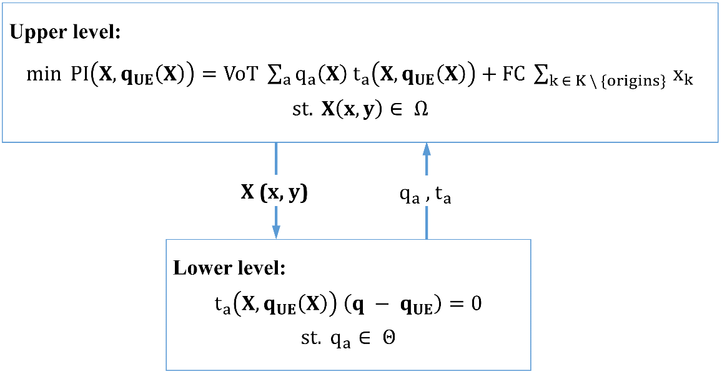
Figure 2. Bi-level optimization process

The feasible space of the locating solutions vector X, denoted as Ω, is defined as:

$$\sum_{k ∈K}{x_{k}} ≤m$$ | (1)
$$\left(D^{e}- max⁡(l_{s,p}^{w})\right)y_{p}^{w} ≥0 ∀p ∈ P^{w}$$ | (2)

Constraint (1) entails the fixed number of total charging stations to be located. Constraint (2) ensures that a path is feasible if only the EVs can be able to arrive a charging station or its destination before running out of charge.

At lower level, $t_{a}(X, q_{UE})$ denotes the vector of link travel times, which is dependent on the vector of locating solutions and the equilibrium link flows. The link travel times can be determined using Bureau of Public Roads (BPR) function:

$$t_{a}= t_{a}^{0}\left[1+0.15{\left(\frac{q_{a}}{C_{a}}\right)}^{4}\right] ∀a ∈A$$ | (3)

Θ denotes the feasible space of the link flow vector and is explicitly defined as:

$$\sum_{p ∈ P^{w}}{f_{p}^{w,e}= q^{w,e}} ∀w ∈W$$ | (4)
$$\sum_{p ∈ P^{w}}{f_{p}^{w,g}= q^{w,g}} ∀w ∈W$$ | (5)
$$f_{p}^{w,e} ≥0; f_{p}^{w,g} ≥0 ∀p ∈ P^{w}$$ | (6)
$$y_{p}^{w} f_{p}^{w,e} ≥0 ∀p ∈ P^{w}$$ | (7)
$$q_{a}^{e}= \sum_{w∈W}{\sum_{p∈P^{w}}{f_{p}^{w,e}δ_{a,p}^{w}}} ∀a ∈A$$ | (8)
$$q_{a}^{g}= \sum_{w∈W}{\sum_{p∈P^{w}}{f_{p}^{w,g}δ_{a,p}^{w}}} ∀a ∈A$$ | (9)
$$q_{a}= q_{a}^{e}+ q_{a}^{g} ∀a ∈A$$ | (10)

Constraints (4) and (5) guarantee the relationship between travel demands and path flows between OD pairs. Constraint (6) ensures the positive value of path flows. Constraint (7) demonstrates that the EVs flow on a path is serviced only if this path is feasible. The relationship between link flows and path flows are described in constraints (8) and (9). Finally, the aggregate flows on each link are determined by the sum of EVs' flows and GVs' flows as in constraint (10).

THE SOLUTION ALGORITHM
The above problem of finding optimal charging locations in the network using by mixed EVs and GVs is a complex combinatorial optimization problem due to its binary-type decision variables and the bi-level structure. Such a convex problem can be solved to obtain good local solution by heuristics and meta-heuristics methods, such as: Hill Climbing, Genetic Algorithm, Simulated Annealing, Tabu Search. The research described here adopts a relatively new method - namely cross-entropy method (CEM) - proposed by Rubinstein, R.Y. and Kroese, D.P. (2004) due to its robustness, fast convergence and insensitivity to the initial solutions. The cross-entropy method originated from an adaptive variance minimization algorithm for estimating the probabilities of rare events on stochastic networks and could be adapted to solve static and noisy combinatorial optimization problems. For further details about CEM and its application, we refer to Ngoduy, D. and Maher, M. (2011, 2012), Abudayyeh et al. (2018).

In general, the CEM can be summarized in two steps: (1) generate a set of candidate solutions according to a parameterized distribution; and (2) update the parameters of the sampling distribution in the manner which steer the problem towards the optimal solution in subsequent iterations. In this study, we consider the charging locations as a binary vector x = $(x_{1},…,x_{n})$ such that vectors x are independent Bernoulli random variables with success probabilities $γ = (γ_{1},..., γ_{n})$, where n is the number of nodes in the network. Accordingly, x ~ Ber($γ$) with $γ_{origins}=1$ and $γ_{destinations}=0$. Corresponding to each set of charging locations, the set of feasible paths y for each vehicle class can be identified with the consideration of driving range. Our problem is to find the minimum of the cost function PI(X,$q_{UE}(X)$) over all X(x, y) in set Ω and the corresponding optimal solution $X^{*}$:

$$z^{*}=PI\left(X^{*}, q_{UE}\left(X^{*}\right)\right)= \min_{X ∈ Ω}{PI(X, q_{UE}(X))}$$ | (11)

$q_{UE}(X)$ is the vector of equilibrium link flows obtained by solving the user-equilibrium problem at lower level with locating solution X. The user-equilibrium problem with the presence of EVs can be solved by classic Frank-Wolfe (F-W) algorithm with path-distance constraints. Without loss of generality, all paths between O-D pairs are assumed to be feasible for GVs due to their relatively long driving range. Subsequently, the flows are only assigned on the feasible least travel time path for each vehicle class between each O-D pair.

Given that the location of charging stations x can be generated randomly from a probability density function p(x) by sampling which satisfies the maximum number of stations constraint, then the above optimization problem can be associated with a stochastic estimation problem estimating the small probability l(z) that randomly chosen solution X on Ω from a probability density function g(x) with sample size N has a value of the objective function PI(X,$q_{UE}(X)$) ≤ z when z is close to (but greater than) $z^{*}$. However, the event $PI(X_{n}, q_{UE}(X_{n})) ≤ z$ is rare and the estimation of l(z) is a nontrivial problem. The problem is then to construct a density g(x), from amongst a family of distribution {p(x;$γ$), $γ ϵ Γ$} that is as close as possible to $g^{*}\left(x\right)$ by minimizing the distance between two distributions, the Kullback-Leibler measure D. In other words, it is then a matter of choosing the values of the parameter vector $γ$ so as to minimize D, and make the sampling as efficient as possible, by making the precision of the estimate of l(z) as good as possible, for the given sample size N. This problem of minimizing D is equivalent to the program:

$$\max_{γ}{D\left(γ\right)}= \max_{γ}{E[I\left(PI\left(X, q_{UE}\left(X\right)\right)≤ z\right) ln(p(x; γ))]}$$ | (12)

The solution ${\hat{γ}}_{t}$ of equation (12) at iteration t is calculated by the elite sample $N_{e}$ of iteration (t-1) with $ρ$% of the best PI values as:

$${\hat{γ}}_{t,j}= \frac{\sum_{k=1}^{N}{I_{\{\left(PI\left(X, q_{UE}\left(X\right)\right)≤ z\right)\}}x_{k,j}}}{\sum_{k=1}^{N}{I_{\{\left(PI\left(X, q_{UE}\left(X\right)\right)≤ z\right)\}}}}, j=1,…, n$$ | (13)

where $x_{k,j}$ is the $j^{th}$ component of the $k^{th}$ random binary vector x.

As a result, an optimal set of charging station locations and a corresponding system cost are identified with a certain level of EVs' penetration. Furthermore, when the EVs' proportion increases, the continued use of installed charging stations in later stages can be ensured by adjusting the parameter vector $γ$. In summary, the CEM-based embedded modified Frank-Wolfe algorithm is implemented for solving the above charging facility location problem as shown in the following pseudo-code:

The CEM-based algorithm
1: | procedure CEM(network parameters, $N, γ^{(1)}, ρ, α, D^{e}, m, FC, VoT$)
2: | $$γ ← γ^{(1)}$$
3: | $$t ←1$$
4: | while stopping condition is not reached do
5: | $$x ←S(N, γ^{\left(t\right)},m)$$ | - randomly sampling location of charging stations
6: | $$y ←F(x, D^{e})$$ | - calculating corresponding feasible paths
7: | $$q_{UE} ←FW(y)$$ | - the equilibrium flow obtained by applying F-W algorithm
8: | $$PI ←PI(X, q_{UE}(X))$$
9: | $$N_{e} ←Select the best 100ρ \% of PI values$$
10: | $$γ_{new}^{(t)} ←Update γ via equation (13)$$
11: | $$γ^{(t+1)} ← α γ_{new}^{(t)}+(1-α)γ^{(t)}$$ | - smoothing the parameter vector
12: | $$t ←t+1$$

Some common criteria can be used as the stopping condition, which is whether (1) the maximum number of iterations has been reached; (2) the maximum difference between best PI and worst PI values during the last two consecutive iterations is sufficiently small; or (3) the maximum distance between two consecutive parameter vectors is sufficiently small.

NUMERICAL STUDIES
The purpose of numerical studies is to illustrate the effectiveness of the solution method in the different networks with different proportions of EVs and analyzes the impact of EVs' proportion and optimal charging solutions on total systems costs. In CEM-based algorithm, the sample size N is 2000 and the elite sample proportion $ρ$ is 5%. At each iteration, the parameter vector is updated using the smoothing rate $α$ = 0.7. The stopping condition applied here is the zero difference between best PI and worst PI values during the last two consecutive iterations. All instances are solved using Spyder (Python 3.6) on a computer equipped with Intel(R) Core(TM) i7-7700 CPU @ 3.60GHz and usable RAM of 15.9 GB, running on Windows 10.

A TOY NETWORK
The proposed framework is firstly tested on a small network with 8 nodes and 13 links as shown in Figure 3. All vehicles will start at node 1 and reach node 8 at the end. Without loss of generality, the link length is assumed to be the same as the free-flow travel time which is labelled on each link and the capacity of each link is 1,800. The network is used by both EVs and GVs with the total O-D demand of 10,000. The EVs' driving range is 30. The maximum number of charging stations is 5 with the investment cost of $ 300,000 per station. The value of time is $ 0.3 per minute.

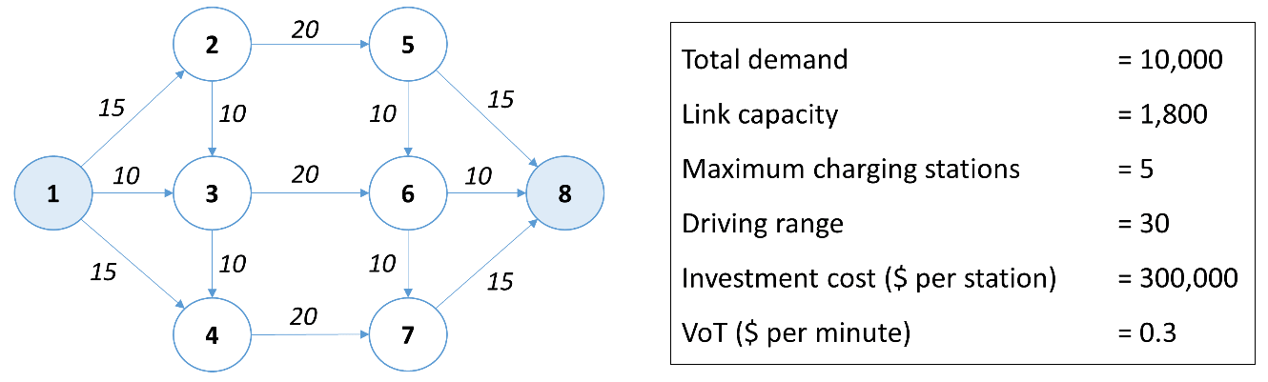
Figure 3. Toy network and input parameters

The optimal charging locations in the toy network with the EVs' penetration increased discretely from 10% to 90% are identified in the computational time of 0.93 hours and shown as in Figure 4.

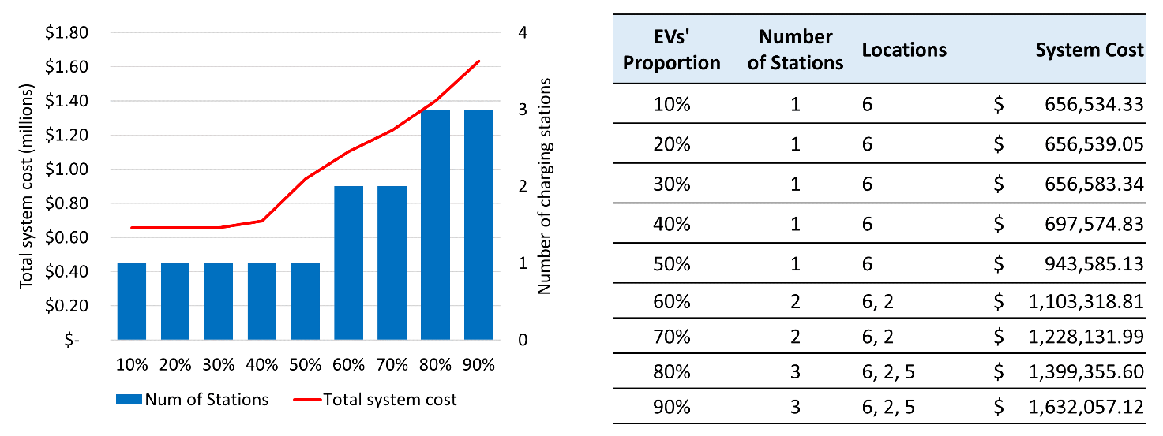
Figure 4. The final results corresponding to different levels of EVs' proportions

As can be seen in Figure 4, when the EVs' penetration increases from 10% to 50%, the system operator just need to build one charging station at node 6 to serve all the EVs with the system cost range from $ 656,534.33 to $ 943,585.13. However, it is required to build one more charging station at node 2 when the EVs' proportion is increased to 60% - 70%. The maximum charging stations needed for 80% and 90% of EVs' penetration is three (at node 6, node 2 and node 5) with the system cost of $ 1,399,355.6 and $ 1,632,057.12, respectively.

A MEDIUM-SIZE NETWORK
In this investigation, a medium-size testing network consisting of 24 nodes and 38 links are considered as in Figure 5. The link length, free-flow travel time and O-D demands are also provided in the figure. The driving range of all EVs is assumed to be 50 and maximum number of charging stations is 5. Although the electrification of transportation can bring long-term sustainability for urban areas, it is plausible that the network becomes more congested with the increasing EVs' penetration. However, the total travel times can be reduced by increasing the number of charging stations in the network. Furthermore, the total travel times of different level of EVs' proportion are reduced and converged at a certain number of charging stations (i.e. three stations) as can be seen in Figure 6.
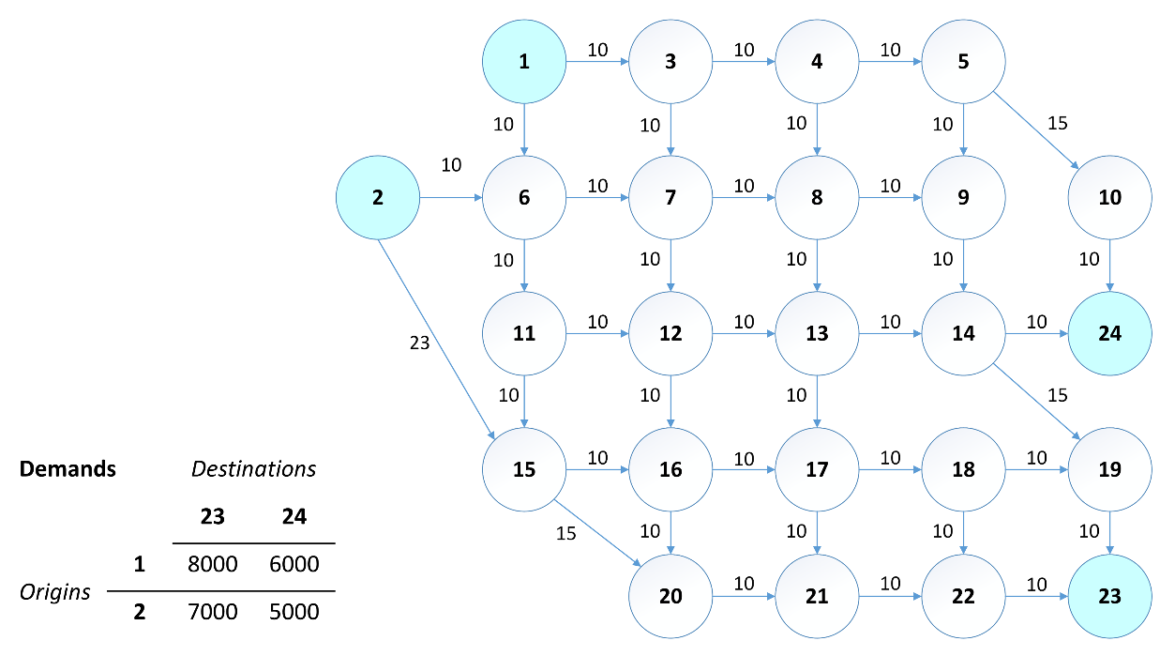
Figure 5. Testing network and the O-D demands

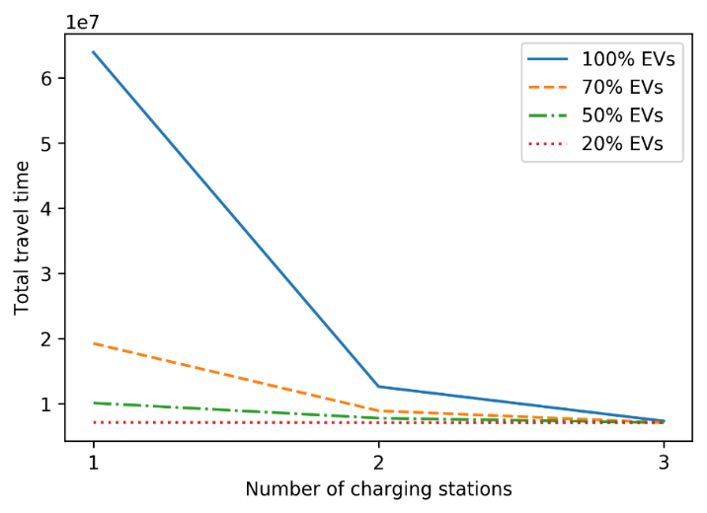
Figure 6. Total travel times and number of charging stations

In this case, we assumed the investment cost per station is $ 500,000 and the value of time is $ 0.3 per minute. The problem are solved with the computational time of 1.81 hours. Table 1 depicts the optimal charging locations and corresponding total system cost at five different level of EVs' penetration - 10%, 30%, 50%, 70%, and 90%.

EVs’ proportion | Number of stations | Location | Total system cost
10% | 1 | 13 | $ 2,640,805.98
30% | 1 | 13 | $ 2,765,255.89
50% | 2 | 13, 16 | $ 3,356,073.88
70% | 3 | 13, 16, 4 | $ 3,658,367.36
90% | 3 | 13, 16, 4 | $ 3,817,747.63
Table 1. The charging locations and total system costs

To illustrate the efficiency and quick convergence of proposed solution algorithm, the shape of sampling distribution with the smallest, median and largest EVs' penetration are shown as in Figure 7, respectively.

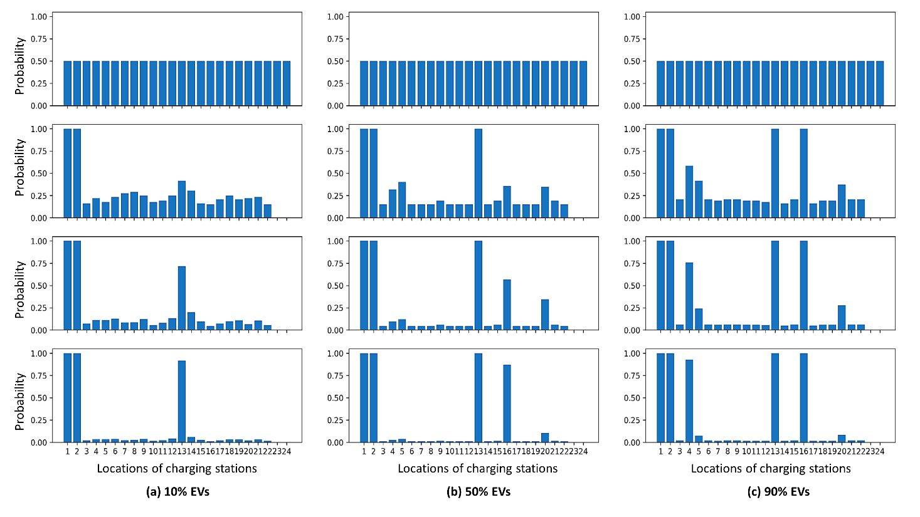
Figure 7. Convergence of charging solutions with different proportions of EVs

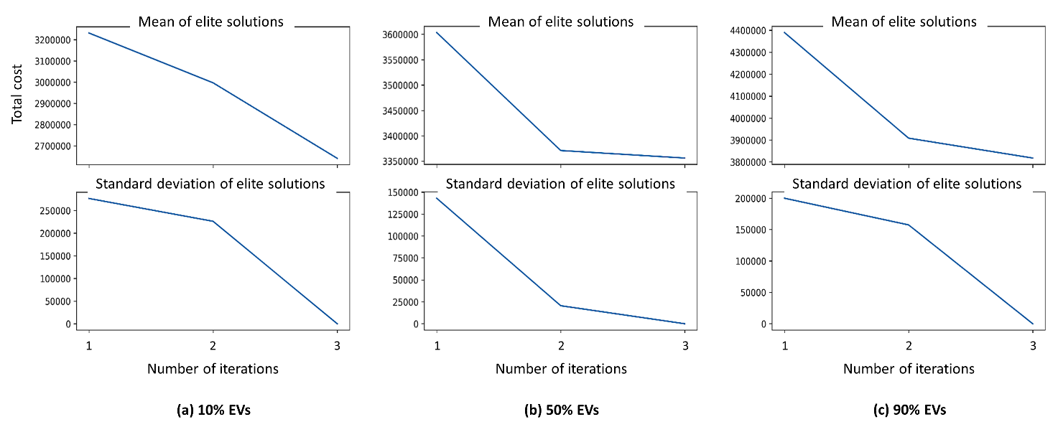
Figure 8. Means and standard deviation of elite solutions over iterations

As can be seen in the Figure 7(a), when EVs' proportion accounts for 10% of the total vehicles in the network, the sampling distribution parameters converges over three iterations and steer the locating solutions to the optimal status at node 13. The mean and standard deviation of best PI values in this case over each iteration are shown in Figure 8(a).

Similar patterns can be seen in the case of median and largest EVs' proportions. In order to ensure the continued exploitation of installed charging stations when the EVs' penetration increasing, the sampling distribution parameters of nodes with charging stations will be assigned to one. It is also noted that the optimal solutions can be obtained without any assumption about the shape of sampling distribution.

CONCLUSION
Although increasing EVs' proportion can bring long-term sustainable development for urban areas, it also may cause more congestion on the transportation network and cost an significant amount of money. Therefore, optimally deployment of the charging stations is significant to minimize the total travel times and reduce the waste due to intensively installation of charging infrastructure. In this paper, we develop a bi-level programme to determine the optimal location of charging stations with the simultaneous considerations of mixed vehicle classes, the installation cost of charging stations, link congestion and route choice behaviours of travellers with multiple recharging. This study also put forward the application of CEM and path-constrained traffic assignment by developing a CEM-based algorithm to solve the charging location problem. The proposed framework has been tested in different size networks and produces the set of optimal locating solution that guarantees the convergences of the solutions over iterations. In the future works, case studies with New Zealand networks may be involved. On the other hand, the model can be improved to capture the uncertain demand and other operational constraints of EVs (i.e. time windows, dwelling time at charging stations).

AUTHOR CONTRIBUTION STATEMENT

Cong Quoc Tran carried out the main research under the supervision of Dong Ngoduy and Mehdi Keyvan-Ekbatani.

REFERENCES
Abudayyeh, D., Ngoduy, D. and Nicholson, A., 2018. Traffic Signal Optimisation in Disrupted Networks with Re-Routing. Transportation Research Procedia, 34, pp.195-202.

Ambarwati, L., Indraistuti, A.K. and Kusumawardhani, P., 2017. Estimating the Value of Time and Its Application. Open Science Journal, 2(2).

Brandstätter, G., Kahr, M. and Leitner, M., 2017. Determining optimal locations for charging stations of electric car-sharing systems under stochastic demand. Transportation Research Part B: Methodological, 104, pp.17-35.

Church, R.L. and Meadows, M.E., 1979. Location modeling utilizing maximum service distance criteria. Geographical Analysis, 11(4), pp.358-373.

Guo, F., Yang, J. and Lu, J., 2018. The battery charging station location problem: Impact of users’ range anxiety and distance convenience. Transportation Research Part E: Logistics and Transportation Review, 114, pp.1-18.

He, F., Yin, Y. and Zhou, J., 2015. Deploying public charging stations for electric vehicles on urban road networks. Transportation Research Part C: Emerging Technologies, 60, pp.227-240.

He, S.Y., Kuo, Y.H. and Wu, D., 2016. Incorporating institutional and spatial factors in the selection of the optimal locations of public electric vehicle charging facilities: A case study of Beijing, China. Transportation Research Part C: Emerging Technologies, 67, pp.131-148.

He, J., Yang, H., Tang, T.Q. and Huang, H.J., 2018. An optimal charging station location model with the consideration of electric vehicle’s driving range. Transportation Research Part C: Emerging Technologies, 86, pp.641-654.

Hodgson, M.J., 1990. A flow‐capturing location‐allocation model. Geographical Analysis, 22(3), pp.270-279.

Hosseini, M., MirHassani, S.A. and Hooshmand, F., 2017. Deviation-flow refueling location problem with capacitated facilities: Model and algorithm. Transportation Research Part D: Transport and Environment, 54, pp.269-281.

Jing, W., Yan, Y., Kim, I. and Sarvi, M., 2016. Electric vehicles: A review of network modelling and future research needs. Advances in Mechanical Engineering, 8(1), p.1687814015627981.

Kim, J.G. and Kuby, M., 2012. The deviation-flow refueling location model for optimizing a network of refueling stations. International journal of hydrogen energy, 37(6), pp.5406-5420.

Kim, J.G. and Kuby, M., 2013. A network transformation heuristic approach for the deviation flow refueling location model. Computers & Operations Research, 40(4), pp.1122-1131.

Kuby, M. and Lim, S., 2005. The flow-refueling location problem for alternative-fuel vehicles. Socio-Economic Planning Sciences, 39(2), pp.125-145.

Li, S. and Huang, Y., 2014. Heuristic approaches for the flow-based set covering problem with deviation paths. Transportation Research Part E: Logistics and Transportation Review, 72, pp.144-158.

Mirchandani, P., Adler, J. and Madsen, O.B., 2014. New logistical issues in using electric vehicle fleets with battery exchange infrastructure. Procedia-Social and Behavioral Sciences, 108, pp.3-14.

Nava, M., 2017. The road ahead for electric vehicles. BBVA Research, pp.1-8.

Ngoduy, D. and Maher, M., 2011. Cross entropy method for a deterministic optimal signalization in an urban network (No. 11-1946).

Ngoduy, D. and Maher, M.J., 2012. Calibration of second order traffic models using continuous cross entropy method. Transportation Research Part C: Emerging Technologies, 24, pp.102-121.

Nozick, L.K., 2001. The fixed charge facility location problem with coverage restrictions. Transportation Research Part E: Logistics and Transportation Review, 37(4), pp.281-296.

Riemann, R., Wang, D.Z. and Busch, F., 2015. Optimal location of wireless charging facilities for electric vehicles: flow-capturing location model with stochastic user equilibrium. Transportation Research Part C: Emerging Technologies, 58, pp.1-12.

Rubinstein, R.Y. and Kroese, D.P., 2004. The cross-entropy method: a unified approach to combinatorial optimization, Monte-Carlo simulation and machine learning. Springer Science & Business Media.

Schroeder, A. and Traber, T., 2012. The economics of fast charging infrastructure for electric vehicles. Energy Policy, 43, pp.136-144.

Upchurch, C., Kuby, M. and Lim, S., 2009. A model for location of capacitated alternative‐fuel stations. Geographical Analysis, 41(1), pp.85-106.

Upchurch, C. and Kuby, M., 2010. Comparing the p-median and flow-refueling models for locating alternative-fuel stations. Journal of Transport Geography, 18(6), pp.750-758.

Wang, Y.W. and Lin, C.C., 2009. Locating road-vehicle refueling stations. Transportation Research Part E: Logistics and Transportation Review, 45(5), pp.821-829.

Wu, F. and Sioshansi, R., 2017. A stochastic flow-capturing model to optimize the location of fast-charging stations with uncertain electric vehicle flows. Transportation Research Part D: Transport and Environment, 53, pp.354-376.

