Field Evaluation of Pavement Quality Indicator as a Replacement for Nuclear Density Meter
Emile van Zyl, Fulton Hogan
Background
The Nuclear Density Meter (NDM) has been used for over 5 decades to assess the density and moisture content of materials including asphalt, modified materials, unbound aggregates and soils. As the NDM uses a radiation source, the regulation of NDM usage has become more stringent; all users of NDMs must be licenced, the management of NDMs is centralised, and personal radiation exposure monitoring has begun. Considering personnel resource shortages a non-nuclear alternative would be greatly beneficial to quality control and project programming. Consequently, non-nuclear density measurement instruments are investigated
The Pavement Quality Indicator (PQI) was developed in the 1990’s, and has been progressively improved since. The principle and operation of the PQI are explained in the paper
The PQI was developed to measure density (& thus voids) in asphalt. Various field evaluation projects across New Zealand with the following objectives:
- Assess the correlation between PQI, NDM and core density/void results on a range of asphalt mixes and layer thicknesses
- Assess whether PQI can fully replace or only complement NDM testing
The research methodology and findings are described in the paper. Main outcome was that the field data confirmed that the PQI can replace the NDM for monitoring compaction in asphalt in the field; the work also yielded some interesting results that no overseas research has found before.
How the PQI works
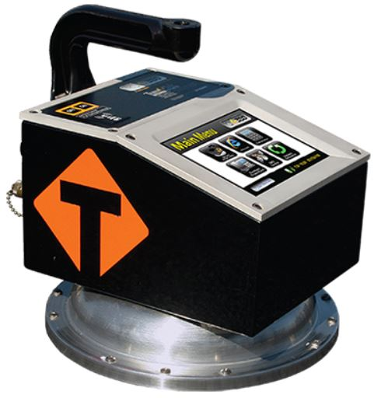
The PQI operation is based on the principle that density of a material (such as asphalt) is directly proportional to the measured dielectric constant of the material.
The PQI consists of a transmitter, isolation ring, a receiver and electronics for converting the signal into a reading. A toroidal-shaped electrical field is generated and transmitted through the material and is picked up by the receiver. The amperage of the received signal is measured and the impedance (resistance to electrical flow) of the material is calculated from V=IZ, where V=voltage, I=amps and Z=impedance. By knowing the electrical impedance of the material, the dielectric constant of the material can be measured.
The dielectric constant of a material is a function of the volume of each component times its individual dielectric constant. Asphalt consists of aggregate, bitumen and air. The dielectric constant of air is 1.0, and of aggregate and bitumen is between 5-6. As the asphalt is compacted, to increase its density, the percentage of air in the mix is reduced and thus a higher dielectric constant is measured for the asphalt. If there is any moisture in the material being measured with the PQI, this makes the measurement more complicated because the dielectric constant of water is 80. Even trace amounts of water can significantly affect the dielectric constant.

