Presentation Title (limited to 10 words)
Visualising Uncertainty: Communicating Coastal Disruption to Transport Networks
Aotearoa is defined by its long coastal edge—home to many communities connected by low-volume roads that are increasingly vulnerable to erosion and inundation. As sea levels rise and land-based flooding intensifies, these communities will face significant change. How do we visualise that uncertainty in a way that informs, empowers, and engages, without technical overwhelm?
Communicating change is challenging but essential. People need to understand what different adaptation pathways mean for them in tangible terms—including access to their homes, livelihoods, and significant places. When dealing with emotive topics - technical reports, charts, and tables often overwhelm rather than inform. When communication is too complex, people disengage—missing the opportunity to meaningfully participate in decisions about their future.
This is where effective visual communication becomes essential. Using clear, approachable graphics can help people understand what it all means for them, enabling participation and reducing fear—giving back a sense of control over the future. It is an artform, striking the balance between realism and imagination, allowing room for uncertainty, but providing a sense of direction.
This poster presents a case study from the CCC Coastal Hazards Adaptation Plan ‘Planning for sea-level rise in Whakaraupō Lyttelton Harbour and Koukourarata Port Levy’, led by the CCC Coastal Hazards Adaptation team. This project involved working alongside the team to translate theoretical scenarios into simple, relatable graphics to support community consultation. The purpose was to show the future intention for Council infrastructure, and what that would mean for how people move around the bay in 30-years time, supporting discussion around reduced service levels, temporary operations, emergency access, and increased use of marine transport.
This poster makes a call to ‘value the visual’ and invites reflection on:
How can we more effectively use visual communication to support conversations with coastal communities facing uncertain futures?

Preference for a poster format.
Example of content. PTO
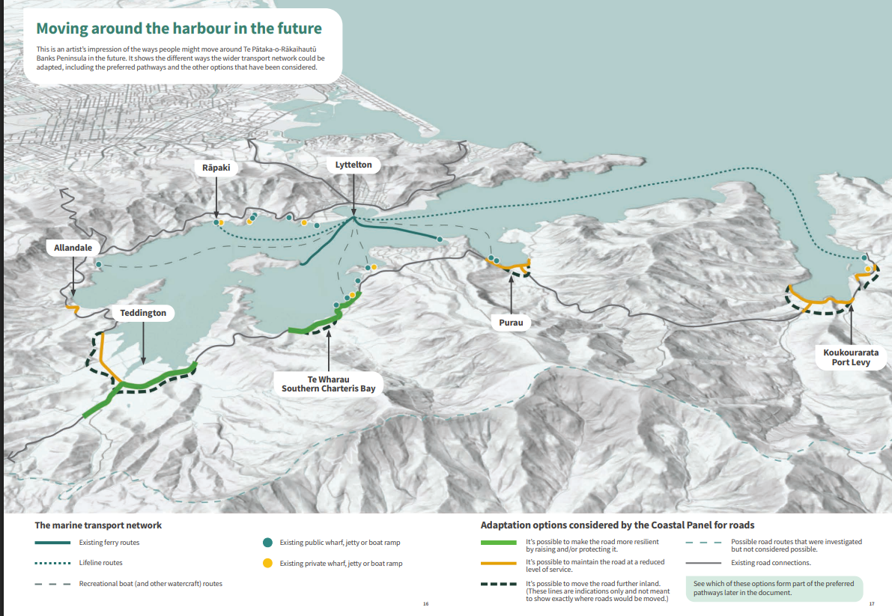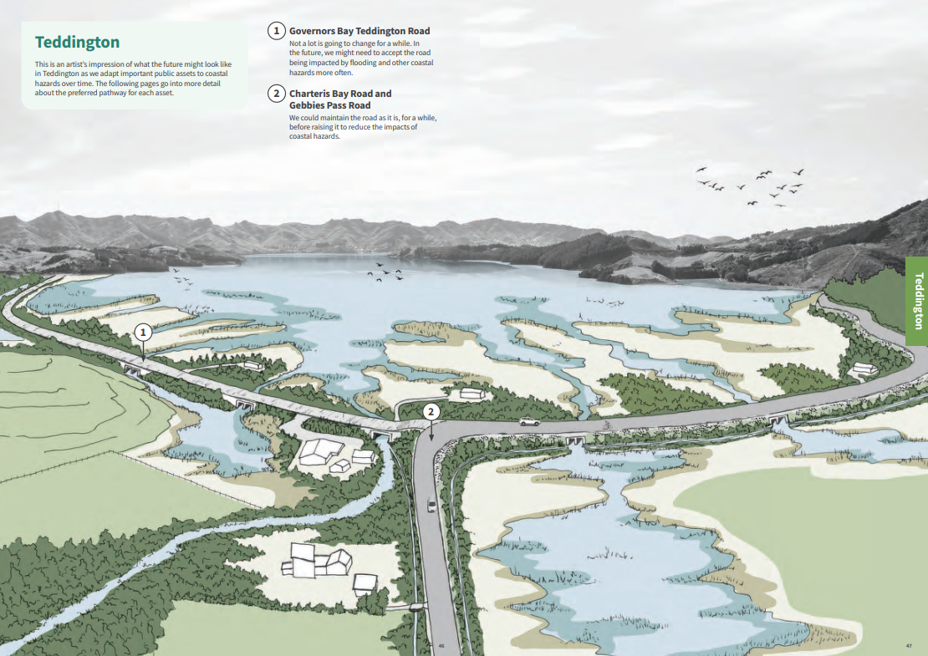
https://ccc.govt.nz/assets/Documents/Environment/Coast/CHA/CHAP-Whakaraupo-Lyttelton-Harbour-and-Koukourarata-Port-Levy-2025.pdf

