PLANNING EV CHARGING – KEY CONCEPTS AND PRACTICE

(This paper has been peer reviewed)

Authors
Dr Elliot Fishman

Dr Fishman works at the Institute for Sensible Transport.

Institute for Sensible Transport
202/26-30 Rokeby Street, Collingwood, Melbourne, VIC Australia 3066
info@sensibletransport.org.au

Presenter: Dr Elliot Fishman

ABSTRACT
Electric vehicle sales have been growing in NZ, but still lag behind many other OECD countries. The development of charging infrastructure in metropolitan and regional areas is critical to achieving a reduction in transport emissions. This presentation outlines the different types of charging infrastructure, how to decide which speed of charger is most appropriate in different contexts, and the role of government in the expansion of charging opportunities.
The second half of the presentation will describe the facilitator role that local government can adopt to ensure the growth of charging opportunities, at least cost to Council. The economics of EV charging will also be described, as well as methods of forecasting demand for charging. Finally, emerging trends in EV charging will be explored and how government are able to capitalise on these. Following the presentation, the audience will understand:
- Different types of charging infrastructure, from slow, overnight chargers, through to ultra-fast chargers that can complete a charge cycle in as little as 15 minutes
- How to select the right speed of charger in different contexts
- What makes a good site for an EV charging station
- The most effective role for government in the development of future charging sites
- Methods of forecasting demand
- The economics of EV charging.

INTRODUCTION
Electric vehicle sales have been growing in NZ, but still lag behind many other OECD countries. The development of charging infrastructure in metropolitan and regional areas is critical to achieving a reduction in transport emissions. The 2023 National electric vehicle charging strategy for Aotearoa New Zealand (New Zealand Government, 2023) seeks to have the charging infrastructure to support 30% of the fleet to be electric by 2035. This would be the fastest transition of any nation on Earth, given that EV penetration in the existing fleet is approximately 2% today, according to EVDB (2025), an online EV database. Ensuring a suitable number of chargers, at the right speeds, in the right places will become essential for NZ to achieve its ambitious EV transition targets.

Charging Our Future: National electric vehicle charging strategy for Aotearoa New Zealand 2023-2035
This Strategy (New Zealand Government, 2023), describes Aotearoa New Zealand’s long-term vision and strategic plan for EV charging infrastructure, which is captured below:
Aotearoa New Zealand’s EV charging infrastructure supports an equitable transition to a low-emissions transport system in which accessible, affordable, secure and reliable charging infrastructure is available to everyone who needs it.
Content in the Strategy directly related to EV charging network planning is summarised below:
- ‘Journey charging hubs’ to be situated every 150 – 200km on main highways by 2028. These hubs are intended to offer multiple high speed chargers and are envisioned to be similar to petrol stations, but with a focus on EV charging.
- Develop 600 charging stations in rural locations by 2028
- Conduct targeted engagement with Māori communities regarding new EV charging stations
- Funding to support EV charging in rural and remote communities
- A consistent, national approach to standardisation of EV charging infrastructure, to improve the customer experience and enhance data sharing capabilities
- Lower barriers to the development of a vibrant commercial EV charging sector, including electricity network issues
- Support the development of an EV charging network designed to enable heavy EVs to use chargers. This may influence bay configuration and power output of chargers.
More recently, the New Zealand Coaition government have committed to build a network of up to ~10,000 public EV chargers by 2030 and released a Supercharging Electric Vehicle Infrastructure Work Programme, which identifies the need to install chargers at a much faster rate than the past, to meet forecast demand.

What is an electric vehicle?
There are several distinct categories of EVs, and it is important to identify the main types, as shown in Figure 1. The following provides a brief description of each of the vehicle categories listed in Figure 1.
- Conventional vehicle – also referred to as an Internal Combustion Engine (ICE) vehicle, is the standard vehicle type widely known and used since the invention of the motor vehicle. It is not an EV.
- Hybrid vehicle – a vehicle that uses petrol/diesel as its only fuel source and also has an electric motor and battery that can store energy from regenerative braking. A Toyota Prius is a common example of a hybrid vehicle.
- Plug-in Hybrid Electric Vehicles (PHEV) - combines a mixture of fuel combustion and electricity. It is like the hybrid vehicle described above; however, it can take electricity from a socket and can store this in a battery. A Mitsubishi Outlander is an example of a model available as a PHEV.
- Battery Electric Vehicles (BEV), or All-Electric, take electricity from a socket and rely entirely on the electricity stored in an on-board battery for propulsion. A Tesla Model Y and a BYD ATTO 3 are two popular models of BEV.

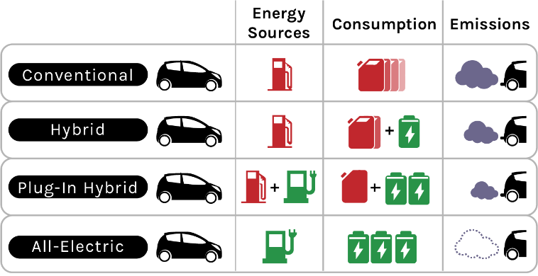
Figure 1 Different types of consumption and electric vehicles
Source: Institute for Sensible Transport (2022)

UNDERSTANDING DIFFERENT TYPES OF EV CHARGING INFRASTRUCTURE
The number of chargers and the speed with which a battery can be charged has improved significantly over recent years. Table 1 provides a snapshot of different charging types. One critically important observation from EV owners regarding their charging habits is that over 90% of charging happens at home, or work. This is the case for people who have off-street parking at their home or workplace which has access to an electrical outlet. However, not all people have the ability to charge at home. This has implications for the selection of appropriate sites for charging infrastructure, and the speed of charger selected. It also has particularly important implications for older residential areas of larger cities in NZ, as some of the housing stock will not have easy access to at home charging.
Vehicle manufacturers are continuing to upgrade their cars to accept high-capacity chargers. What this means from a usability perspective is that in the medium term an EV will be able to be fully charged in as little as 15 minutes. However, only a few vehicles will support such high-speed charging, and doing so is costly due to battery optimisation trade-offs.
A key point is that while high powered ultra-fast chargers are exceptionally useful when EV users are only looking to gain a large increase in range within a short period of time, in inner city areas, this will not be a large proportion of the market. The most efficient place to charge an EV is when it is going to be stationary for long periods (overnight and at work), or during dwell times of ~1 – 2 hours. This approach is much more cost effective, resulting in a larger number of charging opportunities for the same quantum of investment. To put this in perspective, an ultra-fast charger (e.g. 350kW) can cost up to NZ$ 800,000, depending on the electricity network upgrade costs.
Table 1 EV charging types
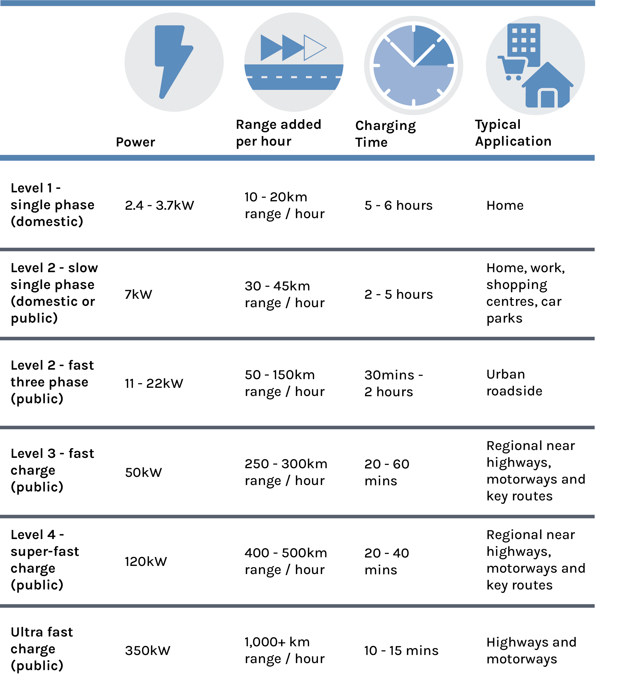
Source: Institute for Sensible Transport (2022)

SEGMENTING THE EV CHARGING USER
It can be helpful to consider the different elements of the EV charging market. These can be broadly classified into three different types, as highlighted in Figure 2.
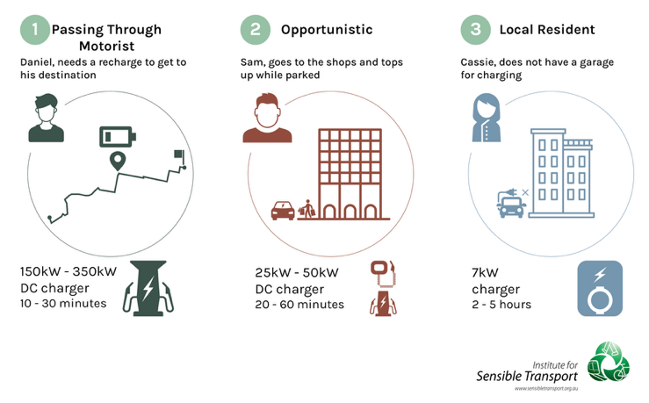
Figure 2 Three types of chargers
Source: Institute for Sensible Transport (2022)
A passing through motorist is someone who has a long distance to travel and is seeking a charging solution that minimises their delay. The preference for these users will be high speed charging and they are generally willing to pay a higher unit cost for electricity, in order to minimise their delay. These chargers will generally be most suitably located close to high volume roads and motorways, supporting longer distance EV traffic. Figure 3 offers an example of a charging station supporting the passing through motorist. It is becoming increasingly important for these stations to be sized to accommodate a larger number of EVs charging simultaneously, as EV numbers increase.
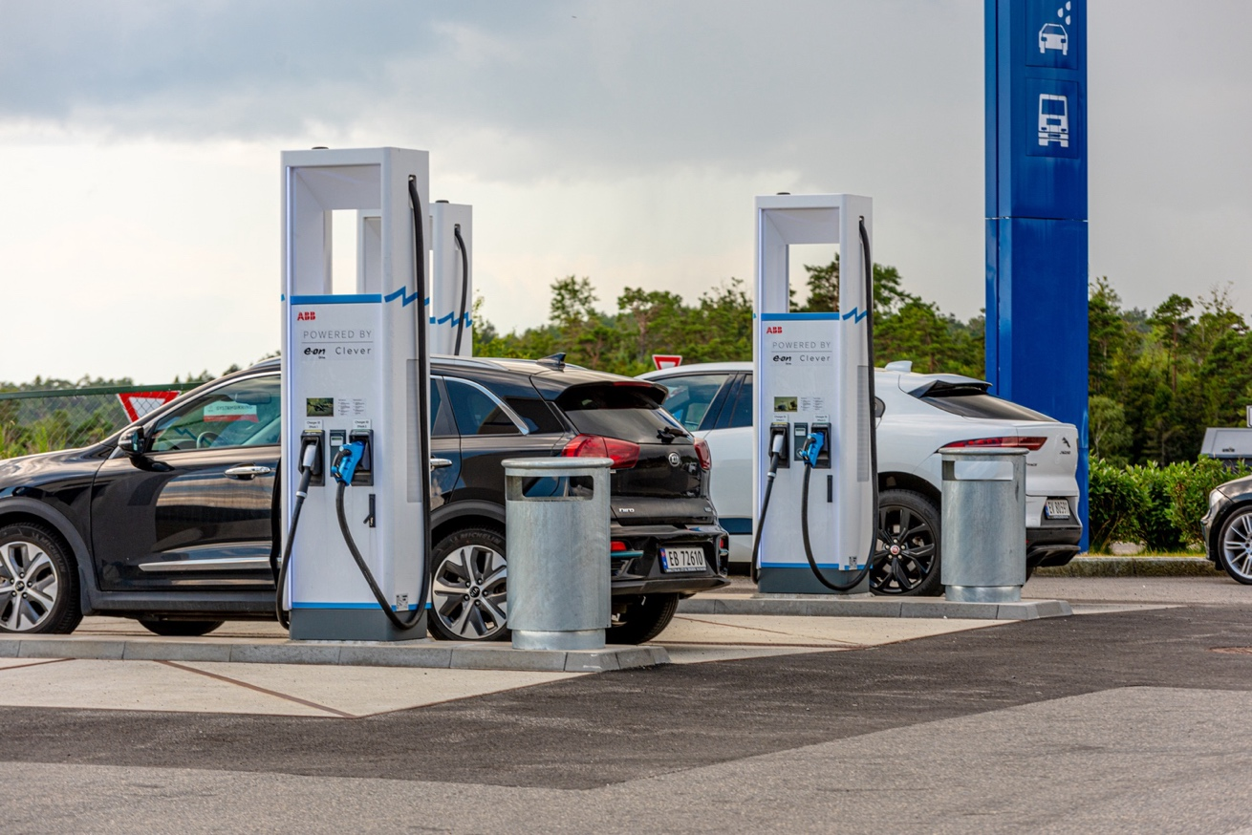
Figure 3 Passing through motorist charging station
The opportunistic charger is someone that was visiting the location anyway. The EV owner takes the opportunity to charge while visiting an area/business (e.g. Figure 4) or vice versa. The charger only needs to be fast enough to provide an adequate amount of electricity within the typical duration of stay for the area in which the charger is located. This is considered to be a significant portion of the market in the inner cities of larger settlements in NZ. The goal for opportunistic charging is gaining the charge required while the owner does something else (e.g. visiting shops, museum, park, restaurant/café).

Figure 4 Opportunistic EV charging
A local resident, without off street parking, will generally require convenient access to either a 50 – 75kW charger at an activity centre (e.g. shopping centre), or a kerbside AC charger (see Figure 5). Slow (AC) chargers can offer a convenient charging opportunity, as the vehicle can fully charge overnight or throughout the day.
Figure 5 provides an example of one of the pole mounted EV chargers that are being installed across the Greater Sydney area.

Figure 5 Pole mounted EV charging
Figure 6 offers a conceptual illustration of the EV charging ecosystem, showing suitable locations for different types of chargers. This is primarily a function of the typical duration of stay for different land uses. The legend, on the right hand side of Figure 6 indicates the speed of charger.

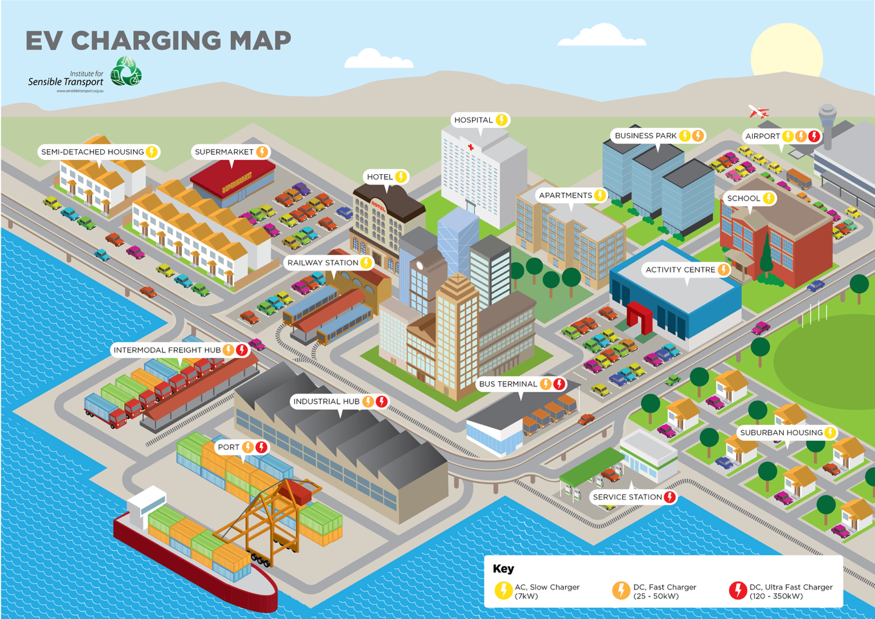
Figure 6 Understanding the EV charging ecosystem
Source: Institute for Sensible Transport (2022)

Plug types
In the past, EV owners had to contend with a multitude of plug types. This is no longer the case and the industry has conformed to a standard AC charger plug and 98% of DC charging has a uniform plug type. These types are shown in Figure 7. The CHAdeMO plug type is only for DC charging but only a handful of EVs use this plug type for fast charging. Early dual-port EV charging stations provided one CCS plug and one CHAdeMO plug. Installing the more widely adopted CCS plug for both ports is likely to yield higher usage. It is understood many older EVs from Japan are imported into NZ and these EVs will generally have a CHAdeMO plug. It is recommended that where a station with four or more charging bays is installed, one should be CHAdeMO with the other three CCS2.
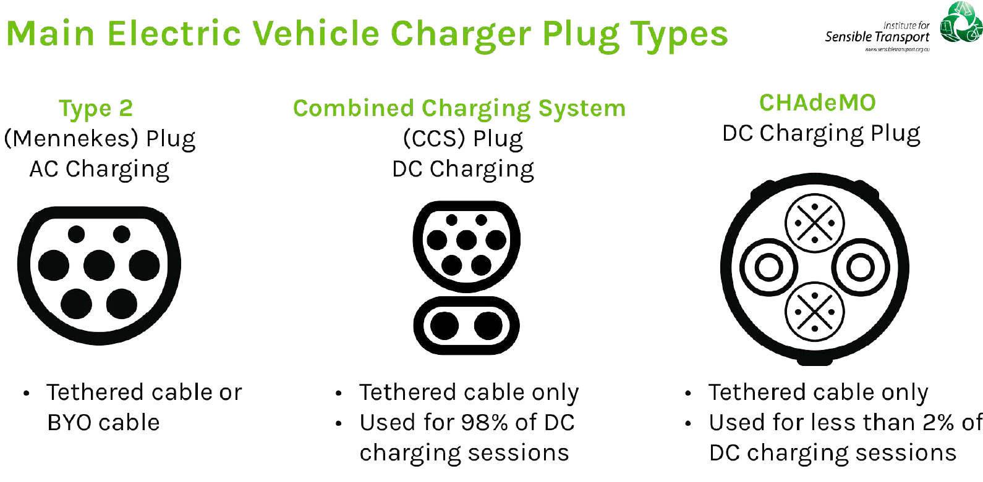
Figure 7 Main EV plug types
Source: Institute for Sensible Transport (2025b)

THE ROLE OF GOVERNMENT IN THE DEVELOPMENT OF FUTURE CHARGING SITES
Ten or more years ago, when EV adoption was in its infancy, it was necessary for government to play a crucial role in the funding of EV charging infrastructure. The take up rates for EVs have grown considerably in the past five years in particular and this has resulted in a stronger business case for the commercial sector to become involved in EV charging projects. ChargeNet is the largest commercial charge point operator, with over 520 fast chargers.
There are a number of positions government can take to accelerate the implementation of an EV charging network, with full ownership and operation at one end of the spectrum, and a lighter, facilitator-only role at the other end. This section offers considerations to assist government in determining the appropriate level of involvement they wish in the EV charging network.
Figure 8 provides a summary of the three key areas of responsibility associated with EV charging. For each of funding, ownership and operation, AC (slow) and DC (fast) charging have been separated, as the way in which different agencies or businesses choose to approach them differ markedly. The key reason for this related to the different capital expenditure and revenue potential. In general, AC charging is cheaper to install but delivers less revenue, whereas DC charging can be very expensive but typically delivers much higher revenue. CPO in Figure 8 refers to Charge Point Operator.

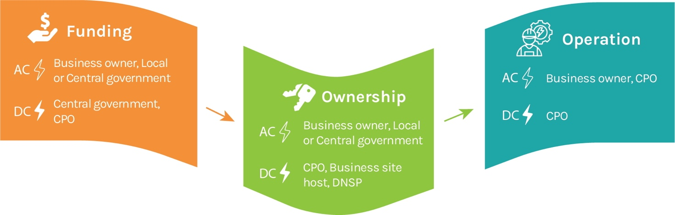
Figure 8 Different roles within the EV charging market
Source: Institute for Sensible Transport (2025a)

Local government
Local government typically have constrained finances and are limited in the capital available to fund large scale, high powered charging networks. They are however the responsible authority for many car parks (both on and off street) and this places them in a powerful position to act as an facilitator to grow charging opportunities. Thus, rather than investing scarce resources in funding chargers, their most effective role will often be using planning tools to identify areas in which demand for chargers is likely to be high, and then working with the private sector through a Request for Quotation.

Central government
Central governments play an important role in creating the overarching strategy or blueprint for EV charging. Creating a funding program and guidelines is also critical. This can help act as a catalyst for the commercial sector, helping to make sites commercially attractive. Funding programs will need to differentiate between the three different types of chargers described earlier (passing through motorist, opportunistic and slow charging for the local resident lacking suitable charging at home). When central government provides funding packages, they are in a stronger position to ensure that the chargers that are installed meet certain usability requirements. This can include all abilities access, drive through bays for long vehicles and or trailers, charging speed and plug type/s.
Ultimately, given the trends in EV ownership, the role of government as a funder may reduce over time. However, it is likely chargers in less built up areas will continue to require significant government support. This is due to the fact that establishment costs may be higher, as the electricity supply may need extensive upgrades (for high speed chargers) and the expected daily use is likely to be much lower than in more built up areas. Maintenance can also be more expensive, as travel time for servicing staff can be much higher.

FORECASTING DEMAND FOR EV CHARGING
Forecasting demand for EV charging is important because offering too few chargers can restrict EV uptake and lead to frustrating experiences (e.g. queuing). Providing far too many chargers will result in higher expenditure than necessary and risks CPO bankruptcy and stranded assets.
Forecasting charging demand requires a nuanced approach sensitive to local area characteristics. In general, charging demand models calibrated to the same three charging categories shown in Figure 2 can be helpful. This helps to ensure that different metrics are used to estimate demand for different types of chargers. For example, slow, overnight charging will need to use built form and residential population data as part of their model. Areas with high rates of terrace houses for example may require low, AC, kerbside chargers. A new suburban, in which all homes have driveways, will be unlikely to require this type of charging infrastructure, as it will always be cheaper and more convenient to charge at home.

Factors to consider
The following factors can be useful to consider when forecasting EV charging requirements (Institute for Sensible Transport, 2022; 2025a):
- Car ownership
- Population growth
- Forecast EV ownership (e.g. 8.5% EV by 2030 etc)
- Road traffic volumes.
- An example of future EV uptake, for a local government area in an Australasian city, is shown in Figure 9. This uses three different projected EV uptake scenarios and shows the number of EV compared to non-EVs.

Figure 9 EV Fleet projections to 2035
Source: Institute for Sensible Transport (2025a)

Quantifying the number of chargers required
A simplified process for determining the number of chargers required is offered in Figure 10.

Figure 10 Steps in determining future EV charging demand
Source: Institute for Sensible Transport (2025b)
The detail on the above steps will be discussed during the Round Table presentation. Ultimately, the process enables government agencies to gain an understanding of the quantum of chargers that may be required, and the mix of charger types (e.g. fast, slow etc). It can also account for the fact that for some suburbs, the bulk of EVs will be charged in the private domain (i.e. homes) and not require public charging. An example of the outputs, drawn from a previous demand forecast, can be seen in Table 2 and Figure 11.

Table 2 Number of ports required and charger types
Charger type | 2030 ports | 2035 ports
Kerbside (11kW) | 50 | 194
Destination (75kW) | 54 | 86
Source: Institute for Sensible Transport (2025a)

Figure 11 Projected EV charging energy demand on and off the public network, in kWh, by year
Source: Institute for Sensible Transport (2025a)

THE ECONOMICS OF EV CHARGING
An understanding of the economics of EV charging is essential for the development of a business case. The economics of EV charging can be broken down into capital expenditure, operational expenditure and revenue. Capital expenditure includes the charging hardware itself, as well as electricity upgrades and civil works around the parking facility itself (e.g. making it all abilities access and landscaping). Operational expenditure includes cost factors such as electricity connection fee (annual charge), communications and billing, as well as insurance and maintenance. The cost of electricity is also an operational expensive but unlike the other operational costs, is highly variable, based on demand. Revenue is simply the amount of money generated via the user fees. It is an industry standard (and generally a customer expectation) that the faster the charging speed, the higher the cost per unit of electricity. Most business cases would assume a lifespan of around 7 years for the charger.
It is important to recognise that there is considerable variability in the cost to install a charger. This is especially true for DC chargers, where electricity upgrade costs can be very high. Each site needs to be assessed individually, and it is quite common for sites to be excluded because their electricity upgrade costs are prohibitive.
While it is understandable to focus attention on sites in which the return on investment is high, it is also important to recognise that there may be some sites that do not stack up economically but are still suitable sites. In particular, there may be locations required from a coverage perspective, even if there level of use is not particularly high. Remote sites are very often not economically viable, but essential for giving the general population confidence that if they were to transition to an EV, they would be able to use the vehicle to travel to locations well outside of cities and townships.
Finally, while DC chargers are almost always considerably more expensive than AC chargers to install, in the main, their return on investment is usually stronger, as more electricity can be sold.

CONCLUSION
This paper has sought to provide an introduction to EV charging and the methods through which public sector agencies are able to plan future EV charging networks. The type of EV charging suitable in different locations depends on the expected needs of the user. At times, a very fast charging outcome will be required, while the same person, at another time, may find a slow charger to be adequate. While most charging will occur at home, a network of public chargers is essential for the EV transition; either for those lacking the ability to charge at home, or for EVs that are well outside their residential area.
This paper has also found that fast charging is not better than slow charging. Ultimately an efficient charging plan seeks to match charging speed with the typical duration of stay at different land uses. A car expected to be parked for 6 hours will not benefit from an ultra-fast charger and will generally find a slow, AC charger to be more suitable.
Government’s role in EV charging depends on the level of government. Central government helps set the strategic goals and funding, while local government, as manager of many parking assets in local communities, will typically play a facilitator role. Charge Point Operators typically work with government and help fund chargers and manage their operation.
Finally, this paper has found that the economics of charging can be variable, depending on a range of factors, such as location of charger, its speed and the forecast demand. While the return on investment is generally improving, there will always be important sites (typically in remote areas) that require a charger for coverage reasons, even if the costs are higher than the revenue. Achieving coverage is important for the widespread adoption of EVs, which is critical for NZ achieving a more resilient transport system.

AUTHOR CONTRIBUTION STATEMENT
Dr Elliot Fishman prepared this paper.

REFERENCES
Institute for Sensible Transport, 2022 Community Electric vehicle Transition Plan: Part A, Prepared for the Northern Councils Alliance, Melbourne, Australia. See https://127565f4-942e-40ae-898c-a7ac79af3f41.filesusr.com/ugd/fa14f0_edcc93e3d0364904b4140681b622c60a.pdf

Institute for Sensible Transport, 2025a Electric Vehicle Charging Implementation Plan, Prepared for the City of Yarra, Richmond, Melbourne.
Institute for Sensible Transport, 2025b Regional Charging Framework, Prepared for the Central Victorian Greenhouse Alliance, Castlemaine, Victoria. See https://sensibletransport.org.au/wp-content/uploads/2026/01/regional_charging_framework_cvga_ist_v4_24062024_redacted.pdf

Ministry of Transport, 2024, Supercharging Electric Vehicle Infrastructure Work Programme, Cabinet Paper. See https://www.transport.govt.nz/assets/Uploads/Supercharging-Electric-Vehicle-Infrastructure-Cabinet-paper-Redacted.pdf

New Zealand Government, 2023 Charging Our Future: National electric vehicle charging strategy for Aotearoa New Zealand 2023 – 2035. See https://www.transport.govt.nz/assets/Uploads/EV-Charging-Strategy.pdf

https://www.transport.govt.nz/assets/Uploads/Supercharging-Electric-Vehicle-Infrastructure-Cabinet-paper-Redacted.pdf

