Milldale

A transport engineering best practice testing ground

Think Piece

(This paper has been peer reviewed)

Author:

Tim Rickards

Principal Civil Engineer, Wood & Partners Consultants Ltd

BEngTech, MEngNZ, CPENG

ABSTRACT

Milldale is a large development at the northern edge of Auckland consisting of approximately 4500 new homes with a mix of densities from standalone through to terraced and apartment buildings. It includes a new school, a retirement village, a town centre with a supermarket and medical centre as well as a range of recreational spaces. Milldale will become a new suburb of Auckland.

At the previous transportation group conference in Tauranga, Bridget Carden and Clare Cassidy (Abley) presented a paper questioning why new developments continue to result in poor design outcomes for active transport. The presentation provided context to the successes at Milldale, and the importance of sharing these success stories.

There is always pressure from the developers to enable car use. They are in the business of selling properties, and their customers are expecting to be able to drive as a primary mode of transport, enabling active modes is seen as being in conflict with this goal. There is also a need for developers to be profitable, and providing for active modes can be seen as adding additional cost.
The Milldale developer and designers have worked closely with Auckland Transport on the design of Milldale and have been able to produce a development which enables and encourages active modes while not overly compromising the ability for residents to use their cars. The majority of Milldale streets are low speed (30 km/h) and larger, higher speed roads have dedicated walking and cycling facilities. The scale of Milldale has allowed designers to utilise best practice to enable active modes and witness the positive effects of this approach.

This paper seeks to share the design journey that has resulted in good outcomes for the Milldale development and hopefully show that not all new developments produce poor active mode outcomes.

1.0 Introduction

1.1 - Milldale
Milldale is one of the largest greenfield development currently under construction in the country and covers an area of approximately 300ha of green field land.

The development is located at the northern edge of the Auckland metropolitan area, directly west of Orewa and the Millwater development. It sits adjacent to the Northern motorway between Silverdale and the Orewa river.

Milldale will provide approximately 4500 new homes with a mix of densities from standalone through to terraced and apartment buildings. It also includes a new school, a retirement village, a town centre with a supermarket, medical centre and various smaller shops, as well as a range of recreational spaces. Once complete it will be a new suburb of Auckland.

1.2 - Woods involvement
Wood & Partners Consultants Ltd (Woods) are engaged as the Civil Engineers, Planners, Surveyors and Urban designers for the project. We have been involved from the master planning / plan change stage (through the Auckland Unitary Plan process), through to the current construction of stage’s P6 & 7.

Woods work with the developer’s construction managers to take each stage through the resource consent process, then undertake the detailed design and EPA approvals, before managing the tender and construction phases of the works and vesting of the final assets to council.

The high level of control over the projects from start to finish provides Woods significant influence over the development outcomes, including the transport.

1.3 - Setting up for success – Designing for People think piece
At the previous transport conference in Tauranga (2023) Bridget Carden and Clare Cassidy (Abley) presented the paper “SETTING UP FOR SUCCESS – DESIGNING FOR PEOPLE THINK PIECE” (CASSIDY, CARDEN, and FLEMING, 2023).

This paper discusses the disconnect between the accepted best practice at a national guidance level and the development outcomes being observed, and recommended some key elements to help bridge these gaps, these included:
- Moving away from minimum requirements culture.
- Embedding best practice.
- Planning for consistency of service.
- Individuals promoting better outcomes.

Milldale has been able to overcome these challenges to deliver strong outcomes for walking and cycling.

The scale of the project has meant that Auckland Transport (AT) have pushed for best practice design, and the project has continued to lift the standard often ahead of the AT Transport Design Manual. The size of the project has meant that it can set its own consistency of service, constructing both the start and end point of journeys and designing for everything in between. Finally key personnel involved in the project have embraced the need to design for walking and cycling as a priority, and this has provided the leadership required to achieve good outcomes.

1.4 - Transport engineering best practice testing ground
Throughout the development of Milldale, AT have pushed for the latest best practice to be adopted on the project. This has led to the design standard changing as the project has progressed. An example of this is with the cycle lanes, with Milldale stage 1 having a quite different approach than what is being now being constructed in the latest stages.

The proposed best practice has often been ahead of it becoming the design standard for the wider industry, this has meant that the Milldale Development is often in a situation of working out the best way to design and construct new features to suit the best practice concepts. Once constructed, features are assessed and tweaked for the next stage to continuously improve the outcomes.

2.0 Milldale Design Journey
2.1 - Millwater
The Milldale design journey starts on the other side of the motorway at Millwater. Woods had a similar role at Millwater, with an associated developer. But there are significant design differences between the two developments.

Millwater, while catering to pedestrians and cyclists with accessways and shared paths, is very car-focused. Carriageways are 7m wide, with no traffic calming or dedicated crossing facilities. The design speed for the development is 50km/h and vehicles are driven accordingly. Millwater is still a pleasant suburb to walk around, but it falls short of what is now being produced at Milldale.

2.2 - Shifting best practice
The early stages of Milldale focused on significantly reducing the lane widths to control speed. Local roads had a carriageway width of 5.6m which feels very tight compared to the adjoining Millwater carriageways. The roads also utilised in-lane parking as a means of creating one-way sections of road to further calm traffic.

The collector roads included on-road cycle lanes with a painted buffer strip to separate them from the vehicle lanes. The footpath widths were also increased from the standard 1.8m in Millwater.

Later stages started to add raised tables and speed bumps instead of the in-lane parking as the primary means of traffic calming.

In stage 3 the decision was made to move the cycle lanes off the road. The timing of this decision was critical as it meant that the main “arterial” road through Milldale, Argent Lane, has separated cycle lanes.

Stage 3 also has the first inclusion of mini-roundabouts at four-way intersections on local roads.

During the later stages of Milldale the road design standards have settled, and strong design outcomes are being achieved.

2.3 - A drive for improvement
Each of these changes has had to be negotiated between the developer, Woods as the consultant, and Auckland Transport.

Auckland Transport have been relentless in their drive for strong transport outcomes, this drive was needed to shift the conversation from “But we have always done it this way” to “What’s the best way to deliver on these requirements/ goals”. AT brought the vision and Woods, the developer, and the civil contractors continue to deliver on that vision.

This change in thinking happened through the design of stages 1 to 3 of the development, and since then all three parties have been aligned in improving and implementing the best practice measures. This alignment has seen significant progress on delivering safe, efficient roads for everyone to use.

2.4 - Measuring success

Now that residents are moving into the later stages of Milldale the benefits of the design can be observed in practice, rather than just theory.

People can be seen walking around the completed stages of the development for recreation, as well as connecting to the new bus network to transfer to Silverdale and onwards to the city.

Students at the new primary school are riding unaccompanied to school each day using the low-speed local streets, off-road cycleway networks and safe crossing points.

Packs of retiree cyclists are making Milldale a destination for their rides, often breaking into the yet to be completed stages to try out the new facilities with their e-bikes.

The posted speed for the roads in the development is 50km/h, but the design of the road environment means that drivers naturally travel at 30km/h on the local roads, and only slightly faster on the collector and arterial roads.

As future stages are developed, including the main town centre for the development, the benefits will continue to be realised.

3.0 Some Best Practice Items
3.1 - Cycling and pedestrian network
Milldale has an extensive Cycling and pedestrian network.
Footpaths are present on both sides of each road and separated cycle facilities are provided on all collector and arterial roads. The speed control on local roads is effective to the point that these can also be considered part of the cycle network.

In addition to this Milldale has incorporated stream-edge recreational paths. These are shared paths that follow the retained watercourses in the development. They are intended as recreational routes rather than commuter routes and provide an enjoyable leisure opportunity to users.

Below is an image of the cycle network. To date over 10km of facilities have been constructed at Milldale. By the end of the project, it is expected that over 25km will have been built.
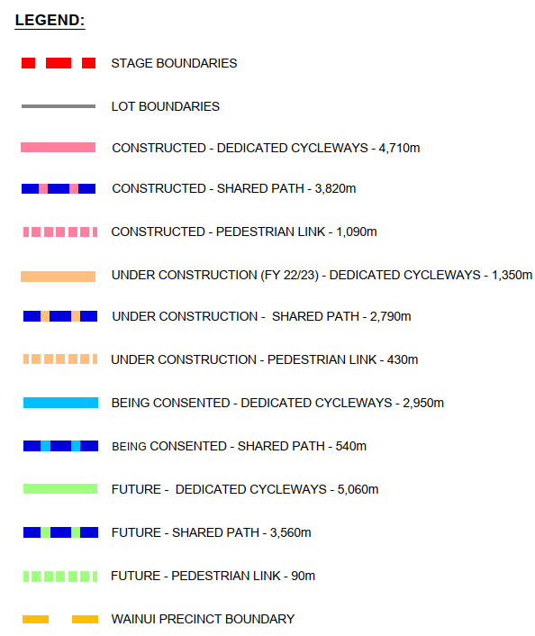
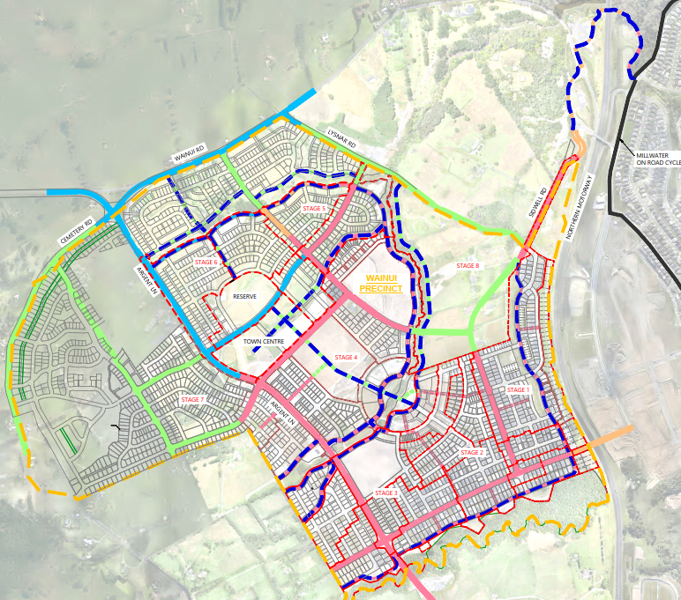
Figure 1: Milldale Cycle Network

Once complete it is intended that Milldale will have one of the most comprehensive cycle networks of any suburb in the country, and will be seen not only as a great place to live and ride a bike, but also as a destination for people from other suburbs to come to for recreation.

The design of the cycle network facilities has developed over time, starting with on-road lanes with painted buffer protection in stages 1 & 2 and changing to fully separated in later stages.

The design of the off-road lanes has also varied, originally using either planted or grassed berms to separate the concrete cycle lane from the footpath. The design has now settled on using a mountable nib kerb or grey tactiles to separate the two facilities. This provides a more efficient build, with limited ongoing maintenance requirements for council once the facilities are vested.
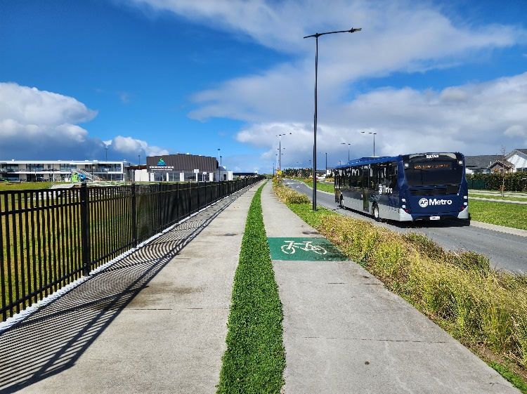
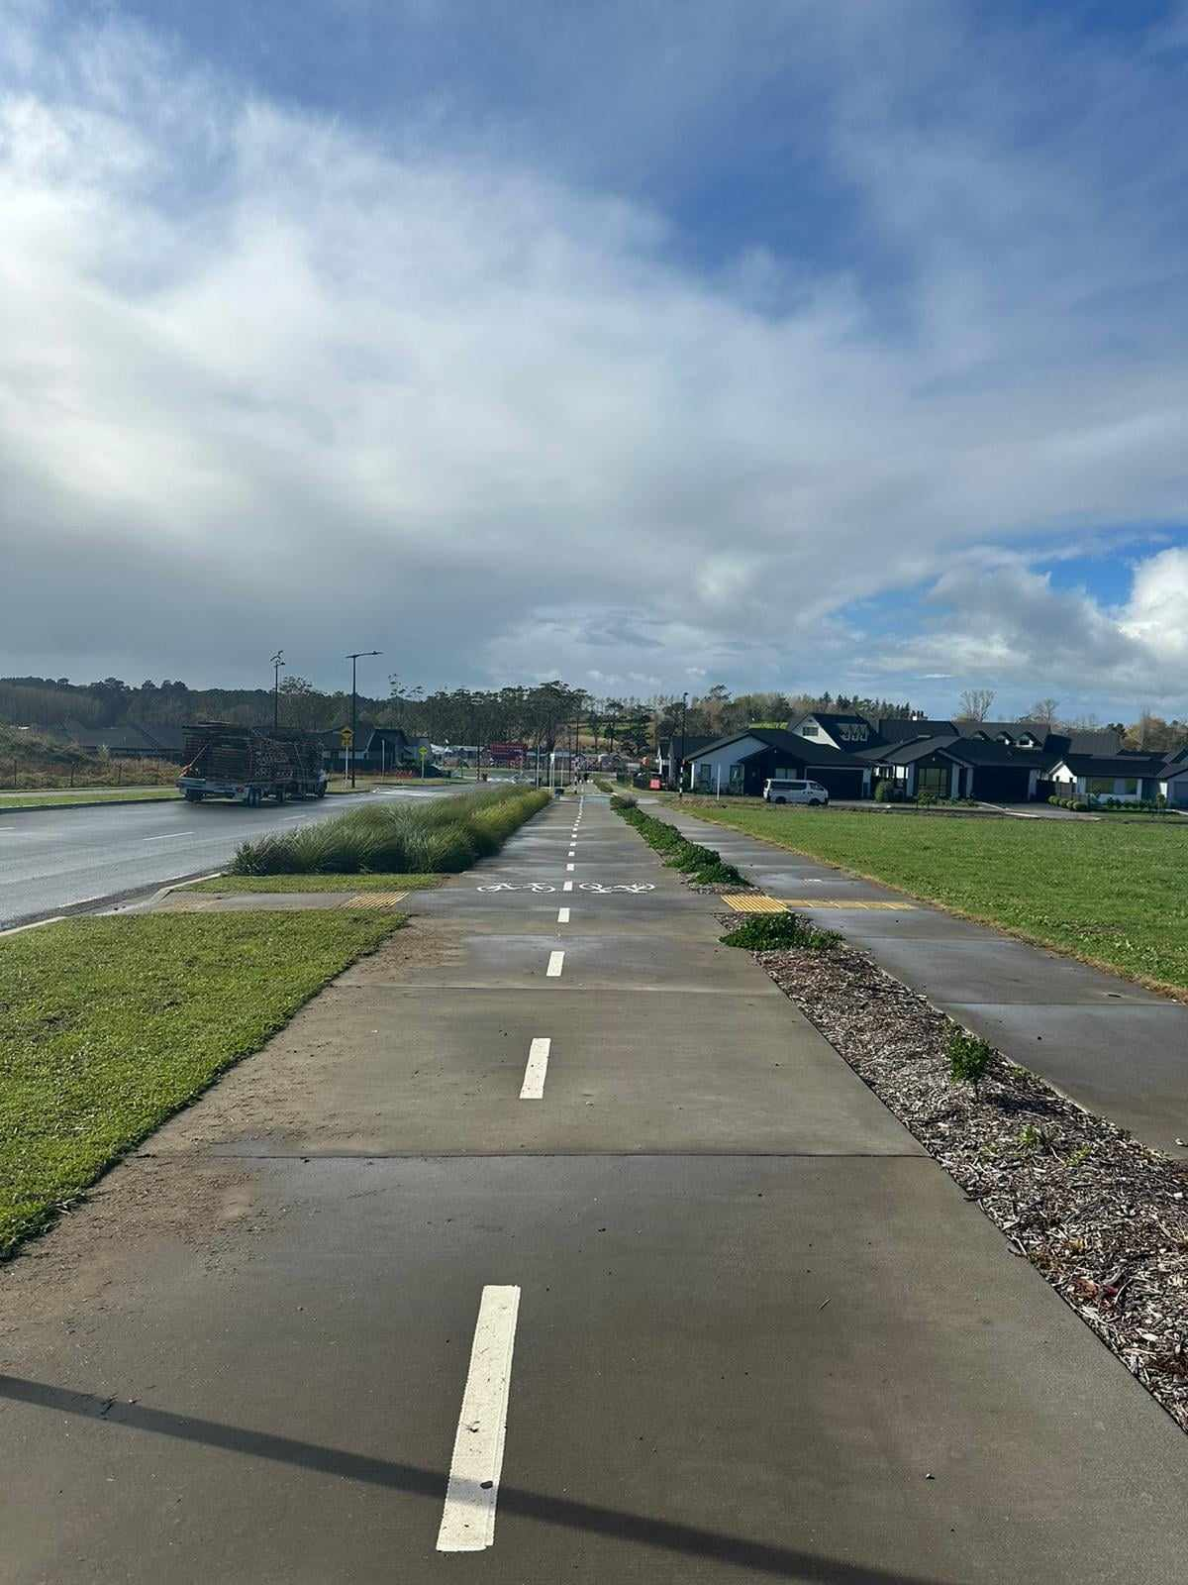
Figure 2: Photos of Milldale’s offroad cycleways

Finally, some key links out of the development have been, or are in the process of being constructed.
- An off-road link to Millwater to the North-east has recently been completed.
- A link to the Highgate development to the east is currently under construction.
- A link to Dairy Flat Highway and Silverdale to the south is partially completed, awaiting future development of the land between Milldale and Silverdale.

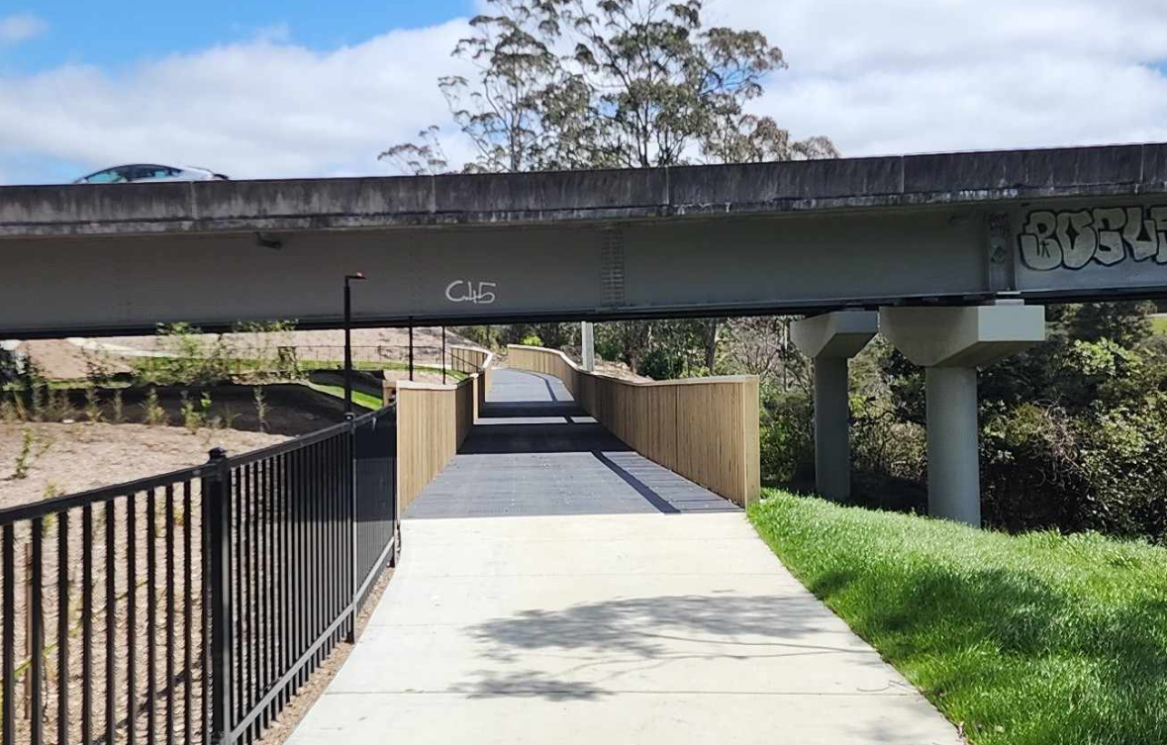
Figure 3: Photo of offroad link to Milldale as it passes under the SH1 (Northern Motorway)

3.2 - Collector Road Roundabouts – Pedestrians and Cyclists
A lot of time has gone into the design of the roundabouts at Milldale to ensure that they cater for all users.

All roundabouts include an off-road circulating cycle lane to allow cyclists to negotiate the intersection safely. The design of the cycle lane adjacent to the footpath and vehicle lane has been carefully managed to avoid conflicts of users and comply with vision impaired user requirements.

The road crossings on the roundabouts are designed to limit any impact between vehicle and cyclists/ pedestrians to below a survivable speed of 30km/h. This is primarily done via a speed table, although some roundabouts at the southern end of the project have utilised kerb aprons to channel traffic into greater deflection to reduce speeds.

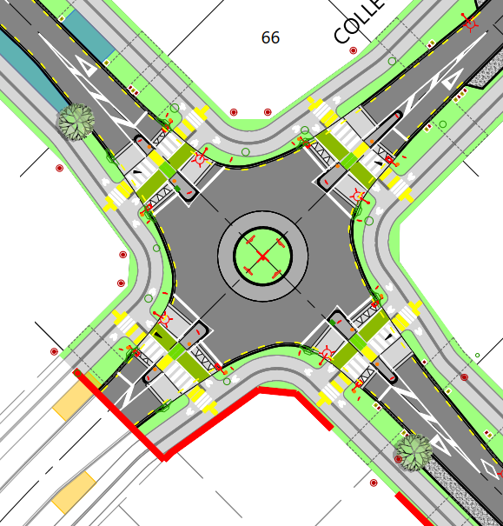
Figure 4: Typical collector road roundabout layout

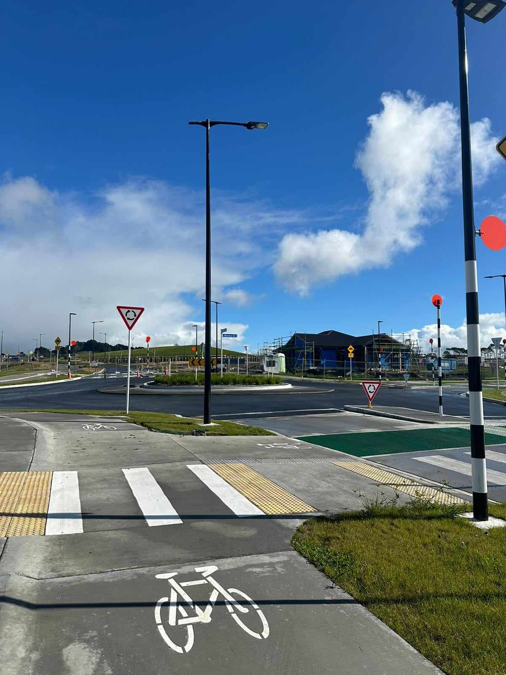
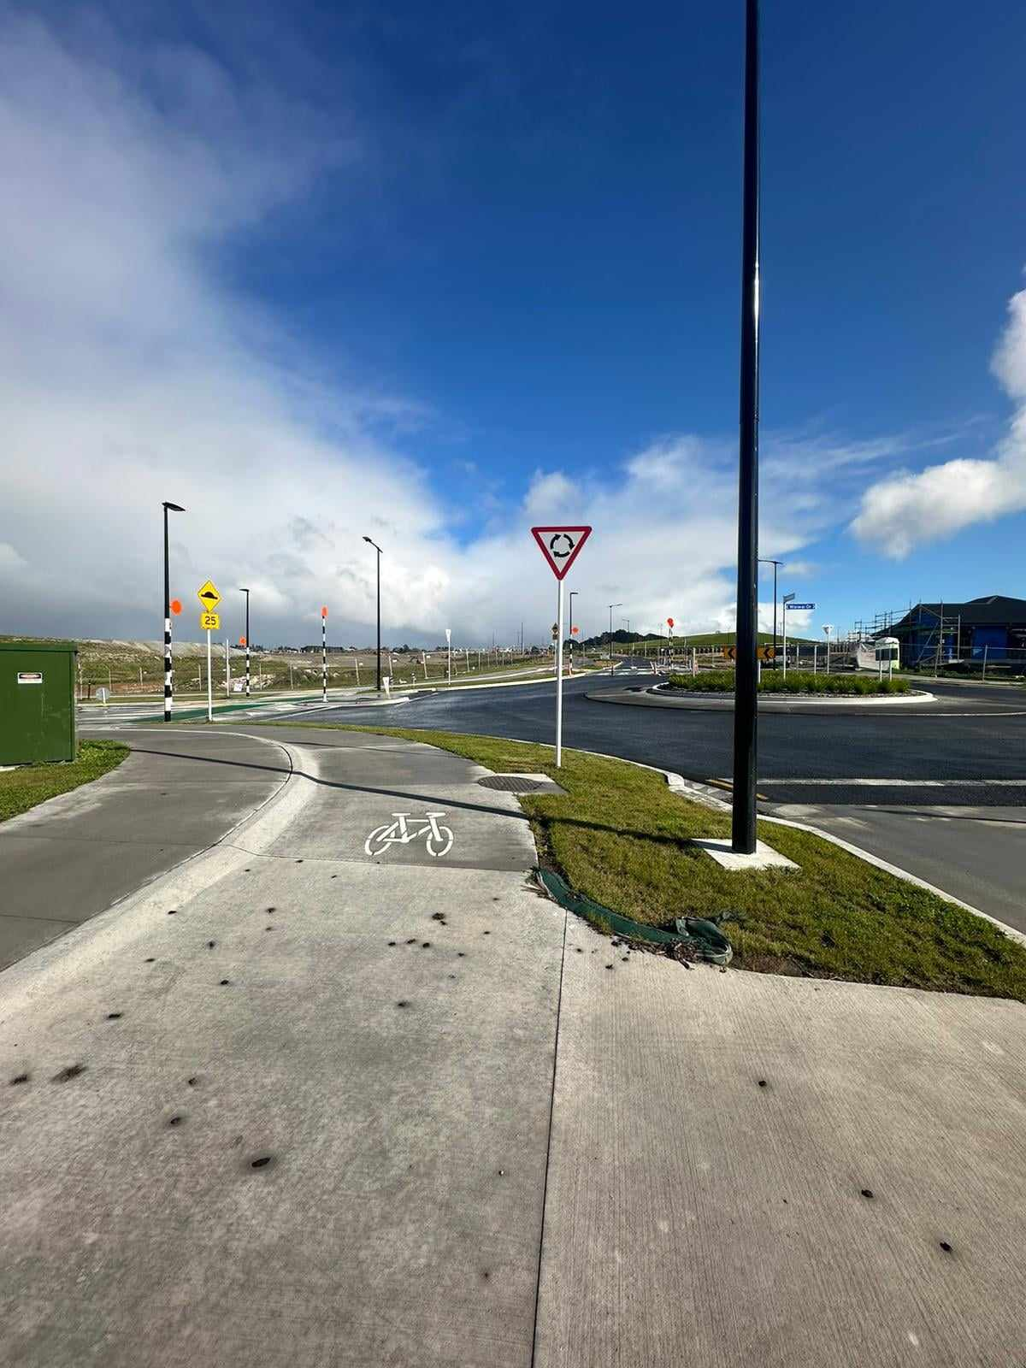

Figure 5: Photos of collector road roundabout

3.4 – Mini roundabouts
Mini roundabouts are used on local roads at 4-way intersections. They are a form of traffic calming, reducing speed through the intersection and on the adjoining roads.
The intention is that a delivery van should be able to track around the roundabout, while larger vehicles track over it. The land required for the mini roundabout should not be more than a standard priority intersection.

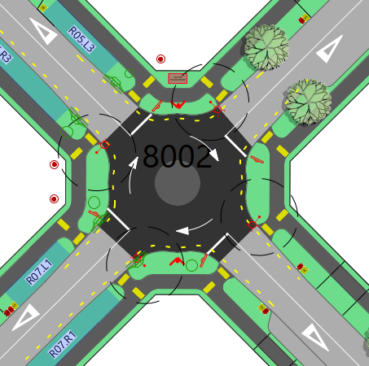
Figure 6: Typical mini roundabout layout
As with all things at Milldale, the design of mini roundabouts has developed over time. Initial designs were too tight, and smaller vehicles tended to track over the island rather than choose to drive around. Later designs have introduced a taper on the approach and departure curves to guide the vehicles into the roundabout. This, while also increasing the height of the central island slightly, has resulted in a higher number of vehicles using the intersections as intended.

3.3 - Speed calming
Speed calming has always been a tricky topic at Milldale. The developer and residents are less than complimentary about the number of tables and speed bumps in the development. But at the same time they enjoy the quiet, low-speed streets.

As a result a range of other measures have been tried to achieve the same outcomes without needing vertical deflection. These include:
- Narrow carriageways – Effective, but speeds creep up as residents get comfortable.
- In-lane parking – Effective when residents are home and cars are parked on street, but less effective through the middle of the day.
- Semi indented parking bays – Similar to in-lane parking, this variation was tried as a way of increasing on road parking while retaining an element of speed calming. Again the measure was effective when cars were present.
- Kerb buildouts – Early implementations of this have not been very successful as the one-lane section was too short. The stage currently under construction includes a longer buildout which is expected to be more successful.
- Mini roundabouts – These have been highly successful in controlling speed.

As a result of the limited success of horizontal deflection calming methods, Milldale has utilised speed tables extensively through the later stages of the development. They are highly effective at controlling speeds.

It is expected that once the full collector road network has been completed the various route options will mean the drivers have more options to limit the number of speed tables they need to traverse to reach their destination.

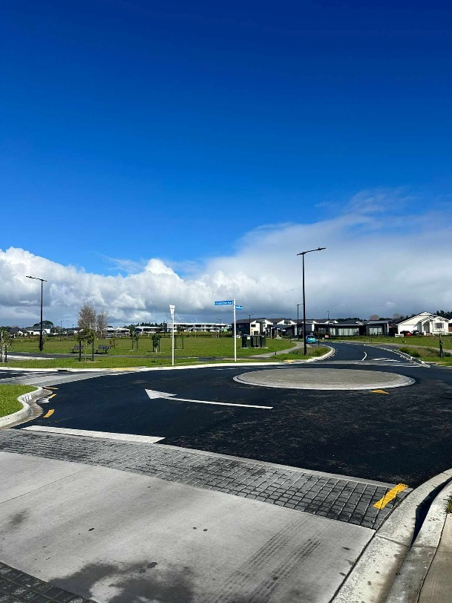

Figure 7: Photo of a Milldale speed table

4.0 Conclusions
The Milldale development is providing strong transport outcomes. This has come about from a strong vision from Auckland Transport and aligned thinking between the council, developer, designer and builders.

The development has been a trial of various transport engineering ideas, but has now reached a point where consistent designs are being approved and built which exhibit best practice for the industry.

This all comes together to provide a place where people want to live.

5.0 References

Auckland Transport (n.d). Transport Design Manual
https://at.govt.nz/about-us/manuals-guidelines/transport-design-manual

CASSIDY, CARDEN, and FLEMING (2023). Setting up for success – Designing for People think piece,
29-31 March 2023, Engineering New Zealand Transport Group Conference, Tauranga 2023.

6.0 Acknowledgements

Bridget Carden, Tracy Fleming and Clare Cassidy (Abley)
Thanks for providing the paper that prompted this paper. Nothing like being told to lift your game to provoke a response.

Andy Irwin and the Auckland Transport Team
As discussed in the paper, Andy and the wider AT design team have been relentless in their drive for change, and this has resulted in the fantastic outcomes we are seeing at Milldale. AT bear a lot of criticism, but there is some fantastic work being done within the organisation. Kia Kaha.

The Woods Milldale design team
The Woods Milldale design team continue to deliver best practice designs for the Milldale development, they are always looking for improvements and efficiencies and this is the key to the success we have had to date. To have other designers being referred to your development as a best practice example is the greatest complement you can get as a designer.

