ROAD LIGHTING- ITS NIGHT SKY IMPACT
This paper has been peer reviewed
Mike Jackett, BSc, MEngSc, Principal, Jackett Consulting, mikejackett@gmail.com (Presenter)

Bill Frith, MSc (Hons), MSc (Transport Engineering), BA, FCILT, AFACRS, MICADTS Research Manager, Road Safety, WSP Research and innovation, william.frith@wsp.com (Presenter)

Julian Chisnall, MIPENZ, ACRS, AssocIESANZ Team Leader, Road Safety (National)
NZTA, julian.chisnall@nzta.govt.nz

ABSTRACT
Streetlighting related sky glow is a legitimate concern but local information about its prevalence and importance is sparse. This project was a first step towards providing such information. Part 1 investigated spatial aspects of sky glow in two relatively dark rural highway settings and part 2 investigated the temporal aspects of sky glow in the Wellington CBD to identify contributions from a range of artificial light sources. A calibrated DSLR camera was used to estimate sky glow.

Part 1 used a series of sky glow measurements up to 2 kilometres along roads aligned at right angles to SH1 lighting at Peka Peka (LED) and MacKays Crossing (HPS). At both sites the sky glow decayed asymptotically reaching minima 1.5 to 2 kilometres from the highway.
At Peka Peka the maximum contribution to sky glow from the SH1 lighting was estimated at 0.097 mcd/m² and at MacKays Crossing 0.18 mcd/m², somewhat higher than that at Peka Peka.

Part 2 investigated the relative contributions to sky glow from various artificial light sources throughout the night. These included variable light from high rise buildings, houses and flats, vehicle headlights and static (unvarying) lights from streetlights, port lighting, railyard lighting, security lighting, and advertising signs. Data sources on these temporal changes were two sets of all-night time-lapse photographs taken from the roof of the Met Service building in Wellington and council traffic volume data, which relates to headlight usage. Static lighting was the most important contributor, followed by high rise and residential buildings, which had dissimilar temporal patterns. Car headlights made a relatively small contribution. The ranges found were:
Vehicle headlights: 3% to 0%
Residential: 18% to 1%
High rise office: 7% to 3%
Static (unvarying) lighting: 72% to 96%
The relative contributions from each static source could not be isolated and await further research.

INTRODUCTION
Artificial lighting during night, particularly light from the blue end of the spectrum, hinders astronomy and detracts from the simple enjoyment of seeing the night sky.

There is community concern about sky glow related to roads, which has been expressed strongly to NZTA staff. However, little is known in absolute terms about the contribution of road lighting to sky glow and just how this varies with distance from the light source. This project has the aim of improving our knowledge in these areas, so that we can better assess the impact of future lighting changes on sky glow.

WHAT IS SKY GLOW?
Sky glow is the term used to describe a luminance produced in the atmosphere which restricts the vision of stars beyond.

It is most obvious in major centres of population where only the brightest stars may be seen. Sky glow can sometimes be a glowing dome of light over distant cities and towns.

While sky glow in rural areas will be less dominant, these are also the most pristine viewing areas in New Zealand where maintaining a dark sky is most important. A low level of sky glow is consistent with the clean green image that New Zealand wishes to project.

The downward scattering of light by air molecules (Rayleigh scattering) or particles (Mie scattering) is what causes Sky Glow.

Rayleigh Scattering
Rayleigh scattering occurs when light interacts with molecules much smaller than the wavelength of light – in the atmosphere these are typically the molecules of nitrogen and oxygen in the lower 12km of atmosphere. The amount of scattering is inversely proportional to the fourth power of the wavelength, meaning that Rayleigh scattering is strongest with short wavelength, blue light.

Mie Scattering
Mie scattering occurs when light interacts with particles (aerosols) around the same size as the wave length of light. Mie scattering does not have a frequency dependence, scattering all frequencies equally, and for this reason Mie scattering is usually associated with the colours of white or grey. The water droplets in clouds are an example of Mie scattering. Mie scattering occurs in the lower 4.5km of the atmosphere where dust / aerosols are most common.

Artificial light contributions to sky glow
The artificial light contributions to sky glow will vary considerably from place to place and by time of night. Listed below are the major contributors.
- Street lighting
- External security, advertising or architectural lighting
- Spill light from internal lighting through the windows of buildings
- External sports ground lighting
- Car headlights.

SKY GLOW MEASUREMENT

Sky Quality Meter
The Sky Quality Meter (SQM), developed by the Unihedron company of Canada, is a relatively low cost, scientifically robust means to measure sky glow (Figure 1). It displays the astronomy measure of magnitudes per square arc second, but a conversion to milli candela per square metre exists.
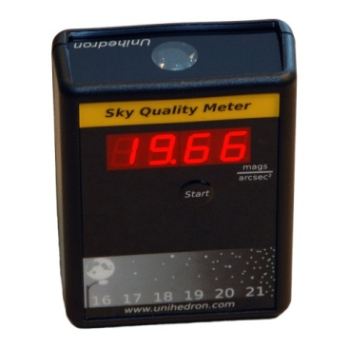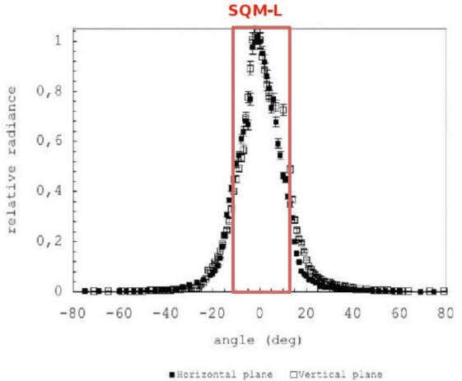
Figure 1: The Unihedron SQM_L hand held meter and its angular response curve illustrating the 20 degrees at “full width, half maximum”
.

Calibrated DSLR Camera
If suitably calibrated a DSLR camera offers significant advantages over a SQM meter.
- The photo taken by the camera provides a permanent reviewable record.
- The camera’s green sensor has a spectral sensitivity similar to the photopic scale of human vision whereas the SQM has a unique broadband sensitivity.
- The camera’s colour data helps identify the source of any sky glow.
- Clouds, trees and sky constrictions can be seen and corrected using photos.
Previous research projects undertaken for NZTA on road lighting have used a LS-110 luminance meter calibrated DSLR camera to determine the luminance of a road surface. Improved accuracy and significantly reduced measurement times resulted.

Comparison with SQM
A sky glow comparison between SQM and the camera resulted in a near linear relationship with the SQM recording luminance values slightly higher than the camera method (see Figure 2).
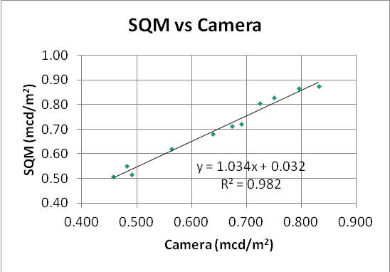
Figure 2: Comparison of SQM sky glow readings with a calibrated camera

Considering the differences in frequency response, calibration and zonal areas used by the devices, the agreement was considered good.

RURAL STUDY (Spatial effects)

Purpose
Very little is known about how a given street lighting installation will affect sky glow and even less about the spatial properties of that effect.

The intent of the rural study is to learn something of these spatial effects by selecting relatively dark areas where the dominant light source is the highway lighting and where a local side road provides access for a series of sky glow measurements.

Two Wellington area sites were chosen; State Highway 1 at Peka Peka road and State Highway 1 at MacKays crossing. Both sites have a section of category V highway lighting and an adjacent largely unlit side road allowing a sky glow profile to be gathered as a function of distance.

Method
Sky glow measurements were made using a calibrated DSLR camera on a monopod held against the body of the survey car. A bubble level helped align the camera vertically.
Photos were taken approximately every 100m using a 18mm lens, and an exposure of 15 seconds, f/3.5 and ISO 3200. This combination was chosen as a compromise between competing needs for limited length star trails, reliably hand holding a camera without movement and avoiding noise issues from high ISO.

Peka Peka Road Site

Background:
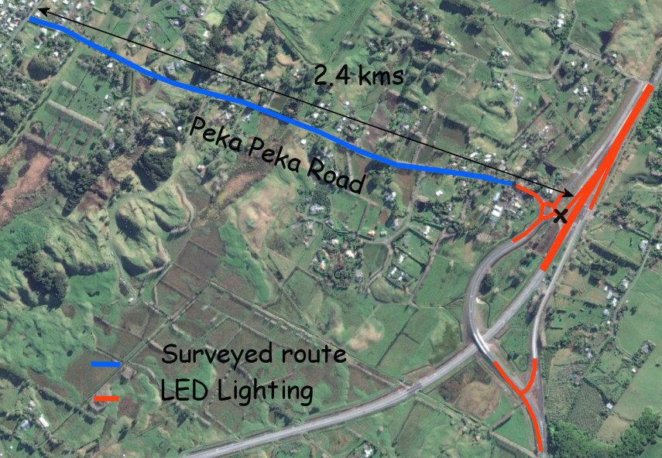
The northern end of the Kapiti expressway (SH1) some 4 kilometres north of Waikanae is lit with a 900m section of category V3, LED street lighting. The adjacent side road (Peka Peka road) has a rural residential development, and few flag lights.

As shown in Figure 3 the Kapiti expressway lighting includes lights on the expressway as well as on the adjoining ramps and roundabout. A single “zero point” (marked with an x in Figure 3) was chosen mid-way between the roundabout and the highway to best represent the centre of the lights for distance measurement.

Figure 3 The Peka Peka road site showing the extent of street lighting (red) present at the time of the survey and the section over which measurements were taken (blue).

Peka Peka Results:
The absolute level of sky glow found at Peka Peka was low by Wellington standards - 0.41 mcd/m² near the expressway to a minimum of 0.32 mcd/m² some 2 kilometres along Peka Peka road.
The extra sky glow contributed by the Kapiti Expressway lighting was estimated by noting the asymptotic nature of the curve and adopting a nominal sky glow value of 0.005 mcd/m² to represent the lowest measured value. In Figure 4 the sky glow (green) curve has been normalized at point (2050 m, 0.005mcd/m²) and a best fit power curve fitted.

In summary:
- The maximum contribution to sky glow from the Kapiti Expressway lighting was estimated to be around 0.097 mcd/m².
- The best fit power function curve for sky glow luminance has an index of -1.30 and a correlation co-efficient of 0.90.
- The red, green and blue colour channels have very similar values for the full length of the road. As these values were normalized at the 2050m point there is effectively no change in the colour of the sky glow along the road, suggesting the area is relatively remote from coloured light sources such as HPS lighting.

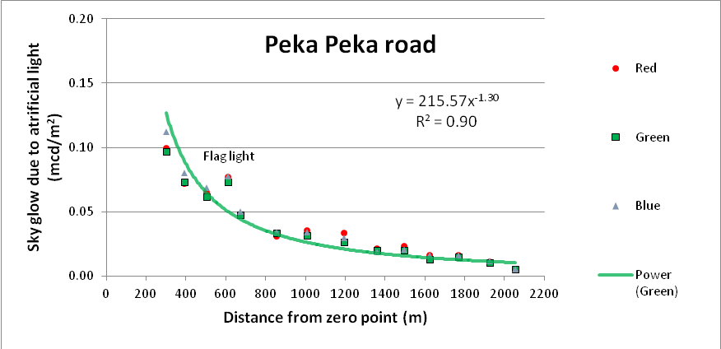

Figure 4: The estimated reduction in sky glow due to street lighting at the Peka Peka site relative to the distance from the zero point.

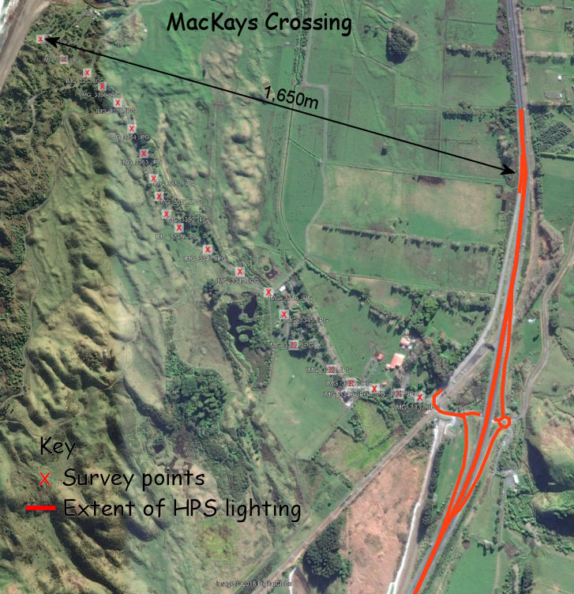
MacKays Crossing Site

Background:
MacKays crossing is an area adjacent to State Highway 1 some 6kms south of Paraparaumu. It is in a rural section of the Kapiti Coast District separated from the sea by Queen Elizabeth park.

The highway is lit to category V3 with 250-watt high pressure sodium lamps in GL600 fittings. The extent of the lighting is shown by the red lines in Figure 5.

The distance measure adopted at MacKays crossing was the shortest distance between survey point and a lit section of highway. (See arrowed 1650m line in Figure 5).
Figure 5: HPS lighting at MacKays crossing.
Although the only occupied house along the route is the ranger’s residence (800m) the adjacent Ramaroa centre had some architectural up-lighting operating. The visual effect was subtle yet its effect on skyglow can be seen in the plots between 400m and 500m. (Figure 6)

MacKays Crossing Results
The sky glow found at MacKays crossing was a little higher than at Peka Peka with values of 0.58 mcd/m² near SH1 and 0.40 mcd/m² near the coast.
The assumption was again made that at the curve for artificial light is asymptotic to a value of 0.005 mcd/m² at the lowest measured point (1650 metres from the highway). The resulting graph (Figure 6) shows the sky glow contribution from highway lighting at MacKays crossing with a best fit power curve regression line fitted.
Summary:
- The maximum contribution to sky glow from the MacKays crossing lighting was estimated to be 0.183 mcd/m^{2,} somewhat higher than that at Peka Peka.
- The best fit power function curve for sky glow luminance has an index of -1.59 and a correlation co-efficient of 0.88.
- The colour sensor plots have been normalized to give a colour neutral (grey) sky glow at the furthest point 1650 metres. The fact that these plots diverge as the highway lighting is approached indicates the natural sky glow is increasingly being influenced by the red rich colours of the HPS lamps.
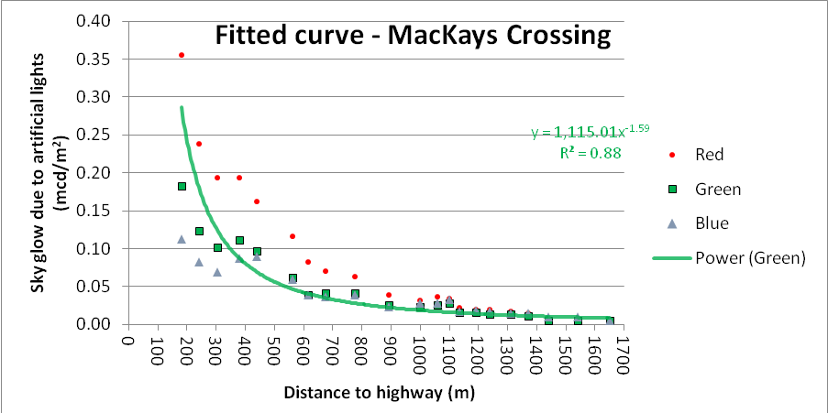
Figure 6: The estimated reduction in sky glow from street lighting at the MacKays crossing site relative to the distance from the lights (highway).

Discussion related to both sites
The curves fitted to the data from Peka Peka road and MacKays crossing were power curves. A power curve fitted the data well and in terms of building on existing knowledge it is a helpful option.
The first relationship established between zenith sky glow and distance from the source came in the1970s from M. F. Walker and is now known as Walker’s Law. It states that;
Intensity $∝$ distance ^{-2.5}
It was intended to apply to distances between 10 and 50 kilometres of a city centre and the negative 2.5 meant that sky glow decreased even faster than the inverse square law.
The inverse square law of light applies when the light can be considered a point source and the plane of measurement is at right angles to the light path. Then;
Intensity $∝$ distance ⁻²
Neither of these options fit the situation of a new linear section of rural highway lighting with measurements made at right angles to it.
It is possible to show mathematically that the change in light intensity at right angles to an infinitely long linear light source is:
Intensity $∝$ distance ⁻¹
At neither MacKays crossing nor Peka Peka road could the highway lighting be considered infinite or for that matter the shape of the highway be considered linear. Arguably then the expectation would be that the decline in sky glow would lie somewhere between the point source option (distance⁻²) and the continuous linear lighting option (distance ⁻¹).
The values found at each site were;
Peka Peka road Intensity ∝ distance^{-1.3}
MacKays crossing Intensity ∝ distance^{-1.6}
The results from Peka Peka road and MacKays Crossing sites both lie within the -1 to -2 power range proposed above. This perhaps gives some credence to that theory, but more studies would be needed to learn what the key parameters are and how they determine both the initial sky glow values and the power relationship with distance.
It is strongly suggested that any future studies of this type incorporate a second stationary camera to act as a control on natural sky glow changes that may occur during the course of the measurements.

WELLINGTON URBAN STUDY (Temporal effects)

Introduction
Lighting from artificial lights fall into two groups. Those that are static or do not change during the night (e.g. street lighting, security lighting) and those that exhibit a temporal pattern (eg. residential lighting, high rise lighting). By examining the temporal patterns of these lighting groups, it is possible to mathematically model them and obtain an estimate of their contribution to sky glow.
The study was based on a method proposed by Bará (2017).“

Method
The study used two cameras operating on 7.5-minute interval time lapse throughout the night. One camera faced directly upwards to photograph the zenith and obtain a measure of the variation in sky glow. The other camera faced down towards Wellington city to record the temporal variation in various categories of artificial light.
The study site chosen was the top of the MetService building in Salamanca road, Kelburn. It has an elevated position giving good views of Wellington CBD and a dark rooftop area with unimpeded views of the night sky.
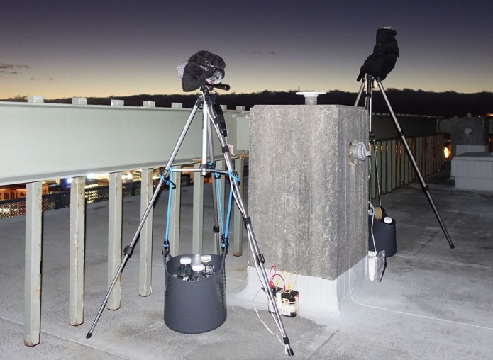
The measurement equipment comprised two cameras (Canon 750D and Canon 80D) mounted on tripods and fitted with interval timers, weights and dew heaters (Figure 7.)
The camera technical details are:
Sky glow: Canon 80D, Exposure 15 sec, f/3.5, ISO 3200, FL 18mm, WB = “daylight” (5200K), RAW + JPG, Interval =7.5 min, operation 7:15pm to 6am, 18 – 19 April 2018
City lights: Canon 750D, Exposure 2 sec, f/5, ISO 800, FL 18mm, WB = “daylight” (5200K), RAW + JPG, Interval =7.5 min, operation 7:15pm to 6am, 18 – 19 April 2018. Angle of view = 60° horizontal x 40° vertical.
Figure 7: Camera equipment on the MetService building roof.

The photos from the sky glow camera were processed as follows:
- Reduced to a 20° circular section centred on the zenith.
- The average pixel value for the Red, Green and Blue channels were obtained from an image editor (“GIMP 2.8”).
- The average Red Green and Blue pixel values were then converted to luminance (mcd/m²) using a set of previously established polynomial equations relating the camera’s exposure to a calibrated luminance meter (Minolta LS 110). The value from the green sensor was taken as the photopic value measuring sky glow in milli-candelas per square metre.

City Light Measurement:

Residential lighting:
Residential lighting is the light emitted through windows of private dwellings or from any external lighting. The profile is of lighting by people at home in their normal night time activity.
An example of “Residential” variation is shown in Figure 8.
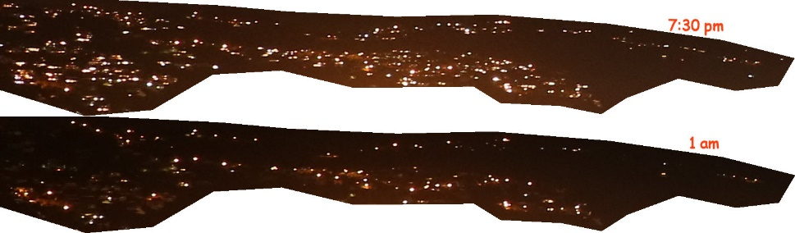
Figure 8: Light visible in the “Residential” area at 7:30pm (upper) and at 1 am (lower).

High Rise Lighting:
High rise buildings formed a dominant part of the city scene from the survey site atop the MetService building. An example of changes in “High Rise” lighting is given in Figure 9.
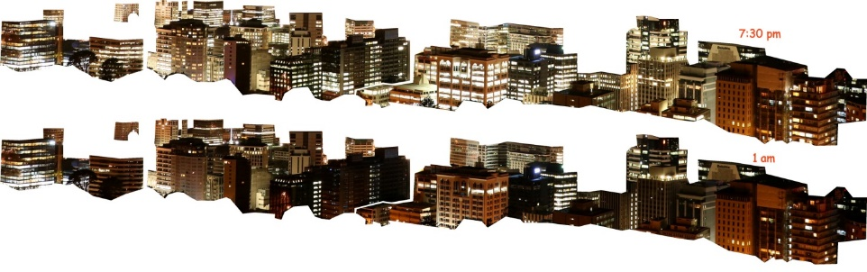
Figure 9: Lights visible in the “High rise” area at 7:30pm (upper) and 1 am (lower).

Car headlights:
As car headlights also contribute to sky glow, temporal estimates of traffic density were included in the study. Traffic volume data in matching quarter hour intervals was kindly researched and provided by the Data Analyst Team at the Wellington city council using their 2016 records.

Results:

Sky glow profile:
The Wellington sky glow profile shown in Figure 10 has been normalised so that all channels are given a single value of 1.0 at 1 am (1am is a convenient sky glow low point). This normalised format is particularly useful in highlighting the temporal behaviour of sky glow irrespective of magnitude.
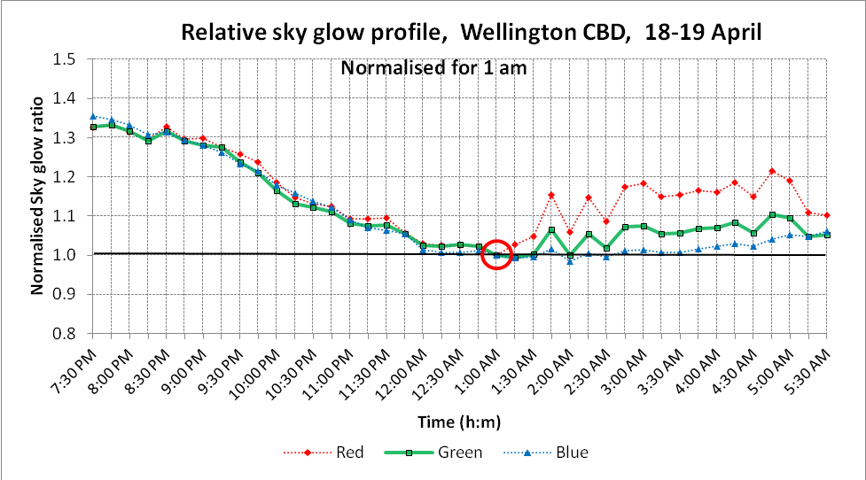
Figure 10: Sky glow profile for Wellington CBD expressed relative to 1am conditions.

An unexpected disturbance to the sky glow plot occurred at around 1 am. A thin layer of high cloud appears to have spread over Wellington at this time. It was not visible to the naked eye and is not physically visible in the photographs, except by a subtle reddening of the image and fuzziness in a dominant star. Its presence is indicated by the rise in the red channel (and lesser rise in the green channel) from 1 am onwards. While it occurred at a time of night not critical to the analysis, the unaffected blue line in Figure 10 logically tracks the path the green line would normally take based on previous all-night studies. Consequently, in the analysis the sky glow profile was modified to follow the green channel to 1 am and the blue channel from 1:15 am.
This event has highlighted yet another benefit of using a camera in that it helps identify and interpret any unexpected temporal changes in sky glow.

Predicting sky glow:
Sky glow will be a function of many variables but here we are modelling just four; residential lighting, high rise lighting, car headlights and the unchanging static component. The static component comprises street lighting, industrial, commercial, security lighting and natural sky glow.
A simple four variable linear regression model using least squares errors was adopted. The best fit model was;
Y = 0.005 a + 0.015 b + 0.33 c + 0.970 d
Where the variables are the relative indexes for
Y = Sky glow
a = Car headlights
b = Residential light
c = High rise building light
d = Static lighting (street lights, industrial, commercial etc and natural sky glow)
in each quarter hour period between 7:30 pm and 5:30 pm.
The temporal pattern of the grouped light sources is shown in Figure 11 and the resulting model fit of predicted verses actual in Figure 12. Finally, the results are summarised in Figure 13, showing the relative contribution to sky glow from of each group of light sources throughout the night
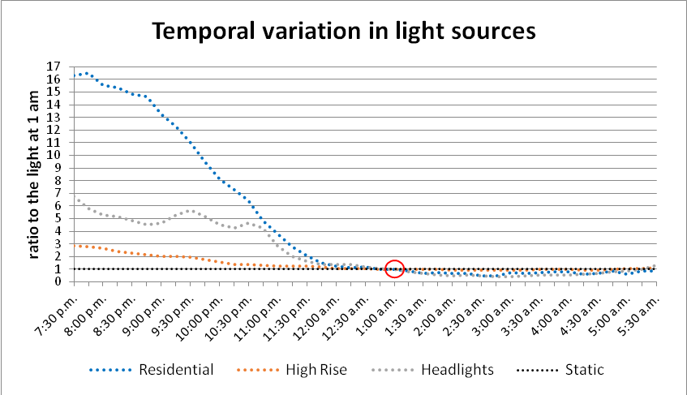
Figure 11: The temporal variation found in the light sources used in the model expressed relative to the light at 1 am.

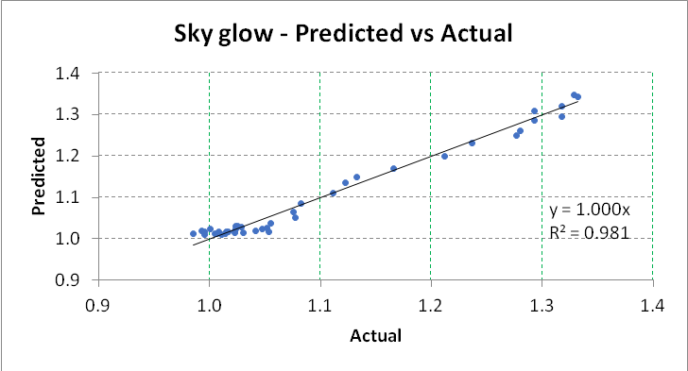
Figure 12: Model scatter plot showing the agreement between the predicted and actual.

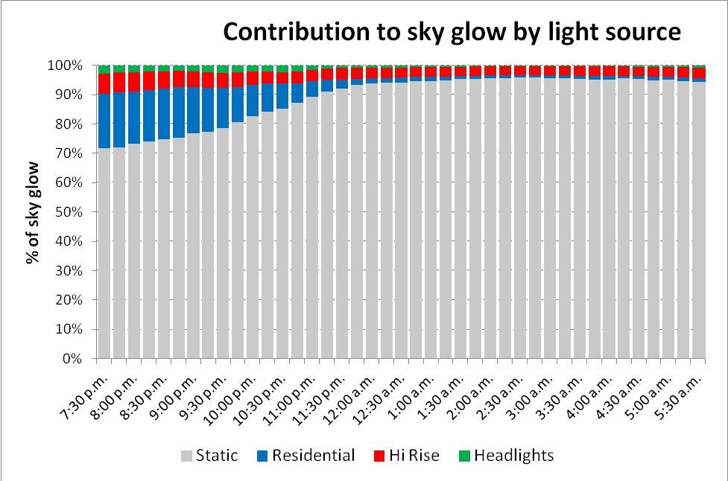
Figure 13: The relative contribution to sky glow from car headlights, residential houses, high rise buildings and static lights sources by time of night.

Discussion
The objective of this study was to match the temporal variation in light sources within a city to the temporal variation in sky glow, so that the contribution from each component part could be estimated.
Car headlights are often cited as a contributor to sky glow, but the temporal data this study shows that their effect is likely to vary from just 3% at 7:30 pm to effectively nil after 1 am. This finding matches the results of Bará et al. (2017), where the estimated vehicle headlight contribution also peaked just under 3%.
Residential lights had the greatest temporal change of any light source, representing 18% of the sky glow contribution at 7:30 pm but dropping to just 1% from 1am onwards.
The observation site was close to high rise commercial buildings. The light profile for high rise is regulated by the hours office workers spend at work and then by the hours delivered by the building cleaners. A surprising number of office buildings had lights on right through the night. The sky glow contribution from high rise buildings was 7% at 7:30 pm dropping to 3% after 1am. From 11:30pm to the end of recording at 5:30am the predicted sky glow contribution from high rise buildings exceeded that of residential areas.
The largest category of lighting contributing to sky glow is the type that has no temporal distribution at all – it was termed “static” because it remains on all night. It includes natural sky glow, street lighting, port lighting, rail yard lighting and many types of commercial, architectural and security lighting, much of which is not visible in the photos. It was not part of this study to quantify contributions from subcategories of static lighting. Static lighting was estimated to contribute 72% of sky glow around 7:30 pm increasing to around 95% in the early hours of the morning.
In the Bará report the static component was labelled as “street lighting” but it is clear in Wellington city that the static component is not simply street lighting. Other static sources from the photos are the port area, the high mast rail yard lighting and up-lighting used to highlight buildings (see Figure 14.) Not seen in the photographs is the application of exterior floodlighting for security and advertising signs, including LED billboards. It was not possible to quantify the sky glow contribution from these sources, but it is noted that their design rarely has the same degree of control on upward waste lighting that applies to modern street lighting. Because of their stronger upward light component, it is possible that these non-street lighting sources make up a sizable proportion of the sky glow from static lighting.

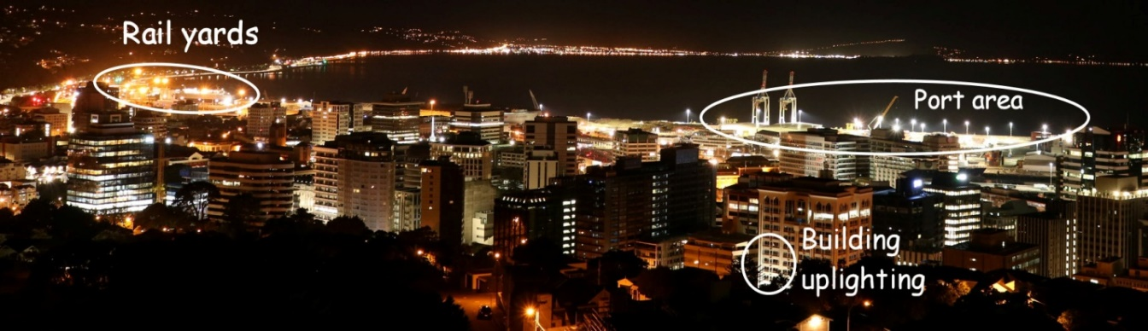
Figure 14: Contributions to sky glow from static light sources include port area lighting, rail yard lighting and up lighting for buildings.

Findings:
- Initial best fit results suggest sky glow decreases with distance from a linear length of rural highway lighting by distance raised to a power of between 1.3 and 1.6.
- When measured using photopic sensitivity the LED lighting at Peka Peka had noticeably lower values of sky glow than the HPS lighting at MacKays Crossing. This is encouraging but is not sufficient to show that LED lighting will reduce skyglow for all observers, particularly given that the two lighting installations were not identical in ways unrelated to the light source.An all-of-night sky glow profile made in Wellington CBD on 18-19 April 2018 showed a reduction of 25% from its its highest point around 7:45 pm to its lowest point around 1am.
- By matching the profiles, the CBD sky glow contribution from each light source throughout the night was found to vary between:
  - Car headlights: 3% to 0%
  - Residential dwellings: 18% to 1%
  - High rise office buildings: 7% to 3%
  - Static (unvarying) lighting: 72% to 96%

AUTHOR CONTRIBUTION STATEMENT
All three authors collaboratively initiated this work. The detailed field work and design was carried out by Mike Jackett and the writing up was done by him and Bill Frith. The work was continuously reviewed by all three authors as it progressed.

REFERENCES:
de Miguel , A Sanchez Aubé, M,. Zamorano, J, . Kocifaj, M, Roby, J and Tapia, C (2017) , Sky Quality Meter measurements in a colour-changing world, MNRAS 467, 2966–2979

Bará, Salvador, Rodríguez-Arós, Ángel, Pérez, Marcos, Tosar, Borja, . Lima, Raul C, de Miguel, Alejandro Sánchez and Zamorano, Jaime (2017), Estimating the relative contribution of streetlights, vehicles and residential lighting in the urban night sky brightness, https://scirate.com/arxiv/1706.04458 Viewed 30 October 2019.

Kodan, Hoshizora (2016), A proposal of measurement of night sky brightness using digital still camera, , http://globeatnight-network.org/presentations/ws_20150108.pdf Viewed 30 October 2019

Unihedron (2005) Dark Sky http://unihedron.com/projects/darksky/magconv.php Viewed 30 October 2019

Kinzey, Bruce (2017) An Investigation of LED Street Lighting’s Impact on Sky Glow, , US DoE, https://www.energy.gov/eere/ssl/downloads/investigation-led-street-lighting-s-impact-sky-glow
Viewed 30 October 2019

Walker, M. F. The effects of urban lighting on the brightness of the night sky, 1977 Publications of the astronomical society of the Pacific, http://iopscience.iop.org/article/10.1086/130142 Viewed 24 January 2020

The surface area of a sphere is given by 4πr² where r is the radius of the sphere. It follows that light from a point in the centre will spread over a surface area which changes by the square of the radius.
The surface area of the curved walls of a cylinder is given by 2πrl where r is the radius and l is the length. It follows that light from a continuous linear light source will spread over a surface area (here the curved walls of a cylinder) which changes in size in proportion to the radius or distance from the light source. This calculation assumes no light is lost from the ends of the cylinder which is true for a line of infinite length.
GIMP 2.8 is a public domain image editor

