medium density housing and transport, pART ONE

(This paper has been peer reviewed)

Author:
Jeanette Ward,
Technical Director, Abley Ltd

Gabi Wolfer
Urban Design Leader, Selwyn District Council (SDC)

Andrew Mazey
Strategic Transport Lead, Selwyn District Council

Shane Binder
Senior Transportation Engineer, Waimakariri District Council (WDC)

Abstract
Medium density housing is booming in metropolitan New Zealand and starting to emerge in urbanised parts of our districts. This housing approach is helping to address housing shortages and promote more efficient land use. It involves smaller units on smaller sites and residential developments that accommodate multiple housing units per land area.
Integrated with these developments are the associated transport needs of residents, as well as servicing requirements such as rubbish collection and emergency services. However, the need to optimise new and existing sites for denser housing can come at a cost. Adequately meeting ongoing transport needs in response to changing land use requires streetscape adaption and fresh thinking.
Under the 2020 National Policy Statement for Urban Development, councils can no longer mandate minimum on-site parking requirements in their district plans, except for accessible parking. Developers can choose to include parking in their designs, but the supply falls short of current demand, pushing parking into the public realm. This can lead to competing uses within the streetscape, adverse impacts on the development residents, and the wider community. On-site cycle parking and storage can be an add-on in the design process lacking the space and security needed and is unlikely to encourage bicycle ownership.
Ultimately, we need lower car ownership in New Zealand to support denser living, but that relies on providing better transport choice; we are not there yet.
Examples from New Zealand will be used to illustrate the safety, accessibility and amenity issues arising from medium density housing and some emerging best practice.
This paper draws on the context of Waimakariri and Selwyn district suburban areas. It examines the fine balance required to meet the needs of the present and future state so that our housing of today creates resilient communities for tomorrow. The authors consider this paper to be Part 1 in the ongoing journey to shape of our urban communities in a resilient manner, and plan to undertake further analysis of outcomes over the next few years.

INTRODUCTION
The National Policy Statement on Urban Development 2020 (NPS-UD) aims to increase housing density, including medium-density housing, in urban areas. Medium-density residential standards (MDRS) are a key part of this, allowing for up to three dwellings per site, up to three stories high, in most residential zones, without requiring resource consent. Medium density housing is rapidly transforming urban landscapes across New Zealand, addressing housing shortages and promoting more efficient land use.
The definition of medium-density housing differs across New Zealand, but it typically refers to a higher density (vertically or horizontally) than the dominant stand-alone dwellings of New Zealand townships. Common typologies that are found in Medium Density areas are stand-alone dwellings with a small footprint on a small section (less than 350m² in Selwyn District) semi-detached (or duplex) dwellings, terraced housing or apartments within a building envelope of four storeys or less. Medium Density housing can occur in existing urban areas on empty sections (infill) or replacing older, less dense building stock (intensification), or be on land that has not been previously developed or built upon, often located on the edge of urban areas (greenfield). As these development types begin to shape suburban areas in districts like Waimakariri and Selwyn, it brings both opportunities and challenges.
The shift toward smaller units and intensified land use demands a rethinking of streetscapes, transport infrastructure, and servicing needs in the context of accessways and streets. With national policy changes removing minimum parking requirements, tensions are emerging between private development choices and public realm impacts.
This paper explores the delicate balance required to support denser living while ensuring good safety, accessibility, and amenity outcomes. It outlines considerations that could be given to transport impacts. The authors consider this paper to be Part 1 in the ongoing journey to shape of our urban communities in a resilient manner, and plan to undertake further analysis of outcomes over the next few years.
The paper is structured as follows: the key transport issues are outlined, the scene is set in terms of national policy and local context for the two districts experiencing high population growth, medium density reviews from Auckland and Christchurch are discussed and then the key issues are discussed in more detail.
MEDIUM DENSITY TRANSPORT ISSUES
This paper is associated with a Round Table discussion that will raise the following three key issues for discussion. This discussion aims to uncover any potential solutions being developed in New Zealand.
Issue 1 - Medium density infill/ intensification in existing streets
A range of impacts on accessibility, safety, parking, servicing (e.g. waste collection) and emergency services access are being experienced in existing streets when medium density infill and intensification occur. This is generally due to space restrictions within the street not catering for the demands of the development, such as parking if it is not provided for on-site.
Issue 2 – Design of new streets in medium density areas
New Zealand District Plans and Code of Practices provisions for new local roads and accessways associated with medium density housing are generally insufficient to accommodate operational/ servicing/ amenity and environmental functions within the allocated minimum space requirements.
Issue 3 – Design of new accessways in medium density areas
New Zealand District Plans and Code of Practices provisions for new accessways (also known as Private Right of Ways (ROW’s)) if provided, are generally not fit for purpose and have not responded to a potential tripling of units per site.

SCENE SETTING
Selwyn District (SDC), Waimakariri District (WDC)and Christchurch City (CCC) together form the spatial extent of Greater Christchurch. Greater Christchurch is an urban area that is governed through a collaborative partnership between local councils, mana whenua, and central government agencies such as the NZ Transport Agency, working together to coordinate urban growth, infrastructure, housing, and environmental planning across the region in conjunction with the regional council, Environment Canterbury (ECan). The extent of Greater Christchurch is shown in Figure 1.
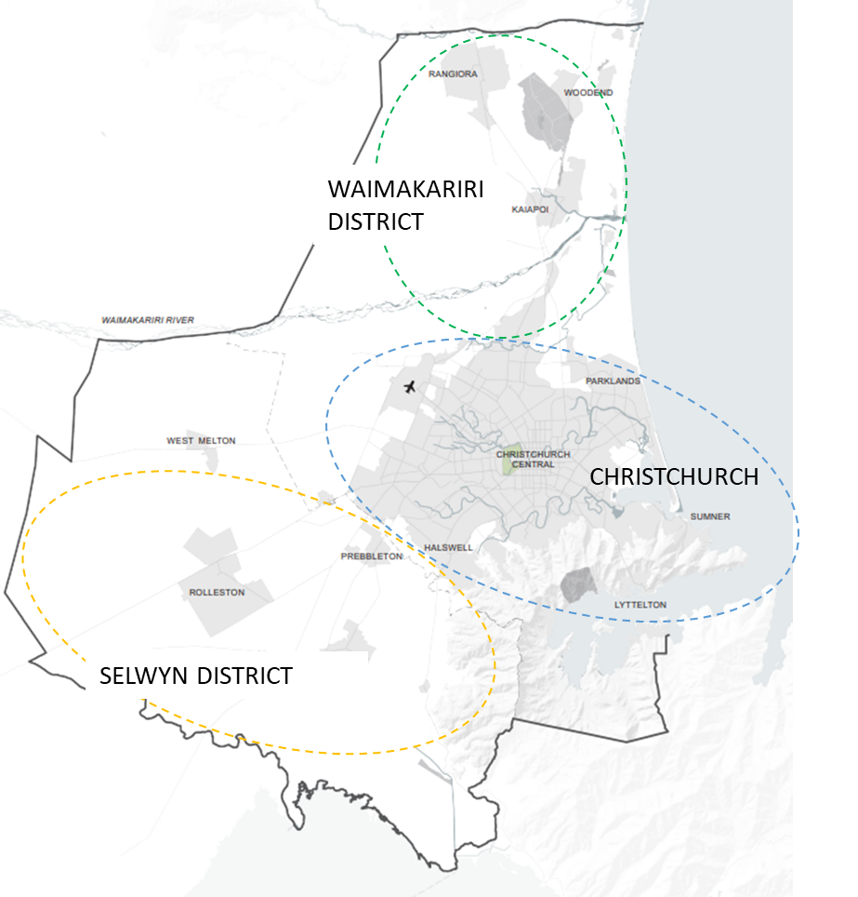
Figure 1 - Greater Christchurch Area
Canterbury is the country’s second most populous region with around 687,000 people. Selwyn District (6,300 km²) accounts for roughly 12% of Canterbury’s population, with about 85,000 residents, most living in the eastern urban commuter belt. Waimakariri District (2,217 km²) has a population of around 70,000 (approximately 10% of the region’s population).
Both districts have been growing faster than Christchurch City, due in part to a longer-term outward movement from the 2010/2011 earthquakes and to the relatively higher amount of land available for greenfield residential development. Selwyn’s population is expected to grow by 30,000 over the next decade (Selwyn Residential Capacity and Demand Model 2023), and Waimakariri predict approximately 15,000 new houses could be required to meet population growth by 2048 (WDC, 2018).
Delivering enough housing continues to be a significant challenge in these fast-growing districts. While MDRS was designed for intensification in a brownfield environment, the application in the districts is dominantly within a new greenfield context. However, the challenge is to unlock this in brownfield areas. What is enabled by the current MDRS package in the District Plan and what is built on the grounds differs profoundly. Part of the reason for this is that medium density in Selwyn and Waimakariri is location specific and expressed differently to medium density in the larger neighbouring Christchurch. That in part has led to the high growth rates in Selwyn where this type of choice is available.
Waimakariri has a larger amount of older housing stock on larger urban sections in the towns of Rangiora and Kaiapoi that can be redeveloped into multi-unit comprehensive housing. There has been a recent trend towards Kāinga Ora (NZ’s public housing agency) and private developers buying single or neighbouring sections with single homes and redeveloping with 3 to 6 units per section accessed by private rights of way.
The Greater Christchurch Spatial Plan (2024) recognises that Greater Christchurch has seen growth through the expansion of urban areas (growing out) happen faster than anticipated and growth through intensification of urban areas (growing up and in) not achieve anticipated levels (see Figure 2). Noting that the divergence from the planned growth direction was a by-product of the earthquakes where many people moved into the surrounding districts with the added benefits of cheaper, stable land that was readily available. To achieve a consolidated urban form and work against further sprawl there is a desire within the Spatial Plan to grow up instead of out as illustrated in the graph below.
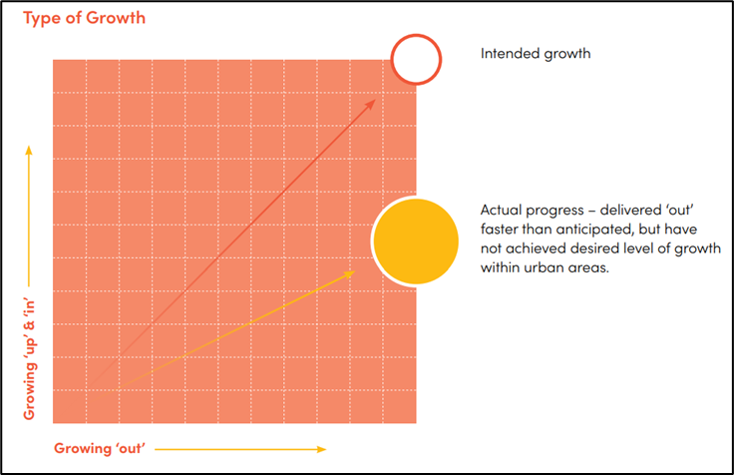

Figure 2 – Intended versus actual pattern of growth (Source: Greater Christchurch Spatial Plan, 2024)
Current growth in Selwyn and Waimakariri predominantly occurs as ‘horizontal density’ (e.g. small unit on a smaller site). Typologies of two storey or more are still in their infancy and despite the government’s mandate enabling multi-storey units at triple the previous density on site, the uptake is rather sporadic, and developers opt out with self-imposed covenants restricting building numbers to 1 unit per site. This is compared with Christchurch where medium density has had a much higher uptake and multi- unit, multi-storey typologies are the pre-dominant medium density typology. Currently 64-80% of all Christchurch building consents are for multi-unit developments compared to 30% in Selwyn (Stats NZ, 2025).
Recent large-scale medium-density greenfield development in Selwyn and Waimakariri trend towards small sections (300-400m²). This results in smaller frontages per section, more driveways per block, and at a higher level, the potential for a greater percentage of the development to be devoted to roading (although not per section). It is understood that smaller residential units with less on-site (storage) space, often have the garage re-allocated to a function such an office. Figure 3 shows the scenario of closely spaced driveways reducing the space of on-street parking.
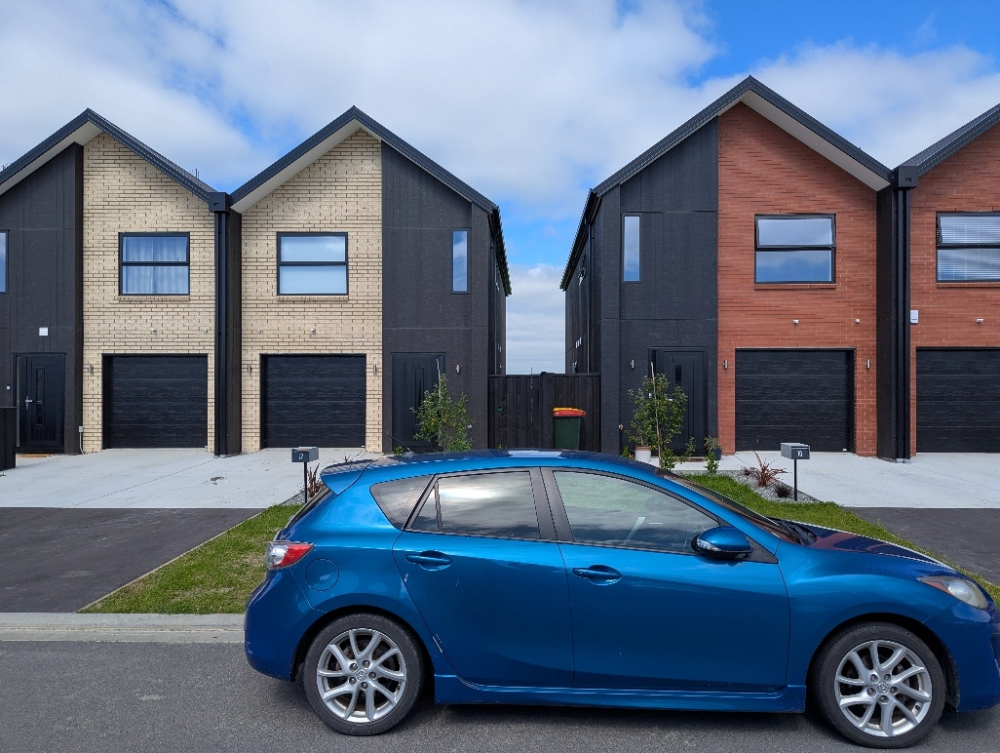
Figure 3 – Example of closely spaced driveways reducing on-street parking capacity (Source: SDC)
Houses are getting smaller, as families are getting smaller and sections are getting smaller as cost of land and construction increases. However as discussed further below, private car ownership remains high. Demographic and socio- cultural changes demand a housing mix, vertical density and alternative housing typologies that are missing in the districts. The current provisions of dominantly stand-alone housing types are land hungry and will not be suitable for changing demographics. The spatial benefits of higher density housing however need to be balanced against increased pressure on the public realm and appropriate transport, safety and amenities measures, which need to be planned concurrently.
THE NEW ZEALAND CONTEXT
Response to National Policy Statement on Urban Development
In response to the NPS-UD both Selwyn and Waimakariri District Councils notified Variations to their Proposed District Plans in August 2022 to incorporate mandatory MDRS. These standards have immediate legal effect for sites within a Medium Density Residential Zone (MDRZ). The zone provides areas for a higher density of residential development than elsewhere in the districts and require a high level of services including footpaths, street lighting, and neighbourhoods that are internally well connected by roads, pedestrian paths, and cycle routes. This is desirable but puts pressure on Councils to provide the services to match the zone expectations. The benefits of higher density development in close proximity to centres, public transport, open space and community infrastructure facilities is well-documented (Bramley, 2022, Olin, 2022). This approach will assist in minimising urban sprawl and increase housing supply and choice within the districts.
Associated car parking policy
Policy 11 for the NPS-UD required the district plans of Tier 1, 2, and 3 territorial authorities to remove any minimum car parking requirements, other than for accessible car parks. SDC and WDC are Tier 1 authorities and have removed minimum car parking rates in line with government direction at a time when, in both districts, sections were larger and parking was largely dealt with on site. The NPS-UD also strongly encouraged local authorities to manage effects associated with the supply and demand of car parking through comprehensive parking management plans (PMPs). In order to meet public and business expectations SDC has invested in significant new public parking areas as part of its ongoing town centre upgrades at its largest townships of Rolleston and Lincoln. Waimakariri recently completed PMPs for the two larger town centres, Rangiora and Kaiapoi, with expanded parking areas expected over the next decade, although this is chiefly for businesses and shoppers and is unlikely to impact residential parking demand.
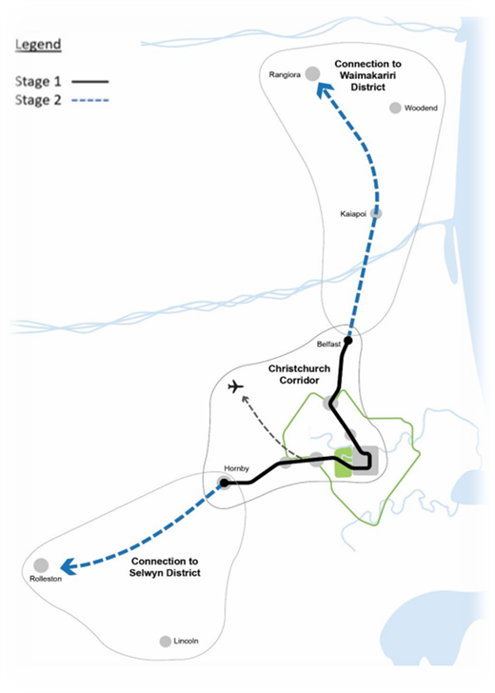
The approach of removing minimum parking contributes to making housing more affordable and is considered best practice internationally. However, it needs to be accompanied with alternatives to private motor vehicle travel to facilitate a reduction in car ownership. Currently New Zealand has a high car ownership rate (approximately 800 vehicles per 1000 thousand people, and 58% of households owning 2 or more vehicles) compared to most other developed countries. European countries with high density urban areas have around 500 vehicles per 1000 people. The removal of minimum parking requirements should be facilitating a step change towards lower car ownership. However, the supporting urban form and lack of alternative transport arrangements are not enabling car ownership reduction.
Residents, particularly in the Selwyn and Waimakariri context, are unlikely to reduce their car ownership in the short term and this is putting pressure on the street environment.
The proposed mass rapid transit (MRT) connections to Christchurch shown in Figure 4 will assist with transport choice for residents in both districts. The Greater Christchurch initiative to improve public transport services was established in the 2020 Greater Christchurch Public Transport Combined Business Case that adopted a programme to improve PT services.
Figure 4 – MRT links (Source:PT Futures Business Case)
This business case included a further PT Futures Mass Rapid Transit (MRT) Indicative Business Case (NZTA, 2023) for a Christchurch system that has the potential in future to expand out to the districts. The benefits from MRT are not likely to be experienced in the short term, rather an expansion of the bus-based public transport system to reach all the new greenfield areas is more feasible. This is an example of no immediate additional resources or legislative impetus being provided to expand public transport and walking/cycling to encourage a corresponding reduction in car use that should go hand in hand with removing parking minimums.
While both districts have parking strategies in place, they currently don’t directly address the increased pressure in the context of increased higher density housing development.
Medium density housing in Selwyn and Waimakariri could include development with no on-site parking or one space per household only. Alternative solutions to solely relying on public space need to be explored now to be able to respond timely and with a long-term view. In Christchurch, it is understood that the ratio of parking spaces provided per unit is one parking space per unit on average and Selwyn developers appear to be adopting this approach. When garages are being provided in developments these are often used for other purposes such as storage of bicycles and outdoor equipment. Some developments are providing secure parking for residents only, such as shown in Figure 5.
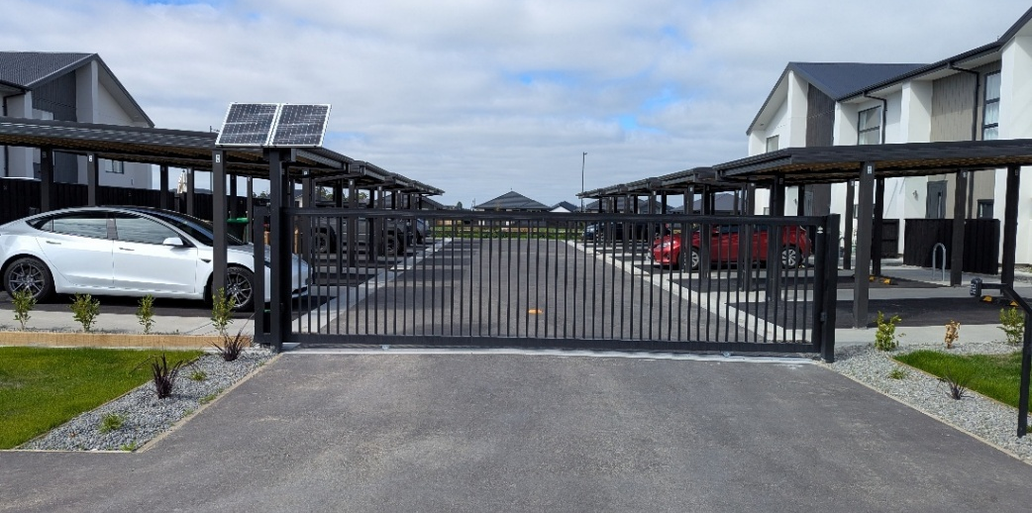
Figure 5 – Example of secure, resident only parking in medium density development (Source: SDC)

ISSUES EXPERIENCED IN NEW ZEALAND – TWO STUDIES
Some Councils in NZ have experienced issues as the scale of medium density housing increases. Auckland and Christchurch for example are experiencing the most uptake of medium density development, particularly intensification, and hence had been progressing specific plan changes for pedestrian and vehicle accessway provision in response to issues arising. Proposed RMA changes and Government direction mean that plan changes and District Plan requirements may not be able to respond to the issues arising. Instead, codes of practice and early engagement with developers may be the most likely instruments to address the issues.
In Auckland a study, Life in Medium Density Housing in Tāmaki Makaurau / Auckland (TMDO, 2023), was undertaken by Auckland Council’s Economic and Social Research and Evaluation team and Tāmaki Makaurau Design Ope (TMDO). The primary purpose of the research was to investigate how Aucklanders are experiencing living in recently built medium density housing, this included transport aspects such as car parking and vehicle storage. In Christchurch a Medium and High Density Housing in Christchurch Urban Design Review (CCC, 2020) was undertaken. It is noted that when parking is referred to by the studies, it is assumed it included resident and visitor parking as there was no mention of the two types as being different in the studies.
The transport related issues found by these two studies are:
- Consistently poor performance relating to communal spaces such as accessways, with the exception of car-free central city developments. The review recommended there needed to be a greater focus on the overall design and amenity of accessways as these usually provide the main access to each unit on foot and by car. However, they often lack a comprehensive landscape design, appropriate separation between the accessway and units or a clear pedestrian access.
- Accessways were used in ways that were not intended but were foreseeable. Examples include wheelie bins stored on accesses where individual storage areas were inconvenient, and cars parked in manoeuvring spaces (in front of garages), sometimes blocking access to front doors. This review was the precursor to a CCC Plan Change (PC14).
- There is an increased number of developments with no onsite car parking provided, resulting in a significant number of cars parking on public streets, and illegally parking over berms and footpaths.
- Where onsite parking is provided, it is often insufficient for the number of vehicles per household, with unanticipated and ‘creative’ parking occurring within driveways (often blocking pedestrian access) or areas intended for landscaping or outdoor living space.
- There is an increasing use of communal carparking areas rather than individual garages due to site layout efficiencies and increased yield (the productive output or financial return generated by a piece of land).
- Provision of visitor parking or loading spaces for delivery vehicles is uncommon.
Figure 6 shows examples from the TMDO study reflecting the above observations and wheelie bin placement on collection day that partially or fully block the footpaths.

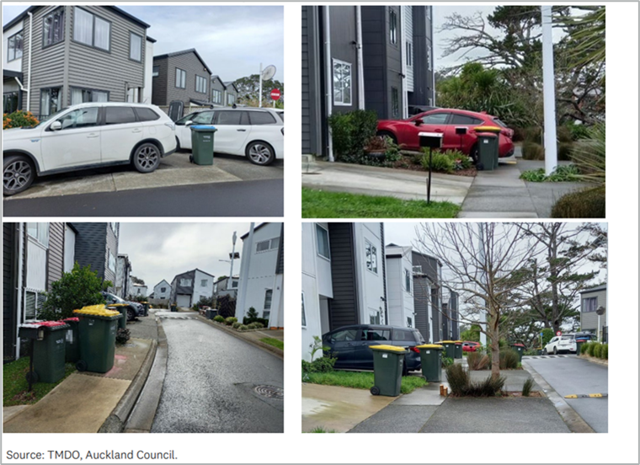

Figure 6 - Examples of the observations made in the TMDO study

TRANSPORT ISSUES DISCUSSION
Overarching issue - General parking considerations
Residential parking demand in association with medium density housing is generally exceeding parking supply (both on-site and on-street). This is a contributing factor to the issues raised in this paper and discussed below.
Developers are not required to provide on-site parking but when they do, guidance is needed on how this might be supplied in a safe manner and with consideration of amenity. Developers also need to appeal to the needs of the market that may influence what they feel comfortable with providing. Options generally include garages or spaces with direct access from the street, rear parking accessed from an accessway/ROW - either to spaces at the rear of each house or to communal car parking. Guidance needs to be supported with a parallel educational process to bring developers on board.
The estimated parking demand for future higher density developments needs to take into account that garages have multiple (storage of cars being one) functions. Designers and reviewers of plans need to be vigilant to design spaces with storage in mind. Site and design specific solutions often sit outside what is currently proposed in the District Plan or Engineering Code of Practice (ECoP) and require an open approach.
The provision of bicycle parking when no garaging is included needs consideration as communal parking, although it might be secure is often not preferred by residents. Developers also tend to not favour communal provision. This issue could be raised with architects in terms of developing smart bike storage solutions integrated into the buildings.
Councils also have a role to play in the management of parking effects. PMPs are becoming more important in terms of anticipating effects, and developing proactive solutions such as resident parking zones (e.g. near centres that have parking overflow into residential streets). This includes more use of Parking Wardens to enforce parking bylaws which may not sit comfortably with new residents that are not used to this approach.

Issue 1 - Medium density infill/ intensification in existing streets
When no or limited on-site parking is provided in association with intensification, the existing frontage street will need to cater for the increase in parking demand. The layout of the street will dictate how this is catered for; for example, a narrow street may mean parking occurs on one side only. Bicycle storage becomes even more critical when the traditional secured space of a garage is not provided, and as such need’s proactive consideration by developers. Accessible parking and loading have historically been accommodated on-site at individual houses and District Plans often do not have requirements for each in a residential context. Larger residential developments with no on-site parking or loading may also require consideration of a change in approach (e.g., retrofitting on-street accessible parking or loading zones, similar to in town centres).
Issue 2 – New street design
The design of streets in new medium density housing areas offers the opportunity to consider of aspects that can impact safety, operations and amenity outcomes. Table 1 outlines a range of aspects and associated considerations.
Aspect | Considerations
Road reserve width | - How to fit all the elements in, e.g., parking, footpath, cycling, services, trees, driveways  - Managing developer expectations on road space within developments (since smaller sections already require more roads to access)
Carriageway width | - Parking parallel, indented or angle  - Parking behaviour (too close to driveways, parking opposite other vehicles on too narrow streets)  - Speed management and side friction  - Large vehicle manoeuvring (emergency responders, rubbish collection)  - Geometric design (safety and operational impacts of low-radius curves, substandard intersection spacing)  - Shared space streets (requires detailed guidance to get good outcomes that have acceptable long-term maintenance costs)  - Tension between creating a space that doesn’t read like a road vs. having a low-maintenance asset  - How to address streetscape and parking when vehicle crossings may be constructed separately from development (by future individual builders)
Pedestrian circulation | - Footpath widths, on one or two sides of street  - Safe intervisibility at vehicle crossings (also crossings of cycleways / shared paths)  - Effects of kerb-adjacent footpaths (poor cross-slope, wheelie bin conflicts, footpath parking, amenity/safety)
Trees and landscaping | - High importance for traffic calming, heat island, stormwater attenuation, creating urban tree canopies  - Increased importance due to the potential lack of on-site greenery
Waste management | - Conflicts with pedestrian circulation, parking
Accommodating services | - Larger power boxes for serving households  - Conflicts between trees and buried services  - Need to consider future access (like fire hydrants in roadway)  - Disruptive effect of trenching when located under footpaths or in roadway
Table 1 - Streetscape elements and management

From a scan of international examples, it is noted that shared space streets are often implemented in residential streets with medium to high density housing. Implementing shared space residential streets in New Zealand is rarely adopted and can result in substandard narrow roads instead of true shared space. Further work in this area could be beneficial.
Issue 3 – Accessway design
The design of accessways when parking is provided in new medium density housing developments, requires consideration of aspects that can impact safety, operations and amenity outcomes. Table 2 outlines the aspects and associated considerations.
Aspect | Considerations
Managing conflicts between vehicles and everyone else | - Providing safe spaces for walking/cycling that are appropriate to scale of development  - Intervisibility between traffic on the accessway and vehicles manoeuvring out of garages or side parking
Personal security | - Adopt Crime Prevention through Environmental Design (CPTED) principles – such as line of sight along the access  - Providing appropriate lighting of accessways (also considering long term costs and maintenance)
Inappropriate parking | - Parking in turnaround spaces  - Parking in the accessway traffic lane and on any footpaths needs to be managed, through design features rather than signage and markings
Provision of heavy vehicle access down long ROWs | - Rubbish collection (if consolidated waste bins on-site)  - Emergency responders  - Deliveries
Greening and amenity | - The space to ensure landscaping can be provided  - Materiality of the surface to create an attractive space  - Provision of play space separate from trafficked areas where children are present
Long term maintenance arrangements | - Including communicating maintenance requirements to future residents as they get more complicated
Defining public space vs. private residents’ space | - Defining public space vs. private residents’ space  - Lack of custodianship (maintenance)
Stormwater management | - Sustainable options could be considered  - Channels can be integrated into the design
Table 2 - On-site private access (Right of ways)
More typically accessways in the intensification scenario are basic with some providing a separate footpath, if the width of the section being developed allows this. However, in the case of recently constructed housing in Figure 7, the flush footpath defined using a darker surface could be used by residents for parking, losing the intent of the path for clear pedestrian access.
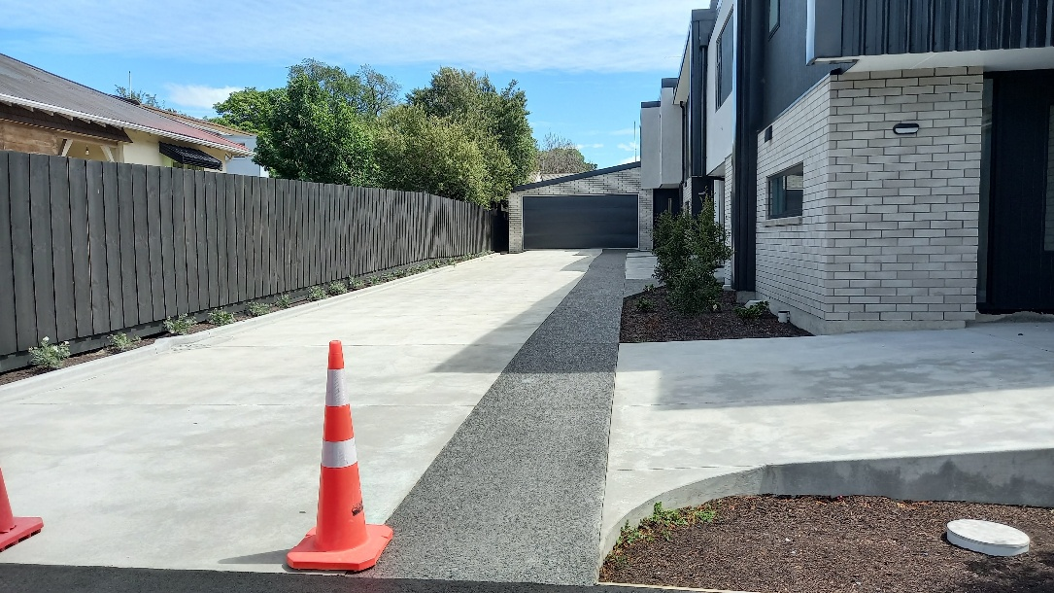

Figure 7 – Recently constructed accessway with delineated pedestrian space (Source: Jeanette Ward)

More recently Christchurch City Council published Multi-unit housing design guidance (CCC, 2025), including accessway design, see Figure 8. The image on the left reflects the current practice shown in Figure 7, however the guidance promotes shared accessway design shown on the right. This includes more landscaping and surfacing that provides cues to drive slowly and share the space.

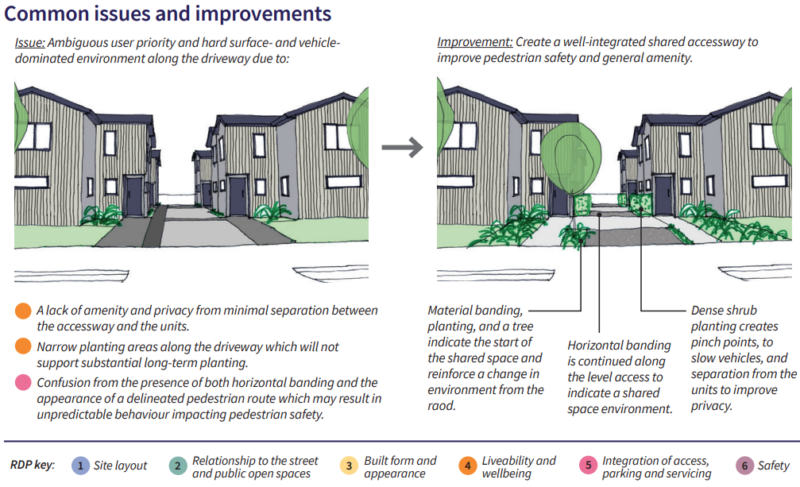

Figure 8 – Accessway design guidelines (Source: CCC)
ADDRESSING THE ISSUES – EXISTING GUIDANCE
When the NPS-UD was introduced the Ministry for the Environment published a Medium Density Design Guide (MfE, 2022) that provides non-statutory guidance for medium density development. It includes some high-level guidance on transport aspects, such as car parking and vehicle accessways; however, it does not provide detailed guidance on accessways and street design. Instead, it relies on District Plans, non-statutory design guidelines and engineering codes of practice (ECoP). There remains uncertainty around the future of District Plans given proposed Resource Management Act (RMA) reforms in New Zealand.

SDC and WDC both have an ECoP, these will be updated to address some of the considerations above. For example, WDC are developing updated requirements for carriageway widths based on examining built streets (even in low density developments). These streets are under pressure from increased on-street parking and the need to cater for fire trucks and waste collection trucks, but retaining side friction to keep driver speeds low is also important. Many streets function as ‘yield streets’ with a carriageway that requires people driving vehicles to yield to one another to pass. These still allow access by very occasional heavier vehicles, and have a typical carriageway width of approximately 7-8m.
SDC had included in a previous District Plan the ability to create narrower streets on the request of the Development community. For the Council this was on the basis it would enable the use of “shared space”, low speed, high amenity streetscapes integrated into the adjoining development. However, what generally resulted was overly narrow standard streets that lacked parking, footpaths and other unacceptable outcomes.
NZ Standards and the Building Code are other sources of requirements that can “force” actions. But these are generally accepted in the development process and cover business as usual aspects (such as lighting) and don’t cover many of the considerations discussed above.
Some councils are likely to develop medium density design guides; these will not include regulatory requirements but can provide illustrations on how to meet the intent of any mandatory requirements in District Plan and ECoPs. For example, Central Otago District Council has developed a draft Medium Density Residential Guide (CODC, 2022) that included street design considerations.

CONCLUSION
Medium density housing is beneficial to society as it contributes to more efficient of land, reducing the extent of urban sprawl. Medium density housing with no on-site parking also contributes to more affordable housing.
Understanding and resolving the transport aspects of providing medium density housing is an evolving area in New Zealand. It is possible that international experience may provide learnings, this needs further examination.
SDC is aware that the current requirements in their District Plan and Engineering Code of Practice will not address the potential issues associated with medium density. They plan to update the Engineering Code of Practice and residential design guidelines. WDC are also looking at changes to their District Plan and Engineering Code of Practice. However there remains uncertainty around the future of District Plans related to proposed RMA reforms. This will put more emphasis on codes of practice and design guidelines, education and early discussions with developers to ensure good transport related outcomes in association with medium density housing.
Findings
- There is little published work in this area however studies from Auckland and Christchurch have shared some issues being experienced with medium density housing, both in the intensification and new development scenarios. Both of these councils have subsequently proposed changes to their District Plans with respect to vehicle accessways but not street design at this stage. In the case of Christchurch, they have also published multi-dwelling design guidance that includes promoting shared space accessways.
- Residential parking demand in association with medium density housing is generally exceeding parking supply (both on-site and on-street). This is a key contributing factor to the issues raised in this paper. The issue is twofold, firstly developers are no longer required to provide car parking and secondly the amount of motor vehicles per households in NZ remains high.

Recommendations
- How Councils ensure appropriate transport provisions are in place when an area is zoned for medium density residential is complex. Council have limited resources and rely on central (e.g. policy and funding) and regional government (e.g. public transport). There will also be public and developer expectations associated with these zones. In the case of intensification, Parking Management Plans are a tool to help Councils understand street and public space impacts.
- New Zealand needs to work towards lowering car ownership to support better use of land. This is not a simple task it relies on commitment from all levels of Government. It will be a long journey, but it must start now.
- In the meantime, the government, regional and local Councils and the development sector need to work together to manage the impacts of high car ownership while still keeping housing affordable.

REFERENCES
Auckland Council’s Economic and Social Research and Evaluation team and Tāmaki Makaurau Design Ope, (2023), Life in Medium Density Housing in Tāmaki Makaurau / Auckland
Bramley (2022), How Transports Planning Supports Density and Transport Equity, Transportation Group NZ Conference 2022
Central Otago District Council, (2022) Medium Density Residential Guide (draft)
Christchurch City Council, (2020), Christchurch a Medium and High Density Housing in Christchurch Urban Design Review
Christchurch City Council, (2025), Multi-unit housing design guidance Ōtautahi Christchurch https://ccc.govt.nz/assets/Documents/The-Council/Plans-Strategies-Policies-Bylaws/Urban-Design/Multi-unit-housing-design/Multi-unit-housing-design-guidance.pdf
Greater Christchurch Partners, (2024), Greater Christchurch Spatial Plan
MfE, (2022), Medium Density Design Guide
Olin et al, (2022), Inclusive and collective urban home spaces: The future of housing in Aotearoa New Zealand, Wellbeing, Space and Society Volume 3, 2022, 100080
Waka Kotahi, NZ Transport Agency (2021a). National Parking Management Guidance https://www.nzta.govt.nz/roads-and-rail/national-parking-management-guidance
Waka Kotahi NZ Transport Agency (2023) PT Futures Mass Rapid Transit Indicative Business Case, DRAFT Indicative Business Case https://ccc.govt.nz/assets/Documents/greaterchristchurch-/HuiHui-Mai/Mass-Rapid-Transit-Indicative-Business-Case-being-considered-by-the-Whakawhanake-Kainga-Komiti-12-May-2023.pdf
Waimakariri District Council, (2018), Waimakariri 2048 District Development Strategy - Tō Tātou Takiwā, Tō Tātou Wāheke 2048. Te Rautaki Whanake Takiwā

Building on vacant or underutilised parcels within existing urban areas (e.g. adding a building at the rear of an existing building).
Developing more homes within the established urban boundary through measures like adding apartments, townhouses, and terrace housing, or converting existing larger houses into multiple units.
Refers to land that has not been previously developed or built upon, often located on the edge of urban areas.

