Life changing outcomes from the Right Track programme
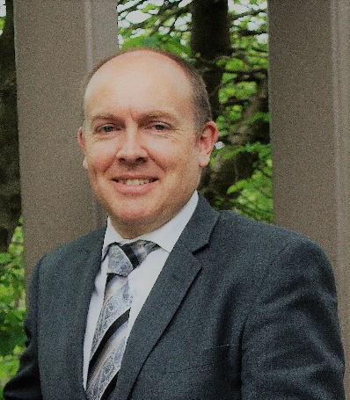

Dr Deane Searle

Intelligence supervisor, Waikato District NZ Police

Dr Deane Searle is a Supervisor with the New Zealand Police, leading a group of researchers that support harm prevention in the crime and crash environments. Deane led the establishment of the New Zealand Institute of Security and Crime Science, University of Waikato. This Institute is the primary research partner of the New Zealand Police and aims to reduce crime and crash through multi-disciplinary, evidence-based research. Deane is a founding member of the formation committee for the Waikato Alcohol and Other Drug Treatment Court. This Court’s role is to connect people with treatment, re-connect them with society and reduce re-offending. Deane’s academic background includes a master’s degree and PhD in counter-terrorism and counter-insurgency.

Mihi Bennett-Smith

Community Engagement Advisor, Hamilton City Council

Mihi Bennett-Smith is new to her role as the Community Engagement Advisor in the City Transportation Unit at the Hamilton City Council. She was previously the Road Safety Coordinator where she spent four years providing road safety outcomes for the City. During this time Mihi developed a keen interest for education and behaviour change through the various programmes, campaigns and training that she assisted and coordinated. She is looking forward to some new challenges in transport and is excited about the opportunities regarding the Vision Zero philosophy in Aotearoa.
Mihi is a beekeeper in her spare time and loves being out in nature with her family when they get the chance.

Combined Overview

The New Zealand Police motto is to build Safer Communities Together. This concept is Deane’s focus; enabling community safety by working collaboratively with others. Deane has supervised over 50 interns from the New Zealand Institute of Security and Crime Science. Examples of the work conducted by these interns include a wayfinding application (like google maps) that is being designed with and for Waikato Hospital, and evidence-based crime prevention enhancements being incorporated into new Hamilton homes through a partnership with Hamilton City Council.

The Right Track programme evaluation was similarly undertaken by an intern, working with the University of Waikato, Waikato Regional Council, Eduk8 Charitable Trust and New Zealand Police. The project’s aim was to give evidence of the effectiveness of the Right Track programme run in Waikato. The results were very encouraging.

Mihi Bennett-Smith has built a good working relationship with The Right Track programme (Te Ara Tutuki Pai) over the past four years in the Road Safety Coordinator role. She has seen and experienced first-hand the positive effect that the programme has not only on the participants, but the families and communities involved. While the focus is about changing driving behaviours and attitudes the programme strives to see a reduction in re-offending.

Hamilton City Council fund one of four Right Track Programmes annually and have done so since 2011. The Waikato cohort are a strong group who are made up of stakeholders from various organisations. These people are passionate about making a difference in the community by giving their time and energy to see people make significant changes in their lives.

