Do models help in accessibility discussions?

This paper has not been peer reviewed

When assessing accessibility, transport engineers historically have had a limited number of tools and been heavily focused on traffic circulation. This has disadvantaged projects for pedestrians or within pedestrian-dense areas, including those that support improved urban realm. In the context of the GPS and improved safety, accessibility and travel choices, this paper discusses the historic modelling and assessment tools, how these failed to transparently assess many relevant accessibility issues, and how this can be improved in the future. This will make reference to Auckland city centre, showing the journey Auckland Transport has been on in terms of better understanding and conveying accessibility and customer experiences. This paper should assist those involved in planning, assessing or explaining the merits of initiatives for pedestrians and people on bikes.

Author/presenter:
Daniel Newcombe, Manager Strategic Projects: Central Access,
Auckland Transport; MNZPI, daniel.newcombe@at.govt.nz

INTRODUCTION
This paper represents the author’s views on how people walking or riding bikes are considered within models for transport planning purposes. This comes from the author’s experience in this area and does not represent Auckland Transport’s position on accessibility modelling. The author is a transport planner, not a modeller, and the paper discusses how accessibility modelling supports or influences transport planning processes.

Although numerous definitions exist, the definition of accessibility in this paper relates to the ease with which an individual can reach or participate in activity opportunities by walking (but can be the first or last leg of a longer trip by various other modes).

BACKGROUND
For project development or more general transport planning, transportation professionals often need to understand current and potential levels of accessibility for road users.

In many rural or suburban areas this is a fairly straight forward process, due to the low number of users and limited user types. User volumes and their origins and destinations can be estimated and forecast with fairly simple processes. However, in busier town centres and city centres, the range and volume of user types, user modes, and the complexity of route choices means that assessing accessibility is far more complicated.

In locations such as Auckland city centre, not only are there an ever growing range of ways to travel around than before – e-scooters, shared e-scooters, bike, e-bikes, shared bikes, electric skateboards, ride-hail, etc. – but there are an ever increasing number of origins/destinations and route options, e.g. through-site links, alleyways, public spaces, underpasses, overbridges, lifts and escalators to access steep sites, and so forth.

The 24-hour nature of a city centre means that peak time travel patterns may be vastly different to interpeak and offpeak travel patterns. For instance, a street may be busiest (in terms of movements) at lunchtime and have a very different set of travel patterns in the evening compared to either of the weekday AM or PM peaks.

Historically, there have been only a limited number of modelling tools for transportation professionals to use and these have been heavily focused on vehicular trips in peak times. This has disadvantaged projects for pedestrians or within pedestrian-dense areas, including those that support improved urban realm.

This paper discusses the issue in terms of whether existing models – either current models or those under development – are a useful way to access accessibility.

WHY IS ACCESSIBILITY IMPORTANT?
Within the 2018 Government Policy Statement on Transport (GPS), ‘access’ is defined as people’s ability to connect with people, goods, services and opportunities and thereby engage in economic and social activity.

Access can be achieved through:
– the transport system which enables physical mobility
– the land use system which brings people closer to opportunities
– technology that allows people to access opportunities virtually.

The GPS identifies four strategic priorities:
¬ safety
¬ access
¬ environment
¬ value for money.

The diagram in Figure 1 summarises how access is considered amongst other GPS issues. In line with the objective of ‘enabling transport choice and access’, the GPS supports investment towards improving the safety of cyclists and pedestrians, as a key part of improving accessibility
and encouraging uptake of cycling and walking as preferred transport modes. It also enables transport choice.

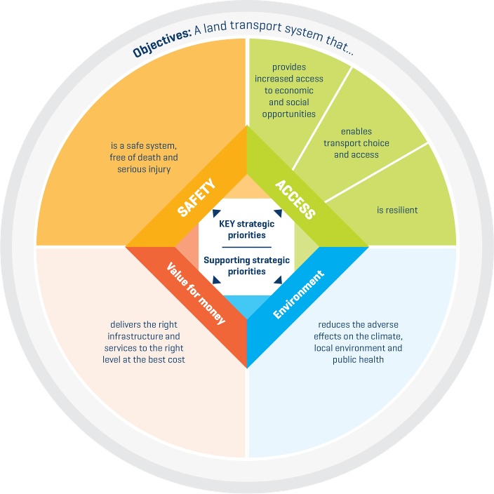

Figure 1: Diagram summarising how access is considered amongst other GPS issues

The GPS places increased focus on urban areas is to ensure that transport and land use planning reduces the need to travel by private motor vehicle by “improving access by reducing the need to travel long distances to access opportunities like employment, education and recreation” and “supporting a mode shift for trips in urban areas from private vehicles to more efficient, low cost
modes like walking, cycling and public transport.”

The ‘Environment’ section of the GPS recognises the importance of urban form for creating liveable cities that value public space and improve access.

The GPS also notes that people live in and visit urban areas (such as city centres) because they value access – access to ideas, jobs, education, goods, services, cultural facilities and public amenities. Hence, “well-connected and accessible urban areas are critical to our economic and social prosperity. It is about creating liveable cities that support economic productivity and
access to opportunities. People in liveable cities have improved health and personal well-being and increased social inclusion as a result of enhanced access and transport choice.”

ACCESSIBILITY ASSESSMENTS
The following discussion relates to accessibility assessments across a network. It is accepted that some of the assessments are far simpler and more relevant when applied to a single linear corridor.

At a local level, some of the tools for understanding accessibility include the commonly used ‘ped shed’ or walking catchment based on a defined walking speed, e.g. 5 and 10 minute walk distances. There are also cycling equivalents. Typically these use footpaths as the available routes, but in reality there are numerous additional route short-cuts (such as a through-site link) or severance points, e.g. a very wide and busy arterials, which are often not considered. These ped-sheds also do not accurately represent human behaviour, where pedestrians may decide to take a less direct route in order to avoid an area of perceived unsafety, pass a favourite café, or just walk in a ‘more interesting’ area. An example is shown in Figure 2 below.

Figure 2: Example of ‘ped-shed’ showing how far a pedestrian could walk within a defined time

Another way of assessing accessibility is through a more typical Level of Service (LOS) measure. The better the LOS for a corridor, the better the accessibility is assumed to be. However, this system has primarily been developed to assess vehicular movement characteristics - throughput, flow, level of interference from other vehicles, etc.

When it comes to walking and cycling modes, LOS is harder to accurately measure, given those users’ unpredictable behaviour and (for pedestrians in particular) less of the journey is about a simple A-to-B trip. There is also usually far less data available for making LOS calculations regarding pedestrians. Hence, LOS assessments for pedestrians often default to measuring average waiting times at signalised intersections, or possibly just the assumed width of a footpath. There is typically little data on the actual volume or patterns of pedestrian movements, or the factors that affect their route choices or experiences.
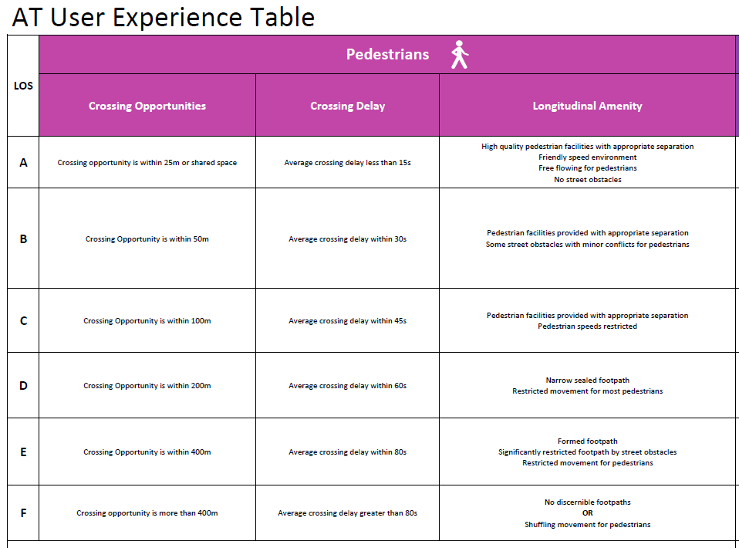
Figure 3: Example of Auckland Transport ‘Level of Service for pedestrians’ table

Many organisations have developed tentative models for pedestrian or cycle networks. These typically rely on known or assumed networks and spot counts to develop predictive characteristics.

Depending on the simplicity of the target network and the availability of survey data, these could be crafted into fairly representative models, however the further into the future these look, the less reliable they become. This is in part due to uncertainty regarding the land use activity along a corridor – e.g. a building may retain the same zoning for decades but go through a vast array of actual uses (e.g. café, office, retail store, vacant site, warehouse) each of which have a unique attractiveness for people walking to or past the site.

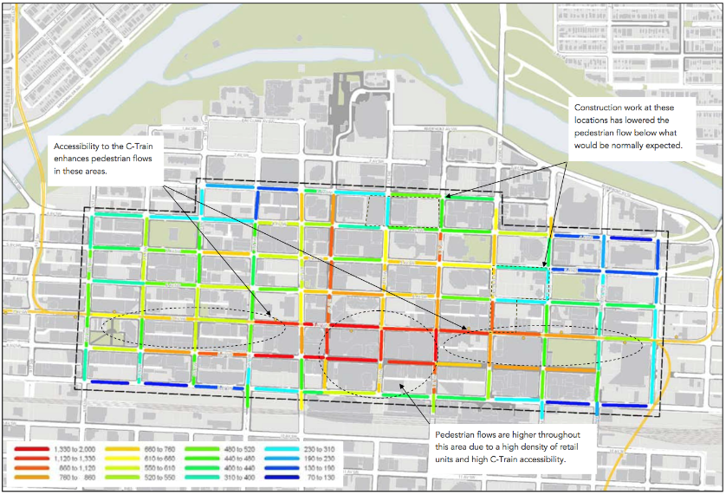
Figure 4: Example of a tool that will estimate the amount of walking activity occurring based on surrounding land uses (note this implies numerical accuracy but doesn’t clarify direction of movement or even which side of the street)

Models also have a hard time predicting human behaviour. People may chose a different route due to current weather conditions, perception of quality or safety of a route, perception of distance, perception of ‘hilliness’, interest in land use activities along the route, or any number of other personalised factors which are extremely difficult to predict or incorporate in a model. And the factors may change according to time of day, day of week and – most importantly – the individual user.

The lack of accurate, up-to-date and comprehensive data on walking and cycling activity is a major factor in reliability of models or projections. On a single linear corridor with few access points or changes in surrounding activity, it may be possible to create a simple model with reliable predictive abilities. However, in any complicated network, such as a city centre, the route choices, access points and destinations are difficult if not impossible to accurately predict. The only way to accurately survey this would be with a large number of surveyors tracking individual journeys to a high degree of accuracy (compared with traffic counts relying on tube counts or in-ground detector loops).

The most accurate or detailed pedestrian modelling are often developed for major events or public safety purposes, e.g. evacuation or access/egress modelling of a train station entrance. For instance, there is a detailed model for pedestrian activity at the future Aotea train station entrance in Victoria St, but no accurate model for those same pedestrians once they leave the station site.

Accessibility assessments are necessary (or at least useful) for street design, network management and operations planning, as well as economic evaluations. Therefore an inaccurate understanding of pedestrian or cycle activity could result in poorly designed infrastructure, operational problems (congestion, conflicts, and so forth) or failure to secure funding or achieve desired project benefits.

It is known that Peter Nunns at Wellington City Council is working on interim guidance for “Valuing footpath and pedestrian improvements” that addresses issues that are not currently covered by the NZ Transport Agency’s Economic Evaluation Manual procedures on valuing walking. Whilst more accurately evaluating the value of walking within the transport system is long overdue, again this will rely on a better understanding of actual walking patterns and volumes.

AUCKLAND CITY CENTRE
Auckland city centre is one of the busiest and densest walking environments in the country. It is an international centre for business, learning, and entertainment. Whilst it covers only 0.08% of the overall area of Auckland, it provides 14% of the region’s employment and 17% of the region’s GDP.

Auckland Transport (AT) monitors travel in and out of the city centre as shown below:

Figure 5: Screenline mode share – Auckland City Centre

The public transport measurement comes from digital records of passenger transactions, the traffic equivalent comes from electronic measurements at intersections on the city fringe, but the active mode measurement is assessed rather than accurately measured. There are annual or quarterly pedestrian and cycle counts, but these snap-shot counts are sparse compared to the ongoing data captured for other modes.

Tellingly there is almost no data on pedestrian movements within the city centre. There are 19 permanent walking volumes count stations available within the city centre operated by the local business association, which collect walking volumes throughout the year. However, these are mostly targeted at retail areas and exclude most of the city centre.

In 2010, Auckland Council commissioned a public life survey which included numerous pedestrian counts. These were repeated in 2015 and the Queen St pedestrian count recorded a 34% increase between the surveys. Due to the lack of alternative data, this statistic has now been used by Auckland Council as indicating a 34% city-wide increase in pedestrian activity, which is unlikely to be true as there hasn’t been an equivalent increase in population or employment.

To assess actual levels of pedestrian activity, a composite of data sets was put together, encompassing known commuter volumes, census estimates of the residential population and student numbers, and crude estimates of tourist/visitor numbers. This indicated that there were between 300-500,000 walking trips per day within the city centre (see Figure 6), assuming each of those people walked at some time during the day.
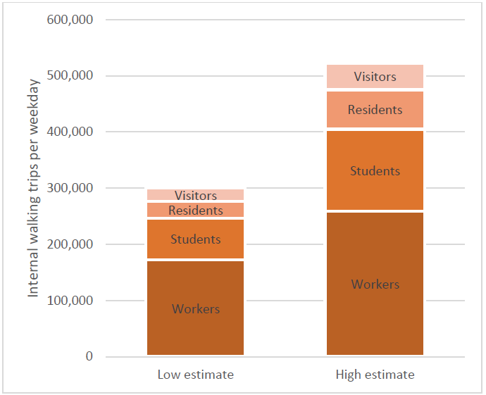
Figure 6: Estimated number of city centre internal walking trips

Of course, the actual number of walking trips is likely to be far higher, as people undoubtably make multiple walking trips each day. However, there is no data on where, when or why those trips occur.

Auckland Transport does report of pedestrian activity within the city centre, as part of a composite ‘dashboard’ each month. This contains very detailed breakdowns of traffic and bus average volumes, average speeds and levels of service. As can be seen in Figures 7 and 8, this can help show where delays or congestion is occurring, usually in relation to major on-street construction programmes.

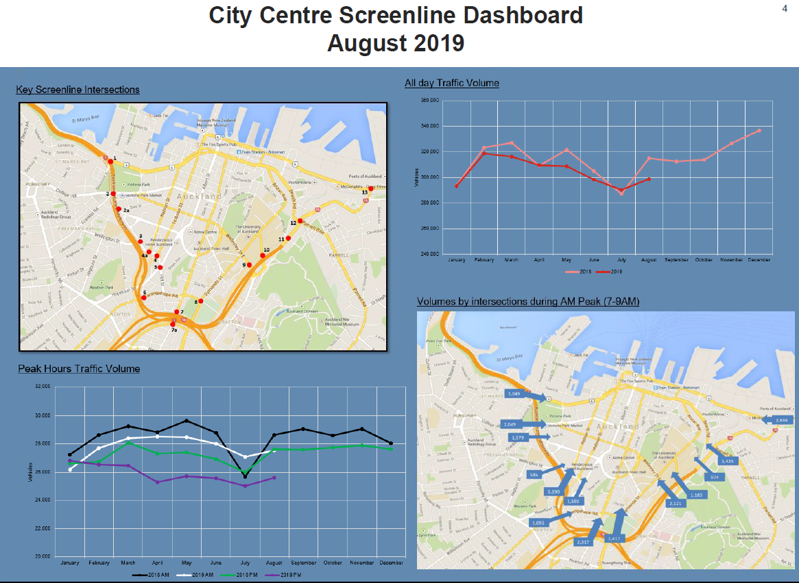

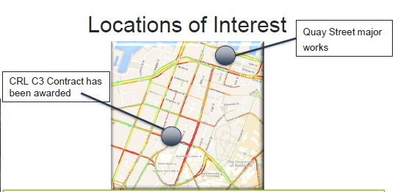
Figures 7 and 8: City centre dashboard outputs based on vehicular monitoring.

By comparison, the pedestrian and cycling assessments (as shown in Figure 9) amount to colour-coded LOS boxes, which tend to be based on intuition (e.g. there has been a lot of disruption and footpath closures this past month, so it is likely to have been worse than normal) rather than actual measurements or even asking pedestrians about their experience.

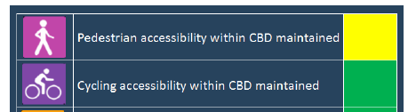
Figure 9: Pedestrian and cyclist LOS from city centre dashboard

Some major projects are required to or volunteer to monitor pedestrian and cycle activity as part of their construction. This is ostensibly to monitor whether the project is having an unacceptable impact on the walking and cycling environment. However, the experience from the Downtown Infrastructure Delivery Programme (DIDP) is enlightening as to the extent that monitoring may be somewhat misleading in its assumed usefulness. Looking at the quarterly reporting (shown in Figures 10 and 11), there appears to be a detailed and regular analysis of pedestrian and cyclist activity around the Quay Street site.
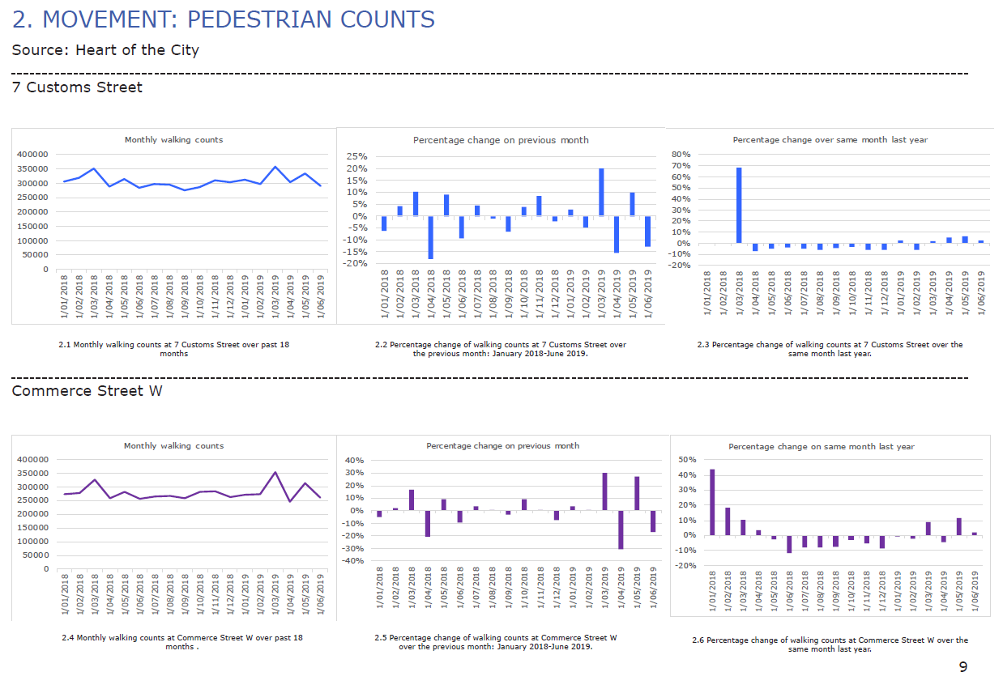

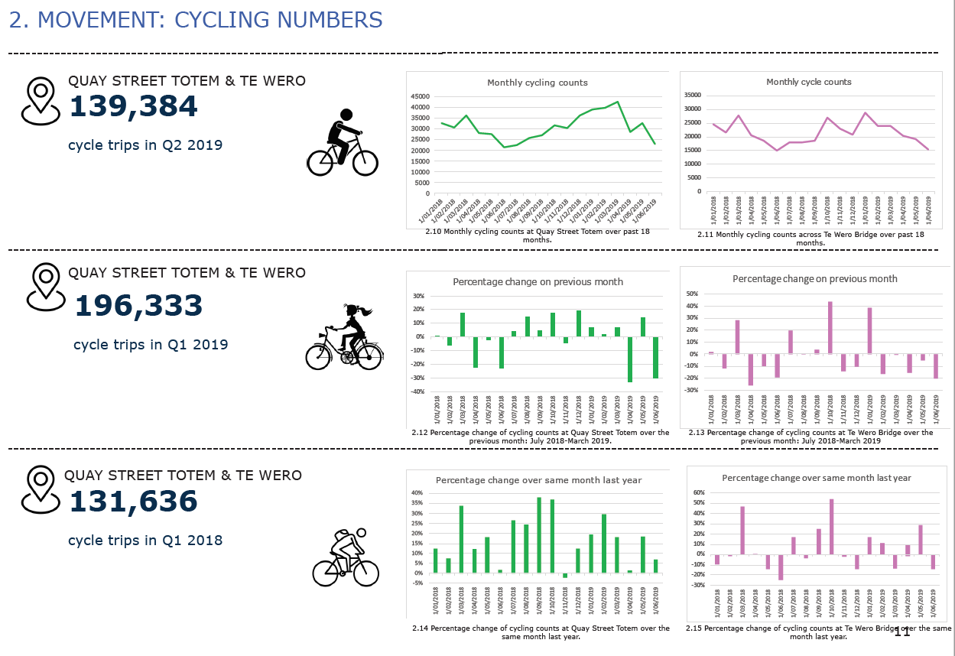
Figures 10 and 11: Examples of pedestrian and cyclist activity for Downtown Programme

However, a quick look at the construction sites (of which there are multiple across several blocks – see below) shows that not only are some footpaths entirely shut, others are significantly constrained and regular crossing facilities are unavailable. The construction sites, footpaths and crossings change week by week, and provide a challenging environment for users. In fact there are only two pedestrian monitoring sites which count footfall, but no other data to understand how this significant disruption is affecting walking and cycling trips in the area.
Figure 12: Major disruption to walking and cycling environment in Quay Street area

MICRO-MOBILITY
Another issue, one which may become more important in years to come, is the presence of micro-mobility modes, particularly shared ones. New shared e-scooters and bicycles are now a common sight on Auckland city centre’s streets, however the trips taken are not accounted for in any projections or modelling.

Although Auckland Transport and Auckland Council are working with the new operators to better understand the take-up of these modes, and what effect it is having on trips made, it may be years before a clear picture emerges and authorities are able to properly provide suitable infrastructure. Shared equipment opens up a massively larger range of users, so there is a real chance that significant proportions of trips which would otherwise have been made by car or taxi or bus, may now be undertaken via micro-mobility modes. And there may be additional trips induced by the new modes – but how many, and when, and what type, are as yet unknown.

All of this makes reliance on existing models an increasingly risky situation.

RECOMMENDATIONS FOR IMPROVEMENTS
There is clearly a deficiency in the provision of walking and cycling modes within existing and emerging transportation models. Some of this is due to the lack of data for these modes, but it is also due to an institutional lack of appreciation of these modes. For complex networks, such as city centres, this can result in a massive under-reporting of trips (especially short, unpredictable, multi-purpose walking trips) and lead to incomplete economic analysis and design provision, even for temporary environments such as construction zones.

The existing situation is that ad hoc snapshot counts are being used as proxies for walking and cycling trends, which is both inappropriate and risky. Ironically, even if a massive effort was placed into more accurate monitoring of walking and cycling movements, the uncertainty surrounding future projections (due to unknowns in human behaviour, changing land uses and emerging micro-mobility modes) means that transportation professionals may still not be confident of future trends.

This is important, as business cases often spend significant effort extolling the changes and benefits of traffic and public transport modes over the coming 30 years, however more significant and immediate impacts on pedestrians and cyclists are by comparison only very lightly considered. There is clearly an imbalance in the data available and reliability placed on what limited data there is.

However, there may be help on the way. Digital tools such as thermal imaging cameras and similar devices can increasingly be used to capture, measure and record walking and cycling activity in a reliable, low-cost, constant way that was previously unavailable. The quality, reliability and ubiquity of these cameras means it may shortly be possible to have sufficient coverage of a network to not only have robust monitoring data, but also create comprehensive models for forward planning. Examples of the emerging technology are shown in Figure 13 and 14.

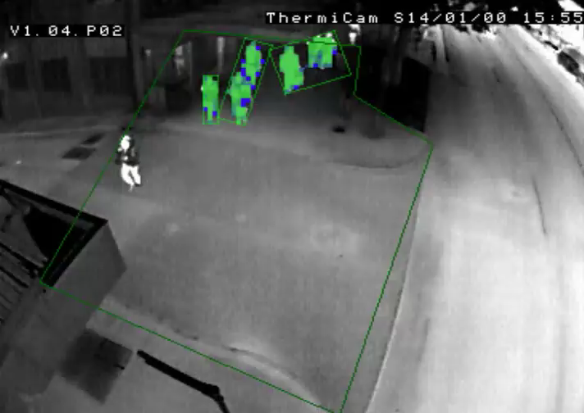
Figure 13: Example of digital camera image with individual pedestrians, and their direction of movement, able to be counted

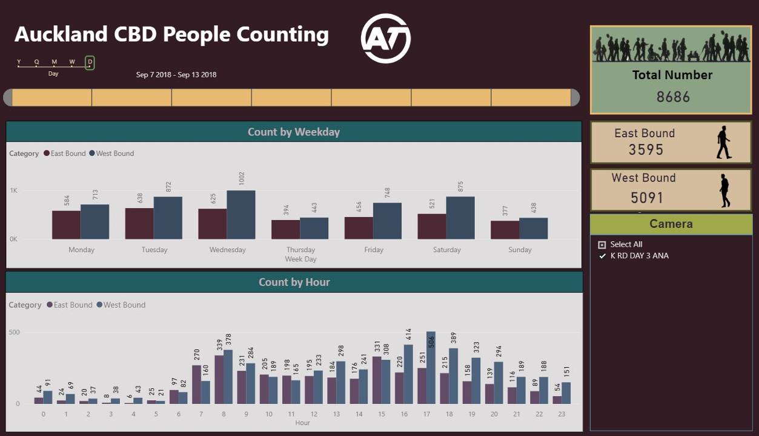
Figure 14: Example of possible output from digital camera with ongoing data on pedestrian movements, which can provide trend information and inform future models

CONCLUSION
Despite the importance given to accessibility by the GPS, and walking and cycling as modes for particular emphasis, this paper outlines the deficiency in the provision of these modes within existing and emerging transportation models.
This has been shown to be due to a combination of lack of data, lack of appreciation and sheer difficulty of modelling complex networks, such as city centres.

For transport planning purposes, this can result in a massive under-reporting of trips (or at least a tacit ignoring of those trips whilst assessing other modes) and lead to incomplete economic analysis and design provision.

Fortunately, this can be somewhat remedied by at least recognising this discrepancy and developing new technologies (such as automated digital cameras) to better monitor walking and cycling trips and work towards new and more accurate models (given that trends will be more easily identified).

REFERENCES
AUCKLAND COUNCIL (2012) City Centre Masterplan, Auckland
AUCKLAND COUNCIL (2017) Estimating Internal Walking Trips, Auckland
AUCKLAND COUNCIL (2010, 2015) Jan Gehl Public Life Survey, Auckland
AUCKLAND COUNCIL (2017) The Relationship between Pedestrian Connectivity and Economic Productivity in Auckland’s City Centre, Auckland
AUCKLAND TRANSPORT (2018) Auckland Walking Strategic Case, Auckland
AUCKLAND TRANSPORT (2019) Downtown Infrastructure Delivery Programme Quarter Two monitoring report, Auckland
NZ GOVERNMENT (2018) Government Policy Statement on Transport, Wellington

