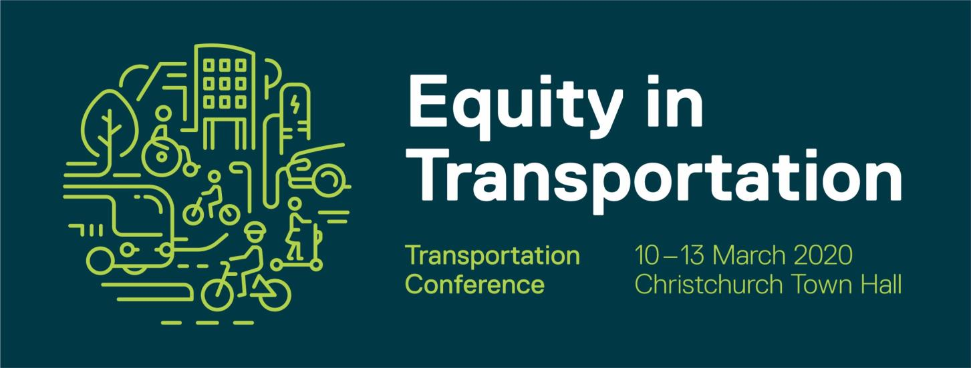

Redefining liveability in cycling heaven
I felt an incredible feeling of loneliness as I climbed back on my bike, in New Zealand, after 3 weeks in Amsterdam. As I descended the hill and rode my usual route to work, I realised I was missing some vital ingredients that had provided me with the happiness I experienced while cycling in Amsterdam. The helmet on my head had ended the feeling of wind through my hair. The streets were deserted of people, the only other presence on the streets were the car drivers wrapped inside their warm steel shells. There was no interaction with anyone, no dancing, no negotiations, no informal rules or cues to read.
I have recently returned home to Christchurch after studying a summer school paper, ‘Planning a Cycling City’ at the University of Amsterdam. I not only learnt about what contributes to a successful cycling city I experienced first-hand the incredible Dutch bicycle culture, how it has contributed to the overall liveability of Dutch cities and the happiness of the Dutch people. I had never before experienced the happiness that cycling brought me while I was in Amsterdam.
I had a narrow understanding of liveability before my trip to the Netherlands. My existing definition of liveability was a culmination of factors that add up to a community’s quality of life. These experiences along with the course literature helped me to redefine and shape my new definition of liveability. This paper expresses this new meaning of liveability. A city that puts people first in planning, provides the freedom of choice for mobility, has fairly distributed street space, allowing people to dance and play in the streets. These factors provide a sociable and stimulating environment where riding a bike is anything but lonely!


