STREETS AS PLACES – A PARTNERSHIP
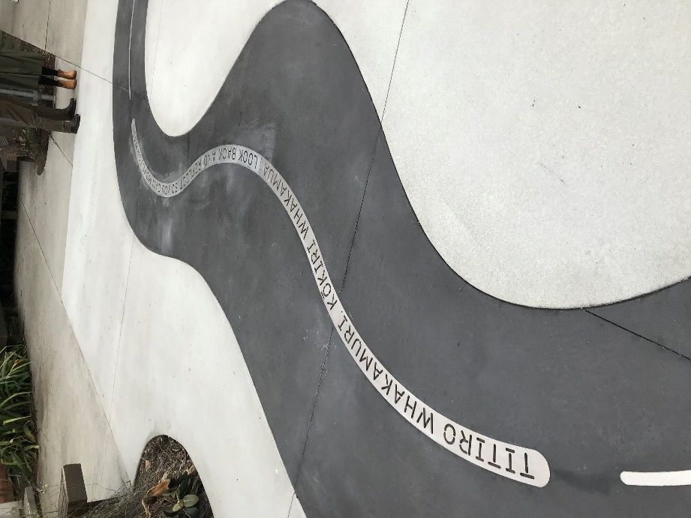  STREETS AS PLACES  A PARTNERSHIP  Fig 1: at sculpture garden SOLA Lincoln University (Author) | KIRSTIE THORPE  BLA (Hons)  NZILA Registered  Member UDF  Senior Landscape Architect  Stantec New Zealand Ltd  Kirstie.thorpe@stantec.com  aBSTRACT  As built environment professionals we all play a role in the development of our cities and streets. We all have a vision of what sort of place we want to live in, move around in, and the environment we want to experience. It is important to remember that streets are public places for people to enjoy as well as movement corridors for motor vehicles.  Landscape Architects working on street design projects are also concerned with current transportation issues and trends.  Street design is of fundamental importance to our experiences of cities and are places in their own right, being the corridors upon which we traverse, but also where we live, work and socialise. Cities and streets are part of the wider landscape and shouldn’t be seen as distinct from the landscape. Each street has its own character and identity that we can use to set the scene or tell a story. In this, Landscape Architects are crucial in bringing streets to life. The practice of examining landscape context and character, can provide a framework for achieving user and place focussed outcomes, to sit alongside movement functions. Thoughtful spatial development and detailing of surfacing, furniture, and planting, developed in partnership with transportation disciplines ensures the realisation of equity in transportation design projects.  This paper will explore a partnership, that of balance between movement and place, transportation and landscape. It will reference urban street projects in New Zealand, Queen Street in Richmond and Franklin Road in Auckland, and a UK project, the Baltic Triangle in Liverpool. All three projects, as multidisciplinary partnerships, will be used as examples to illustrate how we can all make streets a product of, and that support, local communities.

This paper has not been peer reviewed

INTRODUCTION
‘The street of to-day can sustain its human drama.
It can glitter under the brilliance of a new form of light.
It can smile through its patchwork of advertisements.
It is the well-trodden path of the eternal pedestrian, a relic of the centuries, a dislocated organ that can no longer function.
The street wears us out.
And when all is said and done we have to admit it disgusts us.
Then why does it still exist?’
Le Corbusier – Plan Voisin, Paris, France, 1925
Le Corbusier himself expressing his distaste at streets in central Paris on the right banks of the Seine River, what had become at that time effectively urban squalor, in what is now one of the most vibrant neighbourhoods in the city. His solution, which was incidentally sponsored by a car manufacturer, included massive glass skyscrapers and a transportation hub set amongst parks and roads. The scheme was never built, but it remains as an iconic piece of theoretical urbanism and one of Le Corbusier’s key works.

This paper will look at past and present perceptions of the roles of streets within our cities. It will examine historic and current best practise for street design, in relation to transport and the landscape. Then look future approaches to street design practice in New Zealand, and how we can reconcile our transport needs with the landscape.

‘Tetiro whakamuri kokiri whakamua’ – ‘Look back and reflect so you can move forward’.

DEFINITIONS

ROAD
A ‘Road’ to me is the surface that allows people to get from place to place. A road is defined in the common law, that New Zealand inherited from Britain, as ‘a place to which the public have access’ that has a ‘”right of way” or “right of passage” granted to the public by the land owner’.

STREET
In New Zealand, the term ‘Street’ is often used interchangeably with road. But it implies something more: movement and networks in places that are well used by people, in an urban setting, for example a city, and an implicit reference to a greater level of service, greater care, and different design standards for different land uses and contexts. Manual for Streets (DfT 2007) notes that a ‘clear distinction can be drawn between streets and roads. Roads are essentially highways whose main function is accommodating the movement of motor traffic. Streets are typically lined with buildings and public spaces, and while movement is still a key function, there are several others, of which the place function is the most important’. Many city plans, and indeed Waka Kotahi NZ Transport Agency’s (The Agency) One Network Road Classification, in New Zealand already take into account a street hierarchy. Within the context of our urban areas we often talk about the street network, an interconnected matrix of access ways, the life of our cities, the way we move around and in them. In using the terms ‘road’ v. ‘street’, we are already taking into account the difference between urban and rural landscape character.

LANDSCAPE AND LANDSCAPE ARCHITECTURE
Many people assume landscape architects design private gardens, and in fairness, many landscape architects do. In transportation, the term ‘landscaping’ seems to refer to planting on the side of a road. This may be a self-perpetuating association by the profession and the perception of landscape architecture in the ‘real world’ and even the ‘design world’ is that of a focus on form and aesthetic over function… a ‘nice to have’ at the end of a project, if it can be afforded, rather than an essential consideration. Landscape is something more;
Landscape includes physical elements, things that people see: images and views; nature: water bodies, mountains, plains, the sea; what covers the land; and the things that we use the land for, the things that we make that reflect our heritage and culture: things like buildings and structures and roads and streets. These are represented as landscape values or layers, that encompass how physical things, both natural and cultural, interact, and how humans interact with them. Landscape increasingly embodies intangible values, implied meanings through metaphor and storytelling.
The statement of philosophy of the New Zealand Institute of Landscape Architects – Tuia Pito Ora (NZILA) states, ‘Landscape Architecture is the sensitive and creative design of the land and spaces we inhabit. Landscape Architects can take on many roles – from designer to land-use mediator to conservationist.’ According to the Landscape Institute (LI) in the UK, landscape architecture is, ‘rooted in an understanding of how the environment works and what makes each place unique. It is a blend of science and art, vision and thought. It is a creative profession skilled in strategic planning, delivery and management. Landscape architects bring knowledge of natural sciences, environmental law and planning policy… And they create delight with beautiful designs, protecting and enhancing our most cherished landscapes and townscapes’.

LANDSCAPE CHARACTER AND IDENTITY
Landscape character is a distinctive combination of these landscape values or layers that gives a particular place or area its identity. Many character assessments exist for New Zealand’s rural landscapes that inform district plans. There are very few that assess our urban places and cities in terms of landscape. Auckland, Greater Wellington and Christchurch are exceptions, but even these only peel back the first few layers.

Understanding the values and features and interactions, is key. Through analysis of the character and identity of a place, landscape architects can ‘read’, plan and design, integrating developments into the landscape.

STREETSCAPES
So far there is little mention of vegetation and planting then, and a lot of thought behind people and the environment, wellbeing and social license. Wiktionary defines streetscape as, ‘the visual elements of a street, including the road, adjoining buildings, street furniture, trees and open spaces, etc., that combine to form the street's character.’

the role OF streets in our cities

the origins
The word street comes from the Latin strata, meaning a paved road. Some of the Roman Roads in England are named things like Ermine Street, Akeman Street and Watling Street, and were of course used to move marching armies. Settlements came to line these roads, and it became known that a ‘road’ was the way people used to travel, and that ‘street’ applied to paved ways.
Many towns in the UK were set out according to the land use of that place, for example a market, a bridgehead a harbour, with the layouts catering for movement on foot. Street widths in the UK were borne from public health concerns; to allow the movement of air and to prevent the spread of fire, and then to ensure that sunlight was able to penetrate to every house (Manual for Streets, DfT, 2007).

Streets now account for approximately 80% of public open space in urban areas (Urban Design Alliance [UDAL] UK, 2000).

development
Le Corbusier’s Plan Voisin for Paris in 1925, painted a grim picture of European streets and what they had become:
‘At the very bottom of this scenic railway lies the street, plunged in eternal twilight. The sky is a remote hope far, far above it. The street is no more than a trench, a deep cleft, a narrow passage. And although we have been accustomed to it for more than a thousand years, our hearts are always oppressed by the constriction of its enclosing walls. The street is full of people: one must take care where one goes. For several years now it has been full of rapidly moving vehicles as well: death threatens us at every step between the twin kerb-stones. But we have been trained to face the peril of being crushed between them’ (Fondation Le Corbusier).

The advent and popularisation of motorised transport took away the need to keep urban settlements walkable. Suburbia was born and illustrated best in post war U.S. where the stereotypical Dad would head off to work in the morning by car, out of the ‘cookie cutter’ suburb, where every house looked the same, and head into the city. As need grew, these roads into the city began to dominate the landscape, cars became status symbols filling the freeways in the US, to what effect?
- Cities becoming slums as people move into the suburbs,
- Effects on health and wellbeing,
- The erosion of the ‘street’ as a place for people who walk or people who cycle, to a place where cars dominate,
- The attitude that the ‘car is king’, that it is the divine right of a person in a car (rather than a privilege) to be driving in that space, and every other user of the street had better get out of the way,
- Only people who couldn’t afford cars taking public transport,
- Urban sprawl,
- Single car occupancy,
- Congestion and parking problems, road rage and emissions.
The car seems to be a recurring theme. Yet we embraced the car and still embrace it. Sitting on ever overflowing roads, in ever larger cars with ever more amenities is a way of life, an inevitable battle that’s current solution seems to be to build more roads.

design of streets
Design of our streets has come to reflect this:
- Wide carriageways to accommodate our wide cars and encouraging faster speeds,
- Large expanses of asphalt a cheap, smooth material, to make the ride smoother. Asphalt takes up most of the street, creating homogenous and grey expanses,
- Large radius turning circles, so that cars don’t have to slow down so much when they turn corners,
- Diminishing widths of footpaths,
- Offset pedestrian crossings, so that pedestrians are forced to be vigilant of cars, and not so much the other way round,
- Exclusion of vegetation, both street trees and low lying, due to sight line concerns or lack of space,
- Traffic signals that prioritise vehicles: 120 seconds wait time at pedestrian crossings. Two minutes that’s a really long time to wait when you are walking, just to clear some tail back or other,
- Car parking is accommodated on our streets, adding width to an already wide hard surface, and cutting down the availability of movement space with static objects,
- Token cycle ways that are narrow and often disconnected.
This design style sounds a lot like a road.

The 1960’s heralded a shift in street design and Urban Philosophy. Jane Jacobs in her 1961 book, The Death and Life of Great American Cities noted that, ‘the simple needs of automobiles are more easily understood and satisfied than the complex needs of cities… Streets in Cities serve many purposes besides carrying vehicles, and city sidewalks – the pedestrian parts of the streets, the main public places of a city, are its most vital organs…if a city’s streets look interesting, the city looks interesting; if they look dull, the city looks dull.’
This style started a response in the urban conscience in the U.S. in the 1960’s and 70’s, where the idea of landscapes in the city became increasingly desirable, regenerating the late nineteenth century concept of the garden city. This coincided with a new breed of landscape theorists and designers, like Lawrence Halprin, Garrett Eckbo and Ian McHarg who investigated landscape as a participatory activity as opposed to a picture or a view. We started seeing the appearance in our cities of designed urban pocket parks, like Paley Park in New York and Wilshire Plaza in Los Angeles, rooftop gardens and gardens in malls, that may have stemmed from a desire to give us relief from the busy streets, fulfil our desire for green space, and water in the city and to mitigate the visual impact of what our streets were becoming.

In post war Britain, the 1963 Buchanan report Traffic in Towns warned of the potential social, environmental and economic damage caused to cities by the motor car. It used a ‘predict and provide’ methodology and recommended that cities should rebuild themselves with modern traffic in mind. Certain standards should always be met, including safety, visual intrusion, noise and pollution and that some limitation of the volume of motor traffic would be unavoidable. By the mid 1970’s it was largely recognised, in development, that the focus on the traffic element wasn’t enough. Transport schemes started to widen their study areas to look at land use and the effects for public transport. In other European countries and in the U.S, such ideas were not bought into legislation until much later, where the importance of traffic flow remained, and still remains, at the forefront of street design.

The Buchanan report also advocated policy planning and consideration of the character being sought for each urban area or precinct, and that the level of traffic should then be managed to produce the desired effect in a safe manner, resulting in towns with a lattice of environmentally planned areas joined by an urban road hierarchy, a network of distribution roads then longer distance traffic being directed away from urban areas. This idea encouraged Dutch planners in Emmen and Delft who were developing the idea of ‘woonerf’ or living streets, that was then introduced back into the UK in the form of the ‘home zone’ in the last decade or so.
In 2007 the Department for Transport published Manual for Streets that heralded a fundamental shift in philosophy for the planning, design and management of streets in the UK. Manual for Streets (MfS) presented a case for placemaking and, among other things, gave practical detailed design solutions that responded to the needs of street users. It also introduced a priority matrix for users of the street putting pedestrians first, and then cyclists, then emergency service vehicles, goods vehicles and the private car last.

Working as a Landscape Architect and Urban Designer under this guidance, at the climax of a ten year street regeneration programme (CCMS – City Centre Movement Strategy) in Liverpool, from 2008 to 2011, presented a greater conscience of the street, and through the priority system, heightened my awareness of the importance of high quality public spaces (public realm). And what way to best express that in those public spaces where most people visit on a daily basis – our streets.

Having a landscape architect as the team leader of the Highways team at the Liverpool City Council was instrumental in ensuring that Liverpool adopted best practice street and public realm design. Liverpool’s own Public Realm Implementation Framework (PRIF) (2020 Liverpool [Mouchel], 2009) that interpreted the principles in MfS to a Liverpool Context. It identified elements that make up the public realm, street and space typologies, suggested material palettes for surfacing, signage, lighting, street trees and street furniture. It also covered highway alignment and layout, carriageway surfacing, road markings, cycle lanes and Green Infrastructure.
The Landscape Institute (LI) published their influential text, Green Infrastructure: connected and multifunctional landscapes in 2009. This publication calls for Green Infrastructure (GI) to be afforded the same priority as more conventional ‘grey’ infrastructure (roads and power lines). The LI state that GI ‘is the network of natural and seminatural features, green spaces, rivers and lakes that intersperse and connect villages, towns and cities. Individually, these elements are GI assets, and the roles that these assets play are GI functions. When appropriately planned, designed and managed, the assets and functions have the potential to deliver a wide range of benefits – from providing sustainable transport links to mitigating and adapting the effects of climate change’. The promotion of green infrastructure in Liverpool, especially on Highways projects bought me to realize that GI was also an important feature of streets.

street landscape design in new zealand
Street design has come a long way in the last eight years. Coming back to New Zealand in 2011, and among dealing with the realities of the Canterbury Earthquakes, I came into a design and planning environment where the Urban Design Protocol (MfE 2005) was the most recent urban design guidance. It offered some strategic principles, but no practical guidance on placemaking or design of the public realm. There was also NZTA’s old urban design policies and Guidelines for Highway Landscaping (NZTA, 2006), and ‘Design of Streets, a reference handbook for high quality streets’ (North Shore City Council 2009) whose introduction was written by Phil Jones, Co – author of MfS.

Compared to working on a street scheme in the UK, there was also more resistance to changes in behaviour with regards to motor vehicle use and parking, less respect afforded to people walking and people riding bikes, less budget to spend on high end materials for hard surfaces, less thought to the entire longevity and effects of maintenance for a project, less focus on pedestrian safety and accessibility, less respect afforded to the conditions that street trees are planted in and more focus on green fluff – the ‘landscaping’ dressing up the edges of a project, and usually right at the very end. In short, our streets were, and are still designed to prioritise cars. When designing a street, there wasn’t much to go on in terms of consistent guidance and easily recognised solutions.
Since then, NZTA has published Bridging the Gap – NZTA Urban Design Guidelines (2013) and Landscape Guidelines (2014) which supersede previous publications and introduce the notion of placemaking and integration of roads into the landscape, primarily focusing on areas that come within NZTA’s jurisdiction. The ironic thing is that I think that I am the only person in my office (full of transportation and planning professionals) that has copies, further indicating to me that this guidance isn’t being fully observed. Whilst this isn’t wrong, I would like to suggest that the design principles in Bridging the Gap and Landscape Guidelines be added to engineer’s road design checklists. There is still minimal local guidance available for streets. Auckland Transport’s Code of Practice (ATCOP) outlines policies and solutions for Auckland streets at both a strategic and detailed level, and Christchurch has its own Streets and Spaces guidance (CERA, 2015).
The term Green Infrastructure has come into use since 2013 and is an area that landscape architects seem to have relinquished in New Zealand to our stormwater colleagues.

Some excellent guidance out of the US, that may be more suitable in terms of a shared movement and place language is Rethinking Streets (SCI and NITC, 2013) that presents an evidence based argument for allocating street space effectively, examining land use and defining movement corridors to make it easy for people to use them – we now know these as complete streets. SCI and NITC published Rethinking Streets for People on Bikes in 2018. The projects and outcomes are fantastic, and the guides uses transportation language instead of planning or landscape language.
In street design we need to change once again. We are now responding to national and global crises – beyond landscape, or transportation – housing, the advent of megacities, public health, food, water – and climate change.

analysis
The key is language, but the conclusion I have come to is that all cities, face the same issues, where the dominance and needs of the car have eroded streets as places for people.

transport trends
There is a growing recognition that streets need to meet all of our needs, not just our need for movement. There is a growing recognition that streets really do more than just move cars. ‘Good streets are good places too – public places where people meet, sit and socialize, conduct business, wander about, play and more’

trends and some global solutions
The trends I have identified are needs based and around liveablility, balancing movement and place. We need our cities, and streets as key public places, to respond to global environmental concerns.

Make the transport and land use connection
‘The more activities and options a street offers, the more it attracts diverse groups of people - which is essential for creating a place that feels vibrant and dynamic’ . Brent Toderian, of Toderian UrbanWORKS said that ‘The best transportation plan is a great land-use plan’, and that transportation is a means, not an end. The goal of transportation planning is to ensure access, and access can be accomplished by this ‘co-location’ idea as well as by mobility.
One of the strongest ideas to emerge is transit-oriented development (TOD), in which mixed use residential and commercial developments are clustered around transit facilities, giving people access to local amenities within walking distance, and to transit facilities that can carry them further without needing to use their cars. Good developments also rely on parking availability, the mix and size of housing units, real-estate marketing and the self-selection of residents and businesses not just on the transit services.

CONTEXT & character SENSITIVE DESIGN
Streets need to be for people. The idea of a complete street is a simple one, and by using design judgment. The results of this paradigm shift are becoming more visible.
One of the streets we designed in Liverpool, Jamaica Street, as part of the CCMS, shows a lot of the really simple things that can be done to turn a street into a place:
- Improved crossing markings, and crossings that respond to desire lines of people who are walking,
- Consistent safety by design and crime prevention treatments,
- Tighter turning radii at intersections,
- Raised tables at intersections for safety of people who are walking (prioritisation) and traffic calming,
- Narrow traffic lanes to calm traffic and make crossing distances shorter for people who are walking,
- Wider footpaths, with space for outdoor retail, dining, and seating,
- Making clear the use of each zone in the street; road, footpath, street furniture zone, space for street trees,
- Large tree pits that provide a healthier growing environment but also improve drainage and reduce the impervious surface.
- Pre cast concrete pavers for the footpath surface to provide relief from the asphalt road,
- LED street lighting to provide white light, enhancing feature recognition,
- Consistent street furniture and hard material palettes.

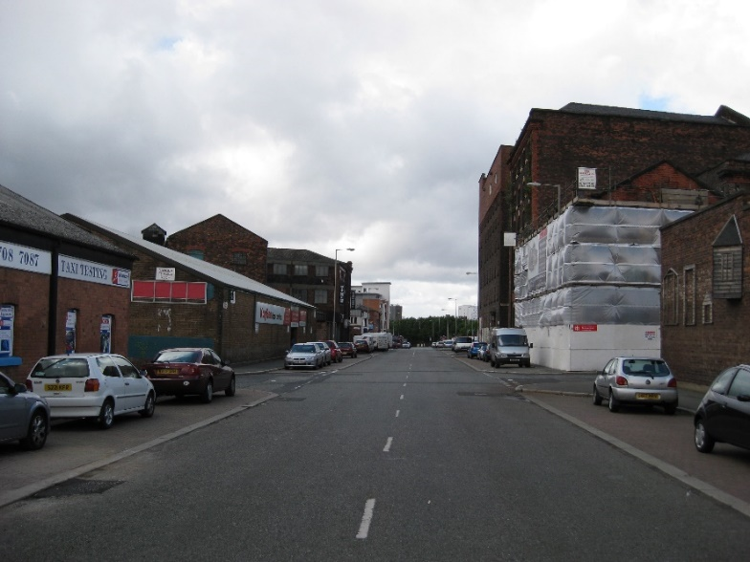
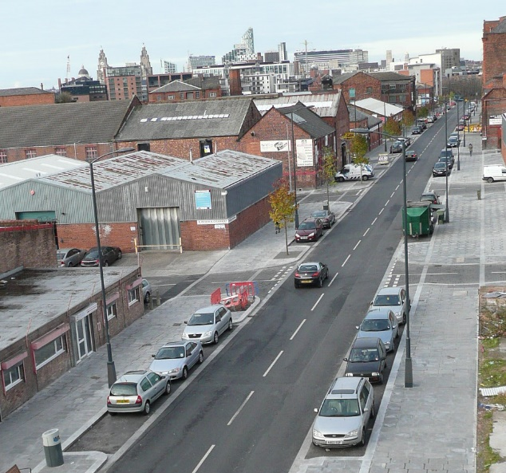
Fig 2 and 3 Jamaica Street before (2009) and after (2011) – images 2020 Liverpool (Mouchel)

make streets into destinations
As previously discussed the Dutch developed woonerf, people focussed ‘living streets’ in dense residential areas. The concept of shared space, where cars are compelled by design to drive slow so that people can walk, bike, and play in safety, has inspired ever more adventurous reconceptualisations of streets. Recently in Europe, the idea has been extended to central urban areas, with "naked streets" stripped of signals, signage and lane markings, encouraging slow speeds and user cooperation. This idea was also explored in Christchurch with the help of Jan Gehl prior to the Canterbury Earthquakes.
There are also conversions of one-way streets back to two-way. Christchurch has explored this idea. Cities in the Mid – West (U.S) that have converted one way to two way streets have noticed the primary benefit of city centre regeneration. ‘Streets which under one-way regimens only flushed cars out into the suburbs are being returned to their original function: providing access to downtown businesses and attractions. Business thrives as two-way traffic increases the number of visible storefronts, and slower traffic engenders a sense of downtowns as places to be experienced, by drivers and pedestrians alike’.

create liveable cities
Liveable cities are those that are walkable, bikeable and transit friendly. We can live in cities where we don’t need to use our cars so much. #AucklandWalkland – Brent Toderian’s challenge to Auckland, making walking the top transportation priority is an example of such a movement.
Time magazine lists Washington DC, New York City and Boston the top three walkable cities in the US. Florence, Paris, Dubrovnik, Vancouver, Munich, Edinburgh, Melbourne, Sydney, Amsterdam, Montreal, Venice, and Marrakech made various lists I looked at.
One of the biggest transport devices being employed in New Zealand cities right now is separated cycle lanes, and its working. Many other cities are focusing on cycle transit following the Dutch model of cycle infrastructure and cycle tracks in Jan Gehl’s Copenhagen. Many cities also employ bike hire schemes like the Velib in Paris, and Cycle Hire schemes in London and Liverpool.
Other transit technology, like light rail, streetcars, car sharing and bus rapid transit are being incorporated into city street networks.
Outside of Christchurch Franklin Road in Auckland is a project that has been well received by the local community. It is so because we looked at Franklin Road as a place, peeled back the layers:

- Undertook robust stakeholder engagement
- Prioritised walking and cycling through separation and providing more space for these modes
- Protected the heritage of the street through retaining and allowing the existing London plane trees to become the life of the street
- Reinstating the heritage bluestone kerbs and using high quality materials
- Employing innovative solutions to lighting and London plane tree protection
- Reallocating space encouraging behavioural change
- Providing a canvas for residents to install and maintain their own roadside planting
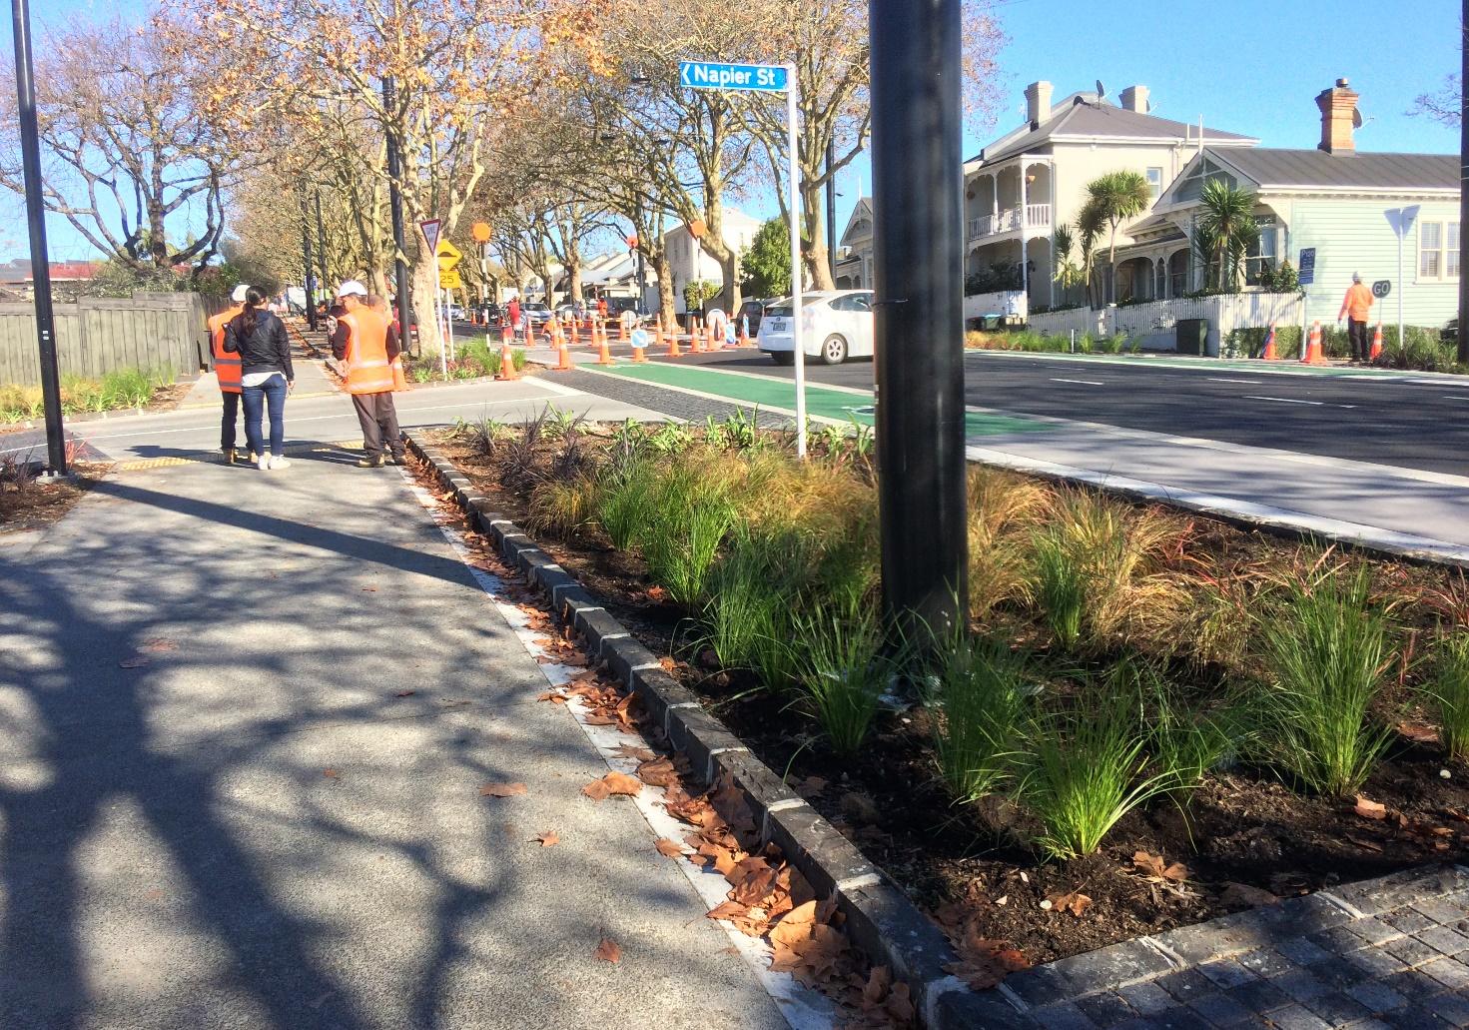
Fig 4 Franklin Road 2019 – Image Stantec
Collectively, these details support Franklin Road to be a more economically, culturally, and environmentally sustainable place.

GREEN INFRASTRUCTURE
I would like to reinforce the idea that the street is a feature in the landscape, one of the things that we see, as opposed to having planting on the margins of streets.
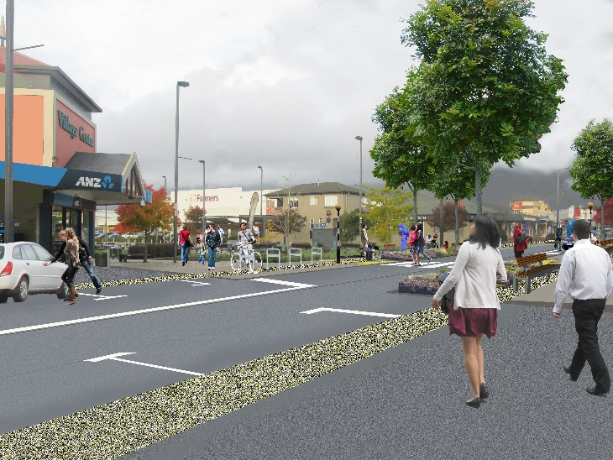
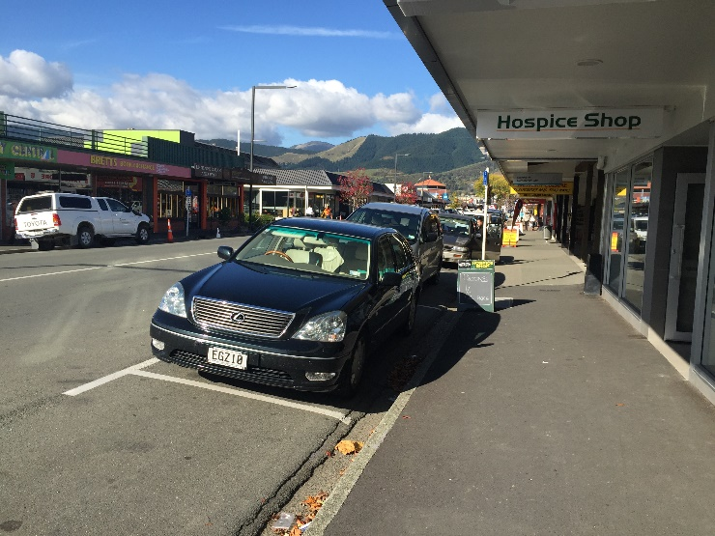
‘Rethinking the Urban Landscape’ (2014, 2015) is an exhibition curated by the Building Centre and the LI in London that has called for a landscape first approach to city and regeneration planning. It aims to show that ‘with long term landscape planning cities can become healthier, safer and happier places to be’. Other benefits, beyond the placemaking function, of incorporating GI into our cities include reducing the risk of flooding, and countering bad air and water quality.

Fig 5 Queen Street before (Author) Fig 6 Sundial Square impression (Author)

The Queen Street upgrade in Richmond Town Centre started as a catchment wide stormwater management study being undertaken by MWH for the Tasman District Council. The solution involved replacing the stormwater pipe down the middle of Queen Street, the main street in Richmond. The whole street now acts as a stormwater swale, its main features include:
- Inverted crown to the entire street drawing stormwater away from shop fronts
- Slot drain in the centre of the street negating a centreline marking
- Roundabouts at either end to divert stormwater and integrate the scheme into the transport network
- Narrow carriageways
- Wide footpaths with a coloured ‘buffer zone’ to separate the footpath and carriageway, provide a space for street furniture and allow retailers to display sandwich boards without cluttering the footpath
- 30kph speed limit
- Retaining on street parking (removed less than 10 car parks)
- Bringing previously developed ‘Sundial Square into the street through materiality and adopting the street furniture from that scheme
- Reusing existing traffic lights
- Leased parking space scheme for businesses
The street now feels calm. A place dominated by people, instead of cars. A series of nodes and non - nodes organises the space. The street too delivers on stormwater and transport safety requirements.

Suggestions for improving practice – A partnership

recognise that roads and streets exist in the landscape
The apparent lack of Urban Landscape Assessments, for me, reinforces the lack of status that landscape has in our cities, especially given that our cities in New Zealand exist in some pretty spectacular landscapes.

Strategic urban and landscape frameworks undertaken for our cities, as regional landscape assessments are currently done, would recognise the urban landscape and urban character areas, and take into account the cumulative effects of potential development pre-feasibility.
Undertaking such assessments would provide decision makers with an overarching framework for assessing the effects to landscape values (Natural Science, Legibility, Aesthetic, Transient, Tangata Whenua, Shared and Recognised, and Historic values) and visual effects (the effects on amenity to different people) of developments on character areas in cities. It would also assist landscape architects with project based landscape assessments as contribution to Assessments of Environmental Effects (AEE’s) and provide a basis for design of public space, providing consistency and coherence.

The NZTA now require Urban and Landscape Design Frameworks (ULDF’s) for their major projects and strategic business case initiatives, ensuring landscape character and place are at the forefront of transportation projects, and that budgets are set with this in mind.

develop multi disciplinary STREET design principles that IDENTIFY WITH AND RESPOND TO GLOBAL TRENDS IN URBANISM
We all play a role in designing streets. It is not down to one discipline, whether that be architecture, engineering, urban design or planning. Design comes from all of us. The Urban Design Forum (UDF) seeks to ‘promote cross - disciplinary understanding of Urban Design’ and to ‘raise awareness of the benefits of urban design at both national and local levels’.
In terms of a response to global trends in street design, in particular, national street design guidance to provide a consistent, legible approach to street design would be useful. We could adopt, or adapt Manual for Streets or the Global Street Design Guide (NACTO, 2016). We also have a growing body of tactical urbanism initiatives led by NZTA guidance Innovating Streets. It would need to be usable (easy to understand) by all professions, and set out some clear goals about what we want our streets to be.

follow public realm implementation frameworks / cars don’t buy things – people do
As the PRIF for Liverpool interprets MfS into the context of that city, such documents in New Zealand, such as the Christchurch City Council Streetscape Guidance and the City Centre Masterplan for Auckland, provide local interpretation, of the strategic urban assessments and national street design guidance. This is an essential step to provide designers with a consistent and agreed approach to street design within the local context. Standards, design details, material palettes and GI guidance that relate to land use and street hierarchy will result in good quality street design, implementation and fit in with the maintenance regime of Local Authorities. Many local authorities have Urban Design Panels to provide advice and make decisions on the suitability of developments. Good guidance will make their jobs easier too.

MAKE STREETS SAFER
I would like to propose that safety isn’t just about traffic modelling, guard rails, frangibile trees and sight lines. People who walk are king in street design, followed by people who cycle. When we make this paradigm shift in New Zealand, evidence suggests that streets will become safer for people, with the added benefit of creating great communities and great places. As fewer people drive, driving will also become safer. ‘The safest kind of street for people is a street full of people’.

DESIGN STREETS AS IF WE ARE THE PEOPLE THAT ARE GOING TO BE USING THEM
In recent years many urbanists (primarily on Twitter, which I find a really useful tool for keeping up with new trends) are now calling for an approach to design of streets as citizens, and not as designers. Jane Jacobs was a journalist and mother who organised grass roots events that put paid to the Lower Manhattan Expressway among other projects. Her book, The Death and Life of Great American Cities introduce concepts that we still use today, like ‘eyes on the street’ and ‘social capital’. She ended up one of last century’s most celebrated urbanists. With a more holistic view of street design we can break down the silo’s that exist between disciplines and return to the idea that streets are for people.

Conclusions
Streets exist in our landscape, yet landscape values and visual impacts are often overlooked in the early design phases for our cities. The popularity of the private car seems to have been the turning point, where our streets stopped being streets, and became unfriendly and unattractive to other modes of movement and access. To identify and respond to global trends, is to identify and respond to the needs of people, the way we move and communicate. We need to adopt clear strategic guidance, where the principles of landscape and movement work together toward implementation. In my experience, successful street projects are team efforts. Partnerships between the community, clients, stakeholders and designers are all essential parts of weaving together the multiple values and objectives that make successful places for people.

Kirstie Thorpe, 13 November 2019

AUTHOR CONTRIBUTION STATEMENT

The author prepared this paper.

REFERENCES
2020 Liverpool [Mouchel], (2009). Liverpool Public Realm Implementation Framework (PRIF)

Department for Transport. (2007). Manual for Streets. Thomas Telford. London. p15.

Jacobs, J. (1961). The death and life of Great American Cities. Vintage Books

Landscape Institute. (2009) Green infrastructure: connected and multifunctional landscapes, Landscape Institute position statement. London.

Lyall, S. (1991). Designing the new landscape. Thames and Hudson Ltd, London.

National Association of City Transportation Officials. (2013). Global Street Design Guide : Global Designing Cities Initiative. Island Press. Washington.

Project for Public Spaces. (2015). A street you go to, not just through: principles for fostering streets as places. https://www.pps.org/article/8-principles-streets-as-places

Schlossberg, M et al. (2013). Rethinking Streets, An evidence based guide to 25 complete street transformations. Sustainable Cities Initiative & National Institute for Transportation and Communities.

Waka Kotahi NZ Transport Agency. (2013) Bridging the gap: NZTA urban design guidelines. Wellington

Waka Kotahi NZ Transport Agency. One Network Framework, due for release in 2020.

Waka Kotahi NZ Transport Agency. (2014) Landscape guidelines. Wellington

http://www.fondationlecorbusier.fr/corbuweb/morpheus.aspx?sysId=13&IrisObjectId=6159&sysLanguage=en-en&itemPos=2&itemCount=2&sysParentName=Home&sysParentId=65
http://www.nzta.govt.nz/resources/what-is-a-road/what-is-a-road.html
Department for Transport. (2007). Manual for Streets. Thomas Telford. London. p15.
Waka Kotahi NZ Transport Agency are currently updating the classification, entitled the One Network Framework, due for release in 2020.
http://www.nzila.co.nz/
From the LI’s Royal Charter of Incorporation. (1997). - http://www.landscapeinstitute.org/about/
Jacobs, J. (1961). The death and life of Great American Cities. Vintage Books
Lyall, S. (1991). Designing the new landscape. Thames and Hudson Ltd, London.
Landscape Institute. (2009) Green infrastructure: connected and multifunctional landscapes, Landscape Institute position statement. London.
Schlossberg, M et al. (2013). Rethinking Streets, An evidence based guide to 25 complete street transformations. Sustainable Cities Initiative & National Institute for Transportation and Communities.
Project for Public Spaces. (2015). A street you go to, not just through: principles for fostering streets as places. https://www.pps.org/article/8-principles-streets-as-places
https://twitter.com/brenttoderian/status/390639363689697280?lang=en
http://www.sasaki.com/blog/view/336/- McClurg and Lyne (2013). 5 Trends in transportation and planning design.
http://www.sasaki.com/blog/view/336/- McClurg and Lyne (2013). 5 Trends in transportation and planning design.
http://time.com/money/2887232/the-futures-most-walkable-cities-prepare-to-be-surprised/
www.buildingcentre.co.uk/exhibition
http://urbandesignforum.org.nz/AboutUDF/tabid/296/Default.aspx
National Association of City Transportation Officials. (2013). Global Street Design Guide : Global Designing Cities Initiative. Island Press. Washington.
https://www.nzta.govt.nz/roads-and-rail/innovating-streets/
Brent Toderian @BrentToderian, 12/12/15

