USING SPEED-CRASH MODELS APPROPRIATELY

(This paper has been peer reviewed)

Bill Frith Road Technical Principal, WSP Research and Innovation MSc (hons) MSc (Transportation Engineering), BA, Life FCILT, Assoc Fellow ACRS, Member ICADTS
Fergus Tate, Technical Director-Transport, WSP NZCE, BE, MScEng, PhD

ABSTRACT

According to Ministry of Transport statistics excessive speed is a prime contributor to road trauma. In 2022 there were 104 fatal crashes, 459 serious injury crashes, and 1405 minor injury crashes where travelling too fast for the conditions was a contributing factor. In these crashes, there were 114 deaths, 572 serious injuries, and 2043 minor injuries.

There is a need to be able to assess the crash impact of speed changes. These changes may be upward or downward and may result from road safety measures, other unrelated factors, or a combination of both. In many cases such analysis requires models that link speed changes to crash changes (speed-crash models).

Speed crash models are well established in the literature but there is little in the way of simple guidance for practitioners on which models are appropriate to use in what contexts. For instance, different models may apply to different road types. Different models may also apply when the speed distribution changes in different ways. The speed distribution may be truncated, as in the case of a successful deployment of mandatory intelligent speed adaptation. In the case of successful Police enforcement, the distribution may to subject an overall downward move and some truncation accompanied by a reduction in the width of the distribution. These impacts may, of course happen in the reverse direction where speeds are allowed to increase. When choosing a model in a particular situation the principles on which the model is based are important.

This paper is intended to provide practitioners with some simple guidance on the type of speed crash model they might use when assessing the crash impact of a speed change, both before and after the event.

INTRODUCTION
According to Ministry of Transport statistics (Ministry of Transport, n.d.). excessive speed is a prime contributor to road trauma. In 2022 there were 104 fatal crashes, 459 serious injury crashes, and 1405 minor injury crashes where travelling too fast for the conditions was a contributing factor. In these crashes, there were 114 deaths, 572 serious injuries, and 2043 minor injuries.

There is a need to be able to assess the crash impact of speed changes. These changes may be upward or downward and may result from road safety measures, other unrelated factors, or a combination of both. In many cases this requires models that link speed changes to crash changes (speed-crash models) as there may be little or no crash information available.

Speed crash models are well established in the literature but there is little in the way of simple guidance for practitioners on which models are appropriate to use in what contexts. For instance, different models may apply to different road types. Different models may also apply when the speed distribution changes in different ways. The speed distribution may be truncated, as in the case of a successful deployment of mandatory intelligent speed adaptation. In the case of successful Police enforcement, the distribution may to subject an overall downward move and some truncation accompanied by a reduction in the width of the distribution. These impacts may, of course happen in the reverse direction where speeds are allowed to increase. When choosing a model in a particular situation the principles on which the model is based are important.

This paper is intended to provide practitioners with some simple guidance on the type of speed crash model they might use when assessing the crash impact of a speed change, both before and after the event.

MODELS LINKING VEHICLE SPEEDS TO INJURY RISK IN THE EVENT OF A COLLISION
Accepting that increased travel speed will lead to increased road trauma, the extent of trauma varies with the participants in the crash. Vulnerable road users, i.e. pedestrians, cyclists and motorcyclists, can withstand only relatively gentle impacts. Figure 1 (Wegman and Aarts 2006, p36). shows the fatality risk for pedestrians increases sharply when travel speed is beyond 30km/hr.

Figure 1:Probability of pedestrian fatality versus travel speed of the crash vehicle.

Austroads (2008) lists the maximum impact speeds compatible with avoidance of serious or fatal injury for various common crash types as:
- pedestrian struck by vehicle: 20km/hr to 30km/hr
- motorcyclist struck by vehicle (or falling off): 20km/hr to 30km/hr
- side impact vehicle striking a pole or tree: 30km/hr to 40km/hr
- side impact vehicle to vehicle crash: 50km/hr
- head-on vehicle to vehicle (equal mass) crash: 70km/hr
Corben (2011) illustrates the fatality risk for collisions with pedestrians compared to the risks for side-on collisions and head-on collisions in Figure 2.
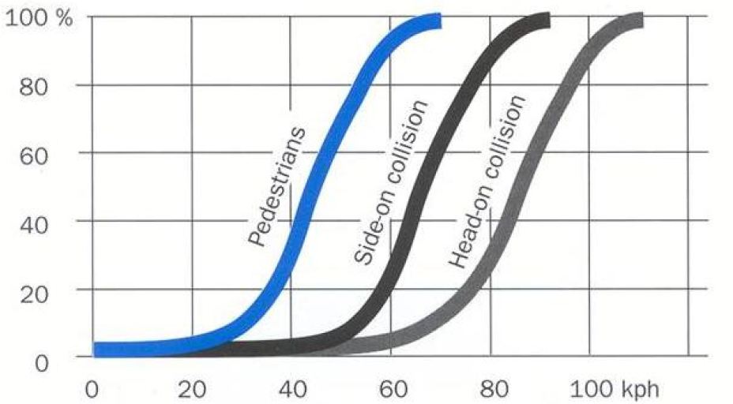

Figure 2: Fatality risk as a function of impact speed
Figure 2 shows S shaped curves of fatality risk with speed for all the crash types. It is likely that similarly shaped curves apply for other crash types and for DSI crashes. The shape of the curves implies that for each crash type there are impact speeds above which the risk is 100%, This means a cut-off point above which the impact speed crash relationship fully flattens meaning certainty of fatal injury. Similar results apply for serious injury but with a less steep slope (Tefft (2011)).

MODELS TO ESTIMATE THE SAFETY BENEFITS OR DISBENEFITS OF SPEED CHANGES
There are various speed crash models that can be used as part of estimating the benefits or disbenefits of speed changes. These can be used for predictions related to future changes or evaluations of the impact of speed changes carried out in the past. It is important to note that these models only estimate the impact of speed changes, not including other changes that may also be happening at the same time.
Such other changes may be infrastructure changes, alcohol/drug enforcement, speed enforcement or in the longer term, changes in the driver/ vehicle mix. Therefore, if one is evaluating the impact of a speed reduction or increase it is important that these other variables be held as constant as possible. If not possible the evaluation may be able to separate their impact from the speed impact using statistical methods.
It is also important to note that the impact of speed change may differ with the level of the pre-change speed and the type of road on which the speed change is occurring.
Speed crash models may be divided into two broad categories:
- mean-speed crash risk models – These deal with changes in mean speed and may involve analyses disaggregated to different speed ranges within the speed distribution
- individual crash risk models- These deal with changes in individual vehicle speeds

Mean Speed Crash Risk Models
These are divided into two types, power models and exponential models.

Power Models

Combining several evaluations of speed changes following highway speed limit changes in Sweden, Nilsson (1981) validated a theoretical model for estimating the relationship between speed change and change in crashes and casualties. This model predicts several power relationships between proportional change in mean travel speed and proportional change in crashes and casualties. The form of the model is very simple:

Crashes_{after}= Crashes_{before}. (Speed_{after}/ Speed_{before})^{Exponent}

Broadly similar models were also produced for differing levels of injury. The exponents ranged from 2 for injury crashes, 3 for DSI (Death and serious injury) crashes, to 4 for fatal crashes. Nilsson (2004) reconfirmed the model, using linear regression results produced by Elvik et al (1997). Elvik et al (2004) found the model adequately described the relationship between speed and safety. The model was considered robust, as it was independent of the infrastructure (within the range of infrastructure used to validate it) but was not well defined for urban speeds or very high speeds, which were both outside the range of the data available to validate the model. Figure 3 from Nilsson (2004, p90) is derived from the model, describing the relationship between speed changes and changes in casualty rates.
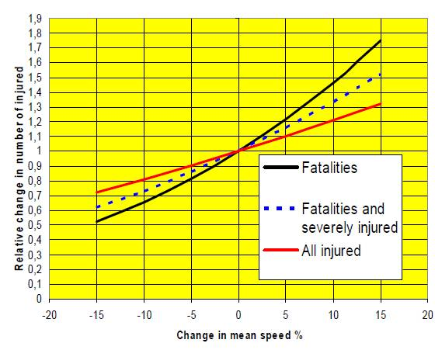
Figure 3: Relationship between speed changes and changes in casualty rates (Nilsson 2004 p90)

Nilsson’s models were derived using data from higher speed Swedish roads, both divided and undivided. His models have since been refined by Cameron and Elvik (2008), who disaggregated by type of road. They used meta-analyses carried out by Elvik, who took advantage of much richer information sources than those available to Nilsson including information on urban speed changes.

Table 1 adapted from Elvik (2009) and Cameron and Elvik (2008) summarises these results. Cameron and Elvik caution that none of the power estimates for mutually exclusive injury categories on urban roads were significantly different from the all-road estimate owing to the relatively small, disaggregated sample sizes. These problems are ameliorated somewhat by using cumulative categories. Their final analysis, using cumulative categories produced smaller powers for urban arterials and monotonically increasing powers as the road standard improved. The differences were statistically significant. For DSIs power estimates are 1.6 for urban arterials, 2.6 for rural highways and 4.9 for freeways corresponding roughly to our expressways and motorways.

Power estimates (with standard error (SE) estimates below | Traffic Environment
Power estimates (with standard error (SE) estimates below | Urban arterial | Rural highway | Freeway | All studies
Cumulative categories
Fatalities | 4.3 | 4.7. | 4.9 | 4.9.
SE | 0.92 | 0.49 | 0.15 | 0.14
DSIs | 1.6 | 2.5 | 4.9 | 3.7.
SE | 0.23 | 0.26 | 0.14 | 0.11
All levels of injury severity | 1.7 | 2.5 | 2.8 | 2.8
SE | 0.17 | 0.16 | 0.03 | 0.03
Table 1 Power and standard error estimates disaggregated by road type adapted from Elvik (2009) and Cameron and Elvik (2008)

These differences in the powers are associated with the different speeds of traffic when speed changes on the different road types occur. These speeds naturally increase with movement from urban to rural and from highway to expressway/motorway. To the casual observer it may seem strange that the exponents are higher for freeways than for rural highways, when freeways are overall the safest of all roads. This is because of the higher speeds available on a freeway, along with the greater consequences of a crash at such a speed.

Should power models be used when the shape of the speed distribution changes?

Nilsson’s original work involved changes in the shape of speed distributions. Nilsson (1981) when describing the speed changes associated with speed limit changes remarked that in most cases the speed distribution changed. The changes to the means and standard deviations of some speed changes used by Nilsson to derive his power model are documented by Oberg (1981), These relate to 110 km/hr roads in Sweden having their speed limits reduced to 90 km/hr from June 21 to August 31, 1979. The changes are illustrated in Table 2 adapted from Oberg (1981, page 17).
The roads involved are:
- motorways where the speed limit changed from 110 km/hr to 90 km/hr.
- highways, where the speed limit changed from 110 km/hr to 90 km/hr, road width >12 m.
- comparison group of highways with an unchanged 90km/hr limit

M1 represents a measurement before the change and M2 and M3 are measurements after the change with M2 being at an earlier time than M3. M4 was an even later measurement for motorways.
Passenger Car

Passenger Car

Road Type | M1 |  | M2 |  | M3 |  | M4
 | Mean | SD | Mean | SD | Mean | SD | Mean | SD
A | 107.5 | 14.0 | 95.0 | 10.5 | 95.5. | 10.9 | 100.6. | 11.9.
B | 97.8 | 13.0 | 90.0 | 9.6 | 90.9. | 103
C | 89.4 | 12.0 | 87.3 | 10.4 | 87.7. | 10.3
Table 2: Means and standard deviations of speed distributions before and after 1979 Swedish speed limit changes

It is apparent that in all 3 cases the speed distribution slimmed considerably in the reduced speed period. Speed distribution shapes are not available but evidence from elsewhere suggests the slimming would be more at the high end of the curve than at the lower end of the curve. An example is Povey et al (2003) who studied changes in speed distribution in New Zealand following improvements in the level of non-camera Police speed enforcement in the early 2000s. The distribution changes are depicted in Figure 4. This shows non-camera speeding tickets and speed distributions on the same scale. Changes in the speed distributions are evident. Both the mean speed and the percentage of vehicles travelling at speeds greater than 110 km/hr have decreased between 2000 and 2002, indicating a slimming of the higher parts of the distribution rather than just a downward movement of the distribution with no accompanying shape change.
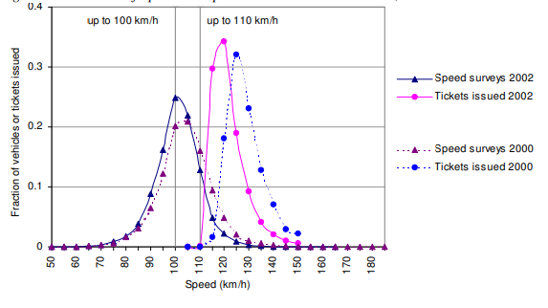
Figure 4: Distributions of open road speeds and non-camera tickets, 2000 vs 2002

This indicates that power models may be used where the shape of the speed distribution typically slims rather than truncates. These situations could include patrol car enforcement (as in Povey et al (2003)) or camera enforcement where there is uncertainty as to whether the camera will issue a ticket (which is a very common scenario), or some forms of ISA (Intelligent Speed Adaptation).

Exponential Models

These are derived from the Nilsson’s power models. Elvik (2012) looked at Nilsson’s power models with respect to the initial speed of the vehicle prior to the change in speed. This has become possible with the availability of data sets over wider speed ranges than those available to Nilsson at the time of his work. Elvik transforming the models into related, but speed environment specific, exponential models. He found that these fitted the data at least as well as the Power model. Elvik describes the form of the exponential model as:

𝑌₁ = 𝑌₀ 𝑒^{𝛽} ^{(𝑣}₁^{− 𝑣}₀⁾

Where 𝑌₁ and 𝑌₀ denote crash numbers after and before a change in speed from 𝑣_{0 to} 𝑣_{1.,} The exponential models were achieved by fitting power models to different speed ranges covering the speed distribution and fitting an exponential distribution to the resultant “sub-powers”. The power exponents and their errors for the ranges chosen are illustrated in Table 3, adapted from Elvik (2012, page 856).

Range for initial speed (km/hr) | No of estimates in  range | Mean initial speed (km/hr) | Mean final speed (km/hr) | Mean estimate of Power Model Exponent | Standard error of exponent
120.0-129.9 | 1 | 120.4 | 121.2 | 47.20 | 19.75
110.0-119.9 | 6 | 113.8 | 101.7 | 3.49 | 1.14
100.0-109.9 | 16 | 103.0 | 100.6 | 3.87 | 0.98
90.0-99.9 | 29 | 95.0 | 91.7 | 3.25 | 0.68
80.0-89.9 | 34 | 84.6 | 82.4 | 3.42 | 0.72
70.0-79.9 | 29 | 74.6. | 72.2 | 1.37 | 0.57
60.0-69.9 | 37 | 64,5 | 57.6 | 1.12 | 0.55
50.0.59.9 | 42 | 54.6 | 48.8 | 1.98 | 0.32
40.0-49.9 | 24 | 45.8 | 39.3 | 2.18 | 0.35
30.0-39.9 | 17 | 35.5 | 30.0 | 1.12 | 0.76
20.0-29.9 | 0
10.0-19.9 | 1 | 17.4 | 13.7 | 6.82 | 6.15
Total or mean | 236 | 70.5 | 65.9 | 2.12 | 0.12
Table 3:The power exponents and their errors for the ranges within the speed distribution

This approach better takes into accounts the individual speeds at different parts of the distribution and corrects for a tendency of the mean-based power model to underestimate the steepness of the speed -crash curve at higher speeds. Table 3 also indicates that the meaningful data begins with the 30.0 to 39.9km/hr range and ends with the 110.0-119.9 km/hr range. This model for fatal crashes is illustrated and compared to the power model in Figure 5 from Elvik et al (2019, page 858). The steeper nature of the exponential curve is worth noting,
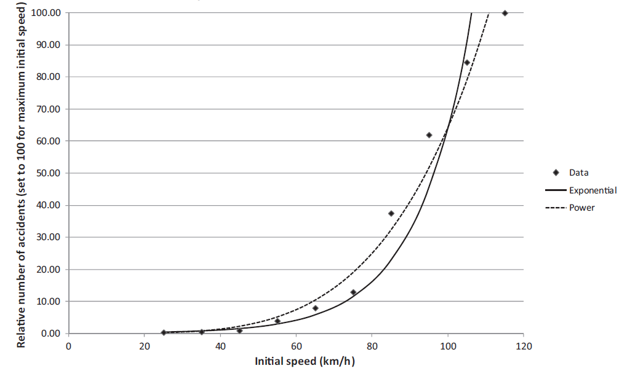
Figure 5: The power and exponential models compared for fatal crashes from Elvik et al (2019, page 858)

Table 4 adapted from Elvik et al (2013, page 855) illustrates the exponents produced by the power model for various crash and road types. It is apparent that some of the confidence intervals in Table 4 are large for some crash/ injury severity/ road type combinations. Combinations with large confidence intervals should be avoided. Also, this table does not contain separate estimates for the road-types rural roads, freeways and urban arterials. In these cases, exponents to be used with the power model are available from Cameron and Elvik (2008).

.
Summary of estimates of exponents by traffic environment

 | Rural roads/freeways Urban/residential roads All roads
Crash/injury seventy | Best estimate | 95% conf  interval | Best estimate | 95 % conf  interval | Best estimate | 95% conf interval
Fatal crash | 4.1 | 2.9 to 5.3 | 2.6 | 0.3 to 4.9 | 3.5 | 2.4 to 4,6
Deaths | 4.6 | 4.0 to 5.2 | 3.0 | -0.5 to 6.5 | 4.3 | 3.7 to 4.9
Serious injury crash | 2.6 | -2.7 to 7.9 | 1.5 | 0.9 to 2.1 | 2.0 | 1.4 to 2.6
Serious injuries | 3.5 | 0.5 to 5.5 | 2.0 | 0.8 to 3.2 | 3.0 | 2.0 to 4.0
Minor injury crashes | 1.1 | 0.0 to 2,2 | 1.0 | 0.6 to 1.4 | 1.0 | 0.7 to 1.3
Minor injuries | I.4 | 0,5 to 2.3 | 1.1 | 0.9 to .3 | 1.3 | 1.1 to 1.5
All injury crashes | 1.6 | 0.9 to 2.3 | 1,2 | 0.7 to 1.7 | 1.5 | 1.2 to 1.8
All injuries | 2,2 | 1.8 to 2.6 | 1.4 | 0.4 to 2.4 # | 2’0 | 1.6 to ,2.4
Table 4 Summary estimates of exponents by traffic environment from Elvik et al (2019)
# Confidence interval established informally
Individual Risk Models
The most well-known individual risk models in New Zealand are those of Kloeden et al. (1997), Kloeden et al (2001) and Kloeden et al (2002). These come out of case-control studies on South Australian roads designed to quantify the relationship between observed free-travel speed and risk of involvement in a casualty crash requiring a visit to hospital. They compared the speeds of crash involved drivers with the average of the speed distribution of non-crash involved drivers. The speeds of crash-involved drivers were estimated by crash reconstruction techniques. Kloeden et al. (1997), and Kloeden et al (2002) relate to urban speed. Part of the rationale in the urban case was that the average was the same as the speed limit so results could be couched as deviations from the speed limit. They found the risk of involvement in a casualty crash doubled with each 5km/hr increase in free-travel speed above the 60km/hr urban speed limit of the time, Similarly in a case-control study of crashes on rural roads with speed limits of 80km/hr and above, Kloeden et al (2001) found the risk of involvement in a casualty crash doubled for vehicles travelling 10 km/hr above the mean control speed and become nearly six times as high when travelling 20 km/hr above the mean control speed. The mean control speeds were disaggregated by speed limit,
Other case-control based individual risk models exist, notably those described in Quimby et al (1999) and Maycock et al. (1998). There are circumstances where individual risk models tend to produce much higher crash change estimates than the power model and the exponential model. These occur where the shape of the speed distribution changes in a more radical way than just slimming or widening. This type of more radical change may happen where the major speed change approaches a truncation of the distribution. An example is mandatory hot gas pedal ISA. Vadeby et al (2012, p 35) compared power model estimates (exponent of 1.5) of changes in all injury crashes associated with some Swedish speed changes with estimates using the individual risk models of Quimby et al (1999) and Maycock et al. (1998). These are portrayed in Table 5.
Model | Speed limit drop 110km/hr to 100km/hr | Speed limit drop 90km/hr to 80km/hr, at fixed camera | New stretch of fixed cameras | ISA with active  gas pedal
Power model (exponent of 1.5) | -5 % | -11% | -11% | -13%
Quimby | -22% | -45% | -58% | -59%
Maycock | -27% | -52% | -82% | -77%
Table 5: All reported crash changes for individual risk models compared to the power model
Similarly, Table 6 derived from Vadeby et al (2012, p 36) compares the results using Kloeden et al (2001) with power model results for DSI crashes, which approximate Kloeden’s crash severity.
Model | Speed limit drop 110km/hr to 100km/hr | Speed limit drop 90km/hr to 80km/hr, at fixed camera | New stretch of fixed cameras | ISA with active  gas pedal
Power model (exponent of 3) | -9 % | -21% | -21% | -25%
Kloeden | -27% | -36% | -73% | -71%
Table 6: DSI crash changes for Kloeden’s risk model compared to the power model
In particular, the individual risk model of Kloeden estimates are around 3 times the power model estimates except for the case of speed limit reduction 90km/hr to 80km/hr, at fixed camera. Vadeby et al (2012) imply that (see Larsson and Brüde, 2010; Swedish Road Administration, 2009 and Elvik et al., 2009) that the individual models produce crash impact estimates considerably higher than the results of actual crash studies while the power model produces broadly similar results.
Waibl et al (2013) discuss how they used the model of Kloeden et al (2002) to assess crash changes with speed. They followed Lia et al (2012) and took the relative-risk curve and combined it with the speed profile to provide a risk profile (Figure 6). The area under the risk profile curve was taken to represent the relative crash risk, and the difference in the areas with and without the speed change from ISA represented the expected crash reduction.

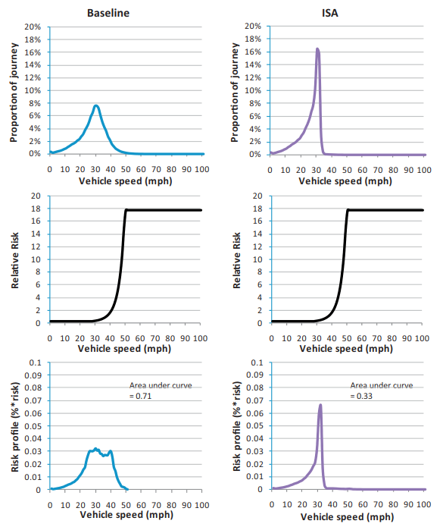
Figure 6 Comparison of risk profiles between baseline and ISA (Lai et al 2012 pg65)

An alternative approach to consider speed distribution changes is to use the power model in its exponential iteration. This uses speed distribution data disaggregated into ranges of 10km/hr width and therefore takes the shape of the distribution into account, to a degree, thus moving in the direction of an individual risk model The exponential model has the very useful property that a given nominal change in average speed gives the same expected percentage change in crashes regardless of the initial average speed. This means that a decrease from 120km/hr to 110 km/hr, which is an 8.4% decrease in average speed will provide the same percentage decrease in crashes as a 20% decrease from 50 to 40km/hr This property relates to the greater severity of the crash at the greater speed, reflected in the steepness of the exponential curve.

The Role of Speed Variance
It is notable that speed variance plays no part in the models discussed above. Elvik (2014) studied the role of speed variance, which of course relates to the shapes of distributions. He concluded that the impact of speed variance on crashes is heavily weighted towards damage only crashes, which are not a road safety concern. This is in accord with previous findings of Frith and Patterson (2001) and Kloeden etc al (2001) that speed variance bears little relation to road trauma. Two points to remember are the following.

- Vehicles need to be close enough to each other to interact for speed variance to meaningful impact on safety. Frith and Patterson (2001) quote work carried out using the 1993 National Traffic Database indicating that of the total vehicle kilometres of travel on New Zealand roads only about 10% are by vehicles at headways of less than 20 metres.

- Often speed means and variances are calculated over long time periods including many vehicles that are separated in time and thus unable to interact. Speed variances calculated in this way have scant safety relevance.

- Both Kloeden et al (2001) and Elvik (2009) found no evidence that slimming the speed distribution by getting slower drivers to increase their speed (therefore reducing speed variance) was advantageous to safety.

CONCLUSIONS

Power And Exponential Models
It is clear from the literature that higher travel speeds are associated with reduced safety, measured by crash and injury increases. The extent of this reduction depends on crash/injury severity, road type and the initial speeds. The rate of increase is greater for more severe injuries and higher speeds. These characteristics are embodied in the power and exponential models.
Speed crash modelling using the power model or the exponential model is a valuable way to estimate the safety impact of mean speed changes. Both methods estimate the percentage change in crashes after a change in mean speed and are simple to use.
Both methods depend on the values of exponents, which vary with road type and initial speed. These exponents have been validated over many studies. The validation process has provided confidence limits for the values of the exponents, which practitioners may use to provide confidence limits for the estimates based on these exponents. Estimates should be made only when these confidence limits are narrow enough to provide a sensible range of values.
The power and exponential models are best suited to situations where the speed distribution moves with an unchanged, slimmed down or widened shape. Where changes are heavily weighted to slowing of the fastest drivers, the results may be conservative. However, the exponential model does make some allowance for changes in the speed distribution shape by being based on disaggregated 10km/hr wide speed tranches. The exponential model’s weakness is that it has been produced only for fatal crashes, injury crashes and property-damage-only crashes and is not fully disaggregated by road type. We await its further refinement.

Individual Risk Models
Like the power and exponential models, they imply that safety decreases exponentially with speed. They embody more underlying assumptions than the power and exponential models and are based on a small number of studies, sometimes only one. They have been shown to overestimate the safety impact of speed changes where their estimates have been compared to the crash changes from speed limit changes, speed camera deployment and hot gas-pedal ISA.
Their usefulness is in highly bespoke situations such as the ISA analyses of Waibl et al (2013) rather than more routine jurisdictional evaluations.
Speed Changes to Reduce Vulnerable Road User Trauma.
The power, exponential and individual risk models mentioned above are unlikely to provide good estimates of the impact of such measures. It is best to rely on the common-sense modelling of the consequences of collision to justify such measures.

RECOMMENDATIONS
- Make sure you are using the right power/exponent for the road type and crash/injury severity being considered
- Unless there is evidence that a measure will produce speed distribution changes well beyond a simple shifting and/or widening or slimming of the distribution, the power or the exponential model should be used
- The exponential model is preferred when considering network/ crash/ injury combinations for which exponents are available
- Always provide confidence limits for your estimates as well as the estimates themselves
- Do not carry out an analysis in the case of unreasonably wide confidence limits
- Rely on modelling of the consequences of collision to justify measures to protect vulnerable road users.
- In cases where the speed distribution is expected to change in an unusual way, a bespoke method may need to be used
- Always check your results afterwards against the real change
REFERENCES
Austroads (2008) Guide to road safety, part 3: speed limits and speed management. Austroads Sydney
Cameron, M. and Elvik, R. (2008) Nilsson’s Power Model connecting speed and road trauma: Does it apply to urban roads? Paper presented at the 2008 Australasian Road Safety Research, Policing and Education Conference

Corben, B (2011) Safe roads and roadsides. A glimpse into the future. Paper presented at Australasian College of Road Safety Conference – A Safe System: Making it Happen! Melbourne, 1–2 September 2011

Elvik, R, Vaa, T, and Mysen, A, B. (1997) Trafikksikkerhetshandbok, Transportokonomisk institutt, Oslo 1997. Page 313-316 (In Norwegian).

Elvik, R.; Christensen, P.; Amundsen, A. H. (2004). Speed and road accidents. An evaluation of
the Power Model. Report 740. Institute of Transport Economics, Oslo

Elvik, R. (2009). The Power model of the relationship between speed and road safety. Update and new analyses. Report 1034. Institute of Transport Economics, Oslo
https://www.toi.no/getfile.php?mmfileid=13206

Elvik, R. (2012). A re-parameterisation of the Power Model of the relationship between the speed of traffic and the number of accidents and accident victims. Accident; analysis and prevention, 50, 854-60

Elvik, R. (2014). Speed and traffic safety. New Models. Report 1296. Institute of Transport Economics, Oslo In Norwegian Viewed via Google machine translation

Elvik R, Vadeby A, Hels T, van Schagen I. (2019) Updated estimates of the relationship between speed and road safety at the aggregate and individual levels. Accid Anal Prev. 2019 Feb; 123:114-122. doi: 10.1016/j.aap.2018.11.014. Epub 2018 Nov 23. PMID: 30472529.

Frith, W.J., & Patterson, T.L. (2001). Speed Variation, Absolute Speed and Their Contribution to Safety, with Special Reference to the Work of Solomon. Institution of Professional Engineers New Zealand (IPENZ) Transportation Group Conference

Kloeden, C. N.; McLean, A. J.; Moore, V. M.; Ponte, G. (1997). Travelling speed and
the risk of crash involvement. Volume 1 – findings. NHMRC Road Accident Research
Unit, University of Adelaide, Adelaide

Kloeden, C. N.; Ponte, G.; McLean, A. J. (2001). Travelling speed and the risk of crash
involvement on rural roads. Report CR 204. Road Accident Research Unit, Adelaide
University, Adelaide

Kloeden, C. N.; McLean, A. J. and Gloonek, J. (2002). Reanalysis of Travelling speed and
the risk of crash involvement in Adelaide South Australia. Australian Transport Safety
Bureau. Road Accident Research Unit, Adelaide University, Adelaide

Lai, F. Carsten, O. M. J; Tate, F. N (2012). How much does Intelligent Speed Adaptation deliver: An analysis of its potential contribution to safety and environment. Accident Analysis and Prevention 48 (2012) 63-72

Larsson, J and Brüde, U. (2010). Traffic safety effects of speed cameras established in
2006. Analysis of personal injuries 2007-2008. VTI Report 696. In Swedish. Viewed via Google machine translation
Maycock, G., Brocklebank, P.J., and Hall, R.D. (1998). Road layout design standards and
driver behaviour. TRL Report No. 332. Transport Research Laboratory TRL, Crowthorne,
Berkshire
Ministry of Transport- Te Manatu Waka (n.d.). Safety — Annual statistics viewed 29 May 2024
< Safety — Annual statistics | Ministry of Transport />

Nilsson, Goran (1981) The Effects of Speed Limits on Traffic Accidents in Sweden In: Reprints of papers presented at the International OECD Symposium "The Effects of Speed limits on Traffic Accidents &Transport Energy Use; Dublin, Ireland, October 6-81981. https://www.diva-portal.org/smash/get/diva2:671036/FULLTEXT01.pdf Viewed 29/5/2024

Nilsson, G. (2004) Traffic safety dimensions and the Power Model to describe the effect of speed on safety. Bulletin 221. Lund Institute of Technology, Department of Technology and Society, Traffic Engineering, Lund.

Oberg, Gudrun (1981) The Influence on Speed and Fuel Consumption of Changed Speed Limits In: Reprints of papers presented at the International OECD Symposium "The Effects of Speed limits on Traffic Accidents &Transport Energy Use; Dublin, Ireland, October 6-8, 1981. https://www.diva-portal.org/smash/get/diva2:671036/FULLTEXT01.pdf Viewed 29/5/2024.

Povey, L J, Frith, W. J. and Keall M. D (2003) An investigation of the relationship between speed enforcement, vehicle speeds and injury crashes in New Zealand Conference of the Transportation Group of The Institution of Professional Engineers New Zealand (IPENZ)

Quimby, A., Maycock, G., Palmer, C. and Buttress, S. (1999). The factors that influence a
driver’s choice of speed – a questionnaire study. TRL Report No. 325. Transport
Research laboratory TRL, Crowthorne, Berkshire.

Swedish Road Administration (2009) The effects of automated road safety cameras on speed and road safety

Tefft, B.C. (2011). Impact Speed and a Pedestrian’s Risk of Severe Injury or Death (Technical Report). Washington, D.C.: AAA Foundation for Traffic Safety

Vadeby, Anna and Forsman, Asa (2012) Speed distribution and traffic safety VTI rapport 746 In Swedish. Viewed via Google machine translation.

Waibl, G, Batt, R, England, J Thomas, J, Mora, K, Frith, B, Rive, G, Jamson, S, Carsten, O and Lai, F (2013) An investigation into the deployment of an advisory ISA system in New Zealand. NZ Transport Agency research report 521. 240pp.

